Lesson 02 Demo 03

Validating Misconfigurations in Security Groups

Objective: To create and configure a security group and validate its compliance and configurations using AWS Trusted Advisor checks to ensure secure and optimized
AWS resources

Tools required: AWS Management Console

Prerequisites: None

Steps to be followed:
- Create and configure a security group
- Validate security configurations using AWS Trusted Advisor checks

Step 1: Create and configure a security group

  - Navigate to the AWS Console Home page
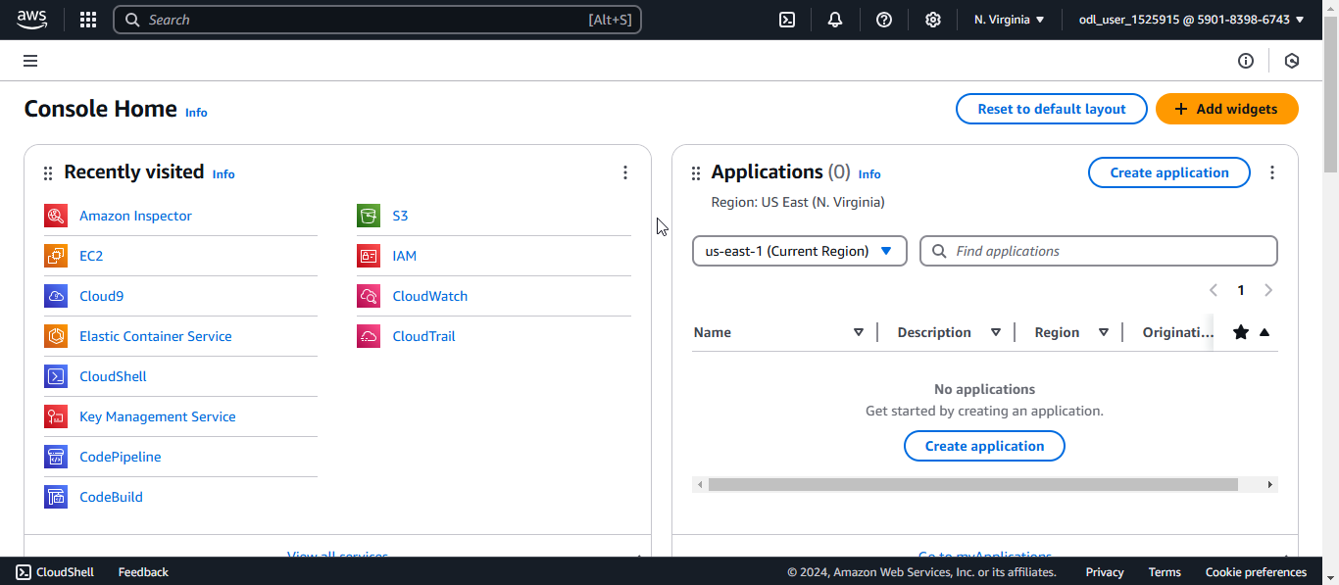

  - Search for and click on EC2
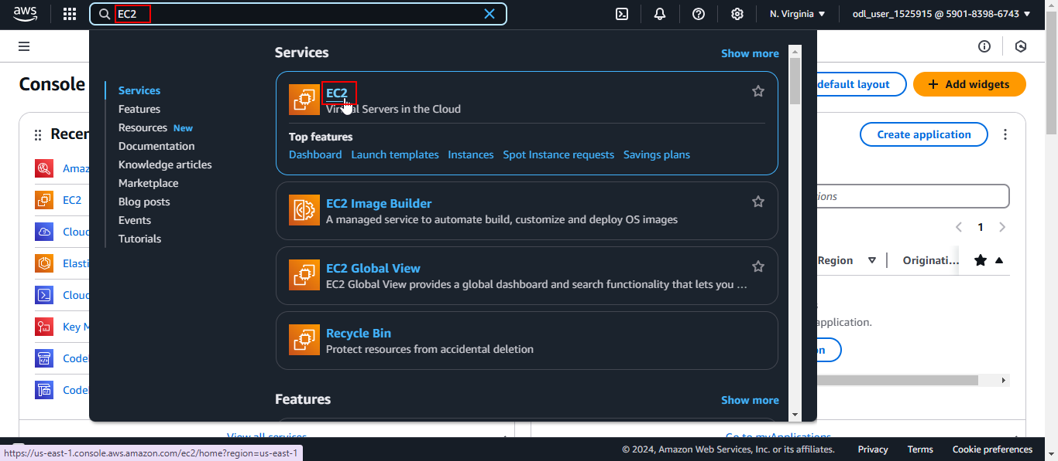
  - Click on Security Groups in the Network & Security section
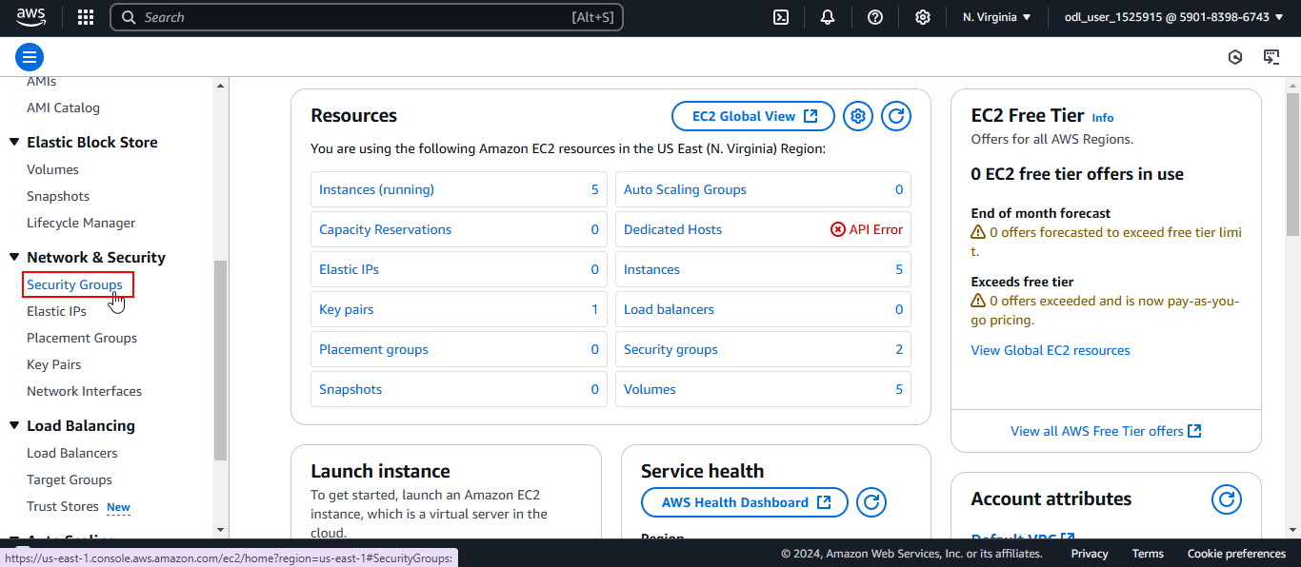
  - Click on Create security group
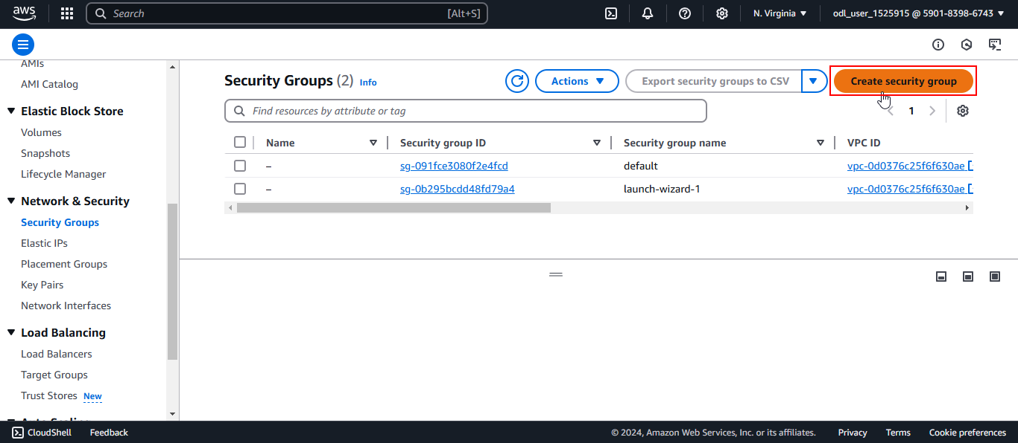

  - Add SecurityGroup as the security group name and Security Group for infrastructure as the description. Then, select the desired VPC.

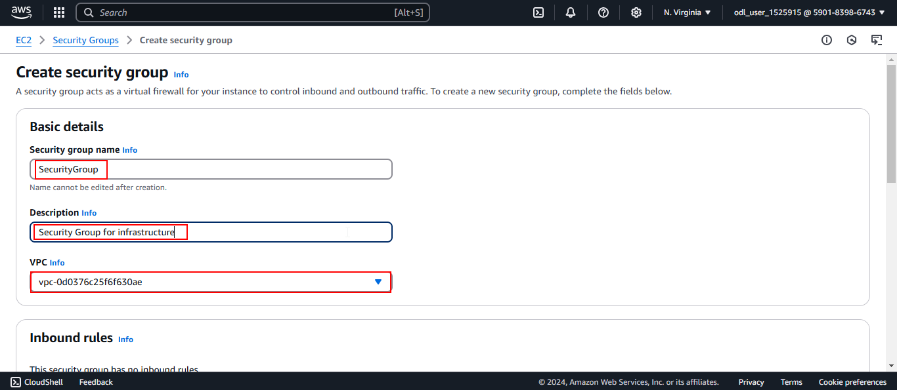

  - Configure outbound rules for SSH (TCP/22 to 0.0.0.0/0), RDP (TCP/3389 to 0.0.0.0/0), and LDAP (TCP/389 to My IP:<YOUR_IP>)

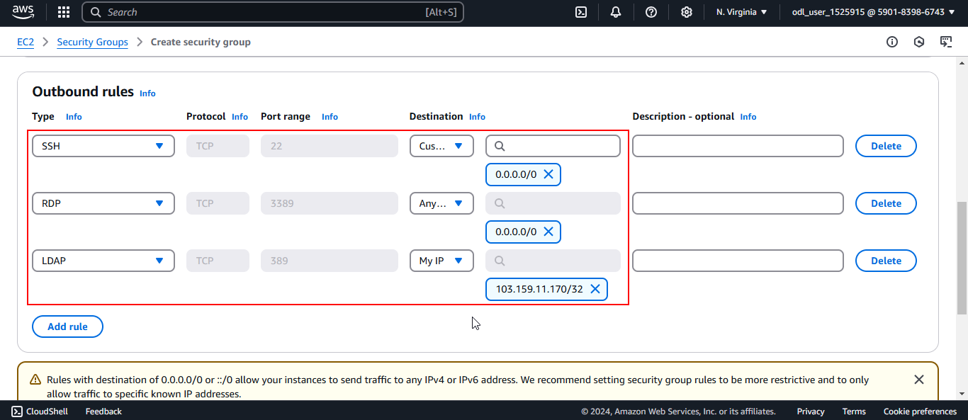
Note: Replace <YOUR_IP> with your actual IP; in this case it is 103.159.11.170/32

  - Click on Create security group
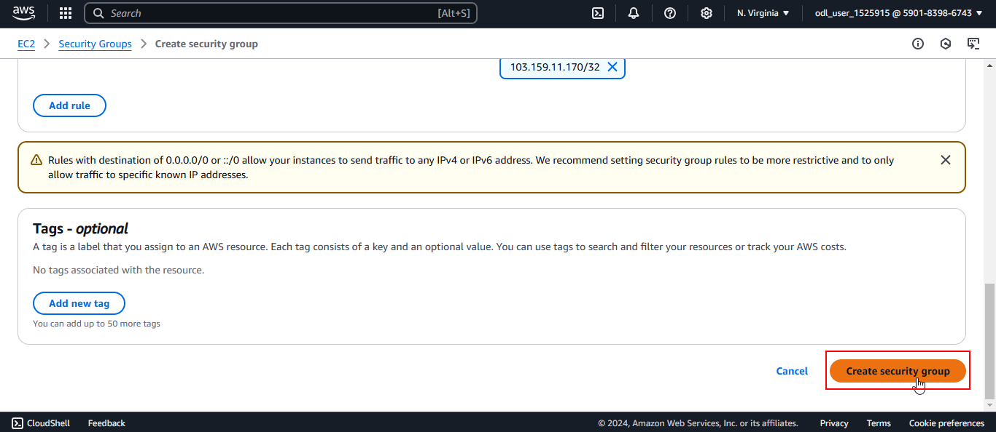
  - Click on Edit inbound rules and configure inbound rules for SSH (TCP/22 to 0.0.0.0/0), RDP (TCP/3389 to 0.0.0.0/0), and LDAP (TCP/389 to My IP:<YOUR_IP>)
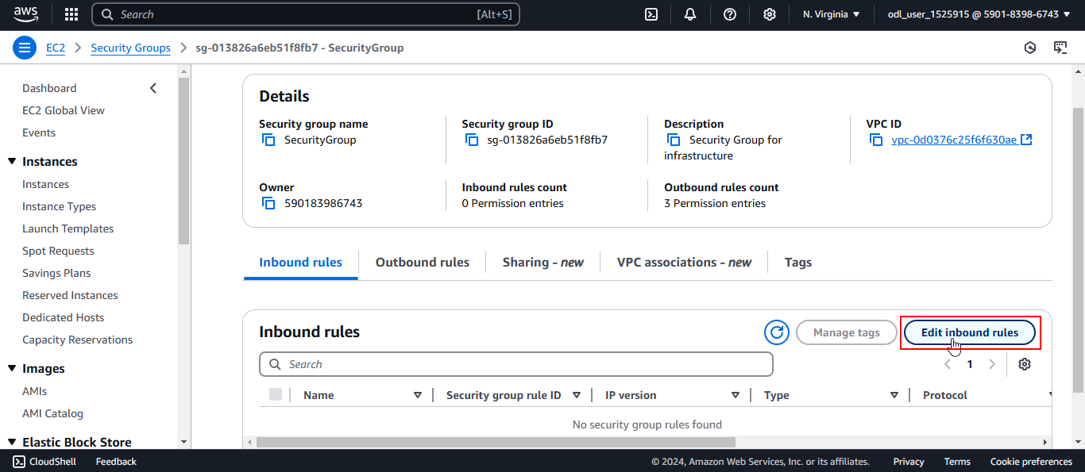
  - Click on Save rules
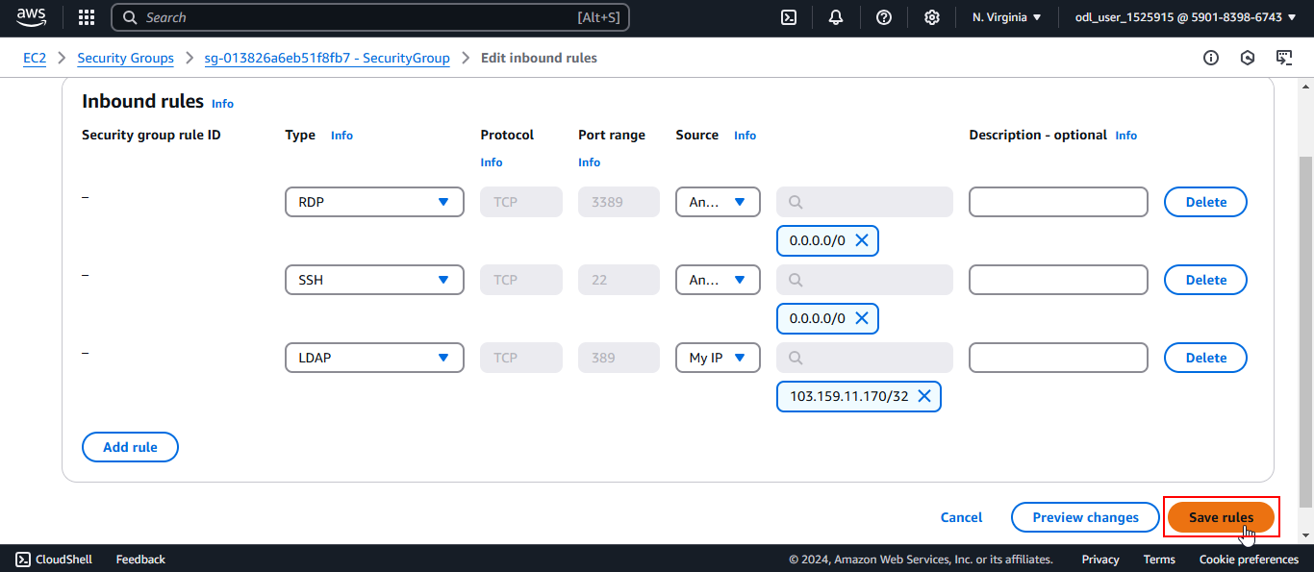
The inbound rules are added successfully.
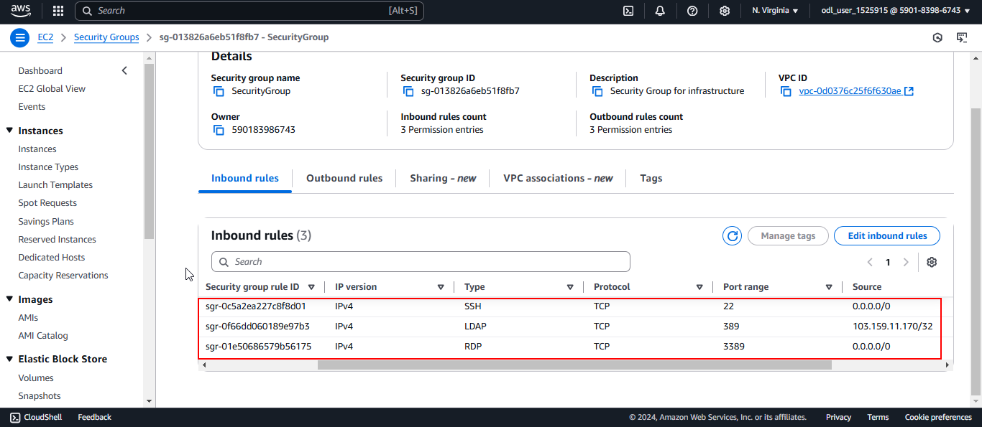

Step 2: Validate security configurations using AWS Trusted Advisor checks

  - Navigate back to the AWS Console Home page



- Search for and click on Trusted Advisor
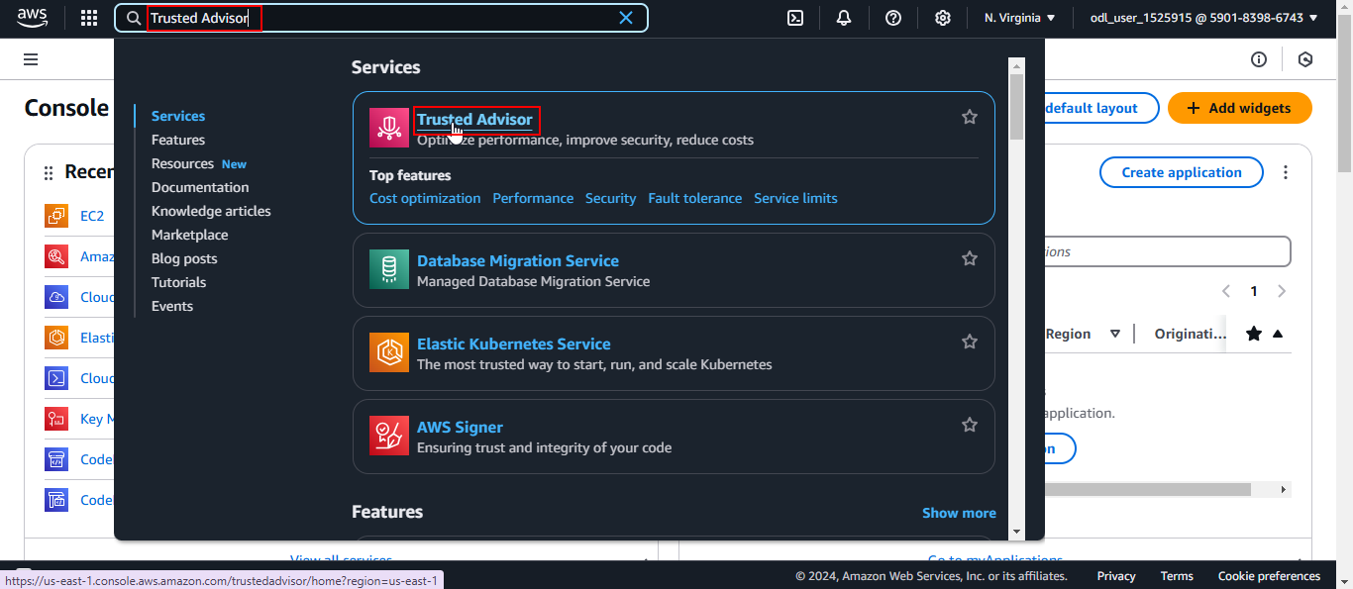
- Click on Security
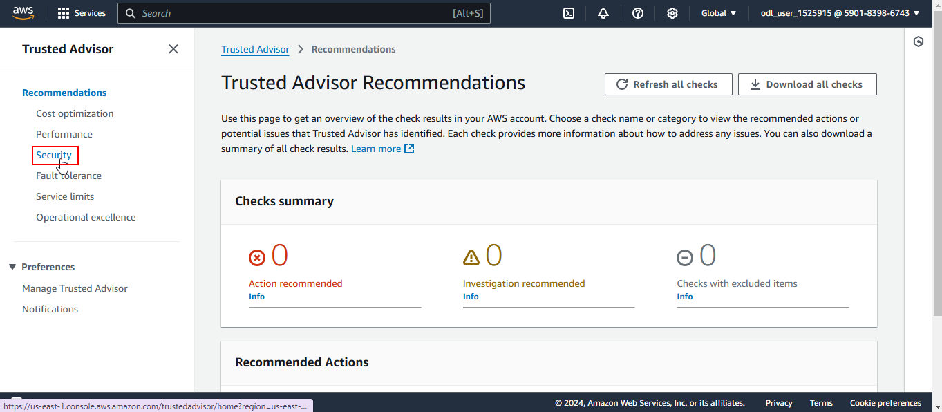
- Click on Refresh all checks
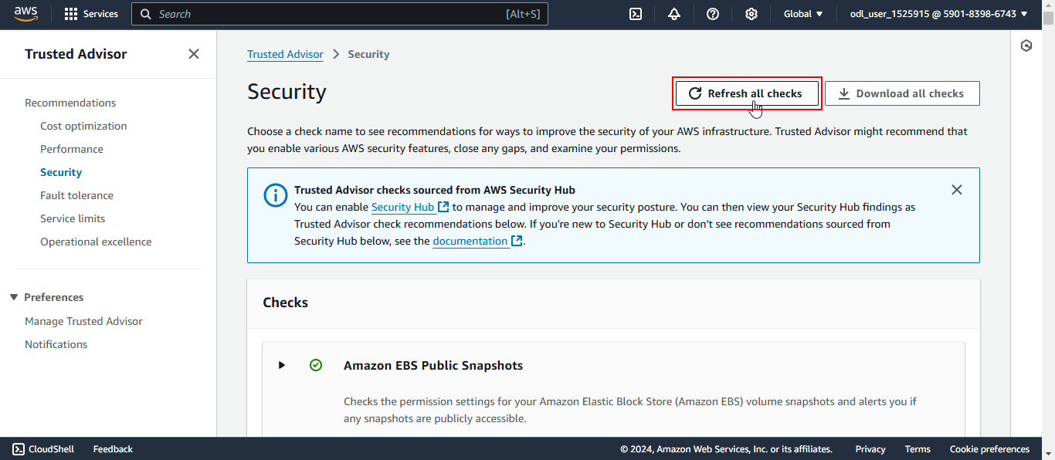
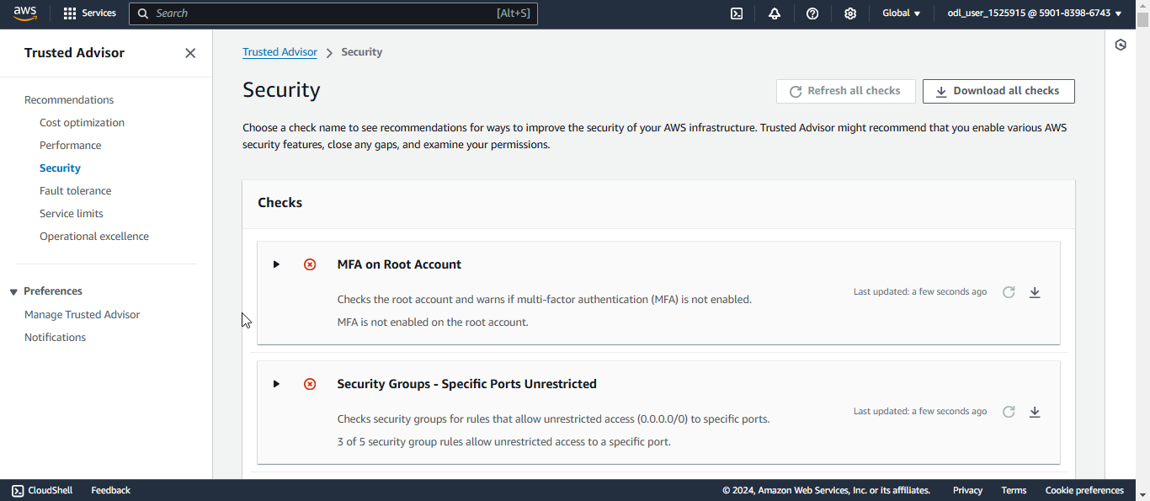
Note: Some checks may fail after the scan is completed due to non-compliant security configurations.

- Click on the desired check to view detailed information
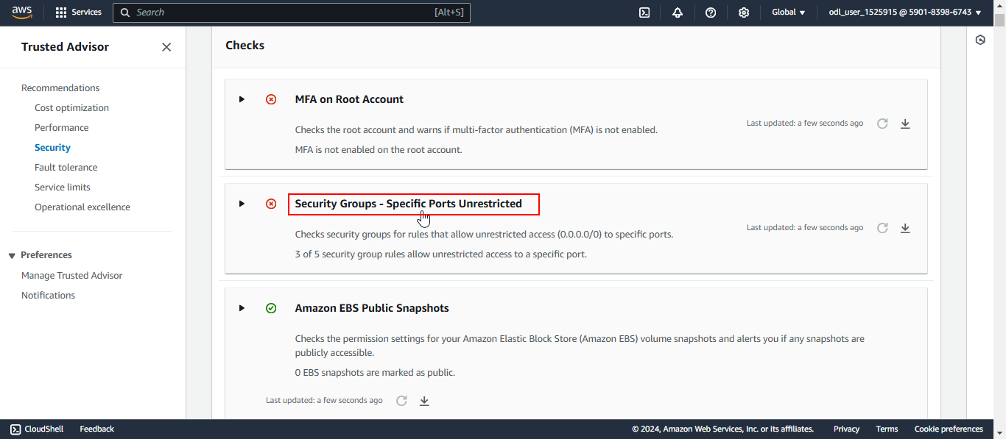
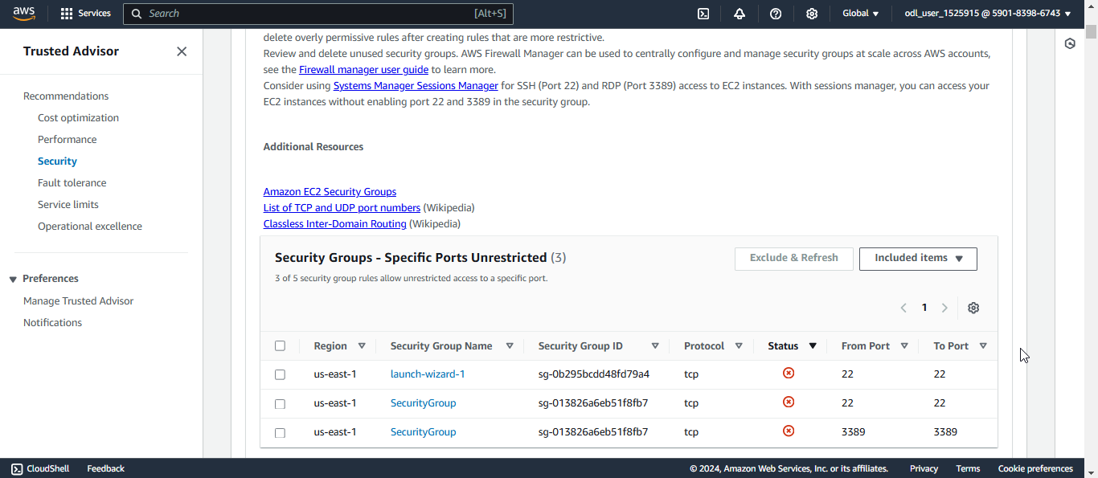

By following these steps, you have successfully created and configured a security group and validated its compliance and configurations using AWS Trusted Advisor checks to ensure secure and optimized AWS resources.

