Lesson 03 Demo 01

Creating a Secure EKS Cluster
Objective: To create a private Amazon EKS cluster using the AWS Management Console, including setting up the VPC, subnets, IAM roles, and security settings, to ensure secure and isolated Kubernetes workloads

Tools required: AWS Console

Prerequisites: None

Steps to be followed:
- Create a VPC
- Configure secure EKS Cluster with private subnets

Step 1: Create a VPC

- Open the AWS Management Console in your practice environment

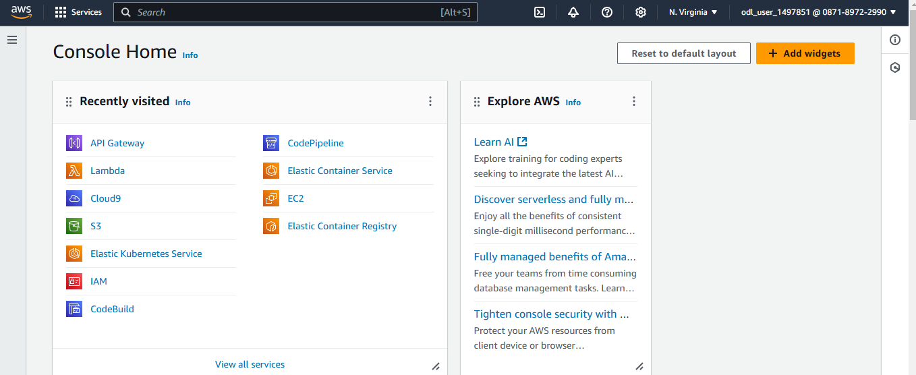

- In the search bar, type VPC and select it
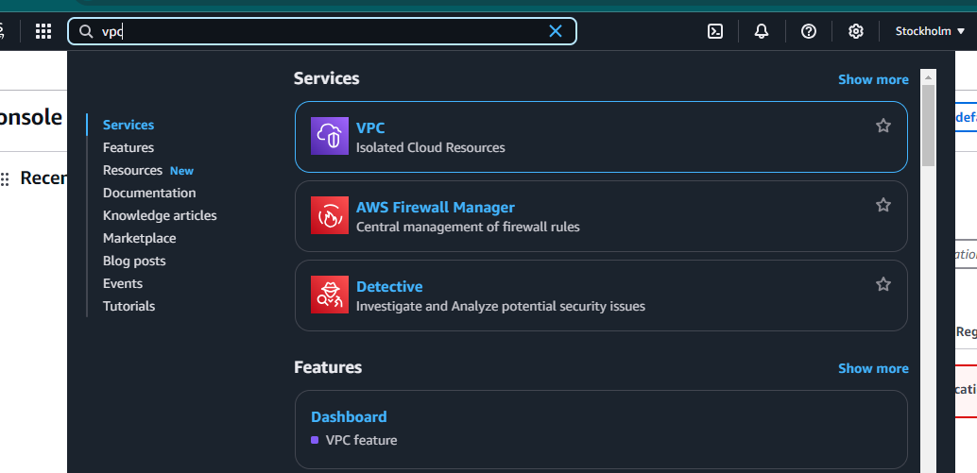
- Click on Create VPC
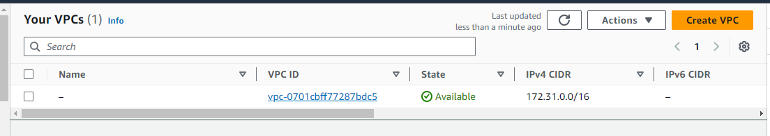
- Select the VPC settings as VPC and more and keep the default values for other settings, or adjust them as needed
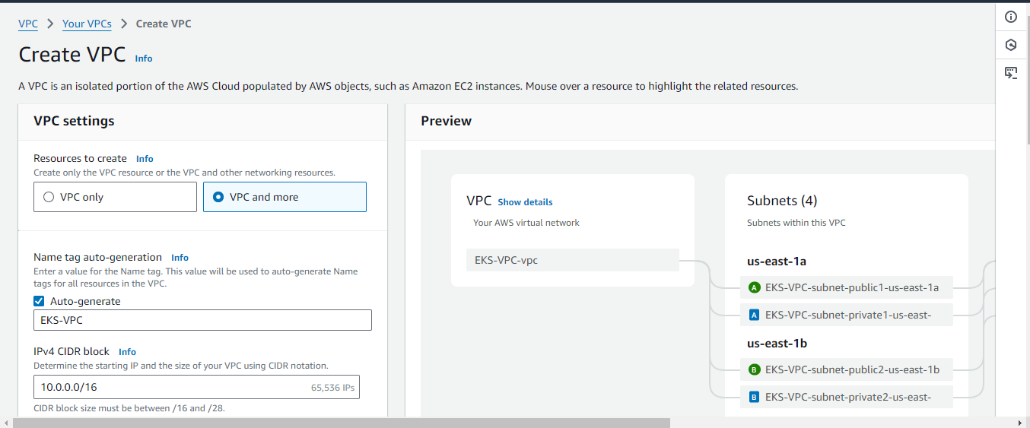
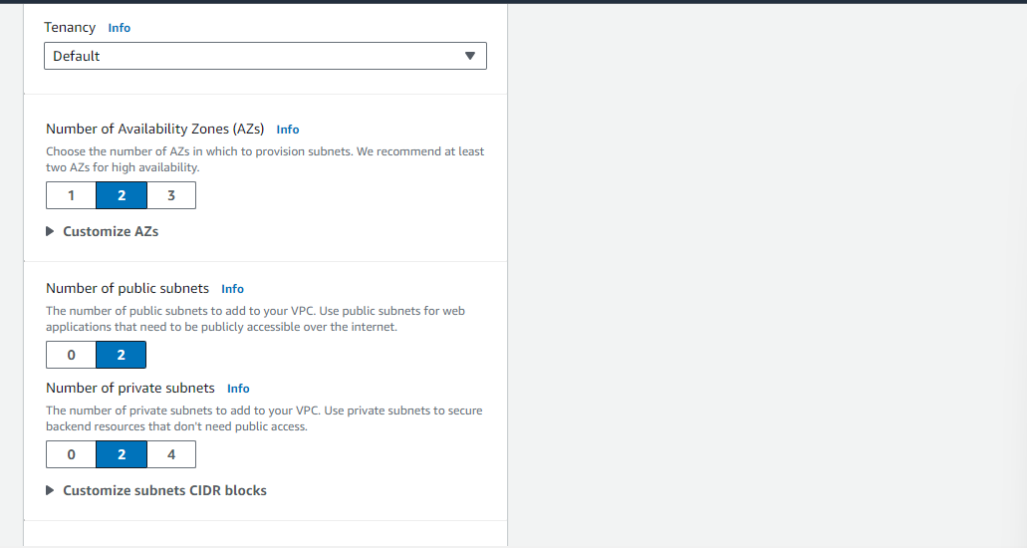
- Click on Create VPC
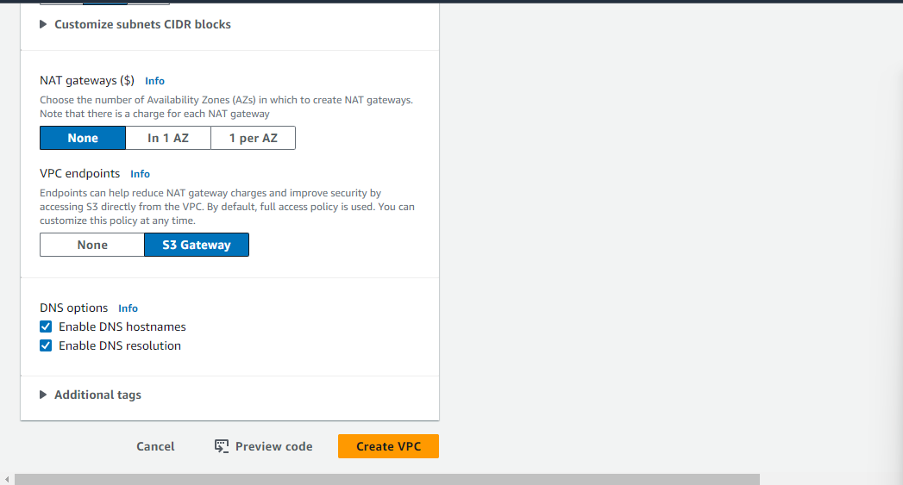

You will see the below screen once created.

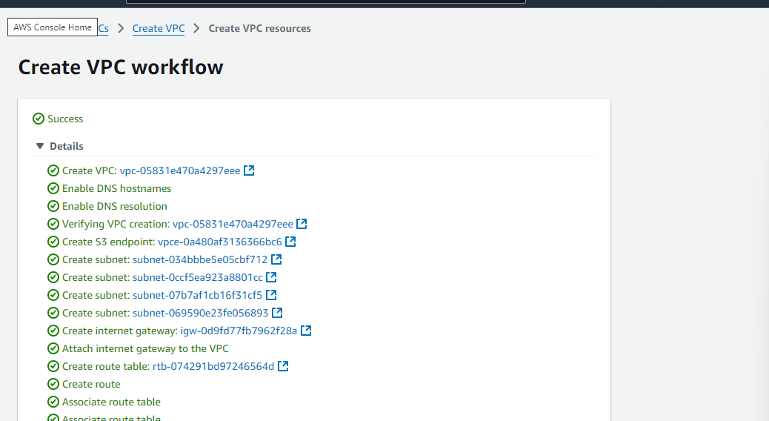

Step 2: Configure secure EKS Cluster with private subnets

- In the AWS Management Console, search for EKS and select Elastic Kubernetes Service
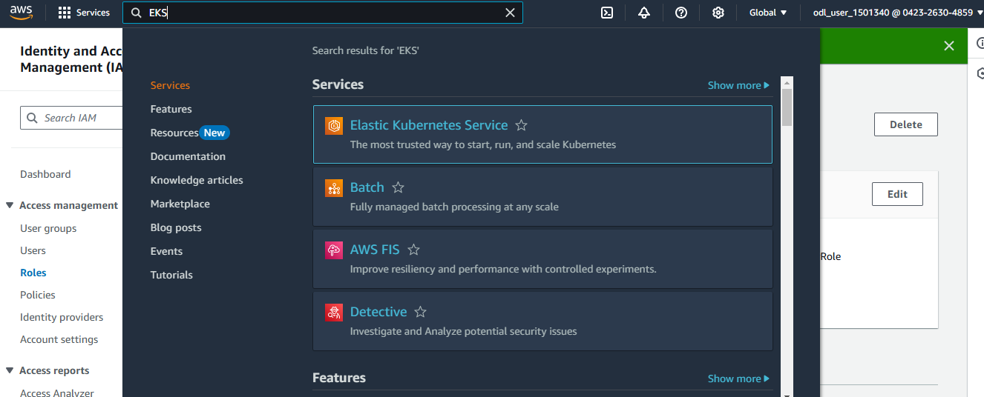

- Click on Add cluster and then select Create
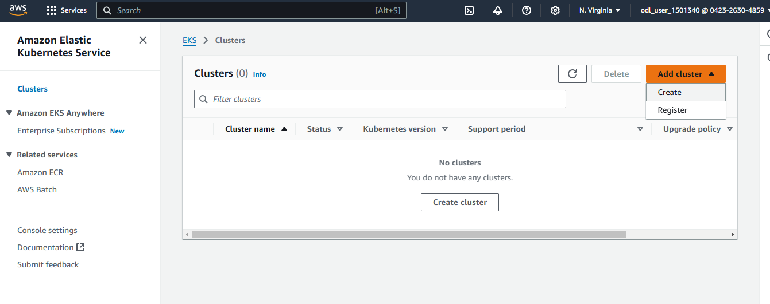
- Provide a desired name for your EKS cluster and click on Create recommended role to create an IAM role
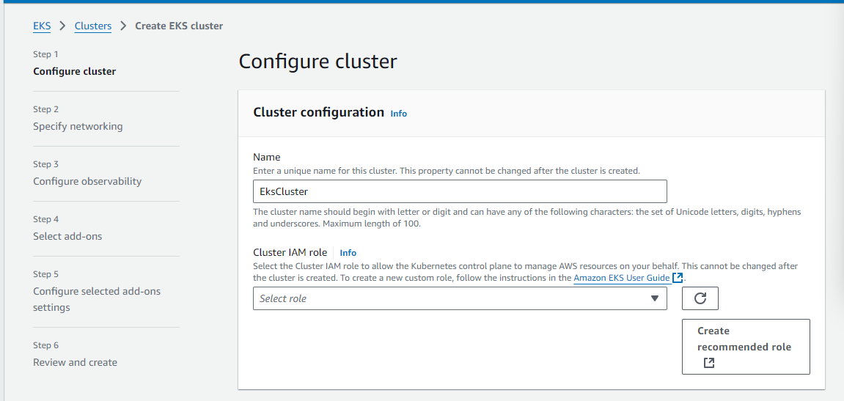

- Select AWS service from the Trusted entity type section
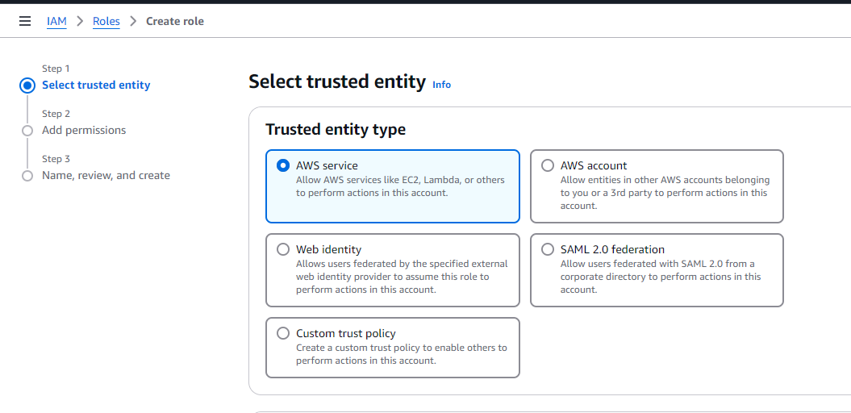
- Select EKS-Cluster as Use case and click Next

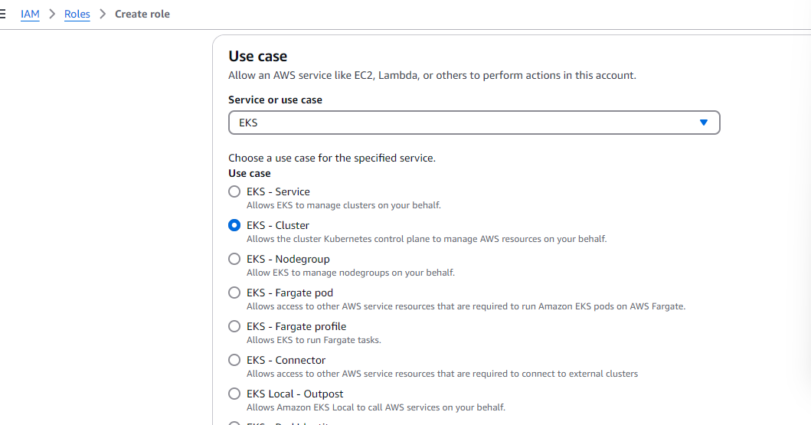
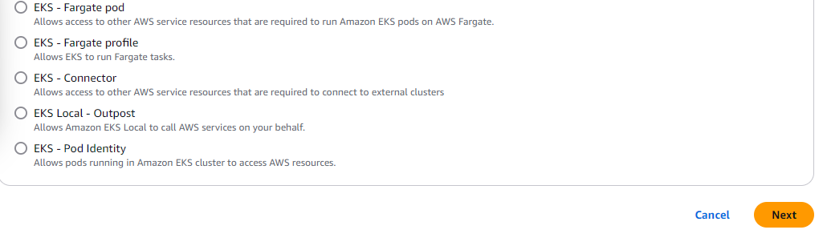
- Enter the Role name
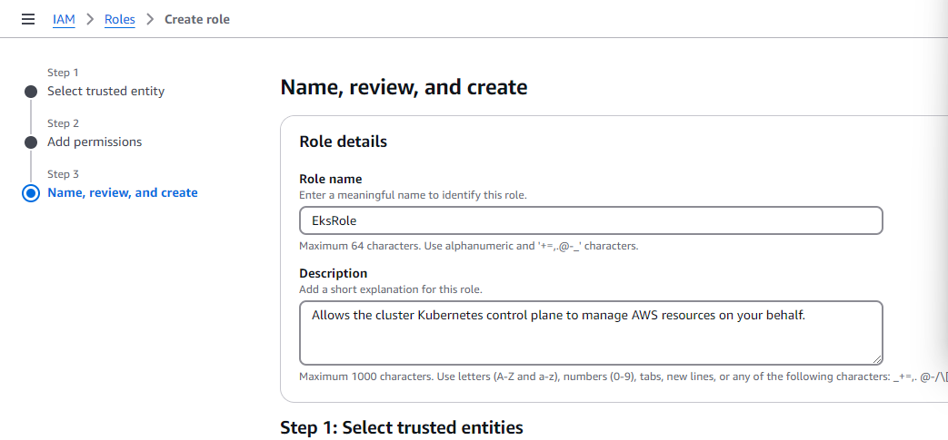
- Now, click on Create role
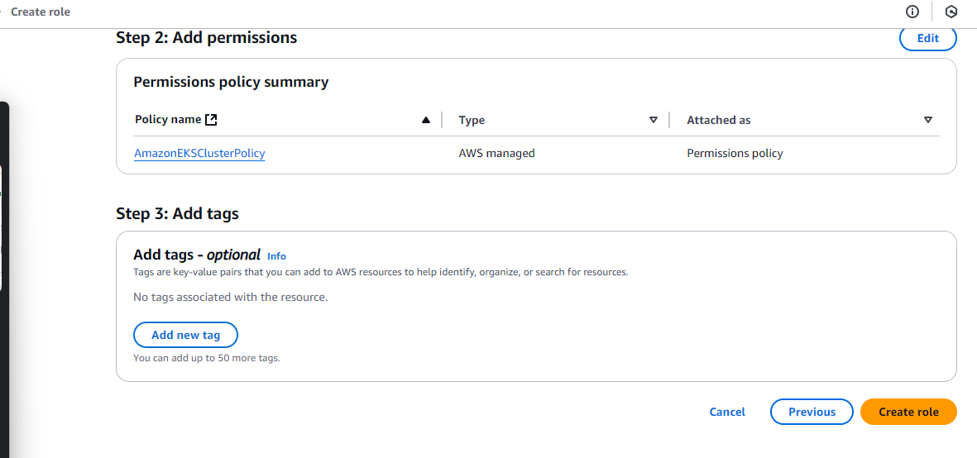
- Navigate back to the cluster and select the newly created IAM role
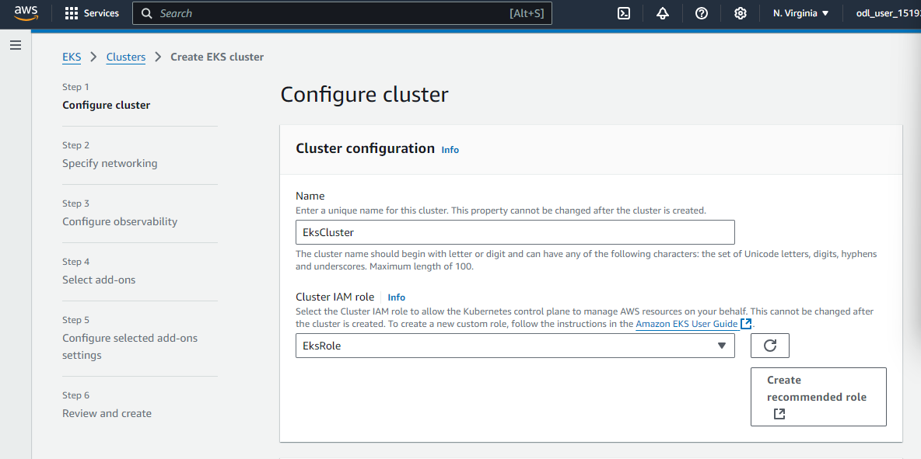

- Click Next
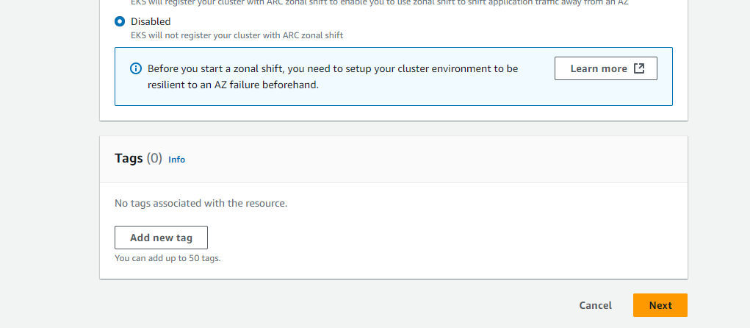

  - Select the previously created VPC and two Subnets. Then, select the default Security groups.
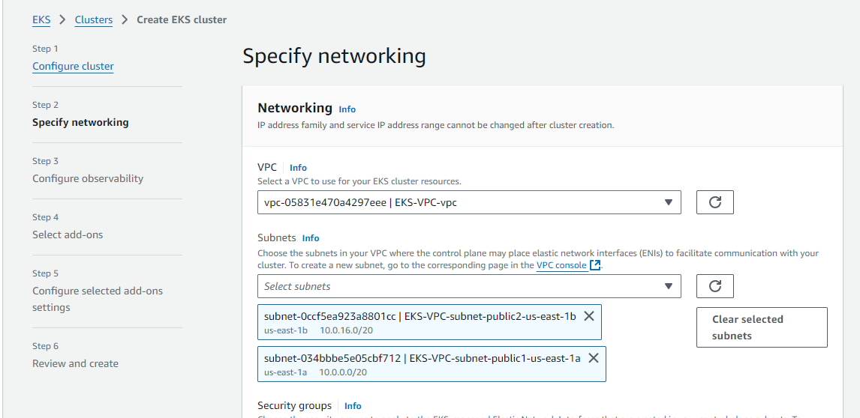

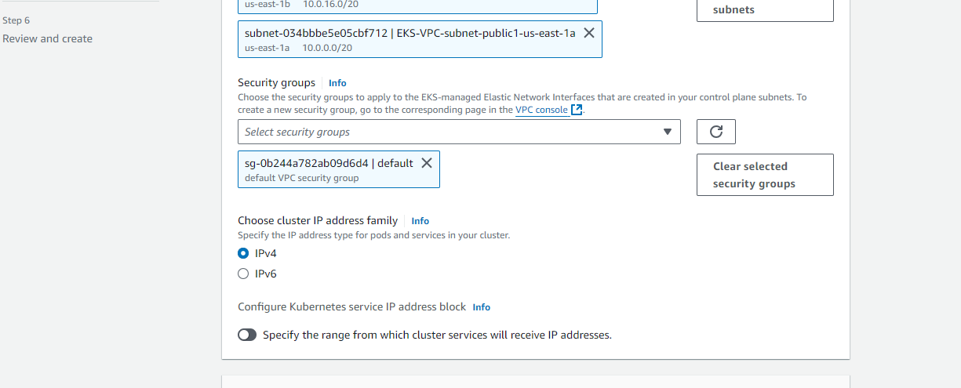

  - Select Cluster endpoint access as Private and click Next
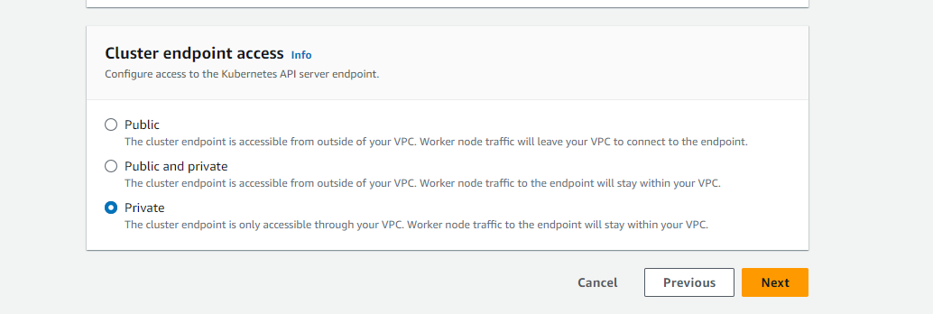

  - Enable the Control plane logs you need and click Next
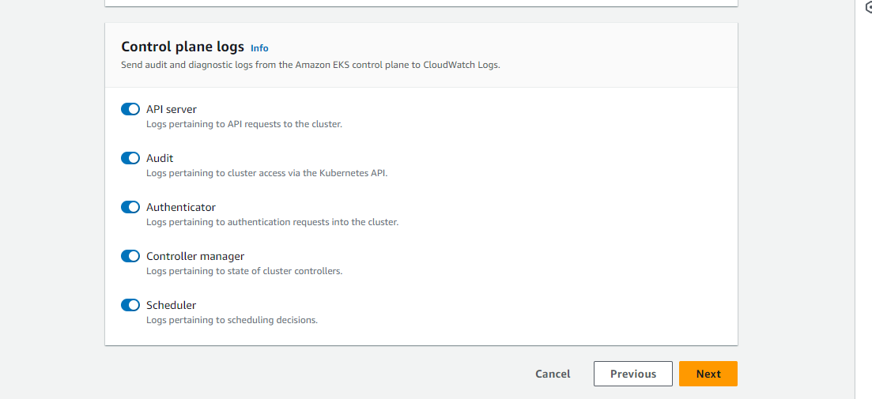

  - Click Next to proceed through the configuration screens
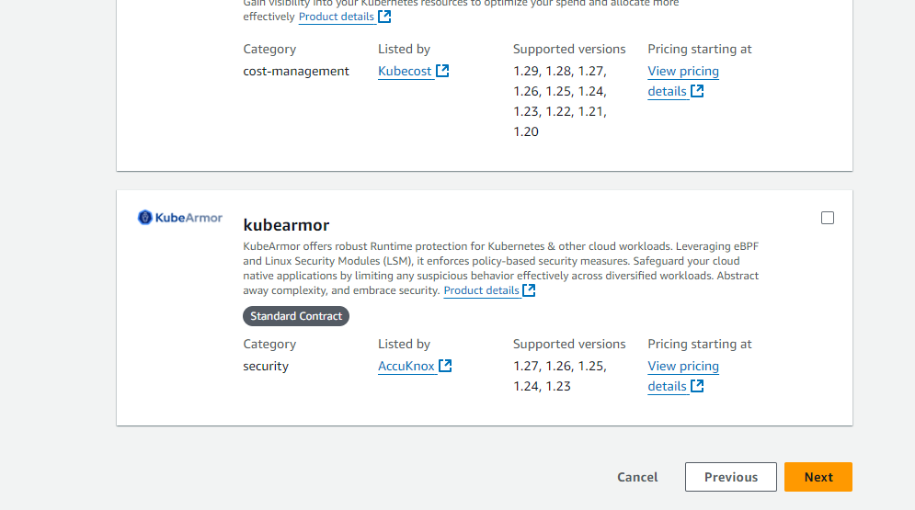

  - Review everything and click Create

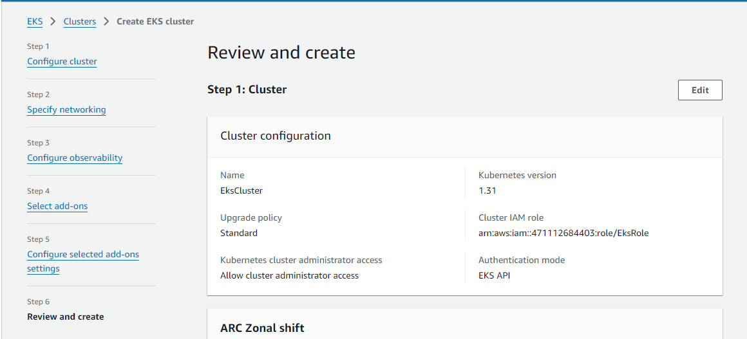

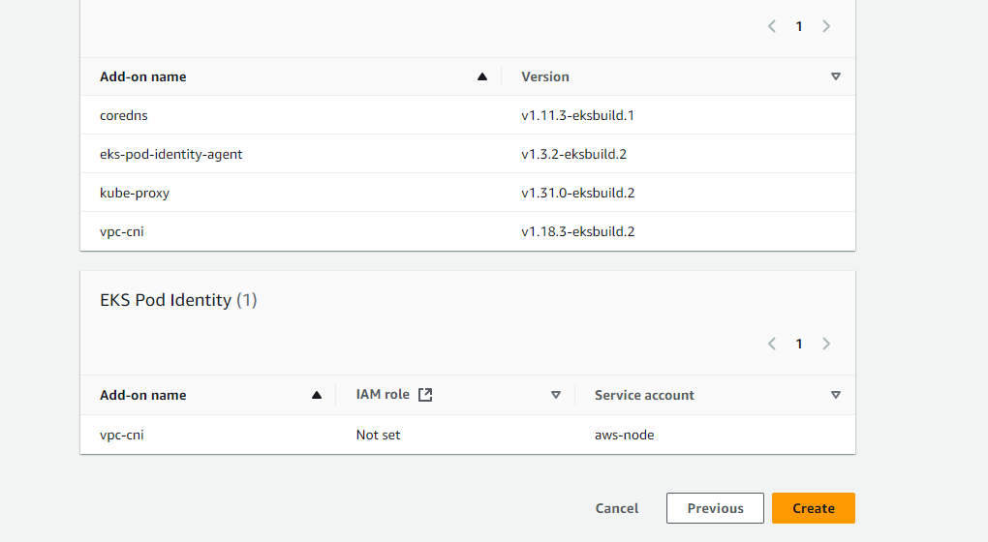

Once created, you can see that the EKS Cluster is launched as shown below:

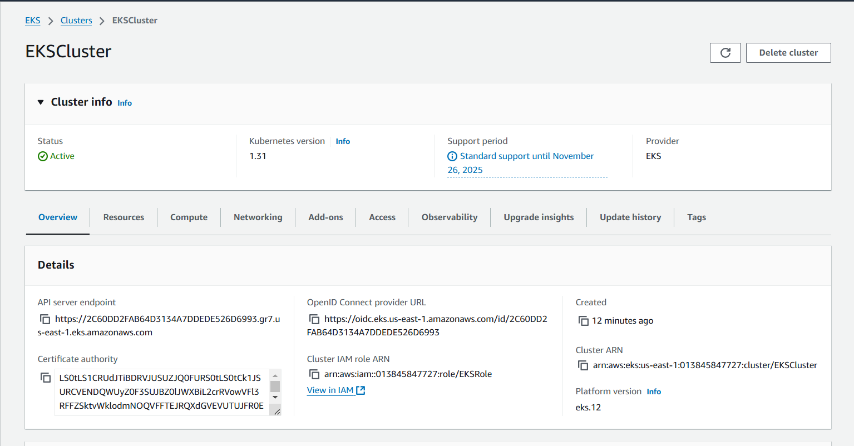
By following these steps, you have successfully created a private Amazon EKS cluster using the AWS Management Console. This includes setting up the VPC, subnets, IAM roles, and security settings to ensure secure and isolated Kubernetes workloads.

