Lesson 01 Demo 03
Running SAST Scan on a Static Web Application
Using GitHub

Objective: To run a SAST scan on a static web application using GitHub workflows integrated with Semgrep for secure code analysis and validation

Tools required: GitHub Actions and Semgrep SAST tool

Prerequisites: None

Steps to be followed:
- Fork the GitHub repository
- Set up a workflow
- Connect the GitHub account with Semgrep
- Validate the SAST scan

Step 1: Fork the GitHub repository

  - Sign in to your GitHub account using the following URL:
https://github.com/login

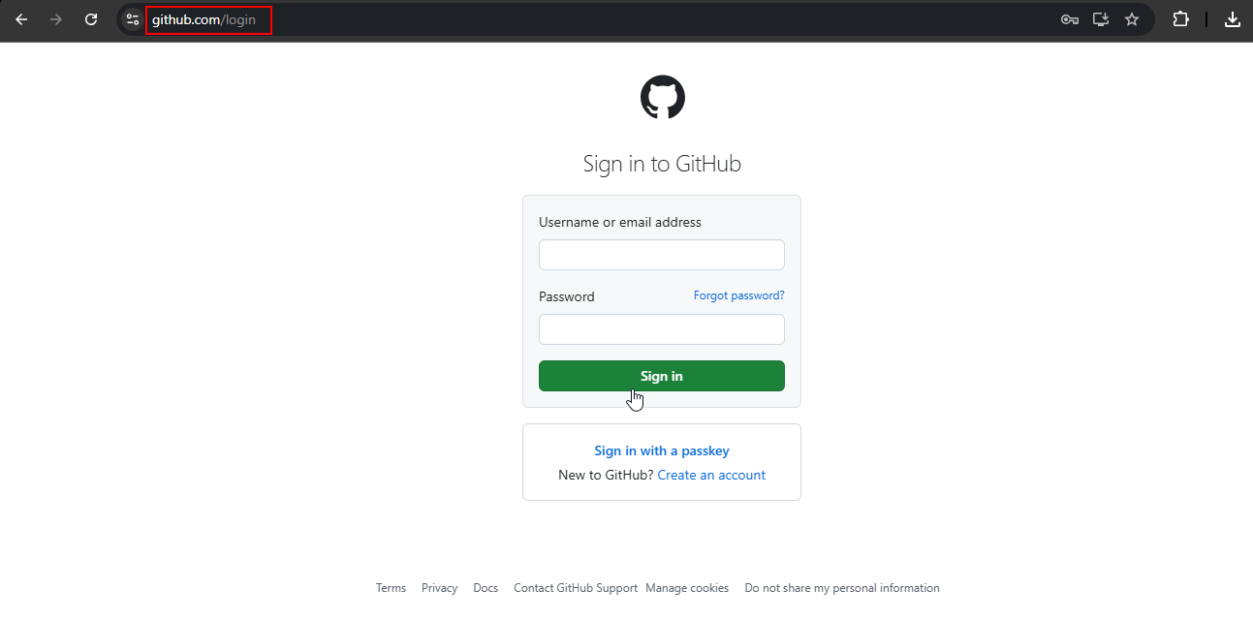

  - Fork the following repository:
https://github.com/GithubWorkstation/JavaProject

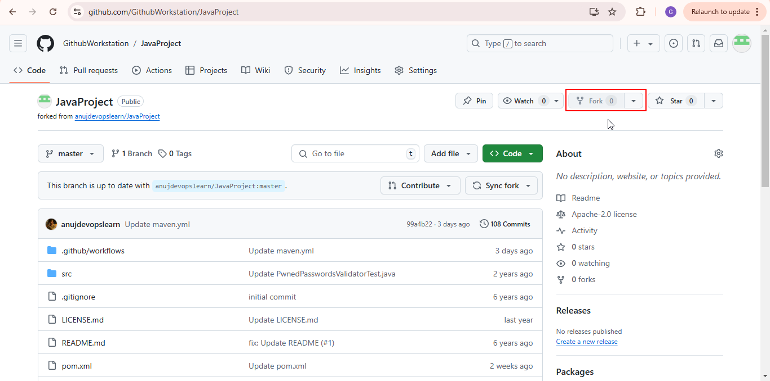

Step 2: Set up a workflow

  - Click on the Actions tab

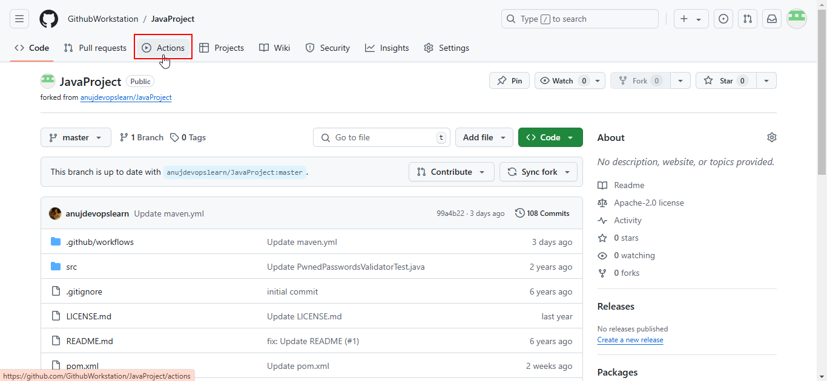

  - Search for Maven and click on Configure in the Java with Maven workflow as shown below:

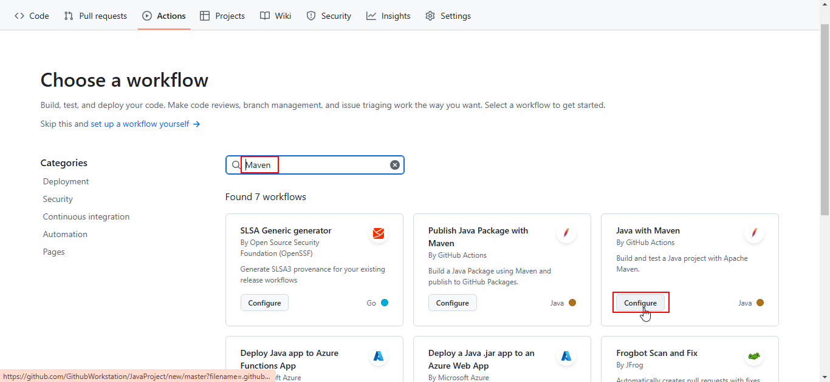

  - Remove the optional step from the workflow as shown below:

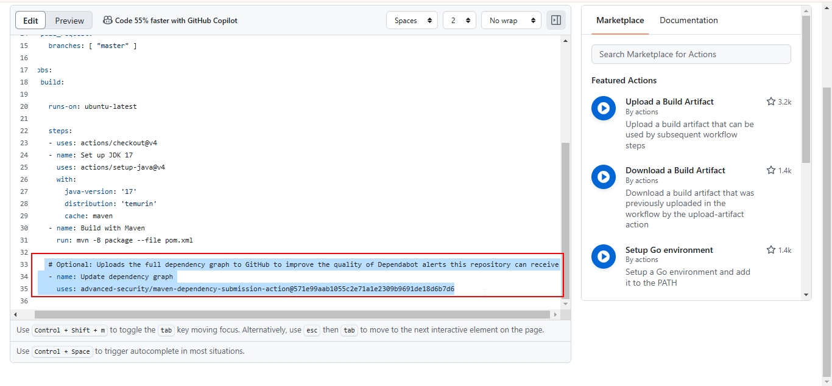

  - Search for and select semgrep-action from Marketplace to proceed with integration in the workflow
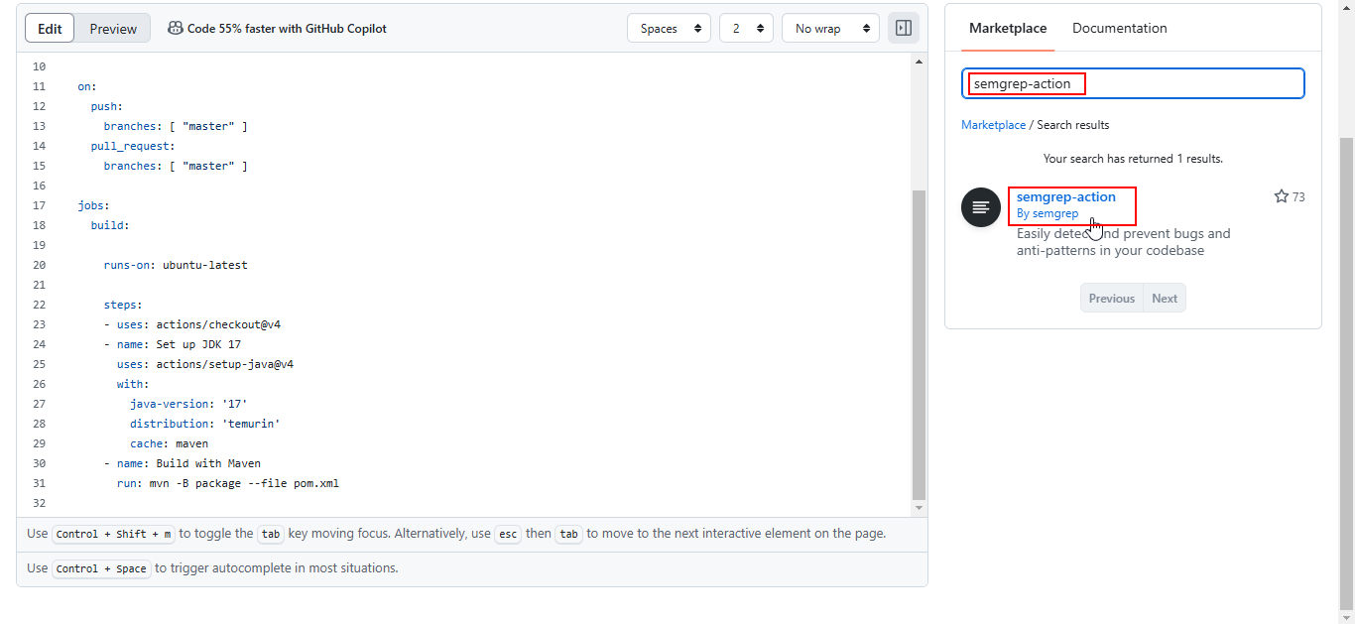
Note: The access token will be generated in the subsequent steps.

Step 3: Connect the GitHub account with Semgrep

  - Navigate to Semgrep website using the following link:
https://semgrep.dev/

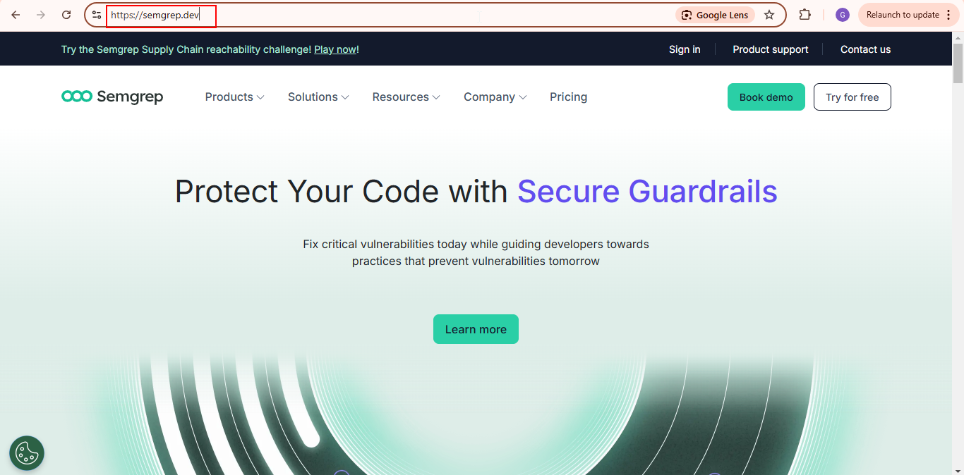

  - Click on Try for free

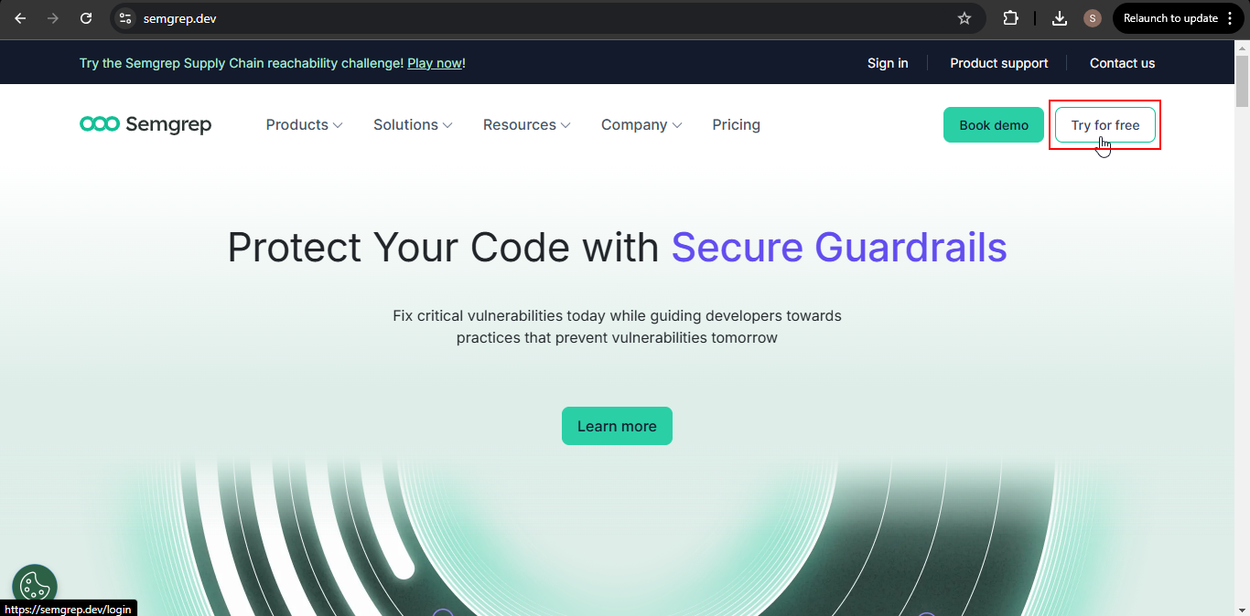

  - Click on the Sign in with GitHub button
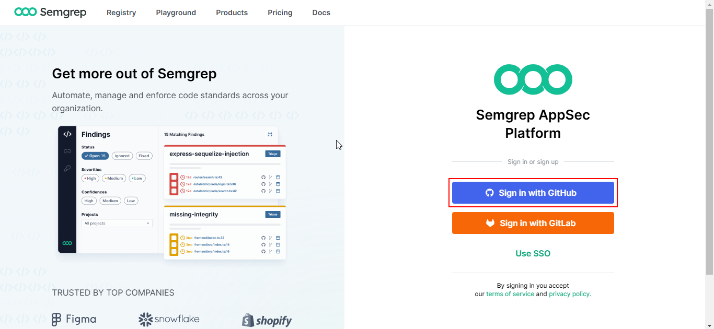

  - Click Authorize semgrep-app
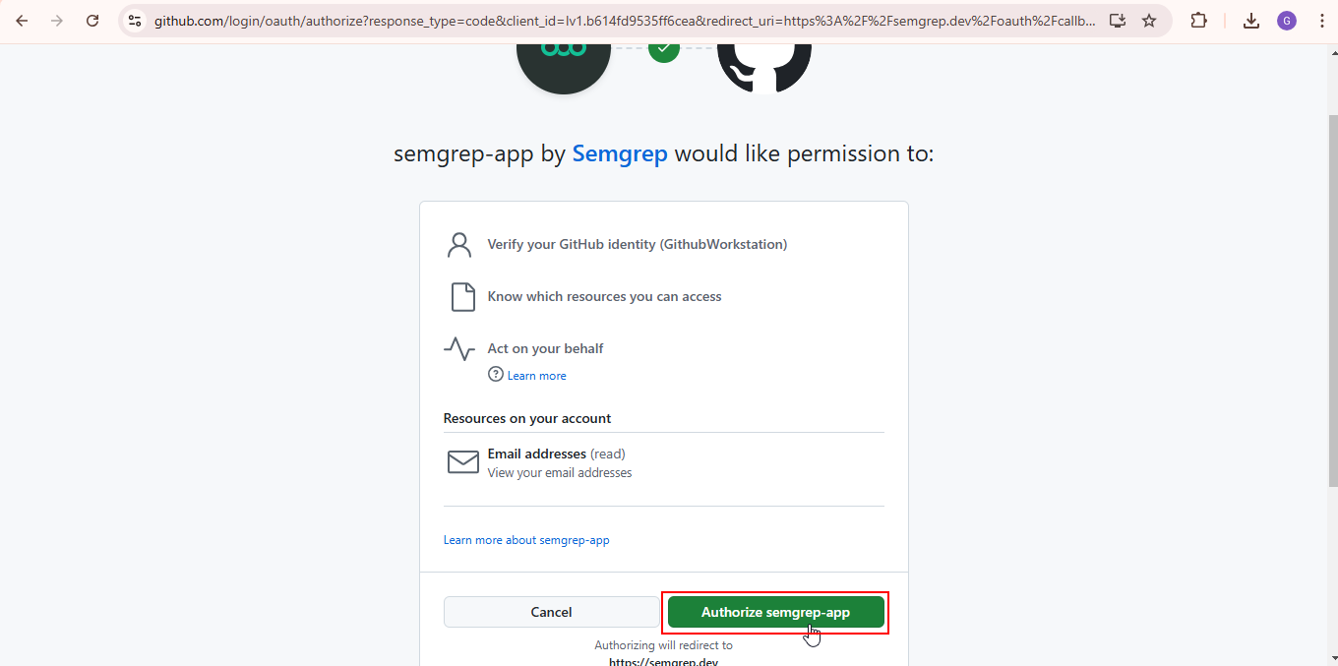
  - Add the organization’s name and click Create new organization
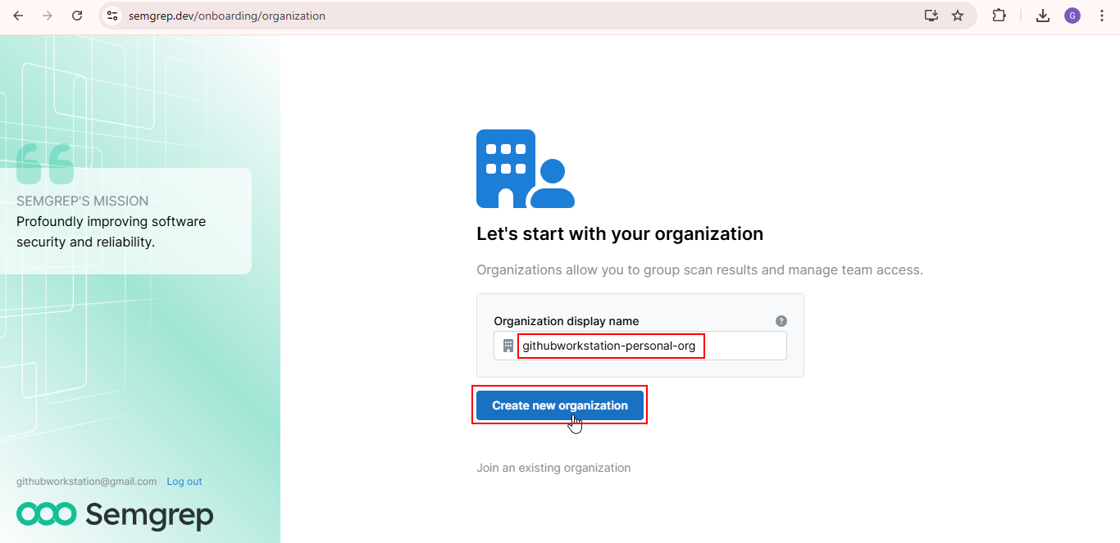

  - Select the required option and click Continue
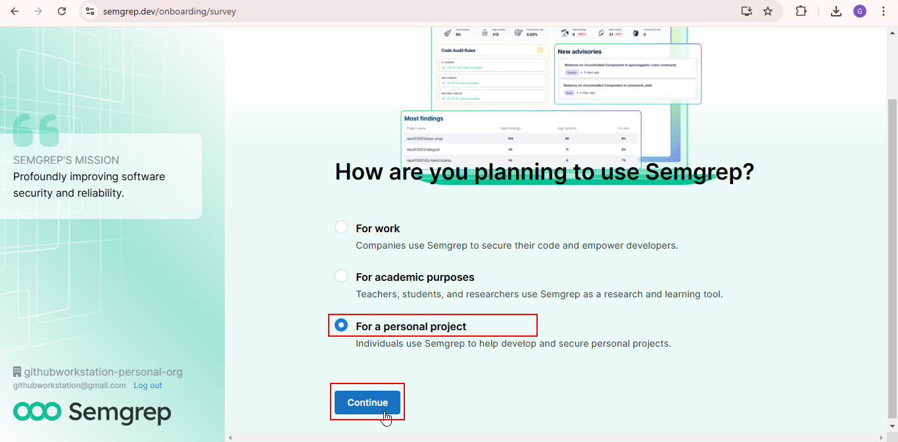
  - Select GitHub to scan the code
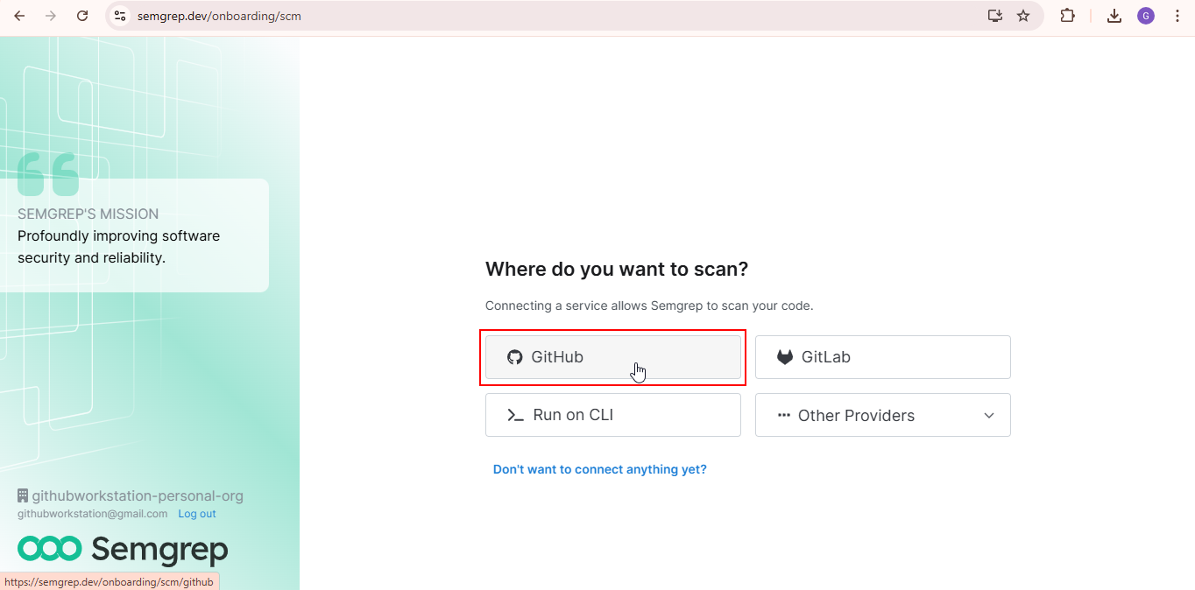
  - Click on Install GitHub App
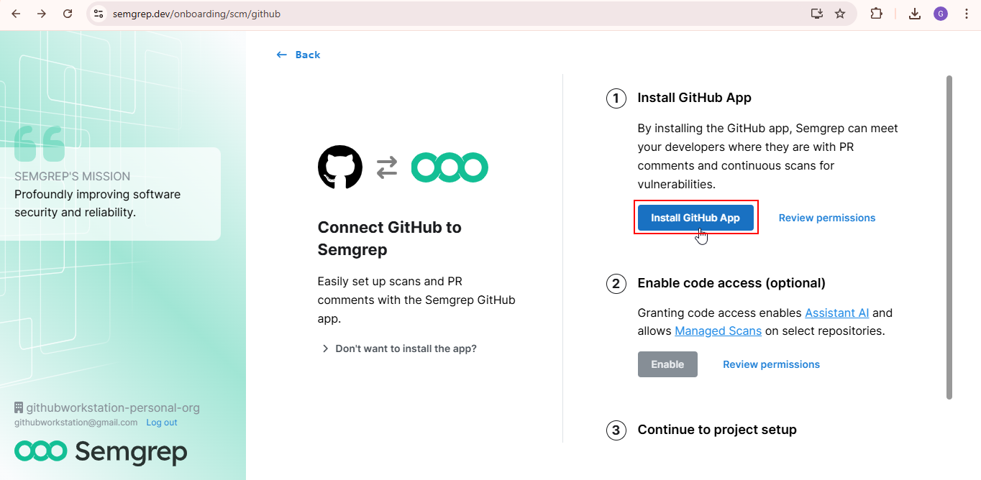
  - Select All repositories
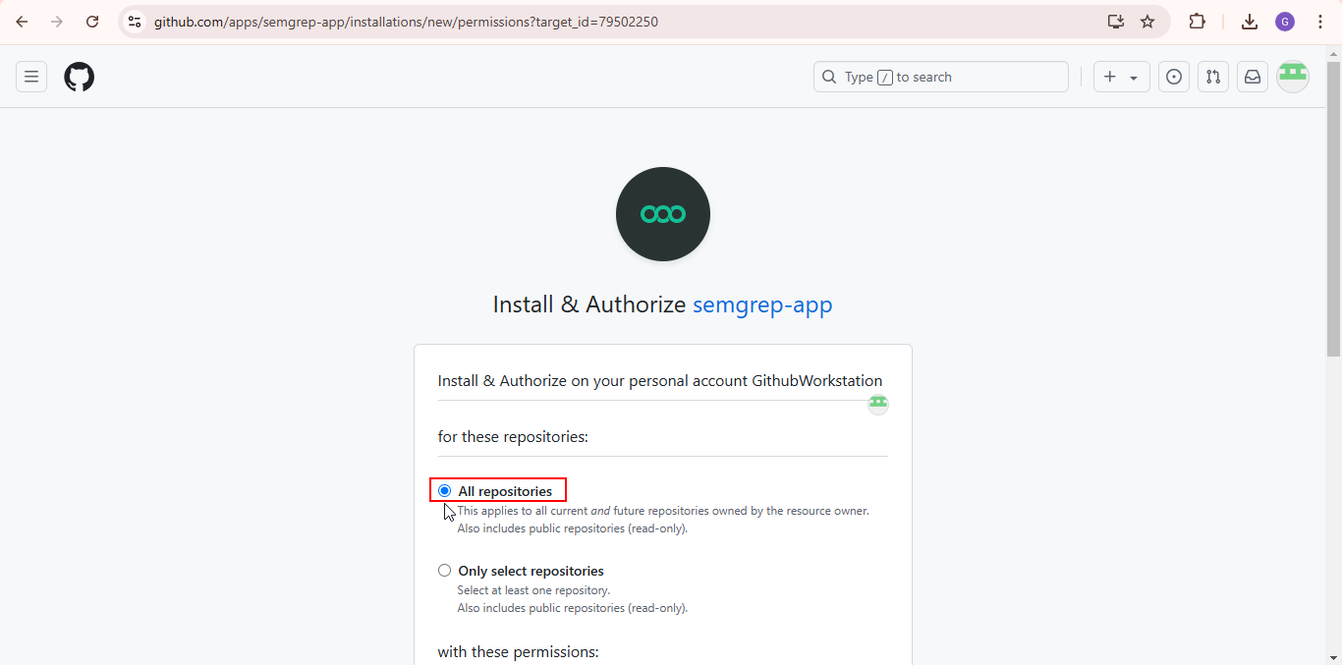
  - Click Install and Authorize
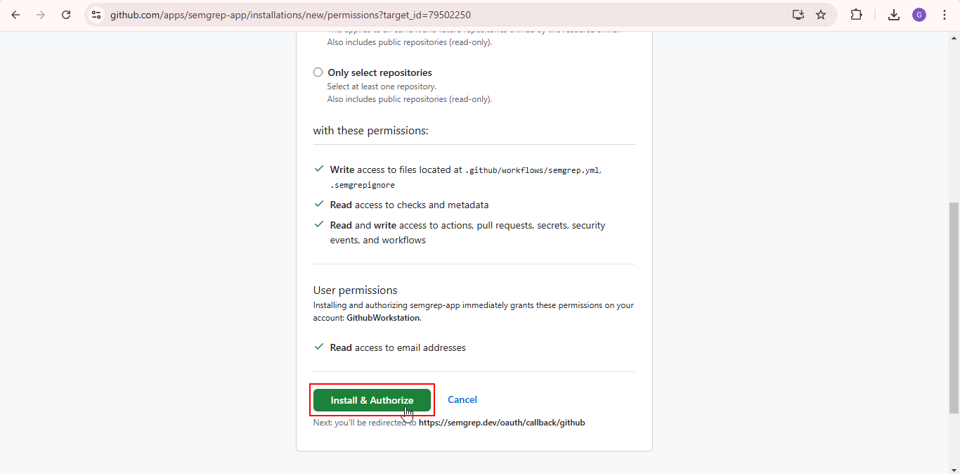
  - Select the account and click Continue
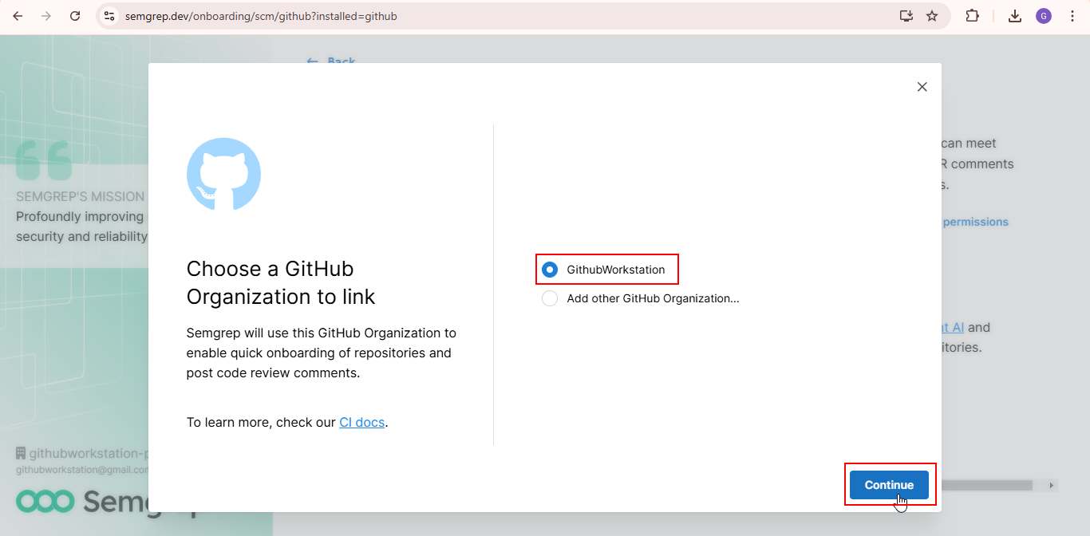
  - Click Register GitHub App
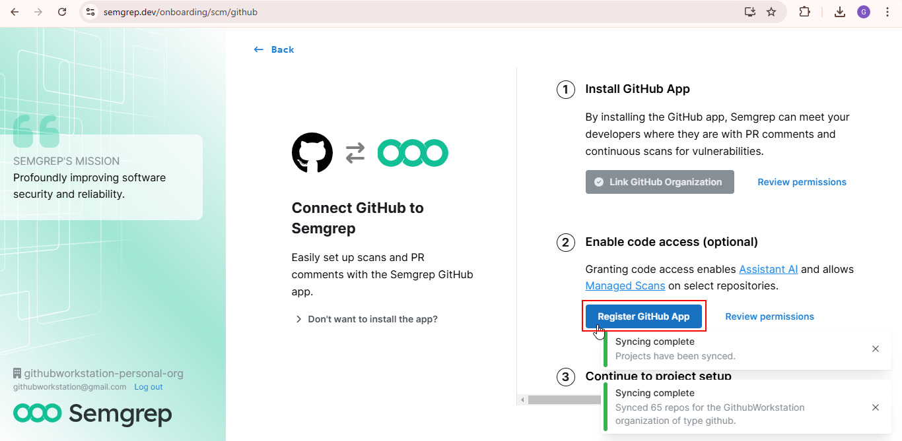
  - Click Create GitHub App for GithubWorkstation as shown below:
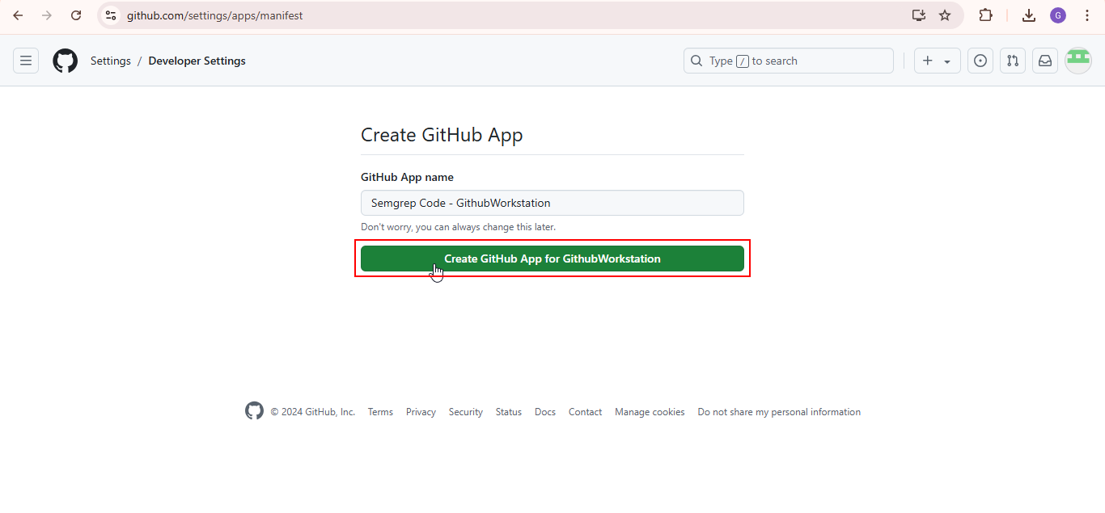
  - Click on Install
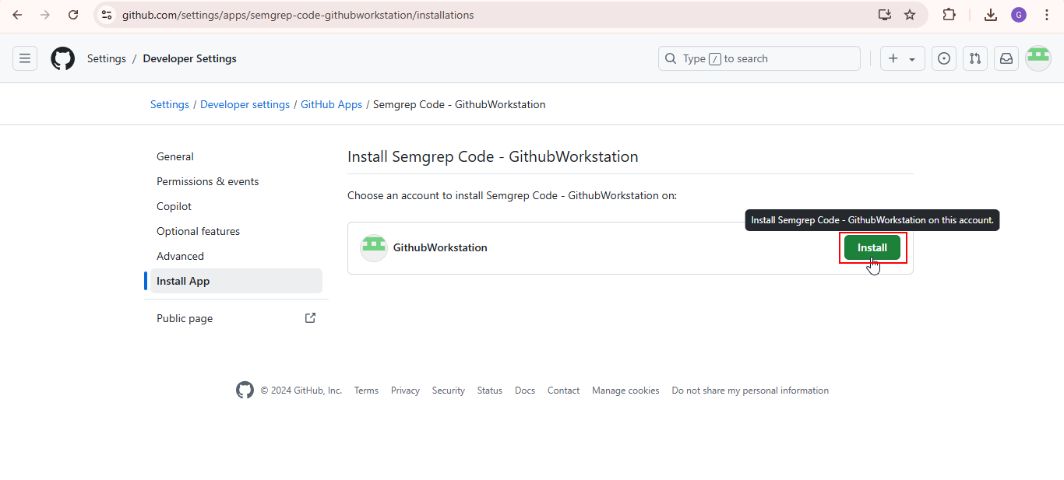
  - Click on Setup projects
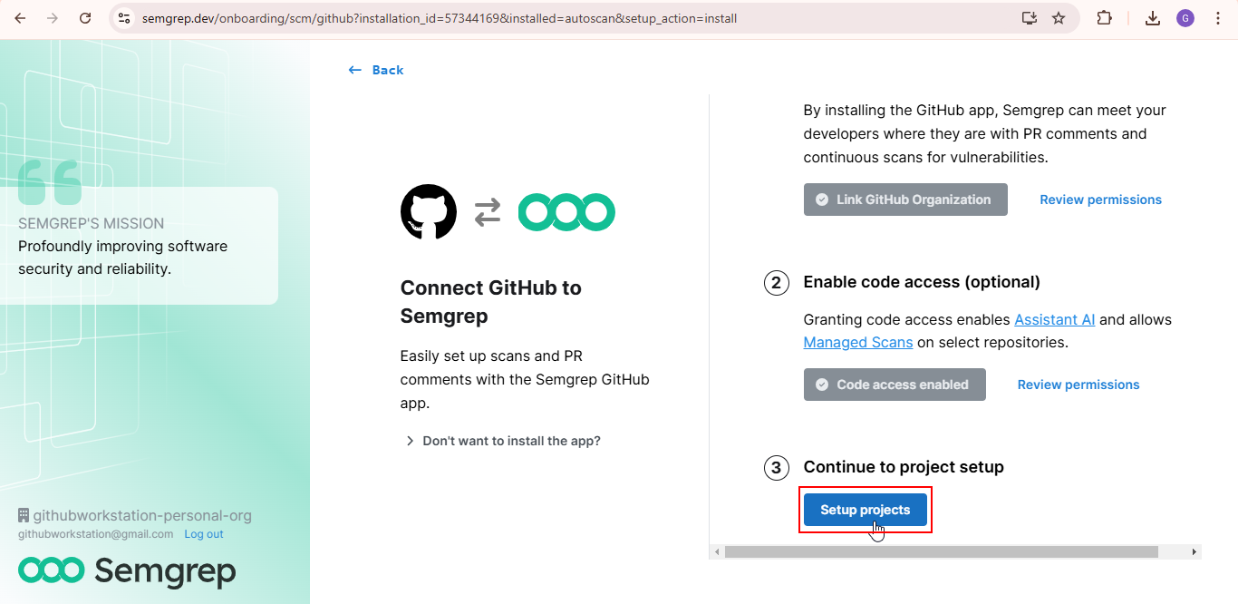

Step 4: Validate the SAST scan

  - Click Settings and then click on Tokens as shown below:

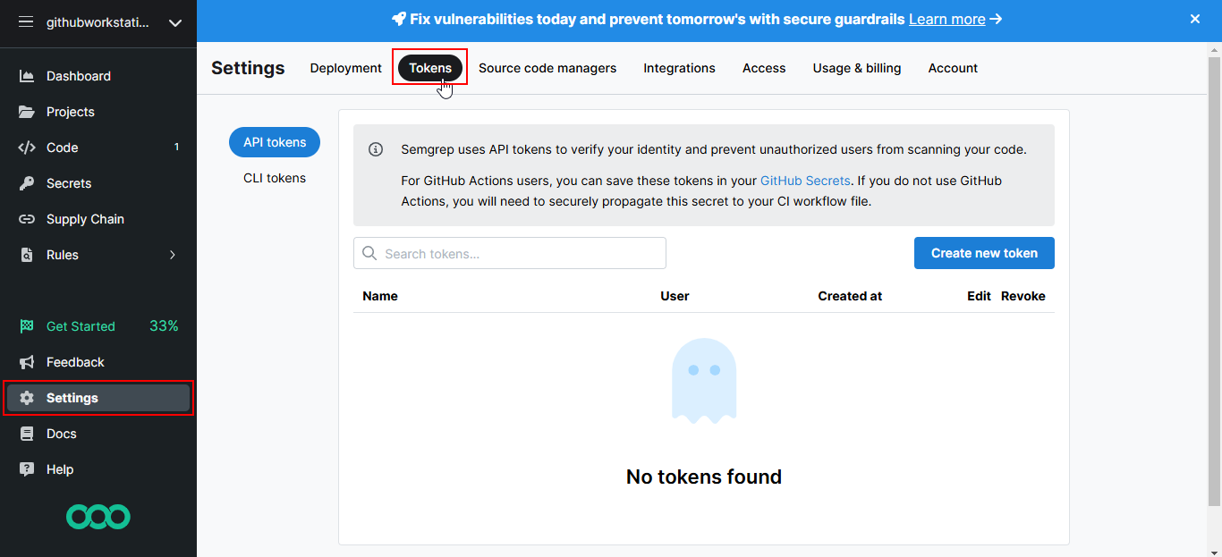

  - Click on Create new token

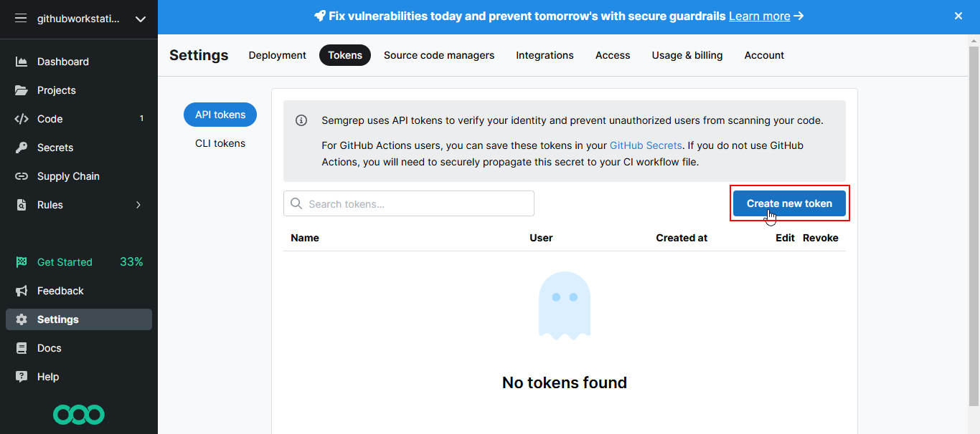

You will see the following interface:
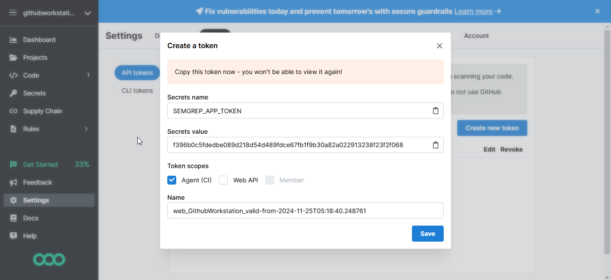
  - Note: Copy the Secrets value

  - Copy the following Semgrep configuration and paste it into the maven.yml file, and then click on Commit changes…
# This workflow will build a Java project with Maven, and cache/restore any dependencies to improve the workflow execution time
# For more information see: https://docs.github.com/en/actions/automating-builds-and-tests/building-and-testing-java-with-maven

# This workflow uses actions that are not certified by GitHub.
# They are provided by a third-party and are governed by
# separate terms of service, privacy policy, and support
# documentation.

name: Java CI with Maven

on:
push:
branches: [ "master" ]
pull_request:
branches: [ "master" ]

jobs:
build:
runs-on: ubuntu-latest
steps:
- uses: actions/checkout@v4
- name: Set up JDK 17
uses: actions/setup-java@v4
with:
java-version: '17'
distribution: 'temurin'
cache: maven
- name: Build with Maven
run: mvn -B package --file pom.xml

semgrep:
# User definable name of this GitHub Actions job.
name: semgrep/ci
# If you are self-hosting, change the following `runs-on` value:
runs-on: ubuntu-latest
container:
# A Docker image with Semgrep installed. Do not change this.
image: semgrep/semgrep
steps:
# Fetch project source with GitHub Actions Checkout. Use either v3 or v4.
- uses: actions/checkout@v4
# Run the "semgrep ci" command on the command line of the docker image.
- run: semgrep ci --sarif > semgrep.sarif
env:
# Connect to Semgrep AppSec Platform through your SEMGREP_APP_TOKEN.
# Generate a token from Semgrep AppSec Platform > Settings
# and add it to your GitHub secrets.
SEMGREP_APP_TOKEN: "YOUR_TOKEN"
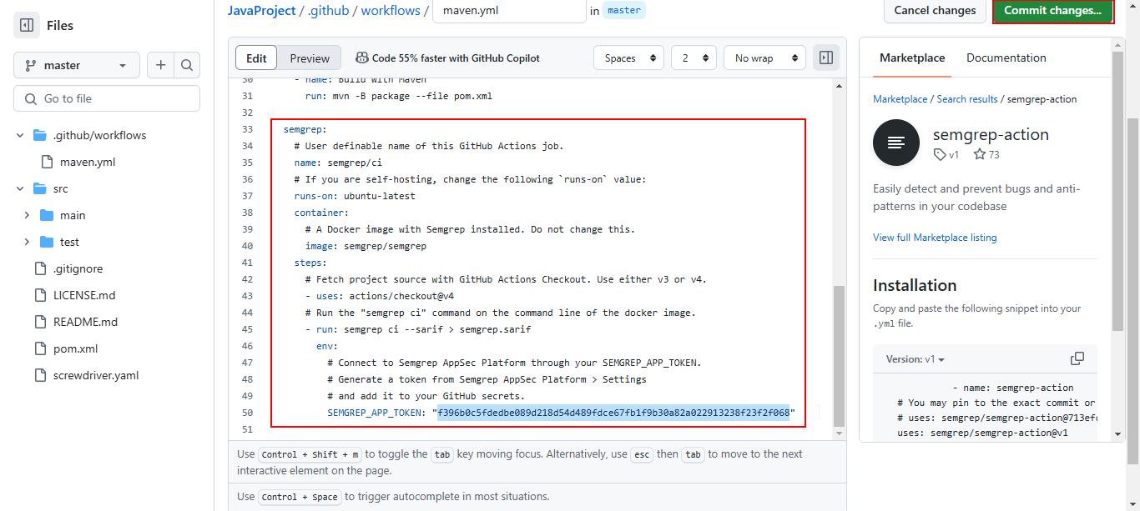
Note: Replace YOUR_TOKEN with the token copied in the previous step

You will see that the pipeline has been invoked successfully.
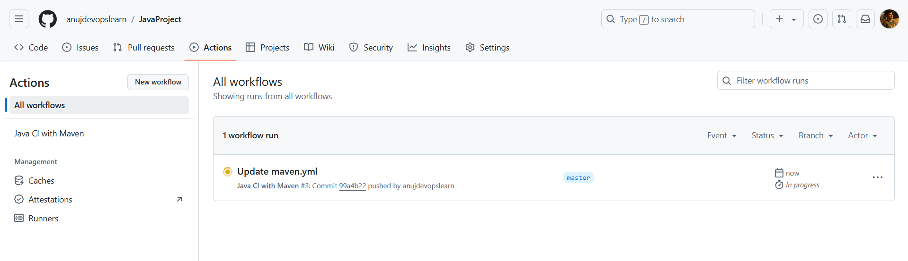
  - Click Update maven.yml, then select semgrep/ci, and choose the run configurations as shown below:
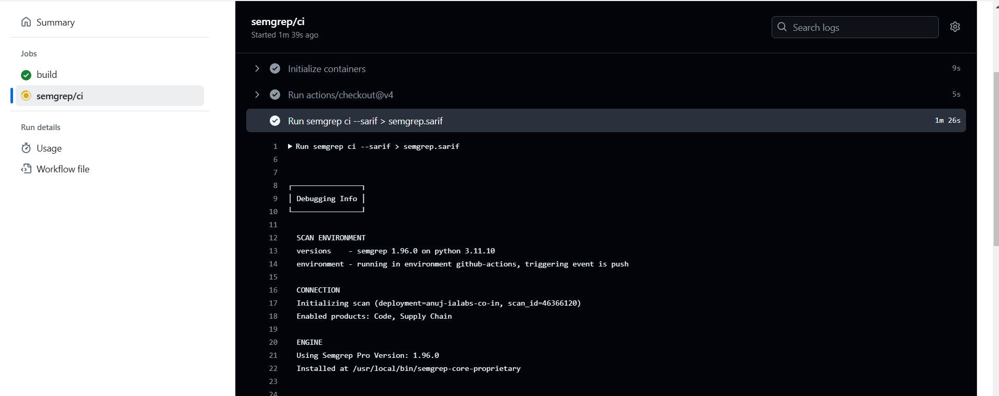
  - Verify the scan status and summary
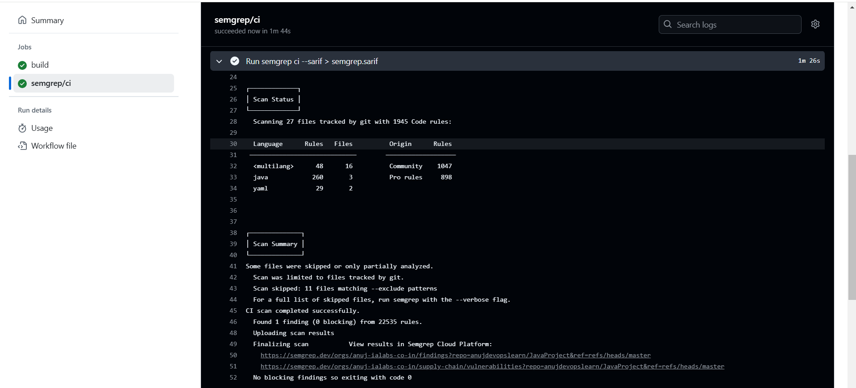
  - Navigate to Semgrep website to view scan results
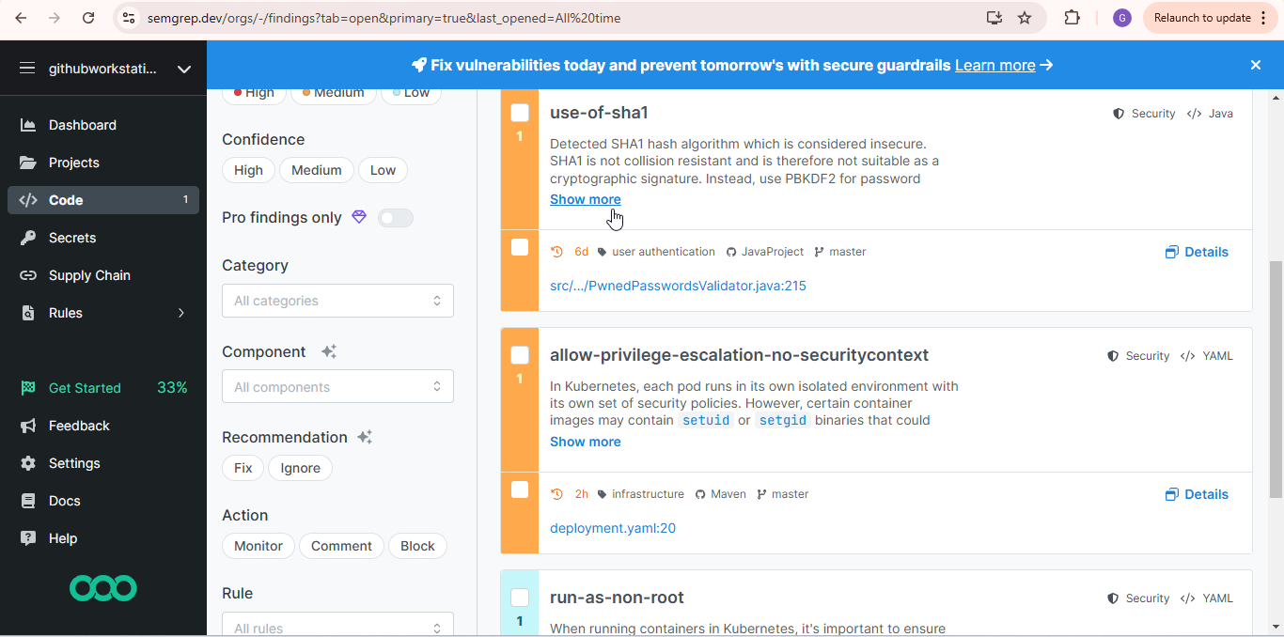
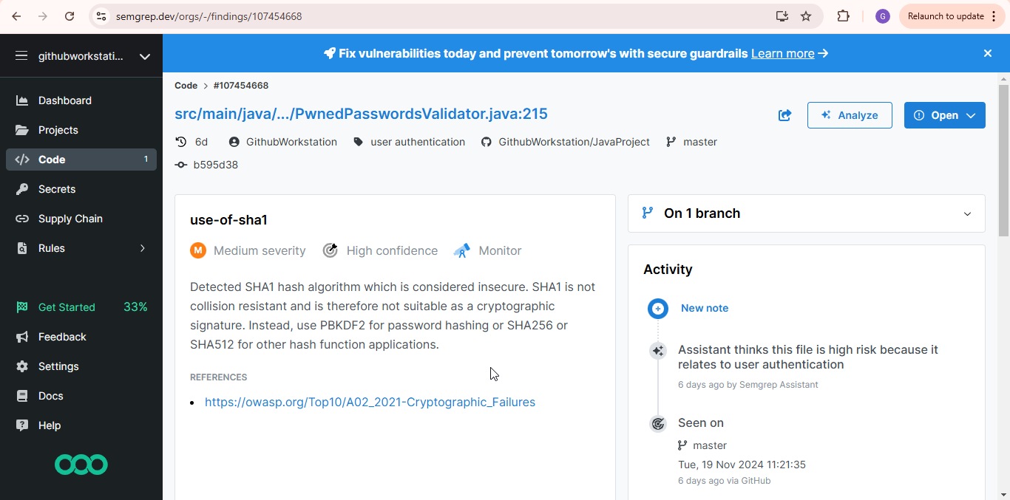
By following these steps, you have successfully executed a SAST scan on a static web application using GitHub workflows and integrated Semgrep for secure code analysis.

