Lesson 01 Demo 02

Configuring Prometheus to Scrape and Visualize the Metrics

Objective: To configure Prometheus to scrape and visualize metrics for monitoring system performance through its web interface for improved observability and real-time insights

Tools required: Linux operating system

Prerequisites: Basic understanding of Web Applications

Steps to be followed:
- Start Prometheus binary
- Explore Prometheus UI

Step 1: Start Prometheus binary

  - Run the following commands to change the current directory to the Prometheus directory and start the Prometheus server:

wget https://github.com/prometheus/prometheus/releases/download/v3.5.0/prometheus-3.5.0.linux-arm64.tar.gz

tar -xvf prometheus-3.5.0.linux-arm64.tar.gz

cd prometheus-3.5.0.linux-arm64/

./Prometheus

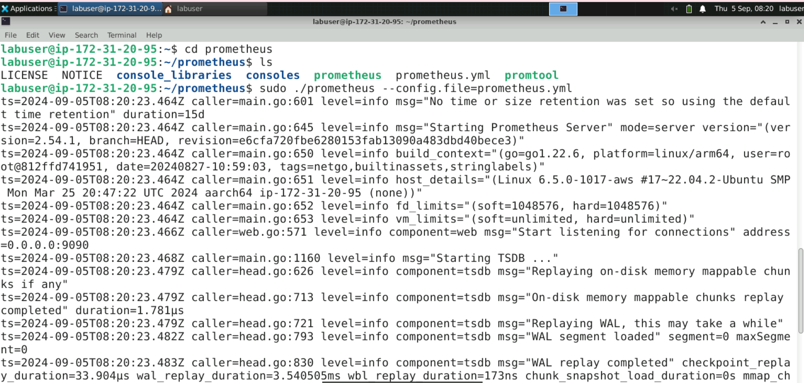

Step 2: Explore Prometheus UI

  - Navigate to the browser and enter the URL http://localhost:9090/ or http://<public-ip>:9090/ to access the Prometheus console

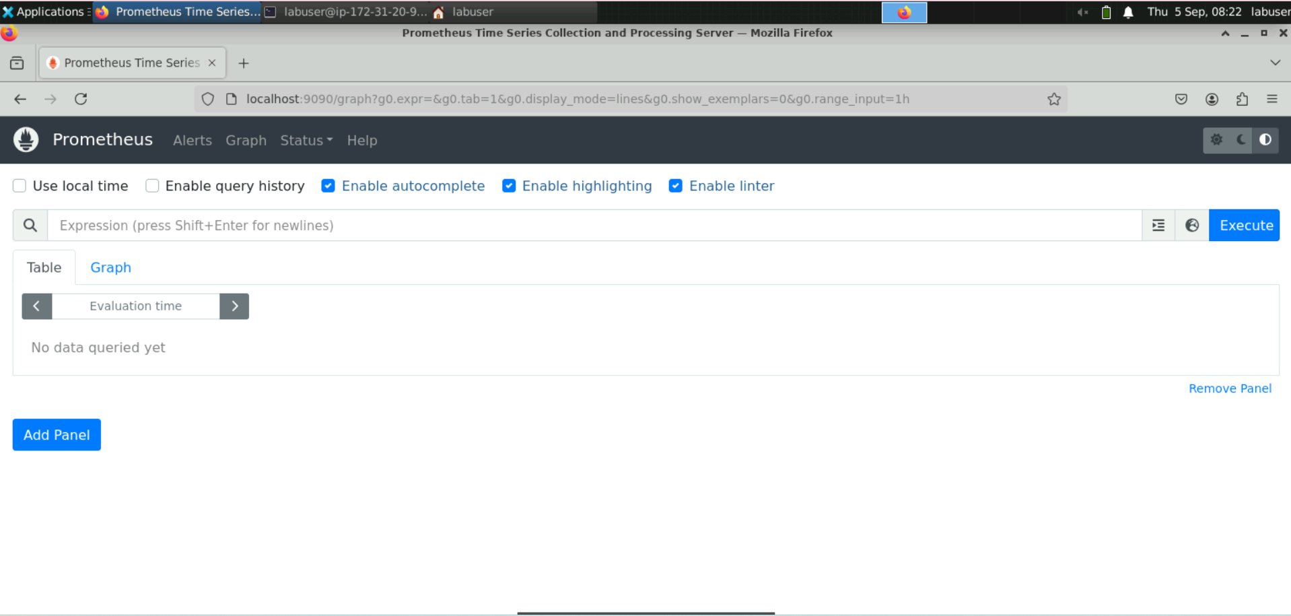

Note: The Prometheus server must run in the terminal to access the Prometheus UI.

  - Navigate to the Expression Browser, type process_vi, and then select the process_virtual_memory_bytes metric as shown

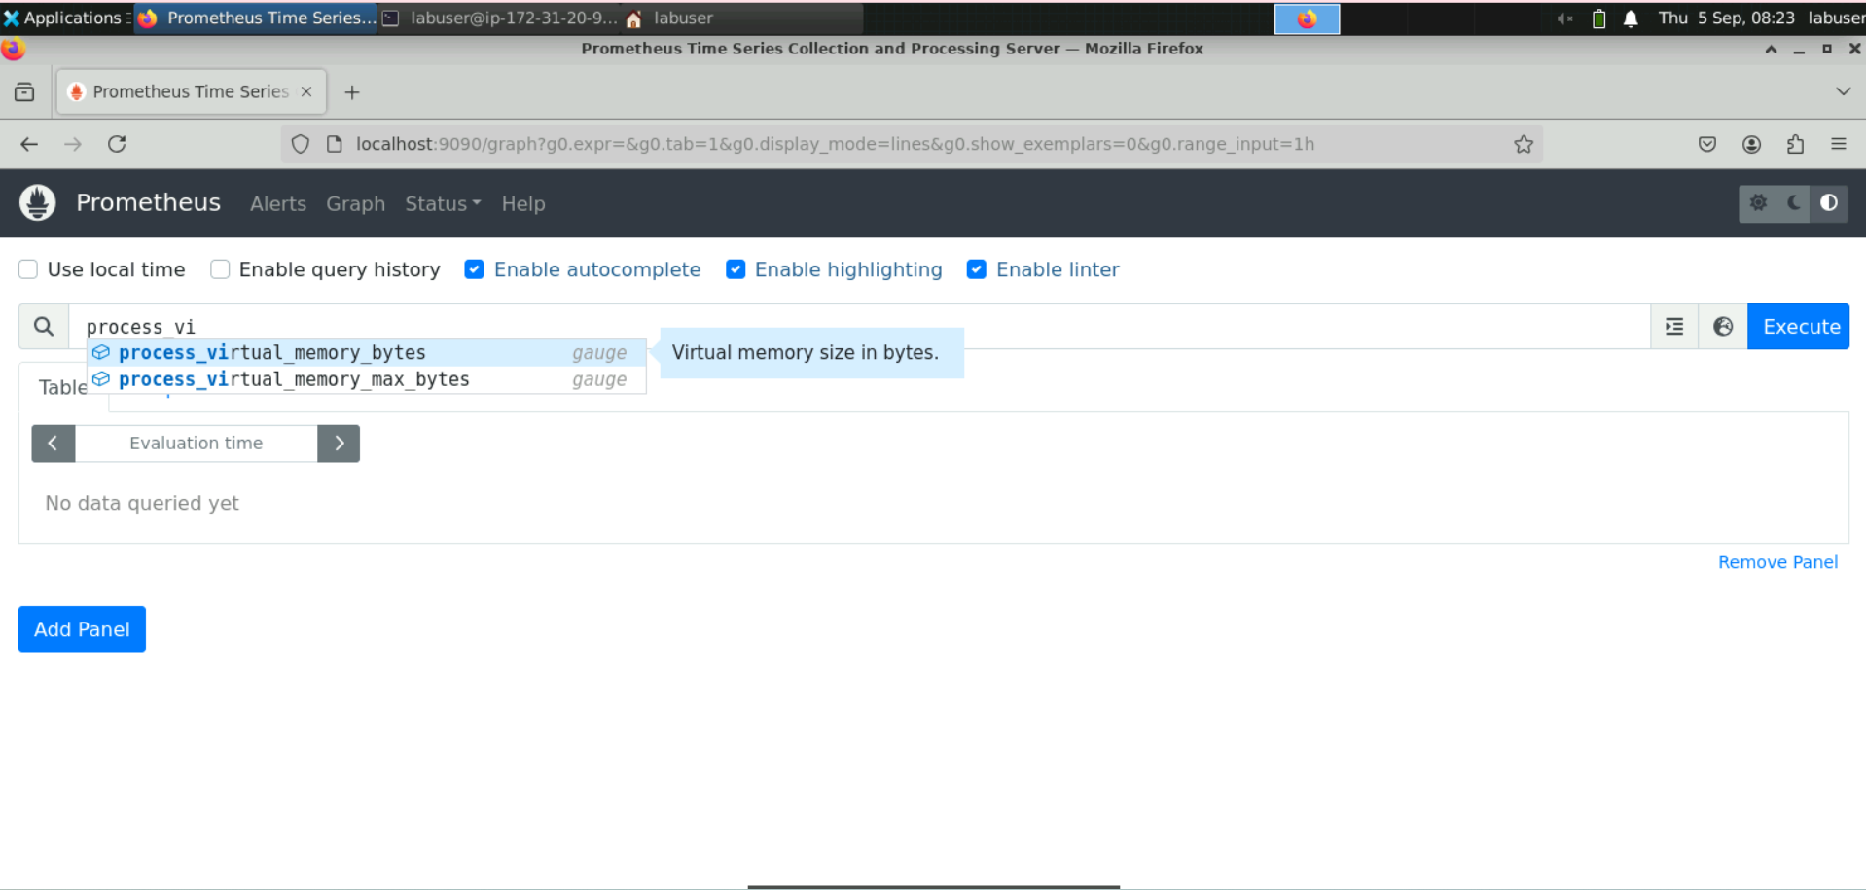

  - Click on Execute

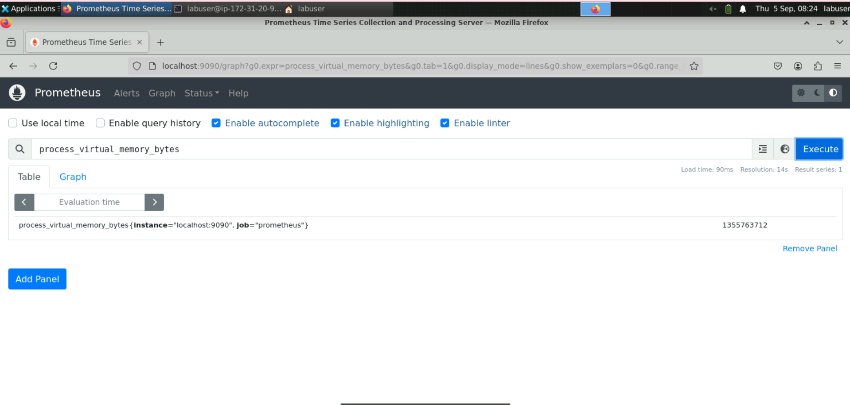

  - Click on the Graph tab to visualize process_virtual_memory_bytes

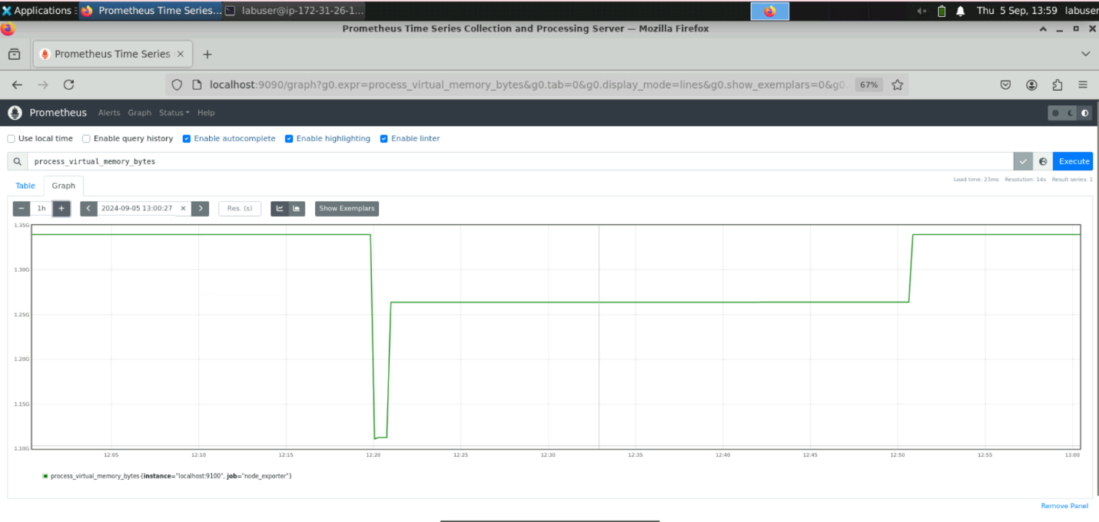

  - Click on the Status section and select Targets

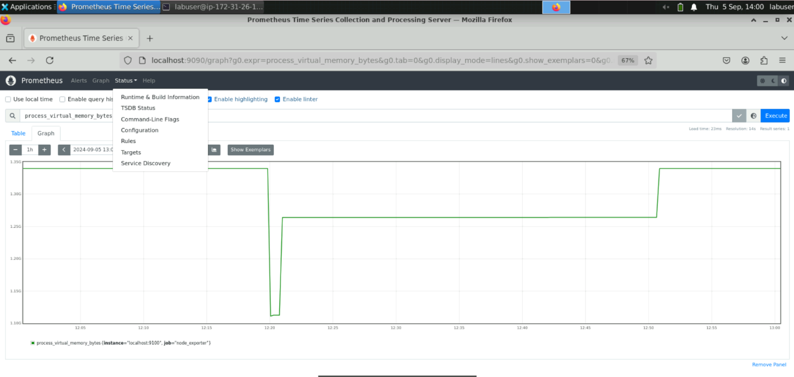

You will see the following interface:
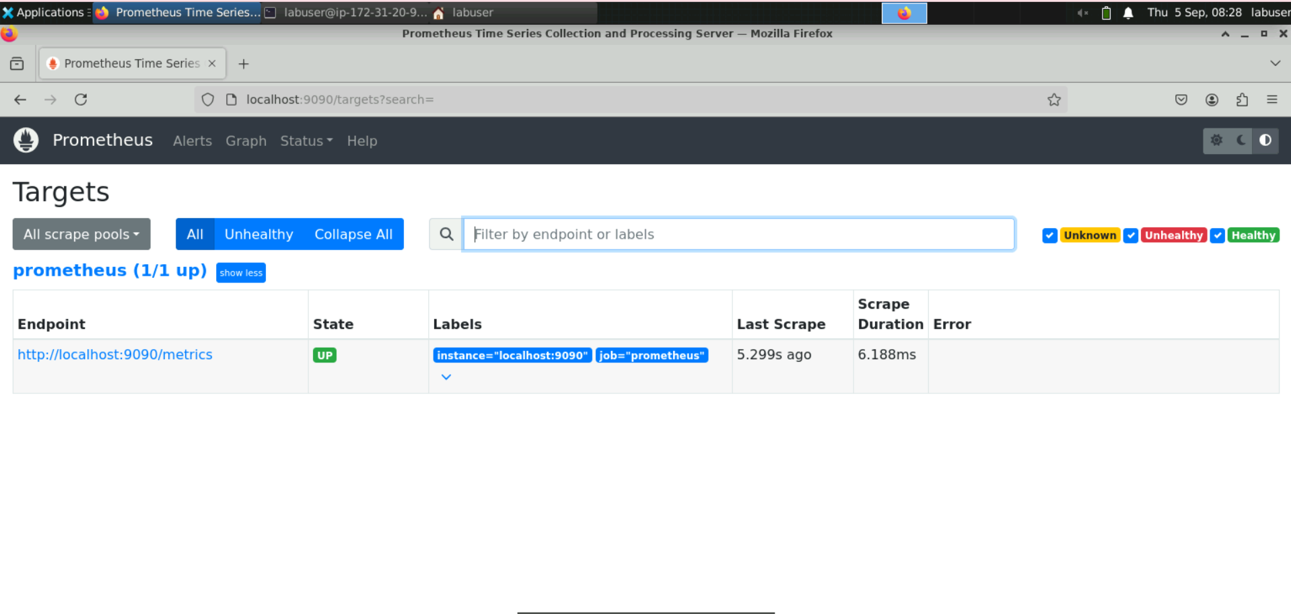

Only a single Prometheus server is in the UP state on this page, indicating that the last scrape was successful. If there had been an issue with the previous scrape, an error message would appear in the Error field.

  - Copy the link http://localhost:9090/metrics from the Targets page and paste it into a new browser tab as shown:

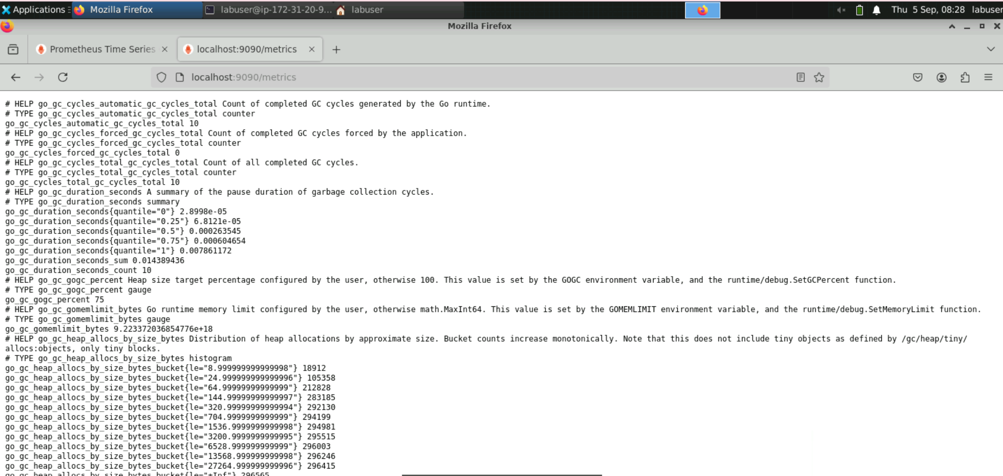
This will display metrics for monitoring the application.

By following these steps, you have successfully configured Prometheus to scrape and visualize metrics for monitoring system performance through its web interface.

