**Lesson 02 Demo 02**

**Writing Basic Queries in PromQL**

**Objective:** To query and analyze monitoring data using Prometheus Query Language (PromQL) for effective monitoring of system performance and health

**Tools required:** Linux operating system

**Prerequisites:** Refer to Demo 01 of Lesson 02 for configuring Node Exporter

Steps to be followed:

1. Query to retrieve a single metric
2. Filter by label
3. Aggregate data with the sum() function
4. Query data using an arithmetic operation
5. Calculate a metric using the rate() function

**Step 1: Query to retrieve a single metric**

1. Navigate to the terminal and run the following command to start the Prometheus server:

**sudo ./prometheus --config.file=prom-node-exporter.yaml**

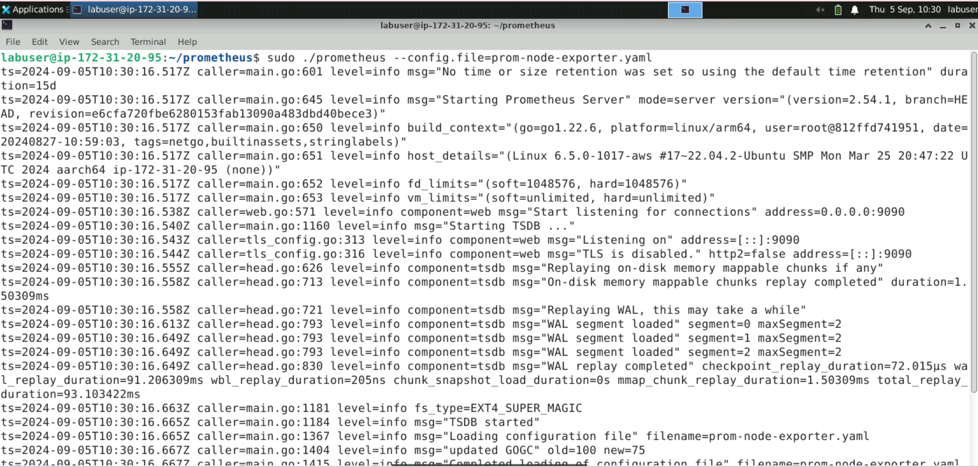

1. Navigate to the browser and enter the URL **http://localhost:9090/** or **http://<public-ip>:9090/** to access the Prometheus console

1. Navigate to the **Graph** section

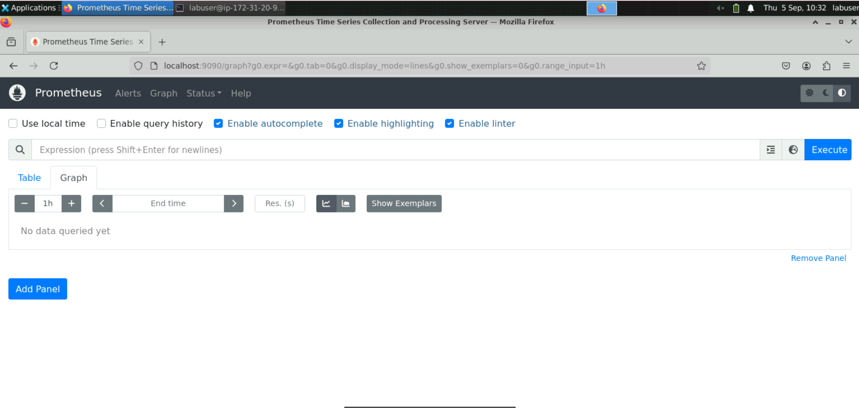

1. Enter the following query in the expression browser to retrieve a single metric, then click on **Execute**:

**node_cpu_seconds_total**

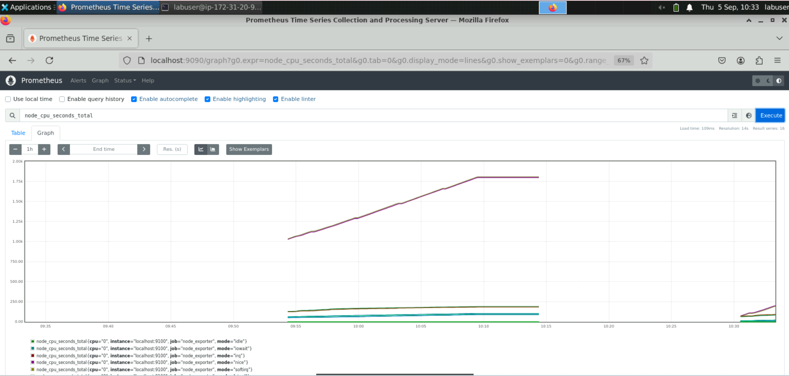

**Step 2: Filter by label**

1. Type **node_filesystem** in the expression browser

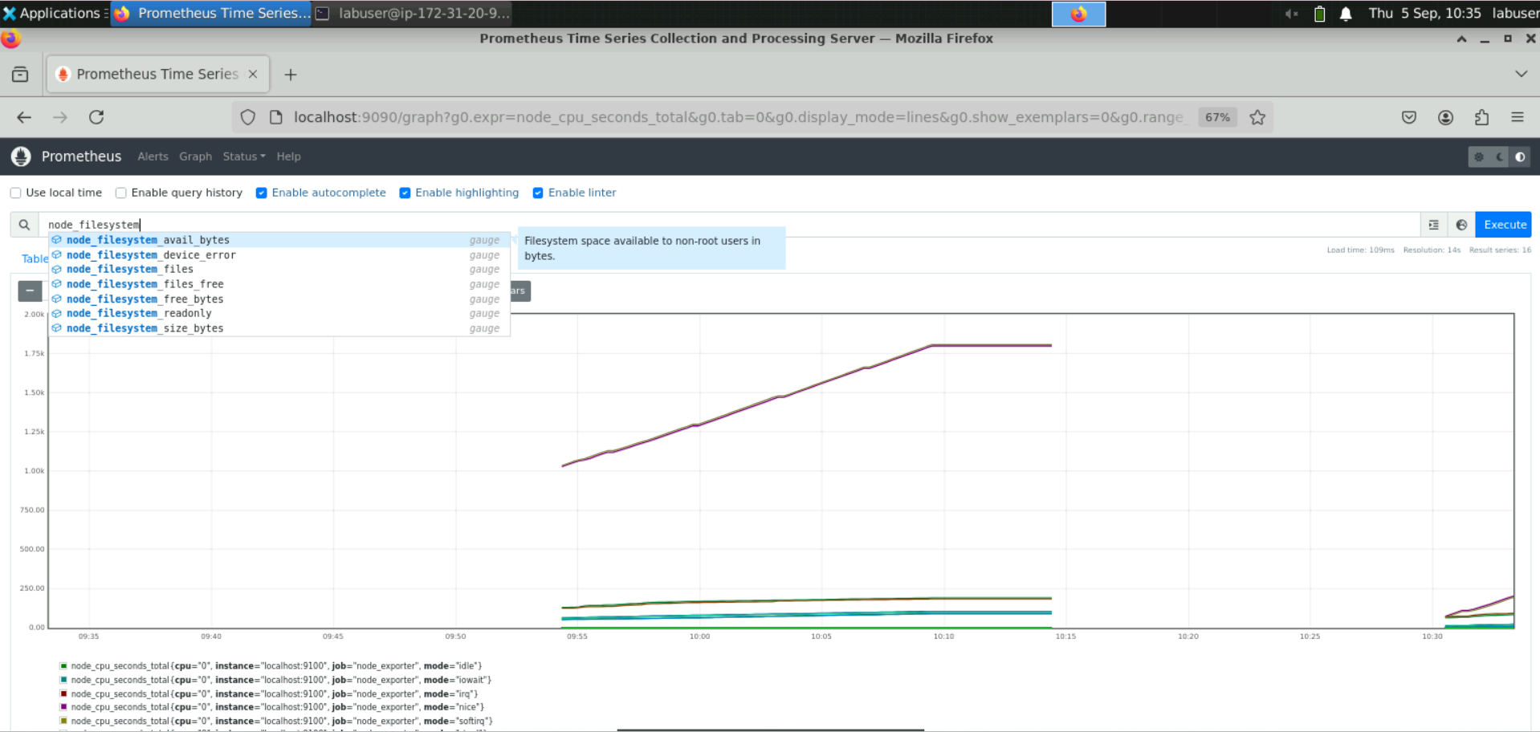

It will display a popup list.

1. Select **node_filesystem_avail_bytes** and click **Execute**

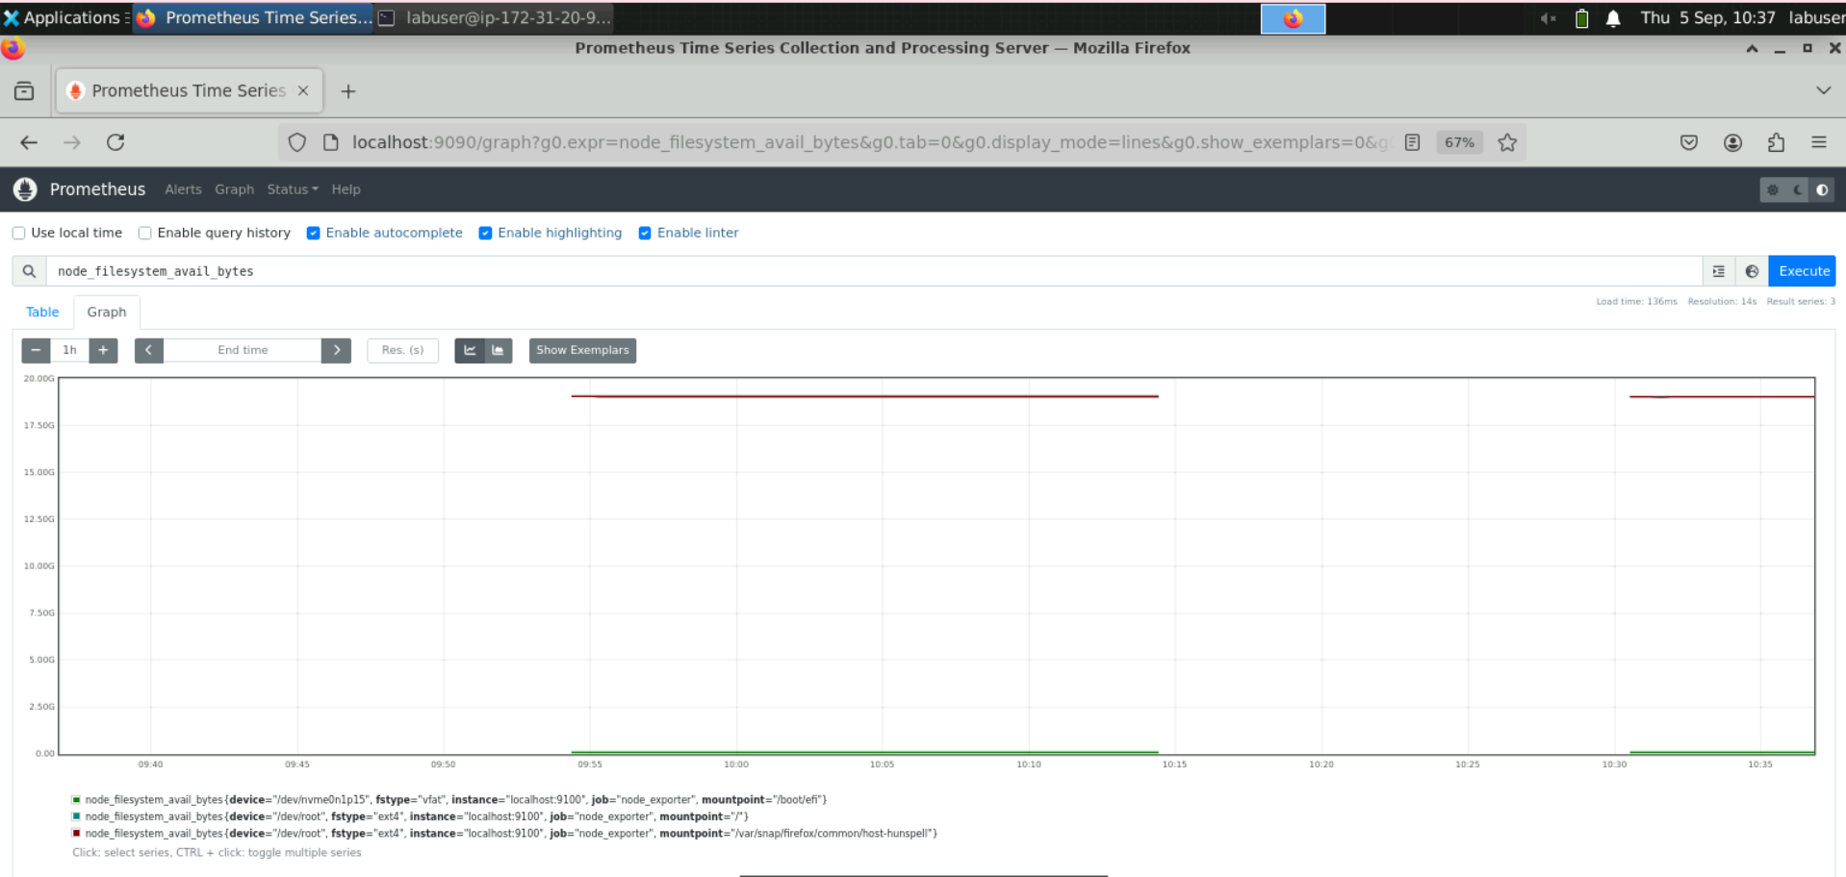

1. Filter by labels using the following query:  
    **node_filesystem_avail_bytes{device=”/dev/”}**

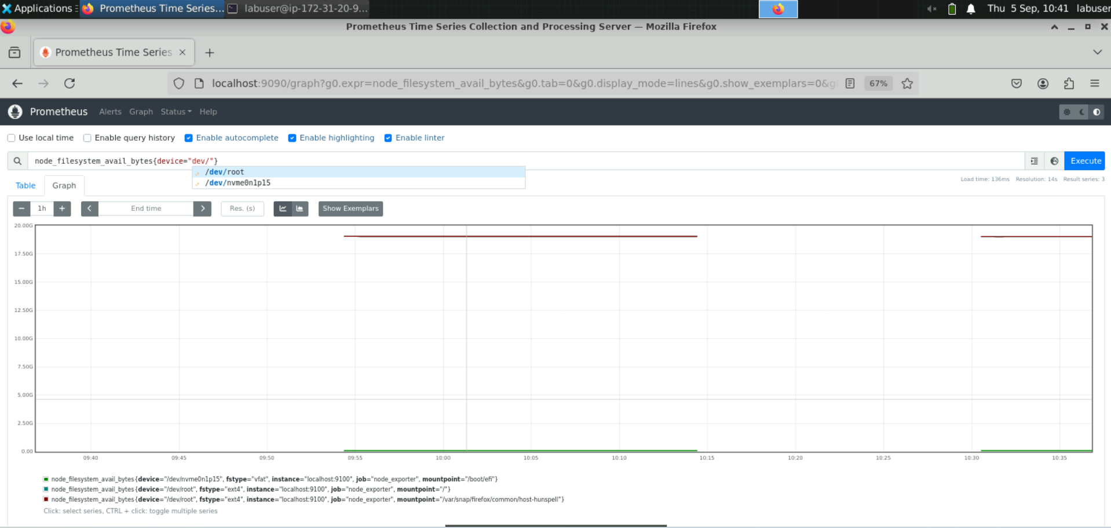

1. Select **/dev/root** and click on **Execute** to run the query  
     
   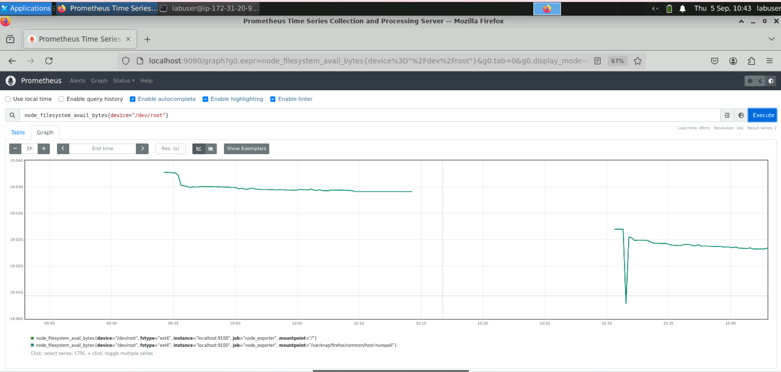

**Step 3: Aggregate data with the sum() function**

1. In the expression browser, enter the following query and execute it:  
   **node_network_transmit_bytes_total**

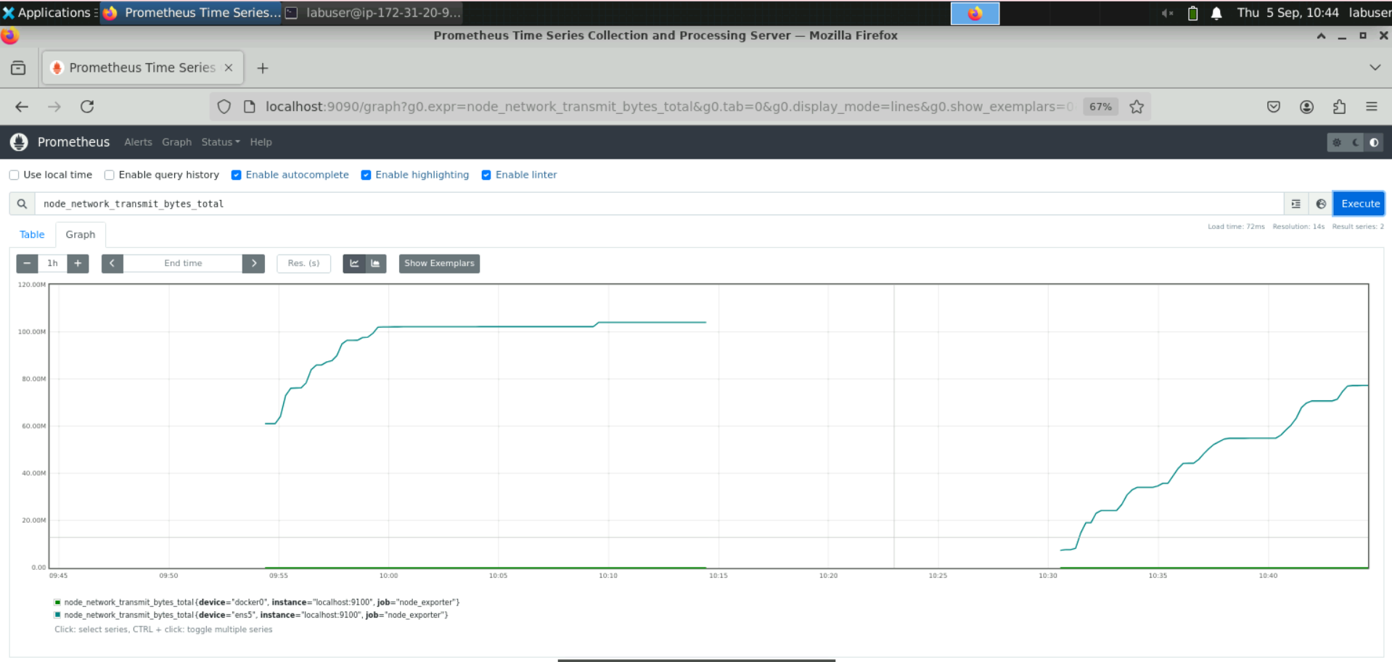

1. Use the following query to sum the total number of bytes transmitted over the network interface and view the graph:

**sum(node_network_transmit_bytes_total)**

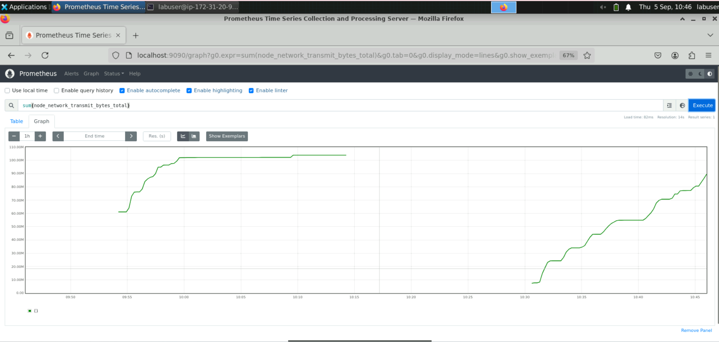

**Step 4: Query data using an arithmetic operation**

* 1. Enter the following query to display the amount of available memory on a node   
     in bytes:

**node_memory_MemAvailable_bytes**

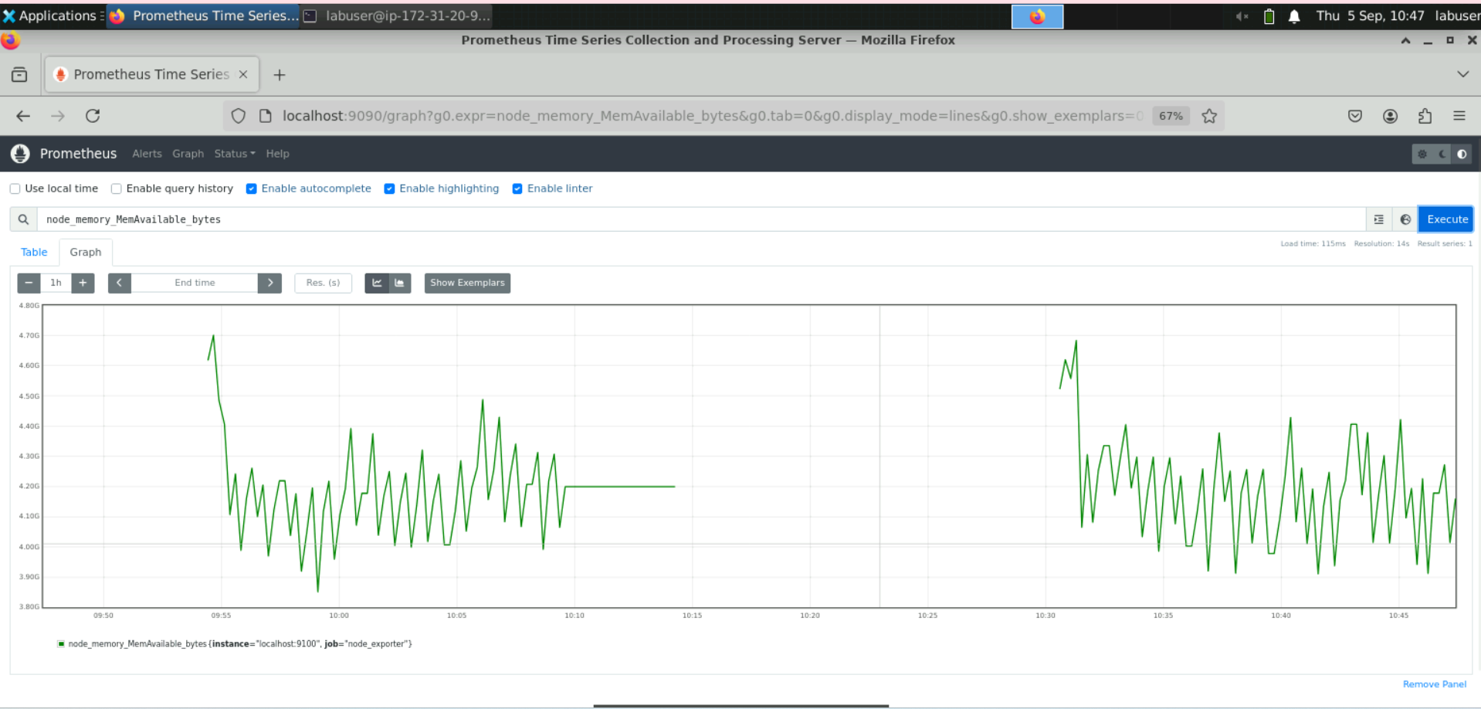

* 1. Divide the query executed in the previous step by **1024** twice to display it in megabytes using the following query:

**node_memory_MemAvailable_bytes / 1024 / 1024**

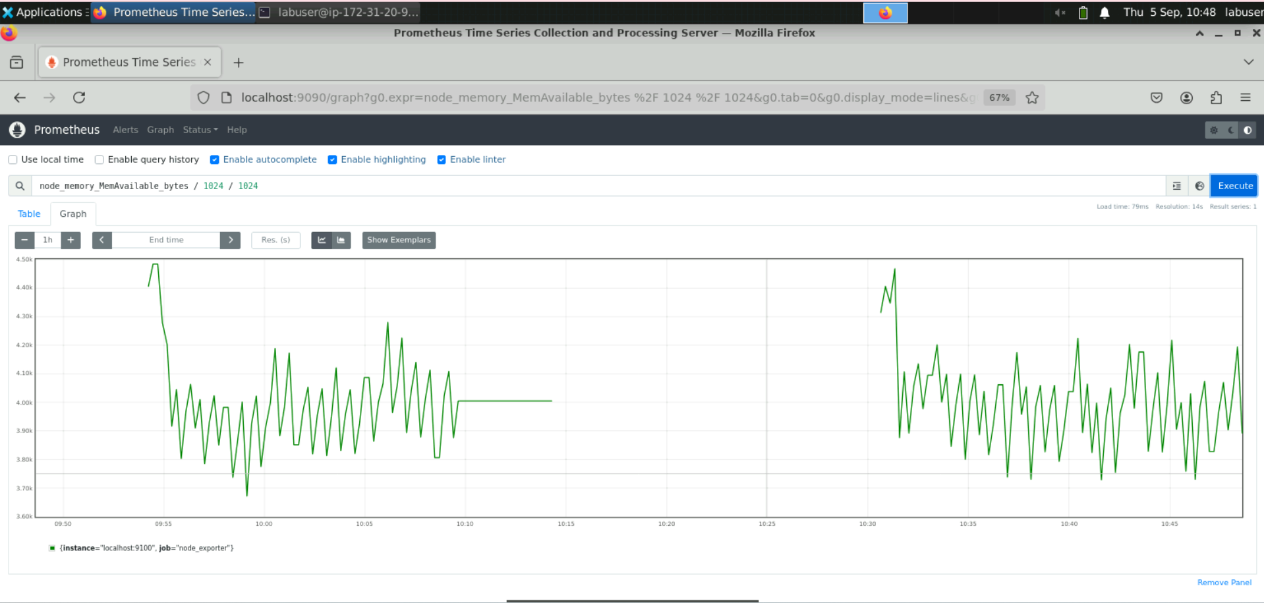

**Step 5: Calculate a metric using the rate() function**

* 1. Execute the following query in the expression browser to represent the total number of bytes received over the network interface since the system started:

**node_network_receive_bytes_total**

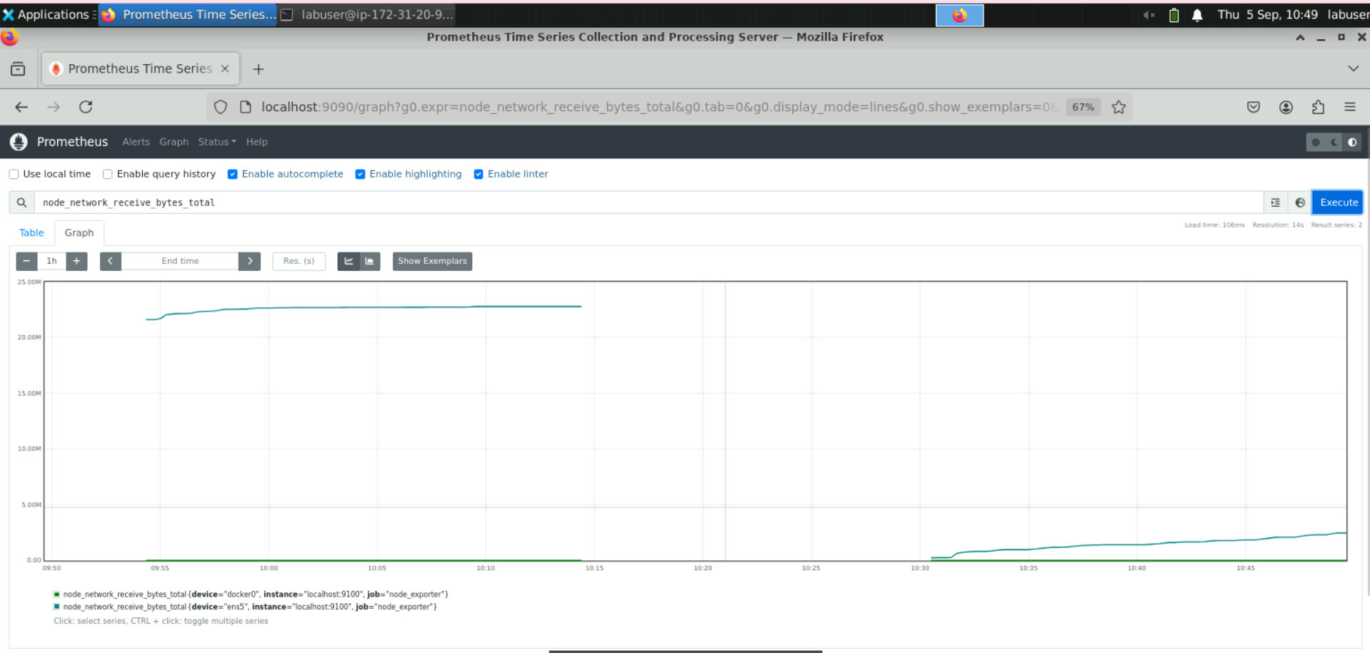

* 1. Enter the following query to calculate the average per-second rate of bytes received over the network interface in the last minute:

**rate(node_network_receive_bytes_total[1m])**

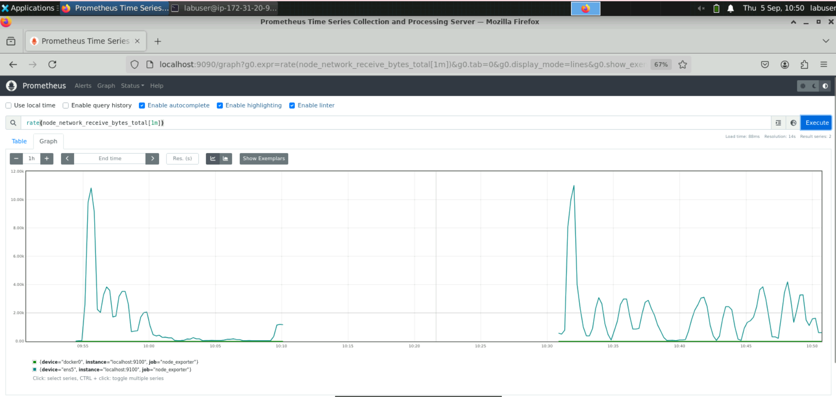

By following these steps, you have successfully queried and analyzed monitoring data using Prometheus Query Language to effectively monitor system performance and health.