Lesson 02 Demo 07

Resolving Merge Conflicts in Git

Objective: To demonstrate how to resolve merge conflicts in Git to maintain a clean codebase and project continuity when conflicting changes occur

Tools required: Git and GitHub

Prerequisites: Create a Git repository; refer Lesson 02 Demo 01

Steps to be followed:
- Create a new branch
- Make changes to the new branch
- Switch to the main branch and make conflicting changes
- Merge the new branch and resolve the merge conflicts

Step 1: Create a new branch

- Execute the following commands to create and modify a new file in the main branch:
touch example.txt
echo "This is an example file. Here we can write text."> example.txt

- Run the following commands to add and commit the changes:
git add example.txt
git commit -m "Add example file"

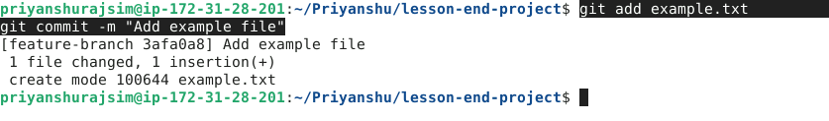

- Run the following command to create and switch to a new branch:
git checkout -b new-branch

Step 2: Make changes to the new branch

- Execute the following commands to create a new file in the new-branch:

echo "Hello, From New Branch." >> example.txt

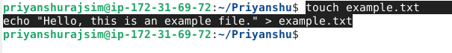

- Run the following commands to add and commit the changes:
git add example.txt
git commit -m "Add example file"

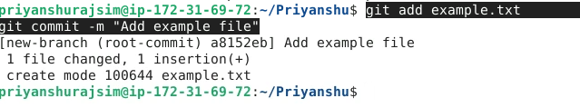

Step 3: Switch to the main branch and make conflicting changes

- Execute the following command to switch to the main branch:
git checkout master

- Execute the following command to delete the example.txt file:

echo "Hello, From Master Barnch." >> example.txt

- Run the following command to commit the change:
git commit -am "Added in example file"

Step 4: Merge the new branch and resolve the merge conflicts

- Use the command below to merge the new branch into the main branch:
git merge new-branch

Note: Altering the same file differently on two branches will result in a merge conflict. To resolve it, open the conflicted file in a text editor and choose which changes to retain.

- After editing, add the resolved file to the staging area using the following command:
git add example.txt

- Commit the resolved changes:
git commit -m "Resolved merge conflict"

By following these steps, you have successfully resolved a merge conflict caused in Git.

