Lesson 02 Demo 01

Creating and Cloning a GitHub Repository

Objective: To create and clone a GitHub repository for understanding the fundamentals of repository management and version control using Git and GitHub

Tools required: Git and GitHub

Prerequisites: You need to have Git installed and a GitHub account to proceed with this demo.

Steps to be followed:
- Create a new GitHub repository
- Clone the GitHub repository

Step 1: Create a new GitHub repository

- Open the browser in your lab, go to github.com, and log in to your account

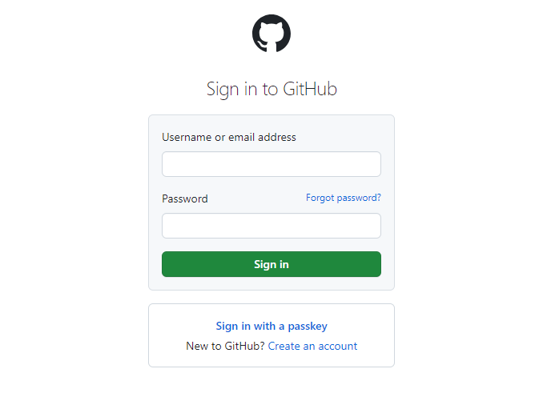
Note: If you do not have a GitHub account, visit the official website at https://github.com/signup and create a new account

- Click on the + icon from the upper-right corner of the page and select New repository from the drop-down menu

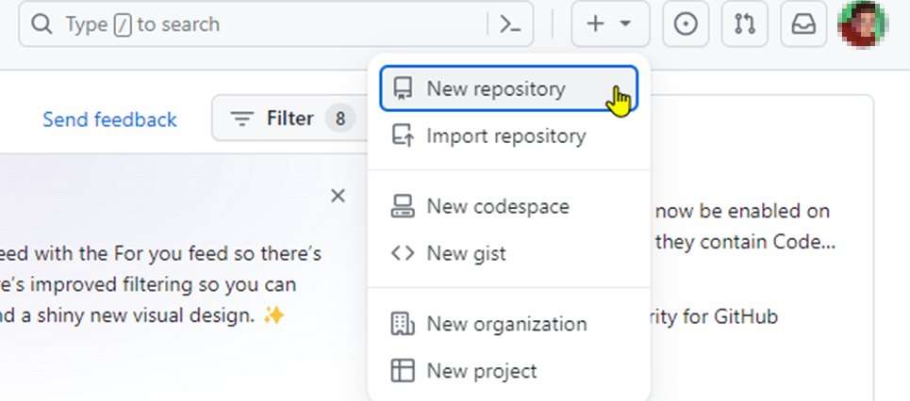

- Enter the Repository name and Description as shown below:

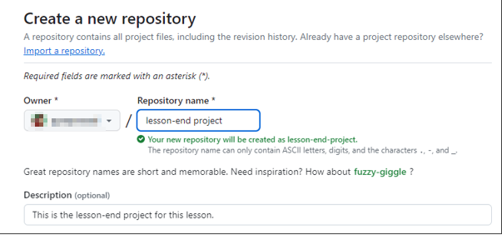
Note: The repository name and description may differ from those shown in the screenshot.

- Choose Public for the repository type

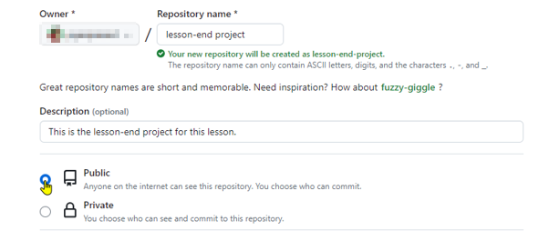

- Select Add a README file option to include a README file for the repository

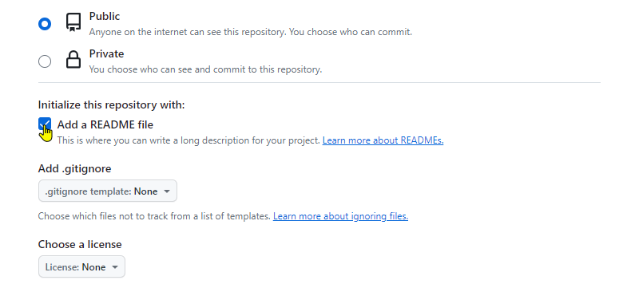

- Click on the Create repository button

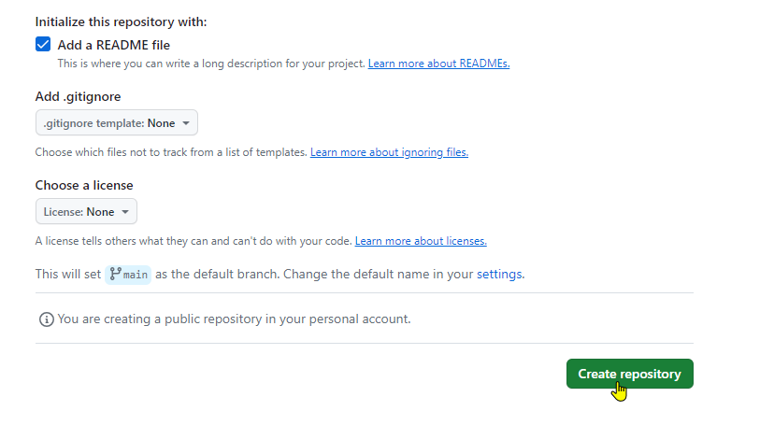

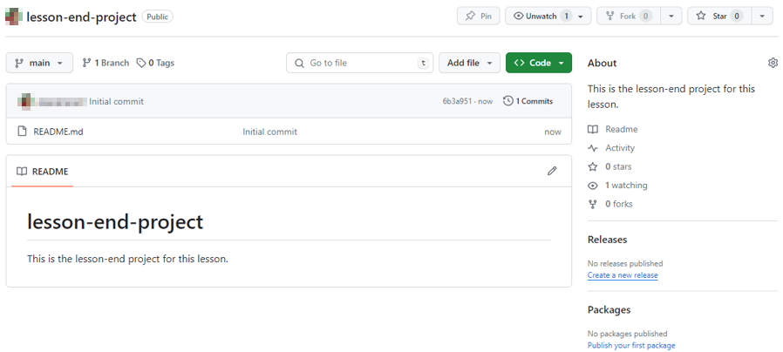

The remote GitHub repository is created.

Step 2: Clone the GitHub repository

- Open the created repository and click on the Code button

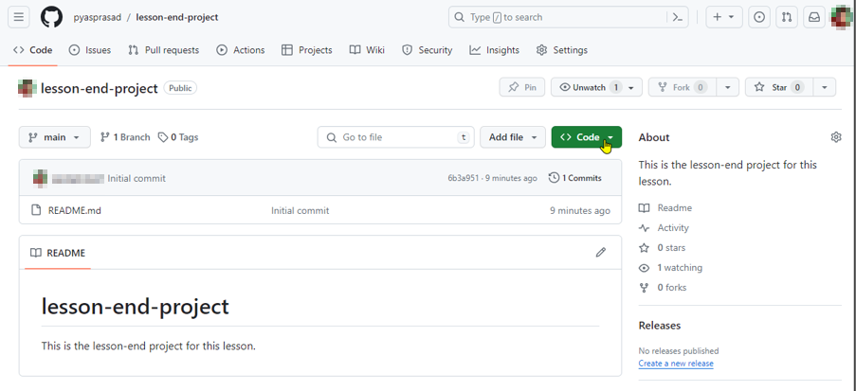

- Click on the copy icon to copy the HTTPS URL as shown below:

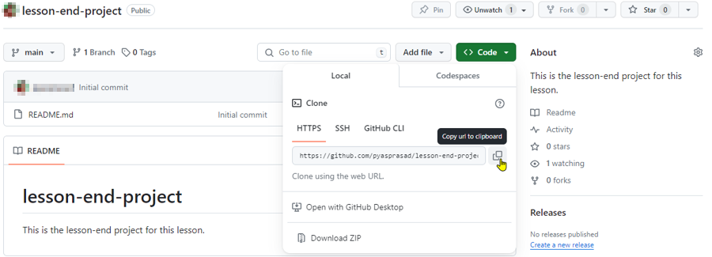

- Open the terminal tab on your lab and use the following command to clone the repository:
git clone <URL>

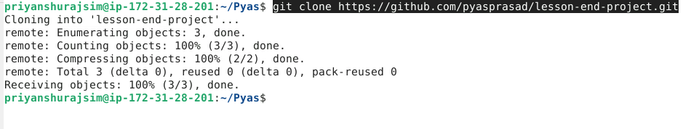
Note: Replace the URL in the command with the copied HTTPS URL from the GitHub repository

By following these steps, you have successfully created and cloned a GitHub repository for understanding the fundamentals of repository management and version control using Git and GitHub.

