Lesson 02 Demo 04

Creating a Branch in Git

Objective: To create a branch in a Git repository to facilitate a collaborative and organized approach to software development
Tools required: Git and GitHub

Prerequisites: You need to have Git installed to proceed with this demo.

Steps to be followed:
- Create a new GitHub repository
- Clone the GitHub repository
- List all the branches in your repository
- Create a new branch
- Delete the branch

Step 1: Create a new GitHub repository

- Click on the New button to create a new repository

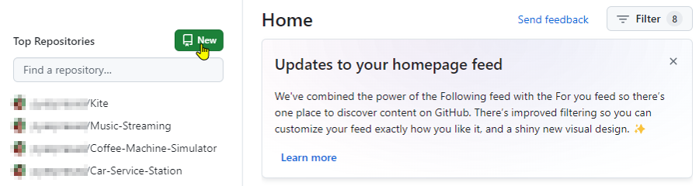

- Enter the repository name and description, then click on the Create repository button

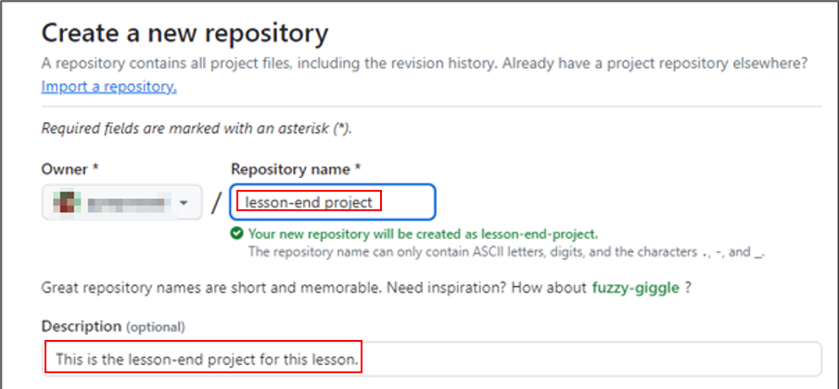

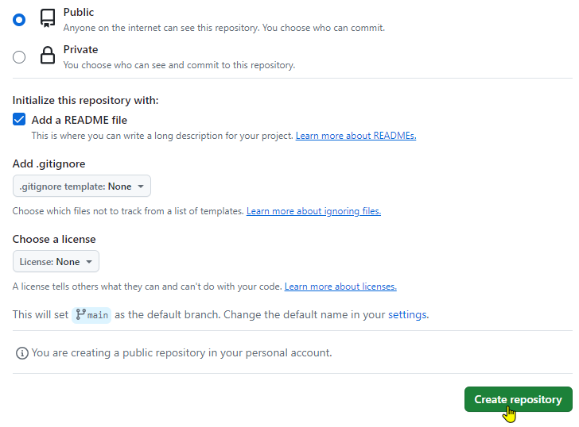

Step 2: Clone the GitHub repository

- Open the created GitHub repository and click on the Code button

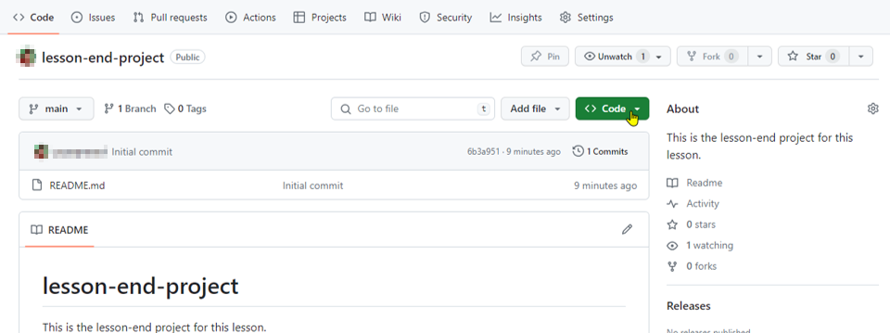

- Click on the copy icon to copy the HTTPS URL as shown below:

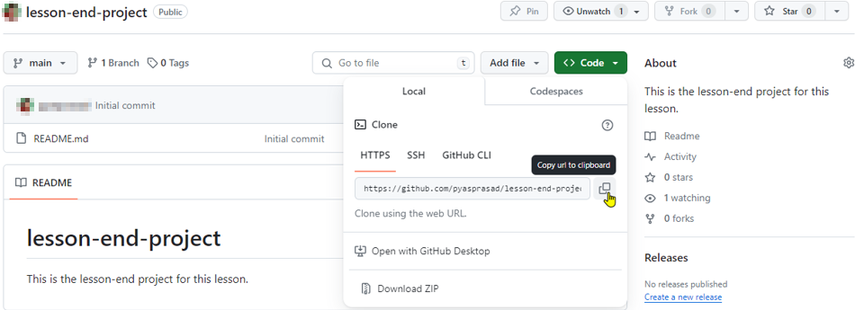

- Open the terminal tab on your lab and use the following command to clone the repository:
git clone <URL>

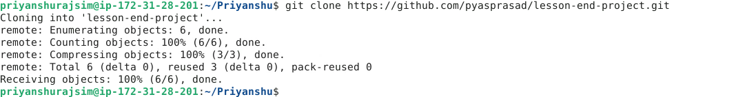

Note: Replace the URL with the copied HTTPS URL from the repository

Step 3: List all the branches in your repository

- Navigate to the cloned repository using the following command:
cd lesson-end-project



- Run the following command to display all repository branches:
git branch

Step 4: Create a new branch

- Run the following command to create a new branch named dev in your repository:
git branch dev

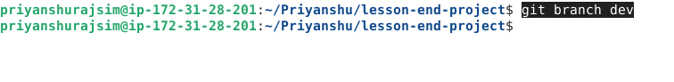

  - Execute the following command to verify the branch creation:
git branch



Step 5: Delete the branch

  - Run the given command to delete the recently created branch:
git branch -d dev

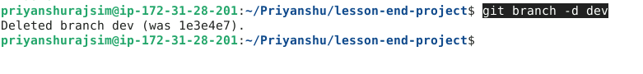

  - Execute the following command to verify the deletion of the branch:
git branch

By following these steps, you have successfully created a branch in a Git repository to facilitate a collaborative and organized approach to software development.

