Lesson 05 Demo 06

Setting up Custom SMTP to Send Email Notification

Objective: To configure SMTP email notification in Jenkins for sending automated notifications and alerts

Tools required: Jenkins

Prerequisites: Jenkins must be operational.

Steps to be followed:
- Create an app password for SMTP configuration
- Configure SMTP configurations in Jenkins

Step 1: Create an app password for SMTP configuration

  - Navigate to your Google account and click on Manage your Google Account

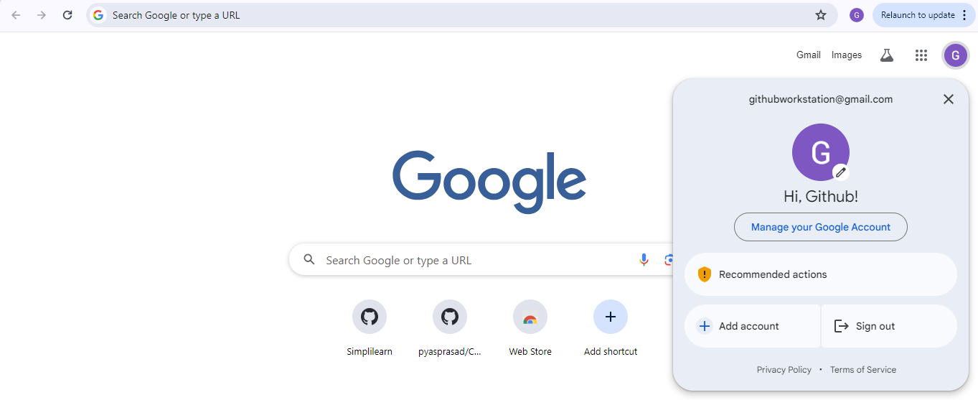

  - Now, navigate to Security and make sure you have 2-Step Verification enabled

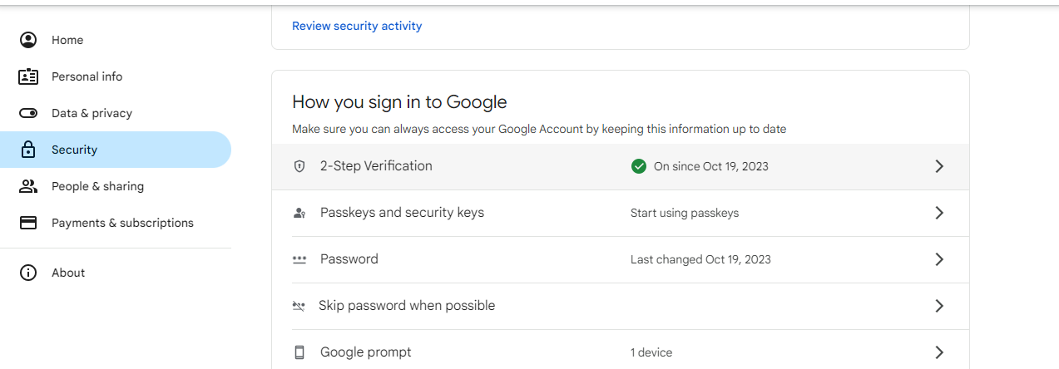

  - In Security, search for App passwords and click on it

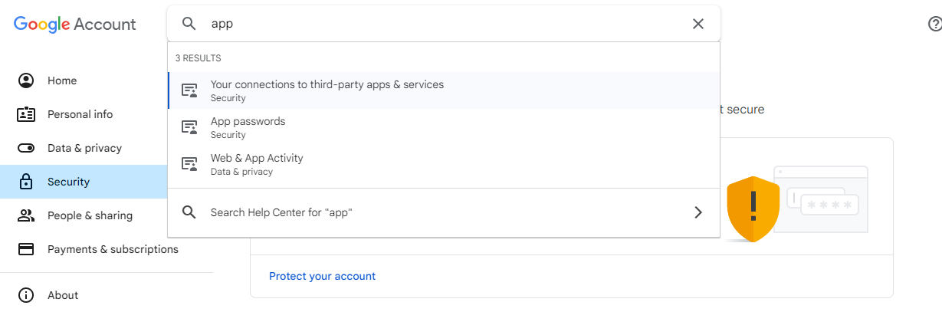

  - Provide the app name as JenkinsSMTP and click on Create

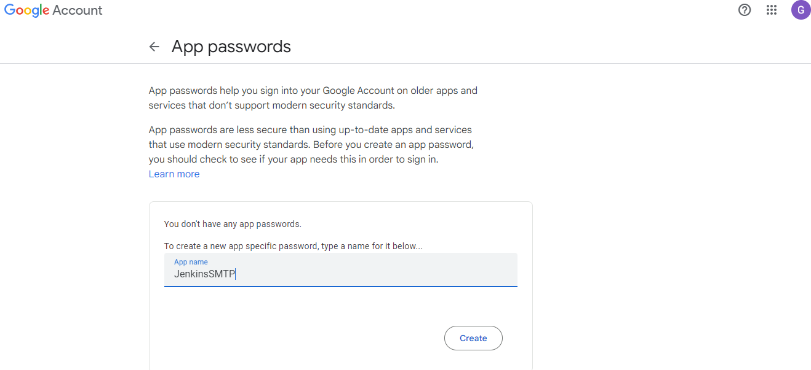

  - It will generate the app password. Copy the password and save it for future reference, then click on Done.

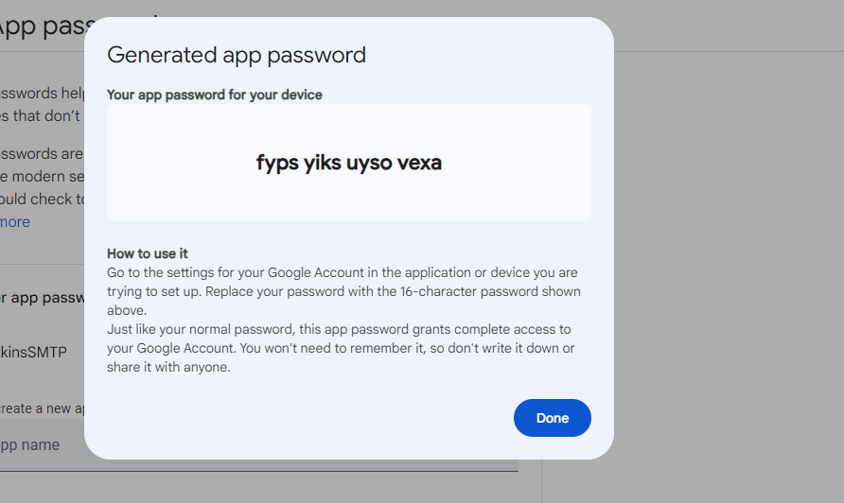

Step 2: Configure SMTP configurations in Jenkins

  - Sign in to Jenkins using your credentials

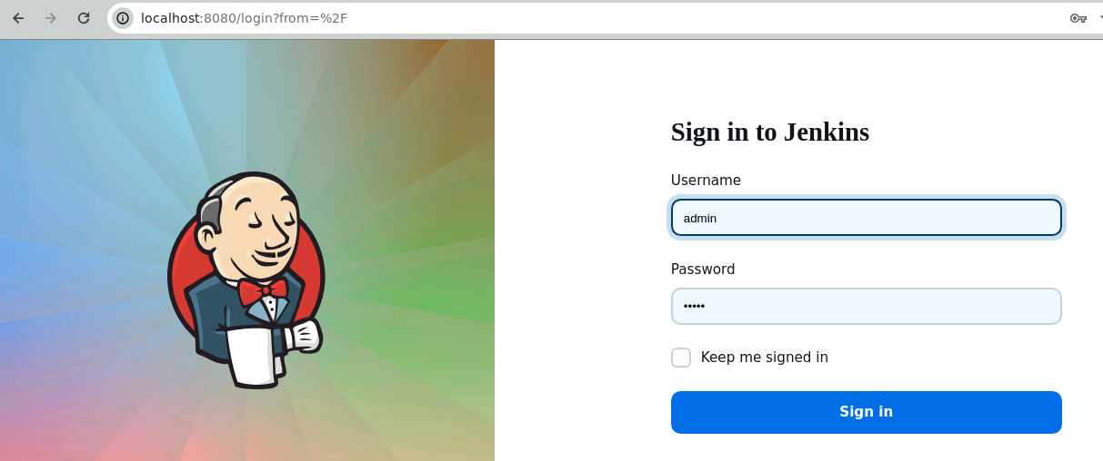
Note: The credentials for accessing Jenkins in the lab are Username: admin and Password: admin.

  - Navigate to Manage Jenkins in the Jenkins dashboard

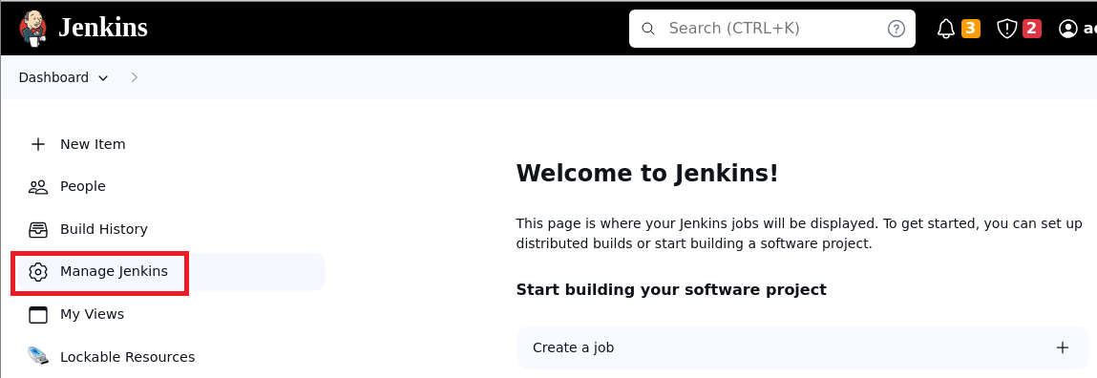

  - Now, click on System under System Configuration

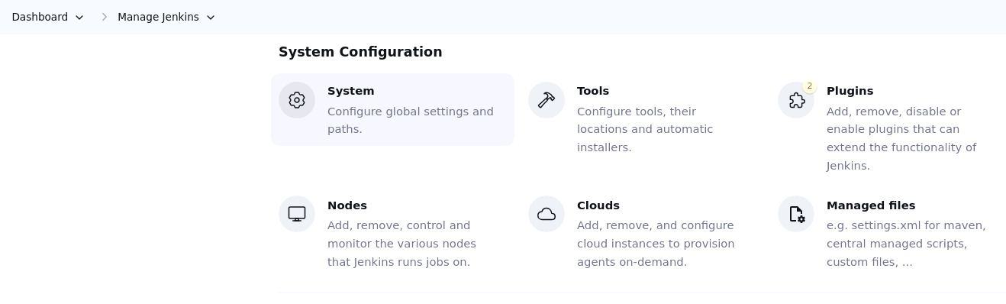

  - In the System section, scroll down to E-mail Notification section and provide smtp.gmail.com as the SMTP server

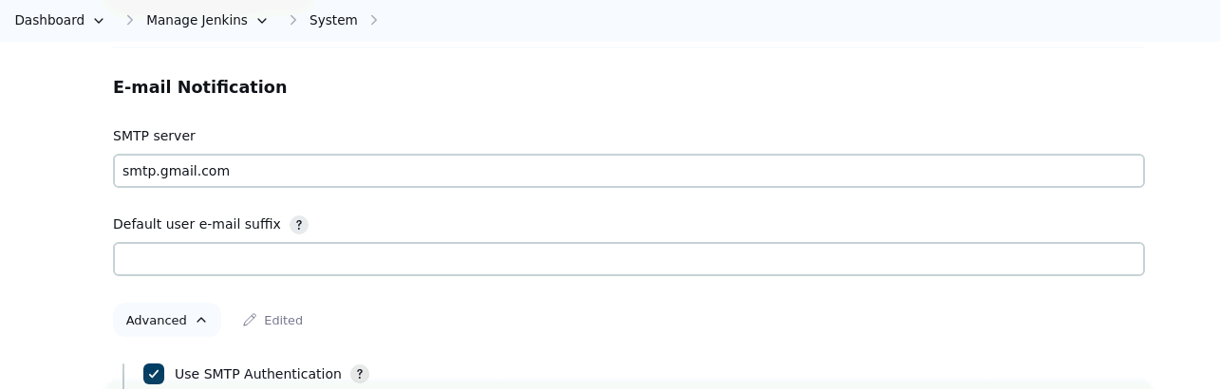

  - Click on Advanced, select Use SMTP Authentication, provide your email ID as User Name, and then provide previously generated App password in the Password

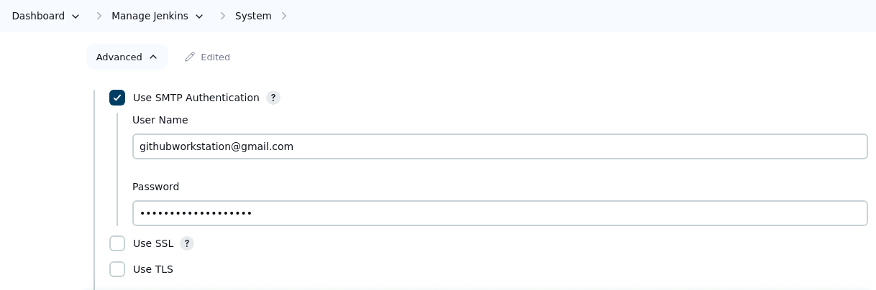

  - Select both Use SSL and Use TLS, and add 465 as the SMTP Port

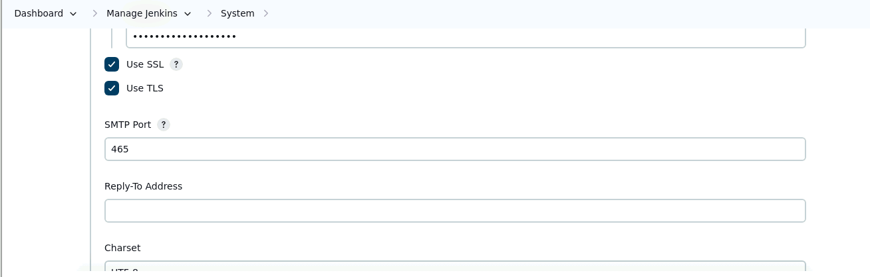

  - Now, click on Test configuration by sending test e-mail, provide your email ID under Test e-mail recipient, then click on Test configuration

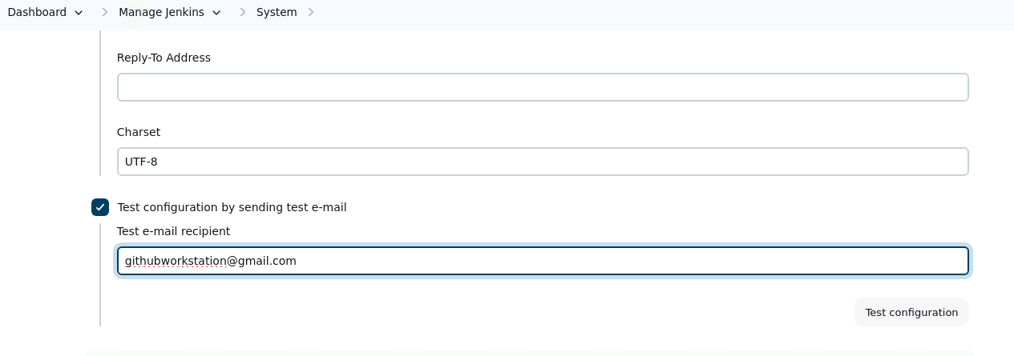

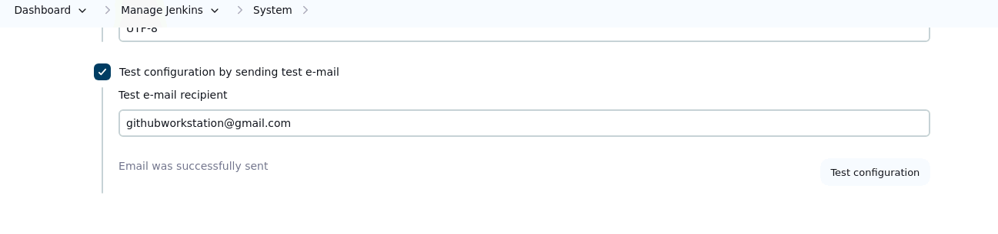

You can see the email has been sent successfully.

By following these steps, you have successfully configured SMTP email notification in Jenkins to send automated notifications and alerts.

