Lesson 03 Demo 04
Stashing in Git

Objective: To use Git stashing and temporarily save uncommitted changes, allowing switch between branches without losing progress
Tools required: Git and Ubuntu
Prerequisites: None
Steps to be followed:
- Set up the environment
- Initialize Git and make initial commits
- Manage branch transitions and changes
- Stash changes and verify

Step 1: Set up the environment
- Open the Ubuntu terminal from your practice lab and create a directory using the following command:
mkdir stashdemo
- Run the following command to navigate to stashdemo :
cd stashdemo/
Step 2: Initialize Git and make initial commits
  - Initialize the Git using the following command:
git init
  - Create a file using the following command:
echo “ ”index.txt
  - Run the following command to stage the changes in the Git repository:
git add .
  - Commit the staged changes using the following command:
git commit -m “created index.txt”
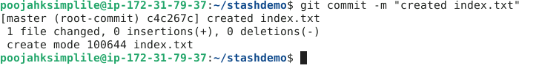
  - Run the following command to create and switch to the feature branch:
git checkout -b feature

Step 3: Manage branch transitions and changes

3.1 Run the following command to list the files:
ls
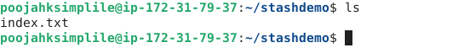
  - Run the following command to create a new file:
vi feature.txt
  - Enter the desired data inside the feature.txt file as shown in the screenshot below:
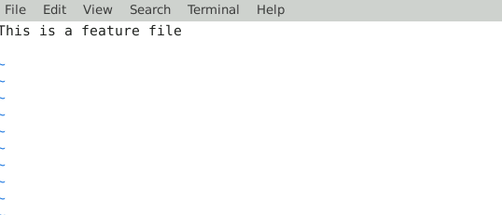
  - Run the following command to display the current state (changed, staged, and untracked) of the working directory files:
git status
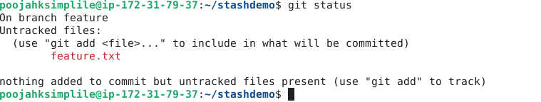

  - Run the following command to stage the changes in the Git repository:
git add .
  - Commit the staged changes using the following command:
git commit -m “feature file WIP”
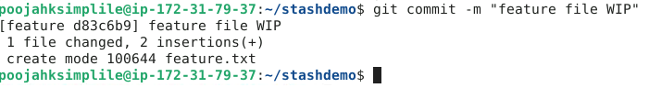
  - Switch to the master branch using the following command:
git checkout master
  - Navigate inside the index.txt using the following command:
vi index.txt
  - Add the desired data inside the index.txt file as shown in the screenshot below:
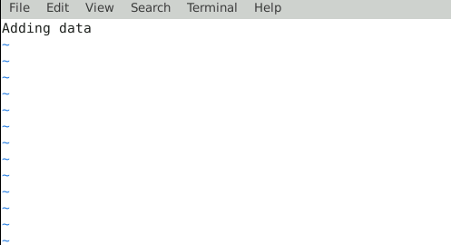
  - Run the following command to stage the changes in the Git repository:
git add .
  - Commit the staged changes using the following command:
git commit -m “index file add ”
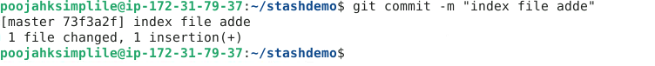
  - Switch to the feature branch using the following command:
git checkout feature
  - Run the following command to display the commit history of the current branch showing a list of commits with details:
git log
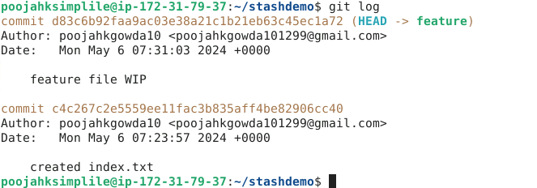
In the above output, observe that the commit on the feature.txt and index.txt files are successful.
  - Open index.txt from the feature branch (current branch) using the following command:
vi index.txt
  - Enter the desired data inside the index.txt file as shown in the screenshot below:
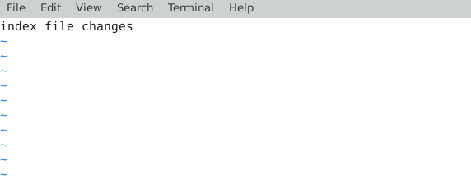
  - Run the following command to display the current state of the working directory files:
git status
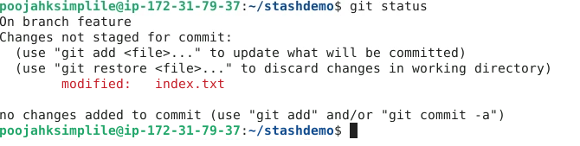
In the above screenshot, observe that the index.txt file has been modified from the feature branch.

Step 4: Stash changes and verify
- Run the following command to switch to the master branch:
git checkout master
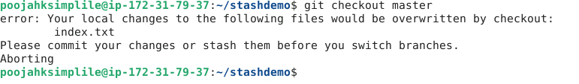
Note: The error message indicates that switching to the master branch would overwrite local changes made to index.txt. Thus, you must either commit or stash these changes before changing branches.

- Run the following command to temporarily save changes:
git stash
- Run the following command to list all stashed changes:
git stash list
By following these steps, you have successfully performed stashing in Git to save uncommitted changes temporarily.

