**Lesson 02 Demo 03**

**Creating a Pull Request in Git**

**Objective:** To create a pull request for merging the local changes into a remote Git repository

**Tools required:** Git and GitHub

**Prerequisites:** You need to have Git installed to proceed with this demo.

Steps to be followed:

1. Create a fork
2. Clone the fork
3. Sync the fork with the original repository
4. Push changes to the GitHub fork
5. Create a pull request

**Step 1: Create a fork**

1. Open the browser in your lab, go to **github.com**, and log in to your account

**Note**: If you do not have a GitHub account, visit the official website at <https://github.com/signup> and create a new account

1. Navigate to the following repository in your browser:

**https://github.com/GithubResources1/Chat-Application**

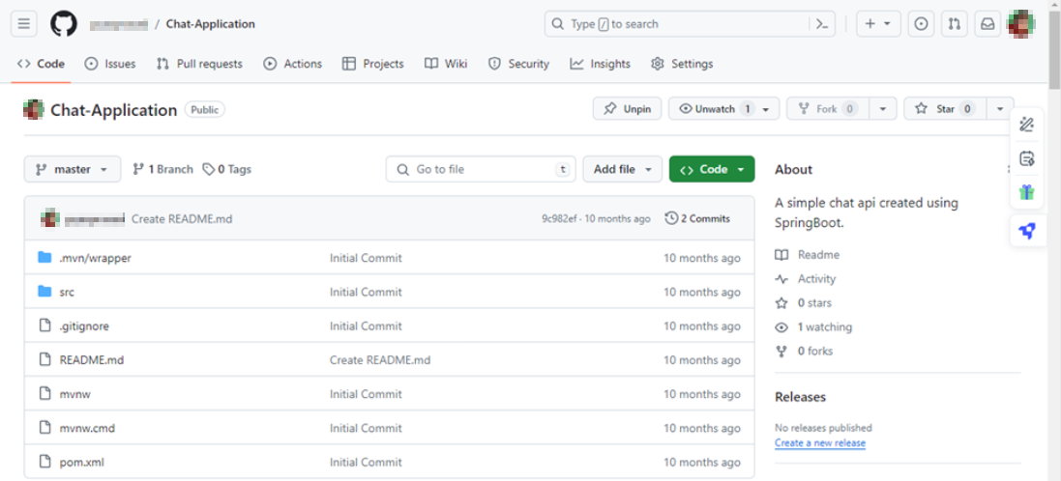

1. Click the **Fork** button in the top-right corner of the page

1. In the **Create a new fork** page, enter the name and description of the forked repository, then click on **Create fork**

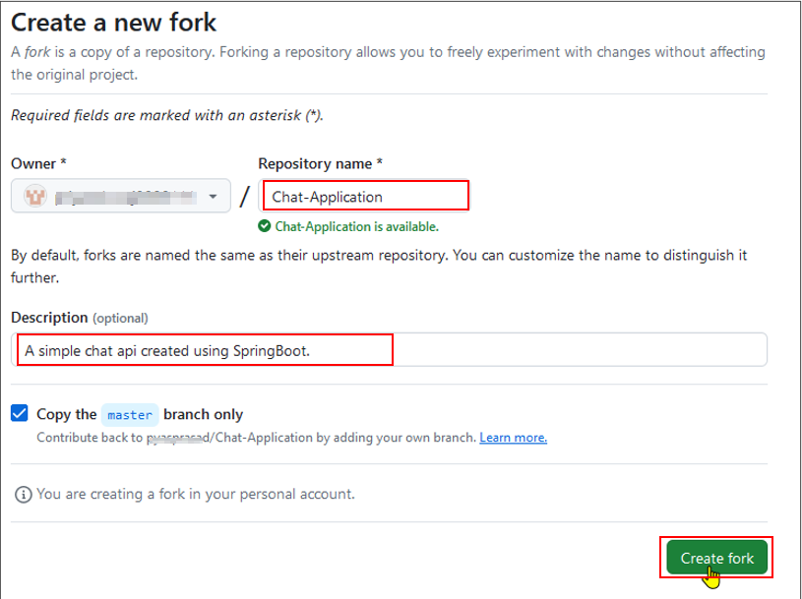

**Step 2: Clone the Fork**

1. Click on the **Code** button in the forked repository page

1. Click on the copy icon to copy the **HTTPS URL** of the forked repository to clone it

1. Open the terminal tab on your lab and use the following command to clone the forked repository inside the local project directory:

**git clone <URL>**

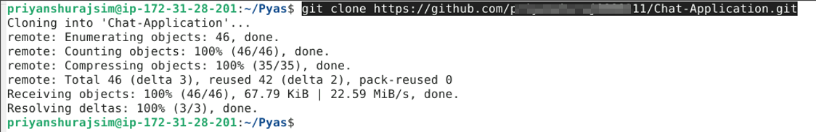

**Note:** Replace the URL with the copied HTTPS URL from the repository

**Step 3: Sync the fork with the original repository**

1. Navigate to the directory where the fork has been cloned using the following command in the terminal:

**cd Chat-Application**

1. Run the following command to view the configured remote repository for your fork:

**git remote -v**

1. Add the original repository as a remote upstream using the following command:

**git remote add upstream <URL>**



**Note:** Replace the URL with the copied URL from the repository

1. Execute the following command to verify the new upstream repository:

**git remote -v**

**Step 4: Push changes to the GitHub fork**

1. After making changes in the local code repository, execute the following command to push the changes to your GitHub fork:

**git push**

**Note**: After executing the Git push command, you will be asked to enter the username and password for your GitHub account.

**Step 5: Create a pull request**

* 1. Click the **Pull requests** button on your GitHub fork’s page

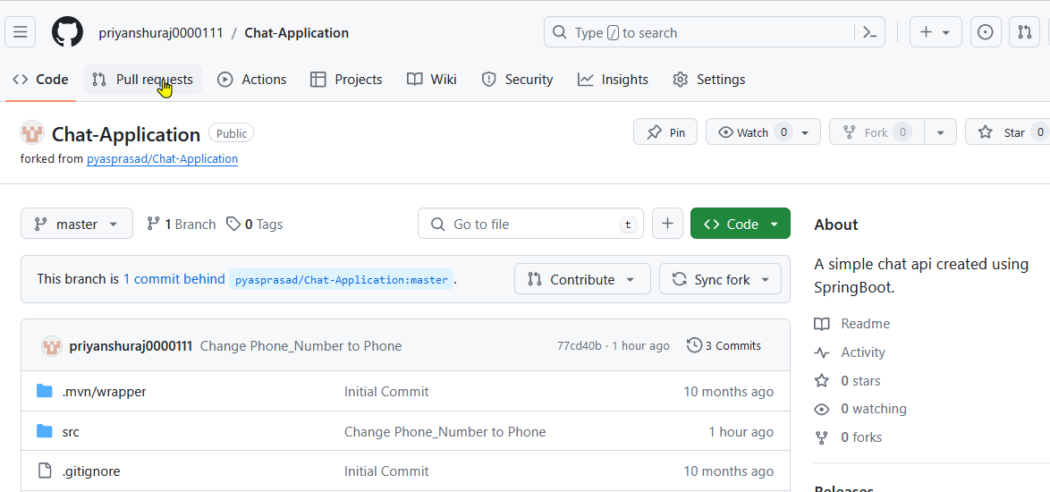

* 1. Click the **New pull request** button

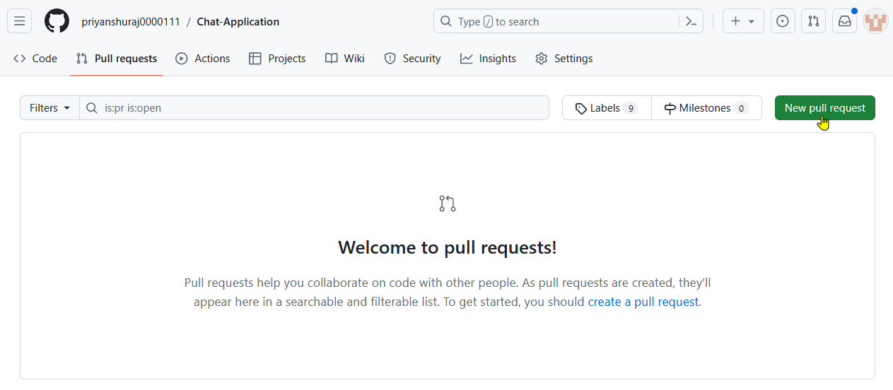

* 1. Select the **Create pull request** button and resolve the merge comments

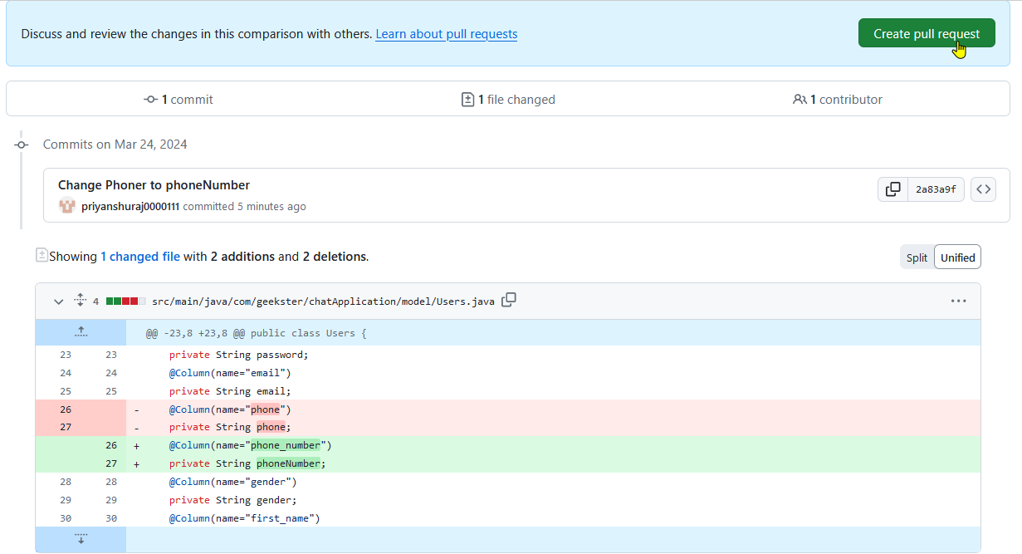

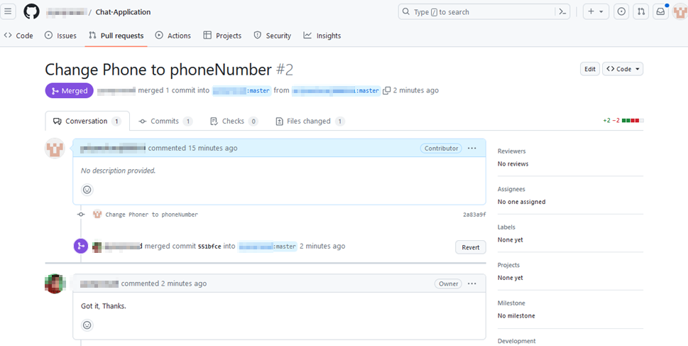

By following these steps, you have successfully created a pull request for merging the local changes into a remote Git repository.