**Lesson 04 Demo 01**

**Creating a New User in Jenkins**

**Objective:** To create a new user in Jenkins for managing access and permissions within the Jenkins environment

**Tools required:** Jenkins

**Prerequisites:** Jenkins must be operational

Steps to be followed:

1. Log in to the Jenkins CI tool
2. Access the user management section to manage users

**Step 1:** **Log in to the Jenkins CI Tool**

1. Go to **Google Chrome**

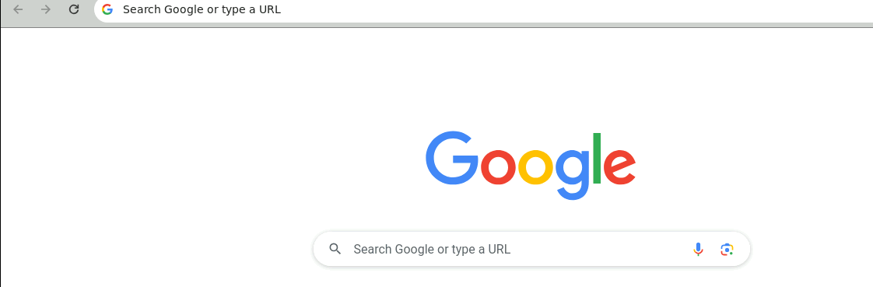

1. Go to Jenkins by typing **localhost:8080** and sign in using your credentials

**Note:** The credentials for accessing Jenkins in the lab are Username: **admin** and Password: **admin**.

**Step 2:** **Access the user management section to manage users**

* 1. Click on **Manage Jenkins**

* 1. Click on **Users** under the **Security** section

* 1. Now, click on **Create User**

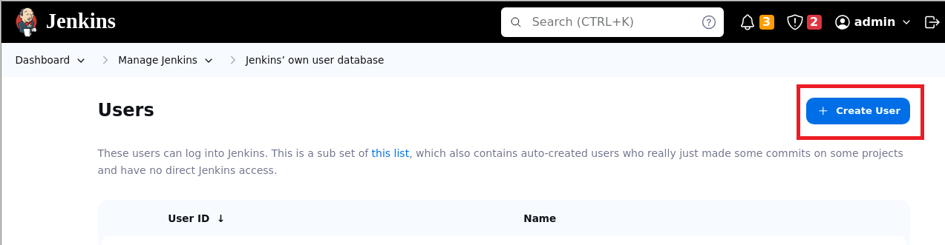

* 1. Provide the basic user details, including username, password, and email ID, and click on **Create User**

Once the user is created, you can use these credentials to access the Jenkins application.

By following these steps, you have successfully created a new user in Jenkins for managing access and permissions within the Jenkins environment.