**Lesson 08 Demo 02**

**Setting up Jenkins Pipeline Job from Git**

**Objective:** To set up a Jenkins pipeline job from Git version control system to enable automated CI for building, testing, and potentially deploying software upon code changes

**Tools required:** Jenkins, Git and Linux

**Prerequisites:** None

Steps to be followed:

1. Create a Git repository
2. Push the pipeline script into the Git repository
3. Create a pipeline script-based freestyle job

**Step 1: Create a Git repository**

|  |
| --- |
| **Note**: If you do not have a GitHub account, visit the official website at **https://github.com/signup** and create a new account |

1. Open the browser in your lab, go to **github.com**, and **Sign in** to your account  
     
   A screenshot of a login form

   Description automatically generated

1. Click on **New** as shown in the screenshot below:

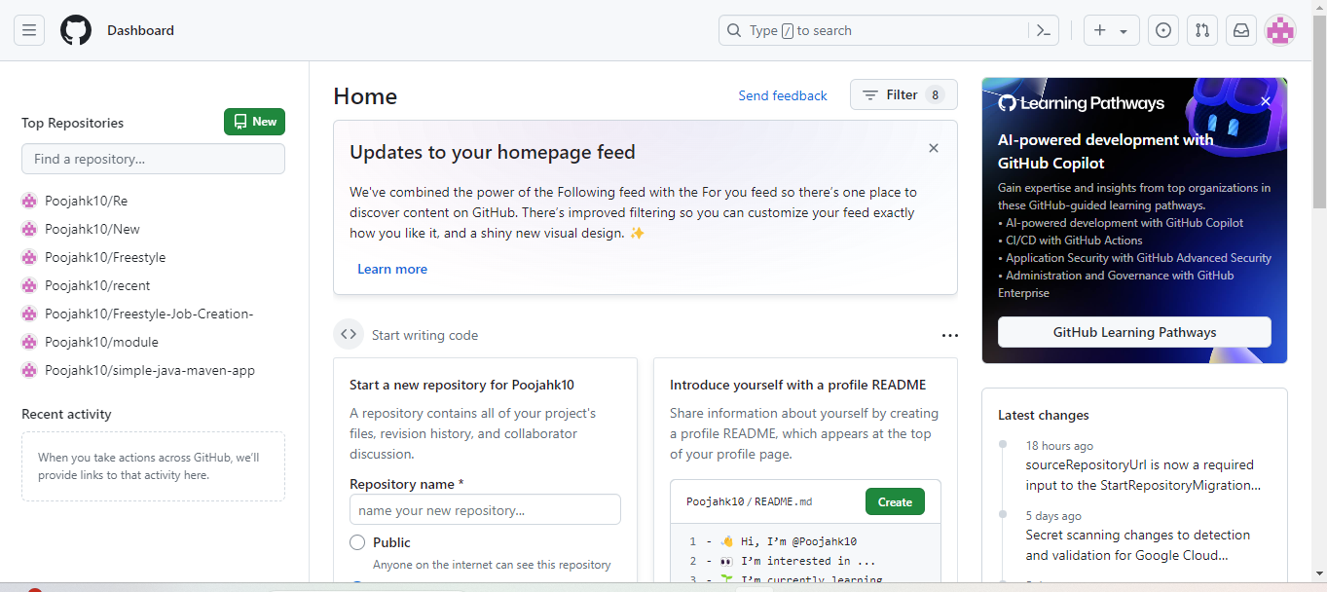

1. Enter a desired name for your repository and choose **Public** as shown in the screenshot below:

1. Click on **Add a README** **file** and then click on **Create repository** as shown in the screenshot below:

1. Click on **Code** as shown in the screenshot below:

1. Copy the repository URL as shown in the screenshot below:

**Step 2: Push the pipeline script into the Git repository**

1. Open the Linux terminal in your lab and clone the repository using the below command:  
   **git clone RepositoryURL**

1. Navigate inside the repository that you had created using the below command:  
   **cd RepositoryName**
2. Initialize the Git using the below command:  
   **git init**



1. Create a file using the below command:  
   **nano demofile**



1. Paste the below pipeline script inside the file as shown in the screenshot below:

**pipeline {**

**agent any**

**stages {**

**stage('Checkout') {**

**steps {**

**// Checkout your source code from version control**

**git 'https://github.com/your/repository.git'**

**}**

**}**

**stage('Build') {**

**steps {**

**// Use Maven to build your project**

**sh 'mvn clean package'**

**}**

**}**

**stage('Test') {**

**steps {**

**// Run tests if applicable**

**sh 'mvn test'**

**}**

**}**

**stage('Deploy') {**

**steps {**

**// Deploy your artifact, if necessary**

**// Example: sh 'mvn deploy'**

**}**

**}**

**}**

**post {**

**success {**

**// This block will be executed if the pipeline runs successfully**

**echo 'Pipeline executed successfully!'**

**}**

**failure {**

**// This block will be executed if the pipeline fails**

**echo 'Pipeline failed!'**

**}**

**}**

|  |
| --- |
| **Note**: Ensure you provide your Git repository URL on line7, save, and exit the page by clicking on **ctrl+S** to save and **ctrl+X** to exit |

**}**

1. Stage and commit the changes using the below commands:  
   **git add .**

**git commit -m “initial commit”**  
  
1. Push the file to the Git repository using the below command:

**git push**

1. Navigate to your Git repository to check for the file that is pushed as shown in the screenshot below:  
     
   A screenshot of a computer

   Description automatically generated