Lesson 02 Demo 02

Pushing a File to the GitHub Repository

Objective: To demonstrate the process of pushing a file to a GitHub repository using Git commands for version control and collaboration

Tools required: Git and GitHub

Prerequisites: You need to have Git installed to proceed with this demo.

Steps to be followed:
- Create a GitHub repository
- Create a repository on the local machine
- Push the changes in the local repository to GitHub
- Check the status of the local and remote repository

Step 1: Create a GitHub repository

- Open the browser in your lab, go to github.com, and log in to your account

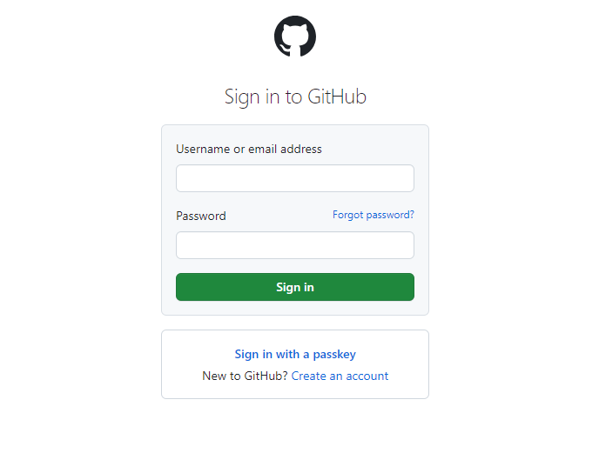

Note: If you do not have a GitHub account, visit the official website at https://github.com/signup and create a new account

- Click on the New button to create a new GitHub repository

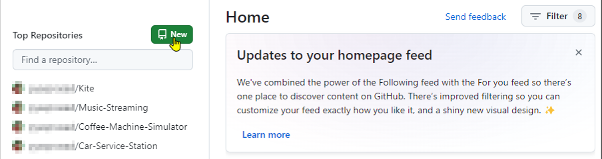

- Enter the repository name and description, then click the Create repository button

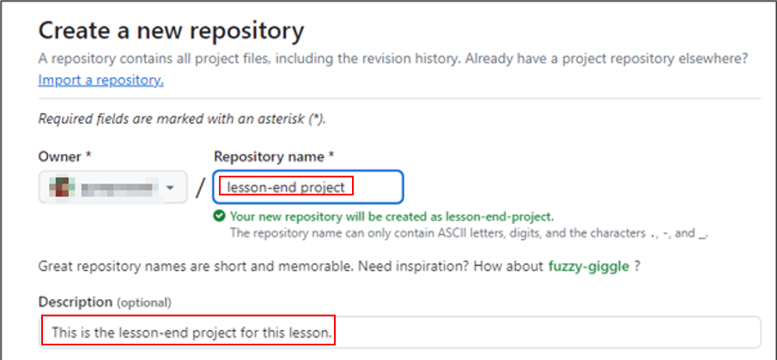

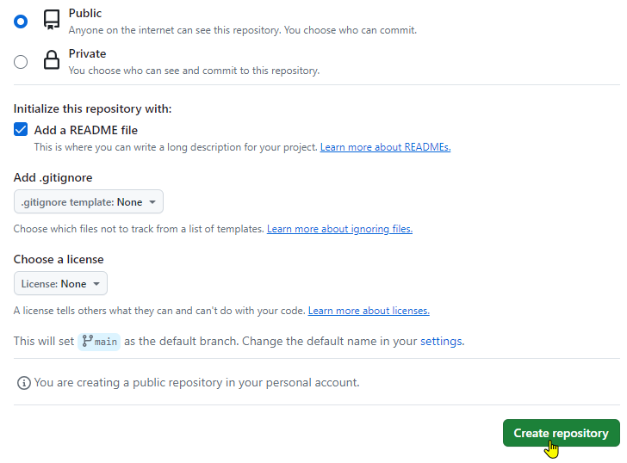

Step 2: Create a repository on the local machine

- Open the terminal tab in your lab, and execute the following command to create a new project directory:
mkdir createnewproject

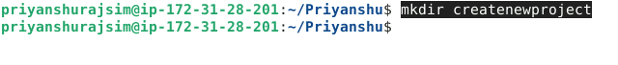

- Run the following command to change the directory:
cd createnewproject

- Create a README file using the following command:
echo "Hello World" >> example.txt

- Initialize the Git repository using the following command:
git init

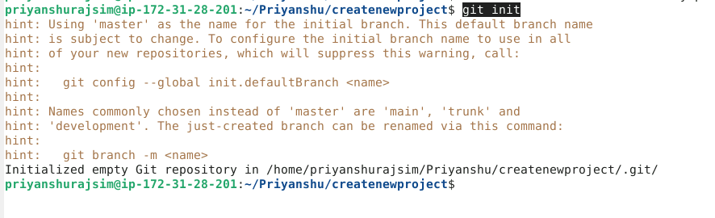

- Add the README file using the command given below:
git add .

- Use the following command to commit the changes:
git commit -m "Added Example file"

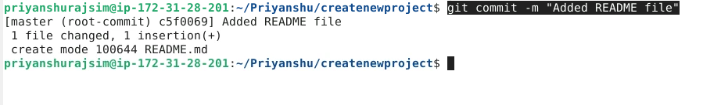

Step 3: Push the changes in the local repository to GitHub

- Open the Terminal and add a remote repository using the following command:
git remote add origin <URL>
Note: While creating the remote repository, copy the HTTPS URL

- Push the changes to the remote repository using the following command:
git push -u origin master

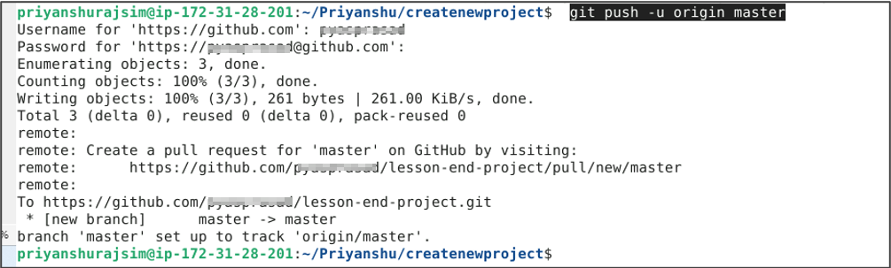
Note: After executing the Git push command, you will be asked to enter the username and password for your GitHub account.

Step 4: Check the status of the local and remote repository

- Run the following command to check the status of the local repository:
git status

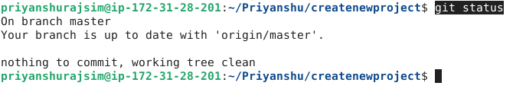

- Visit github.com to inspect the remote repository

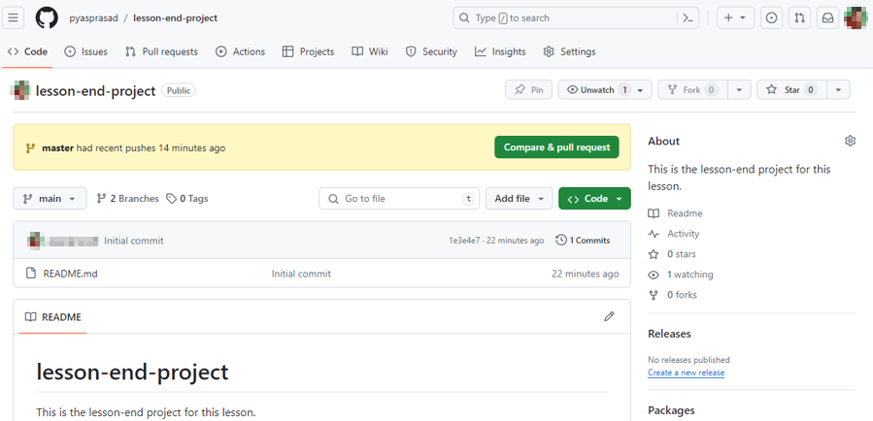

By following these steps, you have effectively demonstrated the process of pushing a file to a GitHub repository using Git commands for version control and collaboration.

