Lesson 08 Demo 03

Configuring Multibranch Jenkins Pipeline Job
Objective: To configure a Multibranch Jenkins pipeline job to facilitate managing multiple projects within a single job setup

Tools required: Jenkins, Git, and GitHub

Prerequisites: None

Steps to be followed:
- Create a Git repository
- Push the code file into the Git repository
- Create a Multibranch Pipeline

Step 1: Create a Git repository

Note: If you do not have a GitHub account, visit the official website at https://github.com/signup and create a new account
- Open the browser in your lab, go to github.com, and sign in to your account
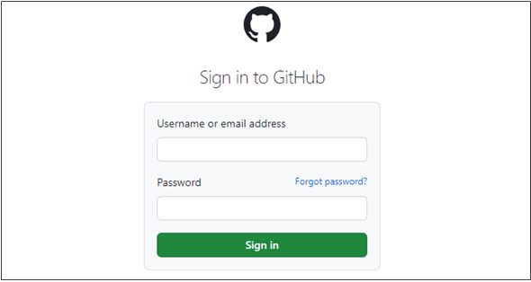

- Click on New as shown in the screenshot below:
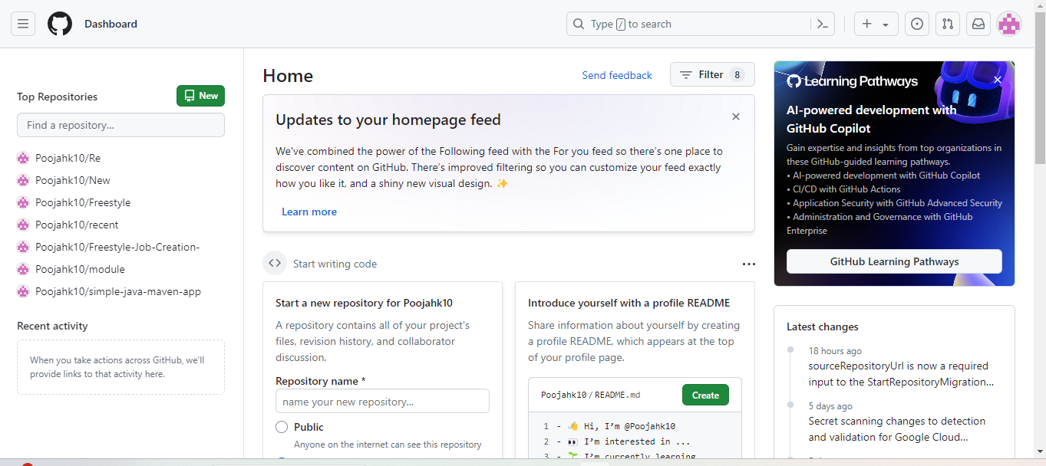

- Enter a desired name for your repository and choose Public as shown in the screenshot below:
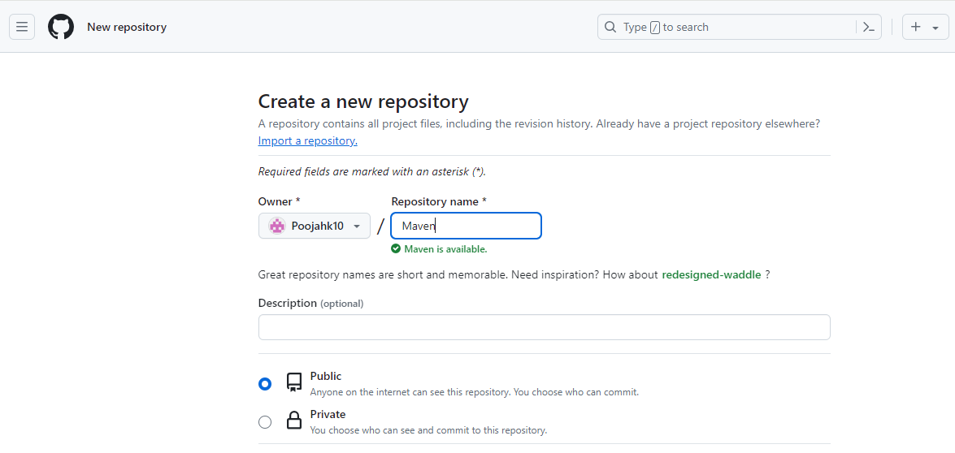

- Click on Add a README file and then click on Create repository as shown in the screenshot below:

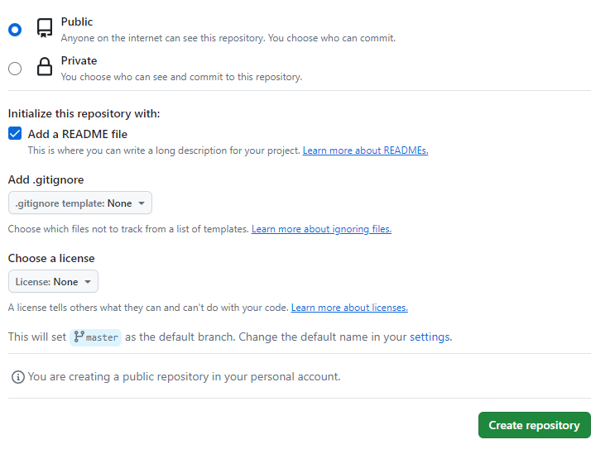

- Click on Code as shown in the screenshot below:
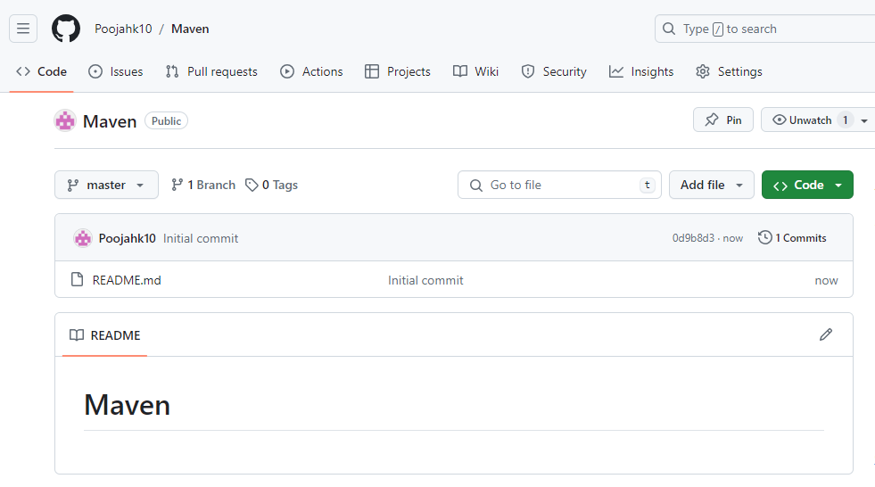

- Copy the repository URL as shown in the screenshot below:

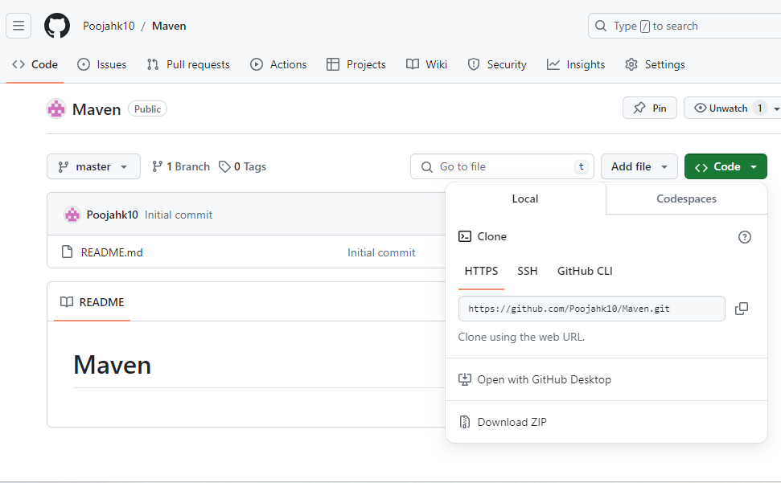
Step 2: Push the code file into the Git repository
- Open the Linux terminal in your lab and clone the repository using the below command:
git clone RepositoryURL
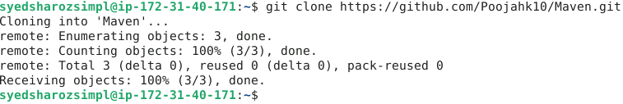
- Navigate inside the repository that you had created using the below command:
cd RepositoryName

- Initialize the Git using the below command:
git init
- Create a file using the below command:
nano demofile
- Paste the below pipeline script inside the file as shown in the screenshot below:
pipeline {
agent any
stages {
stage('Checkout') {
steps {
// Checkout your source code from version control
git 'https://github.com/your/repository.git'
}
}
stage('Build') {
steps {
// Use Maven to build your project
sh 'mvn clean package'
}
}
stage('Test') {
steps {
// Run tests if applicable
sh 'mvn test'
}
}
stage('Deploy') {
steps {
// Deploy your artifact, if necessary
// Example: sh 'mvn deploy'
}
}
}

post {
success {
// This block will be executed if the pipeline runs successfully
echo 'Pipeline executed successfully!'
}
failure {
// This block will be executed if the pipeline fails
echo 'Pipeline failed!'
}
}
Note: Ensure you provide your Git repository URL on line7, save, and exit the page by clicking on ctrl+S to save and ctrl+X to exit
}
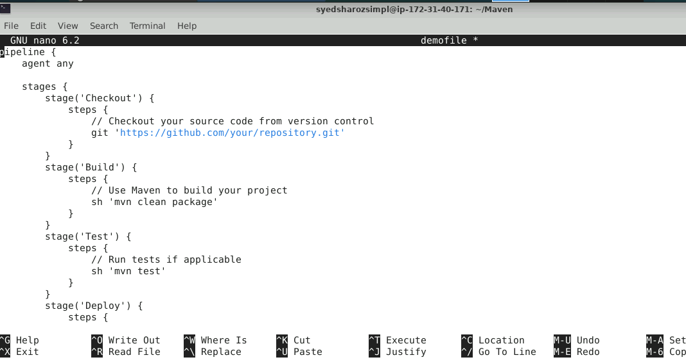
- Stage and commit the changes using the below commands:
git add .
git commit -m “initial commit”
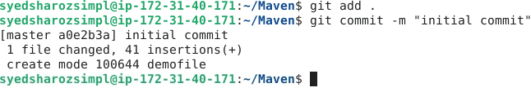

- Push the file to the Git repository using the below command:
git push
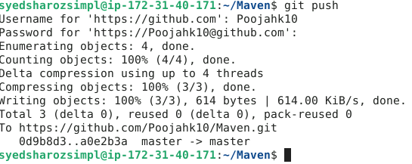
- Navigate to your Git repository to check for the file that is pushed:
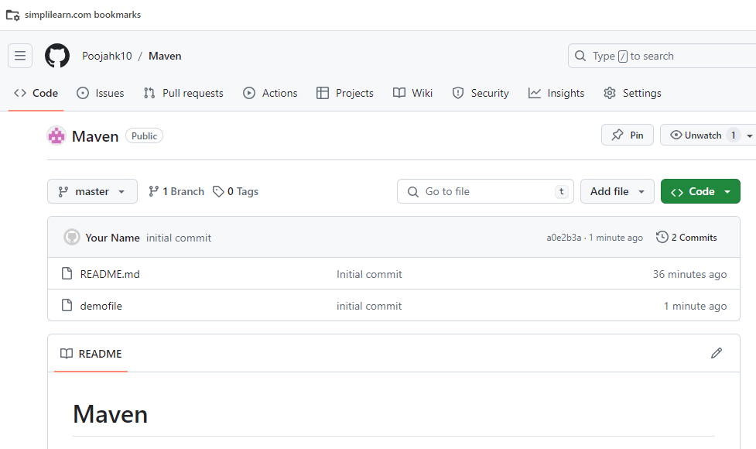

Step 3: Create a Multibranch Pipeline
Note: Use the given credentials to access Jenkins in the lab: Username is admin and Password is admin
- Open the browser, go to the Jenkins Dashboard by typing localhost:8080 in your browser, provide the credentials, and click the Sign in button
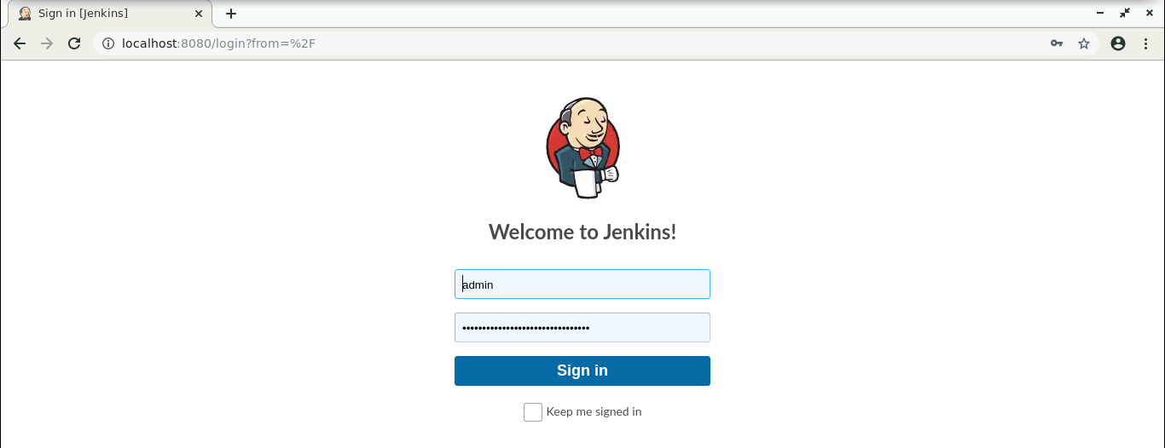
- Click on New Item as show in the screenshot below:
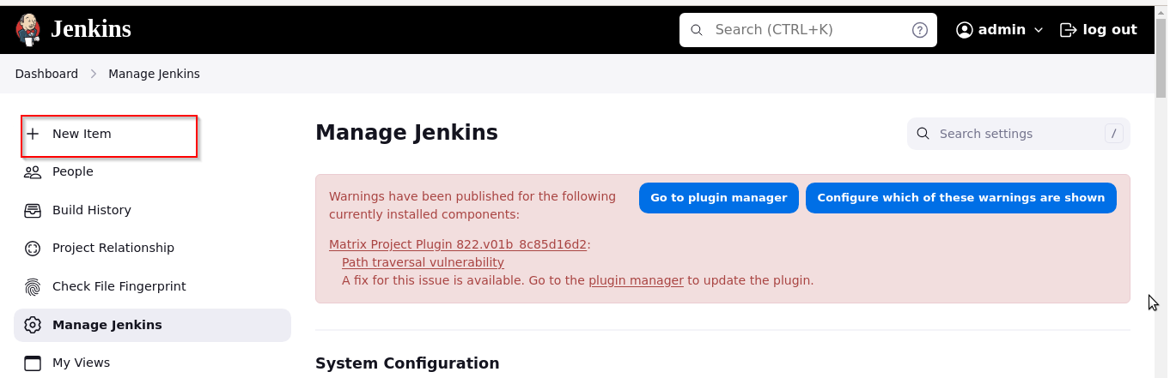

- Enter a desired name for the project as shown in the screenshot below:
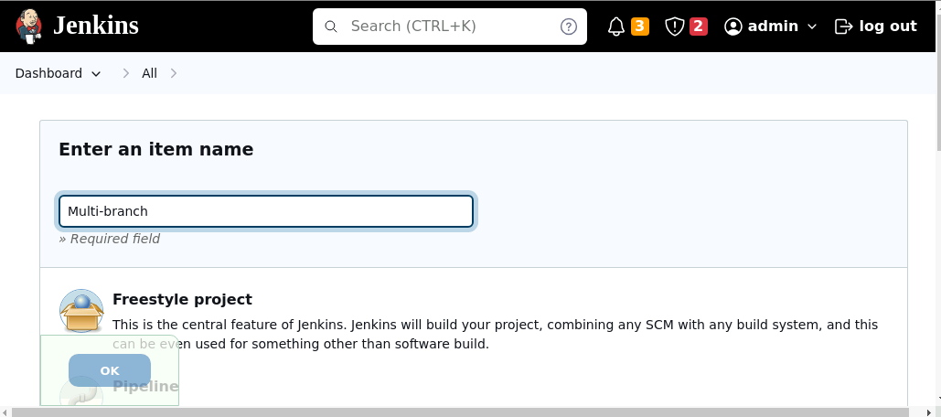
- Scroll down to Multibranch Pipeline, click on it, and then click on the OK button as shown in the screenshot below:
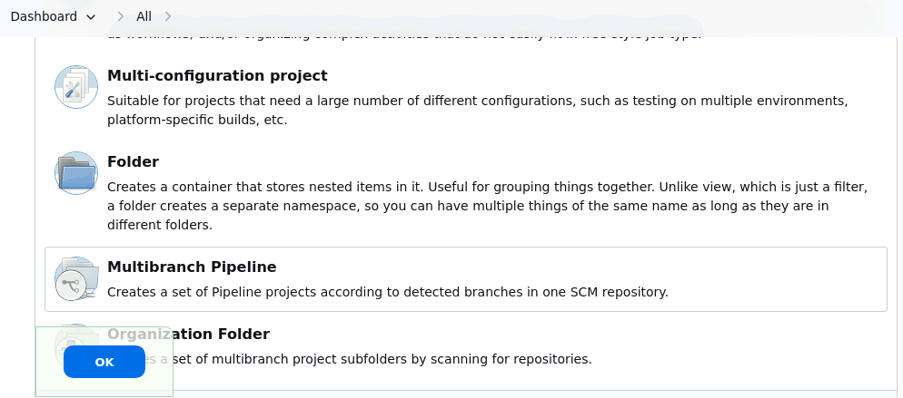

- Enter a desired name for Display Name as shown in the screenshot below:
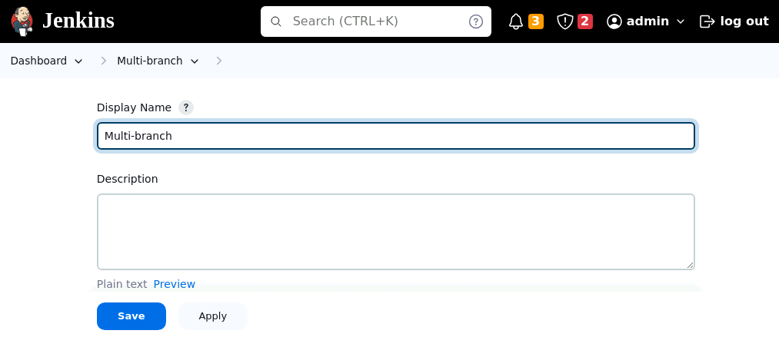
- Scroll down to Branch Sources and then click on Add source as shown in the screenshot below:
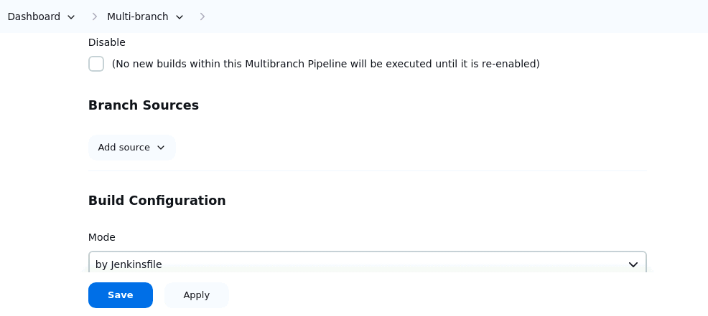

- Click on GitHub as shown in the screenshot below:
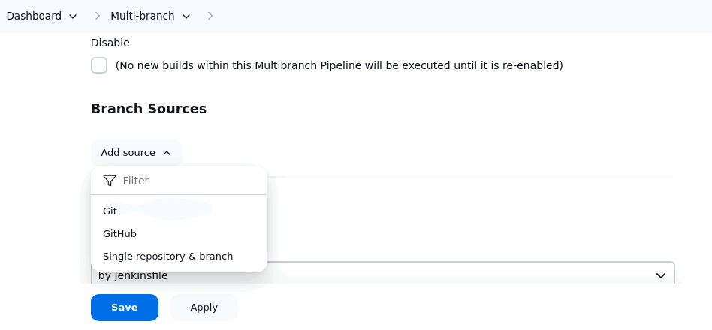
- Scroll down to Repository HTTPS URL as shown in the screenshot below:
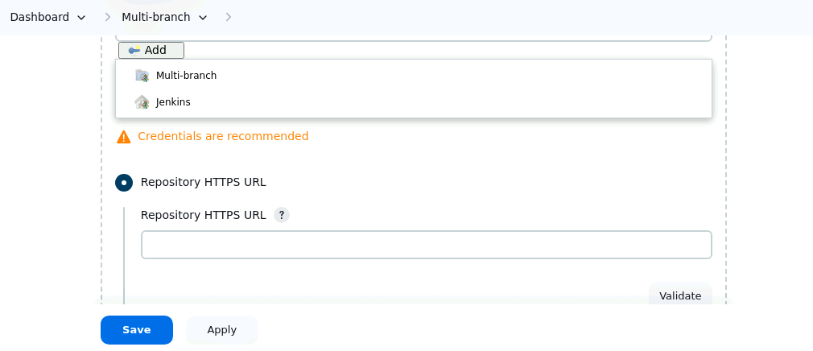

- Enter the repository URL and then click on the Save button as shown in the screenshot below:
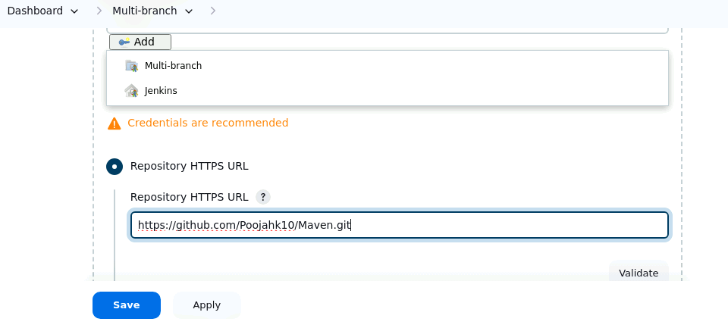
- Click on Scan Repository Log as shown in the screenshot below:
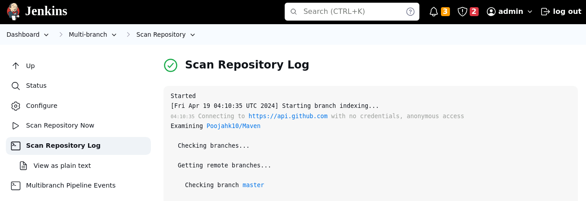

- Scroll down to verify that the status is displayed as SUCCESS as shown in the screenshot below:
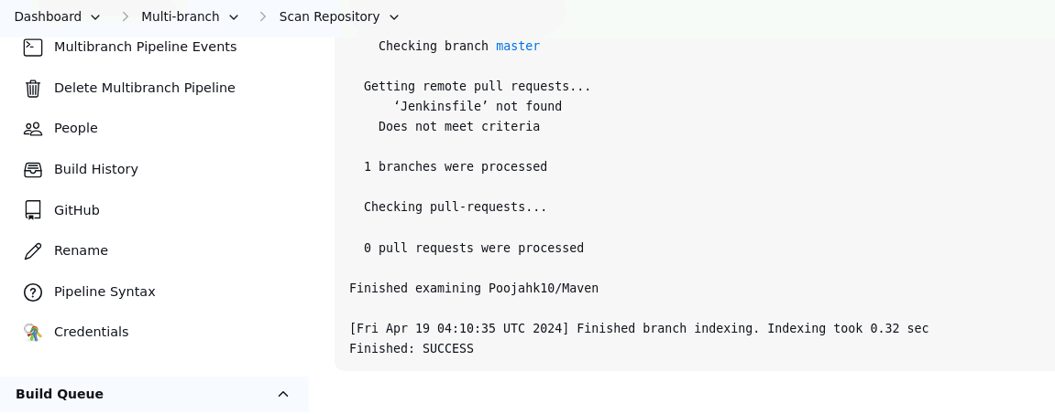
By following these steps, you have successfully configured a Multibranch Jenkins pipeline job to facilitate managing multiple projects within a single job setup.

