Lesson-End Project

Implementing CI/CD Pipeline for Deploying Application to Tomcat Apache

Project agenda: To implement a continuous integration and continuous deployment (CI/CD) pipeline in Jenkins for deploying a Java application to Tomcat Apache

Description: You work as a DevOps Engineer in an IT firm. Your company is undertaking a project to modernize its application deployment processes, aiming to streamline the deployment of new software updates. As part of this initiative, you are tasked with setting up a continuous integration and continuous deployment (CI/CD) pipeline to automate the deployment of applications to the Tomcat Apache server hosted on an Ubuntu VM.

Tools required: Jenkins and Tomcat Apache

Prerequisites: You need to have a Jenkins up and running.

Expected deliverables: A step-by-step guide for setting up and implementing a CI/CD pipeline for deploying applications to Tomcat Apache on an Ubuntu VM, including integration with Jenkins for automated builds and deployments.

Steps to be followed:
- Install Tomcat Apache 9 on Ubuntu VM
- Log in to Jenkins CI tool and install the Deploy to Container plugin
- Configure the deployment stage in Jenkins pipeline

Step 1: Install Tomcat Apache 9 on Ubuntu VM

- Open the terminal in your lab and use the following command to switch to the root user:
sudo su

- Install Tomcat Apache and other required packages using the following command:
apt update
apt install tomcat9 tomcat9-admin

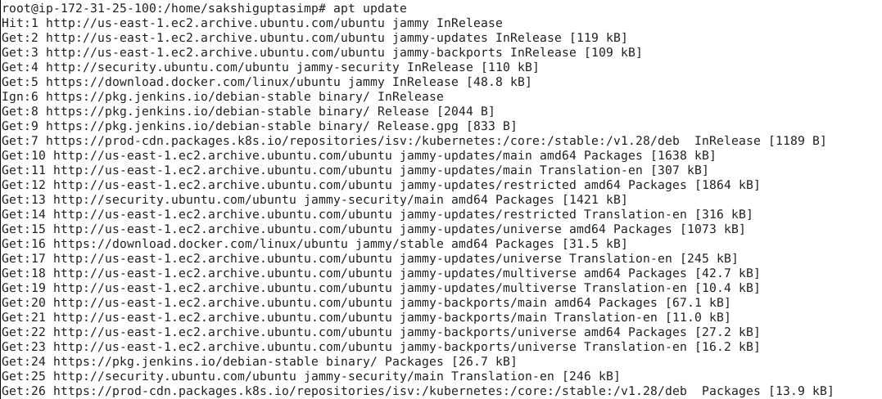

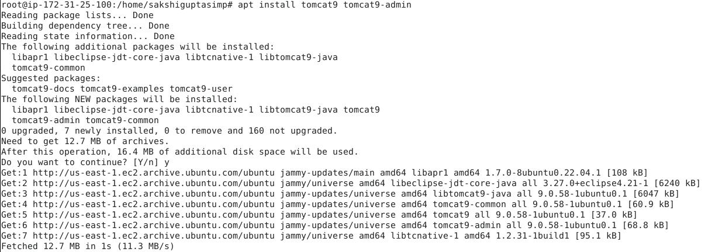

- Once the installation is done, open the tomcat-users.xml file using the following command:
vi /etc/tomcat9/tomcat-users.xml

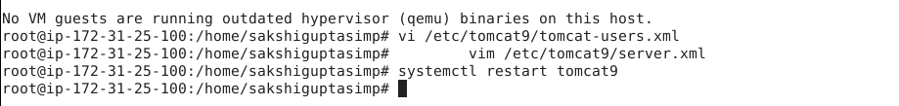

- Add the following content in tomcat-users.xml file:
<user username="tomcat" password="password" roles="admin-gui,manager-gui,manager-script"/>

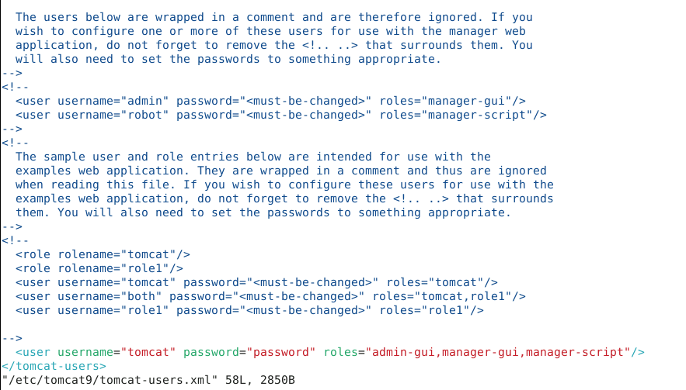

Note: To save the file and exit, press Esc, type :wq, and then press Enter

- Open the server.xml file using the following command and scroll down to change the connector port number of Tomcat to 9090:
vim /etc/tomcat9/server.xml

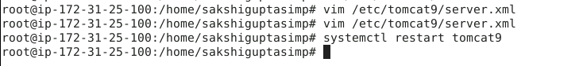

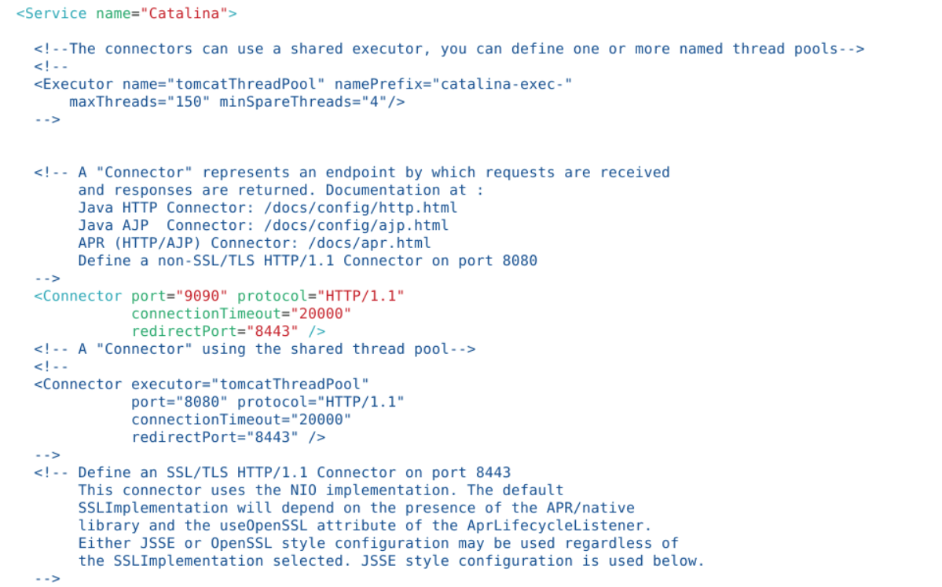

Note: To save the file and exit, press Esc, type :wq, and then press Enter

- Restart Tomcat using the following command:
systemctl restart tomcat9



- Navigate to localhost:9090 in your web browser and access Tomcat

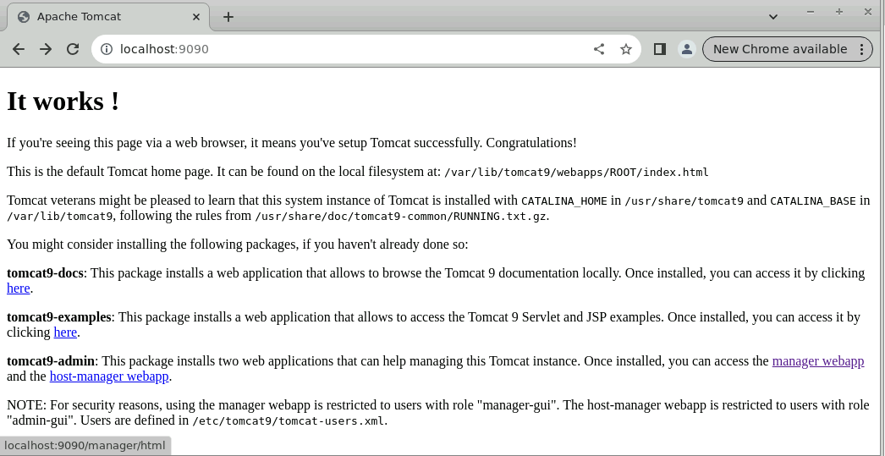

- Click and access the manager webapp to make sure the Tomcat setup is complete



- Enter the credentials and click on Sign in

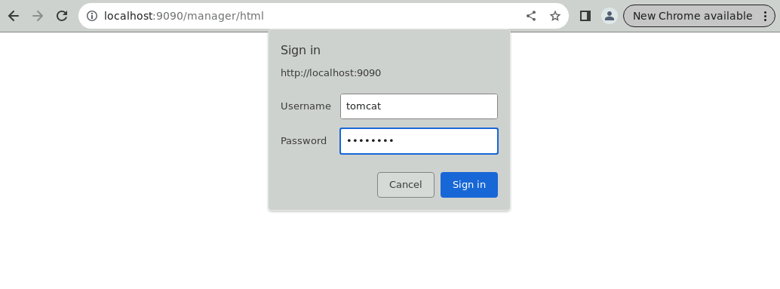
Note: The credentials for accessing Tomcat manager web app are
Username: tomcat and Password: password.

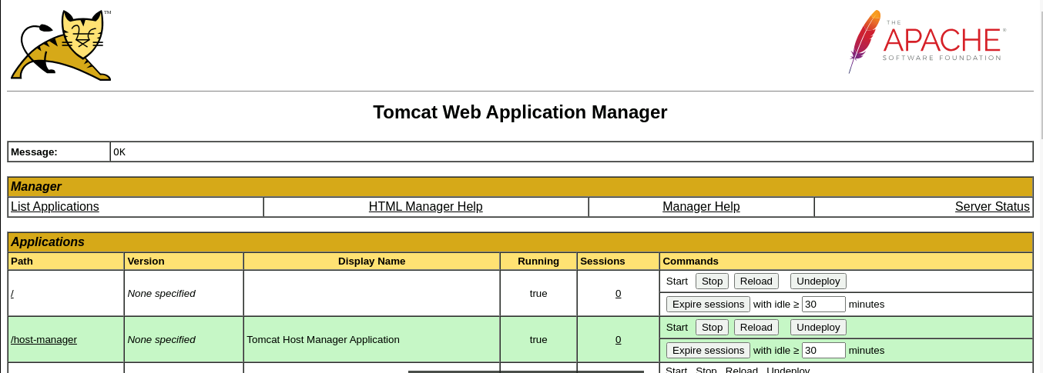

Step 2: Log in to Jenkins CI tool and install the Deploy to Container plugin

- Navigate to localhost:8080 in your web browser, enter your credentials, and click on Sign in

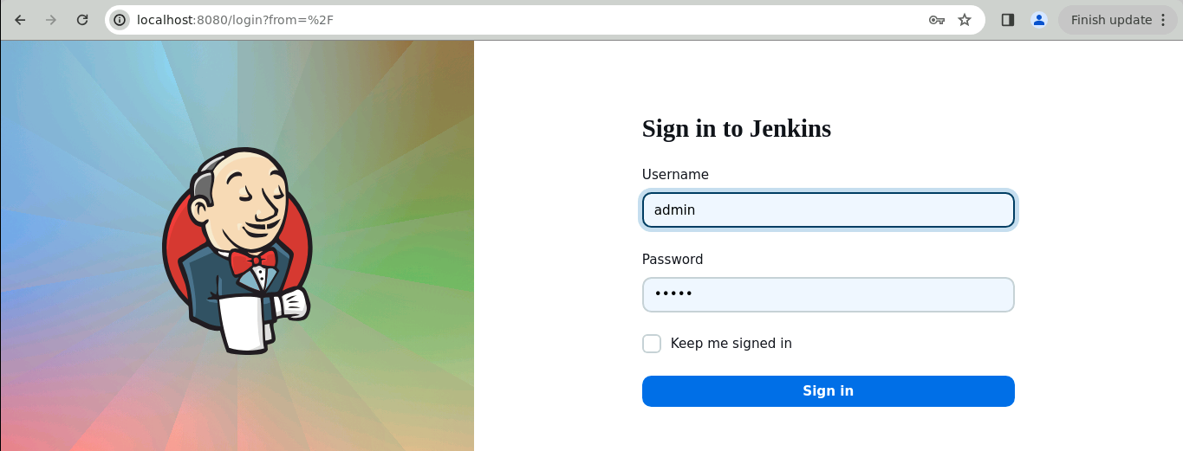
Note: The credentials for accessing Jenkins in the lab are Username: admin and Password: admin.

- Click on Manage Jenkins on the Jenkins dashboard

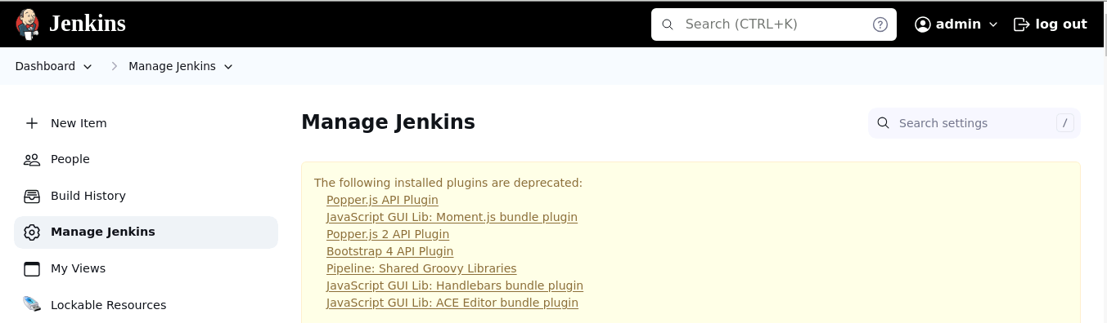

- Scroll down and click on Plugins under System Configuration

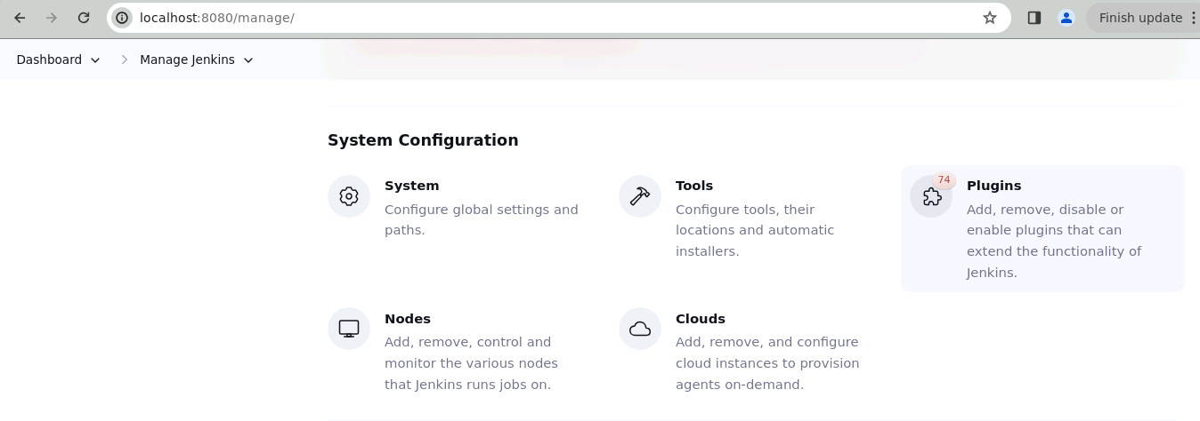

- Navigate to Available plugins and search for Deploy to container plugin

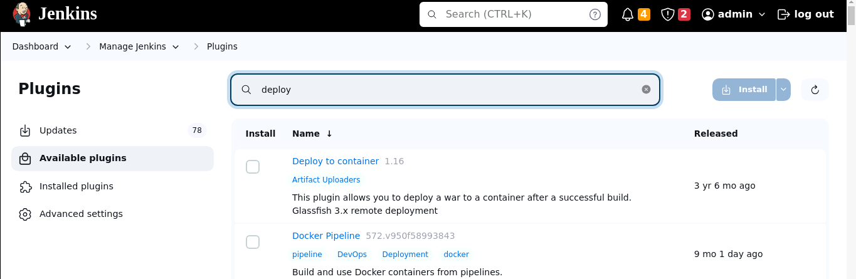

- Select the Deploy to container plugin and click on Install

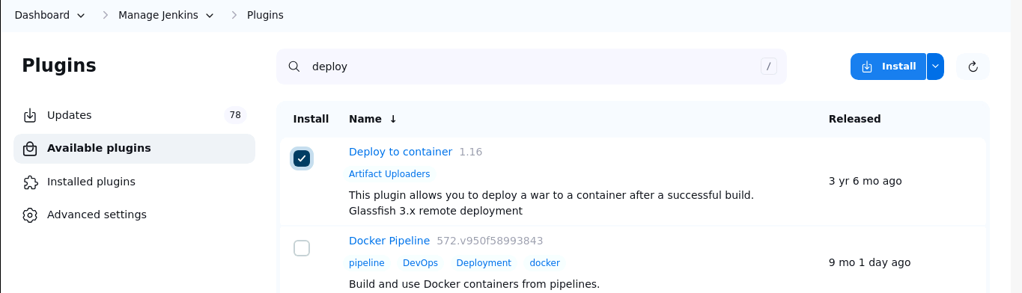

- After installation, navigate to the following URL to restart Jenkins:
http://localhost:8080/restart



Step 3: Configure the deployment stage in Jenkins pipeline

- Enter your credentials and Sign in to the Jenkins CI tool

Note: The credentials for accessing Jenkins in the lab are Username: admin and Password: admin.


- Click on New Item to create a new Jenkins job

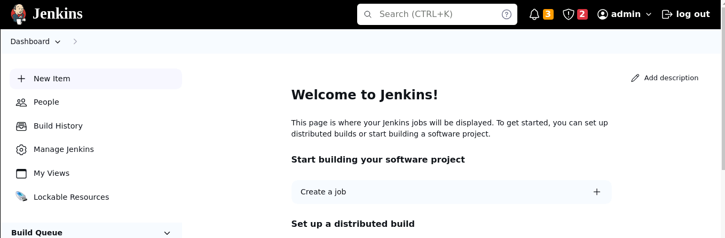

- Select Pipeline when creating a Jenkins job, provide a custom job name, and then click OK to continue

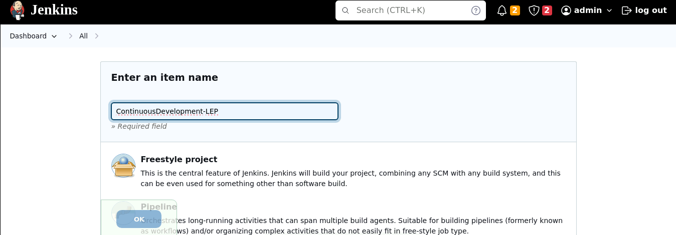

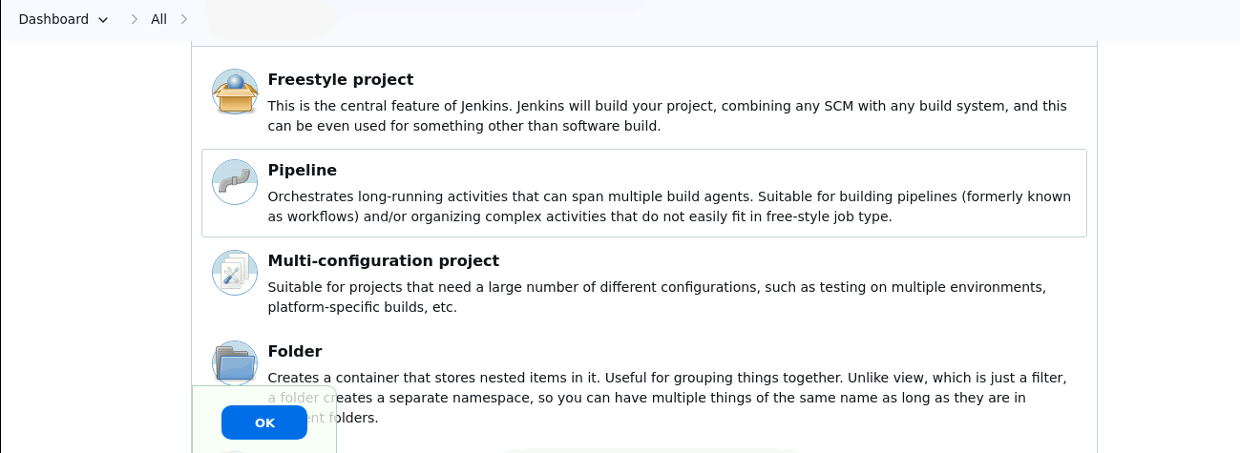

- Go to the Pipeline section

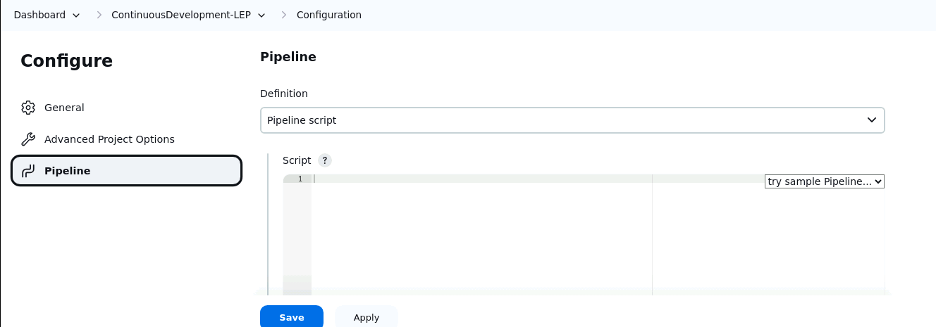

- Enter the following code under Script and Save the job:
pipeline{

tools{

maven 'mymaven'
}

agent any

stages{
stage ('Clone a repo')
{
steps {
git 'https://github.com/github-simplilearn-net/MavenBuild.git'
}
}

stage ('Package the code')
{
steps{
sh 'mvn package'
}
}

stage ('Deploy the code')
{
steps{
deploy adapters: [tomcat9(credentialsId: 'tomcat-id', path: '', url: 'http://localhost:9090/')], contextPath: null, war: '**/*.war'
}
}

}
}

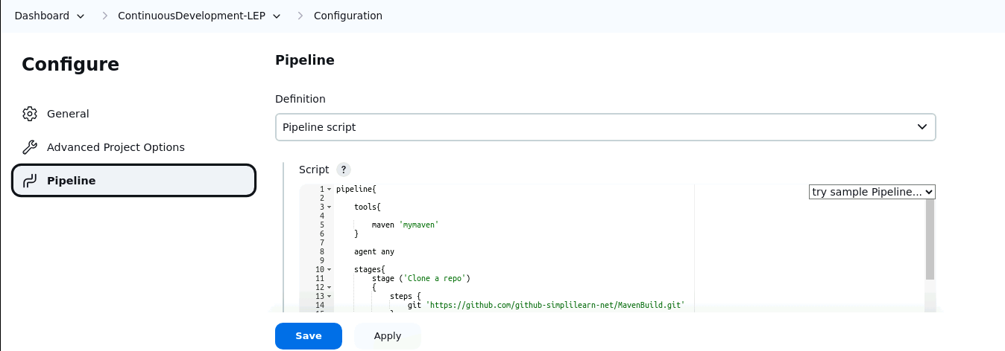

- Click on Build Now and then select Console Output to check the output

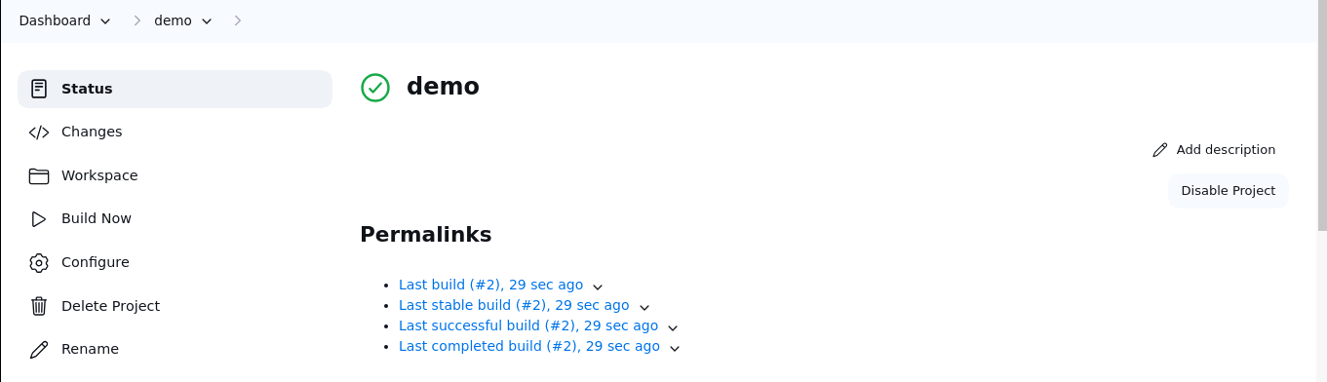

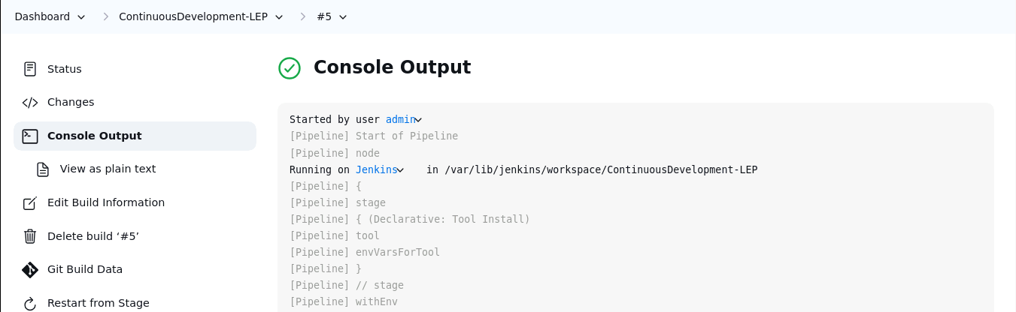

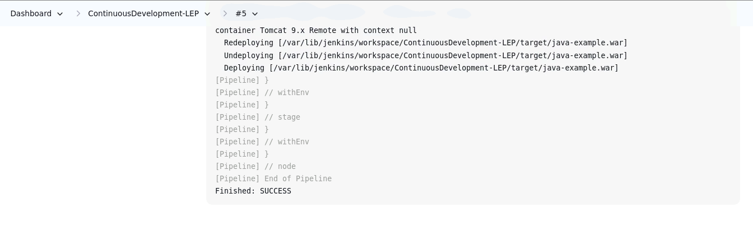

- Access the deployed application in your web browser with the following URL:
http://localhost:9090/java-example/
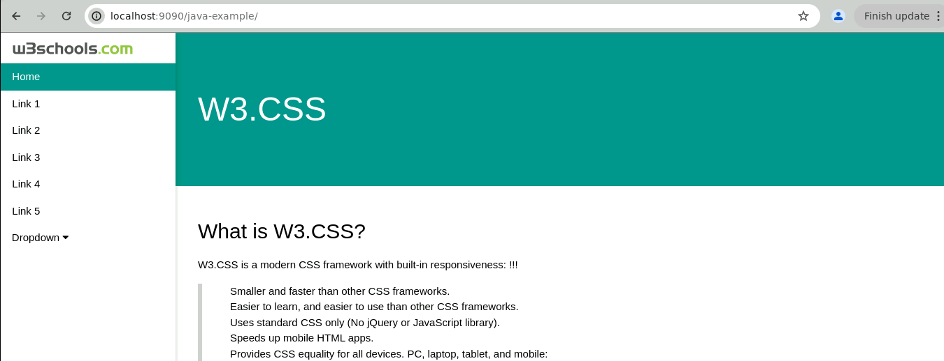

By following these steps, you have successfully implemented a continuous integration and continuous deployment (CI/CD) pipeline in Jenkins for deploying a Java application to Tomcat Apache.

