Lesson 02 Demo 06

Merging Branches in Git

Objective: To demonstrate how to merge branches in Git to integrate changes from one branch into another while maintaining a cohesive codebase and version history

Tools required: Git and GitHub

Prerequisites: You must have Git installed to proceed with this demo.

Steps to be followed:
- Create a new GitHub repository
- Clone the GitHub repository
- List all the branches in your repository
- Create and switch to the new branch
- Create a file and commit the changes
- Check the status of the new branch
- Switch back to the main branch
- Merge the branches

Step 1: Create a new GitHub repository

- Click on the New button to create a new repository

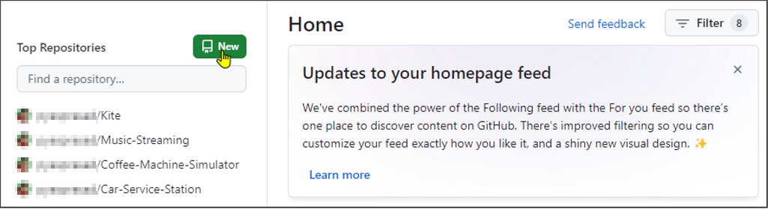

- Enter a repository name and click on the Create repository button

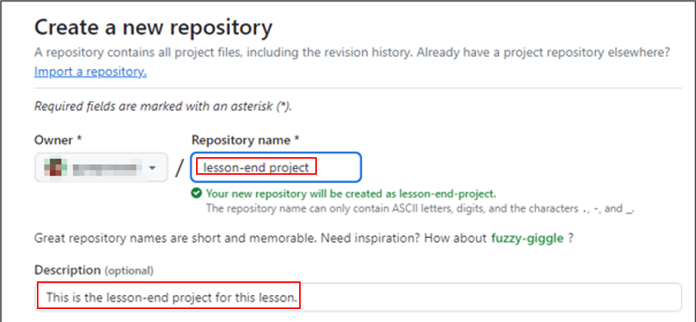

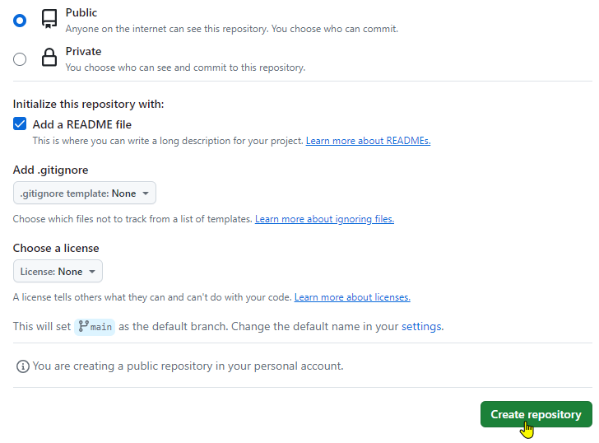

Step 2: Clone the GitHub repository

- Open the created repository in GitHub and click on the Code button

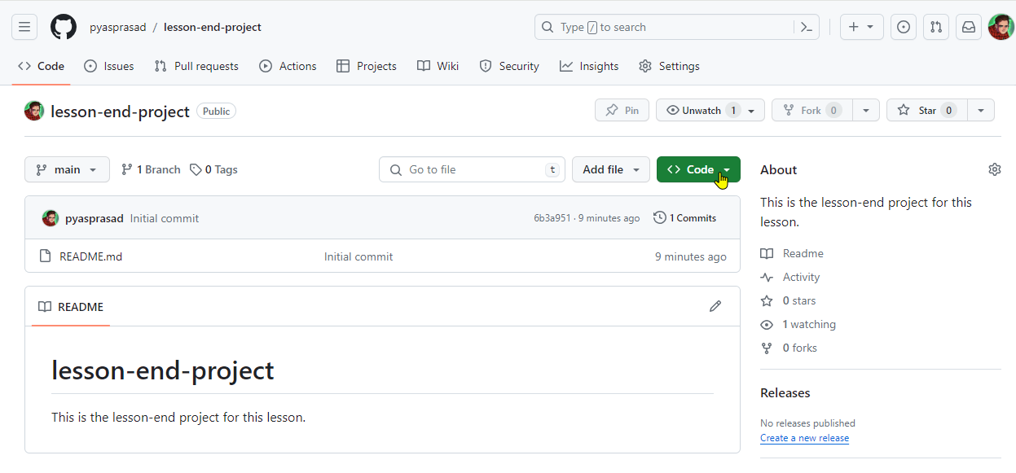

- Click on the copy icon to copy the HTTPS URL, as shown below:

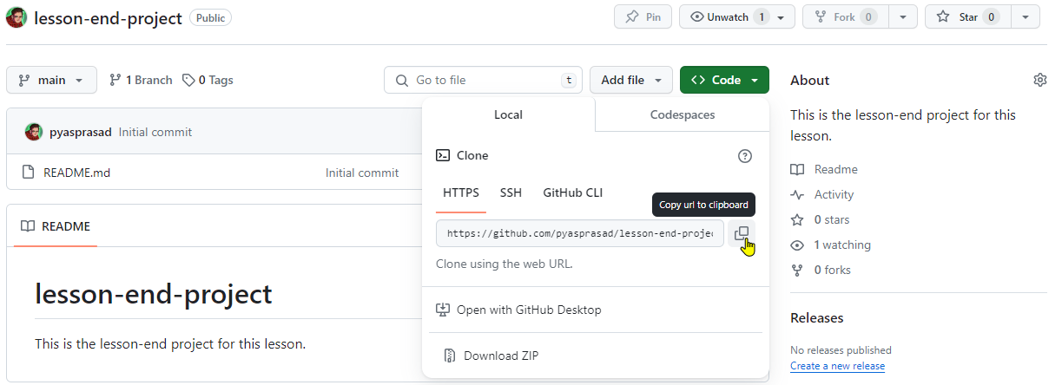

- Open the terminal tab on your lab and use the following command to clone the repository:
git clone <URL>

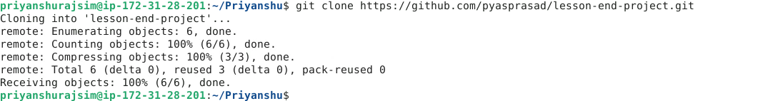

Note: Replace the URL with the copied URL from the directory

Step 3: List all the branches in your repository

- Navigate to the cloned repository using the following command:
cd lesson-end-project



- Run the following command to display all repository branches:
git branch

Step 4: Create and switch to the new branch

- Run the following command to create a new branch in your repository:
git branch dev

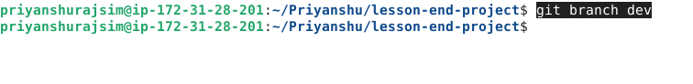

- Use the following command to switch to the newly created branch:
git checkout dev

Step 5: Create a file and commit the changes

  - Execute the given command to create a file:
vi index.html

  - Add the given code snippet into the index.html file:
<html>
<body>
<p> This is a Test HTML file. </p>
</body>
</html>

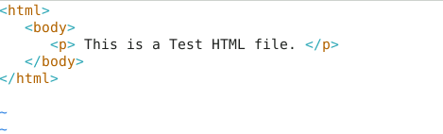
Note: Press i to edit the files. Press the Esc button to exit insert mode and enter :wq to save the file

  - Use the following command to add the file to the dev branch:
git add .

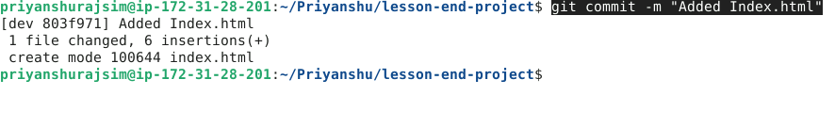

  - Use the following command to commit the changes:
git commit -m "Added Index.html"



Step 6: Check the status of the new branch

  - Check the status of the new branch using the following command:
git status

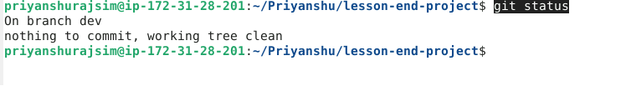

Step 7: Switch back to the main branch

  - Use the following command to switch back to the main branch:
git checkout main

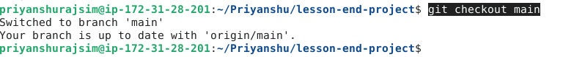

Step 8: Merge the branches

  - Use the following command to merge the dev branch to the main branch:
git merge dev

