Lesson 03 Demo 01

Creating a New User in Jenkins

Objective: To create a new user in Jenkins for managing access and permissions within the Jenkins environment

Tools required: Jenkins

Prerequisites: Jenkins must be operational

Steps to be followed:
- Log in to the Jenkins CI tool
- Access the user management section to manage users

Step 1: Log in to the Jenkins CI Tool

- Go to Google Chrome

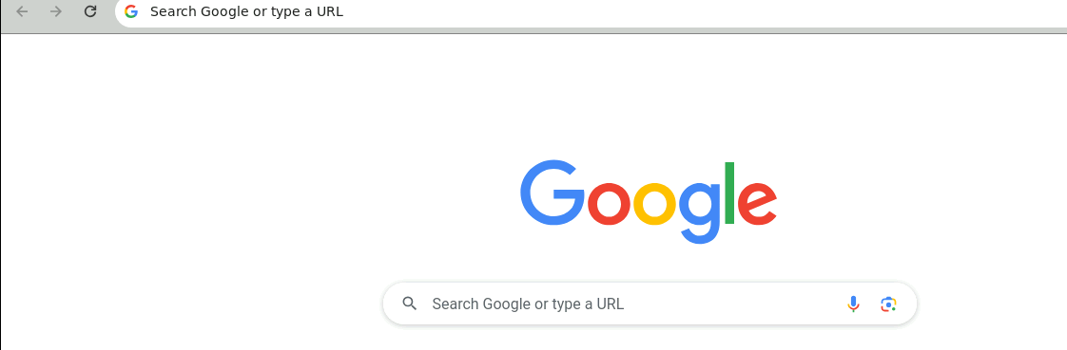

- Go to Jenkins by typing localhost:8080 and sign in using your credentials

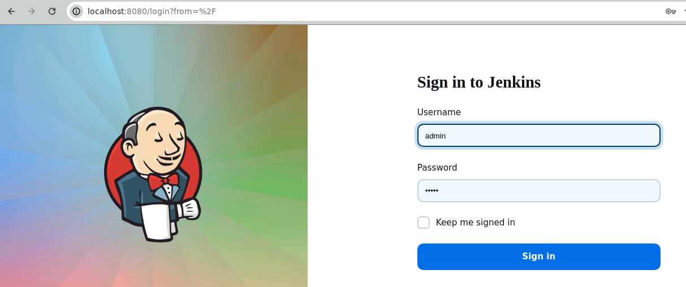

Note: The credentials for accessing Jenkins in the lab are Username: admin and Password: admin.

Step 2: Access the user management section to manage users

  - Click on Manage Jenkins

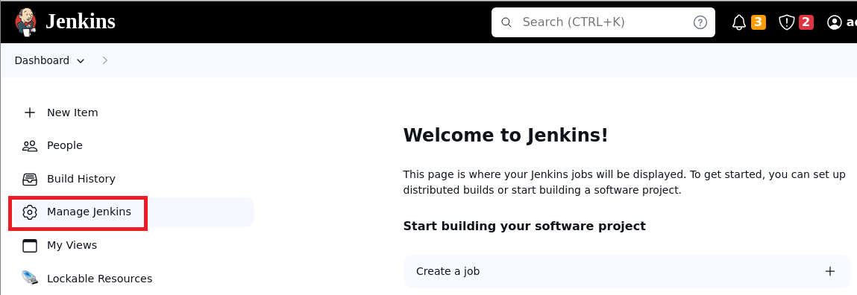

  - Click on Users under the Security section

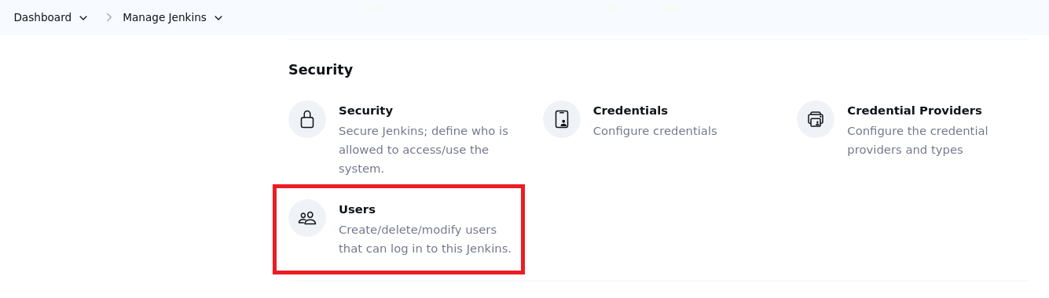

  - Now, click on Create User

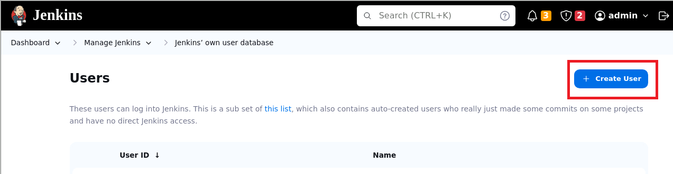

  - Provide the basic user details, including username, password, and email ID, and click on Create User

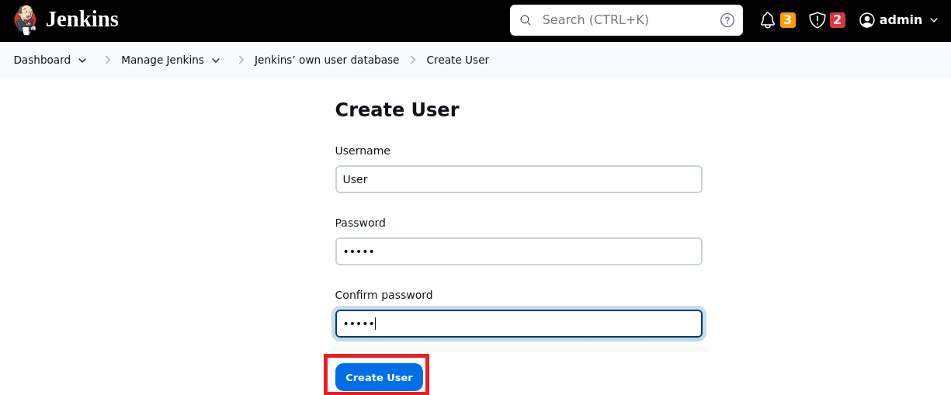

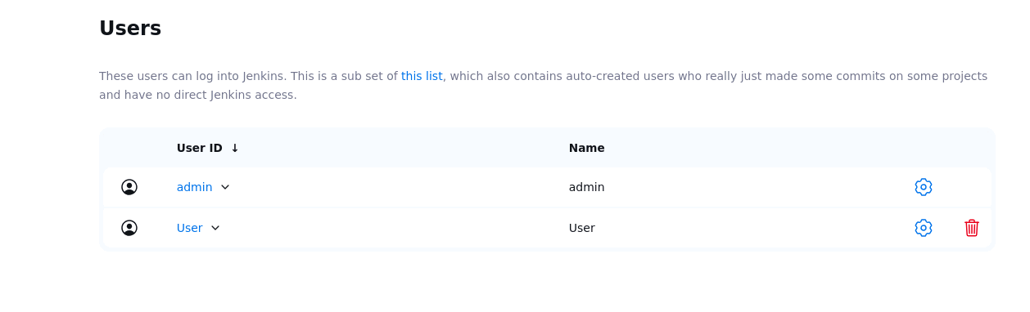

Once the user is created, you can use these credentials to access the Jenkins application.

By following these steps, you have successfully created a new user in Jenkins for managing access and permissions within the Jenkins environment.

