Lesson 10 Demo 03

Creating an Event-Based Workflow

Objective: To create an event-based workflow using the GitHub Actions trigger to automatically initiate continuous integration processes whenever new code is pushed to the repository

Tools required: GitHub Actions

Prerequisites: None

Steps to be followed:
- Create a new GitHub repository
- Create and execute a new workflow file using the GitHub Actions trigger

Step 1: Create a new GitHub repository

- Open the browser in your lab, go to github.com, and log in to your account

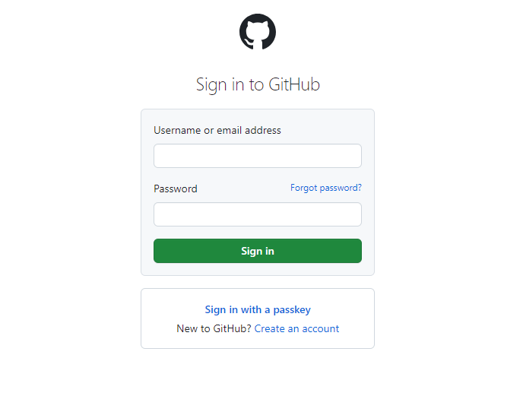
Note: If you do not have a GitHub account, visit the official website at https://github.com/signup and create a new account

- Click on the + icon from the upper-right corner of the page and select New repository from the drop-down menu

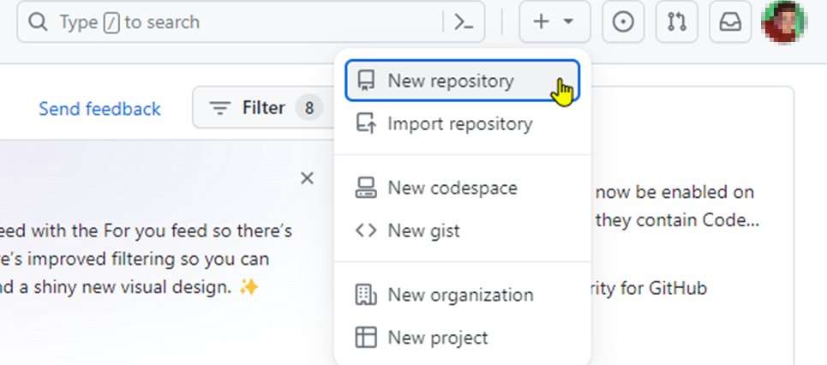

- Enter the name and description of the GitHub repository

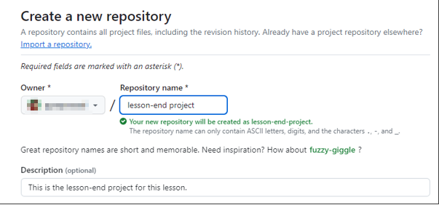

- Choose Public for the repository type

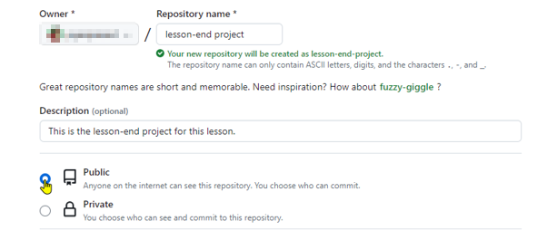

- Select Add a README file to include a README file for the repository

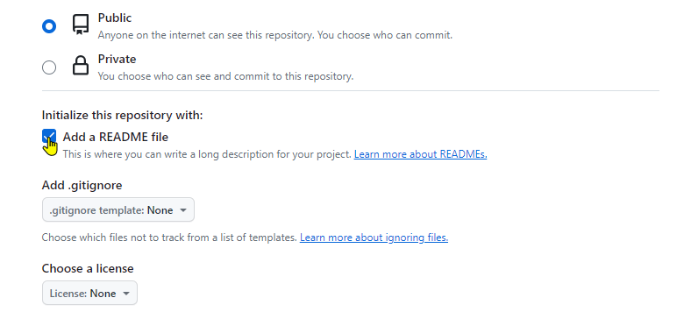

- Click on the Create repository button

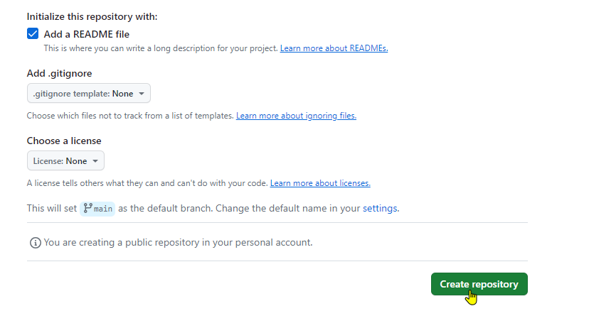

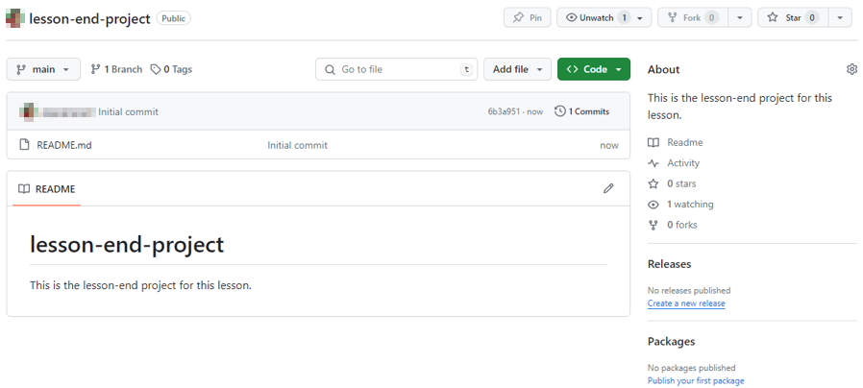

The remote GitHub repository is created.

Step 2: Create and execute a new workflow file using the GitHub Actions trigger

- Navigate to the Actions tab and click on set up a workflow yourself to create a .github/workflows directory

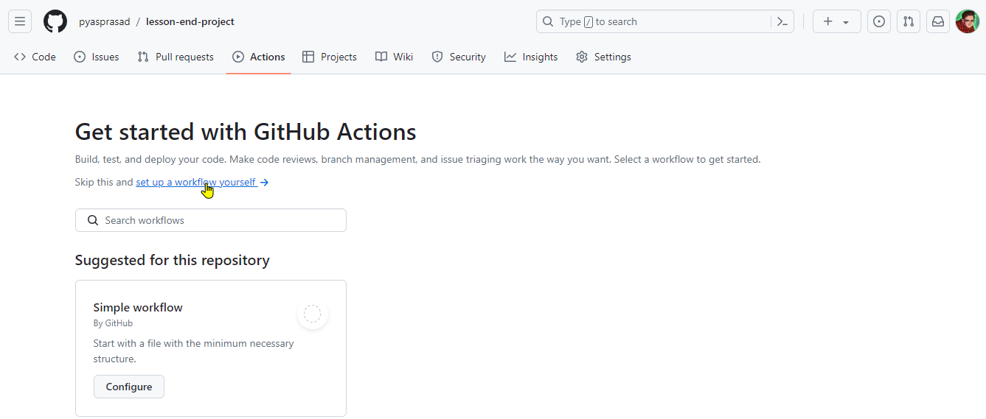

  - Create a new workflow file basic1-workflow.yml with the below code, and then click on Commit changes:

name: GitHub Actions Demo
run-name: Testing out GitHub Actions Event Trigger
on:
push:
branches:
- master
pull_request:
branches:
- master
jobs:
Basic-Workflow:
runs-on: ubuntu-latest
steps:
- run: echo " Job is executing as part of Basic workflow"

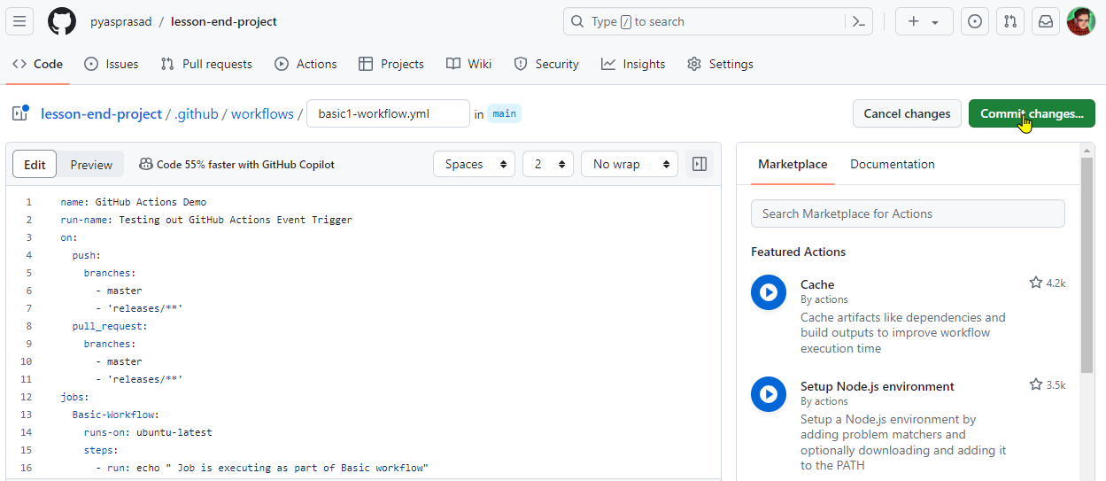

  - Add Commit message as Create basic1-workflow.yml and click on Commit changes to save the workflow file in the code repository

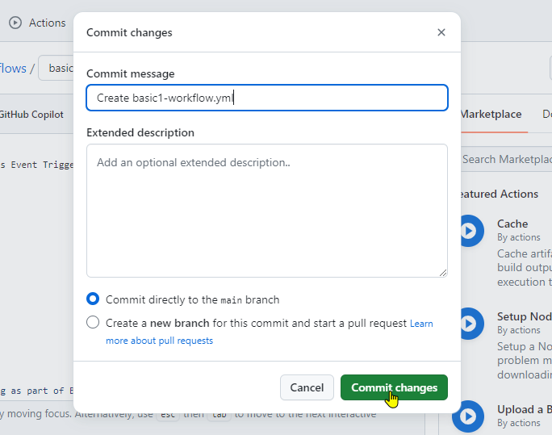

  - Navigate to the Actions tab, and under All workflows, click on the
Create basic1-workflow.yml workflow to execute the workflow

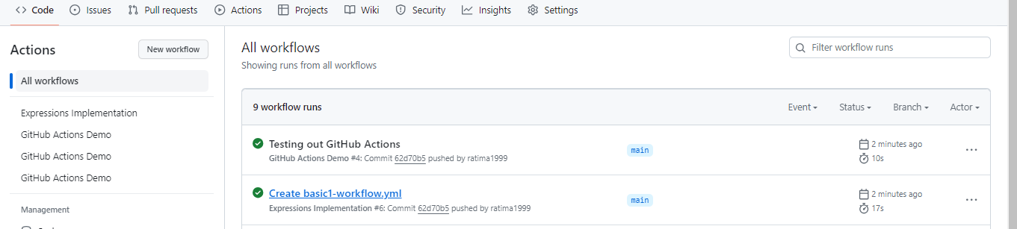

  - Click on the build_job to see the output

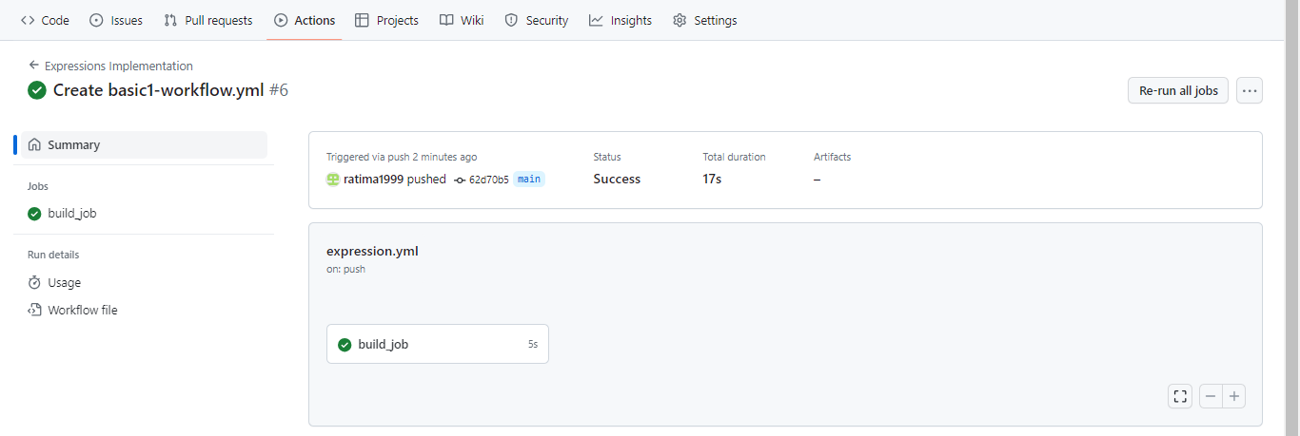

The following build_job screen will appear:

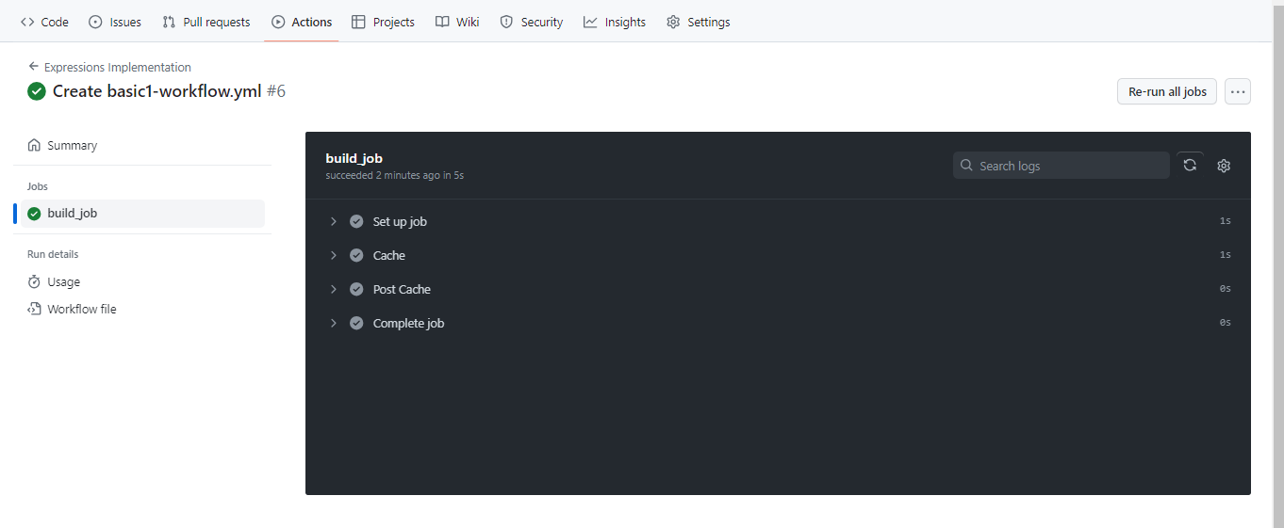

  - Expand the output located under build_job

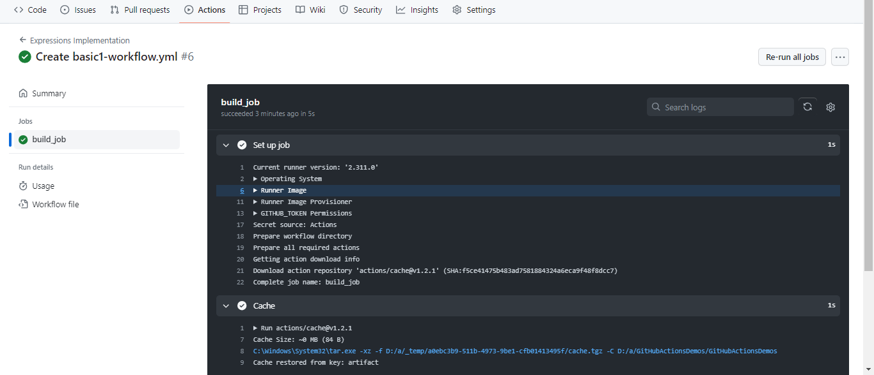

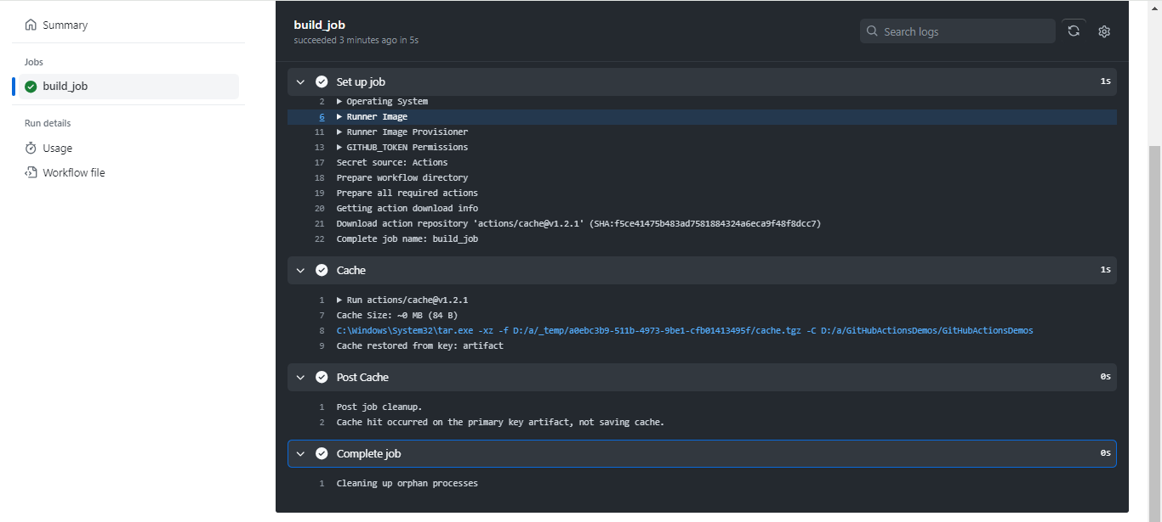

By following these steps, you have successfully created an event-based workflow using the GitHub Actions trigger to automatically initiate continuous integration processes whenever new code is pushed to the repository.

