

System Provisioning and

Configuration M**anagement**



**Submitted to- Submitted by-**

Dr. Hitesh Kumar Sharma Vrishaangan VS

500101934

(Devops) B-1

Assignment-1

**STEP 1: Setup Terraform Project**

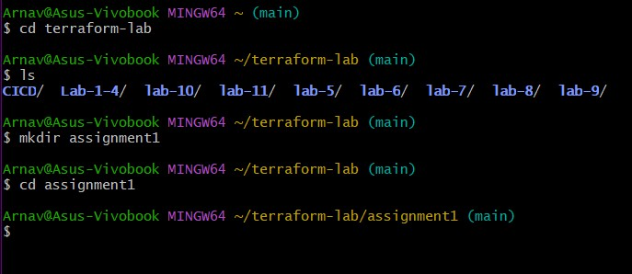

Create Terraform files

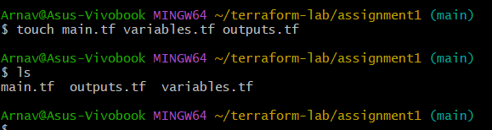

⬛ **STEP 2: Create IAM User & Get Credentials**

1. Go to AWS Console → IAM → Users → Add User

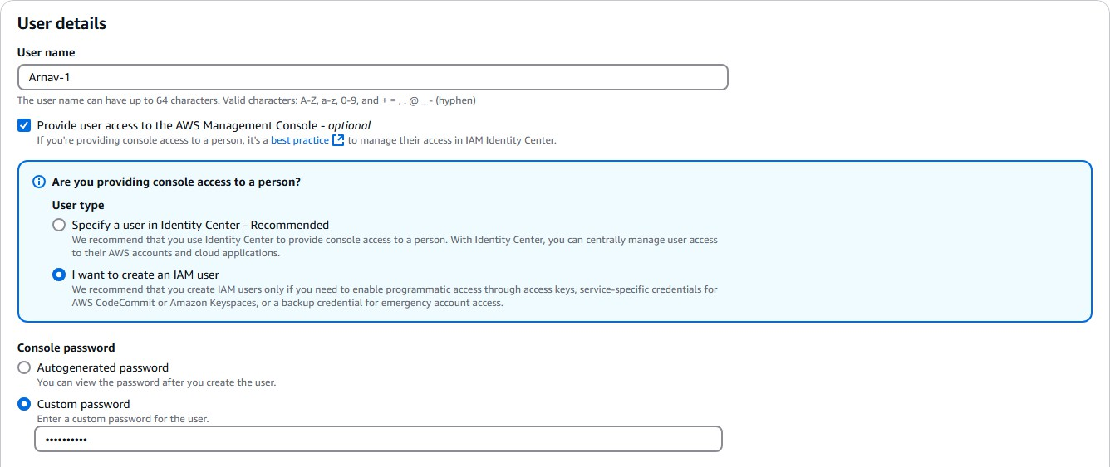

1. Attach **Administrator access**
2. Save the **Access Key ID** and **Secret Access Key**

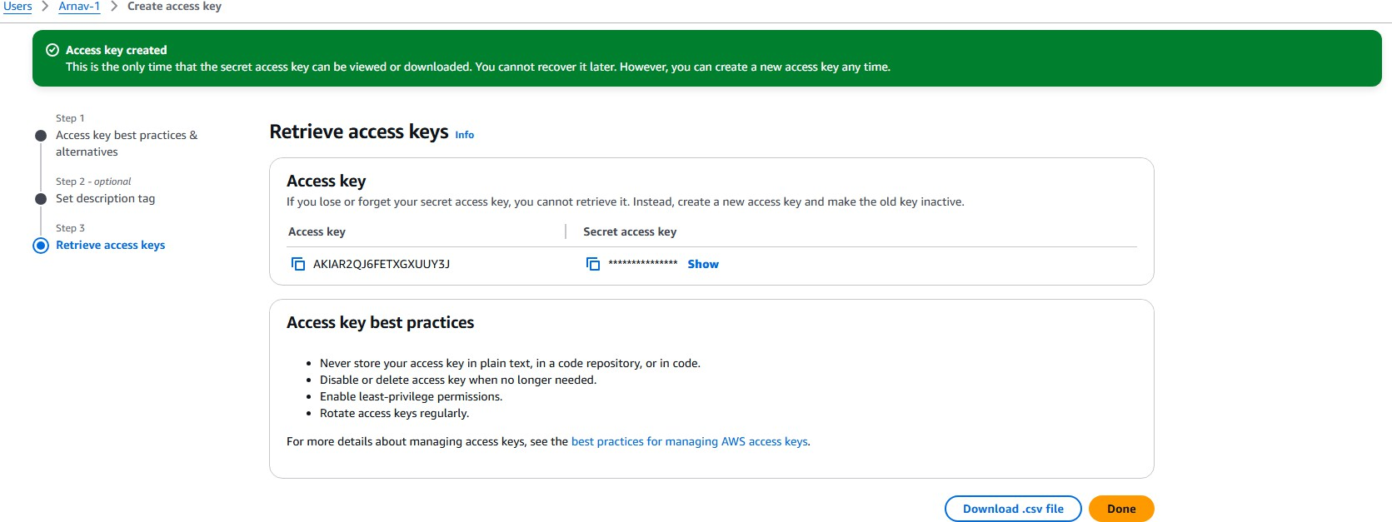

**STEP 3: Get Latest Amazon Linux 2 AMI ID**

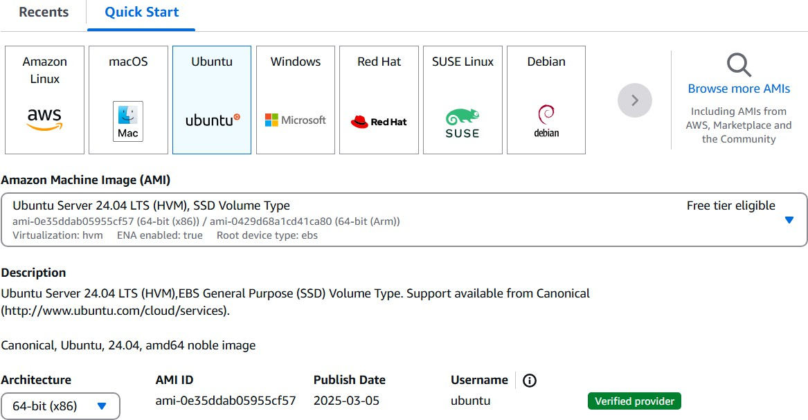

**STEP4 : Terraform Code (main.tf)**

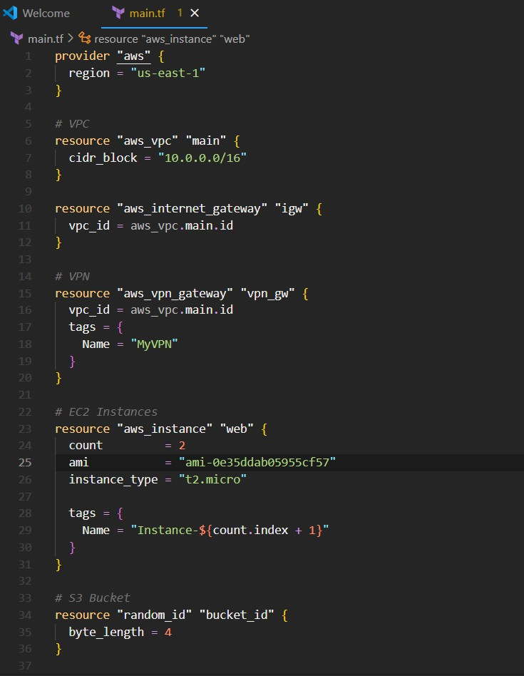

**STEP 5: Run Terraform Commands**

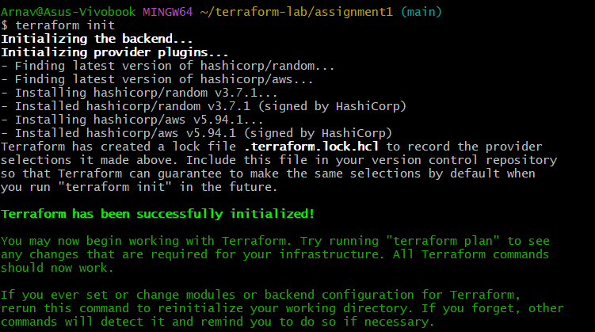

Terraform validate

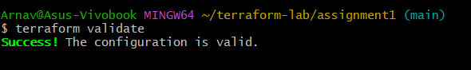

Terraform plan

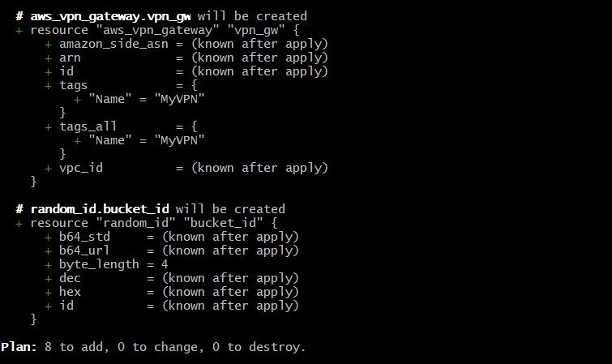

Terraform apply -auto-approve

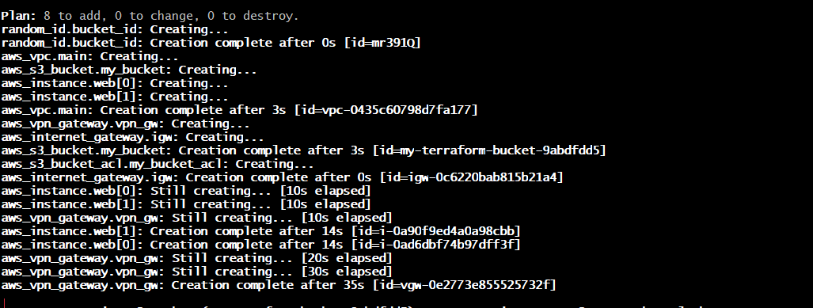

Check for created resources

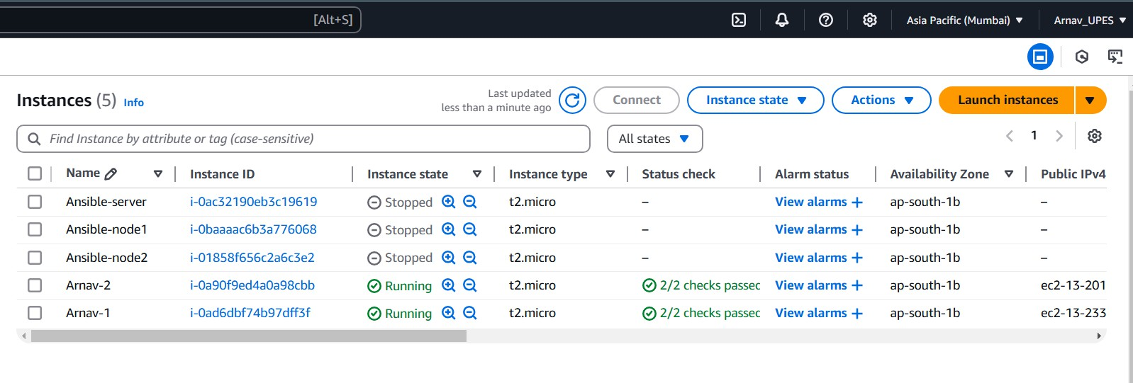

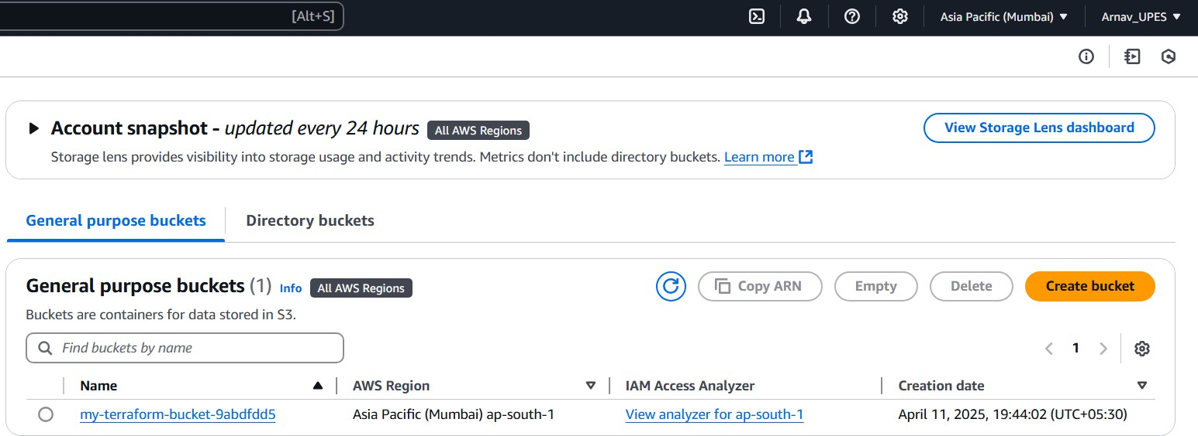

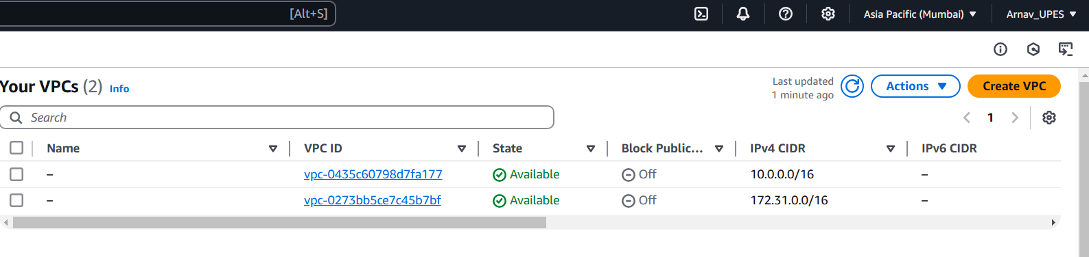

Terraform destroy -auto-approve

