**School of Computer Science**

**UNIVERSITY OF PETROLEUM AND ENERGY STUDIES**

**DEHRADUN, UTTARAKHAND**



System Monitoring And Configuration Mangement

**Lab File**

**(2023-2024)**

**for**

**6th Semester**

Submitted To: Submitted By:

Dr. Hitesh Kumar Sharma Abhishek Agarwal

B. Tech. CSE DevOps

[6h Semester]

Sap id- 500093614

Batch 2

R2142210028

**LAB EXERCISE 8**

**Aim: Creating a VPC in Terraform Objective**

Step 1: Create a main.tf file

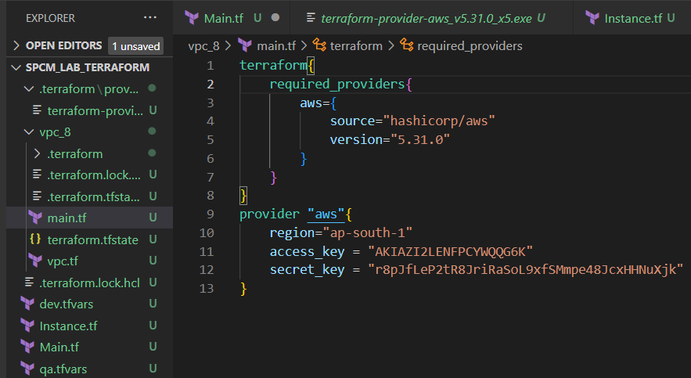

Step 2: Create a vpc.tf file

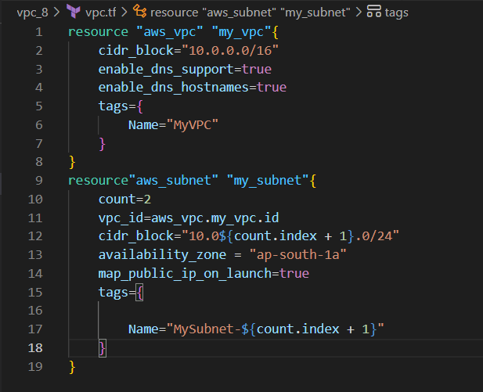

Step 3: Now run terraform init command to Initialize.

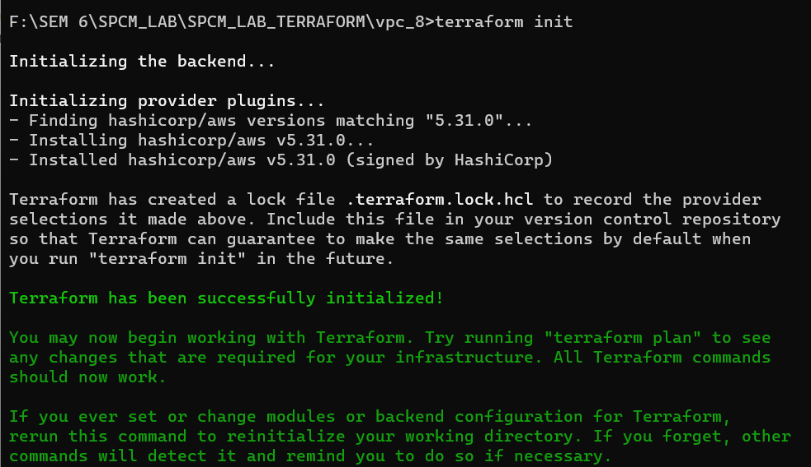

Step 4: Now run the terraform validate command to check if any error is present or not.

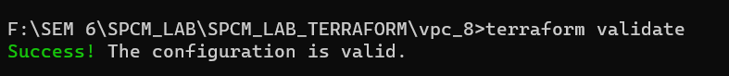

Step 5: Now run terraform plan command

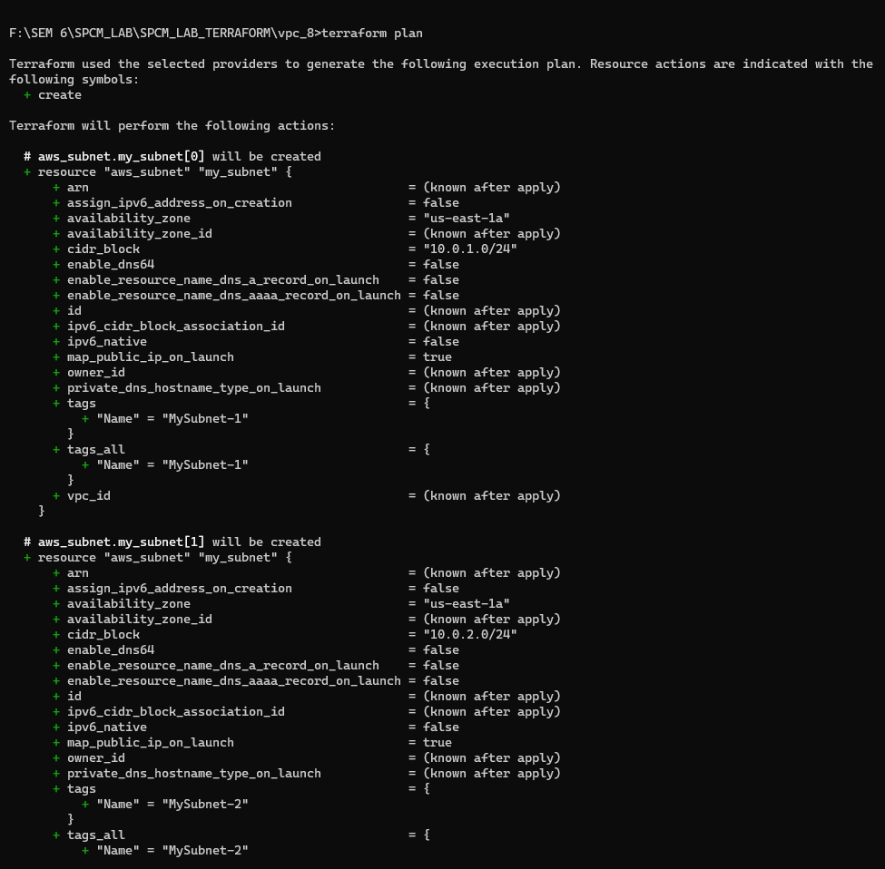

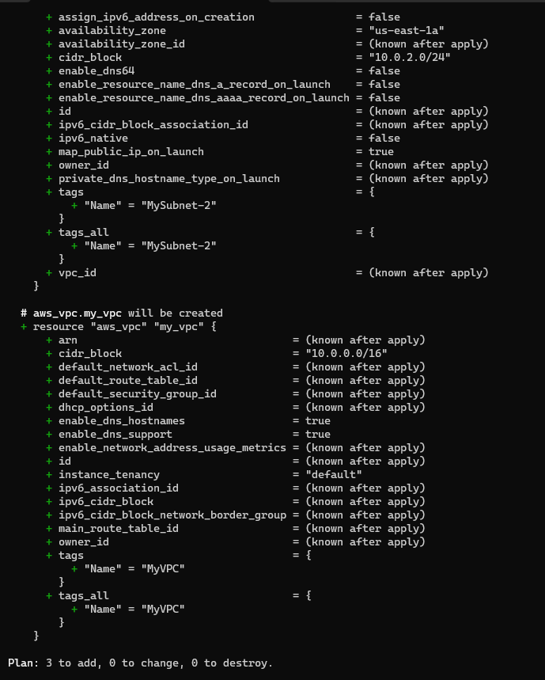

Step 6: Now run the terraform apply command.

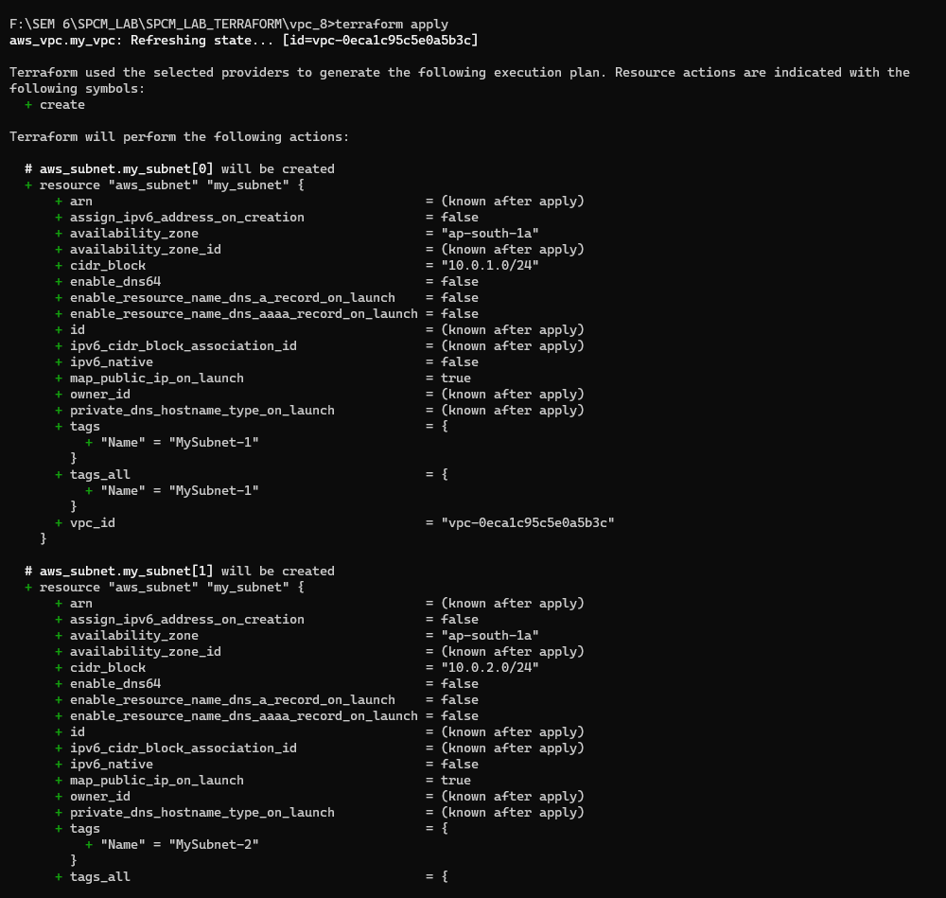

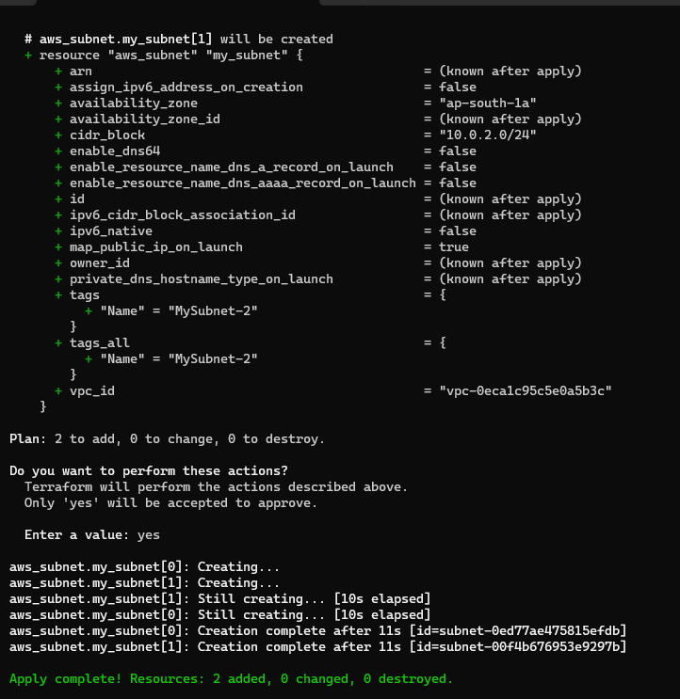

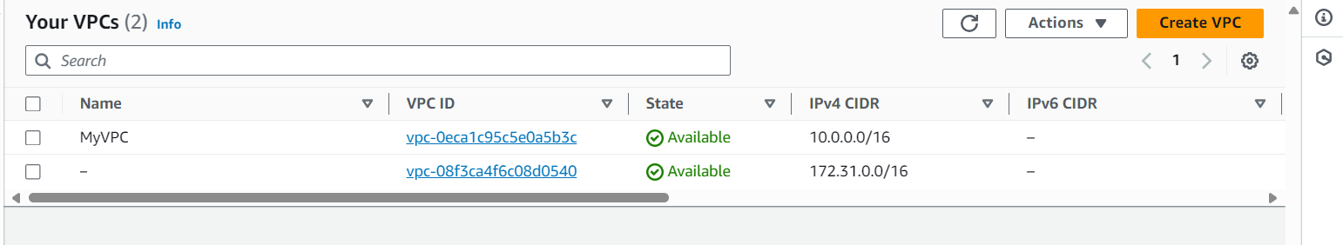

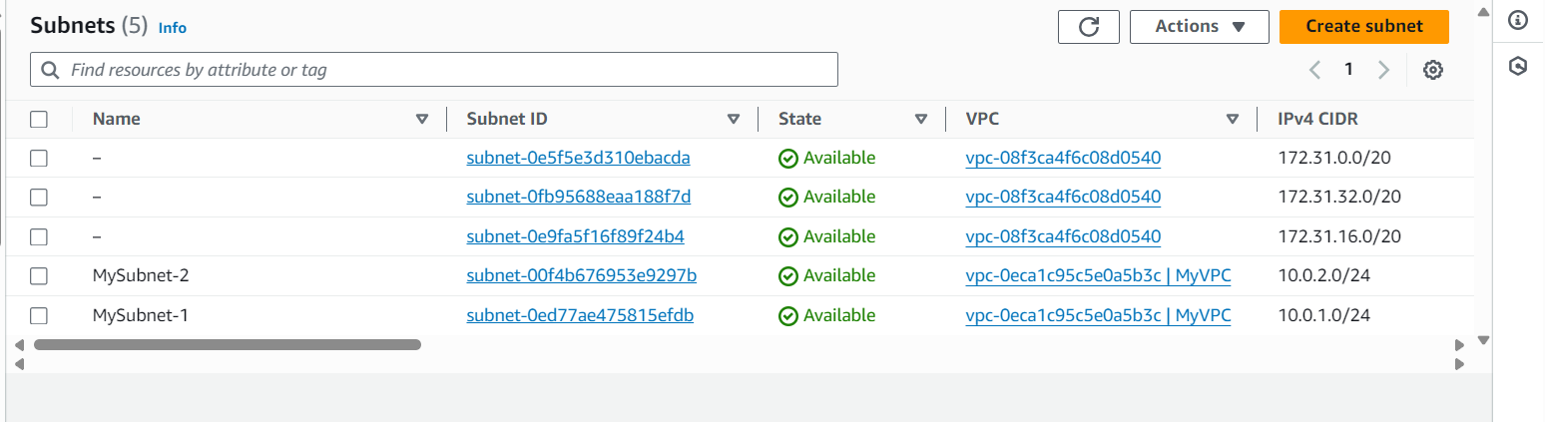

Step 7: Now run the terraform destroy to destroy the VPC created.

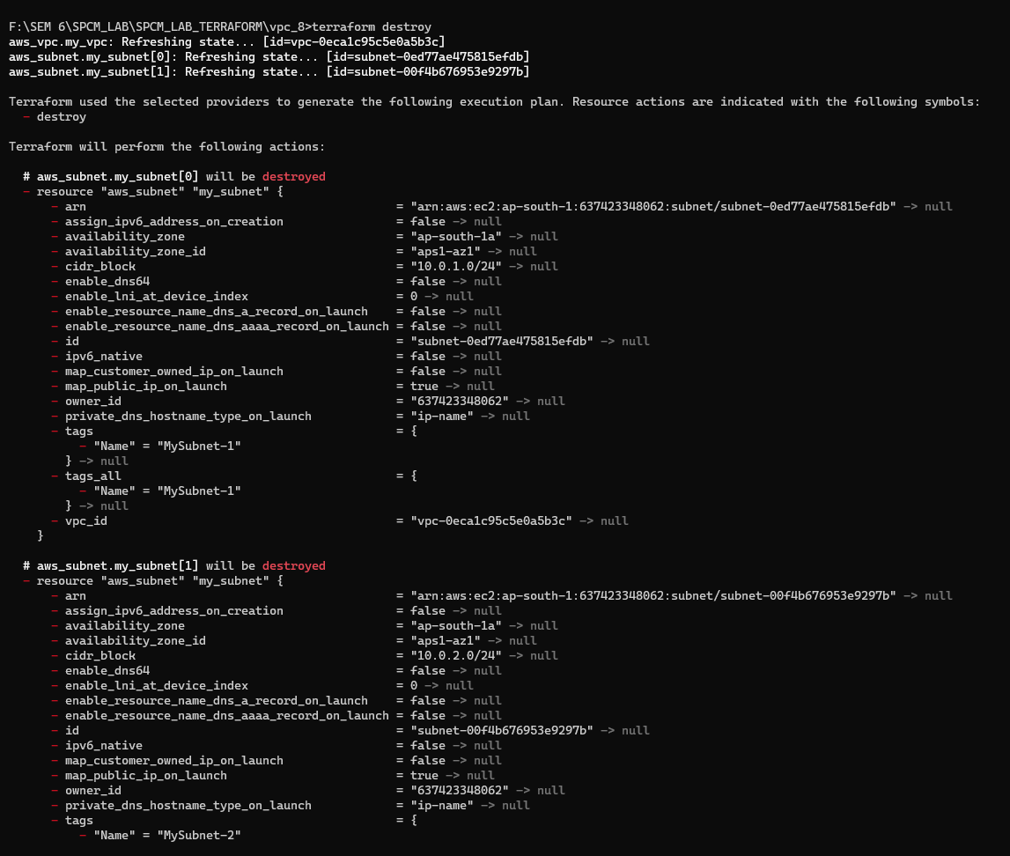

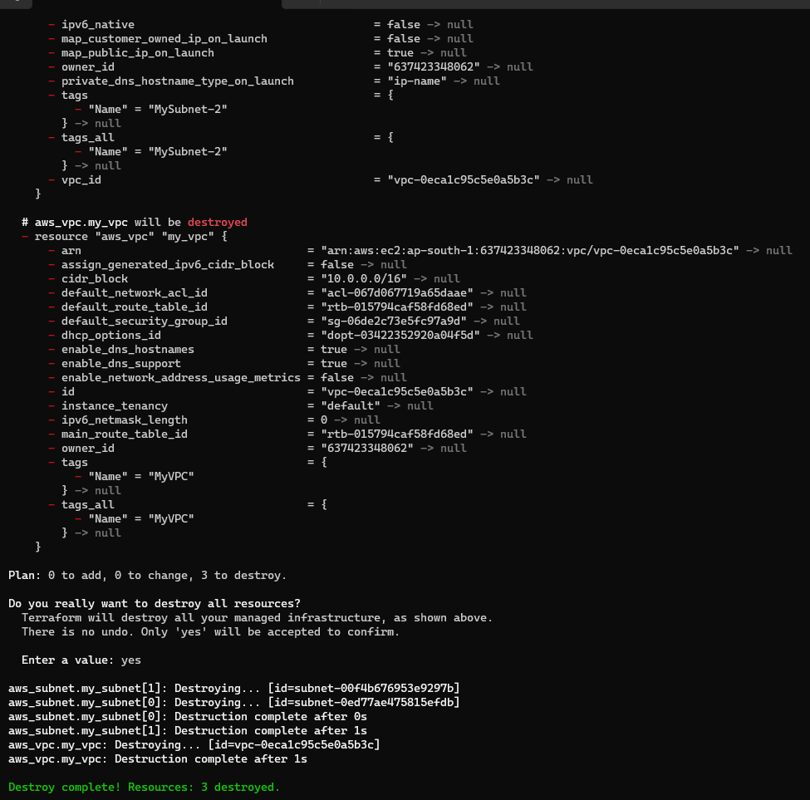

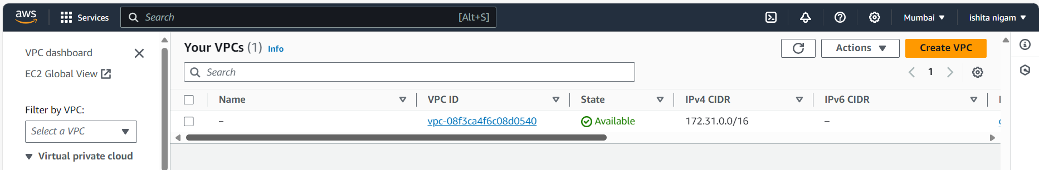

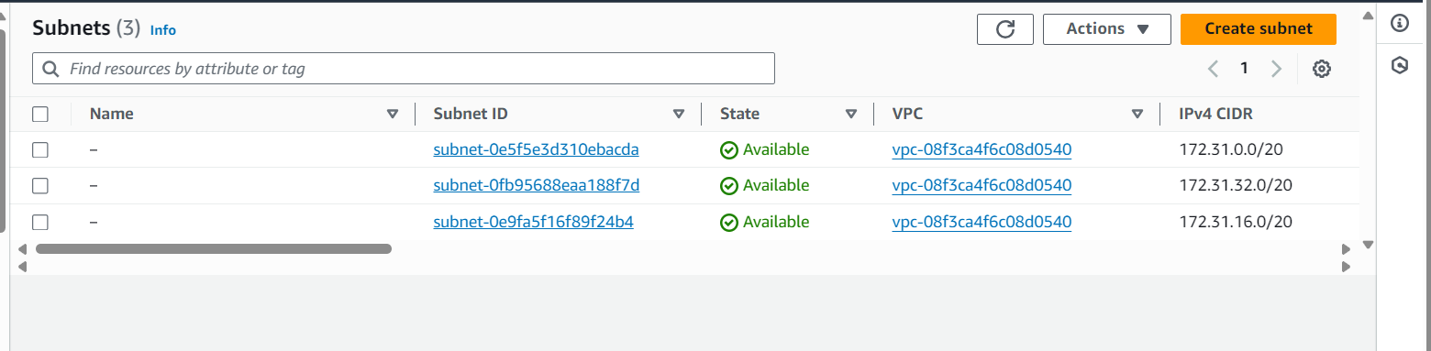

Step 8: Now update the vpc.tf file.

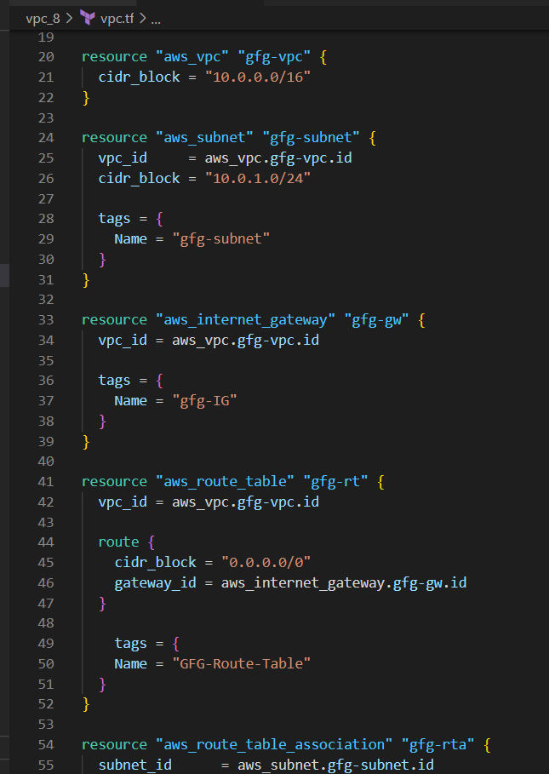

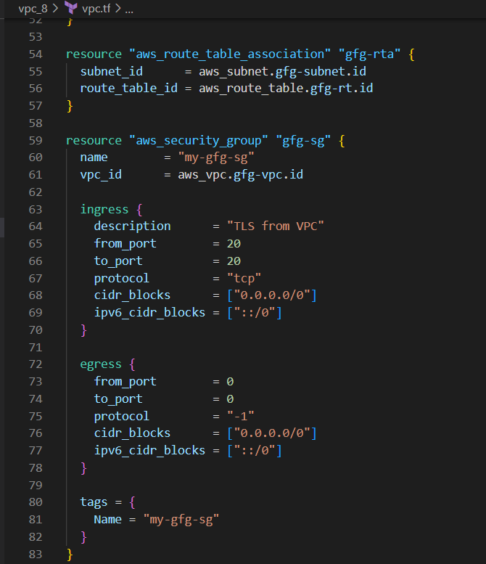

Step 9: Now again run the terraform run and validate command.

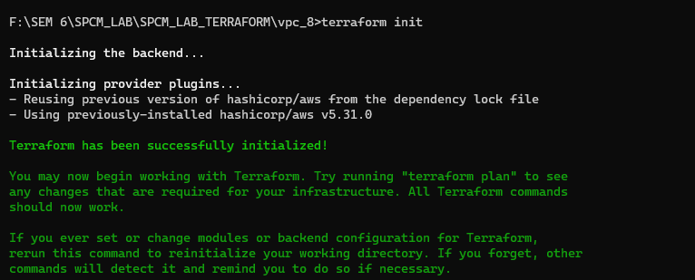



Step 10: Now again run the terraform plan command.

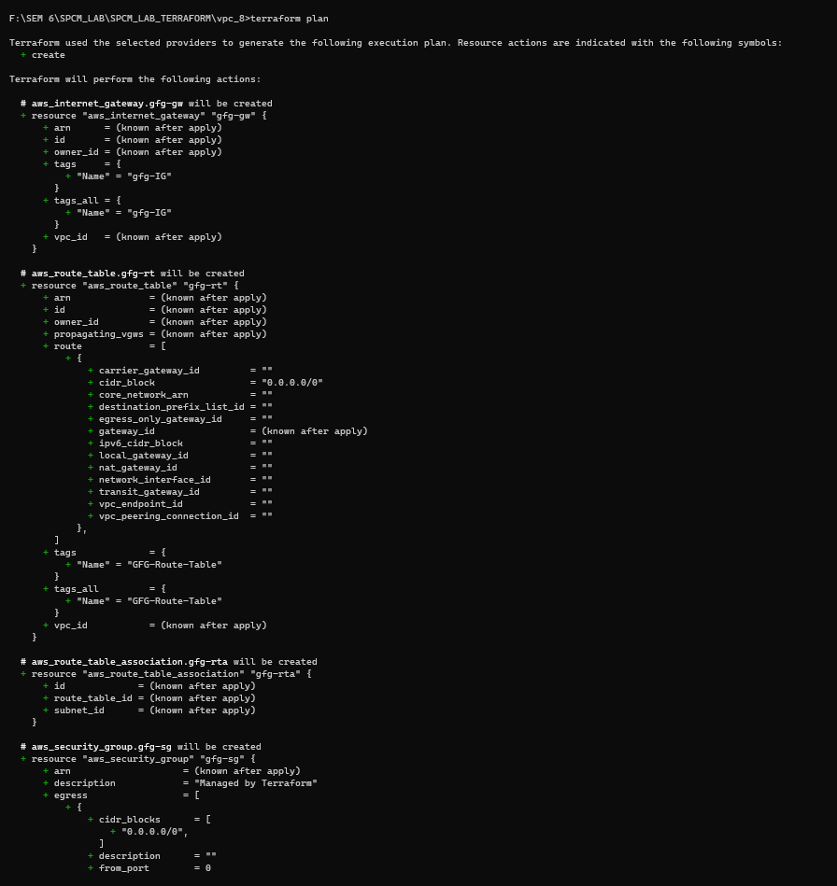

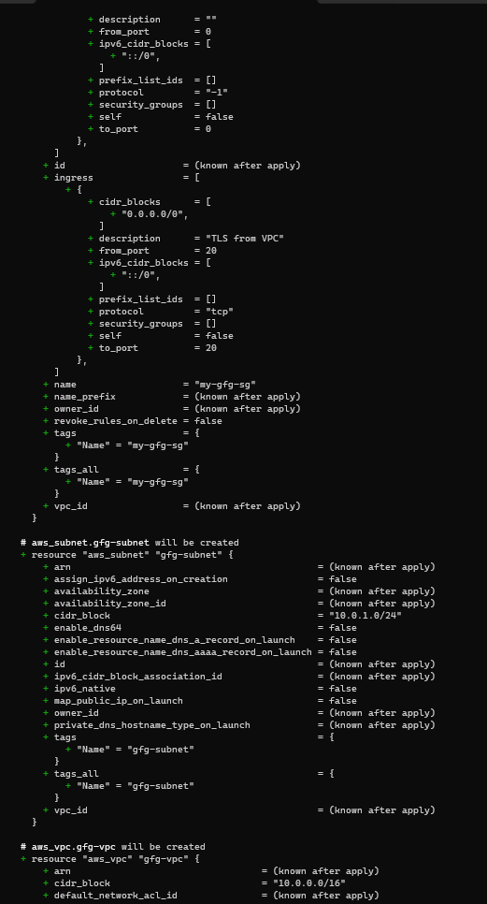

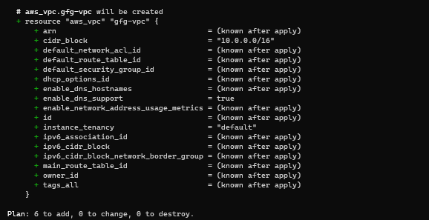

Step 11: Now run the terraform apply command.

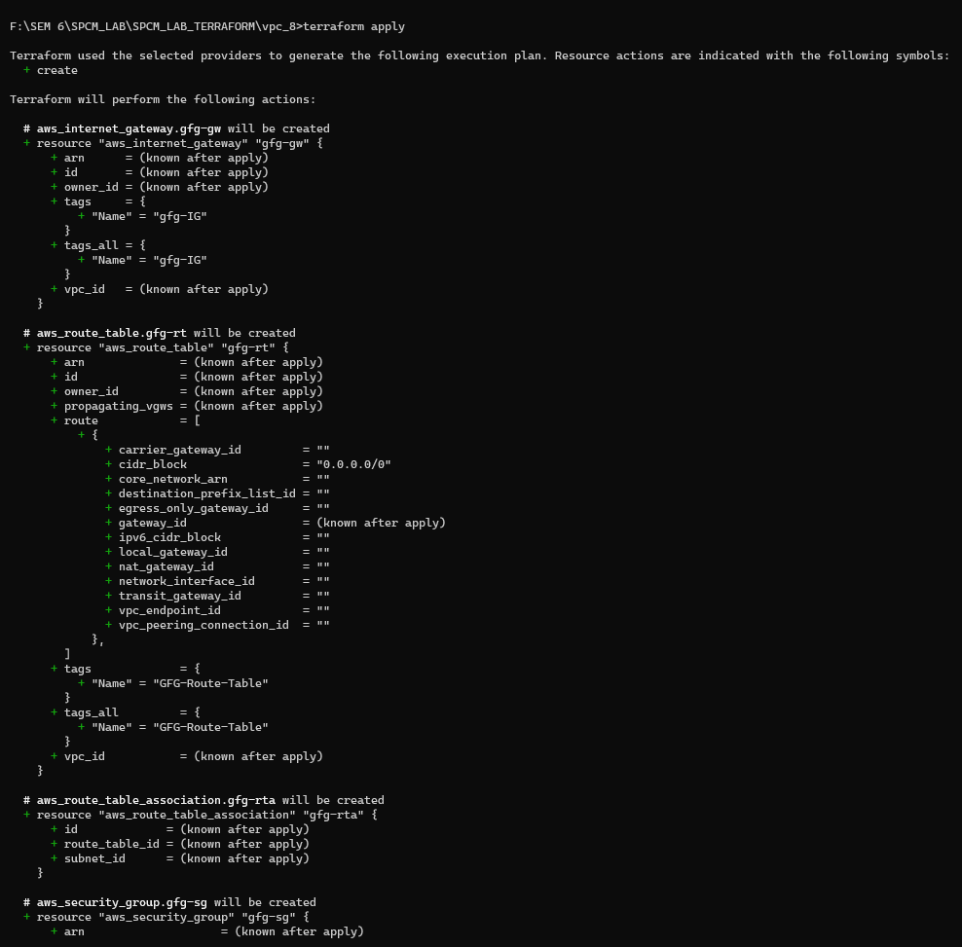

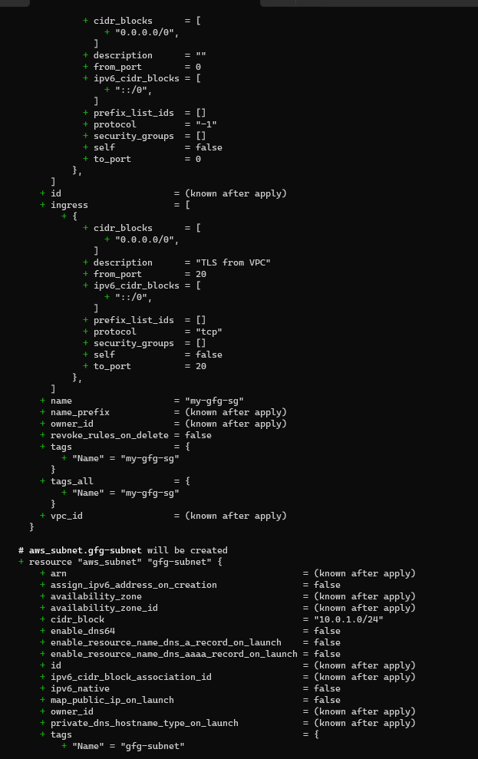

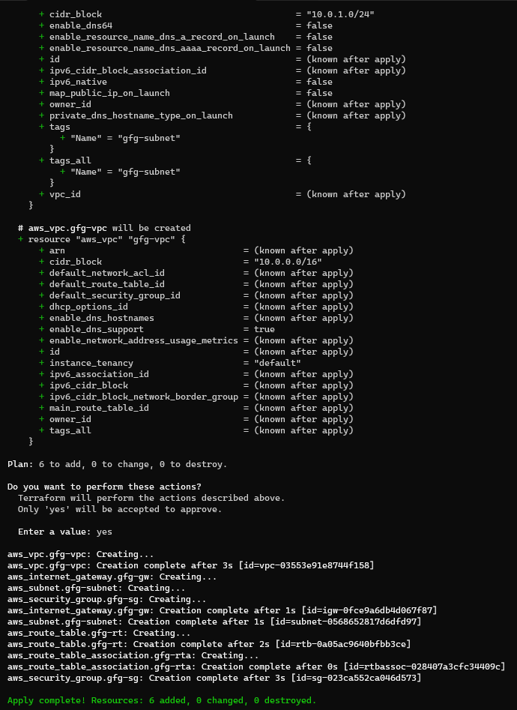

VPC:

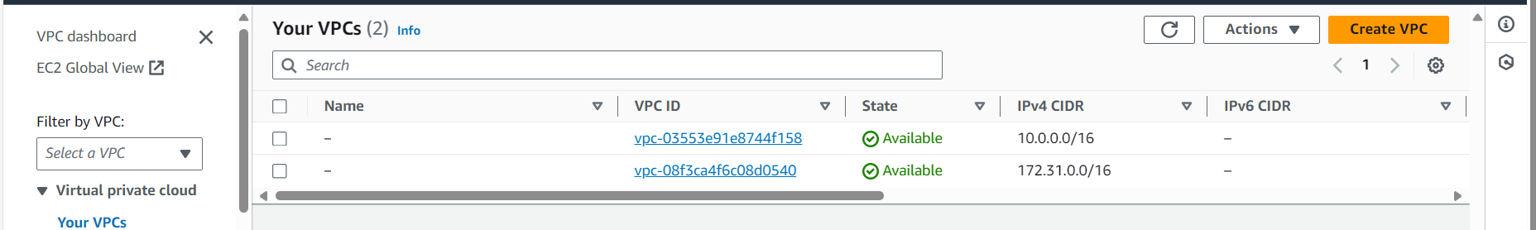

SUBNET:

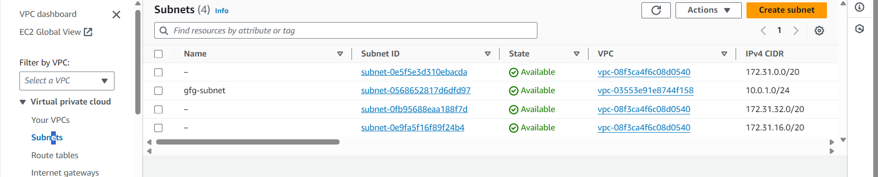

ROUTE TABLE:

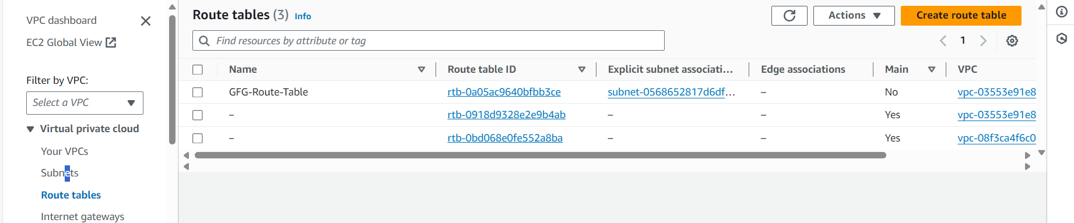

INTERNET GATEWAY:

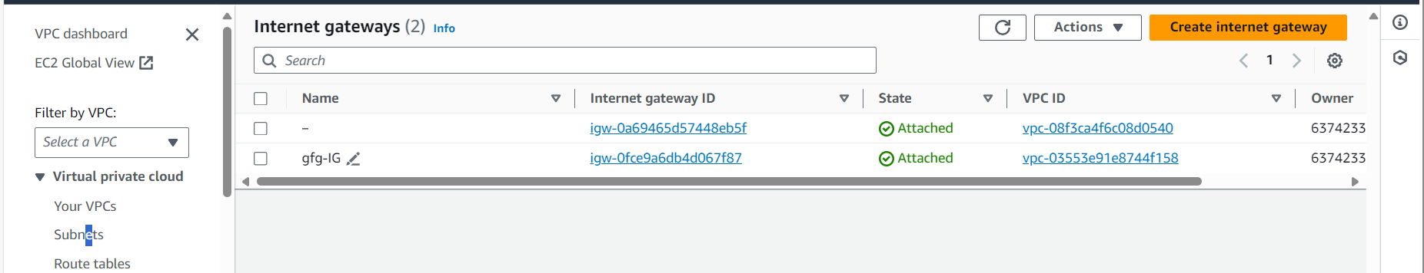

Step 12: Now run terraform destroy command.

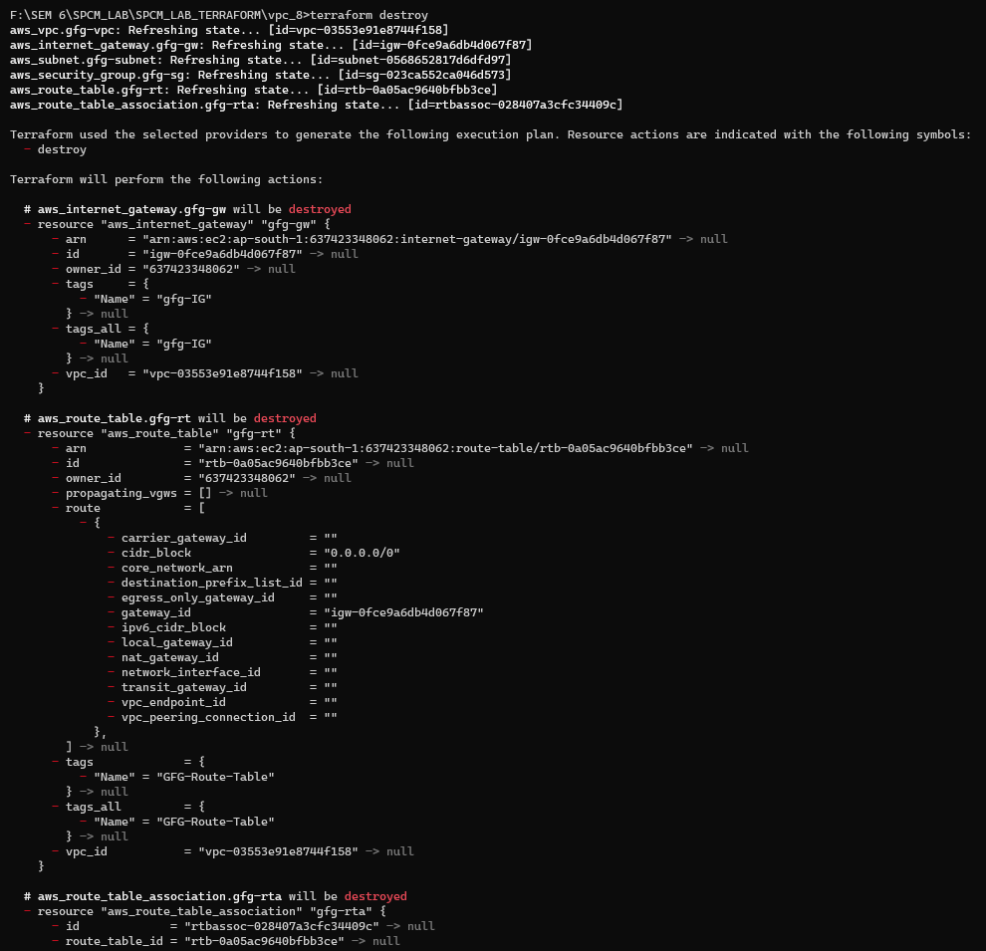

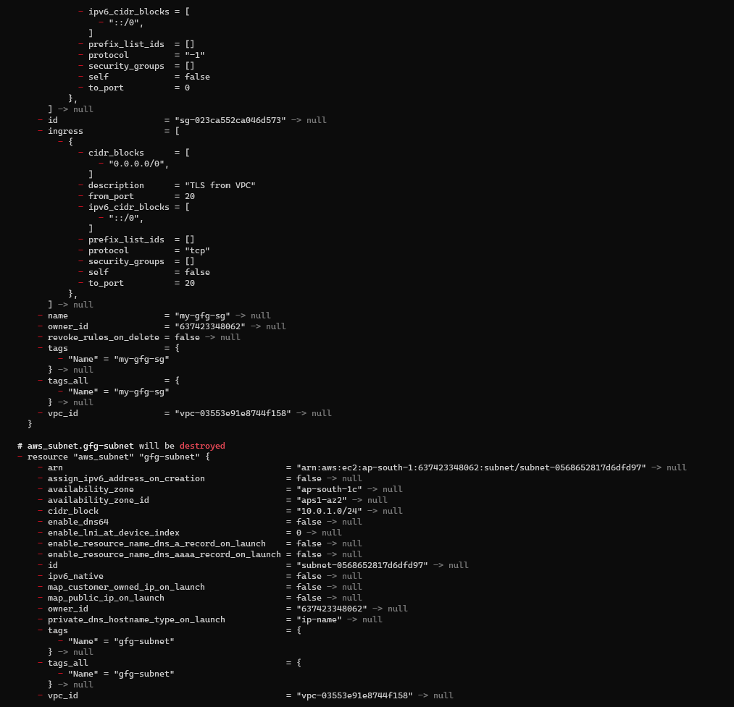

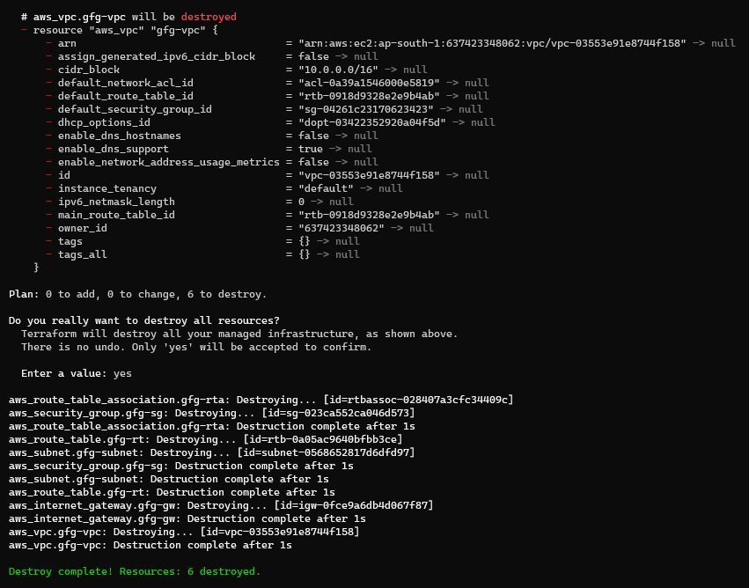

VPC:

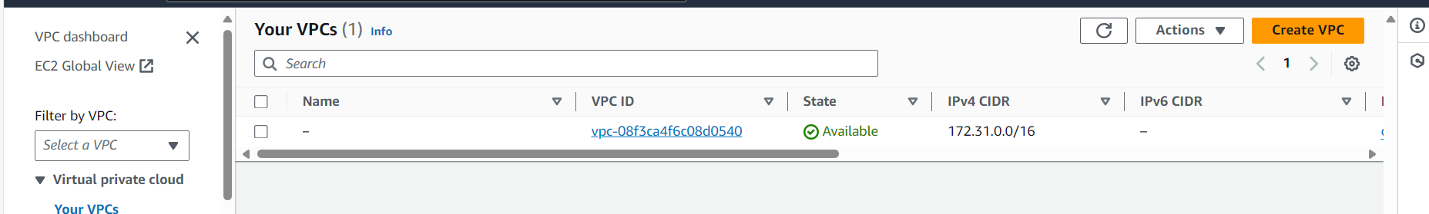

SUBNET:

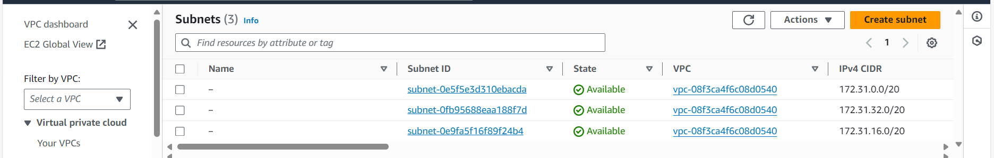

ROUTE TABLE:

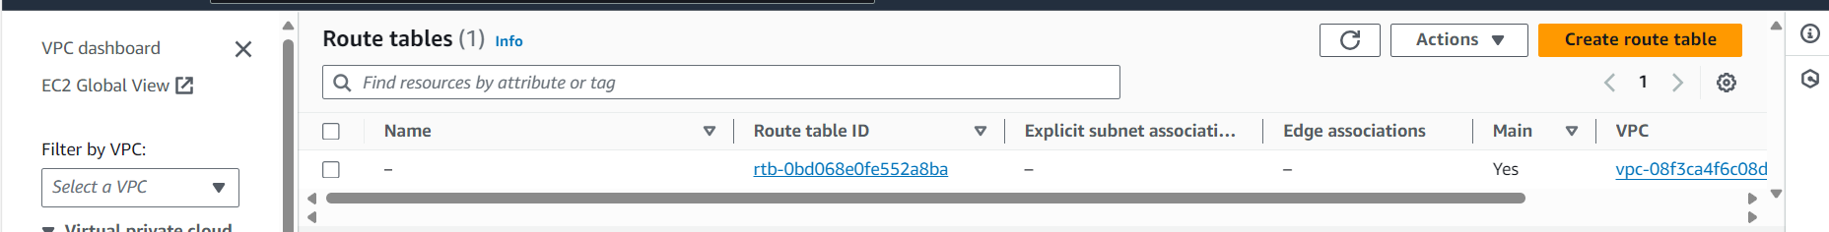

INTERNET GATEWAY:

