LAB-5

Terraform Variable with Command Line Argument

Step1: Make changes in var.tf file
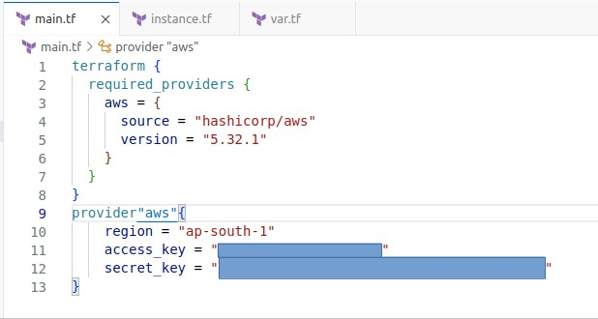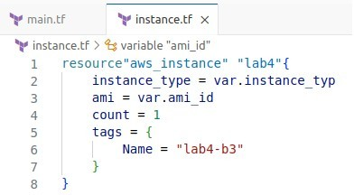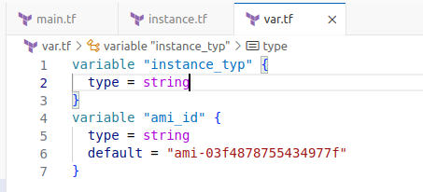
Step 2: Now we need to run terraform cycle
Now we have to ways to declare variable in CLI First: We can give value after running terraform plan
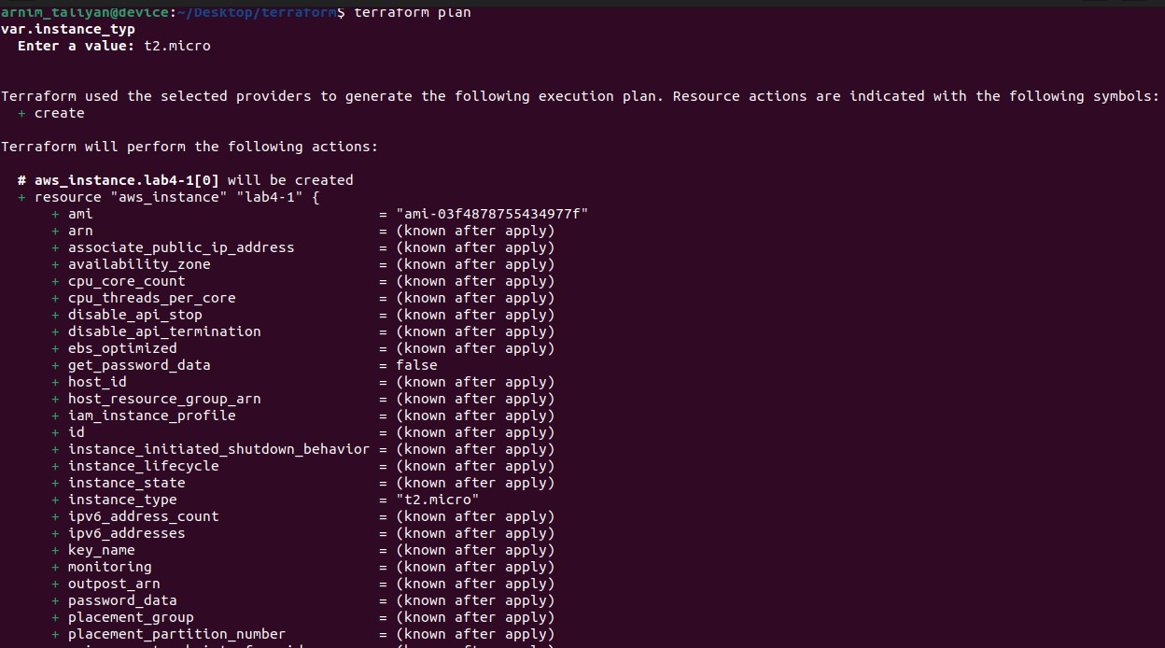
Second: By declaring variable during running command
