LAB-3

Provisioning on EC2 Instance on AWS

Step 1: Create Terrafrom configuration file for EC2 instance
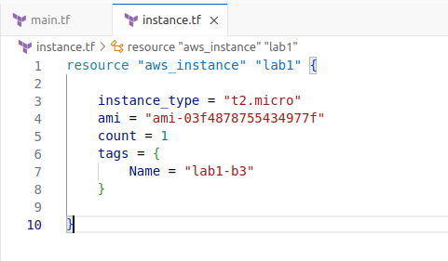
Step 2: Review Plan
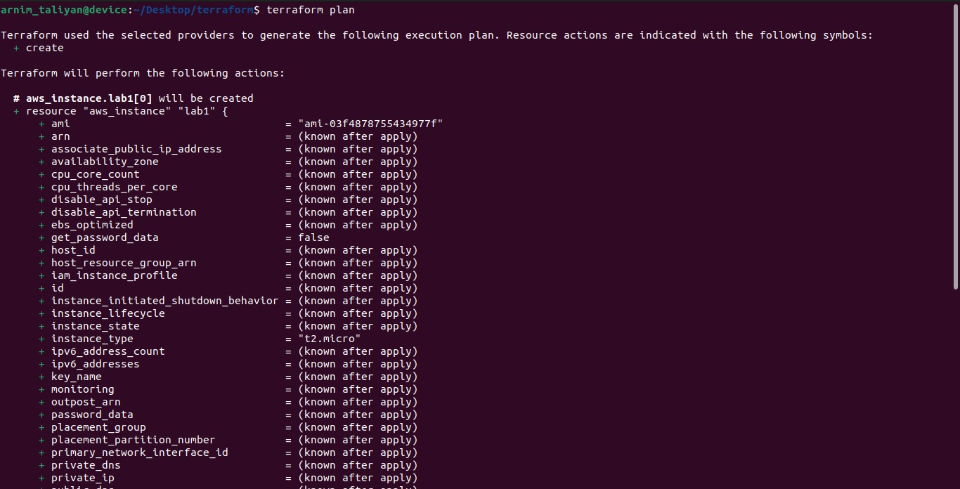
Step 3: Apply Changes
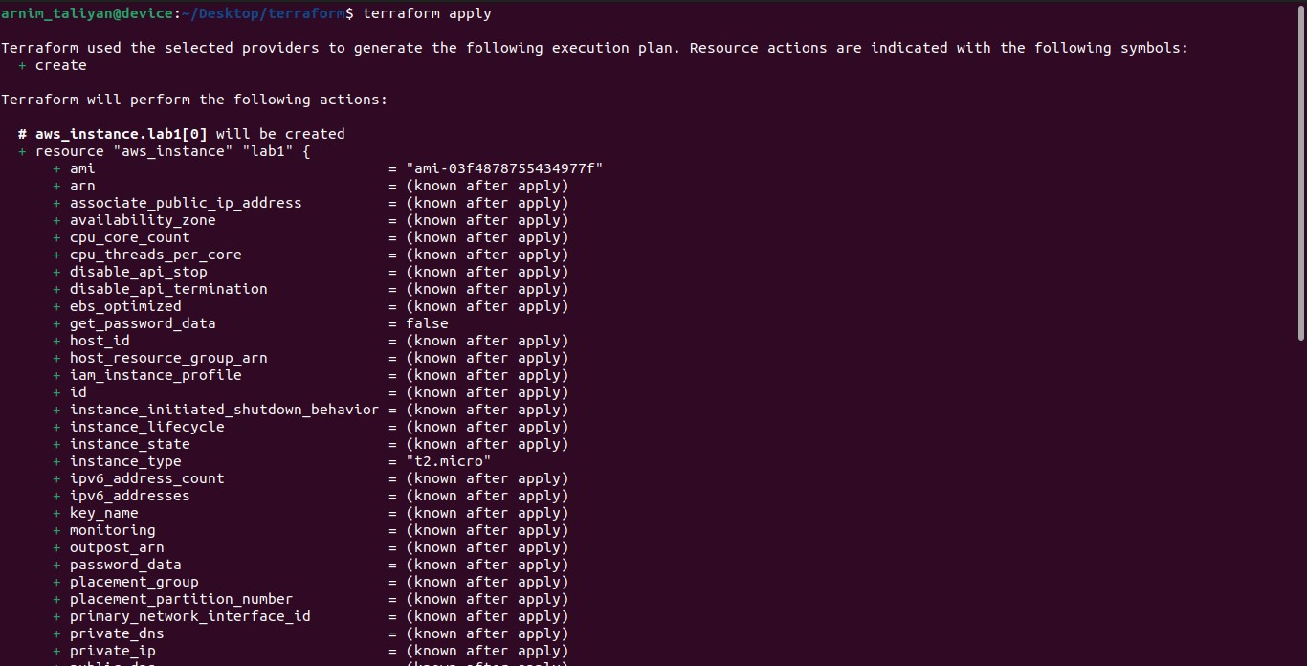

Step 4: Verify Resources
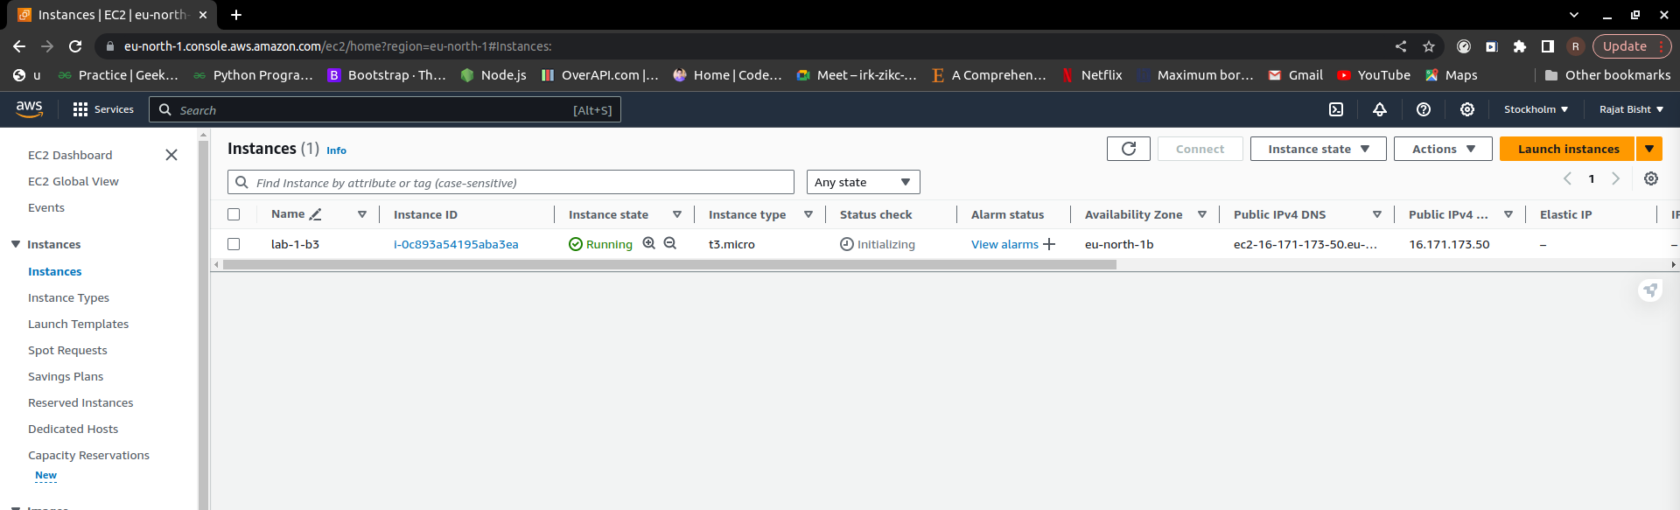
Step 5: Cleanup Resources
