LAB-6

Terraform Multiple tfvars Files

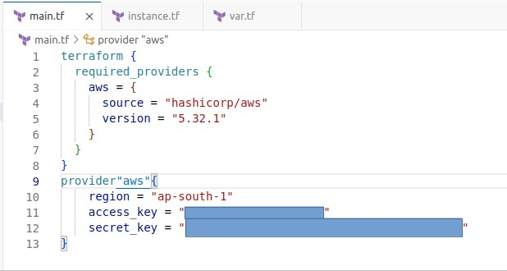
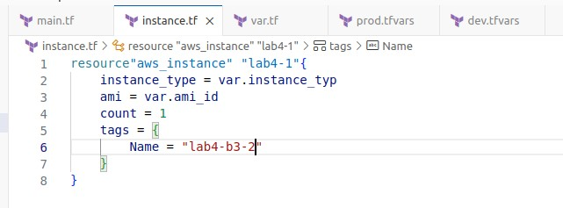
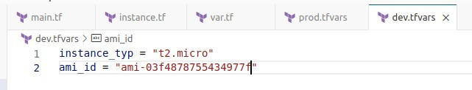
Step 1: Create dev.tfvars and prod.tfvars
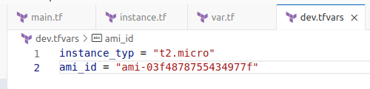
Step 4: To run terraform plan we need to use -var-file=dev.tfvars or -var- file=prod.tfvars
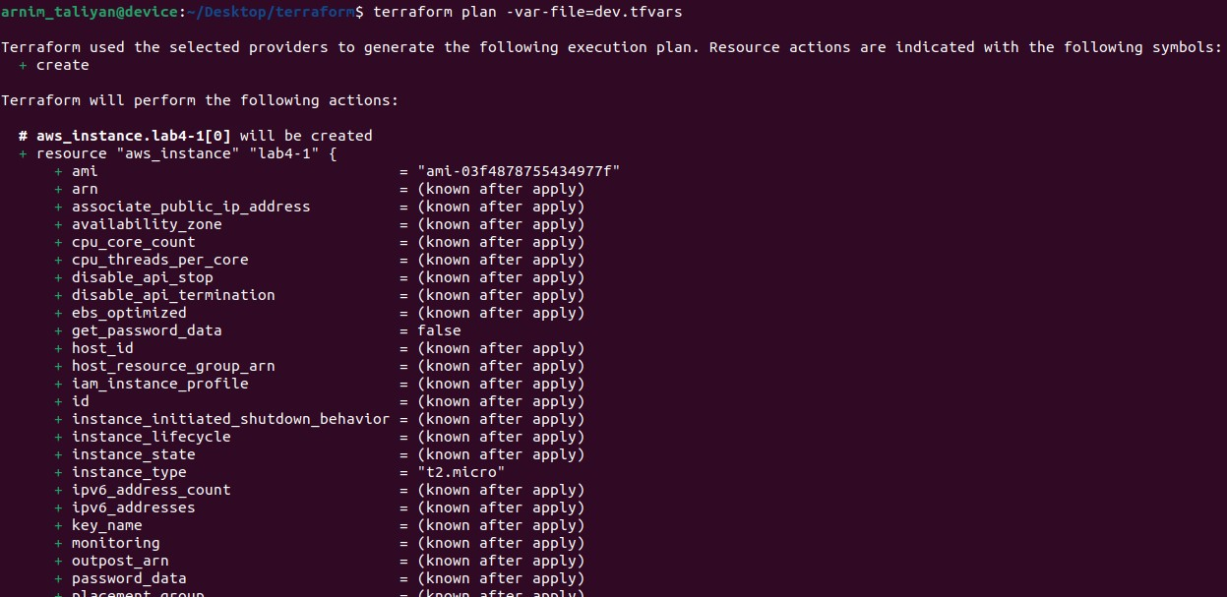
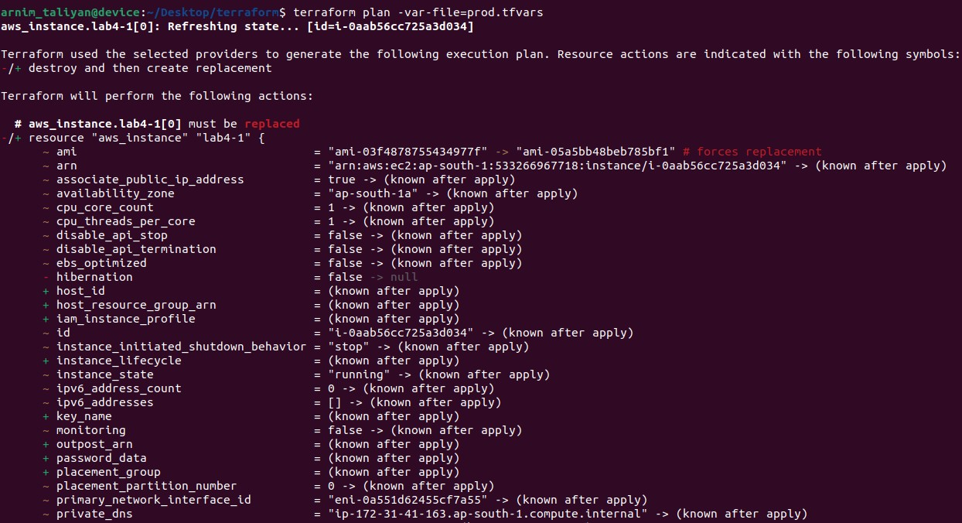

Step 3: To run terraform apply and destroy we need to use -var- file=dev.tfvars or -var-file=prod.tfvars
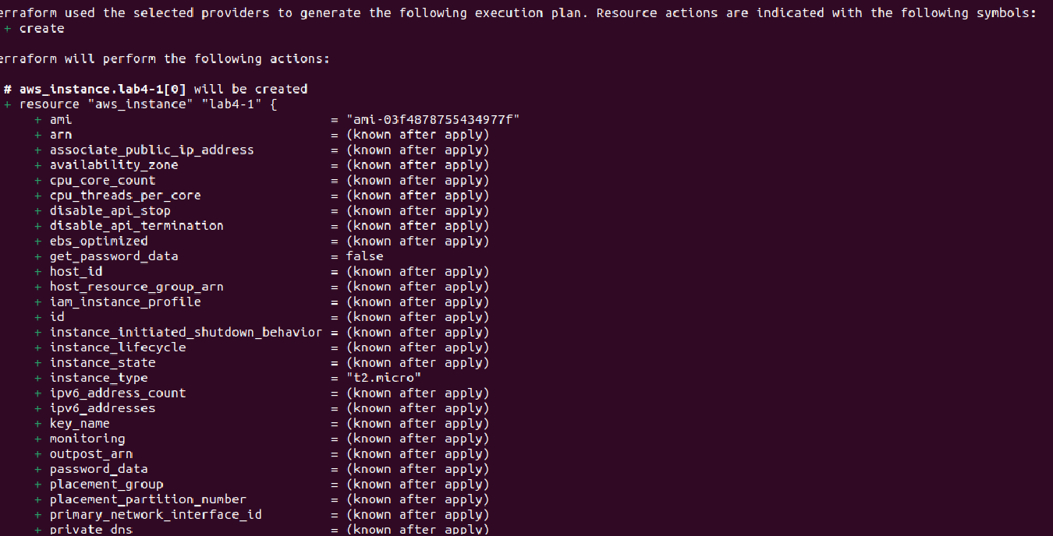
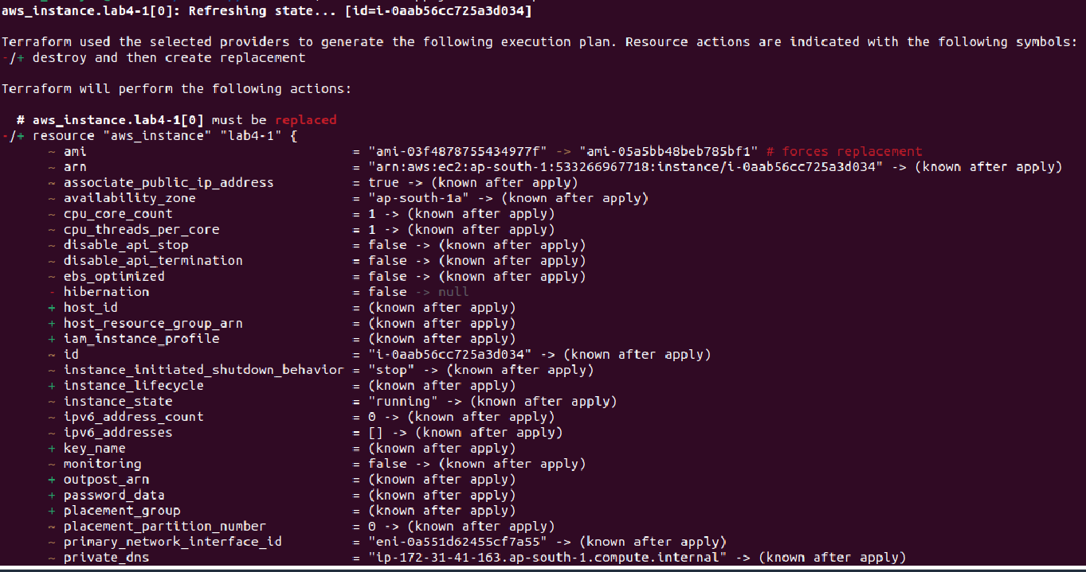
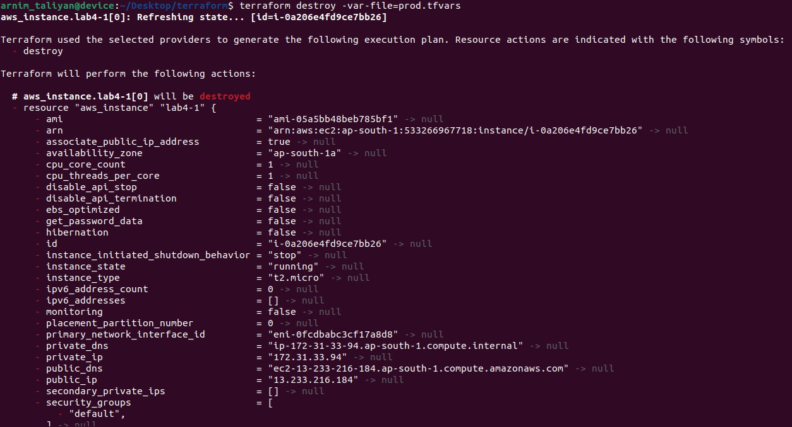
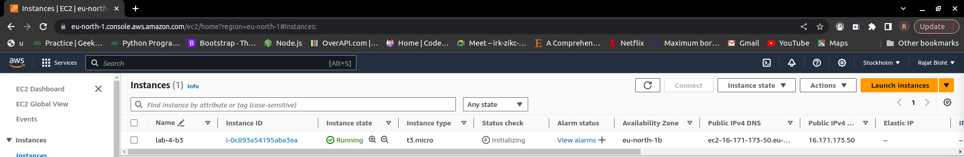

When we run terraform apply -var-file=prod.tfvars previously created terraform apply -var-file=dev.tfvars automatically destroy.

