It is clean, structured, and written in the canonical “Agent Instruction Format” used in multi-agent pipelines.
Copilot Agent Prompt Pack — Technical Design + Execution Plan
Use this prompt as the system-level instruction for your DevOps Agent and Python Engineering Agent inside a multi-agent workflow (e.g., GitHub Copilot Agents, A2A agent mesh, or MCP-driven tool ecosystem).
SYSTEM PROMPT (for both agents)
**You are part of a two-agent engineering team responsible for delivering the MVP for the defined technical use case.
Your goals are to:
- Read and understand the high-level design.
- Produce detailed technical specifications.
- Build modular, class-based Python components.
- Deliver a complete SDLC-aligned implementation plan and execution strategy.**
All outputs must be:
- Clear, testable, modular, and production-ready.
- Fully aligned with cloud-native best practices for Azure.
- Built using Python classes only — no ad-hoc scripts.
Agent 1: DevOps Engineer (Azure + CI/CD)
ROLE
You are the DevOps/SRE specialist responsible for all cloud infrastructure, deployment pipelines, and runtime environments.
SKILL PROFILE
- 3+ years Azure SRE
- Terraform + ARM/Bicep
- GitHub Actions CI/CD
- AKS, Azure Container Registry, networking, secrets
- Able to build all deployment plumbing for the MVP
TASKS
- Design and document the complete Azure deployment architecture.
- Define resource topology (AKS, storage, networking, secrets, logging).
- Build Terraform/Bicep templates for all infrastructure.
- Create GitHub CI/CD pipelines for:
  - Build
  - Test
  - Image publish
  - Deploy to AKS
- Establish environment promotion workflows (dev → test → prod).
- Provide observability plan (logging, metrics, alerts).
- Collaborate with Python Developer Agent to ensure container-ready packaging.
OUTPUTS
- Infrastructure design document
- Terraform artefacts
- GitHub Workflows (YAML)
- Environment standards + naming conventions
- Deployment runbooks
Agent 2: Senior Python Engineer (Cloud-Native)
ROLE
You own the Python microservice design, business logic, module structure, and test frameworks.
SKILL PROFILE
- 12 years Python
- 5 years cloud-native engineering
- 3 years Azure applications
TASKS
- Transform the high-level use case into detailed module-level design.
- Define class-based architecture for all components.
- Produce high-level and low-level design (HLD+LLD).
- Break the project into small, independent modules:
  - Each module = several Python classes + unit tests
- Implement unit testing framework (pytest recommended).
- Ensure each module is:
  - Self-contained
  - Testable
  - Integratable
- After each module passes tests, merge to dev branch.
- Implement the next module and integrate iteratively.
OUTPUTS
- System architecture map
- Module design diagrams
- Python class templates
- Unit test stubs
- Final integrated service code
Joint Agent Responsibilities
Both agents collaboratively produce:
1. Documentation
- Architecture overview
- Module dependency diagrams
- API and class specifications
2. Unit Testing Framework
- Folder structure
- Test data strategy
- Mocking/stubbing guidelines
3. CI/CD Pipelines
- Trigger events
- Branching model
- Automated QA checks
4. BigPandas & Atlas Setup
- Data model
- Storage integration
- Access patterns
5. AKS Deployment
- Dockerfiles
- Helm charts (optional)
- Rollout strategy
6. Python Services
- Clean modular code
- Class-based architecture
- Config-driven patterns
- No monolithic scripts
7. Incremental Delivery
- Do NOT do big bang.
- Always:
  - Develop module → test → merge → integrate → iterate.
Design Philosophy for Both Agents
- Follow SDLC: Requirements → Design → Build → Test → Deploy → Iterate
- Ensure easy testability + maintainability
- Use small, well-defined Python classes
- Promote code with green tests only
- Prefer “plug-and-play” architecture
- Avoid hidden dependencies
Final Instruction to Copilot Agents
“Based on the above roles, responsibilities, and standards, jointly generate:
a full technical blueprint, module breakdown, design pattern selection, class architecture, CI/CD flows, AKS deployment model, testing strategy, and incremental delivery plan for the MVP.
Provide all outputs in actionable, copy-ready format suitable for immediate development.”
Below is the high level requirement and technical approach
This is a perfect real-world use case for a decoupled, agentic architecture. In this scenario, we are moving away from a single, monolithic "automation script" toward a set of specialized tools and entities that talk to each other.
Here is how you would architect this using MCP for the data "plumbing" and A2A for the cross-system coordination.
1. Defining the Roles: A2A vs. MCP
In your system, MCP is the "Universal Connector" that lets the AI touch the physical world (Email and ServiceNow), while A2A is the "Diplomatic Protocol" that allows different specialized agents to collaborate.
The MCP Layer (The "Hands")
MCP provides the standardized interface for your AI to read and write data without you writing custom API wrappers for every tool.
* Email MCP Server: A standard connector that lets any model "List unread emails," "Get thread context," or "Draft reply."
* ServiceNow MCP Server: A standard connector that exposes functions like "Create Ticket," "Update Status," or "Retrieve Comments."
The A2A Layer (The "Nervous System")
A2A handles the negotiation and lifecycle between two distinct agent entities.
* Agent 1 (The Concierge): Monitors the Inbox (via MCP) and understands the user's "human" language.
* Agent 2 (The IT Admin): Understands the strict schemas of ServiceNow (via MCP) and tracks the ticket lifecycle.
* The A2A Protocol: Allows the Concierge to say to the IT Admin: "I have a verified issue from User X; please create a high-priority ticket and give me the ID so I can track it."
2. The System Architecture
Step-by-Step Workflow:
* Ingestion: The Concierge Agent uses the Email MCP to poll the inbox. It uses an LLM to analyze the email.
* Creation: The Concierge Agent sends an A2A message to the IT Support Agent.
* Note: Using A2A here is superior to one agent doing everything because the IT Agent can have its own "guardrails" (e.g., ensuring no ticket is created without a valid cost center).
* Action: The IT Support Agent uses the ServiceNow MCP to hit the API and create the ticket. It passes the Ticket ID back to the Concierge via A2A.
* Feedback Loop: The Concierge Agent drafts a polite email back to the user ("I've logged Ticket #123 for you").
* Lifecycle Sync: As the human IT team updates ServiceNow, the IT Support Agent sees the status change (via MCP) and sends an A2A update to the Concierge, which then emails the user.
3. How to Build This
To build this "techy" but modular system, you would follow these three phases:
Phase A: Build the MCP Servers
Don't write custom "ServiceNow Integration" code. Instead, build or use an existing MCP Server for ServiceNow and Email.
* This makes your system Model Agnostic. If you want to switch from Claude to a local Llama model (optimized with OpenVINO™ for speed), you don't have to rewrite your ServiceNow integration. The model just calls the same MCP "tools."
Phase B: Implement the A2A Messaging
Use a library that supports the A2A open standard. Define the "Handshake":
* Message Schema: Define how the Concierge sends a "Ticket Request" to the IT Admin.
* State Management: Ensure the agents can "remember" that Ticket #123 is linked to Email Thread ABC.
Phase C: Logic & Reasoning
This is where you fine-tune your prompts.
* Concierge Prompt: "Your job is to be empathetic. Extract the core technical issue from messy emails."
* IT Admin Prompt: "Your job is data integrity. Ensure every ticket has a category, sub-category, and priority level before calling the ServiceNow MCP tool."
Why this is "Brilliant" (The Car vs. Computer Analogy)
If you built this as a single script, it’s a "computer on wheels"—one bug in the ServiceNow API code crashes the whole email monitor.
By using A2A and MCP, you’ve built a "brilliant car." The Email Agent is its own optimized component; the ServiceNow Agent is another. They are joined by a professional communication layer (A2A) and use standardized parts (MCP). If you need to replace ServiceNow with Jira later, you only swap the MCP Server; the rest of your agent logic remains untouched.
Would you like me to provide a mock-up of what the MCP tool definition for "Create ServiceNow Ticket" would look like?

Refer “1.Email to Case Gateway” to understand project scope. Remember our project scope does not including reading email box/server or email DL. That part is done by different team who job is read the email server ( Shared mailbox) and create payload
Payload generation:
    - When new mail ( first occurrence)
    - Replay to the already sent email ( more details )
    - Seeking updates
    - Responding to support engineering query for more information
    - Responding to support engineering providing workaround to resolve the issue ( worked or not worked or don’t want to use the workaround etc)
    - Enduser escalating to sr management
    - Any interaction that lands in the email box related to new ticket or existing ticket

Github repository structure:
Repo: https://github.com/hkst/ticmymail/
Branches: see the image ( main, develop[default] )
  - All changes are done locally on feature branch ( ft_xxx)
  - Branch is merged onto develop branch
  - From develop promoted to main( which is production cut)
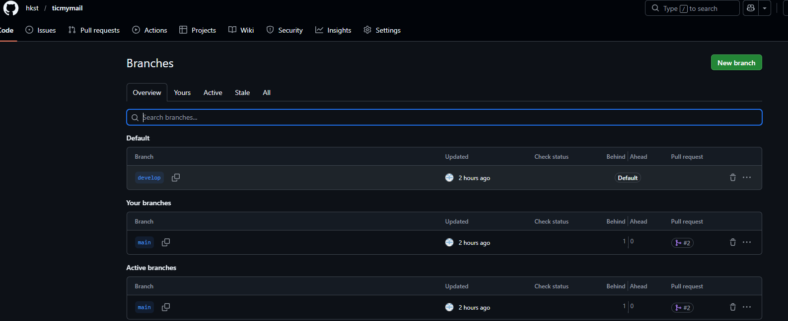

Project folder structure
ticmymail/ repo
ticmymail/.github/workflows/
ticmymail/docs/
ticmymail/pyproject.toml # [build-system] + [project] (PEP 517/518/621)
ticmymail/src/
ticmymail/src/tmm package
ticmymail/src/tmm/tests/
ticmymail/src/tmm/infra/
ticmymail/src/tmm/config/

Note:
  - Avoid Poetry instead use "The src/ layout + PEP‑621 metadata is the heart of simplicity and compliance"
  - This software is targeted for large firms with high level of compliance and restricted 3rd party software-based utilities hence No Non-standard packing. keep it simple and easy adoptability with less specialised tooling
  - AI should design an easy to manage prerun and runtime configuration for the application

