Singing Dogs

A Mix of Random Shader Effects

Sean Song  
CS: Game Design  
 University of California,   
 Santa Cruz

Sandra Tiu-Latt  
 CS: Game Design  
University of California,   
 Santa Cruz

Lily Young  
Art & Design: Games and Playable Media  
 University of California,   
 Santa Cruz

ABSTRACT

In our project, we wanted to do something simple, fun, but allowed us to highlight several different components.

The creative vision for the project was to have two dogs barking at each other based on the music that was playing. As the dogs bark, they would emit smaller dogs and sparkles coming from its mouth. The goal that we were going for was a light-hearted, cute scene with dogs.

Our basic components include an audio listener and a particle system. But we *jazzed* it up with several shaders in order to create fun visual effects.

1 Creating the Models

As a 3D modeler, my technical challenges were making the model perform well. This shiba model was particularly challenging for me because it was my first organic model, so I made the model not function how it is supposed to. The problem was that the faces and vertices of the model were acting strange like some were appearing inside the model and it was connecting in a strange way. Some of my colleagues had to help me fix it, so it became properly made. The solution to this problem was to cut the model to delete all the extras inside and remirror it. I feel like this problem happened because I mirrored it wrong the first time. When I made the sparkle, it caught me off guard. I knew what a sparkle looked like in 2D but somehow I could not visualize making a 3D one. When my colleagues explained to me, I began to understand. They wanted a sparkle that was equal on all sides whether it be on the X-axis, Y-axis, or Z-axis. When I began implementing it in Blender, it was challenging because it did not work if I just simply mirrored it. The solution I found to this problem was to delete all the faces and keep one outline of the shape and copy and paste it manually.

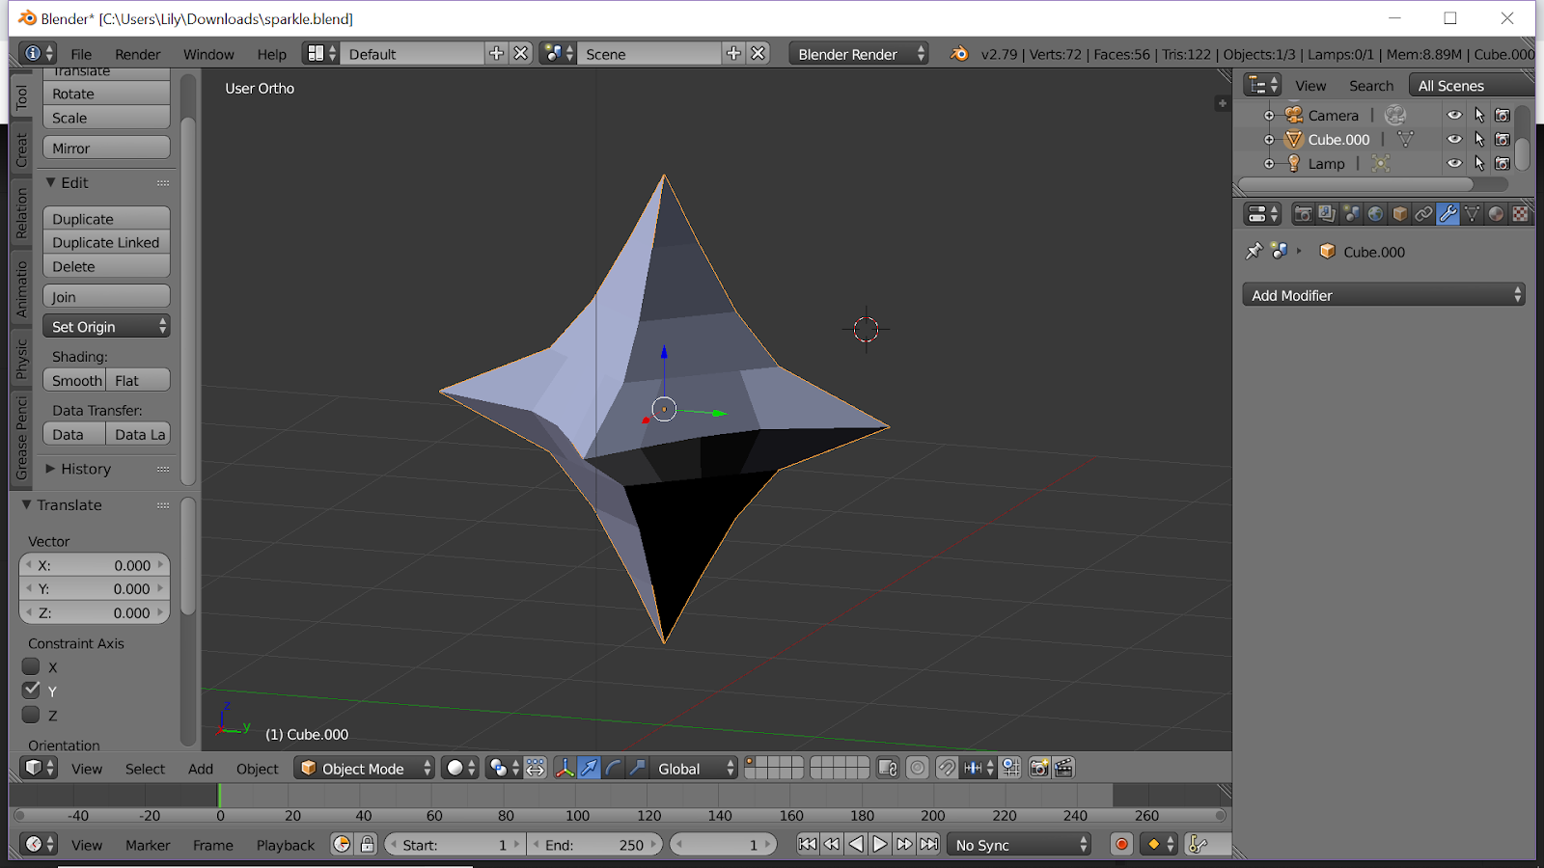

Figure 1: Sparkle Model

1.1 The Shiba

In order to use the model in Unity successfully, we had to make sure the textures stayed properly. Originally, we had colored the dog with materials in Blender. However, we realized that was a mistake in Unity as it did not stay. Instead we chose to UV unwrap the dog and create a texture so that we could just import the texture along with the model in to Unity.

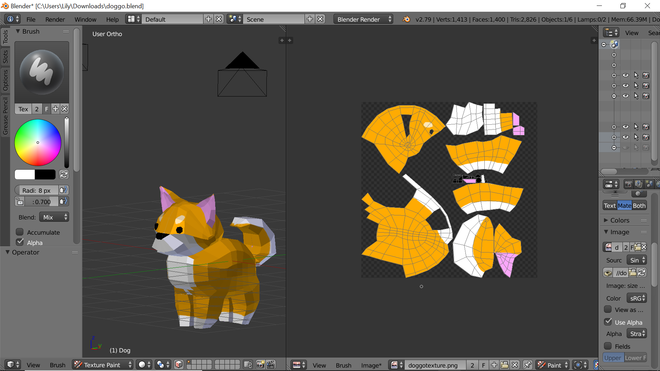

Originally we wanted it so that the dogs would have barking animations in tune to the music, however, as we tried to animate—nothing would work.

We tried rigging but none of the bones would stick to the mesh, and without it, you couldn’t animate just the mouth. However, we decided that we would be fine without the animation as the focus was on the other effects in the scene.

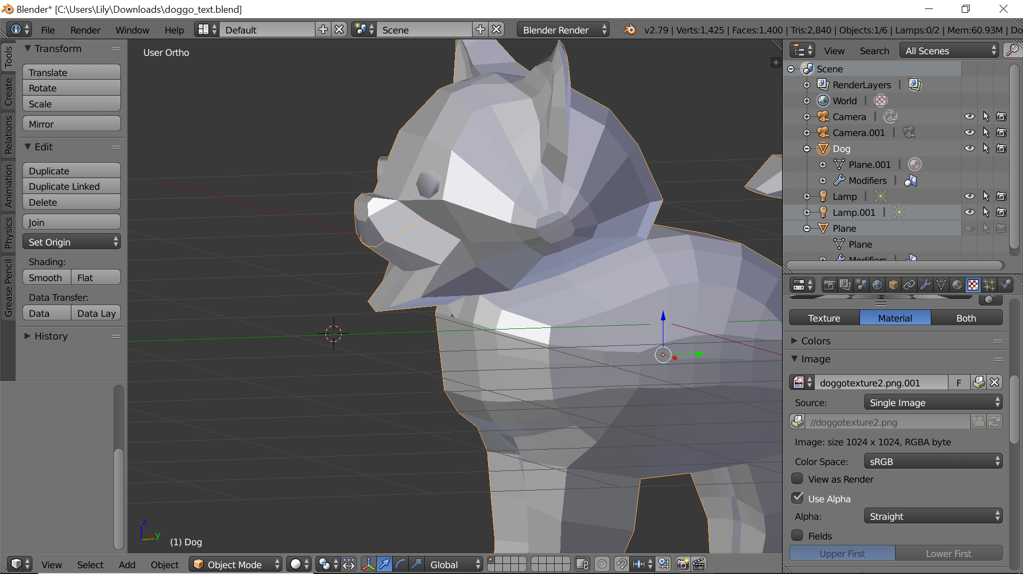

2 Setting the Scene

In order to achieve our goal, we needed to set the scene. Since we wanted the dogs to bark out to music- we also wanted to include a disco floor and ball.

2.1 Disco Floor

Originally we planned to create a cool, eclectic “disco” floor using the Game of Life algorithm we learned this past quarter. We modified it so that the colors were different, and tweaked numbers so that there were in between shades of black and white. Ultimately, we decided this disco floor was too busy and scrapped it.

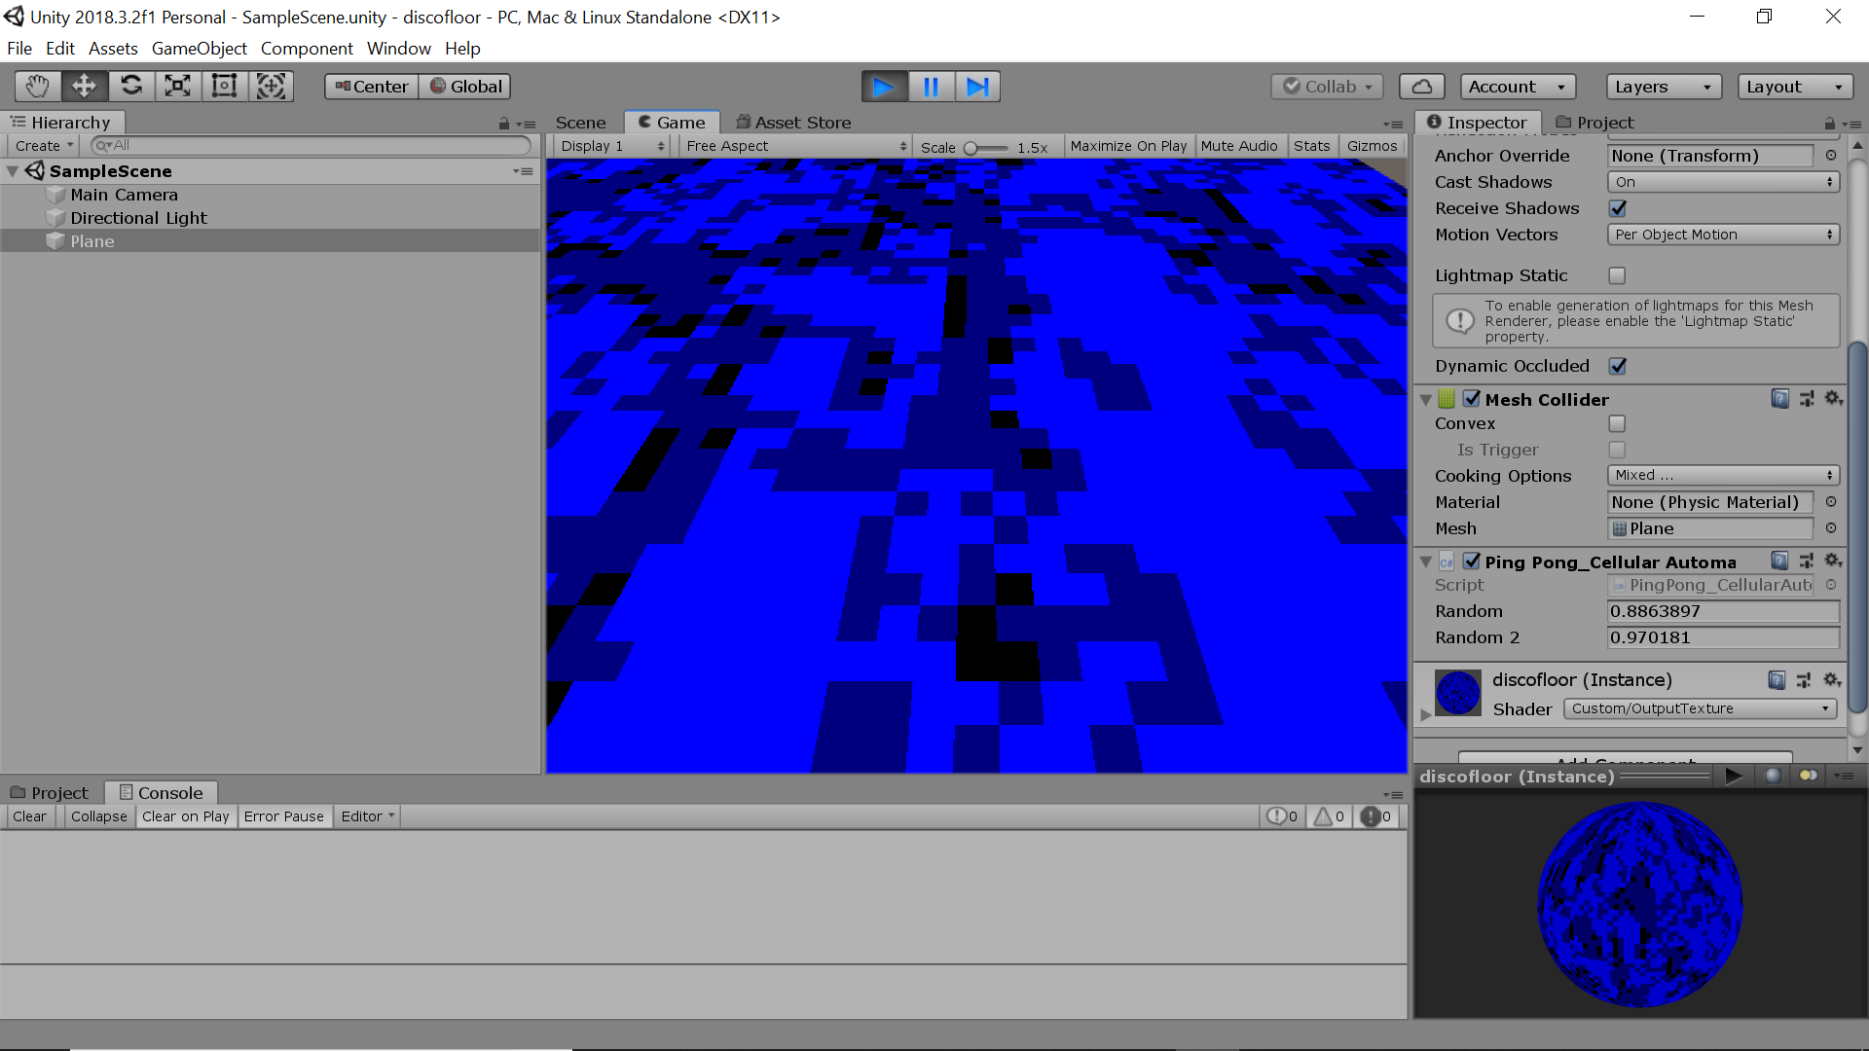

2.1 Disco Ball

Sljf

3 Adding the Effects

Now, on to the fun stuff! We added several different components in order to make the singing dogs stand out. We added a shader to make the sparkles rainbow, we added a bloom filter to make them glow, and we added a toon shader to create a cartoon effect.

3.1 Toon Shader

Lksjld

3.2 Rainbow Shader

lksjld

3.3 Bloom Shader

lksjld

4 Putting it All Together With Audio

Last but not least- the audio!

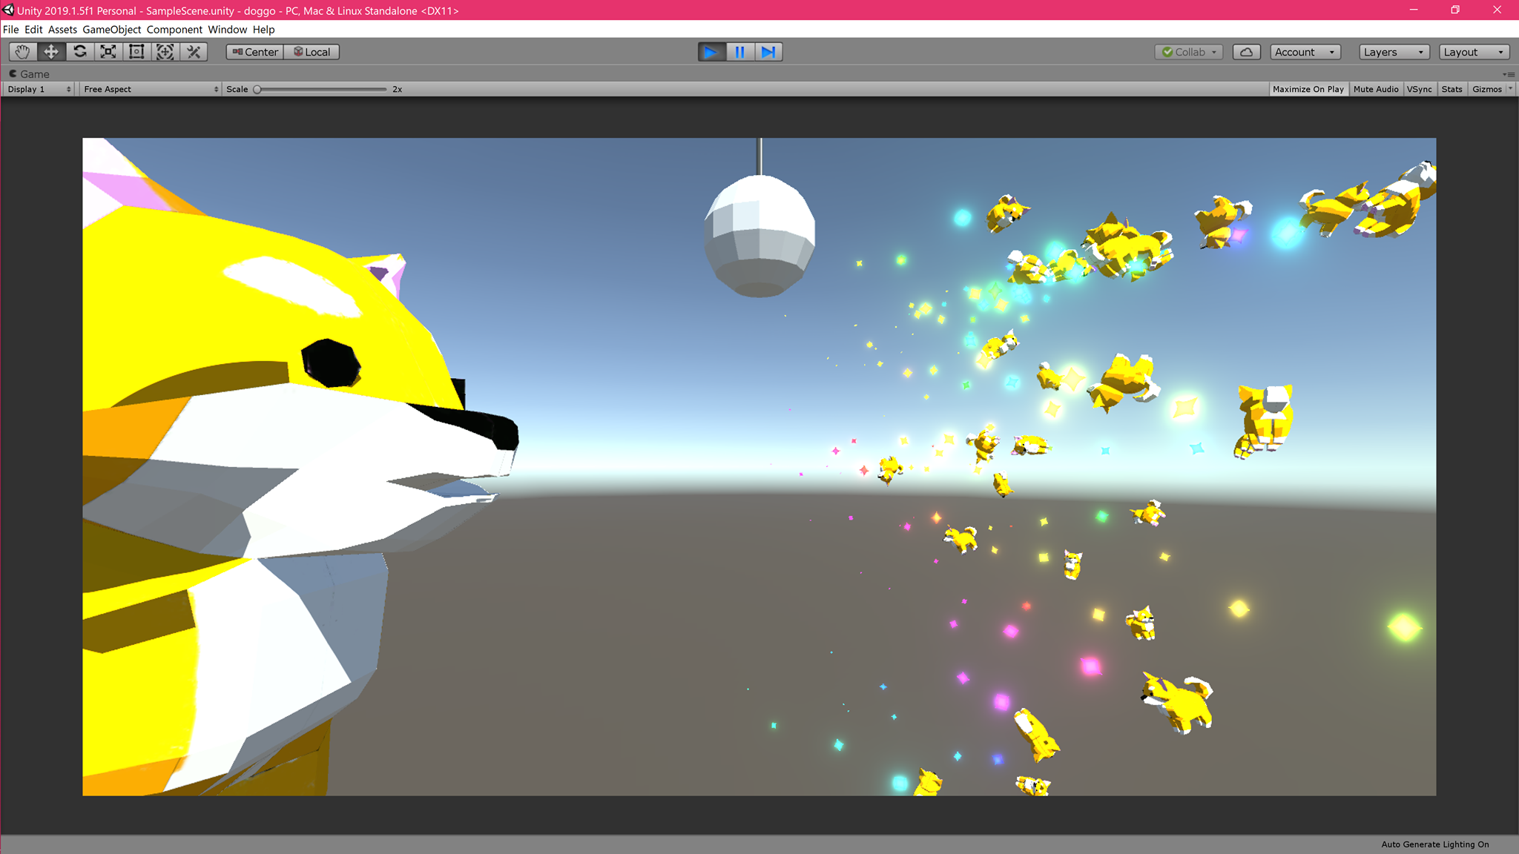

REFERENCES

[1] FNM Surname (2018). Article Title. Journal Title, 10(3), 1–10.

[2] F.N.M Surname, Article Title, https://www.acm.org/publications/proceedings-template.

[3] F.N.M Surname and F.N.M Surname, 2018 Article Title, The title of book two (2nd. ed.). Publisher Name, City, State, Country.

[4] Ian Editor (Ed.). 2018. *The title of book two* (2nd. ed.). University of XXX Press, City, Chapter 100. DOI: <http://dx.doi.org/10.1000/0-000-00000-0>.

Conference Name:ACM Woodstock conference

Conference Short Name:WOODSTOCK’18

Conference Location:El Paso, Texas USA

ISBN:978-1-4503-0000-0/18/06

Year:2018

Date:June

Copyright Year:2018

Copyright Statement:rightsretained

DOI:10.1145/1234567890

RRH: F. Surname et al.

Price:$15.00