Object Detection Application
- Totokan APP Usage
- Download Totokan APP in app store or google play

- Video streaming through P2P
(1) Add Camera | (2) Enter UID & Password  UID = PIXMAX-00002536-BA604  Password = 12345678
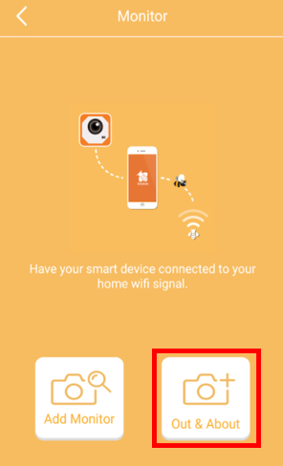 | 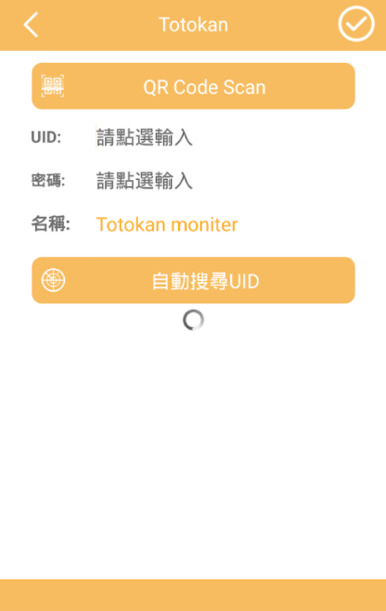
(3) Select Camera  Wifi icon will turn red, when the device is detected. | (4) Start Streaming  Click the icon and start streaming.
 | 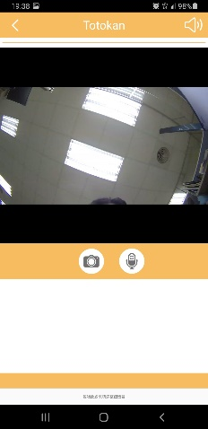
- AmebaPro Setup
- Before using “Totokan” to stream, you will be asked to make AmebaPro connect to wifi.
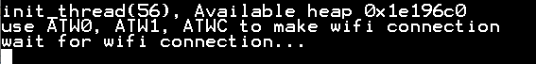

- Set Wifi Information to AmebaPro
  - Set Wifi SSID with AT command
>>ATW0=SSID
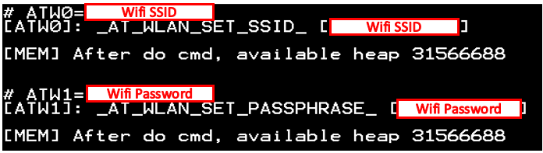
  - Set Wifi Password with AT command
>>ATW1=Password
  - Set Wifi Connection with AT command
>>ATWC
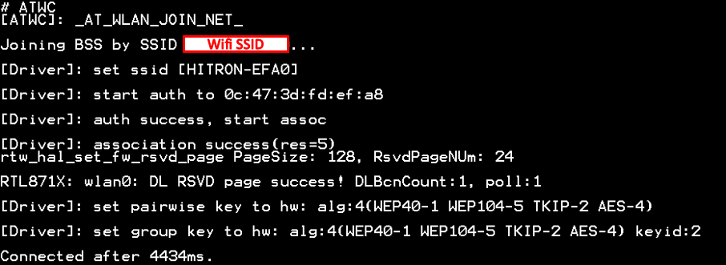

- Use AT command to set UID
>>ATUD=PIXMAX-XXXXXXXX-XXXXX,XXXXXX
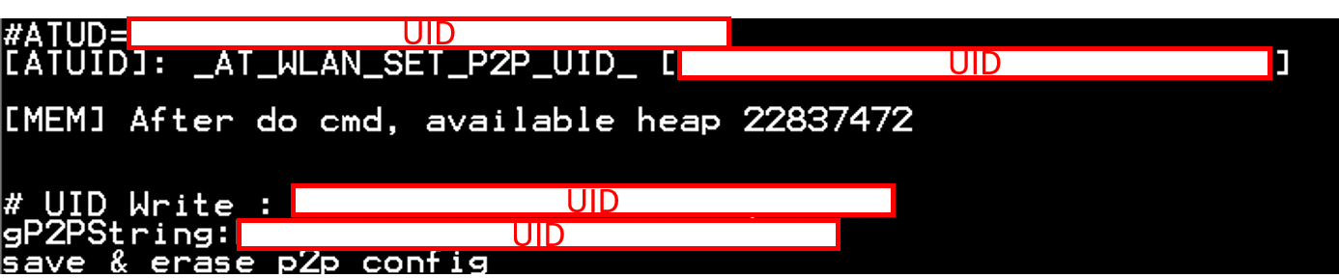

- Check the correct UID is set and can start streaming.
