

MQTT Diag 通訊規格

設備診斷與監控通訊協議規格書

適用範圍: WiFi 診斷事件、設備健康監控  
通訊協議: MQTT v3.1.1 / v5.0  
版本: v1.0

# 目錄

目錄 2

MQTT Diag 通訊協定規格 v1.0 (rtkMQTT) 8

1. 術語定義 8

2. 設計原則 8

3. Topic 命名空間 8

3.1 上行（Device → Controller） 8

3.2 下行（Controller → Device） 9

3.3 群組/廣播（可選） 9

4. Device ID 規範 9

5. 安全與存取控制 (Future Work) 9

5.1 傳輸安全 (待實作) 9

5.2 存取控制清單 (待實作) 9

5.3 審計與監控 (待實作) 9

6. 設備上下線偵測 10

6.1 Last Will Testament (LWT) 機制 10

6.2 LWT 設定要求 10

6.3 上下線狀態管理 10

7. 共通 Payload 格式 10

7.1 什麼是共通 Payload 格式 10

7.2 必要欄位說明 11

7.3 選用欄位說明 11

7.4 完整訊息範例 12

7.5 版本相容性規則 12

8. MQTT 使用時機 12

8.1 發布頻率 12

8.2 訂閱模式 12

8.3 命令處理 13

9. 上行結構定義（Device → Controller） 13

9.1 `state`（retained） 13

9.2 `telemetry/{metric}` 13

9.3 `evt/{event_type}`（事件/告警） 14

9.4 `attr`（retained，裝置屬性） 15

10. 下行命令（Controller → Device） 15

10.1 `cmd/req`（Controller → Device） 15

10.2 `cmd/ack`（Device → Controller） 16

10.3 `cmd/res`（Device → Controller） 16

11. 典型命令清單（建議命名） 17

12. 診斷資料傳輸機制 17

12.1 主動診斷事件傳輸 17

12.2 被動詳細診斷請求 17

12.3 診斷命令格式 17

12.3 設備相依性 18

12.4 常見診斷類型 18

13. 錯誤碼建議 19

14. 版本控管 19

15. 順序、重送與冪等 19

16. 監控與審計建議 19

17. 測試案例（最低集合） 19

18. JSON Schema（簡化示例） 20

17.1 `state/1.0` 20

17.2 `cmd.light.set/1.0` 20

19. 實作指南（裝置端） 21

20. 實作指南（Controller/後端） 21

21. 範例訂閱樣式 21

22. WiFi 診斷實際應用範例 22

23.1 漫遊問題診斷範例 22

23.2 連線失敗診斷範例 24

23.3 ARP 遺失診斷範例 25

23.4 時序圖與通訊流程 26

Controller 全域監控 26

特定場域監控 27

設備類型監控 27

23.5 診斷資料結構定義 27

23.6 實作指南 28

23. 變更紀錄（Changelog） 28

附錄 29

A. 系統架構與元件關係 29

B. MQTT 通訊流程與時序圖 32

MQTT WiFi 診斷通訊流程與時序圖 32

1. 通用診斷流程時序圖 32

2. 漫遊診斷完整流程 34

3. 連線失敗診斷流程 36

4. ARP 遺失診斷流程 37

5. 訂閱模式與 Topic 路由 38

5.1 Controller 訂閱策略 38

6. 錯誤處理與恢復流程 38

6.1 命令超時處理 38

6.2 連線中斷恢復 39

7. 效能最佳化建議 39

7.1 訊息大小控制 39

7.2 頻率控制 39

7.3 批次處理 39

C. WiFi 連線失敗診斷範例 40

WiFi 連線失敗診斷完整 MQTT 範例 40

情境描述 41

MQTT 訊息流程 41

1. 連線失敗事件觸發 (Device → Controller) 41

2. Controller 請求詳細診斷 (Controller → Device) 42

3. Device 命令確認 (Device → Controller) 42

4. Device 回傳詳細連線失敗診斷 (Device → Controller) 42

5. 狀態更新反映連線問題 (Device → Controller) 45

診斷分析結果 46

失敗原因分析 46

建議修復動作 46

Controller 監控建議 46

D. ARP 遺失診斷範例 48

ARP 遺失診斷完整 MQTT 範例 48

情境描述 49

MQTT 訊息流程 49

1. ARP 遺失事件觸發 (Device → Controller) 49

2. Controller 請求詳細網路診斷 (Controller → Device) 50

3. Device 命令確認 (Device → Controller) 50

4. Device 回傳網路診斷分析 (Device → Controller) 50

5. 遙測資料持續監控 (Device → Controller) 54

6. 狀態更新顯示網路品質改善 (Device → Controller) 54

診斷分析結果 55

根本原因 55

即時處理動作 55

持續監控策略 56

E. WiFi 漫遊診斷範例 57

漫遊問題診斷完整 MQTT 範例 57

情境描述 57

MQTT 訊息流程 57

1. 事件觸發 (Device → Controller) 57

2. Controller 請求詳細診斷 (Controller → Device) 58

3. Device 命令確認 (Device → Controller) 58

4. Device 回傳詳細診斷結果 (Device → Controller) 58

5. 狀態更新 (Device → Controller) - 定期發送 60

診斷分析結果 60

根本原因分析 60

建議動作 60

Controller 後續動作建議 61

# MQTT Diag 通訊協定規格 v1.0 (rtkMQTT)

定義設備與控制器間的 MQTT 診斷通訊協定，包含狀態回報、遙測、事件與命令的訊息格式。適用於 IoT 裝置、伺服器、網路設備等各類設備的診斷狀態回報。

## 1. 術語定義

* **Device（設備）**: 連接 MQTT Broker 的設備，包含 IoT 裝置、伺服器、網路設備等
* **Controller（控制器）**: 發送命令並收集設備診斷資料的雲端或本地服務
* **Broker**: MQTT 訊息代理伺服器
* **Tenant/Site**: 租戶/場域，用於資料隔離與路由
* **Topic**: MQTT 主題路徑
* **LWT**: Last Will and Testament 遺囑訊息
* **Diagnosis（診斷）**: 設備健康狀態、效能指標、錯誤資訊等診斷資料

## 2. 設計原則

* **統一主題結構**: 以設備為中心的上下行訊息路徑設計
* **可擴充性**: 命令與 Schema 獨立演進，使用語義化版本控制
* **可觀測性**: 支援全域與範圍訂閱模式，便於監控與除錯
* **安全性**: TLS 加密、ClientID 認證與 ACL 存取控制 (這一個版本不需要)
* **診斷導向**: 專注於設備健康狀態、效能指標與故障診斷資訊的結構化傳輸，特別支援 WiFi 連線品質、漫遊事件、掃描結果等無線網路診斷

## 3. Topic 命名空間

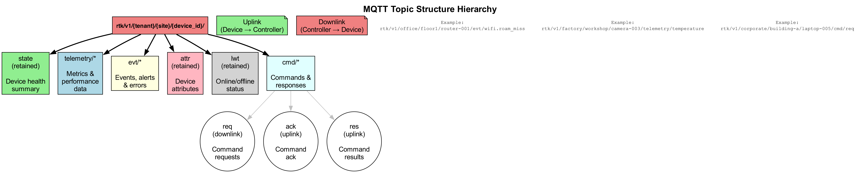

根路徑採版本化：

rtk/v1/{tenant}/{site}/{device_id}/...

### 3.1 上行（Device → Controller）

* state：設備狀態摘要與診斷資訊（retained）
* telemetry/{metric}：遙測資料與效能指標，支援高頻分流
* evt/{event_type}：事件、告警、錯誤與診斷事件
* attr：設備靜態屬性與規格資訊（retained）
* cmd/ack：命令接收確認
* cmd/res：命令結果回覆
* lwt：LWT 上下線通知（retained）

### 3.2 下行（Controller → Device）

* cmd/req：命令請求（統一路徑）。

### 3.3 群組/廣播（可選）

裝置可額外訂閱其所屬群組命令：

rtk/v1/{tenant}/{site}/group/{group_id}/cmd/req

裝置對群組命令的 ack/res 仍回自己的裝置路徑，便於逐台追蹤。

## 4. Device ID 規範

* device_id：全域唯一標識符，不可變更，格式：^[a-z0-9-]{20,40}$（建議使用 ULID/KSUID）
* MQTT clientId = device_id
* 避免使用 MAC 或序號作為主鍵，此類資訊應存放於 /attr topic 或後端資料庫

## 5. 安全與存取控制 (Future Work)

此章節定義完整的安全機制與存取控制規範，包含：

### 5.1 傳輸安全 (待實作)

* TLS 加密設定
* Client certificate 認證
* Token-based 認證機制

### 5.2 存取控制清單 (待實作)

* 裝置端 Topic 發布/訂閱權限
* Controller 端權限管理
* 租戶間資料隔離

### 5.3 審計與監控 (待實作)

* 連線記錄與審計日誌
* 異常行為偵測
* 安全事件通報機制

**注意**: 目前開發版本暫不實作安全控制機制，所有連線預設為可信任環境。

## 6. 設備上下線偵測

### 6.1 Last Will Testament (LWT) 機制

LWT 是 MQTT 的內建機制，用於偵測設備異常斷線。當設備與 MQTT Broker 的連線意外中斷時（如網路故障、設備當機），Broker 會自動發布預先設定的「遺囑訊息」通知其他訂閱者。

### 6.2 LWT 設定要求

設備在建立 MQTT 連線時必須設定以下 LWT 參數：

* **LWT Topic**: rtk/v1/{tenant}/{site}/{device_id}/lwt
* **LWT Payload**: {"status":"offline","ts":<timestamp>}
* **LWT Retained**: true

### 6.3 上下線狀態管理

**設備上線時**:

主動發布上線狀態到相同 topic：

{  
 "status": "online",  
 "ts": 1723526400000  
}

**設備正常下線時**:

發布離線狀態後再斷開連線：

{  
 "status": "offline",   
 "ts": 1723526500000,  
 "reason": "normal_shutdown"  
}

**設備異常斷線時**:

MQTT Broker 自動發布預設的 LWT 訊息，讓 Controller 立即得知設備離線狀態。

## 7. 共通 Payload 格式

### 7.1 什麼是共通 Payload 格式

所有透過 MQTT 傳送的 JSON 訊息都應該包含一些共通欄位，這些欄位用於：

* **版本控制**: 確保不同版本的設備和系統能正確解析訊息
* **時間追蹤**: 記錄事件發生的精確時間
* **除錯追蹤**: 在複雜系統中追蹤訊息流向

無論是狀態回報、遙測資料、事件通知還是命令，都使用相同的基本結構。

### 7.2 必要欄位說明

#### `schema` (字串)

* **用途**: 標識訊息的類型和版本，讓接收端知道如何解析這個訊息
* **格式**: <訊息類型>/<版本號>
* **範例**:
* state/1.0 - 設備狀態訊息 v1.0
* evt.wifi.roam_miss/1.0 - WiFi 漫遊失效事件 v1.0
* cmd.diagnosis.get/1.0 - 診斷資料請求命令 v1.0

#### `ts` (整數)

* **用途**: 記錄訊息產生或事件發生的時間，用於排序、關聯和分析
* **格式**: Unix timestamp 毫秒 (int64)
* **範例**: 1723526400000 (對應 2024-08-13 08:00:00 UTC)
* **注意**: 所有設備必須使用相同的時間基準

### 7.3 選用欄位說明

#### `trace` (物件，選用)

* **用途**: 在分散式系統中追蹤單一操作的完整流程
* **常用欄位**:
* req_id: 請求唯一識別碼
* correlation_id: 關聯多個相關訊息
* span_id: 分散式追蹤的區段識別碼

**範例**:

{  
 "schema": "evt.wifi.connect_fail/1.0",  
 "ts": 1723526400000,  
 "trace": {  
 "req_id": "conn-retry-001",   
 "correlation_id": "user-session-12345"  
 },  
 "severity": "error",  
 "connection_info": {  
 "ssid": "OfficeWiFi"  
 }  
}

### 7.4 完整訊息範例

**設備狀態訊息**:

{  
 "schema": "state/1.0",  
 "ts": 1723526400000,  
 "health": "ok",  
 "cpu_usage": 45.2,  
 "wifi_stats": {  
 "rssi": -52,  
 "connected": true  
 }  
}

**診斷事件訊息**:

{  
 "schema": "evt.wifi.arp_loss/1.0",   
 "ts": 1723526401000,  
 "trace": {  
 "correlation_id": "network-issue-001"  
 },  
 "severity": "warning",  
 "arp_statistics": {  
 "success_rate": 0.6  
 }  
}

### 7.5 版本相容性規則

* **前向相容**: 實作必須忽略未知的 JSON 欄位
* **版本升級**:
* 小版本升級 (1.0 → 1.1): 新增欄位，不移除現有欄位
* 大版本升級 (1.x → 2.0): 可能移除或改變現有欄位
* **解析原則**: 如果 schema 版本不相容，應記錄警告但不中斷處理

## 8. MQTT 使用時機

### 8.1 發布頻率

* **狀態資料** (state): 每 30-60 秒或狀態改變時
* **遙測資料** (telemetry/*): 每 10-60 秒，依重要性調整
* **事件資料** (evt/*): 立即發布
* **設備屬性** (attr): 啟動時或屬性變更時

### 8.2 訂閱模式

* Controller 使用通配符訂閱: rtk/v1/+/+/+/state、rtk/v1/+/+/+/evt/#
* Device 只訂閱自己的命令: rtk/v1/{tenant}/{site}/{device_id}/cmd/req

### 8.3 命令處理

* Device 收到 cmd/req 後立即回 cmd/ack (< 1 秒)
* 命令執行完成後發布 cmd/res，包含結果或錯誤

## 9. 上行結構定義（Device → Controller）

### 9.1 `state`（retained）

**Topic**

rtk/v1/{tenant}/{site}/{device_id}/state

**Payload（範例）**

{  
 "schema": "state/1.0",  
 "ts": 1723526400,  
 "health": "ok",  
 "fw": "1.2.3",  
 "uptime_s": 4567,  
 "cpu_usage": 45.2,  
 "memory_usage": 62.8,  
 "disk_usage": 78.5,  
 "temperature_c": 42.1,  
 "net": { "rssi": -62, "ip": "10.0.1.23", "bytes_rx": 1048576, "bytes_tx": 524288 },  
 "diagnosis": {  
 "last_error": null,  
 "error_count": 0,  
 "restart_count": 3  
 }  
}

**欄位說明**

|  |  |  |
| --- | --- | --- |
| * health: `ok | warn | error`，設備整體健康狀態 |

* `cpu_usage`: CPU 使用率百分比（0-100）

* memory_usage: 記憶體使用率百分比（0-100）
* disk_usage: 磁碟使用率百分比（0-100）
* temperature_c: 設備溫度（攝氏度）
* net: 網路介面資訊與統計
* diagnosis: 診斷相關資訊，包含錯誤狀態與統計

### 9.2 `telemetry/{metric}`

**Topic**

rtk/v1/{tenant}/{site}/{device_id}/telemetry/{metric}

**Payload（範例：wifi.scan_result - 以 WiFi 設備為例）**

{  
 "schema": "telemetry.wifi.scan_result/1.0",  
 "ts": 1723526400,  
 "scan_info": {  
 "internal_scan_skip_cnt": 10,  
 "environment_scan_ap_number": 8,  
 "current_bssid": "aa:bb:cc:dd:ee:ff",  
 "current_rssi": -45  
 },  
 "roam_candidates": [  
 {  
 "bssid": "11:22:33:44:55:66",  
 "rssi": -42,  
 "channel": 6,  
 "ap_load": 30  
 },  
 {  
 "bssid": "77:88:99:aa:bb:cc",   
 "rssi": -48,  
 "channel": 11,  
 "ap_load": 25  
 }  
 ],  
 "scan_timing": {  
 "last_scan_time": 1723526395,  
 "last_full_scan_complete_time": 1723526380  
 }  
}

**常見 metric 類型:**

* **硬體診斷**: temperature, cpu_usage, memory_usage, disk_usage, fan_speed
* **網路診斷**: interface.eth0.rx_bytes, interface.eth0.tx_bytes, ping_latency, bandwidth_usage
* **WiFi 診斷**: wifi.scan_result, wifi.roam_candidate, wifi.connection_quality, wifi.rssi, wifi.channel_utilization
* **應用診斷**: response_time, error_rate, queue_depth, connection_count
* **IoT 特定**: battery_voltage, humidity, power_consumption, signal_strength

高頻診斷資料應分 metric 發布以降低傳輸成本。

### 9.3 `evt/{event_type}`（事件/告警）

**Topic**

rtk/v1/{tenant}/{site}/{device_id}/evt/{event_type}

**Payload（範例：system.error）**

{  
 "schema": "evt.system.error/1.0",  
 "ts": 1723526401,  
 "seq": 1023,  
 "severity": "warning",  
 "error_code": "HIGH_TEMPERATURE",  
 "message": "CPU temperature exceeded 80°C",  
 "source": "thermal_monitor",  
 "details": {  
 "current_temp": 82.5,  
 "threshold": 80.0,  
 "location": "cpu_core_0"  
 }  
}

**常見 event_type 類型:**

* **系統診斷**: system.error, system.warning, system.recovery
* **硬體事件**: hardware.fault, hardware.overheat, power.failure
* **網路事件**: network.disconnected, network.latency_high, interface.down
* **WiFi 事件**: wifi.roam_triggered, wifi.scan_failed, wifi.signal_weak, wifi.ap_changed
* **應用事件**: service.crashed, memory.low, disk.full

### 9.4 `attr`（retained，裝置屬性）

**Topic**

rtk/v1/{tenant}/{site}/{device_id}/attr

**Payload（範例）**

{  
 "schema": "attr/1.0",  
 "model": "TB-Hub-8K",  
 "sn": "A1B2C3",  
 "hw": "revC",  
 "schema_state": "1.0",  
 "cap": { "light": true, "ports": 8 }  
}

**欄位說明**

* schema: 訊息格式版本標識（必要的共通欄位）
* model: 設備型號，用於識別硬體規格和相容性
* sn: 設備序號，用於保固查詢和硬體追蹤
* hw: 硬體版本，如 PCB 版本，用於韌體相容性判斷
* schema_state: 此設備支援的 state 訊息格式版本
* cap: 設備能力描述，讓 Controller 知道設備支援哪些功能
* light: 是否支援燈控功能
* ports: 設備的埠數量

## 10. 下行命令（Controller → Device）

所有命令統一走 cmd/req，裝置收到即回 cmd/ack，完成後回 cmd/res。

### 10.1 `cmd/req`（Controller → Device）

**Topic**

rtk/v1/{tenant}/{site}/{device_id}/cmd/req

**Payload**

{  
 "id": "c-1001",  
 "op": "light.set",  
 "schema": "cmd.light.set/1.0",  
 "args": { "on": true, "brightness": 80 },  
 "timeout_ms": 5000,  
 "expect": "result",   
 "reply_to": null,  
 "ts": 1723526400  
}

* id：命令唯一識別，去重與關聯 ack/res。
* op：命令名稱（資源導向，如 device.reboot、net.wifi.config）。

|  |  |  |
| --- | --- | --- |
| * expect：`ack | result | none`。 |

* `reply_to`：如需回到不同 topic 可覆寫（一般為空）。

### 10.2 `cmd/ack`（Device → Controller）

**Topic**

rtk/v1/{tenant}/{site}/{device_id}/cmd/ack

**Payload**

{  
 "id": "c-1001",  
 "ts": 1723526401,  
 "accepted": true,  
 "err": null  
}

### 10.3 `cmd/res`（Device → Controller）

**Topic**

rtk/v1/{tenant}/{site}/{device_id}/cmd/res

**Payload（成功）**

{  
 "id": "c-1001",  
 "ts": 1723526403,  
 "ok": true,  
 "result": { "on": true, "brightness": 80 },  
 "progress": null,  
 "err": null  
}

**Payload（失敗）**

{  
 "id": "c-1001",  
 "ts": 1723526403,  
 "ok": false,  
 "result": null,  
 "err": { "code": "E_UNSUPPORTED", "msg": "capability not available" }  
}

* 長任務可在處理期間定期發布含 progress 的 res（0\~100 或階段字串），最後再送最終 res。

## 11. 典型命令清單（建議命名）

|  |  |  |  |
| --- | --- | --- | --- |
| op | 說明 | args 範例 | 結果 result 範例 |
| light.set | 設定燈狀態 | { "on": true, "brightness": 80, "color": "#ffaa00" } | { "on": true, "brightness": 80 } |
| device.reboot | 重新啟動 | {} | { "uptime_s": 0 } |
| report.push | 立即回報特定資料 | { "what": ["state", "telemetry.temperature"] } | { "pushed": ["state", "telemetry.temperature"] } |
| diagnosis.get | 取得診斷資料 | { "type": "wifi", "detail_level": "full" } | 設備相依的診斷資料結構 |
| fw.update | 韌體更新 | { "version": "1.2.4", "url": "https://...", "sha256": "..." } | { "phase": "done", "version": "1.2.4" } |
| net.wifi.config | 設定 Wi‑Fi | { "ssid": "x", "psk": "y" } | { "connected": true, "ip": "..." } |

命令的實際清單由各產品線維護，並以 schema 版本化。

## 12. 診斷資料傳輸機制

### 12.1 主動診斷事件傳輸

設備在檢測到異常狀況時，會主動透過 evt/{event_type} 發送診斷事件，包含：

* 觸發條件與嚴重程度
* 初步診斷資訊與環境參數
* 建議後續動作

### 12.2 被動詳細診斷請求

Controller 可透過 diagnosis.get 命令主動請求設備回報特定類型的詳細診斷資料。設備收到診斷命令後，應立即透過 cmd/res 回傳當前的完整診斷狀態。

### 12.3 診斷命令格式

**Command Request:**

{  
 "id": "diag-001",  
 "op": "diagnosis.get",  
 "schema": "cmd.diagnosis.get/1.0",  
 "args": {  
 "type": "wifi",  
 "detail_level": "full",  
 "include_history": false  
 },  
 "timeout_ms": 10000,  
 "expect": "result",  
 "ts": 1723526400  
}

**Command Response (範例 - WiFi 設備):**

{  
 "id": "diag-001",  
 "ts": 1723526401,  
 "ok": true,  
 "result": {  
 "diagnosis_type": "wifi",  
 "device_type": "wifi_router",  
 "data": {  
 "current_connection": {  
 "bssid": "aa:bb:cc:dd:ee:ff",  
 "rssi": -45,  
 "channel": 6,  
 "link_speed": 150  
 },  
 "scan_results": [  
 {  
 "bssid": "11:22:33:44:55:66",  
 "ssid": "AP_Name_1",  
 "rssi": -42,  
 "channel": 6  
 }  
 ],  
 "roam_history": [  
 {  
 "timestamp": 1723526300,  
 "from_bssid": "ff:ee:dd:cc:bb:aa",  
 "to_bssid": "aa:bb:cc:dd:ee:ff",  
 "reason": "signal_weak"  
 }  
 ]  
 }  
 }  
}

### 12.3 設備相依性

* **診斷資料內容**: 每種設備類型的診斷資料結構完全不同
* **支援的診斷類型**: 各設備根據硬體能力支援不同的 type 參數
* **回應時間**: 複雜診斷可能需要較長處理時間，建議設定適當的 timeout_ms

### 12.4 常見診斷類型

* wifi: WiFi 連線狀態、掃描結果、漫遊記錄
* network: 網路介面統計、路由表、連線狀態
* system: CPU、記憶體、磁碟使用狀況
* hardware: 硬體感測器資料、溫度、風扇轉速
* application: 應用程式狀態、服務運行情況

## 13. 錯誤碼建議

|  |  |
| --- | --- |
| 代碼 | 說明 |
| E_TIMEOUT | 命令處理逾時 |
| E_UNSUPPORTED | 裝置不支援該 op 或參數 |
| E_BUSY | 裝置忙碌，無法處理 |
| E_INVALID_ARGS | 參數格式錯誤 |
| E_FORBIDDEN | 權限不足或 ACL 拒絕 |
| E_INTERNAL | 內部錯誤 |

## 14. 版本控管

* **Topic 版本**：rtk/v1/...；破壞式變更升 v2。
* **Schema 版本**：每種 payload schema 採語意化版本（SemVer）。
* **相容原則**：
* 裝置/後端對未知欄位需忽略。
* 新增欄位為不破壞性；移除/改義需升大版並逐步淘汰。

## 15. 順序、重送與冪等

* **命令去重**：裝置應以 id 做去重，對重複 id 只執行一次，重傳先回覆既有結果。
* **超時與重試**：Controller 端可在 timeout_ms 到期後重試；重試必須沿用同一個 id。
* **送達順序**：MQTT 僅保證同一連線與同一 topic 的消息順序；跨 topic 需以 ts/seq 校正。

## 16. 監控與審計建議

* 監控訂閱：rtk/v1/+/+/+/cmd/#、rtk/v1/+/+/+/evt/#、rtk/v1/+/+/+/lwt。
* 寫入審計：所有 cmd 的 req/ack/res 需落庫（含 tenant/site/device_id/id/op/ts）。
* 異常告警：
* 同一 device_id 多重連線（疑似複製）。
* 過久未更新 state 或頻繁 offline。

## 17. 測試案例（最低集合）

1. **裝置上線／下線**：

* 上線發布 lwt: online（retained），Broker 斷線自動發布 offline。

1. **狀態 retained**：

* 新訂閱者立即收到最後一筆 state/attr。

1. **命令 RPC**：

* Controller 發 cmd/req → 裝置回 ack → 完成回 res（成功/失敗皆測）。

1. **重試與冪等**：

* Controller 重送相同 id，裝置不得重複執行，需回覆既有結果。

1. **群組命令**（如使用）：

* 群組下發 → 裝置各自回到自身 ack/res。

1. **ACL 驗證**：

* 裝置嘗試超權限 publish/subscribe 應被拒絕。

## 18. JSON Schema（簡化示例）

下列為示例片段，實務可拆成多檔版本化維護。

### 17.1 `state/1.0`

{  
 "$schema": "https://json-schema.org/draft/2020-12/schema",  
 "title": "state/1.0",  
 "type": "object",  
 "required": ["schema", "ts", "health"],  
 "properties": {  
 "schema": {"const": "state/1.0"},  
 "ts": {"type": "number"},  
 "health": {"enum": ["ok", "warn", "error"]},  
 "fw": {"type": "string"},  
 "uptime_s": {"type": "number"},  
 "battery_v": {"type": "number"},  
 "net": {  
 "type": "object",  
 "properties": {  
 "rssi": {"type": "number"},  
 "ip": {"type": "string"}  
 },  
 "additionalProperties": true  
 }  
 },  
 "additionalProperties": true  
}

### 17.2 `cmd.light.set/1.0`

{  
 "$schema": "https://json-schema.org/draft/2020-12/schema",  
 "title": "cmd.light.set/1.0",  
 "type": "object",  
 "required": ["id", "op", "schema", "args"],  
 "properties": {  
 "id": {"type": "string"},  
 "op": {"const": "light.set"},  
 "schema": {"const": "cmd.light.set/1.0"},  
 "args": {  
 "type": "object",  
 "properties": {  
 "on": {"type": "boolean"},  
 "brightness": {"type": "number", "minimum": 0, "maximum": 100},  
 "color": {"type": "string"}  
 },  
 "additionalProperties": false  
 },  
 "timeout_ms": {"type": "number"},  
 "expect": {"enum": ["ack", "result", "none"]},  
 "reply_to": {"type": ["string", "null"]},  
 "ts": {"type": "number"}  
 },  
 "additionalProperties": true  
}

## 19. 實作指南（裝置端）

1. 以 clientId=device_id 連線 Broker，設置 LWT offline（retained）。
2. 上線後發布 lwt=online 與最新 attr/state。
3. 訂閱 cmd/req（以及群組 req，如有）。
4. 收到命令：

* 解析 payload → 立刻回 ack（含 id）。
* 執行命令；長任務定期回 res（含 progress）。
* 完成後回最終 res（ok=true/false）。

1. 週期性發布 state 與必要 telemetry，異常以 evt/* 通報。

## 20. 實作指南（Controller/後端）

1. 封裝 sendCommand(op, args, device_id, timeout)：

* 產生 id → 發布 cmd/req。
* 等待 ack，超時重試（同 id）。
* 視 expect 等待 res，處理超時與最終態。

1. 日誌/審計：完整記錄 req/ack/res 與錯誤碼。
2. 指標/告警：命令成功率、延遲分佈、裝置上線率、事件頻度等。

## 21. 範例訂閱樣式

* 全租戶所有命令流：rtk/v1/+/+/+/cmd/#
* 某站台所有裝置狀態：rtk/v1/{tenant}/{site}/+/state
* 某裝置所有遙測：rtk/v1/{tenant}/{site}/{device_id}/telemetry/#

## 22. WiFi 診斷實際應用範例

本章節基於真實的 WiFi 診斷資料，展示完整的 MQTT 診斷通訊流程，涵蓋漫遊問題、連線失敗、網路異常等典型場景。

### 23.1 漫遊問題診斷範例

#### 情境描述

辦公室 AP office-ap-001 檢測到 RSSI 降至 -75dBm 持續 10 秒，但未觸發漫遊機制。

#### 完整 MQTT 流程

**步驟 1: 事件觸發**

Topic: rtk/v1/office/floor1/office-ap-001/evt/wifi.roam_miss

{  
 "schema": "evt.wifi.roam_miss/1.0",  
 "ts": 1723526401000,  
 "severity": "warning",  
 "trigger_info": {  
 "rssi_threshold": -70,  
 "duration_ms": 10000,  
 "cooldown_ms": 300000  
 },  
 "diagnosis": {  
 "internal_scan_skip_count": 3,  
 "environment_ap_count": 8,  
 "candidate_ap_count": 2,  
 "current_bssid": "aa:bb:cc:dd:ee:ff",  
 "current_rssi": -75,  
 "candidates": {  
 "5g": {  
 "bssid": "11:22:33:44:55:66",  
 "rssi": -42,  
 "channel": 36  
 },  
 "6g": {  
 "bssid": "77:88:99:aa:bb:cc",  
 "rssi": -48,  
 "channel": 37  
 }  
 },  
 "scan_timing": {  
 "last_scan_time": 1723526395000,  
 "last_full_scan_complete_time": 1723526380000  
 }  
 }  
}

**步驟 2: Controller 請求詳細診斷**

Topic: rtk/v1/office/floor1/office-ap-001/cmd/req

{  
 "id": "roam-diag-001",  
 "op": "diagnosis.get",  
 "schema": "cmd.diagnosis.get/1.0",  
 "args": {  
 "type": "wifi.roaming",  
 "detail_level": "full",  
 "include_history": true,  
 "include_rf_stats": true  
 },  
 "timeout_ms": 15000,  
 "expect": "result",  
 "ts": 1723526402000  
}

**步驟 3: Device 回傳詳細診斷結果**

Topic: rtk/v1/office/floor1/office-ap-001/cmd/res

{  
 "id": "roam-diag-001",  
 "ts": 1723526403500,  
 "ok": true,  
 "result": {  
 "diagnosis_type": "wifi.roaming",  
 "data": {  
 "roaming_analysis": {  
 "trigger_reasons": ["poor_signal_quality", "scan_skip_detected"],  
 "skip_analysis": {  
 "total_skips_10sec": 3,  
 "skip_reasons": ["scan_in_progress", "channel_switch_delay"],  
 "last_successful_scan": 1723526395000  
 }  
 },  
 "current_connection": {  
 "bssid": "aa:bb:cc:dd:ee:ff",  
 "ssid": "OfficeWiFi-5G",  
 "rssi": -75,  
 "channel": 149,  
 "bandwidth": "80MHz",  
 "connection_duration_ms": 1847500  
 },  
 "roam_candidates": [  
 {  
 "band": "5G",  
 "bssid": "11:22:33:44:55:66",  
 "rssi": -42,  
 "channel": 36,  
 "load_percentage": 25,  
 "roam_score": 85  
 },  
 {  
 "band": "6G",   
 "bssid": "77:88:99:aa:bb:cc",  
 "rssi": -48,  
 "channel": 37,  
 "load_percentage": 15,  
 "roam_score": 92  
 }  
 ],  
 "rf_statistics": {  
 "interference_level": "moderate",  
 "channel_utilization_percent": 45,  
 "retry_rate_percent": 12.5  
 }  
 }  
 }  
}

### 23.2 連線失敗診斷範例

#### 情境描述

筆記型電腦 laptop-005 嘗試連線企業 WiFi 時在 WPA3 SAE 認證階段失敗。

**事件觸發**

Topic: rtk/v1/corporate/building-a/laptop-005/evt/wifi.connect_fail

{  
 "schema": "evt.wifi.connect_fail/1.0",  
 "ts": 1723526501000,  
 "severity": "error",  
 "connection_info": {  
 "role_type": "STA",  
 "target_bssid": "cc:dd:ee:ff:00:11",  
 "ssid": "CorporateNet-5G",  
 "security_type": "WPA3_SAE"  
 },  
 "failure_details": {  
 "join_status": "AUTH_TIMEOUT",  
 "tx_fail_category": "AUTH",  
 "auth_mode": "WPA3SAE",  
 "auth_algo": "SAE",  
 "response_status_code": 0,  
 "failure_stage": "authentication"  
 }  
}

**診斷結果** (簡化)

Topic: rtk/v1/corporate/building-a/laptop-005/cmd/res

{  
 "id": "connect-diag-002",  
 "ok": true,  
 "result": {  
 "data": {  
 "connection_stages": {  
 "authentication": {  
 "status": "timeout",  
 "duration_ms": 2500,  
 "sae_exchange": {  
 "commit_sent": true,  
 "commit_response_received": false  
 }  
 }  
 },  
 "failure_analysis": {  
 "primary_cause": "sae_timeout",  
 "contributing_factors": ["ap_sae_processing_delay", "possible_ap_overload"],  
 "recommendations": ["retry_with_different_ap", "check_ap_load_balance"]  
 }  
 }  
 }  
}

### 23.3 ARP 遺失診斷範例

#### 情境描述

智能攝影機 smart-camera-003 偵測到連續 2 次 ARP response 未收到。

**事件觸發**

Topic: rtk/v1/factory/workshop/smart-camera-003/evt/wifi.arp_loss

{  
 "schema": "evt.wifi.arp_loss/1.0",  
 "ts": 1723526601000,  
 "severity": "warning",  
 "trigger_info": {  
 "consecutive_loss_count": 2,  
 "cooldown_ms": 300000  
 },  
 "network_info": {  
 "current_bssid": "bb:cc:dd:ee:ff:00",  
 "current_rssi": -67,  
 "channel_hw_match": true,  
 "scan_in_progress": false  
 },  
 "arp_statistics": {  
 "source_ip": "192.168.10.203",  
 "destination_ip": "192.168.10.1",  
 "req_tx_fail_count": 2,  
 "req_count": 5,  
 "rsp_count": 3,  
 "success_rate": 0.6  
 }  
}

**診斷分析結果** (簡化)

{  
 "result": {  
 "data": {  
 "root_cause_analysis": {  
 "primary_causes": ["channel_interference", "ap_load_fluctuation"],  
 "probability_scores": {  
 "rf_interference": 0.8,  
 "ap_overload": 0.6,  
 "network_congestion": 0.7  
 }  
 },  
 "rf_diagnostics": {  
 "channel_analysis": {  
 "channel_utilization": 65,  
 "interference_sources": [  
 {  
 "type": "industrial_equipment",  
 "strength": "moderate",  
 "estimated_impact": "medium"  
 }  
 ]  
 }  
 }  
 }  
 }  
}

### 23.4 時序圖與通訊流程

#### 典型診斷流程

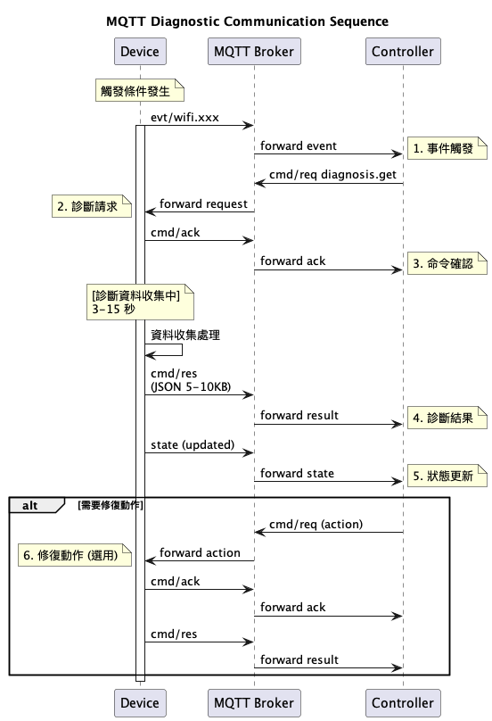

#### 訂閱模式建議

# Controller 全域監控

rtk/v1/+/+/+/evt/wifi.# # 所有 WiFi 事件

rtk/v1/+/+/+/lwt # 設備上下線狀態

rtk/v1/+/+/+/state # 設備健康狀態

# 特定場域監控

rtk/v1/office/+/+/evt/# # 辦公室所有事件

rtk/v1/factory/+/+/evt/wifi.# # 工廠 WiFi 事件

# 設備類型監控

rtk/v1/+/+/smart-camera-+/evt/# # 智能攝影機事件

### 23.5 診斷資料結構定義

#### WiFi 漫遊候選 AP 結構

{  
 "wifi_roam_candidate": {  
 "bssid": "string (MAC address format)",  
 "rssi": "integer (-100 to 0)",  
 "channel": "integer (1-165)",  
 "load_percentage": "integer (0-100)",  
 "roam_score": "integer (0-100)"  
 }  
}

#### 連線失敗分析結構

{  
 "connection_failure_analysis": {  
 "primary_cause": "enum [auth_timeout, assoc_timeout, key_install_fail]",  
 "failure_stage": "enum [beacon_detection, authentication, association, four_way_handshake]",  
 "contributing_factors": ["array of strings"],  
 "recommendations": ["array of strings"]  
 }  
}

#### ARP 統計結構

{  
 "arp_statistics": {  
 "source_ip": "string (IPv4)",  
 "destination_ip": "string (IPv4)",  
 "req_count": "integer",  
 "rsp_count": "integer",   
 "success_rate": "number (0-1)",  
 "avg_response_time_ms": "number"  
 }  
}

### 23.6 實作指南

#### Device 端實作要點

1. **事件觸發條件**: 依據個別單位資料中的觸發條件實作
2. **診斷資料收集**: 結合 RF 統計、流量分析、環境掃描
3. **冷卻機制**: 5 分鐘內相同事件不重複發送
4. **資料結構**: 遵循 JSON Schema 定義

#### Controller 端實作要點

1. **智能診斷請求**: 根據事件類型請求相應的診斷資料
2. **根因分析**: 利用診斷結果進行自動化分析
3. **修復建議**: 提供可執行的修復動作命令
4. **趨勢監控**: 追蹤診斷事件的模式和頻率

## 23. 變更紀錄（Changelog）

* **1.0**：首版，定義統一路徑、RPC 命令模型、Retained/LWT、安全與 ACL、群組命令與 Shadow 選項、JSON Schema 範例、WiFi 診斷實際應用範例。

# 附錄

## A. 系統架構與元件關係

*系統整體架構圖，說明 Device、Controller、MQTT Broker 之間的關係與資料流向*

MQTT Diag System Architecture Diagram

=========================================

![MQTT Diag System Architecture](system_architecture_complete.png)

## 系統架構與元件關係

MQTT Diag 系統採用中心化的訊息代理架構，由以下核心元件組成：

### 核心元件

1. **Controller (控制器)**

- 雲端或本地部署的控制服務

- 負責發送診斷命令與收集診斷資料

- 監控設備健康狀態與事件

2. **MQTT Broker (訊息代理)**

- 中央訊息路由器

- 處理 retained 訊息機制

- 管理 LWT (Last Will Testament) 訊息

3. **各類診斷設備**

- WiFi 路由器：提供 WiFi 診斷、漫遊事件

- 伺服器：系統指標、效能資料

- IoT 感測器：環境資料、電池狀態

- 網路交換器：埠統計、連線事件

### 訊息流向

1. **上行通訊 (Device → Controller)**

- state: 設備狀態摘要

- telemetry: 遙測資料與效能指標

- evt: 事件、告警、診斷事件

- attr: 設備屬性資訊

2. **下行通訊 (Controller → Device)**

- cmd/req: 診斷命令請求

3. **命令回應 (Device → Controller)**

- cmd/ack: 命令接收確認

- cmd/res: 命令執行結果

Topic Structure:

rtk/v1/{tenant}/{site}/{device_id}/

├── state (retained)

├── telemetry/

│ ├── wifi.scan_result

│ ├── cpu_usage

│ └── temperature

├── evt/

│ ├── wifi.roam_triggered

│ ├── system.error

│ └── hardware.fault

├── attr (retained)

├── cmd/

│ ├── req (downlink)

│ ├── ack (uplink)

│ └── res (uplink)

└── lwt (retained)

Key Components:

===============

1. MQTT Broker:

- Central message router

- Handles retained messages

- Manages LWT messages

2. Controller (Cloud/Local):

- Sends diagnosis commands

- Collects diagnostic data

- Monitors device health

3. Devices (Various Types):

- WiFi Router: WiFi diagnostics, roaming events

- Server: System metrics, performance data

- IoT Sensor: Environmental data, battery status

- Network Switch: Port statistics, link events

4. Message Types:

- state: Device health summary

- telemetry: Metrics and performance data

- evt: Events, alerts, errors

- attr: Device attributes and capabilities

- cmd: Command request/acknowledgment/response

- lwt: Last Will Testament for online/offline status

Communication Patterns:

======================

1. Periodic Reporting:

Devices regularly publish state and telemetry data

2. Event-Driven:

Devices publish events when specific conditions occur

3. On-Demand Diagnosis:

Controller requests specific diagnostic data using diagnosis.get command

4. Device Lifecycle:

LWT messages track device online/offline status

## B. MQTT 通訊流程與時序圖

*詳細的 MQTT 訊息交換時序圖，包含各種診斷場景的完整通訊流程*

# MQTT WiFi 診斷通訊流程與時序圖

## 1. 通用診斷流程時序圖

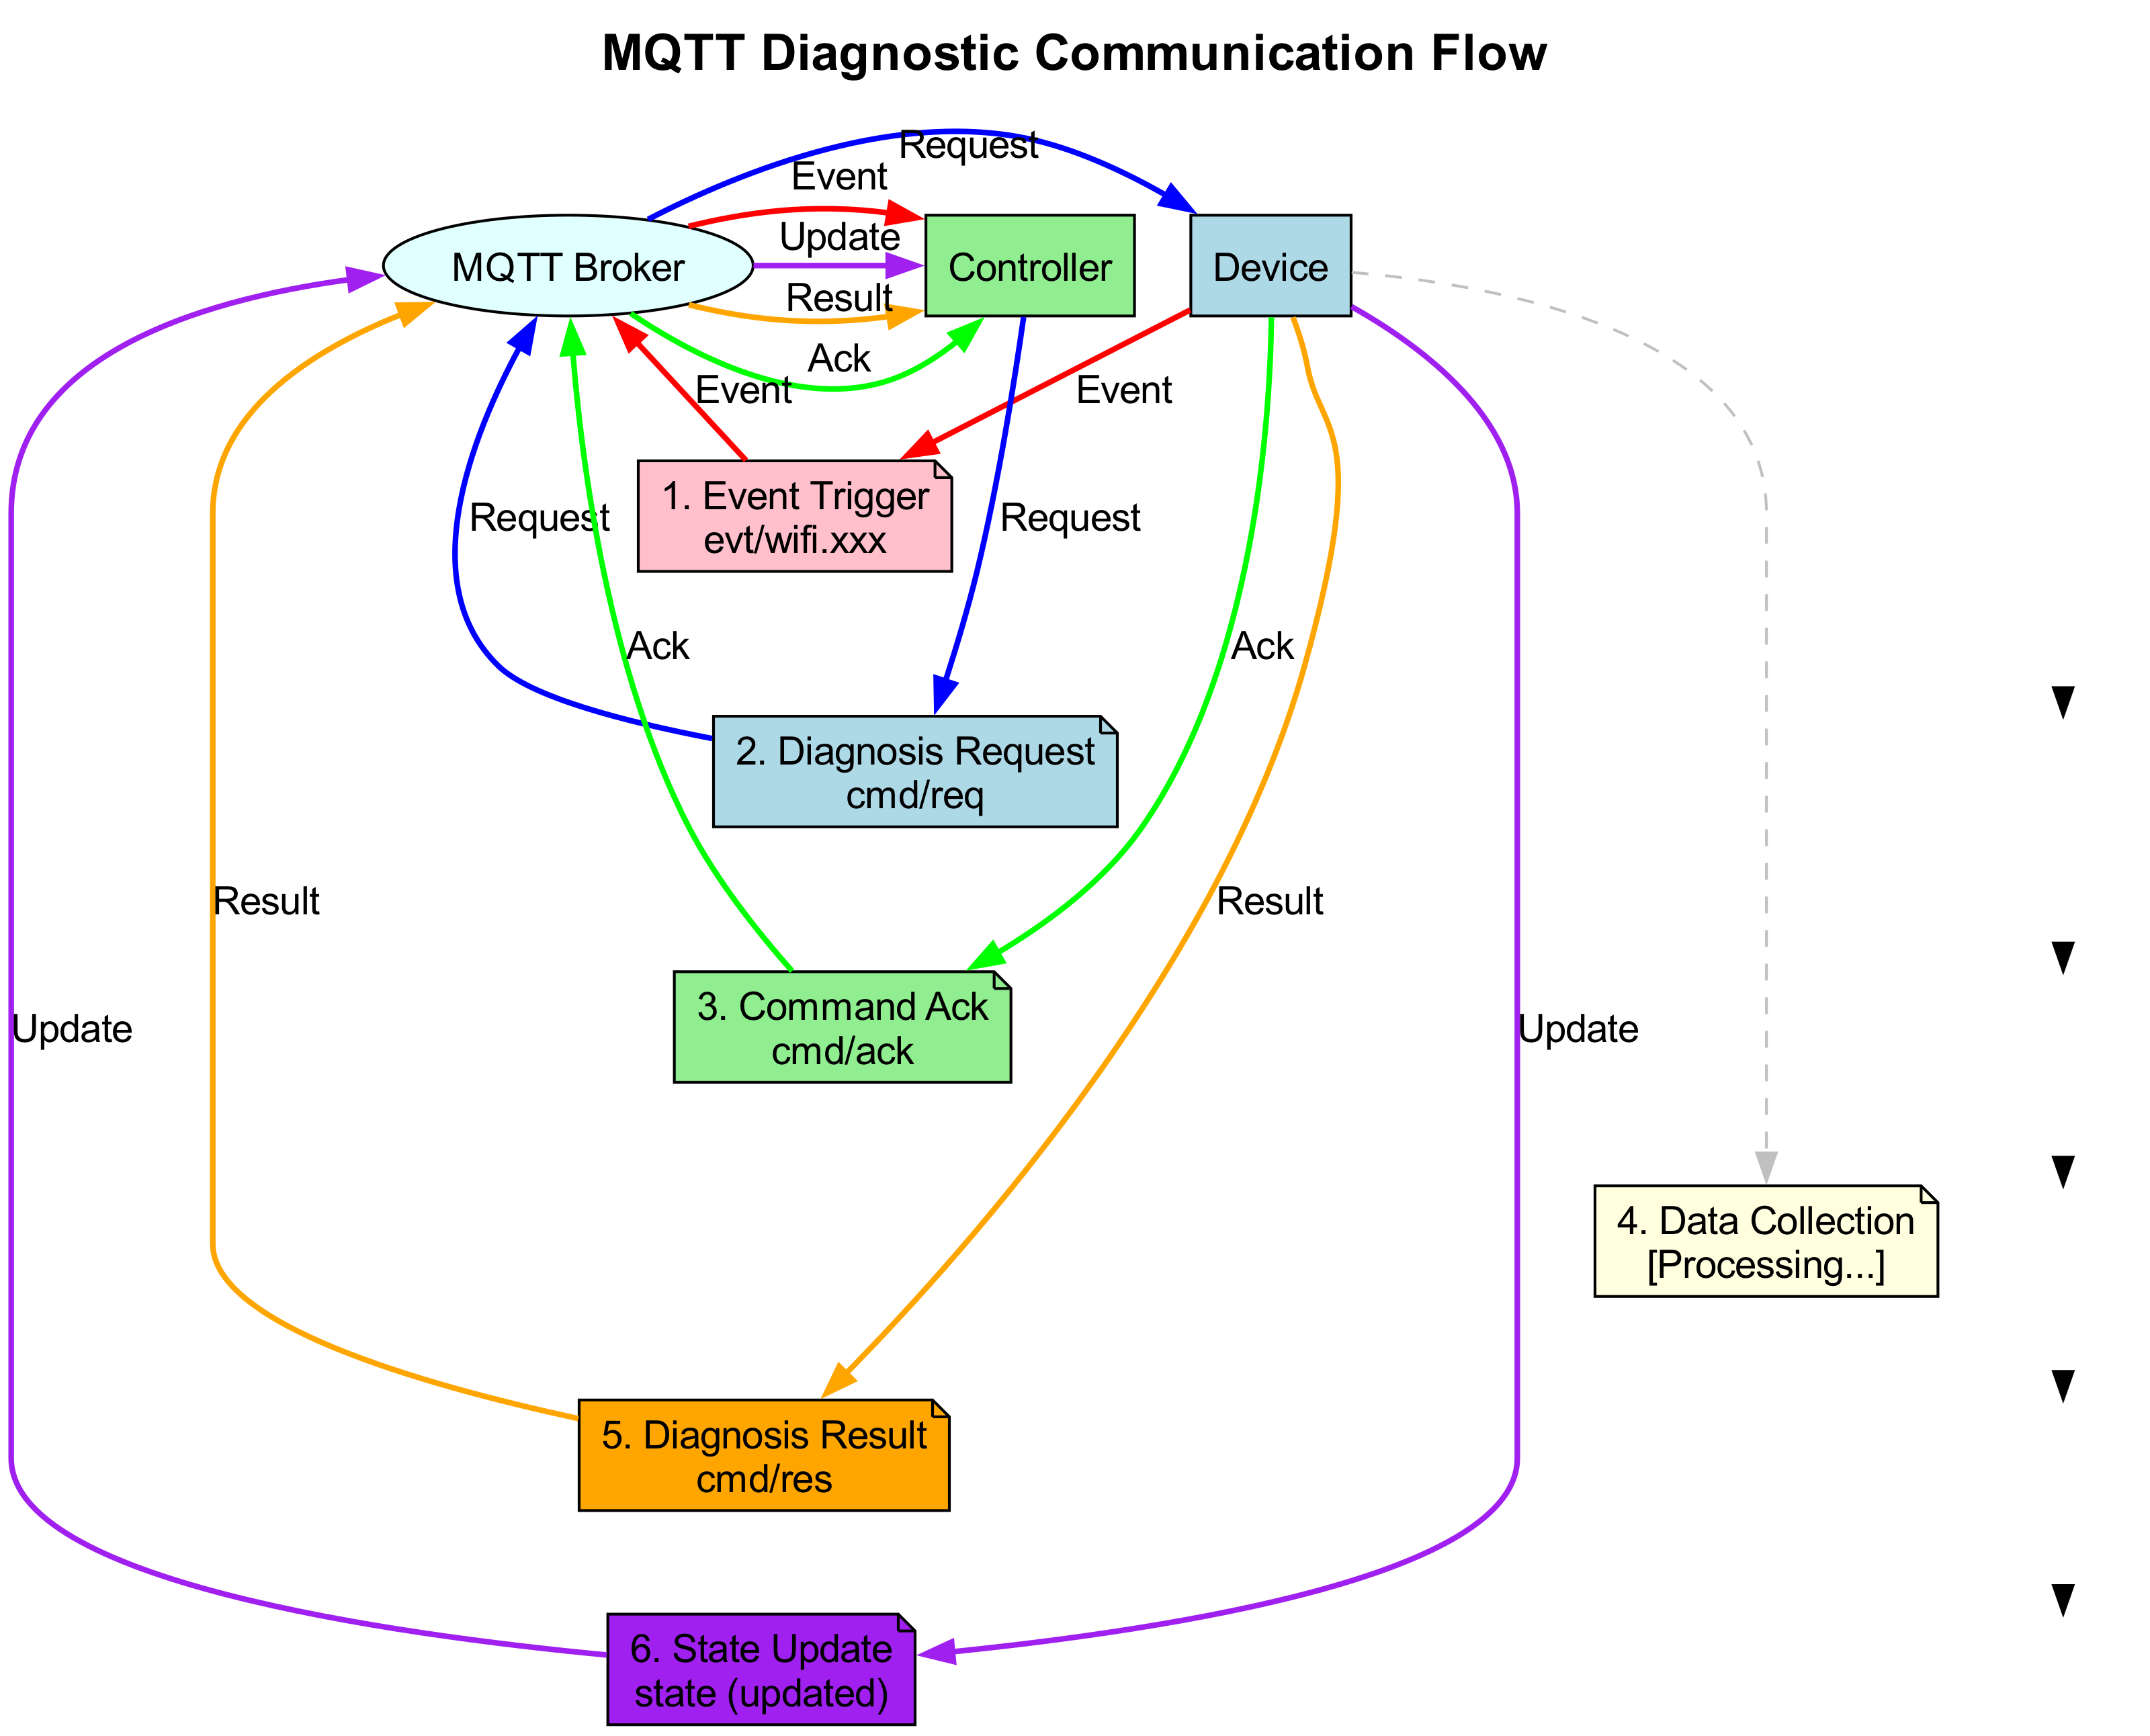

**詳細序列圖**：



## 2. 漫遊診斷完整流程

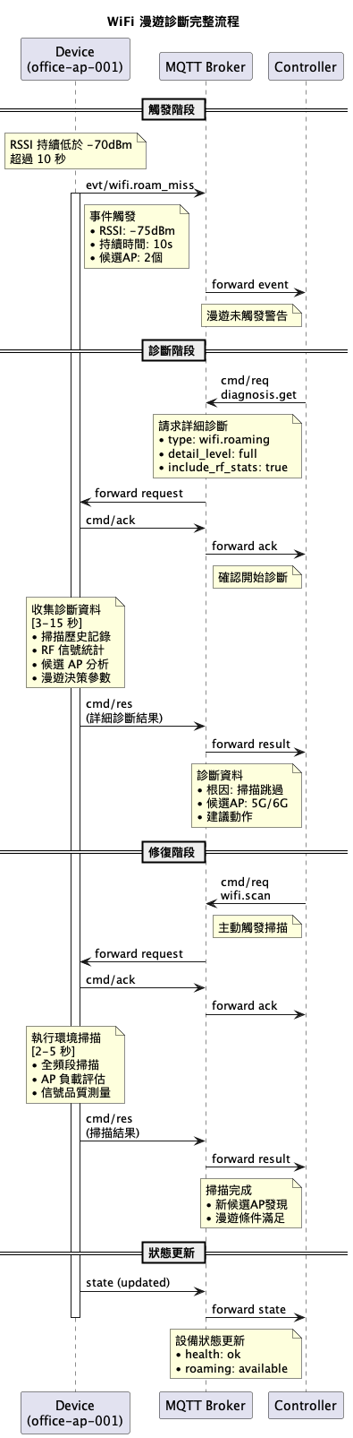

**詳細序列圖**：

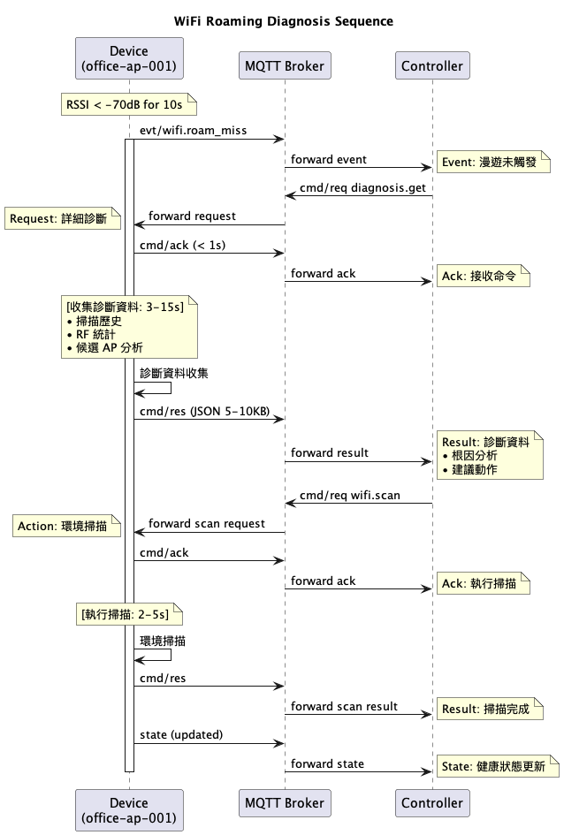

## 3. 連線失敗診斷流程

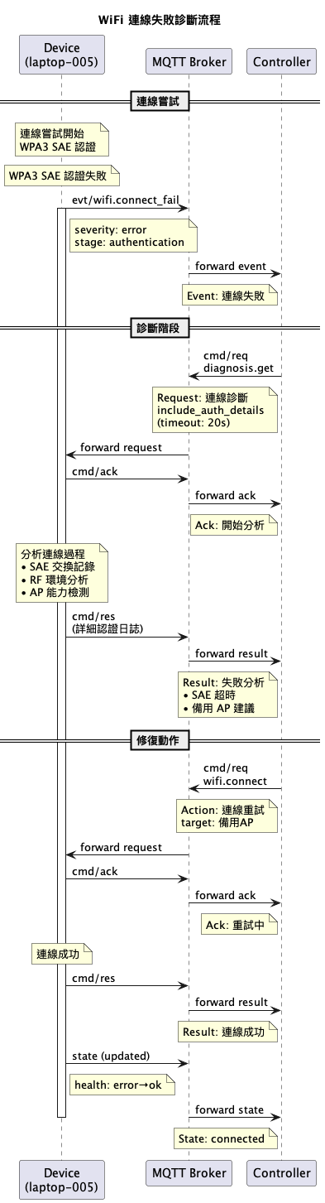

## 4. ARP 遺失診斷流程

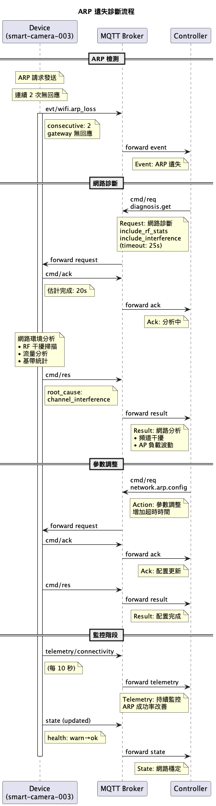

## 5. 訂閱模式與 Topic 路由

### 5.1 Controller 訂閱策略

全域監控:  
├── rtk/v1/+/+/+/evt/# # 所有事件  
├── rtk/v1/+/+/+/lwt # 設備上下線  
└── rtk/v1/+/+/+/state # 設備狀態  
  
特定場域監控:  
├── rtk/v1/office/+/+/evt/# # 辦公室事件  
├── rtk/v1/factory/+/+/evt/wifi.# # 工廠 WiFi 事件  
└── rtk/v1/corporate/+/+/cmd/ack # 企業命令確認  
  
設備類型監控:  
├── rtk/v1/+/+/smart-camera-+/evt/# # 智能攝影機  
├── rtk/v1/+/+/laptop-+/evt/wifi.# # 筆記型電腦 WiFi  
└── rtk/v1/+/+/office-ap-+/telemetry/# # 辦公室 AP 遙測

## 6. 錯誤處理與恢復流程

### 6.1 命令超時處理

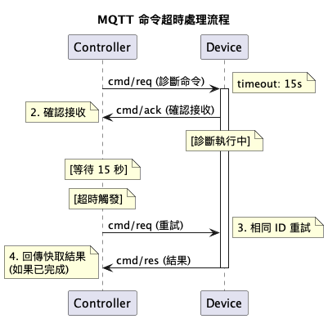

### 6.2 連線中斷恢復

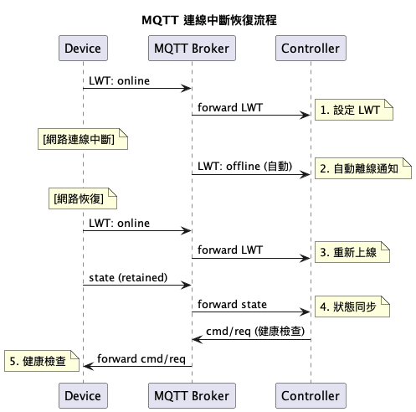

## 7. 效能最佳化建議

### 7.1 訊息大小控制

* **Event 訊息**: < 1KB (關鍵資訊)
* **Diagnostic 結果**: < 10KB (詳細分析)
* **Telemetry**: < 500B (定期指標)
* **State**: < 2KB (完整狀態)

### 7.2 頻率控制

* **Events**: 立即發送 + 5分鐘冷卻期
* **Diagnostics**: 按需請求，最大 1 次/分鐘
* **Telemetry**: 10-60 秒間隔
* **State**: 30-60 秒或狀態變更時

### 7.3 批次處理

{  
 "id": "batch-diag-001",  
 "op": "diagnosis.batch_get",  
 "args": {  
 "types": ["wifi.roaming", "wifi.interference", "wifi.performance"],  
 "correlation_id": "network_issue_001"  
 }  
}

## C. WiFi 連線失敗診斷範例

*最常見的連線問題診斷，包含認證失敗、超時等處理流程*

# WiFi 連線失敗診斷完整 MQTT 範例

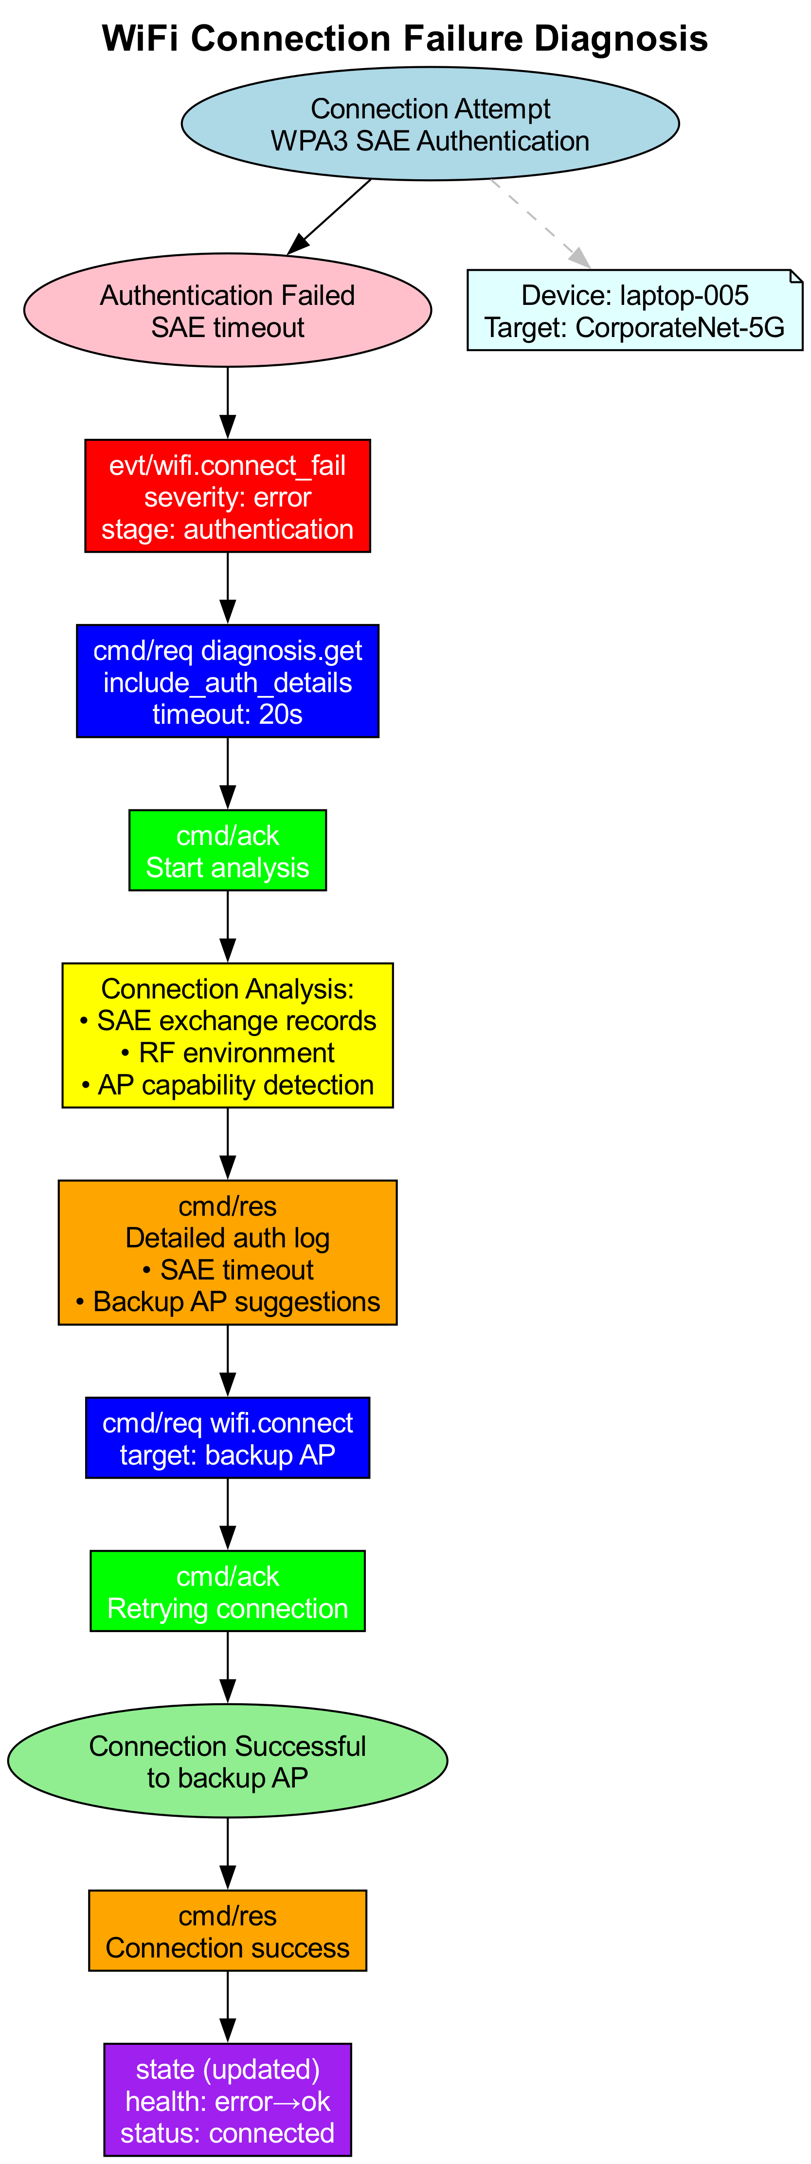

**詳細序列圖**：

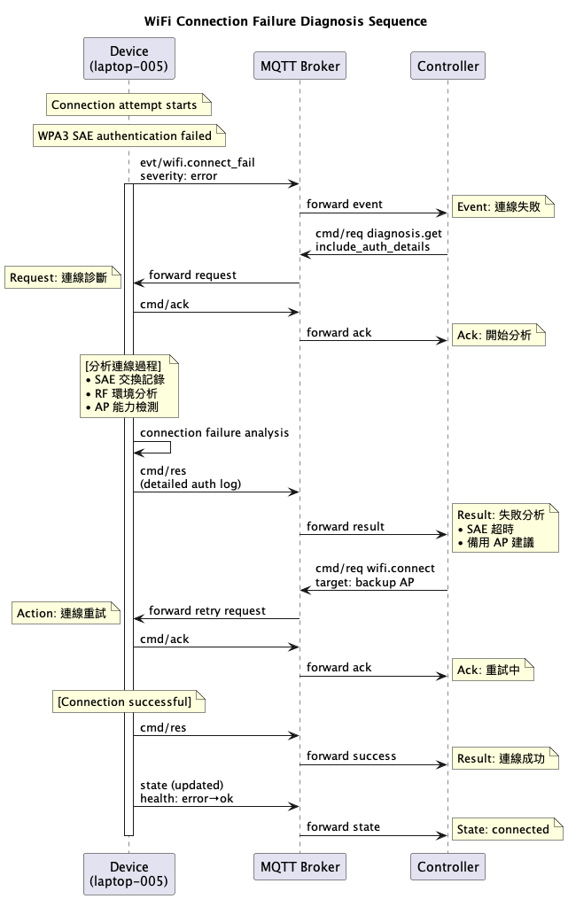

## 情境描述

用戶設備 laptop-005 嘗試連接到企業 WiFi CorporateNet-5G，但在 WPA3 認證階段失敗。

## MQTT 訊息流程

### 1. 連線失敗事件觸發 (Device → Controller)

**Topic**: rtk/v1/corporate/building-a/laptop-005/evt/wifi.connect_fail

**Retained**: false

{  
 "schema": "evt.wifi.connect_fail/1.0",  
 "ts": 1723526501000,  
 "severity": "error",  
 "connection_info": {  
 "role_type": "STA",  
 "target_bssid": "cc:dd:ee:ff:00:11",  
 "ssid": "CorporateNet-5G",  
 "security_type": "WPA3_SAE"  
 },  
 "failure_details": {  
 "join_status": "AUTH_TIMEOUT",   
 "join_rx_count": 18,  
 "tx_fail_category": "AUTH",  
 "auth_mode": "WPA3SAE",  
 "auth_algo": "SAE",  
 "four_way_status": 0,  
 "response_status_code": 0,  
 "failure_stage": "authentication"  
 },  
 "environment": {  
 "rssi": -52,  
 "channel": 44,  
 "bandwidth": "80MHz",  
 "interference_level": "low"  
 }  
}

### 2. Controller 請求詳細診斷 (Controller → Device)

**Topic**: rtk/v1/corporate/building-a/laptop-005/cmd/req

{  
 "id": "connect-diag-002",  
 "op": "diagnosis.get",  
 "schema": "cmd.diagnosis.get/1.0",  
 "args": {  
 "type": "wifi.connection",  
 "detail_level": "full",  
 "include_auth_details": true,  
 "include_rf_analysis": true,  
 "target_bssid": "cc:dd:ee:ff:00:11"  
 },  
 "timeout_ms": 20000,  
 "expect": "result",  
 "ts": 1723526502000  
}

### 3. Device 命令確認 (Device → Controller)

**Topic**: rtk/v1/corporate/building-a/laptop-005/cmd/ack

{  
 "id": "connect-diag-002",  
 "ts": 1723526502150,  
 "accepted": true,  
 "err": null  
}

### 4. Device 回傳詳細連線失敗診斷 (Device → Controller)

**Topic**: rtk/v1/corporate/building-a/laptop-005/cmd/res

{  
 "id": "connect-diag-002",  
 "ts": 1723526503800,  
 "ok": true,  
 "result": {  
 "diagnosis_type": "wifi.connection",  
 "device_type": "laptop_client",  
 "collection_time": 1723526503000,  
 "data": {  
 "connection_attempt": {  
 "start_time": 1723526498000,  
 "end_time": 1723526501000,  
 "total_duration_ms": 3000,  
 "attempt_count": 1,  
 "retry_count": 0  
 },  
 "target_ap_info": {  
 "bssid": "cc:dd:ee:ff:00:11",  
 "ssid": "CorporateNet-5G",  
 "rssi": -52,  
 "channel": 44,  
 "bandwidth": "80MHz",  
 "band": "5G",  
 "security": {  
 "type": "WPA3_SAE",  
 "akm_suite": "SAE_SHA256",  
 "pairwise_cipher": "CCMP_128",  
 "group_cipher": "CCMP_128",  
 "mgmt_group_cipher": "BIP_CMAC_128"  
 },  
 "capabilities": {  
 "ht_supported": true,  
 "vht_supported": true,  
 "he_supported": true,  
 "mfp_capable": true,  
 "mfp_required": true  
 }  
 },  
 "connection_stages": {  
 "beacon_detection": {  
 "status": "success",  
 "duration_ms": 200,  
 "beacons_received": 3,  
 "probe_responses_received": 2  
 },  
 "authentication": {  
 "status": "timeout",  
 "duration_ms": 2500,  
 "auth_algorithm": "SAE",  
 "auth_transactions": [  
 {  
 "sequence": 1,  
 "timestamp": 1723526498500,  
 "direction": "tx",   
 "status": "sent",  
 "tx_attempts": 3,  
 "ack_received": true  
 },  
 {  
 "sequence": 2,  
 "timestamp": 0,  
 "direction": "rx",  
 "status": "timeout",  
 "expected": true,  
 "received": false  
 }  
 ],  
 "sae_exchange": {  
 "commit_sent": true,  
 "commit_response_received": false,  
 "confirm_sent": false,  
 "confirm_response_received": false,  
 "pwd_id": null,  
 "rejected_groups": []  
 }  
 },  
 "association": {  
 "status": "not_attempted",  
 "reason": "authentication_failed"  
 },  
 "four_way_handshake": {  
 "status": "not_attempted",  
 "reason": "authentication_failed"  
 }  
 },  
 "failure_analysis": {  
 "primary_cause": "sae_timeout",  
 "contributing_factors": [  
 "ap_sae_processing_delay",  
 "possible_ap_overload"  
 ],  
 "recommendations": [  
 "retry_with_different_ap",  
 "check_ap_load_balance",  
 "verify_sae_configuration"  
 ]  
 },  
 "rf_environment": {  
 "channel_info": {  
 "primary_channel": 44,  
 "secondary_channel": 48,  
 "center_frequency": 5230,  
 "bandwidth": "80MHz"  
 },  
 "signal_quality": {  
 "rssi": -52,  
 "snr": 28,  
 "noise_floor": -95,  
 "signal_strength": "good"  
 },  
 "interference": {  
 "level": "low",  
 "sources": ["microwave"],  
 "channel_utilization": 25,  
 "adjacent_channel_interference": false  
 }  
 },  
 "device_state": {  
 "wifi_driver_version": "22.140.1",  
 "firmware_version": "ucode-36.177a0a2c",  
 "regulatory_domain": "TW",  
 "power_management": "disabled",  
 "roaming_enabled": true,  
 "sae_h2e_enabled": true,  
 "pmf_enabled": true  
 },  
 "network_scan_results": [  
 {  
 "bssid": "cc:dd:ee:ff:00:11",  
 "ssid": "CorporateNet-5G",  
 "rssi": -52,  
 "channel": 44,  
 "security": "WPA3_SAE",  
 "load": "medium"  
 },  
 {  
 "bssid": "cc:dd:ee:ff:00:22",   
 "ssid": "CorporateNet-5G",  
 "rssi": -58,  
 "channel": 48,  
 "security": "WPA3_SAE",  
 "load": "low"  
 },  
 {  
 "bssid": "cc:dd:ee:ff:00:33",  
 "ssid": "CorporateNet-2G",  
 "rssi": -45,  
 "channel": 6,  
 "security": "WPA2_PSK",  
 "load": "high"  
 }  
 ]  
 }  
 },  
 "err": null  
}

### 5. 狀態更新反映連線問題 (Device → Controller)

**Topic**: rtk/v1/corporate/building-a/laptop-005/state

**Retained**: true

{  
 "schema": "state/1.0",  
 "ts": 1723526504000,  
 "health": "error",  
 "fw": "ucode-36.177a0a2c",  
 "uptime_s": 8923,  
 "cpu_usage": 15.3,  
 "memory_usage": 68.4,  
 "temperature_c": 45.2,  
 "wifi_stats": {  
 "connection_status": "disconnected",  
 "last_connected_ssid": "HomeWiFi",  
 "last_disconnect_time": 1723523891000,  
 "connection_attempts": 1,  
 "connection_failures": 1,  
 "last_failure_reason": "auth_timeout"  
 },  
 "net": {  
 "interface": "wlan0",  
 "ip": null,  
 "connection_type": "wifi",  
 "connected": false  
 },  
 "diagnosis": {  
 "last_event": "wifi.connect_fail",  
 "last_event_time": 1723526501000,  
 "error_count": 1,  
 "warning_count": 0,  
 "connectivity_status": "no_internet"  
 }  
}

## 診斷分析結果

### 失敗原因分析

1. **SAE 認證超時**: AP 未在預期時間內回應 SAE commit 訊息
2. **AP 負載問題**: 可能的 AP 處理延遲或過載
3. **配置相容性**: SAE 參數設定可能存在不相容

### 建議修復動作

#### 立即動作

1. **嘗試連線備用 AP**:

{  
 "id": "auto-retry-001",  
 "op": "wifi.connect",  
 "schema": "cmd.wifi.connect/1.0",  
 "args": {  
 "ssid": "CorporateNet-5G",  
 "bssid": "cc:dd:ee:ff:00:22",  
 "security": "WPA3_SAE",  
 "priority": "high",  
 "timeout_ms": 30000  
 }  
}

#### 長期解決方案

1. **SAE 參數調整**: 檢查 H2E (Hash-to-Element) 設定
2. **AP 負載平衡**: 建議 IT 部門檢查 AP 負載分佈
3. **韌體更新**: 確認裝置與 AP 韌體相容性

### Controller 監控建議

**設定連線重試策略**:

{  
 "id": "retry-policy-001",  
 "op": "policy.set",  
 "schema": "cmd.policy.set/1.0",  
 "args": {  
 "policy_type": "connection_retry",  
 "max_retries": 3,  
 "retry_interval_ms": 5000,  
 "fallback_security": "WPA2_PSK",  
 "prefer_less_loaded_ap": true  
 }  
}

## D. ARP 遺失診斷範例

*網路連線品質診斷，包含封包遺失檢測與網路環境分析*

# ARP 遺失診斷完整 MQTT 範例

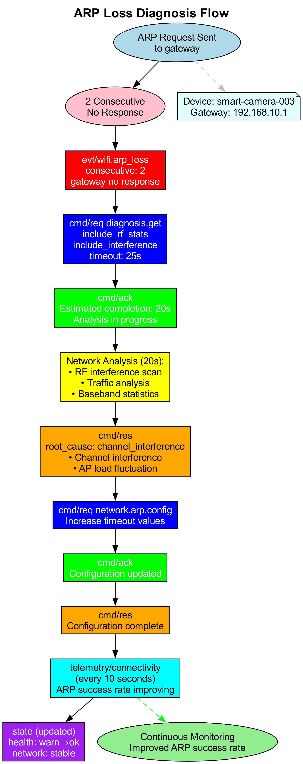

**詳細序列圖**：

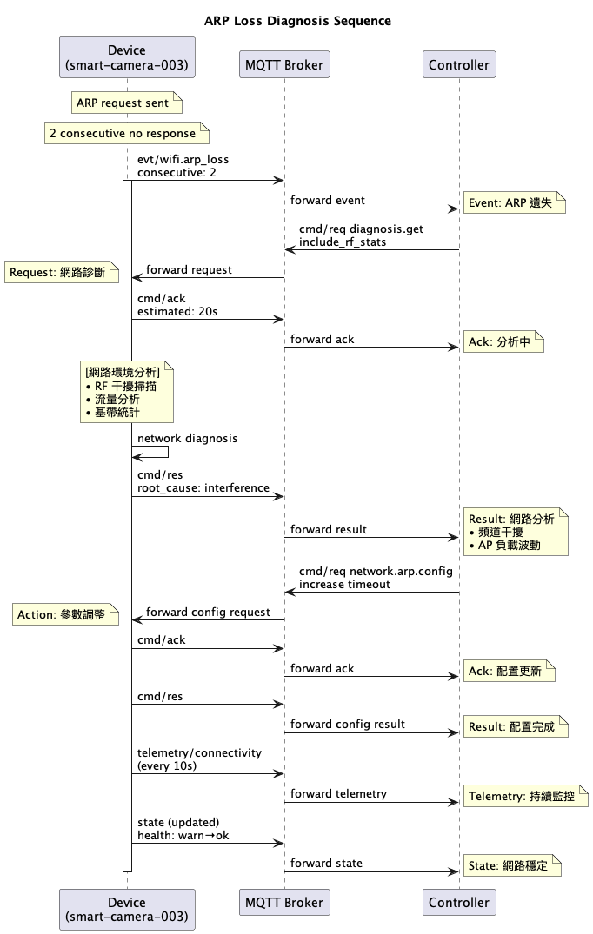

## 情境描述

IoT 設備 smart-camera-003 在監控網路環境中，連續2次 ARP response 未收到，可能導致網路連線中斷。

## MQTT 訊息流程

### 1. ARP 遺失事件觸發 (Device → Controller)

**Topic**: rtk/v1/factory/workshop/smart-camera-003/evt/wifi.arp_loss

**Retained**: false

{  
 "schema": "evt.wifi.arp_loss/1.0",  
 "ts": 1723526601000,  
 "severity": "warning",  
 "trigger_info": {  
 "consecutive_loss_count": 2,  
 "cooldown_ms": 300000,  
 "detection_window_ms": 15000  
 },  
 "network_info": {  
 "current_bssid": "bb:cc:dd:ee:ff:00",  
 "current_rssi": -67,  
 "channel_hw_match": true,  
 "scan_in_progress": false,  
 "link_quality": "degraded"  
 },  
 "arp_statistics": {  
 "source_ip": "192.168.10.203",  
 "destination_ip": "192.168.10.1",  
 "req_tx_fail_count": 2,  
 "req_count": 5,  
 "rsp_count": 3,  
 "success_rate": 0.6  
 },  
 "immediate_indicators": {  
 "packet_loss_detected": true,  
 "latency_increase": true,  
 "throughput_degraded": false  
 }  
}

### 2. Controller 請求詳細網路診斷 (Controller → Device)

**Topic**: rtk/v1/factory/workshop/smart-camera-003/cmd/req

{  
 "id": "arp-diag-003",  
 "op": "diagnosis.get",  
 "schema": "cmd.diagnosis.get/1.0",  
 "args": {  
 "type": "wifi.network",  
 "detail_level": "full",  
 "include_rf_stats": true,  
 "include_traffic_analysis": true,  
 "include_interference_scan": true,  
 "analysis_window_sec": 60  
 },  
 "timeout_ms": 25000,  
 "expect": "result",   
 "ts": 1723526602000  
}

### 3. Device 命令確認 (Device → Controller)

**Topic**: rtk/v1/factory/workshop/smart-camera-003/cmd/ack

{  
 "id": "arp-diag-003",  
 "ts": 1723526602300,  
 "accepted": true,  
 "estimated_completion_ms": 20000,  
 "err": null  
}

### 4. Device 回傳網路診斷分析 (Device → Controller)

**Topic**: rtk/v1/factory/workshop/smart-camera-003/cmd/res

{  
 "id": "arp-diag-003",  
 "ts": 1723526606500,  
 "ok": true,  
 "result": {  
 "diagnosis_type": "wifi.network",  
 "device_type": "smart_camera",  
 "collection_time": 1723526606000,  
 "analysis_window": {  
 "start_time": 1723526546000,  
 "end_time": 1723526606000,  
 "duration_sec": 60  
 },  
 "data": {  
 "network_connectivity": {  
 "gateway_ip": "192.168.10.1",  
 "dns_servers": ["192.168.10.10", "8.8.8.8"],  
 "dhcp_server": "192.168.10.1",  
 "subnet_mask": "255.255.255.0",  
 "connection_uptime_sec": 28947  
 },  
 "arp_analysis": {  
 "target_analysis": {  
 "ip": "192.168.10.1",   
 "mac": "aa:bb:cc:dd:ee:01",  
 "role": "gateway",  
 "reachability": "intermittent"  
 },  
 "recent_requests": [  
 {  
 "timestamp": 1723526598000,  
 "target_ip": "192.168.10.1",  
 "tx_attempts": 3,  
 "response_received": true,  
 "response_time_ms": 12  
 },  
 {  
 "timestamp": 1723526595000,  
 "target_ip": "192.168.10.1",  
 "tx_attempts": 3,  
 "response_received": false,  
 "timeout_ms": 3000  
 },  
 {  
 "timestamp": 1723526592000,  
 "target_ip": "192.168.10.1",  
 "tx_attempts": 3,  
 "response_received": false,  
 "timeout_ms": 3000  
 }  
 ],  
 "statistics": {  
 "total_requests": 15,  
 "successful_responses": 10,  
 "failed_requests": 5,  
 "success_rate": 0.67,  
 "average_response_time_ms": 18.5  
 }  
 },  
 "ap_connection_info": {  
 "bssid": "bb:cc:dd:ee:ff:00",  
 "ssid": "Factory-IoT-5G",  
 "channel": 149,  
 "bandwidth": "80MHz",  
 "band": "5G",  
 "rssi": -67,  
 "link_speed_mbps": 200,  
 "connection_duration_sec": 28947  
 },  
 "rf_diagnostics": {  
 "signal_quality": {  
 "rssi": -67,  
 "snr": 18,  
 "noise_floor": -95,  
 "signal_strength": "fair",  
 "trend": "declining"  
 },  
 "channel_analysis": {  
 "primary_channel": 149,  
 "center_frequency": 5745,  
 "channel_utilization": 65,  
 "interference_sources": [  
 {  
 "type": "bluetooth",  
 "strength": "weak",  
 "frequency_overlap": false  
 },  
 {  
 "type": "industrial_equipment",   
 "strength": "moderate",  
 "frequency_overlap": true,  
 "estimated_impact": "medium"  
 }  
 ]  
 },  
 "rf_calibration": {  
 "last_calibration": 1723495200000,  
 "calibration_status": "normal",  
 "errors_detected": false,  
 "next_calibration_due": 1723581600000  
 }  
 },  
 "traffic_analysis": {  
 "recent_5min": {  
 "rx_bytes": 2457600,  
 "tx_bytes": 1843200,  
 "rx_packets": 1890,  
 "tx_packets": 1432,  
 "rx_errors": 23,  
 "tx_errors": 8,  
 "rx_dropped": 12,  
 "tx_dropped": 3  
 },  
 "beacon_monitoring": {  
 "beacons_expected": 300,  
 "beacons_received": 287,  
 "beacon_loss_rate": 0.043,  
 "consecutive_missed_max": 3,  
 "avg_beacon_interval_ms": 102.1  
 },  
 "packet_loss_analysis": {  
 "overall_loss_rate": 0.021,  
 "upstream_loss_rate": 0.018,  
 "downstream_loss_rate": 0.024,  
 "loss_pattern": "sporadic",  
 "correlation_with_interference": true  
 }  
 },  
 "baseband_statistics": {  
 "rx_sensitivity": -85,  
 "false_alarm_rate": 2.1,  
 "cca_busy_time_percent": 35,  
 "txop_utilization": 0.23,  
 "retry_statistics": {  
 "short_retries": 145,  
 "long_retries": 28,  
 "retry_rate": 0.12  
 }  
 },  
 "environmental_factors": {  
 "nearby_networks": [  
 {  
 "ssid": "Factory-Guest",  
 "bssid": "bb:cc:dd:ee:ff:01",  
 "channel": 153,  
 "rssi": -72,  
 "interference_potential": "low"  
 },  
 {  
 "ssid": "Industrial-Control",   
 "bssid": "cc:dd:ee:ff:00:11",  
 "channel": 149,  
 "rssi": -58,  
 "interference_potential": "high"  
 }  
 ],  
 "channel_congestion": {  
 "primary_channel_busy": 0.65,  
 "secondary_channel_busy": 0.42,  
 "recommendation": "consider_channel_switch"  
 }  
 }  
 },  
 "root_cause_analysis": {  
 "primary_causes": [  
 "channel_interference",  
 "ap_load_fluctuation"  
 ],  
 "contributing_factors": [  
 "industrial_equipment_interference",  
 "co_channel_ap_competition",  
 "declining_signal_strength"  
 ],  
 "probability_scores": {  
 "rf_interference": 0.8,  
 "ap_overload": 0.6,  
 "hardware_issue": 0.2,  
 "network_congestion": 0.7  
 }  
 },  
 "recommendations": {  
 "immediate_actions": [  
 "monitor_signal_strength_trend",  
 "consider_ap_roaming",  
 "increase_arp_timeout"  
 ],  
 "short_term_fixes": [  
 "request_channel_change",  
 "optimize_ap_placement",  
 "reduce_non_critical_traffic"  
 ],  
 "long_term_solutions": [  
 "deploy_additional_ap",  
 "implement_load_balancing",  
 "upgrade_to_wifi6e"  
 ]  
 }  
 },  
 "err": null  
}

### 5. 遙測資料持續監控 (Device → Controller)

**Topic**: rtk/v1/factory/workshop/smart-camera-003/telemetry/wifi.connectivity

**Retained**: false

{  
 "schema": "telemetry.wifi.connectivity/1.0",   
 "ts": 1723526610000,  
 "metrics": {  
 "arp_success_rate": 0.72,  
 "avg_response_time_ms": 15.3,  
 "packet_loss_rate": 0.019,  
 "rssi": -66,  
 "link_quality": 68,  
 "throughput_mbps": {  
 "rx": 12.5,  
 "tx": 8.3  
 }  
 },  
 "trend_indicators": {  
 "signal_improving": true,  
 "connectivity_stabilizing": true,  
 "interference_decreasing": false  
 }  
}

### 6. 狀態更新顯示網路品質改善 (Device → Controller)

**Topic**: rtk/v1/factory/workshop/smart-camera-003/state

**Retained**: true

{  
 "schema": "state/1.0",  
 "ts": 1723526611000,  
 "health": "warn",  
 "fw": "2.1.4",  
 "uptime_s": 28954,  
 "cpu_usage": 42.1,  
 "memory_usage": 58.7,  
 "temperature_c": 52.3,  
 "wifi_stats": {  
 "connection_status": "connected",  
 "ssid": "Factory-IoT-5G",  
 "rssi": -66,  
 "link_quality": "fair",  
 "packet_loss_rate": 0.019,  
 "arp_success_rate": 0.72,  
 "last_connectivity_issue": 1723526601000,  
 "interference_level": "moderate"  
 },  
 "net": {  
 "interface": "wlan0",  
 "ip": "192.168.10.203",  
 "gateway": "192.168.10.1",  
 "dns": ["192.168.10.10", "8.8.8.8"],  
 "bytes_rx": 48576000,  
 "bytes_tx": 23456000,  
 "connection_uptime_sec": 28947  
 },  
 "diagnosis": {  
 "last_event": "wifi.arp_loss",  
 "last_event_time": 1723526601000,  
 "error_count": 0,  
 "warning_count": 1,  
 "network_stability": "improving"  
 },  
 "device_specific": {  
 "camera_streaming": {  
 "status": "active",  
 "resolution": "1080p",  
 "bitrate_kbps": 2500,  
 "frames_dropped": 12,  
 "stream_health": "good"  
 }  
 }  
}

## 診斷分析結果

### 根本原因

1. **頻道干擾**: 工業設備在相同頻道產生干擾，導致封包遺失
2. **AP 負載波動**: 同頻道其他 AP 競爭造成的週期性干擾
3. **訊號強度下降**: RSSI 從 -60dBm 降至 -67dBm

### 即時處理動作

**調整 ARP 參數**:

{  
 "id": "arp-tune-001",  
 "op": "network.arp.config",   
 "schema": "cmd.network.arp.config/1.0",  
 "args": {  
 "timeout_ms": 5000,  
 "retry_count": 5,  
 "probe_interval_sec": 30,  
 "adaptive_timeout": true  
 }  
}

**請求頻道切換評估**:

{  
 "id": "channel-eval-001",  
 "op": "wifi.channel.evaluate",  
 "schema": "cmd.wifi.channel.evaluate/1.0",   
 "args": {  
 "current_channel": 149,  
 "candidate_channels": [36, 40, 44, 48, 157, 161],  
 "evaluation_duration_sec": 30,  
 "include_interference_scan": true  
 }  
}

### 持續監控策略

**加強遙測頻率**:

{  
 "id": "monitor-enhance-001",  
 "op": "telemetry.schedule",  
 "schema": "cmd.telemetry.schedule/1.0",  
 "args": {  
 "metrics": ["wifi.connectivity", "wifi.interference"],  
 "interval_sec": 10,  
 "duration_sec": 1800,  
 "alert_thresholds": {  
 "arp_success_rate": 0.8,  
 "packet_loss_rate": 0.05,  
 "rssi_threshold": -70  
 }  
 }  
}

## E. WiFi 漫遊診斷範例

*複雜的漫遊機制診斷，包含 AP 選擇與切換過程分析*

# 漫遊問題診斷完整 MQTT 範例

## 情境描述

設備 office-ap-001 在辦公室環境中，RSSI 降到 -75dBm 並持續 10 秒，但系統未觸發漫遊機制。

## MQTT 訊息流程

### 1. 事件觸發 (Device → Controller)

**Topic**: rtk/v1/office/floor1/office-ap-001/evt/wifi.roam_miss

**Retained**: false

{  
 "schema": "evt.wifi.roam_miss/1.0",  
 "ts": 1723526401000,  
 "severity": "warning",  
 "trigger_info": {  
 "rssi_threshold": -70,  
 "duration_ms": 10000,  
 "cooldown_ms": 300000  
 },  
 "diagnosis": {  
 "internal_scan_skip_count": 3,  
 "environment_ap_count": 8,  
 "candidate_ap_count": 2,  
 "current_bssid": "aa:bb:cc:dd:ee:ff",  
 "current_rssi": -75,  
 "candidates": {  
 "2g": {  
 "bssid": "00:00:00:00:00:00",  
 "rssi": 0,  
 "channel": 0  
 },  
 "5g": {  
 "bssid": "11:22:33:44:55:66",  
 "rssi": -42,  
 "channel": 36  
 },  
 "6g": {  
 "bssid": "77:88:99:aa:bb:cc",  
 "rssi": -48,  
 "channel": 37  
 }  
 },  
 "scan_timing": {  
 "last_scan_time": 1723526395000,  
 "last_full_scan_complete_time": 1723526380000  
 }  
 }  
}

### 2. Controller 請求詳細診斷 (Controller → Device)

**Topic**: rtk/v1/office/floor1/office-ap-001/cmd/req

{  
 "id": "roam-diag-001",  
 "op": "diagnosis.get",  
 "schema": "cmd.diagnosis.get/1.0",   
 "args": {  
 "type": "wifi.roaming",  
 "detail_level": "full",  
 "include_history": true,  
 "include_rf_stats": true  
 },  
 "timeout_ms": 15000,  
 "expect": "result",  
 "ts": 1723526402000  
}

### 3. Device 命令確認 (Device → Controller)

**Topic**: rtk/v1/office/floor1/office-ap-001/cmd/ack

{  
 "id": "roam-diag-001",  
 "ts": 1723526402200,  
 "accepted": true,  
 "err": null  
}

### 4. Device 回傳詳細診斷結果 (Device → Controller)

**Topic**: rtk/v1/office/floor1/office-ap-001/cmd/res

{  
 "id": "roam-diag-001",   
 "ts": 1723526403500,  
 "ok": true,  
 "result": {  
 "diagnosis_type": "wifi.roaming",  
 "device_type": "wifi_access_point",  
 "collection_time": 1723526403000,  
 "data": {  
 "roaming_analysis": {  
 "trigger_reasons": [  
 "poor_signal_quality",  
 "scan_skip_detected"  
 ],  
 "skip_analysis": {  
 "total_skips_10sec": 3,  
 "skip_reasons": ["scan_in_progress", "channel_switch_delay"],  
 "last_successful_scan": 1723526395000,  
 "scan_interval_ms": 5000,  
 "expected_scan_count": 2,  
 "actual_scan_count": 0  
 },  
 "environmental_scan": {  
 "total_ap_detected": 8,  
 "same_ssid_ap_count": 3,  
 "better_rssi_ap_count": 2,  
 "roam_candidate_count": 2  
 }  
 },  
 "current_connection": {  
 "bssid": "aa:bb:cc:dd:ee:ff",  
 "ssid": "OfficeWiFi-5G",  
 "rssi": -75,  
 "channel": 149,  
 "bandwidth": "80MHz",  
 "band": "5G",  
 "connection_duration_ms": 1847500,  
 "last_roam_time": 1723524553500  
 },  
 "roam_candidates": [  
 {  
 "band": "5G",  
 "bssid": "11:22:33:44:55:66",  
 "ssid": "OfficeWiFi-5G",   
 "rssi": -42,  
 "channel": 36,  
 "bandwidth": "80MHz",  
 "estimated_throughput_mbps": 450,  
 "load_percentage": 25,  
 "roam_score": 85  
 },  
 {  
 "band": "6G",  
 "bssid": "77:88:99:aa:bb:cc",  
 "ssid": "OfficeWiFi-6G",  
 "rssi": -48,  
 "channel": 37,  
 "bandwidth": "160MHz",   
 "estimated_throughput_mbps": 980,  
 "load_percentage": 15,  
 "roam_score": 92  
 }  
 ],  
 "rf_statistics": {  
 "interference_level": "moderate",  
 "noise_floor_dbm": -95,  
 "channel_utilization_percent": 45,  
 "retry_rate_percent": 12.5,  
 "packet_loss_rate_percent": 2.1  
 },  
 "scan_history": [  
 {  
 "timestamp": 1723526395000,  
 "duration_ms": 850,  
 "channels_scanned": [36, 40, 44, 48, 149, 153, 157, 161],  
 "ap_found": 8,  
 "trigger_reason": "periodic_background"  
 },  
 {  
 "timestamp": 1723526380000,  
 "duration_ms": 1200,  
 "channels_scanned": [36, 40, 44, 48, 149, 153, 157, 161],  
 "ap_found": 7,  
 "trigger_reason": "roam_evaluation"  
 }  
 ]  
 }  
 },  
 "err": null  
}

### 5. 狀態更新 (Device → Controller) - 定期發送

**Topic**: rtk/v1/office/floor1/office-ap-001/state

**Retained**: true

{  
 "schema": "state/1.0",  
 "ts": 1723526404000,  
 "health": "warn",  
 "fw": "1.2.3",  
 "uptime_s": 4567,  
 "cpu_usage": 35.2,  
 "memory_usage": 42.8,  
 "temperature_c": 38.5,  
 "wifi_stats": {  
 "current_rssi": -75,  
 "connection_quality": "poor",  
 "roaming_enabled": true,  
 "last_roam_attempt": 0,  
 "roam_candidate_count": 2  
 },  
 "net": {  
 "interface": "wlan0",  
 "ip": "10.0.1.23",  
 "bytes_rx": 1048576,  
 "bytes_tx": 524288,  
 "packets_dropped": 127  
 },  
 "diagnosis": {  
 "last_event": "wifi.roam_miss",  
 "last_event_time": 1723526401000,  
 "error_count": 1,  
 "warning_count": 3  
 }  
}

## 診斷分析結果

基於這次診斷資料，可以得出以下結論：

### 根本原因分析

1. **掃描跳過問題**: 10秒內有3次掃描被跳過，導致無法及時發現更好的AP
2. **掃描觸發延遲**: 上次完整掃描距離事件發生已經21秒
3. **候選AP可用**: 環境中有2個更好的AP可供漫遊

### 建議動作

1. **立即動作**: 觸發一次完整的環境掃描
2. **配置調整**: 降低掃描間隔或調整掃描跳過條件
3. **持續監控**: 關注後續5分鐘內的漫遊行為

### Controller 後續動作建議

**觸發環境掃描命令**:

{  
 "id": "emergency-scan-001",  
 "op": "wifi.scan",  
 "schema": "cmd.wifi.scan/1.0",  
 "args": {  
 "scan_type": "full_active",  
 "channels": [36, 40, 44, 48, 149, 153, 157, 161],  
 "dwell_time_ms": 100,  
 "priority": "high"  
 },  
 "timeout_ms": 10000,  
 "expect": "result",  
 "ts": 1723526405000  
}