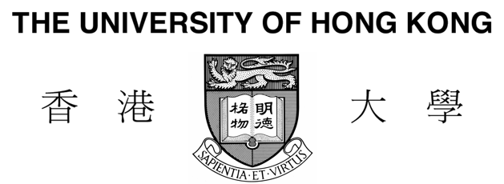

## For Office Use

□Membership fee received

Acknowledged:

PGSA No.:

Date of Receipt:

**POSTGRADUATE STUDENT ASSOCATION**

**Membership Application Form**

|  |  |  |  |
| --- | --- | --- | --- |
| **PERSONAL INFORMATION** | | | |
| Surname (in full): | | Given name (in full): | |
| Name in Chinese (if applicable): | | | University No.: |
| Gender: | Nationality: | | Date of Birth (dd/mm/yyyy): |
| Email: | | Contact No.: | |
| Personal Interests: | | | |
| **ACADEMIC INFORMATION** | | | |
| Study Programme: | | Registration Date: | |
| Faculty: | | Academic Year: | |
| Department: | | Expected Graduation Date: | |
| **PGSA EXECUTIVE COMMITTEE** | | | |
| Are you interested in join the Executive Committee of PGSA? □ Yes □ No | | | |
| If yes, which area(s) would you like to work for? (You may select three at most. Please indicate order)   |  |  |  |  | | --- | --- | --- | --- | | □Secretary | □Treasury | □Academic Programme | □Sports Programme | | □Membership | □External Relationship | □Publication | □Social Program | | | | |
| **MEMBERSHIP FEE PAYMENT (The fee is life-long)** | | | |
| I would like to pay the 100HKD PGSA membership fee by: □ Cheque □ Deposit □ Cash  Note: Cheques should be payable to "**Postgraduate Student Association, University of Hong Kong**".  Deposit should be made to the PGSA account at HSBC A/C **082-278128-001**. | | | |

The information provided will be used for application-related purposes only and kept confidential. Under the Personal Data (Privacy) Ordinance, applicants have rights to request access to and/or correction of their personal data held by PGSA of the University of Hong Kong. Requests should be made to the PGSA office, The University of Hong Kong (E-mail: [pgsa@hku.hk](mailto:pgsa@hku.hk); Address: P407, Graduate House, No. 3 University Drive, The University of Hong Kong).

Date: _________________________ Signature: _________________________