

Functional Safety Concept Lane Assistance

**Document Version: [Version]**

**Template Version 1.0, Released on 2017-06-21**



# Document history

|  |  |  |  |
| --- | --- | --- | --- |
| Date | Version | Editor | Description |
| 2018-06-17 | 1.0 | H. Kube | Initial version |
|  |  |  |  |
|  |  |  |  |
|  |  |  |  |
|  |  |  |  |

# Table of Contents

Document history

Table of Contents

Purpose of the Functional Safety Concept

Inputs to the Functional Safety Analysis

Safety goals from the Hazard Analysis and Risk Assessment

Preliminary Architecture

Description of architecture elements

Functional Safety Concept

Functional Safety Analysis

Functional Safety Requirements

Refinement of the System Architecture

Allocation of Functional Safety Requirements to Architecture Elements

Warning and Degradation Concept

# Purpose of the Functional Safety Concept

The purpose of the functional safety concept is to refine safety goals in functional safety requirements and then allocate these requirements to sub-systems in the high-level architecture.

# Inputs to the Functional Safety Concept

## Safety goals from the Hazard Analysis and Risk Assessment

|  |  |
| --- | --- |
| **ID** | **Safety Goal** |
| Safety_Goal_01 | The oscillating steering torque from the lane departure warning function shall be limited. |
| Safety_Goal_02 | The lane keeping assistance function shall be time limited and the additional steering torque shall end after a given time interval so that the driver cannot misuse the system autonomous driving. |
| Safety_Goal_03 | The lane keeping assistance shall be able to detect yellow lane markings and prefer them over white lane markings. |
| Safety_Goal_04 | The lane departure warning shall not apply any torque to the wheel in case the lane markings are not clearly visible. |

## Preliminary Architecture

The figure below describes the Lane Assistance item architecture.

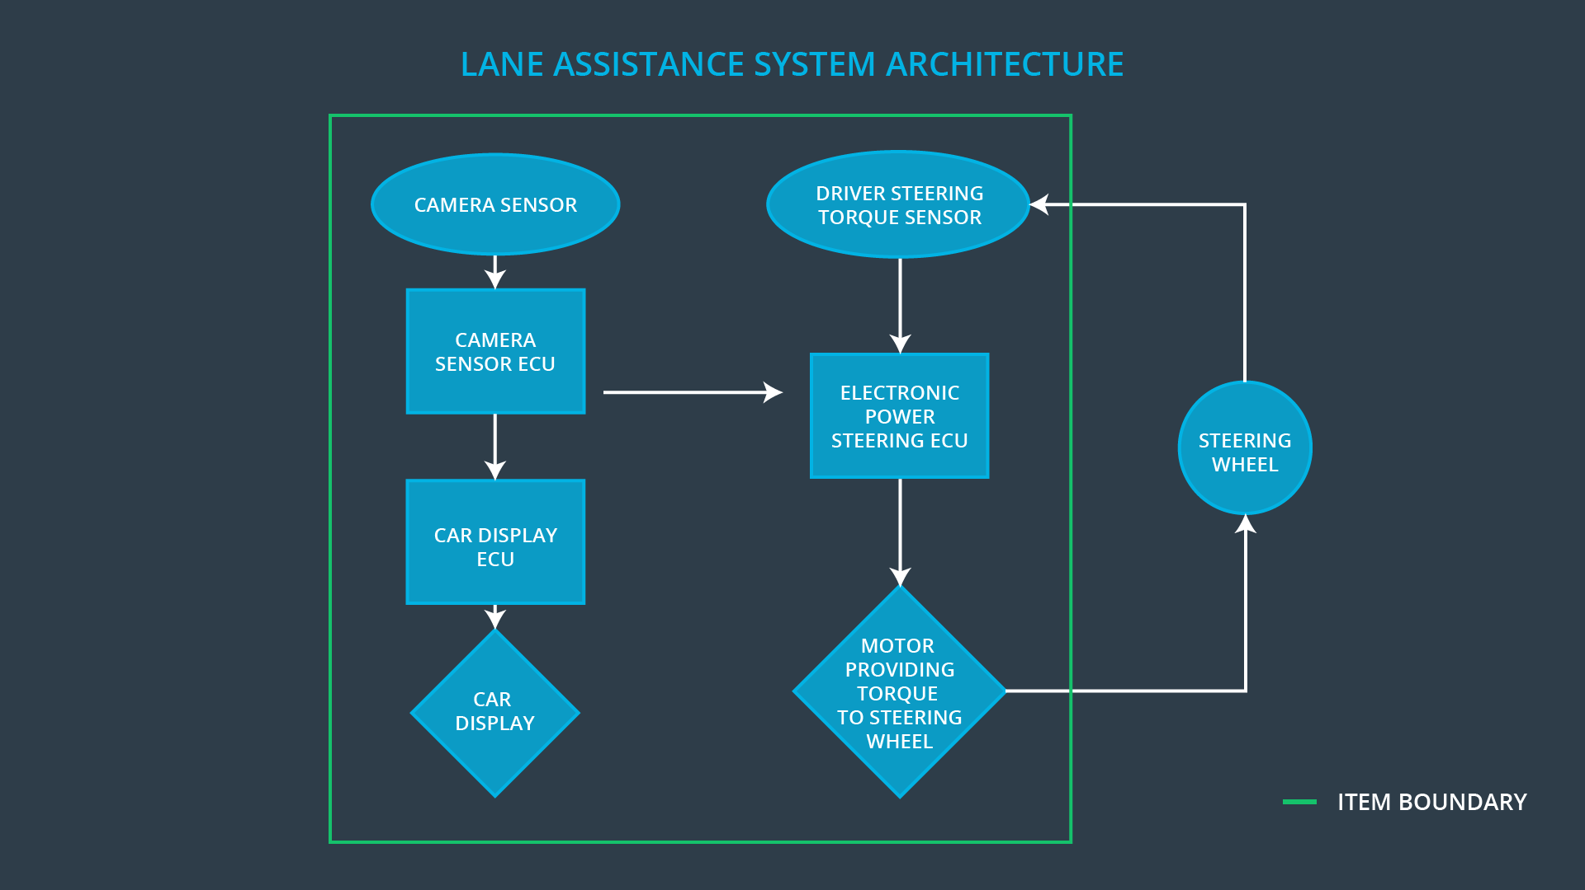

### Description of architecture elements

|  |  |
| --- | --- |
| **Element** | **Description** |
| Camera Sensor | Captures road images and provide them to the Camera Sensor ECU |
| Camera Sensor ECU | Analyzes the road images, detect the lane markings positions, and calculates the verhicle position in respect to the ego lane. |
| Car Display | Shows the driver the lane keeping assistance warning and status. |
| Car Display ECU | Generates warning and status signals and show them on the Car Display. |
| Driver Steering Torque Sensor | Measures the torque applied by the driver to the wheel. |
| Electronic Power Steering ECU | Compares the torque measured by the Driver Steering Torque Sensor, compares this with the torque requested by the lane keeping assistance and drives the motor to apply the missing torque. |
| Motor | Applies the torque requested by the Electronic Power Steering ECU to the wheel. |

# Functional Safety Concept

The functional safety concept consists of:

* Functional safety analysis
* Functional safety requirements
* Functional safety architecture
* Warning and degradation concept

## Functional Safety Analysis

|  |  |  |  |
| --- | --- | --- | --- |
| **Malfunction ID** | **Main Function of the Item Related to Safety Goal Violations** | **Guidewords (NO, WRONG, EARLY, LATE, MORE, LESS)** | **Resulting Malfunction** |
| Malfunction_01 | Lane Departure Warning (LDW) function shall apply an oscillating steering torque to provide the driver a haptic feedback | MORE | The lane departure warning function applies an oscillating torque with very high torque amplitude (above limit). |
| Malfunction_02 | Lane Departure Warning (LDW) function shall apply an oscillating steering torque to provide the driver a haptic feedback | MORE | The lane departure warning function applies an oscillating torque with very high torque amplitude (above limit). |
| Malfunction_03 | Lane Keeping Assistance (LKA) function shall apply the steering torque when active in order to stay in ego lane | NO | The lane keeping assistance function is not limited in time duration which leads to misuse as an autonomous driving function. |
| Malfunction_04 | Lane Keeping Assistance (LKA) function shall apply the steering torque when active in order to stay in ego lane | WRONG | The camera sensor might detect the wrong lane markings in road construction zones |
| Malfunction_05 | Lane Departure Warning (LDW) function shall apply an oscillating steering torque to provide the driver a haptic feedback | WRONG | The camera sensor might detect the lane markings wrong in situation with degraded view (e. G. dense fog). |

## Functional Safety Requirements

Lane Departure Warning (LDW) Requirements:

|  |  |  |  |  |
| --- | --- | --- | --- | --- |
| **ID** | **Functional Safety Requirement** | **ASIL** | **Fault Tolerant Time Interval** | **Safe State** |
| Functional  Safety  Requirement  01-01 | The lane keeping item shall ensure that the lane departure oscillating torque amplitude is below Max_Torque_Amplitude. | C | 50 ms | Lane assistance functionality is deactivated. |
| Functional  Safety  Requirement  01-02 | The lane keeping item shall ensure that the lane departure oscillating torque frequency is below Max_Torque_Frequency. | C | 50 ms | Lane assistance functionality is deactivated. |
| Safety Requirement 01-03 | The lane keeping item shall not apply any torque to the wheel if the contrast of the road images is below Min_Image_Contrast. | B | 50 ms | Lane assistance functionality is deactivated. |

Lane Departure Warning (LDW) Verification and Validation Acceptance Criteria:

|  |  |  |
| --- | --- | --- |
| **ID** | **Validation Acceptance**  **Criteria and Method** | **Verification Acceptance**  **Criteria and Method** |
| Functional  Safety  Requirement  01-01 | The how different drivers react to different torque value to prove that an appropriate value is chosen. | Verify that the system is turned off if the torque exceeds Max_Torque_Amplitude |
| Functional  Safety  Requirement  01-02 | The how different drivers react to different torque frequency to prove that an appropriate value is chosen. | Verify that the system is turned off if the torque exceeds Max_Torque_Frequency |
| Functional Safety Requirement 01-03 | Validate the contrast level of the road images at which the camera is just able to detect the lane markings properly. | Verify that the no torque is applied if the contrast level is below Min_Image_Contrast |

Lane Keeping Assistance (LKA) Requirements:

|  |  |  |  |  |
| --- | --- | --- | --- | --- |
| **ID** | **Functional Safety Requirement** | **ASIL** | **Fault Tolerant Time Interval** | **Safe State** |
| Functional  Safety  Requirement  02-01 | The electronic power steering ECU shall ensure that the lane keeping assistance torque is applied for only Max_Duration. | B | 500 ms | Lane keeping function is deactivated |
| Functional Safety Requirement 02-02 | The lane keeping assistance shall detect the color of the line markings and prefer yellow markings over white markings | C | 50 ms | Yellow lines are detected |

Lane Keeping Assistance (LKA) Verification and Validation Acceptance Criteria:

|  |  |  |
| --- | --- | --- |
| **ID** | **Validation Acceptance**  **Criteria and Method** | **Verification Acceptance**  **Criteria and Method** |
| Functional  Safety  Requirement  02-01 | Validate the Max_Duration chosen does not allow the driver to use the car as self-driving car. | Verify that the lane keeping assistance is deactivated after the driver does not apply any torque to the wheel for more than Max_Duration |
| Functional Safety Requirement 02-02 | Validate that the camera can clearly distinguish yellow lines from white lines. | Verify that the yellow lines are recognized and used if they are present in the camera image. |

## Refinement of the System Architecture

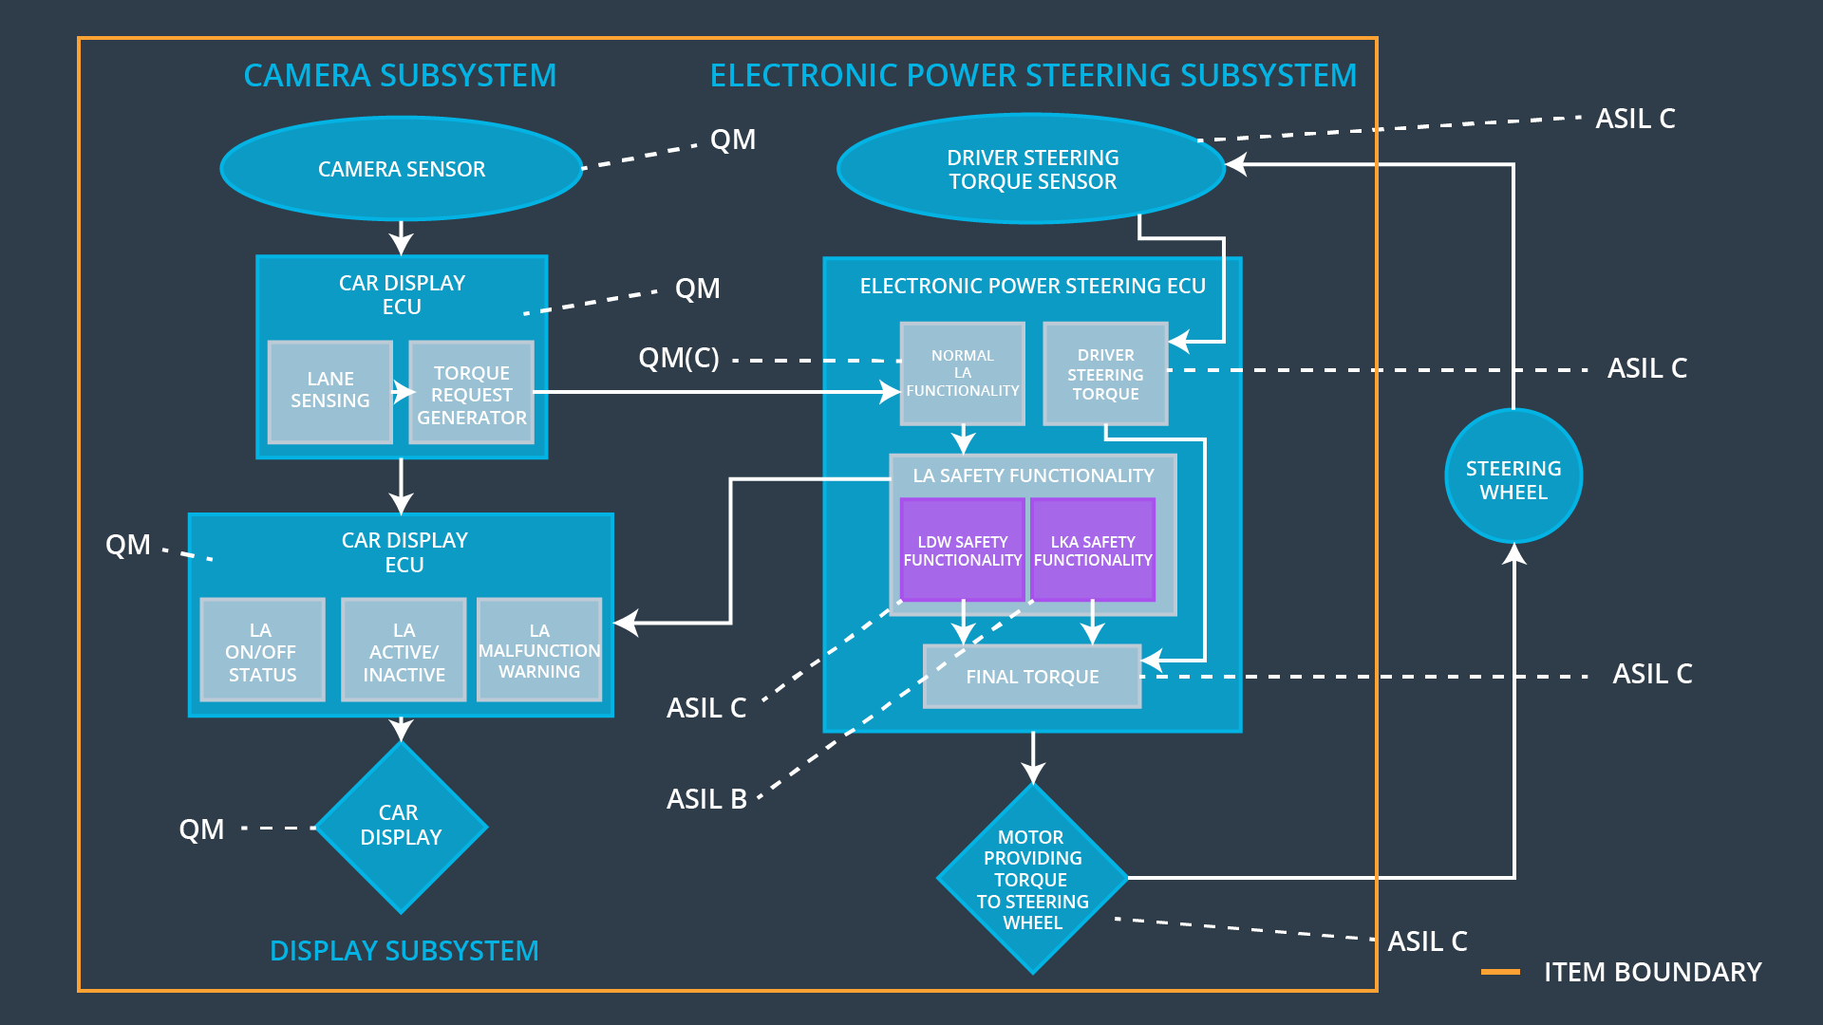

## Allocation of Functional Safety Requirements to Architecture Elements

|  |  |  |  |  |
| --- | --- | --- | --- | --- |
| **ID** | **Functional Safety Requirement** | **Electronic Power Steering ECU** | **Camera ECU** | **Car Display ECU** |
| Functional  Safety  Requirement  01-01 | The lane keeping item shall ensure that the lane departure oscillating torque amplitude is below Max_Torque_Amplitude. | **X** |  |  |
| Functional  Safety  Requirement  01-02 | The lane keeping item shall ensure that the lane departure oscillating torque frequency is below Max_Torque_Frequency. | **X** |  |  |
| Functional  Safety  Requirement  01-03 | Validate the contrast level of the road images at which the camera is just able to detect the lane markings properly. |  | **X** |  |
| Functional  Safety  Requirement  02-01 | The electronic power steering ECU shall ensure that the lane keeping assistance torque is applied for only Max_Duration. | **X** |  |  |
| Functional  Safety  Requirement  02-02 | The lane keeping assistance shall detect the color of the line markings and prefer yellow markings over white markings |  | **X** |  |

## Warning and Degradation Concept

|  |  |  |  |  |
| --- | --- | --- | --- | --- |
| **ID** | **Degradation Mode** | **Trigger for Degradation Mode** | **Safe State invoked?** | **Driver Warning** |
| WDC-01 | Turn off Lane Departure Warning functionality | Malfunction_01,  Malfunction_02,  Malfunction_05 | Yes | Lane Departure Warning indicator on car display |
| WDC-02 | Turn off Lane Keeping Assistance functionality | Malfunction_03,  Malfunction_04 | Yes | Lane Keeping Assistance Malfunction indicator on car display |