

Technical Safety Concept Lane Assistance

**Document Version: [Version]**

**Template Version 1.0, Released on 2017-06-21**



# Document history

|  |  |  |  |
| --- | --- | --- | --- |
| Date | Version | Editor | Description |
| 2018-06-18 | 1.0 | H. Kube | Initial version |
|  |  |  |  |
|  |  |  |  |
|  |  |  |  |
|  |  |  |  |

# 

# Table of Contents

Document history

Table of Contents

Purpose of the Technical Safety Concept

Inputs to the Technical Safety Concept

Functional Safety Requirements

Refined System Architecture from Functional Safety Concept

Functional overview of architecture elements

Technical Safety Concept

Technical Safety Requirements

Refinement of the System Architecture

Allocation of Technical Safety Requirements to Architecture Elements

Warning and Degradation Concept

# Purpose of the Technical Safety Concept

The purpose of the Technical Safety Concept is to refine the Functional Safety Requirements established in the Functional Safety Concept and allocate them to the system architecture.

# Inputs to the Technical Safety Concept

## Functional Safety Requirements

|  |  |  |  |  |
| --- | --- | --- | --- | --- |
| **ID** | **Functional Safety Requirement** | **ASIL** | **Fault Tolerant Time Interval** | **Safe State** |
| Functional  Safety  Requirement  01-01 | The lane keeping item shall ensure that the lane departure oscillating torque amplitude is below Max_Torque_Amplitude. | C | 50 ms | Lane assistance functionality is deactivated. |
| Functional  Safety  Requirement  01-02 | The lane keeping item shall ensure that the lane departure oscillating torque frequency is below Max_Torque_Frequency. | C | 50 ms | Lane assistance functionality is deactivated. |
| Functional  Safety  Requirement  02-01 | The electronic power steering ECU shall ensure that the lane keeping assistance torque is applied for only Max_Duration. | B | 500 ms | Lane keeping function is deactivated |

## Refined System Architecture from Functional Safety Concept

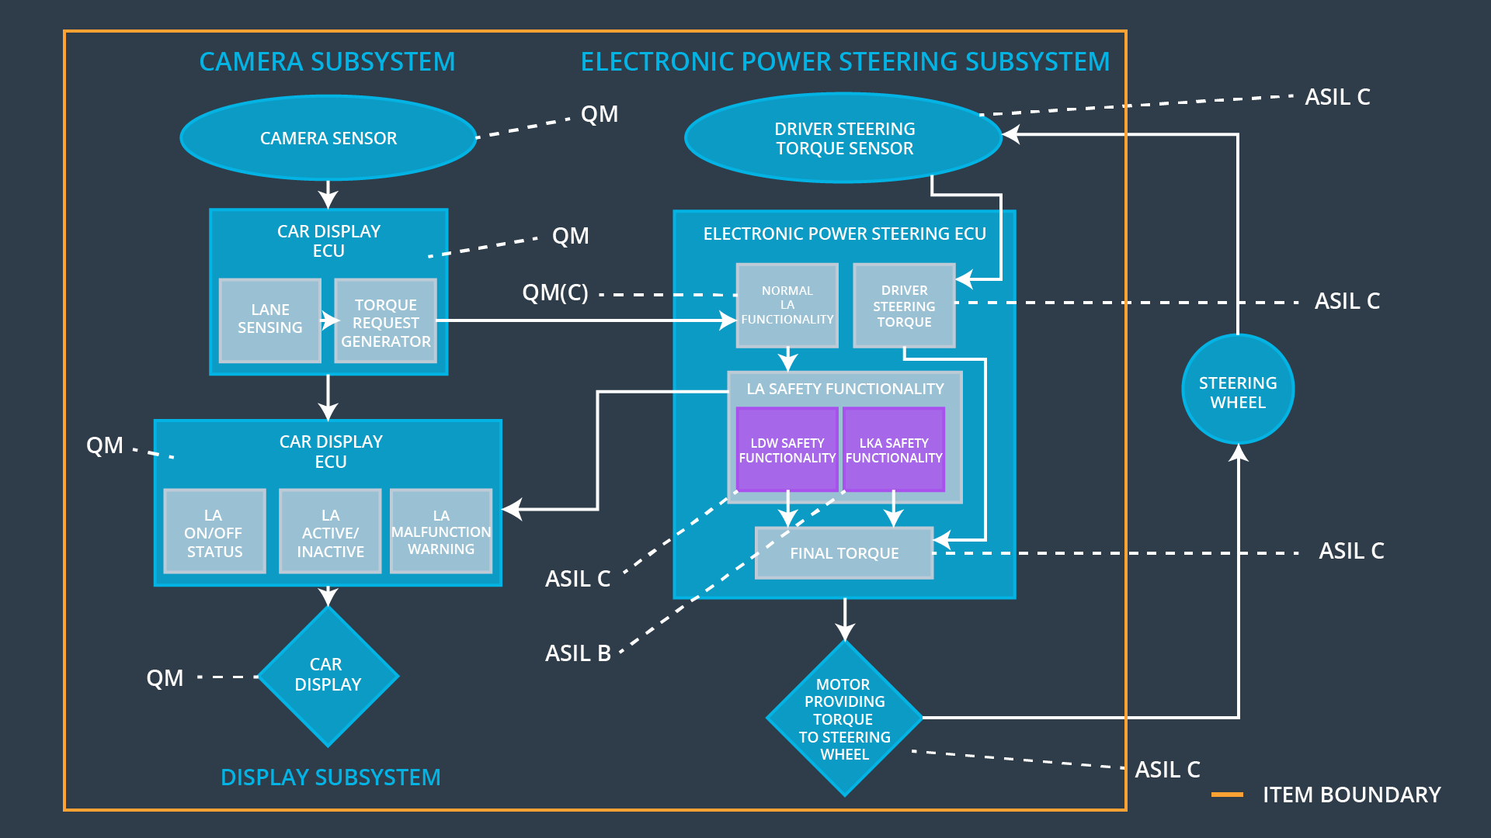

### 

### Functional overview of architecture elements

|  |  |
| --- | --- |
| **Element** | **Description** |
| Camera Sensor | Captures road images and provides them to the Camera Sensor ECU |
| Camera Sensor ECU - Lane Sensing | Detects lane markings in the road image |
| Camera Sensor ECU - Torque request generator | Generates a torque request to the Electronic Power Steering ECU |
| Car Display | Shows the driver the lane keeping assistance warning and status. |
| Car Display ECU - Lane Assistance On/Off Status | Indicates whether Lane Assistance is on |
| Car Display ECU - Lane Assistant Active/Inactive | Indicates whether Lane Assistant is active |
| Car Display ECU - Lane Assistance malfunction warning | Indicates whether the system is malfunctioning. |
| Driver Steering Torque Sensor | Measures the torque applied by the driver to the wheel. |
| Electronic Power Steering (EPS) ECU - Driver Steering Torque | Processes the measurement result of the Driver Steering Torque sensor. |
| EPS ECU - Normal Lane Assistance Functionality |  |
| EPS ECU - Lane Departure Warning Safety Functionality |  |
| EPS ECU - Lane Keeping Assistant Safety Functionality |  |
| EPS ECU - Final Torque |  |
| Motor | Applies the torque requested by the Electronic Power Steering ECU to the wheel. |

# Technical Safety Concept

## Technical Safety Requirements

**Lane Departure Warning (LDW) Requirements:**

Functional Safety Requirement 01-01 with its associated system elements

(derived in the functional safety concept)

|  |  |  |  |  |
| --- | --- | --- | --- | --- |
| **ID** | **Functional Safety Requirement** | **Electronic Power Steering ECU** | **Camera ECU** | **Car Display ECU** |
| Functional  Safety  Requirement  01-01 | The lane keeping item shall ensure that the lane departure oscillating torque amplitude is below Max_Torque_Amplitude | X |  |  |

Technical Safety Requirements related to Functional Safety Requirement 01-01 are:

|  |  |  |  |  |  |
| --- | --- | --- | --- | --- | --- |
| **ID** | **Technical Safety Requirement** | **ASIL** | **Fault Tolerant Time Interval** | **Architecture Allocation** | **Safe State** |
| Technical  Safety  Requirement  01 | The LDW safety component shall ensure that the amplitude of the 'LDW_Torque_Request' sent to the 'Final Electronic Power Steering Torque' component is below 'Max_Torque_Amplitude'. | C | 50 ms | LDW Safety | Signal LDW_Activation_Status is cleared |
| Technical  Safety  Requirement  02 | As soon as the LDW function deactivates the LDW feature, the 'LDW Safety' software block shall send a signal to the car display ECE to turn on a warning light. | C | 50 ms | LDW Safety | Signal LDW_Error_Status is set |
| Technical  Safety  Requirement  03 | As soon as a failure is detected by the LDW function, it shall deactivate the LDW feature an the 'LDW_Torque_request' shall be set to zero. | C | 50 ms | LDW Safety | LDW_Torque_Request is 0 |
| Technical  Safety  Requirement  04 | The validity and integrity of the data transmission for 'LDW_torque_Request' signal shall be ensured. | C | 50 ms | Data Transmission Integrity Check | LDW_Activation_Status is cleared, LDW_Error_Status is set and LDW_Torque_Request is 0 |
| Technical  Safety  Requirement  05 | Memory test shall be conducted at start up of the EPS ECU to check for any faults in memory. | A | Ignition cycle | Memory Test | LDW_Activation_Status is cleared, LDW_Error_Status is set and LDW_Torque_Request is 0 |

Functional Safety Requirement 01-2 with its associated system elements

(derived in the functional safety concept)

|  |  |  |  |  |
| --- | --- | --- | --- | --- |
| **ID** | **Functional Safety Requirement** | **Electronic Power Steering ECU** | **Camera ECU** | **Car Display ECU** |
| Functional  Safety  Requirement  01-02 | The lane keeping item shall ensure that the lane departure oscillating torque frequency is below Max_Torque_Frequency | X |  |  |

Technical Safety Requirements related to Functional Safety Requirement 01-02 are:

|  |  |  |  |  |  |
| --- | --- | --- | --- | --- | --- |
| **ID** | **Technical Safety Requirement** | **ASIL** | **Fault Tolerant Time Interval** | **Architecture Allocation** | **Safe State** |
| Technical  Safety  Requirement  01 | The LDW safety component shall ensure that the frequency of the 'LDW_Torque_Request' sent to the 'Final Electronic Power Steering Torque' component is below 'Max_Torque_Frequency'. | C | 50 ms | LDW Safety | Signal LDW_Activation_Status is cleared |
| Technical  Safety  Requirement  02 | As soon as the LDW function deactivates the LDW feature, the 'LDW Safety' software block shall send a signal to the car display ECE to turn on a warning light. | C | 50 ms | LDW Safety | Signal LDW_Error_Status is set |
| Technical  Safety  Requirement  03 | As soon as a failure is detected by the LDW function, it shall deactivate the LDW feature an the 'LDW_Torque_request' shall be set to zero. | C | 50 ms | LDW Safety | LDW_Torque_Request is 0 |
| Technical  Safety  Requirement  04 | The validity and integrity of the data transmission for 'LDW_torque_Request' signal shall be ensured. | C | 50 ms | Data Transmission Integrity Check | LDW_Activation_Status is cleared, LDW_Error_Status is set and LDW_Torque_Request is 0 |
| Technical  Safety  Requirement  05 | Memory test shall be conducted at start up of the EPS ECU to check for any faults in memory. | A | Ignition cycle | Memory Test | LDW_Activation_Status is cleared, LDW_Error_Status is set and LDW_Torque_Request is 0 |

**Lane Keeping Assistance (LKA) Requirements:**

Functional Safety Requirement 02-1 with its associated system elements

(derived in the functional safety concept)

|  |  |  |  |  |
| --- | --- | --- | --- | --- |
| **ID** | **Functional Safety Requirement** | **Electronic Power Steering ECU** | **Camera ECU** | **Car Display ECU** |
| Functional  Safety  Requirement  02-01 | The lane keeping item shall ensure that the lane keeping assistance torque is applied for only Max_Duration | X |  |  |

Technical Safety Requirements related to Functional Safety Requirement 02-01 are:

|  |  |  |  |  |  |
| --- | --- | --- | --- | --- | --- |
| **ID** | **Technical Safety Requirement** | **ASIL** | **Fault Tolerant Time Interval** | **Allocation to Architecture** | **Safe State** |
| Technical  Safety  Requirement  01 | The LKA safety component shall ensure that the duration of the 'LKA_Torque_Request' sent to the 'Final Electronic Power Steering Torque' component is below 'Max_Duration'. | B | 500 ms | LKA Safety | Signal LKA_Activation_Status is cleared |
| Technical  Safety  Requirement  02 | As soon as the LKA function deactivates the LKA feature, the 'LKA Safety' software block shall send a signal to the car display ECE to turn on a warning light. | B | 500 ms | LKA Safety | Signal LKA_Error_Status is set |
| Technical  Safety  Requirement  03 | As soon as a failure is detected by the LKA function, it shall deactivate the LKA feature an the 'LKA_Torque_request' shall be set to zero. | B | 500 ms | LKA Safety | LKA_Torque_Request is 0 |
| Technical  Safety  Requirement  04 | The validity and integrity of the data transmission for 'LKA_torque_Request' signal shall be ensured. | B | 500 ms | Data Transmission Integrity Check | LKA_Activation_Status is cleared, LKA_Error_Status is set and LKA_Torque_Request is 0 |
| Technical  Safety  Requirement  05 | Memory test shall be conducted at start up of the EPS ECU to check for any faults in memory. | A | Ignition cycle | Memory Test | LKA_Activation_Status is cleared, LKA_Error_Status is set and LKA_Torque_Request is 0 |

## Refinement of the System Architecture

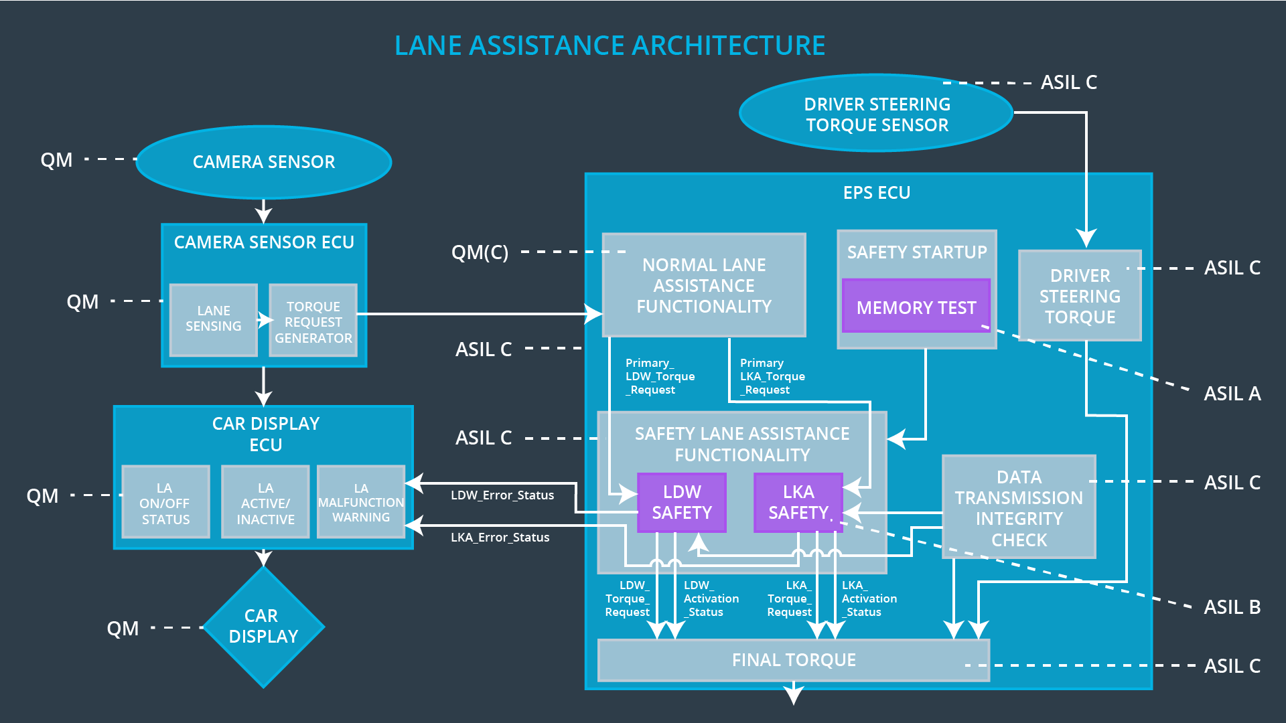

## Allocation of Technical Safety Requirements to Architecture Elements

All technical safety requirements described in this document are allocated to the Electronic Power Steering ECU. For exact allocation refer to the tables above.

## Warning and Degradation Concept

|  |  |  |  |  |
| --- | --- | --- | --- | --- |
| **ID** | **Degradation Mode** | **Trigger for Degradation Mode** | **Safe State invoked?** | **Driver Warning** |
| WDC-01 | Turn off Lane Departure Warning functionality | Malfunction_01,  Malfunction_02,  Malfunction_05 | Yes | Lane Departure Warning indicator on car display |
| WDC-02 | Turn off Lane Keeping Assistance functionality | Malfunction_03,  Malfunction_04 | Yes | Lane Keeping Assistance Malfunction indicator on car display |