
HKU ENGG1101
Active Learning Team
ROBOARM Contest 2026/27
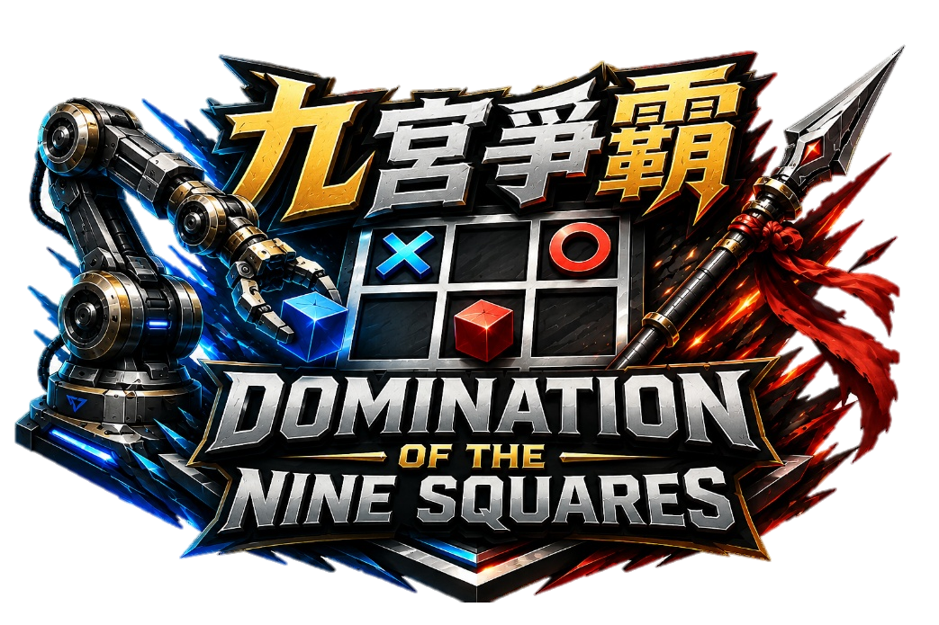
"九宮爭霸"
Domination of the Nine Squares

Theme and Rules
21/09/2026 Updated

Table of Contents
1. Introduction 3
1.1 Background 3
1.2 Objectives 3
1.3 Terms and Definitions 4
2. Contest Overview 7
3. Game Procedures and Competition Tasks 8
3.1 Preparation of the Game 8
3.2 Start of the Game 9
3.3 During the Game 9
3.4 Robot Retries 11
3.5 Scoring 12
3.6 Deciding the Winner 13
4. Violations 13
5. Disqualifications 13
6. Robot and Design Limitations 13
6.1 Number and Configuration of Robots 14
6.2 Permitted Modifications 14
6.3 Prohibited Modifications 14
6.4 Robot Specifications 14
7. Other Provisions 14
8. Important Dates and Workshop Schedule 15
8.1 Course Workshop Schedule 15
9. Appendix 15

Introduction

Background
The purpose of this contest is to provide students in HKU course ENGG1101 Engineering Challenges I with an opportunity to apply and demonstrate what they have learned during Semester 1. The contest provides a controlled setting in which student teams integrate, test, demonstrate, and refine the engineering knowledge developed during the course.
    - Every team shall use the standardized robotic arm platform supplied or approved by the course teaching team. The contest therefore evaluates how effectively a team improves the performance of a common platform rather than how extensively it replaces the platform.
    - The game theme is “Domination of the Nine Squares.” Two Robots operate simultaneously on opposite sides of a shared vertical three-by-three Tic-Tac-Toe Rack. Each team seeks to form a Connected Line of three of its Blocks while using regulated Attack Attempts to disrupt the opponent.

1.2 Objectives
Engineering design:
The contest aims to help students to apply requirements analysis, prototyping, verification, and design-for-reliability to a real integrated system.
Motion planning and calibration:
The contest aims to help students improve skills related to robotic arm repeatability, accuracy, collision avoidance, and recovery.
System integration:
This contest aims to allow students to combine mechanics, electronics, and software knowledge into one testable system.
Teamwork and communication:
Teams are expected to allocate responsibilities, maintain shared technical records, communicate decisions, and operate under time pressure.
Strategy and robot operation:
Teams are expected to make lawful decisions that balance scoring, defense, risk, and time throughout the competition.

Terms and Definitions
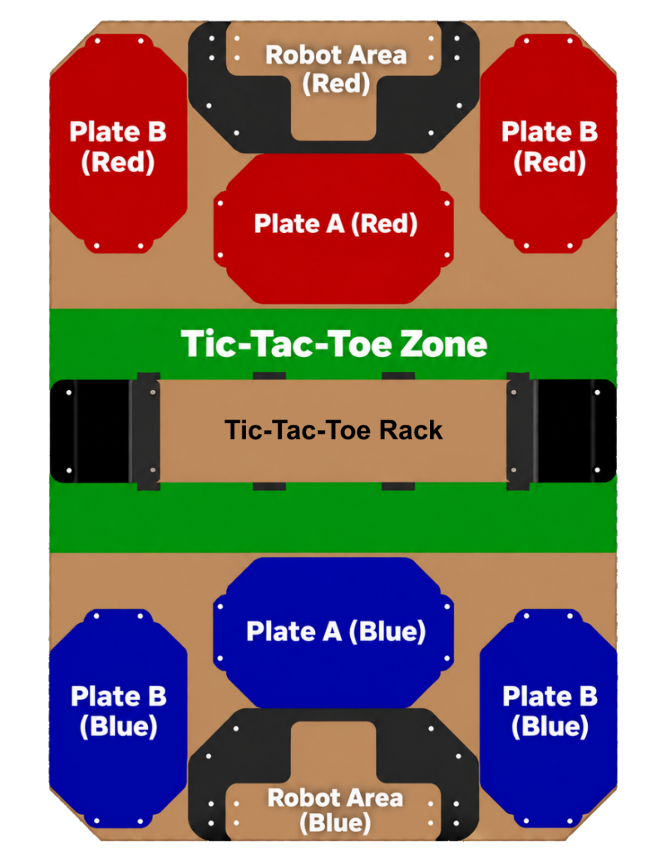
Figure 1: Game field without robot arms (Top view)
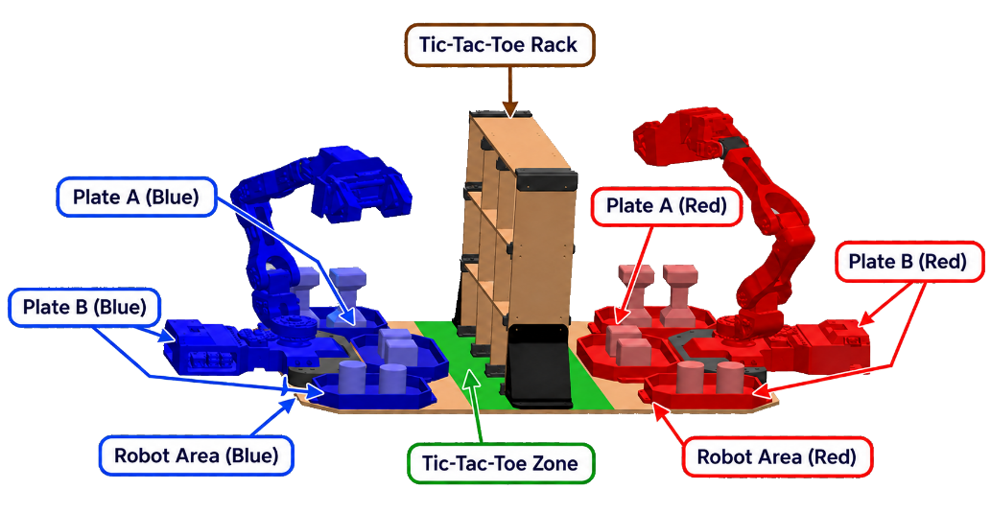
Figure 2: Game field with robot arms (Perspective view)

Terms and definitions used in the rules of ROBOARM Contest 2026/27 are given in the following table:
Abbreviation | Terms | Definitions
PP | Preparation Period | The one-minute period before the Game Period during which authorized Game Field Members may position the Robot and arrange the allocated Blocks.
GP | Game Period | The three-minute period during which the Robots may perform the competition tasks.
GV | Great Victory | The winning condition achieved when a team forms a Connected Line of three legally placed Blocks on the TTTR.
TTTR | Tic-Tac-Toe Rack | The vertical three-by-three rack onto which teams place their Blocks.
TTTZ | Tic-Tac-Toe Zone | The green central area surrounding the TTTR. A Robot may enter this area only to complete a legal Placement or a referee-authorized Attack Attempt.
RA | Robot Area | The marked Robot Area on each team’s side in which the Robot shall be positioned during the PP, at the Start Signal, and during an authorized Robot Retry.
PA | Plate A | The designated central plate in a team’s Block Supply Area on which allocated Blocks may be arranged before and during the Game.
PB | Plate B | Either of the two designated side plates in a team’s Block Supply Area. Together with Plate A, the two Plate B areas hold that team’s allocated Blocks.
N/A | Block | An official Game Piece allocated to a team for placement on the TTTR.
N/A | Cube | An official cube-shaped Block A worth 10 points when legally placed.
N/A | Cylinder | An official cylinder-shaped Block B worth 20 points when legally placed.
N/A | Trophy | An official trophy-shaped Block C worth 40 points when legally placed.
N/A | Game | A competition between two teams consisting of a one-minute PP followed by a three-minute GP.
N/A | Attack Attempt | One authorized attempt by a Robot to remove an eligible Opponent Block from the TTTR.
N/A | Attack Tokens | A token awarded after a Successful Placement. One Attack Token permits one Attack Attempt. No more than three Attack Tokens may be awarded to a team during a Game, whether or not earlier tokens have been used.
N/A | Connected Line | Three legally placed Blocks belonging to the same team arranged consecutively in a horizontal, vertical, or diagonal line on the TTTR.
N/A | Game Field Member | An authorized team member permitted to enter the Game Field during the PP or an approved Robot Retry. Each team may designate up to two Game Field Members, including the Operator.
N/A | Head Referee | The competition official responsible for controlling the Game and making the final decision on Game-related matters.
N/A | Opponent Block | A legally placed Block belonging to the opposing team.
N/A | Operator | The registered team member authorized to control the Robot during the Game.
N/A | Robot | The standardized robotic arm platform, including all approved attachments, sensors, controllers, cables, and accessories used by a team.
N/A | Robot Retry | A referee-authorized procedure allowing a team to reposition or restart its Robot in accordance with Section 3.4.
N/A | Successful Attack | A legal Attack Attempt that causes the declared Opponent Block to leave its scoring position on the TTTR.
N/A | Successful Block Pickup | The action of securely grasping and completely lifting a Block clear of its original supporting surface using the Robot.
N/A | Successful Placement | A placement in which the Robot releases a Block in a valid TTTR position, the Block remains stable without Robot support, and the placement is confirmed by a referee.
N/A | Violation | An action prohibited by this Rulebook and subject to the penalties specified in Section 4.

Contest Overview
This contest forms part of the HKU ENGG1101 Engineering Challenges I course. During the course, students are assigned to teams to assemble, program, test, and further develop the robotic arm platform provided by the teaching team. The contest allows each team to demonstrate the engineering knowledge, technical skills, and system improvements developed throughout the course.
Performance in the contest does not directly determine or modify a student’s course grade. Any assessed course activities associated with the robot project shall be graded separately in accordance with the assessment criteria published by the teaching team.
The general game rules are as follows:
  - Each Game consists of a one-minute Preparation Period (PP) followed by a three-minute Game Period (GP).
  - During the PP, authorized team members may set up the Robot, controller, allocated Blocks within their team’s designated Block Supply Area (Plate A and the two Plate B areas), and other approved equipment in their prescribed starting positions. All Robots and Blocks shall comply with the prescribed starting arrangement before the Game begins.
  - All preparation activities shall stop when the one-minute PP expires. Team members then leave the Game Field and move to their designated positions as instructed by the referees.
  - The three-minute Game Period begins upon the official Start Signal issued by the Head Referee. No Robot may begin game-affecting motion before the Start Signal.
  - Each team shall use only the robotic arm provided or expressly approved by the teaching team. Teams are encouraged to improve and further develop the Robot within the limitations specified in Section 6.
  - Each team may use only one Robot during a Game. All connected mechanisms, controllers, cables, sensors, computers, and accessories used to operate that Robot are considered parts of the same Robot; a second independent robot or mechanism is prohibited.
  - The primary task of each Robot is to collect its allocated Blocks and place them onto the Tic-Tac-Toe Rack (TTTR).
  - A team scores by completing legal Placements on the TTTR. The point value for each official Block type is specified in Section 3.5.
  - Upon completing a Successful Placement on the TTTR, the team shall be awarded one Attack Token by the Head Referee.
  - A team may receive no more than three Attack Tokens during a Game, whether or not previously awarded tokens have been used.
  - A team may consume one Attack Token to perform one Attack Attempt using its robot arm. During the Attack Attempt, the Robot may attempt to remove an eligible Opponent Block from the TTTR, thereby reducing the opponent’s score or preventing the formation of a Great Victory.
  - An Attack Token is consumed when the Attack Attempt begins, regardless of whether the Opponent Block is successfully removed. All Attacks shall comply with the detailed Attack Rules specified in Section 3.3.
  - A Great Victory (GV) is achieved when a team completes a Connected Line consisting of three of its legally placed Blocks. The three Blocks may be connected horizontally, vertically, or diagonally on the TTTR.
  - The Game ends immediately when either team achieves a Great Victory, when the three-minute Game time expires, or when the Game is otherwise terminated by the Head Referee in accordance with this Rulebook.
  - A team that achieves a Great Victory wins the Game immediately. If neither team achieves a Great Victory before time expires, the team with the higher final score wins the Game.
  - If both teams have the same final score when time expires, the winner shall be determined using the tie-breaking procedure specified in Section 3.6.
  - The winning team shall advance to the next round where the published competition format provides for elimination or progression between rounds.

Game Procedures and Competition Tasks

Preparation of the Game
    - Each Game begins with a one-minute Preparation Period (PP).
    - PP begins upon the instruction of the Head Referee.
    - During the PP, each team shall place its Robot within its designated Robot Area and arrange its allocated Blocks within its Block Supply Area.
    - Each Robot shall begin the Game in its approved starting configuration. All parts of the Robot, including its end-effector, attachments, sensors, and cables, shall be entirely within the Robot Area and its vertical projection.
    - Before the Start Signal, no part of the Robot may extend beyond the horizontal boundary of the Robot Area at any height.
    - Blocks can be placed in any position or orientation within the team’s Block Supply Area, provided that:
- every Block remains entirely within the Block Supply Area;
- no Block is placed directly on the Robot or held by its end-effector;
- the arrangement does not obstruct the opposing team or any competition official.
    - Each team may assign up to two authorized Game Field Members, including the Robot Operator, to participate in the preparation process.
    - Game Field Members may:
- position the Robot;
- connect and activate the approved controller;
- arrange the team’s allocated Blocks;
- perform final visual and communication checks; and
- confirm the operation of the Robot’s emergency stop.
    - Game Field Members shall not:
- modify or repair the robot arm;
- upload or replace software;
- recalibrate the Robot using the Game Field;
- move or adjust any part of the Game Field;
- touch the opposing team’s Robot, Blocks, or equipment; or
- perform any action prohibited by a referee.
    - Before the Preparation Period ends, the referees will inspect the Robots’ starting positions and configurations, the number and arrangement of Blocks, and the condition of the Game Field.
    - All Game Field Members shall leave the Game Field and move to their designated positions. Only the robot arm operator may remain at the Operator Station.
    - If a team is not ready when the PP expires, it must begin the Game in its current condition. The team may request a Robot Retry after the Game starts in accordance with Section 3.4.
    - Where a team cannot begin safely, the Head Referee may prevent the Robot from participating until the safety issue has been corrected. This shall not automatically entitle the team to a restart or replay.

Start of the Game
    - A countdown shall indicate the remaining time during the final seconds of the Preparation Period (PP). Upon expiry of the PP, the Head Referee initiates the official Start Signal. The three-minute Game Period (GP) shall begin automatically when the Start Signal is given.
    - A Robot may be powered before the Start Signal but shall not perform any game-affecting motion before the signal is given.
    - A False Start occurs when, before the Start Signal:
- a robot begins game-affecting motion;
- an operator issues a command that causes the robot to move;
- a team member enters or touches the Game Field without authorization.
    - A team that commits a False Start shall receive a Violation. Where the False Start creates a significant competitive advantage, presents a safety risk, or is committed repeatedly, the Head Referee may impose an additional penalty in accordance with Section 4.
    - When the game starts, the robot must comply with the size, weight, power-source, and other technical requirements specified in Section 6.

During the Game

General Operation
      - Both Robots may operate simultaneously throughout the three-minute Game Period.
      - Only the registered robot arm Operator may control the Robot during the Game.
      - The Operator shall remain within the designated Operator Station unless otherwise instructed by a referee.
      - Except when entering the TTTZ to complete a legal Placement or a referee-authorized Attack Attempt, the Robot shall remain on its own side of the Game Field. The Robot shall not enter or extend into the opponent’s side, including the vertical space above it.
      - Team members shall not enter the Game Field or touch the Robot, TTTR, Blocks, or any field equipment without permission from a referee.
      - A disconnected controller or team-side equipment failure shall not stop the Game timer. The team may request a Robot Retry in accordance with Section 3.4.

Collecting and Placing Blocks
      - A Robot may collect only the Blocks allocated to its team.
      - A Successful Block Pickup occurs when the Robot securely grasps and completely lifts a Block clear of its original supporting surface.
      - A Robot may place a Block only in an unoccupied position on the TTTR.
      - A Successful Placement is completed when:
- the Block is placed in an unoccupied position on the TTTR;
- the Robot has fully released the Block;
- the Block remains stable without support from the Robot; and
- the placement is confirmed by a referee.
      - A Block that remains held, supported, or stabilized by the Robot shall not be considered successfully placed.
      - A Robot may adjust its own Block before releasing it, provided that the Robot does not intentionally contact an Opponent Block or damage the TTTR.
      - A team earns one Attack Token for each Successful Placement confirmed by the Head Referee, subject to the three-token limit in Section 3.3.3.
      - A Block placed outside a valid TTTR position, in an occupied position, or by an unauthorized method shall not score and shall not earn an Attack Token.

Attack Tokens
      - A team shall receive one Attack Token for each Successful Placement confirmed by a referee.
      - A team may receive no more than three Attack Tokens during a Game, whether or not previously awarded tokens have been used.
      - After a team has received three Attack Tokens during a Game, no additional Attack Token shall be awarded for any later Placement.
      - Attack Tokens have no point value and shall be used only to authorize Attack Attempts.

Attack Attempts
      - All legally placed Opponent Blocks on the TTTR are eligible to be removed by an Attack.
      - A team may perform an Attack Attempt only when it possesses at least one unused Attack Token.
      - Before performing an Attack Attempt, the Operator shall clearly call “Attack.”
      - The Robot shall remain completely outside the TTTZ until a referee authorizes the Attack Attempt.
      - After receiving authorization, the Attack Attempt begins when any part of the Robot enters the TTTZ or the vertical space above it.
      - One Attack Token shall be consumed when the Attack Attempt begins. The Operator then hands one Attack Token to the Head Referee.
      - Each Attack Token permits the Robot to enter the TTTZ once for one Attack Attempt.
      - During an Attack Attempt, the Robot may attempt to remove one Opponent Block from the TTTR.
      - The Attack Attempt ends when all parts of the Robot have completely left the TTTZ and the vertical space above it.
      - After an Attack Attempt ends, any subsequent entry into the TTTZ for attacking purposes shall require another Attack declaration, referee authorization, and Attack Token.
      - A Robot that has entered the TTTZ to complete a Placement shall completely leave the TTTZ before requesting or beginning an Attack Attempt.
      - Entry into the TTTZ for the purpose of completing a legal Placement shall not be considered an Attack Attempt, provided that the Robot does not intentionally contact an Opponent Block.
      - Repeated impacts, hammering, continuous shaking, or deliberate vibration of the TTTR are prohibited.
      - The Attack Token remains consumed regardless of whether any Opponent Block is successfully removed.
      - An Opponent Block is successfully removed when it falls out of its scoring position or otherwise ceases to satisfy the requirements of a legally placed Block.
      - All Blocks removed from the TTTR during an Attack shall remain out of play, and their previously awarded points shall be deducted.
      - Entering the TTTZ for attacking purposes without an available Attack Token or referee authorization shall constitute a Violation.
      - During one team’s Attack Attempt, the opposing Robot may continue to operate simultaneously, provided that it complies with all applicable area and safety restrictions.

Dropped Blocks
      - A Block shall be considered a Dropped Block if it is released outside a valid TTTR position or falls from the Robot before completing a Successful Placement.
      - A Dropped Block that remains entirely within the team’s permitted area may be recovered by the Robot.
      - A Dropped Block that enters the opposing team’s area, leaves the Game Field, or obstructs the TTTR shall not be recovered without permission from a referee.
      - Team members shall not retrieve or reposition a Dropped Block by hand except during an authorized Robot Retry.
      - A Dropped Block shall not score and shall not earn an Attack Token.

Robot Retries
    - A team may request a Robot Retry if its Robot becomes disabled, disconnected, incorrectly positioned, or otherwise unable to continue normal operation.
    - There is no limit on the number of Robot Retries, but the Game timer continues to run.
    - The Robot Operator shall request a Retry by clearly calling “Retry.” A Retry may begin only after a referee gives approval.
    - No person may enter the Game Field or touch the Robot until a referee authorizes the Retry.
    - Game time shall continue during a team-requested Retry.
    - During a Retry, authorized team members may:
- reposition the robot arm;
- reconnect the robot controller or communication wire;
- restart the robot arm;
- remove a Block held by the robot;
- reposition a Dropped Block back to the Block Supply Area; and
- rearrange Blocks in the Block Supply Area.
    - During a Retry, team members shall not:
- move, replace, or retrieve any Block already on the TTTR;
- recalibrate the Robot using the TTTR; or
- interfere with the opposing team.
    - A Block held by the Robot when a Retry is called must be removed from the Robot. An authorized Game Field Member shall return the Block to the team’s Block Supply Area.
    - The Robot may resume operation only after the Operator clearly calls “Start” and the referee gives approval to continue. The Operator shall not move the Robot before receiving the referee’s approval.

Scoring

General Scoring
      - Points shall be awarded only for Blocks that have been legally placed on the TTTR and remain in a valid scoring position.
      - The score awarded for a Block shall depend on its official Block type.
      - The official point values shall be as follows:
Block Type | Description (Image Attached in Appendix) | Score (points)
Block A | Cube-shaped Block | 10
Block B | Cylinder-shaped Block | 20
Block C | Trophy-shaped Block | 40

      - If a Block falls out of the TTTR or otherwise ceases to satisfy the requirements of a legally placed Block, the points previously awarded for that Block shall be removed, regardless of whether the Block was displaced accidentally, by the team’s own Robot, or by a legal Attack performed by the opposing team.
      - A Block that moves during an Attack but remains legally positioned on the TTTR shall continue to score.
      - Attack Tokens have no point value.
      - Points scored after the three-minute Game Period expires shall not be counted.

Great Victory
      - A Great Victory is achieved when a team has three legally placed Blocks forming one Connected Line on the TTTR.
      - A Connected Line may be formed horizontally, vertically or diagonally.
      - All three Blocks shall remain legally placed and stable when the line is confirmed.
      - Blocks of different sizes, shapes, or point values may form a Great Victory, provided that all three Blocks belong to the same team and occupy three consecutive positions.
      - Once the Head Referee confirms a Great Victory, the Game shall end immediately.
      - A Great Victory takes priority over the numerical point score. A team that achieves a Great Victory wins even if its current point score is lower than that of the opposing team.

Deciding the Winner
The winning team shall be determined in the following order. Each subsequent criterion shall be applied only if the teams remain tied under the preceding criterion:
- the team that achieves Great Victory;
- the team that gains a higher final point score;
- the team with the greater number of legally placed Blocks remaining on the TTTR;
- the team with the greater number of unused Attack Tokens;
- the team that completed its first Successful Placement on the TTTR in the shorter time after the Start Signal;
- the team that completed its first Successful Block Pickup in the shorter time after the Start Signal;
- the team with fewer Violations during the Game;
- if the teams remain tied, the Head Referee shall apply a fair tie-break procedure announced to both teams before it begins.

Violations
A team that commits any of the following actions shall receive a Violation and shall be subject to a mandatory Robot Retry under Section 3.4. Additional penalties may be imposed where expressly stated:
  - Any part of the Robot enters or extends into an area or space in which it is not permitted to operate.
  - The team commits a False Start.
  - The Robot intentionally contacts or moves an Opponent Block without performing a legal Attack.
  - The Robot repeatedly strikes, shakes, or applies excessive force to the TTTR.
  - The Robot touches or interferes with the opposing Robot, Block Supply Area, Operator, or equipment.
  - A team member enters the Game Field or touches the Robot, TTTR, or any Game Piece without the referee’s permission.
  - The Robot resumes operation following a Retry before the Operator calls “Start” and receives approval from the referee.
  - The team fails to obey an instruction given by the Head Referee or another authorized referee.

Disqualifications
A team that intentionally commits any of the following acts shall be disqualified from the Game:
  - Any act that poses danger to the game field, its surroundings, the robots, the participants, officials and the public.
  - Any other act that goes against the spirit of fair play.
  - Any act of disobedience against the referee’s warning or decision.

Robot and Design Limitations
The Robot used in the contest shall comply with the following regulations.

Number and Configuration of Robots
    - Each team may use only one Robot during a Game.
    - The Robot must be based on the standardized robotic arm platform provided or approved by the teaching team.
    - The Robot shall not separate into independent parts, intentionally or unintentionally, during the Game.
    - Any mechanism, attachment, controller, cable, sensor, computer, or accessory connected to or used to operate the Robot may be considered part of the Robot.

Permitted Modifications
    - Teams may develop or modify only the following aspects of the Robot:
  - software and control algorithms;
  - motion planning and trajectory generation;
  - calibration methods;
  - computer vision and artificial intelligence;
  - sensor-fusion systems;
  - graphical user interfaces and operator controls;
  - Block-detection and TTTR-detection systems; and
  - additional mechanisms based on the provided robotic arm design.
    - All modified grippers, end-effectors, sensors, and attachments shall be securely mounted and shall pass Robot Inspection before being used in a Game.

Prohibited Modifications
    - Unless expressly approved by the teaching team, teams shall not modify or replace:
- the servo models;
- the robot arm base;
- the arm geometry or link lengths;
- the main power-system configuration; or
- any standardized component designated by the teaching team.

Robot Specifications
    - At the beginning of the Game, the Robot and all of its attachments shall fit entirely within the Robot Area and its vertical projection. No separate maximum height applies within that projection.
    - Each team must use a power source approved by the teaching team.
    - All Robots shall be designed, built, and operated so that they do not endanger either team, competition officials, nearby persons, or the venue.
    - Only Class 2 or lower-class laser products may be used, and they shall be operated so that no person is exposed to hazardous laser radiation.

Other Provisions
    - For matters not covered by this Rulebook, teams shall follow the decisions of the organizers and referees.
    - Unless otherwise stated, the dimensions and weights of the Game Field and Game Pieces specified in this Rulebook may vary by ±5%.
    - Teams shall follow all safety-related decisions of the organizers and referees concerning the Robot and people in the vicinity.
If a demonstration video, briefing, or other supporting material conflicts with this Rulebook, this Rulebook and the Head Referee’s instructions shall take precedence.

Important Dates and Workshop Schedule

Course Workshop Schedule
The teaching team will publish the confirmed workshop dates, assignment deadlines, and contest schedule separately during the semester.
WS-1 | Build Your Own Prototype Arm  Assemble a prototype robotic arm using 3D-printed parts, motors, and an ESP32 and control with a laptop on webserial (Assignment 1, Gamerule Release)
WS-2 | Raspberry Pi Basics & Git Collaboration  Set up a Raspberry Pi and run your first Python scripts. (Project Release) and learn Git/GitHub for version control, collaboration, and project management in robotics development.
WS-3 | From Imagination to Real Objects + (3D Printing)  Learn the fundamentals of Fusion 360 and 3D modeling. Create a design from a sketch and measure real objects to build accurate digital models
WS-4 | Control & Automate the Arm with AI & Raspberry Pi  Control the robotic arm with a Raspberry Pi that follows predefined rules to execute instructions with camera and AI.
WS-5 | Mini Challenge: Robot Arm Contest  (Assignment 2 Release)

Appendix
Figure 3: Official Game Blocks (multiple views)
