Neutron Collimator Simulation
Development Log
Harriet | with Juan P. | Geant4 Monte Carlo | Last updated: 30 September 2026

1. Aim of the project
Design a collimator that turns a fast neutron source into a thermal neutron beam with low angular spread, for neutron imaging of metallic parts. The design (from Juan's notes) uses a moderator made of HDPE, a borated HDPE sheet with a pinhole, extra HDPE blocks for shielding, a lead block to suppress gammas, and optionally graphite as a reflector. Monte Carlo simulations are used to optimise the dimensions, positions and materials of these parts.
Fixed lab dimensions: HDPE blocks are 10 × 10 × 10 cm; the borated HDPE sheet is 0.3 cm or 3 cm thick.

1.1 Quantities requested by Juan
- Normalisation: all results per primary event.
- Energy spectra of neutrons and gammas at the screen, with a logarithmic energy axis.
- Spatial maps at the screen, split by energy: thermal (0–0.025 eV), epithermal (0.025 eV–50 keV), fast (50 keV–5 MeV).
- Cadmium ratio as an indicator of the thermal fraction of the beam (exact definition to be confirmed).
- Neutron-to-gamma ratio = neutron fluence (n/cm²) / gamma dose (Sv). Target for radiography: 10⁶–10¹⁰ n·cm⁻²·Sv⁻¹.
- Goal: enhance the thermal flux while reducing the fast component as much as possible.

2. Simulation setup

2.1 Code
Location: ~/Geant4/neutron_example/Collimator (source in src/, headers in include/, build in build/). The earlier Cherenkov/scintillator tutorial code was replaced with a clean project.
Part | Implementation
Physics | QGSP_BIC_HP (high-precision neutron transport below 20 MeV) + G4ThermalNeutrons (thermal scattering)
HDPE | (CH₂)n, 0.95 g/cm³, 293.6 K. Hydrogen defined as TS_H_of_Polyethylene so bound-hydrogen thermal scattering data are used
Borated HDPE | HDPE + 5 wt% natural boron, 1.00 g/cm³ (typical values, to be checked against the lab sheet's datasheet)
World, pinhole | Vacuum (G4_Galactic); the pinhole is a hole cut in the borated sheet, filled with vacuum
Source | Point source, 2 MeV neutrons (D-D), isotropic over 4π, at z = −3 cm. "Per primary" = per neutron emitted by the source
Geometry control | Macro commands /collimator/... (hdpeThickness, boratedThickness, pinholeDiameter, screenGap, boronMassFraction, sideShielding), set before /run/initialize

2.2 Diagnostics
- Screen: 30 × 30 cm vacuum plane behind the borated sheet. Every neutron and gamma is recorded once as it enters (particle type, energy, x, y, cos θ). Output: ntuple "Screen".
- Beam spot: the same screen data restricted to r < 30 mm behind the pinhole.
- Moderator exit (added in Entry 3): neutrons and gammas leaving the back face of the central moderator block, i.e. what is available to enter the pinhole. Output: ntuple "ModExit".
- Normalisation: histogram "nPrimaries" counts the primary events in each run.
- Analysis: collimatorAnalysis.C (one run) and sweepAnalysis.C (thickness sweep). Thermal is reported with two cuts: < 0.025 eV (Juan's definition) and < 0.5 eV (cadmium cutoff).
Beam axis is +z. The front face of the moderator is at z = 0.

3. Log entries

Entry 1 – Baseline geometry (run 1)
Setup: 10 cm HDPE block (10 × 10 cm), 3 cm borated HDPE sheet (10 × 10 cm) with a 1 cm pinhole (L/D = 3), screen 5 cm behind the sheet. 100,000 primaries.

Results at the screen (per primary)
Particles | Counts | Per primary
All neutrons | 2517 | 2.52 × 10⁻²
Thermal (< 0.025 eV) | 16 | 1.6 × 10⁻⁴
Epithermal | 365 | 3.65 × 10⁻³
Fast (> 50 keV) | 2136 | 2.14 × 10⁻²
Gammas | 363 | 3.63 × 10⁻³
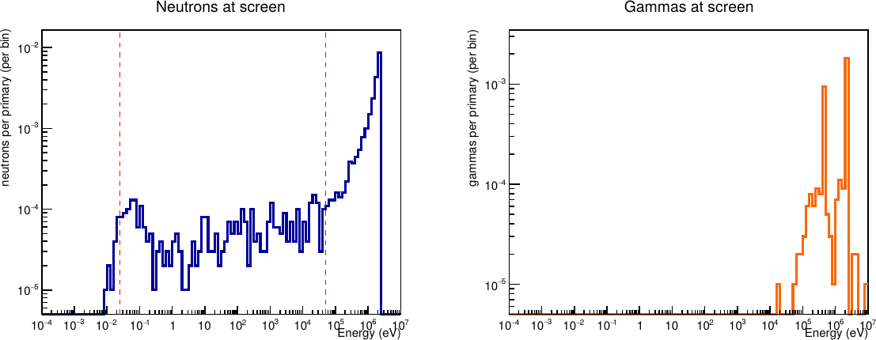
Figure 1. Run 1: neutron (left) and gamma (right) spectra at the screen. Dashed lines: 0.025 eV and 50 keV.
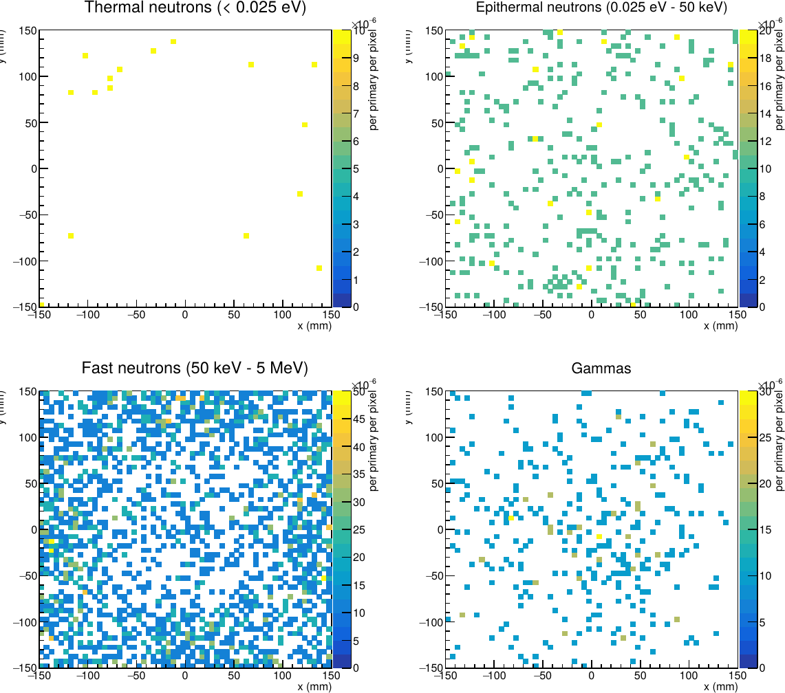
Figure 2. Run 1: spatial maps at the screen, split by energy.

Observations
- The physics behaves as expected: uncollided 2 MeV peak, flat slowing-down region (1/E) between ~1 eV and ~10 keV, and a thermal peak around 0.03–0.1 eV.
- Gamma lines at 2.2 MeV (neutron capture on hydrogen) and ~0.48 MeV (capture on boron-10), plus a few counts near 5 MeV (capture on carbon).
- 85% of neutrons at the screen are fast. The screen (30 × 30 cm) is much wider than the block (10 × 10 cm); off-axis neutrons cross only part of the HDPE and leave through its unshielded sides. The fast map is densest at the edges.
- The 16 thermal neutrons are scattered randomly: they leak from the sides of the block, not through the pinhole.
- The 0.025 eV cut falls in the middle of the thermal peak, so most thermal neutrons are counted as epithermal.

Entry 2 – Surrounding HDPE blocks (run 2)
Change: 8 HDPE blocks added around the moderator (3 × 3 stack, 30 × 30 cm), and the borated sheet enlarged to 30 × 30 cm to cover the whole back. Everything else as in run 1. 100,000 primaries.

Results (per primary)
Particles | Run 1: screen | Run 2: screen | Run 2: beam spot (r < 30 mm)
All neutrons | 2.52 × 10⁻² | 1.44 × 10⁻² (1441) | 1.09 × 10⁻³ (109)
Thermal (< 0.025 eV) | 1.6 × 10⁻⁴ | 0 (0) | 0 (0)
Thermal (< 0.5 eV) | – | 3.1 × 10⁻⁴ (31) | 1.0 × 10⁻⁵ (1)
Epithermal | 3.65 × 10⁻³ | 4.59 × 10⁻³ (459) | 3.3 × 10⁻⁴ (33)
Fast (> 50 keV) | 2.14 × 10⁻² | 9.82 × 10⁻³ (982) | 7.6 × 10⁻⁴ (76)
Gammas | 3.63 × 10⁻³ | 3.15 × 10⁻² (3153) | 1.67 × 10⁻³ (167)
Raw counts in brackets.
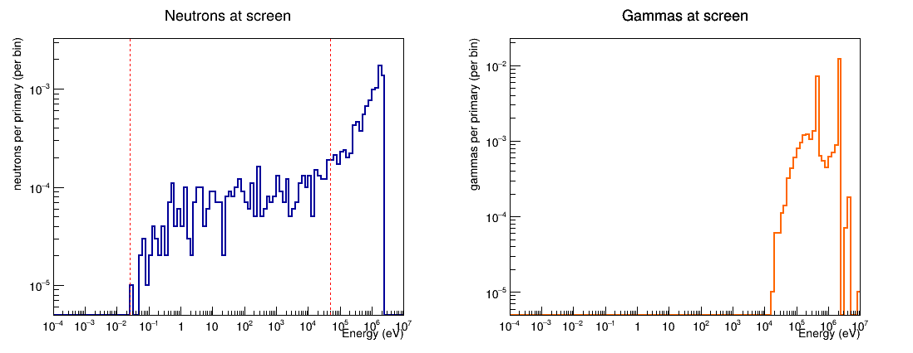
Figure 3. Run 2: spectra at the screen with the 3 × 3 stack.
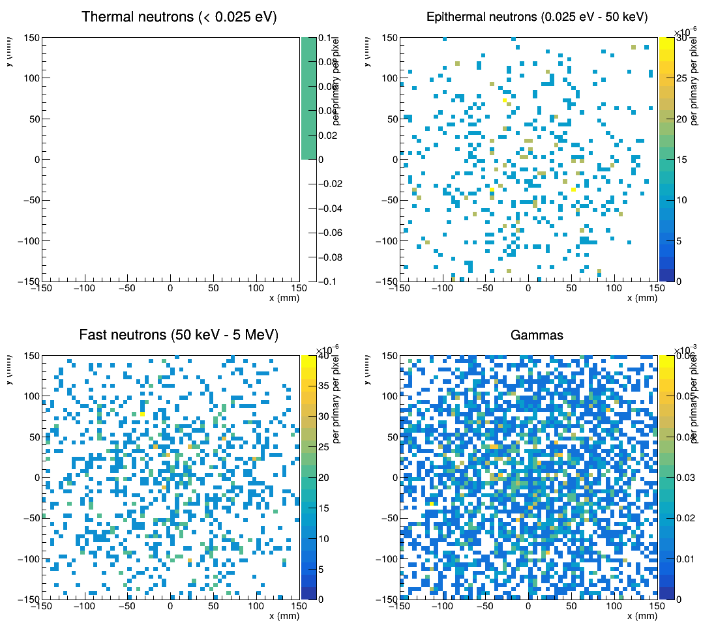
Figure 4. Run 2: spatial maps at the screen.

Observations
- Fast neutrons at the screen are halved: the side leakage is blocked.
- The thermal peak disappears from the screen spectrum: the borated sheet absorbs thermal neutrons very effectively. The only open path is the 1 cm pinhole (0.8 cm² out of a 900 cm² back face).
- The 31 thermal neutrons (< 0.5 eV) elsewhere on the screen are mostly 0.1–0.5 eV, where boron absorbs less strongly, so a few pass through 3 cm of borated HDPE.
- Gammas increase 9×: more HDPE means more hydrogen captures (2.2 MeV). HDPE does not stop gammas, which is why the design includes a lead block. The gamma map is uniform: gammas come from the whole stack.
- Only 1 thermal neutron reaches the beam spot per 100,000 primaries. All particle types are equally concentrated in the centre (≈ 7% of counts in 3% of the area), so the pinhole beam is not yet visible above the background. A better diagnostic is needed to compare designs.

Entry 3 – Moderator exit diagnostic (run 3)
Change: added the "ModExit" diagnostic (stepping action) that records particles leaving the back face of the central moderator. Geometry identical to run 2. 100,000 primaries.

Results: particles leaving the moderator back face (10 × 10 cm)
Particles | Counts | Per primary | Per cm² per primary | Stat. error
All neutrons | 2131 | 2.13 × 10⁻² | 2.13 × 10⁻⁴ | 2%
Thermal (< 0.025 eV) | 140 | 1.40 × 10⁻³ | 1.40 × 10⁻⁵ | 8%
Thermal (< 0.5 eV) | 811 | 8.11 × 10⁻³ | 8.11 × 10⁻⁵ | 4%
Epithermal | 1128 | 1.13 × 10⁻² | 1.13 × 10⁻⁴ | 3%
Fast (> 50 keV) | 863 | 8.63 × 10⁻³ | 8.63 × 10⁻⁵ | 3%
Thermal < 0.5 eV within 18° | 86 | 8.6 × 10⁻⁴ | 8.6 × 10⁻⁶ | 11%
Gammas | 967 | 9.67 × 10⁻³ | 9.67 × 10⁻⁵ | 3%

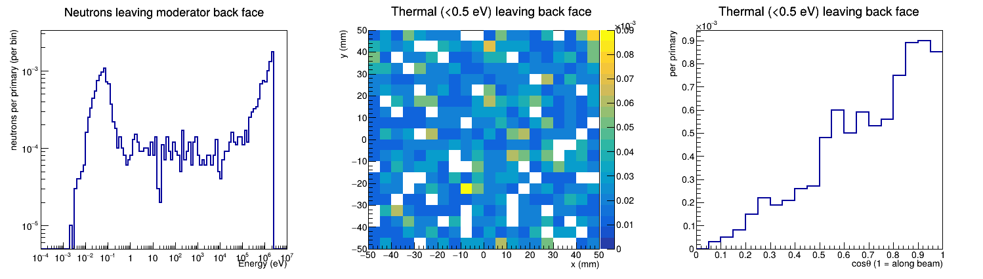
Figure 5. Run 3: neutrons leaving the moderator back face. Left: energy spectrum. Middle: where thermal neutrons (< 0.5 eV) leave. Right: their angle to the beam axis.

Observations
- 811 thermal counts at the back face compared with 1 in the beam spot: this diagnostic gives enough statistics to compare designs with 100,000 primaries.
- Consistency check: 8.6 × 10⁻⁶ thermal per cm² within 18° (the acceptance of a 1 cm hole with L/D = 3) × 0.79 cm² pinhole area ≈ 0.7 thermal neutrons per 100,000 primaries through the pinhole, consistent with the 1 count seen in the beam spot.
- Screen results are identical to run 2: same random seed, and the new diagnostic only observes.
- Clear thermal peak around 0.05–0.1 eV; only 140 of 811 thermal neutrons are below 0.025 eV.
- Thermal neutrons leave uniformly over the whole face, so the pinhole position within the face is not critical.
- The angular distribution rises roughly as cos θ (diffuse emission). Only ≈ 11% of thermal neutrons are within 18°. Higher L/D gives a sharper image but a smaller acceptance angle, so fewer neutrons: this is the main trade-off for the pinhole.

Entry 4 – Moderator thickness sweep
Change: HDPE thickness varied: 2, 4, 6, 8, 10, 12 cm (script sweep.sh, analysis sweepAnalysis.C). 3 × 3 stack, 3 cm borated sheet, 1 cm pinhole. 100,000 primaries each. The 8 surrounding blocks change thickness together with the moderator.

Results: leaving the moderator back face, per cm² per primary (raw counts)
HDPE | Thermal < 0.5 eV | Thermal < 0.025 eV | Thermal < 0.5 eV, < 18° | Fast > 50 keV | Gammas | Thermal / fast
2 cm | 6.39e-5 (639) | 9.90e-6 (99) | 7.40e-6 (74) | 1.34e-3 (13416) | 1.58e-5 (158) | 0.05
4 cm | 1.25e-4 (1247) | 1.78e-5 (178) | 1.35e-5 (135) | 6.84e-4 (6838) | 4.72e-5 (472) | 0.18
6 cm | 1.42e-4 (1423) | 2.37e-5 (237) | 1.68e-5 (168) | 3.45e-4 (3453) | 7.49e-5 (749) | 0.41
8 cm | 1.12e-4 (1121) | 1.90e-5 (190) | 1.23e-5 (123) | 1.77e-4 (1769) | 9.88e-5 (988) | 0.63
10 cm | 8.11e-5 (811) | 1.40e-5 (140) | 8.60e-6 (86) | 8.61e-5 (861) | 9.70e-5 (970) | 0.94
12 cm | 4.65e-5 (465) | 7.00e-6 (70) | 5.00e-6 (50) | 4.47e-5 (447) | 9.38e-5 (938) | 1.04

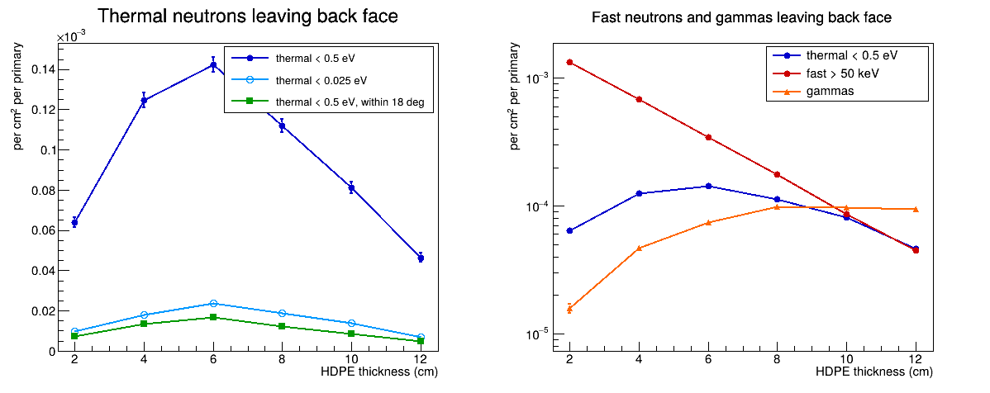
Figure 6. Thickness sweep. Left: thermal neutrons leaving the back face. Right: thermal vs fast neutrons and gammas (log scale).

Observations
- Thermal output peaks at 6 cm: about 75% more thermal neutrons than the current 10 cm design (statistical errors ≈ 3%). The same optimum is found with the 0.025 eV cut, so the conclusion does not depend on the thermal definition.
- Consistent with Juan's earlier finding (10 cm better than 20–30 cm) and his expectation of an optimum below 10 cm.
- Fast neutrons fall by about a factor 2 per 2 cm of HDPE. At 6 cm there are 4× more fast neutrons than at 10 cm; thermal/fast rises from 0.41 (6 cm) to 0.94 (10 cm).
- Gammas rise with thickness and level off from about 8 cm.
- Trade-off: 6 cm maximises thermal flux; 8–10 cm gives a cleaner beam. 8 cm is a possible compromise (≈ 20% less thermal than 6 cm, half the fast neutrons).
- The fraction of thermal neutrons within 18° is ≈ 12% at every thickness, so the ranking should carry through the pinhole.

4. Decisions and open points
Topic | Status
Thermal definition | Use 0 – 0.025 eV as main definition (Juan). Also report < 0.5 eV, since the thermal peak lies around 0.05–0.1 eV and the cadmium ratio uses the Cd cutoff.
What to optimise | Per Juan: enhance thermal flux, reduce fast component; quantify with thermal flux, cadmium ratio and neutron-to-gamma ratio. Report all three for each design.
Moderator thinner than 10 cm | Open: lab blocks are 10 cm cubes. Juan suggested simulating below 10 cm; practicality to be discussed.
Borated HDPE composition | Open: 5 wt% boron and 1.00 g/cm³ assumed; confirm from the lab sheet's datasheet.
Cadmium ratio definition | Open: Juan to confirm the exact definition.
Random seed | All runs use the same default seed. Set different seeds when independent runs are needed.

5. Next steps
- Lead block: add the lead brick behind the moderator (as in Juan's design) and vary its thickness (Juan's suggestion).
- Neutron-to-gamma ratio: convert gamma fluence at the screen to dose (Sv) and compute n·cm⁻²·Sv⁻¹; compare with the 10⁶–10¹⁰ target.
- Cadmium ratio: add to the analysis once the definition is confirmed.
- Later: graphite reflector (optional), pinhole L/D optimisation, larger final runs.

Appendix – How to run
From the build folder:
cmake .. && make -j4 # rebuild after code changes
./collimator # interactive view (vis.mac)
./collimator run3.mac # batch run
root -l './collimatorAnalysis.C("collimator_run3.root")'
bash ../sweep.sh # thickness sweep
root -l './sweepAnalysis.C'
Tips learned: run cmake .. after adding macros or .C files (it copies them into build); close ROOT with .q before re-running a changed macro; give each run its own output name with /analysis/setFileName.

