Harrison Kunkel
Project 1
Antrl Screenshots

#hai#kbye
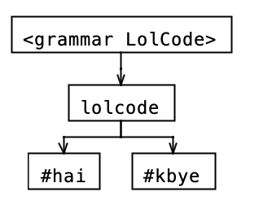
#hai
#OBTW This is a LOLCODE Markdown source file #TLDR
#MAEK HEAD
#GIMMEH TITLE The Simpsons #OIC
#MKAY
#kbye
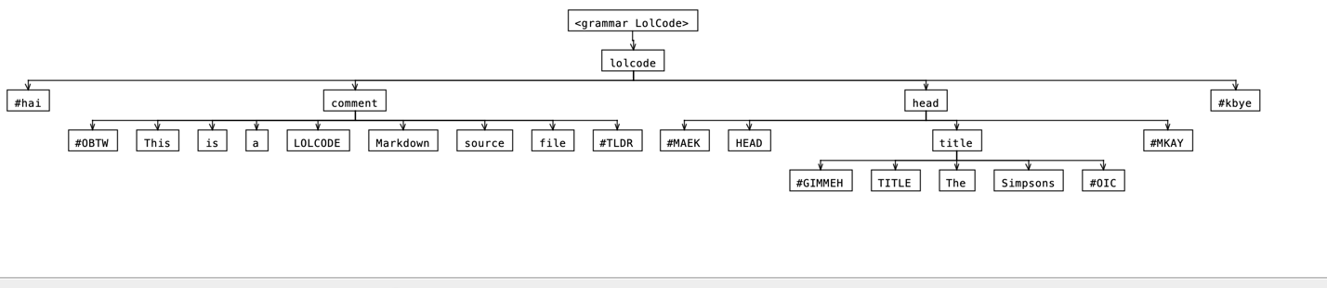

#hai
#MAEK HEAD
#GIMMEH TITLE The Simpsons #OIC
#MKAY
#kbye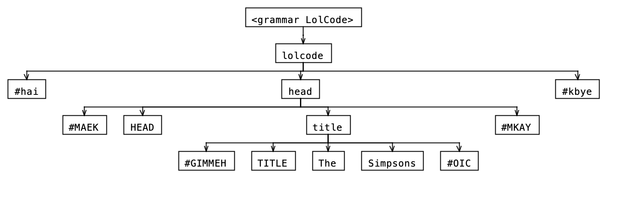
#HAI
#OBTW This is a LOLCODE Markdown source file #TLDR
#MAEK HEAD
#GIMMEH TITLE The Simpsons #OIC
#MKAY
#MAEK PARAGRAF
The Simpsons! #NEWLINE

#GIMMEH LINX www.thesimpsons.com #OIC

#NEWLINE

The members of the #GIMMEH BOLD Simpson #OIC family are:

#MAEK LIST
#GIMMEH ITEM Homer Simpson #OIC
#GIMMEH ITEM Marge Simpson #OIC
#GIMMEH ITEM Bart Simpson #OIC
#GIMMEH ITEM Lisa Simpson #OIC
#GIMMEH ITEM Maggie Simpson #OIC
#MKAY

#NEWLINE

#MKAY
#KBYE

#HAI
#MAEK PARAGRAF
The Simpsons! #NEWLINE
#GIMMEH BOLD Homer Simpson #OIC
#GIMMEH ITALICS Marge Simpson #OIC
#MKAY
#KBYE
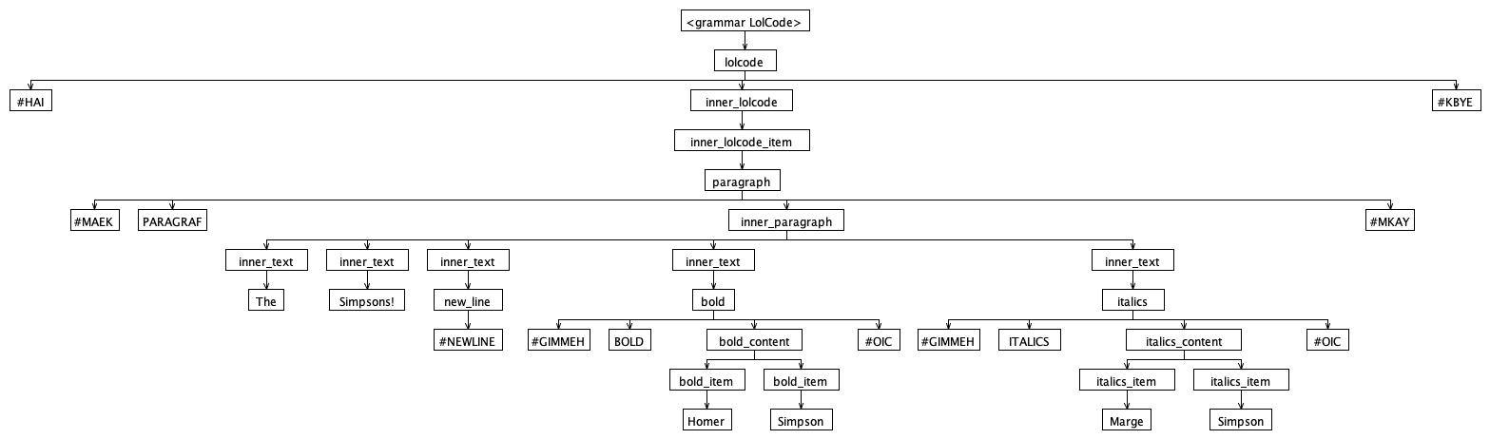

HEAD AFTER PARAGRAF SHOULD FAIL
#HAI
#MAEK PARAGRAF
The Simpsons! #NEWLINE
#GIMMEH BOLD Homer Simpson #OIC
#GIMMEH ITALICS Marge Simpson #OIC
#MKAY
#MAEK HEAD
#GIMMEH TITLE The Simpsons #OIC
#MKAY
#KBYE
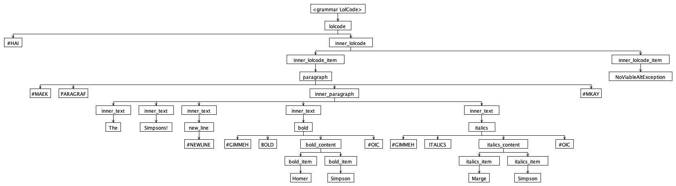

#HAI
#MAEK PARAGRAF
The Simpsons! #NEWLINE
#GIMMEH BOLD Homer Simpson #OIC
#GIMMEH ITALICS Marge Simpson #OIC
#MKAY
The Simpsons! #NEWLINE
#GIMMEH BOLD Homer Simpson #OIC
#GIMMEH ITALICS Marge Simpson #OIC
#KBYE 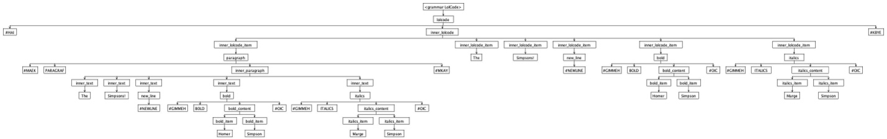

The Simpsons! #NEWLINE
#GIMMEH BOLD Homer Simpson #OIC
#GIMMEH ITALICS Marge Simpson #OIC
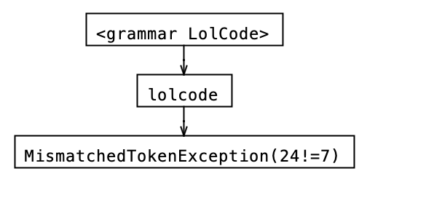
#hai
#MAEK HEAD
#TITLE The Simpsons #OIC
#MKAY
#kbye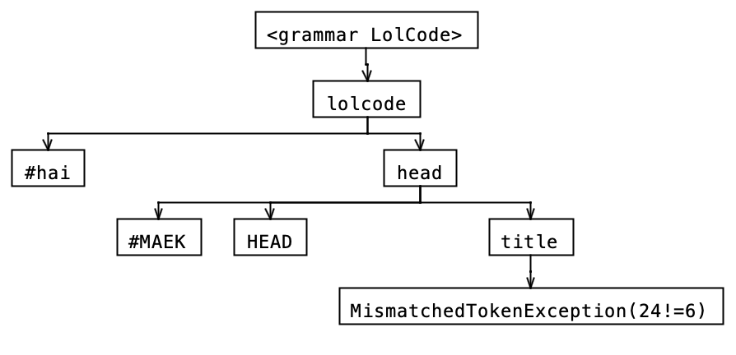
#HAI
The Simpsons! #NEWLINE
#GIMMEH BOLD #IHAZ lastname #ITIZ Simpson #MKAY Homer #LEMMESEE lastname #OIC #OIC
#KBYE
