

**EED604E OPTIMIZATION**

**HOMEWORK 3**

**Dr. Öğr. Üyesi Mohammed ALKRUNZ**

**Istanbul Aydin University**

**Engineering Faculty, Electrical and Electronics Department**

**2024-2025 Fall Semester**

Hüseyin KURT

**MRAC CONTROL WITH LYAPUNOV RULE**

# **Introduction**

Adaptive control is a powerful control methodology used for systems with uncertain or time-varying parameters. Unlike fixed-gain controllers, adaptive controllers continuously adjust their parameters to ensure the desired performance and stability of the system. A specific class of adaptive control, known as Model Reference Adaptive Control (MRAC), aims to make the system output track a predefined reference model that represents the desired closed-loop behavior.

# **Methodology**

In this study, we consider a single-input single-output (SISO) system described by the transfer function:

$$G\left(s\right)=\frac{b}{(s+a)}$$

where a>0 and b>0 are unknown system parameters. The objective is to design a control system that ensures the plant output y(t) follows the output of a reference model defined by the transfer function:

$$G_{m}\left(s\right)=\frac{2}{(s+2)}$$

The controller is designed as:

$$u\left(t\right)=θ_{1}*u_{c}\left(t\right)-θ_{2}*y(t)$$

where $u_{c}$ is the reference input, $y(t)$ is the plant output, and $θ_{1}$ and $θ_{2}$ are adaptive parameters. These parameters are updated online using adaptive laws to minimize the tracking error between the plant output and the reference model output.

To ensure the stability of the closed-loop system and the convergence of the tracking error, we employ Lyapunov's stability theory. Lyapunov theory provides a systematic way to analyze the stability of dynamic systems by constructing a scalar energy-like function called the Lyapunov function. A well-chosen Lyapunov function guarantees that the system states remain bounded and that the tracking error converges to zero.

For the MRAC system, we define a Lyapunov function candidate as:

$$V\left(e,\overline{θ_{1}},\overline{θ_{2}}\right)=\frac{e^{2}}{2}+\frac{{\overline{θ_{1}}}^{2}}{2γ}+\frac{{\overline{θ_{2}}}^{2}}{2γ}$$

where $\overline{θ_{1}}$ and $\overline{θ_{2}}$ are difference actual value and true value, $γ$ is adaptation gain. The time derivative of the Lyapunov function is shown to be negative semi-definite, which ensures that the error e converges to zero as t→∞ and the adaptive parameters $θ_{1}$ and $θ_{2}$ stabilize. The mathematical analysis of this example is in the appendix part.

This study follows like; first, the system dynamics, controller design, and adaptation laws are presented. Next, Lyapunov theory is applied to prove the stability and convergence of the closed-loop system. Finally, the designed MRAC system is implemented in simulations to validate its performance.

# **Simulation and Results**

The system consisting of MRAC controller simulated with Lyapunov rule. In the steady state, the desired value for error is to minimize or zero. Unknown parameters are used for a = 1 and b = 0.5.

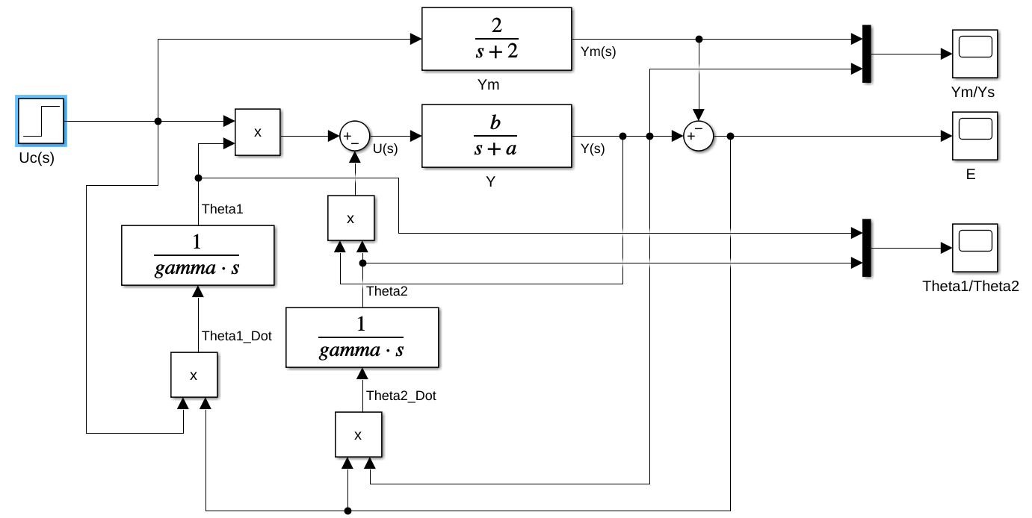

*Figure 1:Block diagram for Lyapunov rule.*

The Lyapunov block diagram for MRAC system is demonstrated on Figure 1. There is step function as input signal with 1 amplitude. It consists of reference model and plant system.

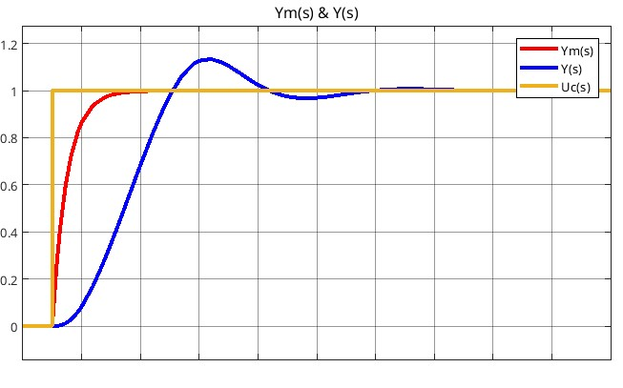

*Figure 2: Control outputs.*

Figure 5 shows the changing on the output of reference model and the plant system. The control able to follow reference model successfully by adjusting the parameter in squared error criteria.

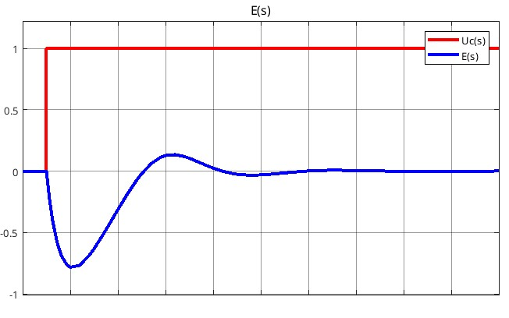

*Figure 3: The error according to control input.*

Figure 3 shows the error between plant system output and reference system output.

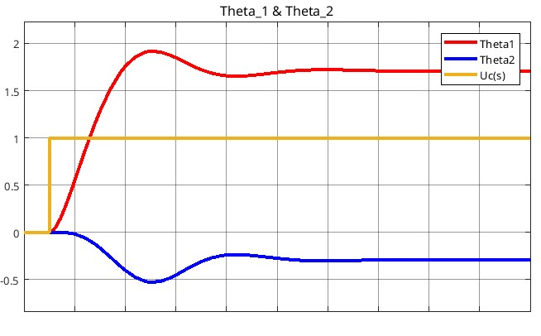

*Figure 4: The parameters changing.*

The parameter values are shown in figure 4. This parameters was reached to steady state values after transient state.

To analyze the performance of the **Model Reference Adaptive Control (MRAC)** system using Lyapunov rule, it is needed to evaluate how the plant output (y(t)) tracks the reference model output ($y_{m}(t)$), along with the behavior of the adaptive parameters $θ_{1}$ and $θ_{2}$ and the tracking error (e(t)). By analyzing the simulation results, you can validate the effectiveness of the MRAC system. If the system output tracks the reference output  and the tracking error converges to zero, the adaptive control design is successful. The error simulated in this study converges to zero. Therefore, the control design achieves to control plant system.

# **Conclusion**

In this study, a Model Reference Adaptive Control (MRAC) system was designed to ensure the output of an uncertain plant tracks the output of a predefined reference model. The plant, characterized by a transfer function. The stability and convergence of the system were analyzed using Lyapunov’s stability theory. It was shown that the time derivative of the Lyapunov function is negative semi-definite, leading to the convergence of the tracking error. Simulation results validated the mathematical analysis, demonstrating the effectiveness of the adaptive control system. The plant output closely tracked the reference model output, and the tracking error diminished over time. The designed MRAC with Lyapunov rule system successfully addressed the challenges of plant parameter uncertainty while ensuring stability and performance.