

**EED604E OPTIMIZATION**

**HOMEWORK 1**

**Dr. Öğr. Üyesi Mohammed ALKRUNZ**

**Istanbul Aydin University**

**Engineering Faculty, Electrical and Electronics Department**

**2024-2025 Fall Semester**

Hüseyin KURT

**Fuzzy Controller for Quarter Car Active Suspension System**

# **Introduction**

There are many algorithms for optimization of the parameter in the modeling. Mainly uses are Recursive Least Square (RLS), Least Mean Square (LMS), Project Approximation (PA), Stochastic Algorithm (SA) etc. In this study, 6 algorithms was compared each other with an example. Example is

Table 5: Compare the algorithms.

|  |  |  |  |
| --- | --- | --- | --- |
| Membership Function | Success Criteria ($mm$) | | |
| RMS | Max | Mean |
| Triangular Gaussian | 12.76 | 28.40 | 5.576 |
| Trapezoidal | 5.921 | 11.65 | 4.233 |
| Triangular Equal | 6.335 | 12.73 | 4.448 |
| Gaussian | 5.293 | 9.107 | 3.068 |

# **Methodolgy**

Mathematical expressions of these algorithms:

# **Simulation Results**

The simulation outputs are:

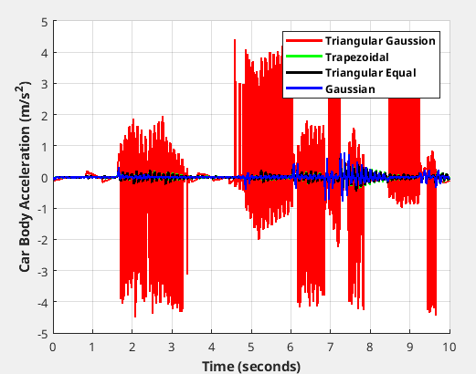

Figure 13: Car body acceleration for second road profile.

The proposed technique under RMS success criteria showing in table 5 has the best stable condition under continuous road disturbance.

# **Conclusion**

The algorithms are reach to desired valus.

# **References**

[1] Moghadam-Fard, H. & Samadi, F.. (2015). Active Suspension System Control Using Adaptive Neuro Fuzzy (ANFIS) Controller. International Journal of Engineering, Transactions A: Basics. 28. 396-401. 10.5829/idosi.ije.2015.28.03c.08.

[2] Thompson AG. Optimum Damping in a Randomly Excited Non-Linear Suspension. Proceedings of the Institution of Mechanical Engineers: Automobile Division. 1969;184(1):169-184. doi:10.1243/PIME_AUTO_1969_184_019_02

[3] Yusuf Altun, Doç. Dr. (2017). Çeyrek taşıt aktif süspansiyon sistemi için LQR ve LQI denetleyicilerinin karşılaştırılması. Gazi Üniversitesi Fen Bilimleri Dergisi Part C: Tasarım ve Teknoloji. 5. 61-70.