

**EED604E OPTIMIZATION**

**HOMEWORK 1**

**Dr. Öğr. Üyesi Mohammed ALKRUNZ**

**Istanbul Aydin University**

**Engineering Faculty, Electrical and Electronics Department**

**2024-2025 Fall Semester**

Hüseyin KURT

**OPTIMIZATION ALGORITHMS**

# **Introduction**

There are many algorithms for optimization of the parameter in the control system modeling. The most used algorithms are Recursive Least Square (RLS), Extended Least Square (ELS), Least Mean Square (LMS), Project Approximation (PA) and Stochastic Algorithm (SA). In this study, 5 algorithms was compared each other with an example. The simulation program used is MATLAB. In the RLS, the estimated parameters are updated recursively to minimize sum of squared differences between true and estimated values. ELS is extension of least square algorithm for nonlinear systems. PA projects a vector onto a constrained subspace to solve estimation problems.

Table 5: Compare the algorithms.

|  |  |  |  |
| --- | --- | --- | --- |
| **Algorithms** | **Adaptivity** | **Complexity** | **Applications** |
| RLS | High | Moderate | Time-Varying Systems Real-Time System |
| ELS | Nonlinear | High | Nonlinear Systems |
| LMS | Simple | Low | Adaptive Filtering |
| PA | Constrained | Variable | Signal Processing, Optimization |
| SA | Stochastic | Low to Moderate | Machine Learning |

Table shows comparing with these algorithms. LMS has low complexity but the adaptation is simple. However, RLS has high adaptation despite having moderate complexity.

# **Methodolgy**

Optimization is an arrangement of the parameters for designing model according to measuring data from the physical system.

$y\left(t\right)=a*y\left(t-1\right)+b*u\left(t-1\right)+c*e\left(t-1\right)+e\left(t\right)$ (1)

Example model used in this study is shown in equation (1). It uses just 1 previous input and output values.

$φ(t)=\left[\begin{matrix}-y(t-1) \\ u(t-1) \\ e(t-1)\end{matrix}\right]$ (2)

$θ=\left[\begin{matrix}a \\ b \\ c\end{matrix}\right]$ (3)

Equation (2) shows the regression vector and equation (3) is shows the parameters estimated.

$y\left(t\right)=φ{\left(t\right)}^{'}θ+ e(t)$ (4)

Equation 4 is regression model. There is an error in this equation. The error show difference between true value (observed) and estimated value.

$P(0)=\left[\begin{matrix}100 & \begin{matrix} 0 & 0\end{matrix} \\ \begin{matrix}0 \\ 0\end{matrix} & \begin{matrix}\begin{matrix}100 & 0\end{matrix} \\ \begin{matrix} 0 & 100\end{matrix}\end{matrix}\end{matrix}\right]$ (5)

$\hat{θ}\left(0\right)=[0 0 0]'$ (6)

The used covariance matrix and beginning estimated value used in this study shows in equation (5) and (6).

|  |
| --- |
|  |

# **Simulation Results**

The simulation outputs are:

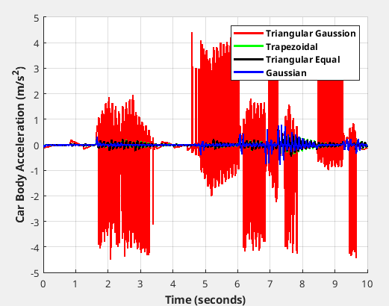

Figure 13: Car body acceleration for second road profile.

The proposed technique under RMS success criteria showing in table 5 has the best stable condition under continuous road disturbance.

# **Conclusion**

The algorithms are reach to desired valus.

# **References**

[1] Moghadam-Fard, H. & Samadi, F.. (2015). Active Suspension System Control Using Adaptive Neuro Fuzzy (ANFIS) Controller. International Journal of Engineering, Transactions A: Basics. 28. 396-401. 10.5829/idosi.ije.2015.28.03c.08.

[2] Thompson AG. Optimum Damping in a Randomly Excited Non-Linear Suspension. Proceedings of the Institution of Mechanical Engineers: Automobile Division. 1969;184(1):169-184. doi:10.1243/PIME_AUTO_1969_184_019_02

[3] Yusuf Altun, Doç. Dr. (2017). Çeyrek taşıt aktif süspansiyon sistemi için LQR ve LQI denetleyicilerinin karşılaştırılması. Gazi Üniversitesi Fen Bilimleri Dergisi Part C: Tasarım ve Teknoloji. 5. 61-70.