

**EED604E OPTIMIZATION**

**HOMEWORK 2**

**Dr. Öğr. Üyesi Mohammed ALKRUNZ**

**Istanbul Aydin University**

**Engineering Faculty, Electrical and Electronics Department**

**2024-2025 Fall Semester**

Hüseyin KURT

**MODEL REFERENCE ADAPTIVE SYSTEMS (MRAS)**

# **Introduction**

# **Methodology**

(1)

* **Squared** **Error:**

In the final we want to error minimize or zero:

Therefore .

Absolute error:

# **Simulation and Results**

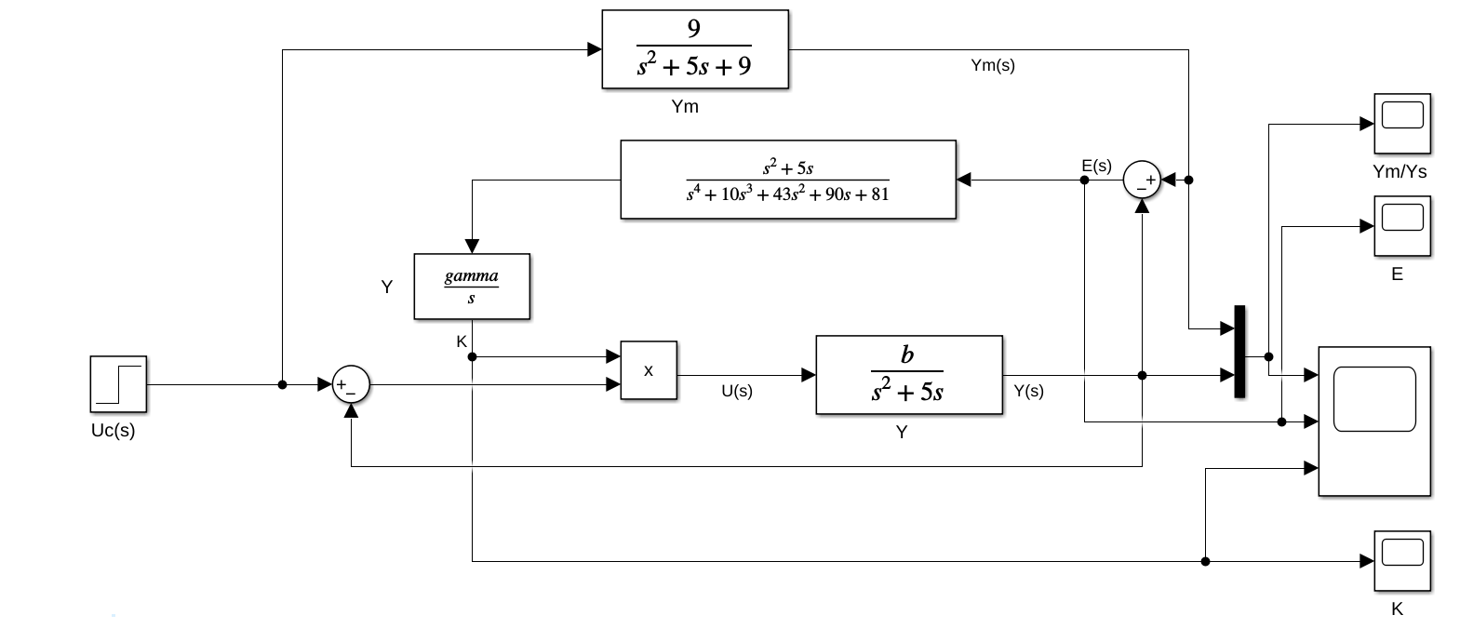

Figure :Block diagram for squared error.

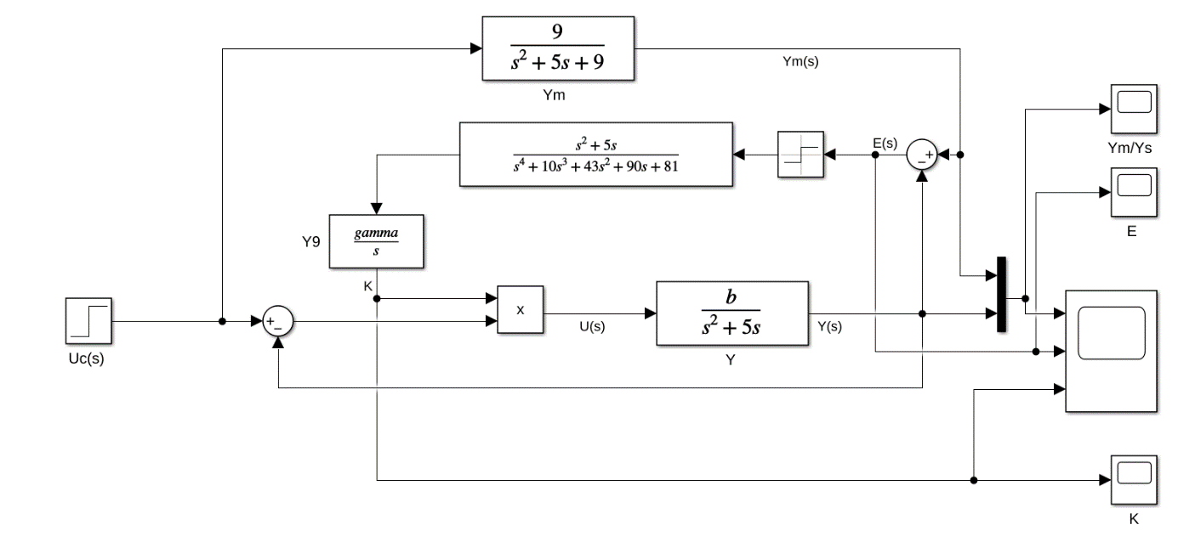

Figure : Block diagram for absalute error.

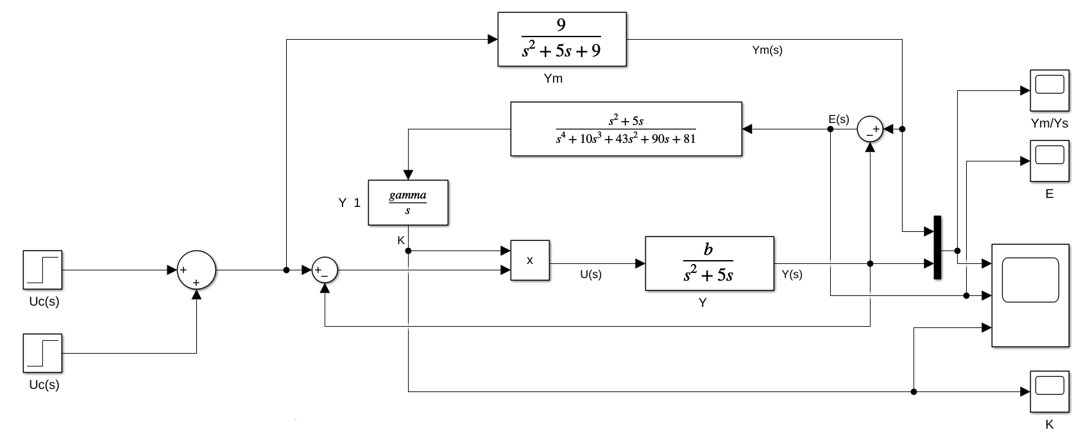

Figure : Block diagram for different amplitude.

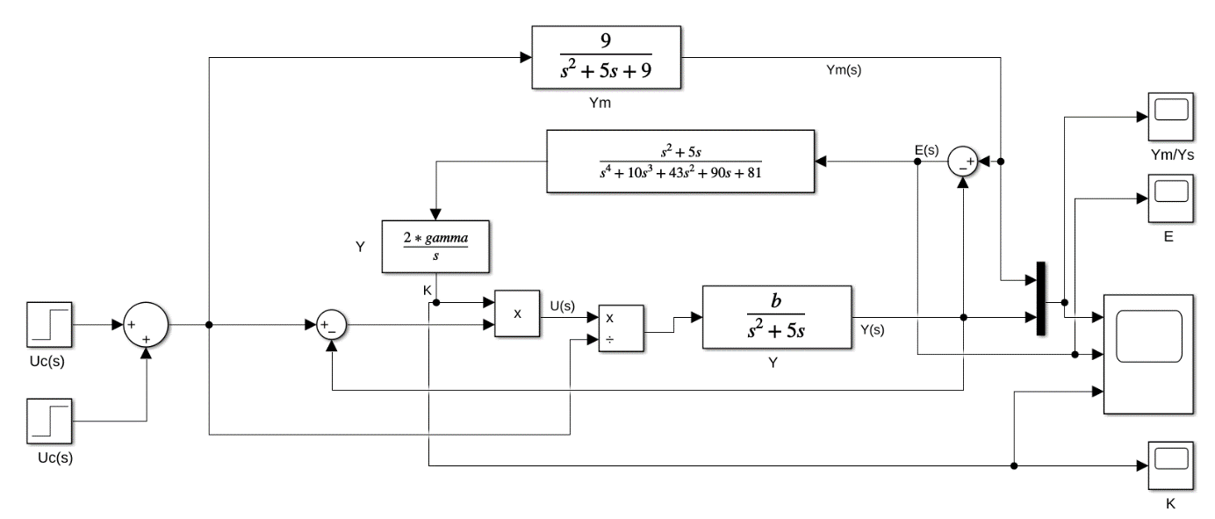

Figure : Block diagram for normalizated adaptive control.

(c)

(b)

(a)

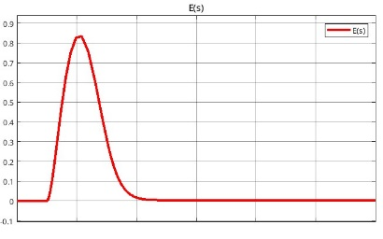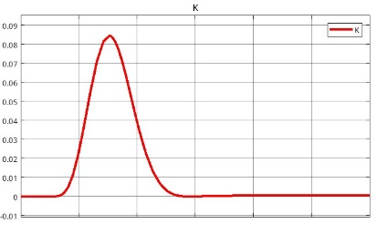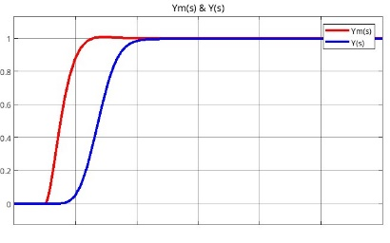

Figure : Control output for squared error.

(c)

(b)

(a)

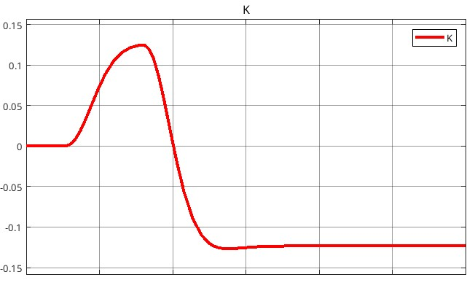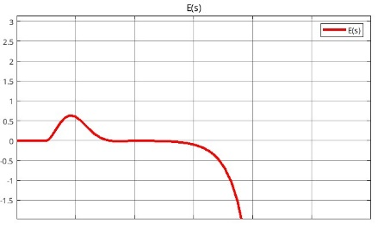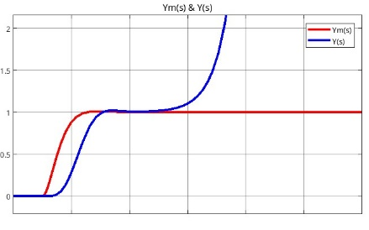

Figure : Control output for absalute error.

(c)

(b)

(a)

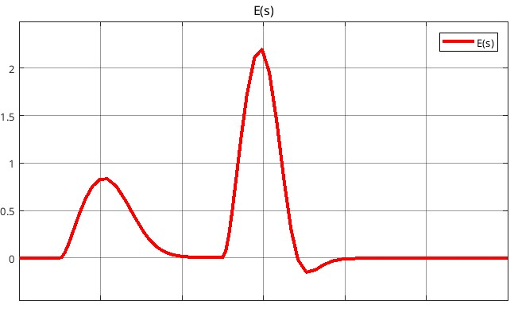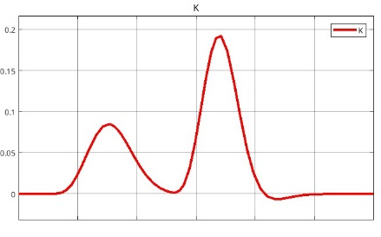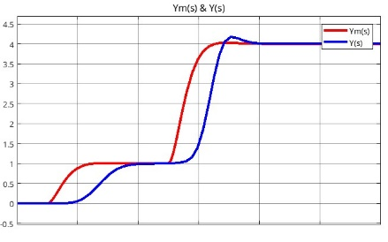

Figure : Control output for different control input.

(c)

(b)

(a)

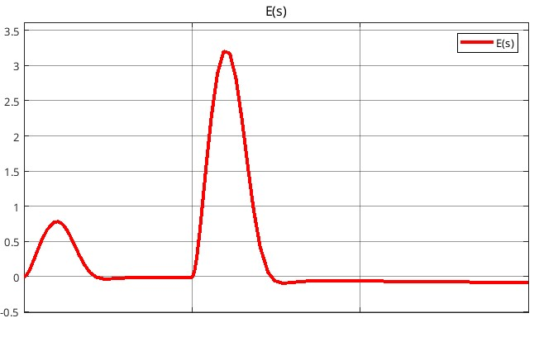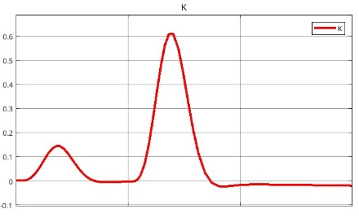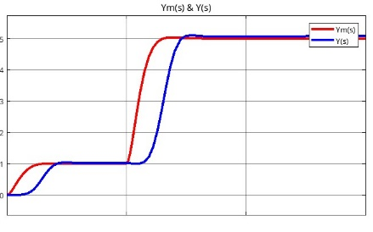

Figure : Control output for normalizated adaptive control.

# **Conclusion**

The modelling physical system is very important to control it. Many algorithms are developed according to requirements and where it uses. Mostly uses are RLS, ELS, LMS, PA and SA. In this study, these algorithms are compared in MATLAB simulation program by using an example. For this example, RLS gives the better result. Closed loop feedback control with current output is better than closed loop feedback using previous output value.