

**EED604E OPTIMIZATION**

**HOMEWORK 2**

**Dr. Öğr. Üyesi Mohammed ALKRUNZ**

**Istanbul Aydin University**

**Engineering Faculty, Electrical and Electronics Department**

**2024-2025 Fall Semester**

Hüseyin KURT

**MODEL REFERENCE ADAPTIVE CONTROL (MRAC)**

# **Introduction**

Model Reference Adaptive Control (MRAC) is a prominent technique in adaptive control systems designed to ensure that a plant (the system to be controlled) follows the behavior of a defined model (reference model). The reference model includes the desired dynamics of the plant system, requiring performance and robustness.  
Adaptive control, in general, is employed when system parameters are uncertain, time varying, or difficult to measure (especially nonlinear system). MRAC achieves adaptation by continuously updating control parameters to minimize the difference between the plant's output and the reference model's output. MRAC updates the control parameters using rules derived from optimization criteria such as MIT rule, Lyapunov, Gradient Descent. MIT Rule minimizes a chosen performance index (squared error or absolute error). Lyapunov-Based Adaptive Control ensures system stability by leveraging Lyapunov functions. Gradient Descent iteratively adjusts parameters to minimize error.

# **Methodology**

The reference model ensures the system requirements according to desired performance specifications of the plant system (settling time, overshoot, steady-state error etc.).

(1)

The employed plant system is second order system demonstrating equation (1).

Equation 2 includes the ptoportional controller of the system. It is closed loop controller.

The reference model shows in equation (2) which has second order model.

The cost function for MIT rule is defined as in equation X. The e is output error and is difference between plant system output and reference mode output.

The changing in time for the parameter defining as K depends on changing on cost function according to K parameter as shown in equation X.

The main purpose of this rule to minimize the error by adjusting the K parameter.

The closed loop input of the plant systems in s domain is indicated in equation X.

Equation X is output of the plant system with the parameter and unknown value.

In the final we want to error minimize or zero:

Therefore .

Absolute error:

# **Simulation and Results**

The system consisting of MRAC controller simulated with MIT rule.

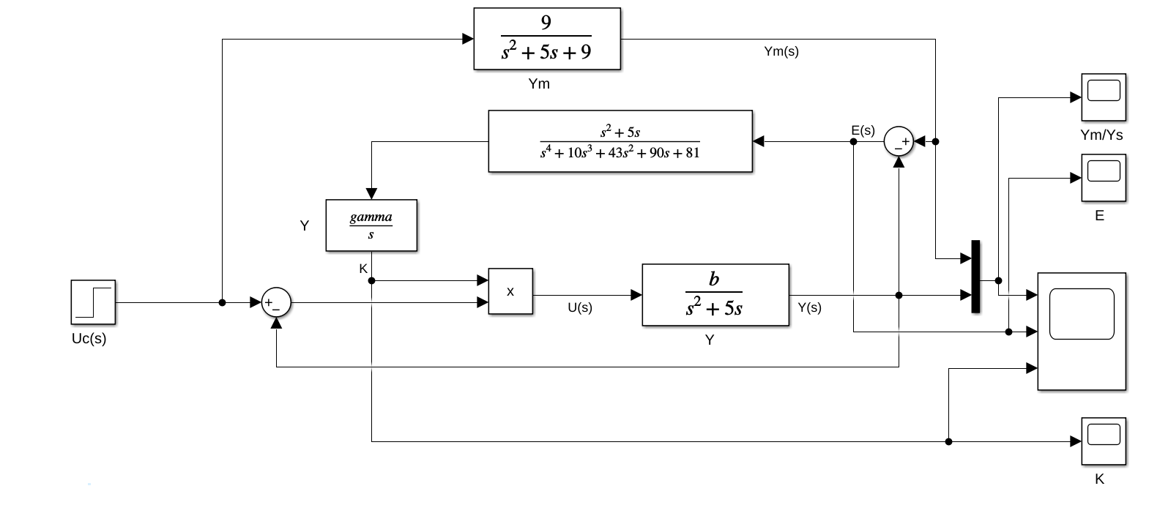

Figure 1:Block diagram for squared error.

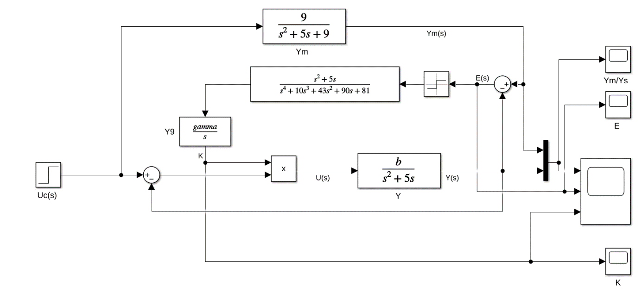

Figure 2: Block diagram for absolute error.

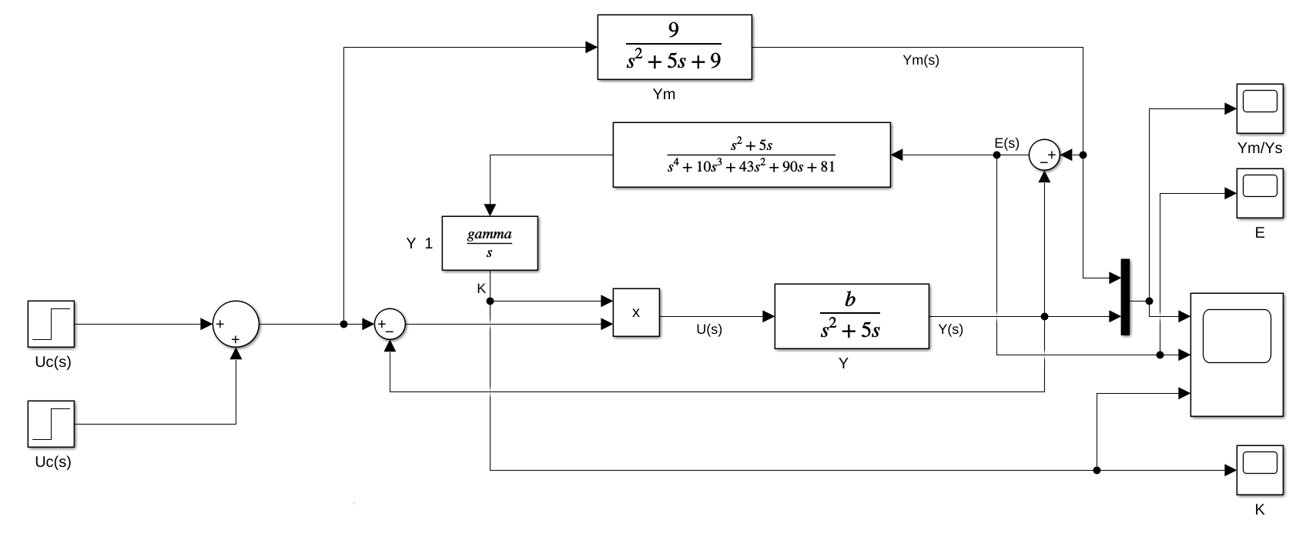

Figure 3: Block diagram for different amplitude.

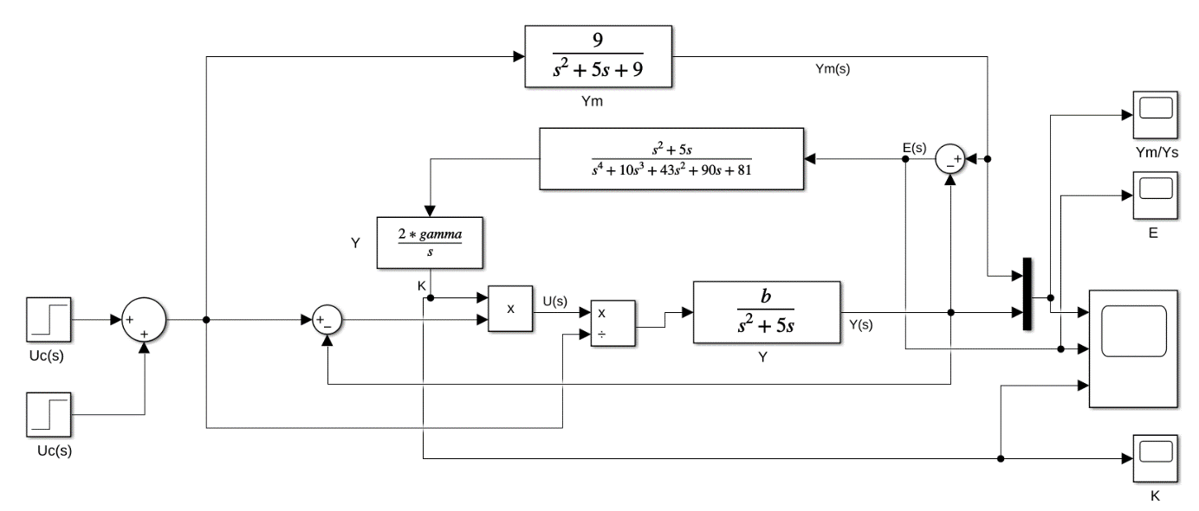

Figure 4: Block diagram for normalizated adaptive control.

(c)

(b)

(a)

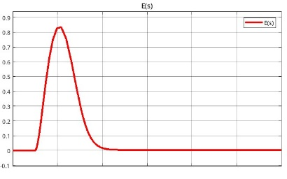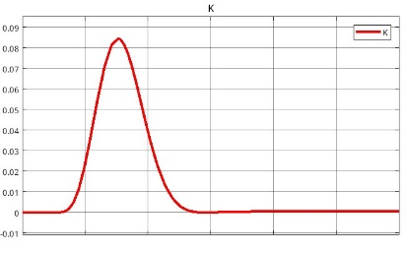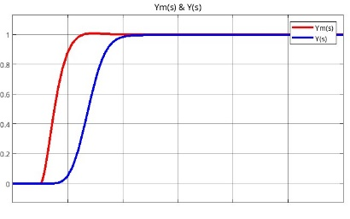

Figure 5: Control output for squared error.

(c)

(b)

(a)

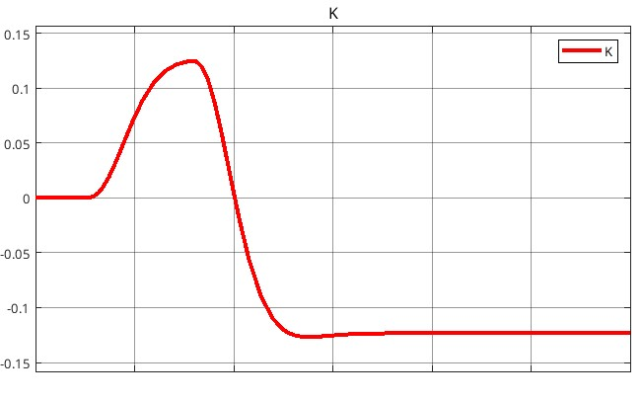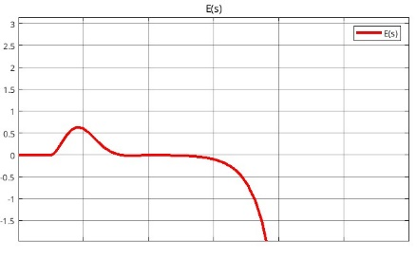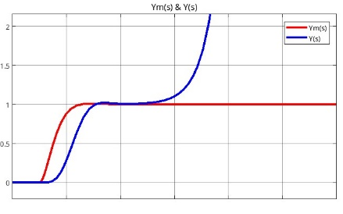

Figure 6: Control output for absolute error.

(c)

(b)

(a)

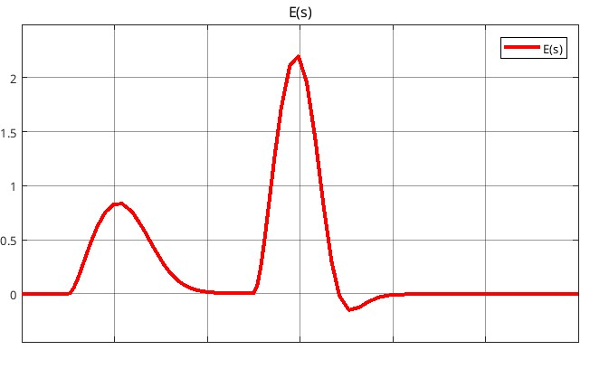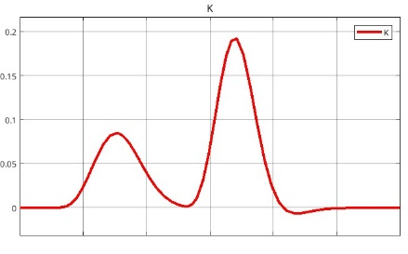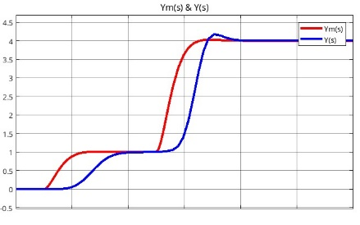

Figure 7: Control output for different control input.

(c)

(b)

(a)

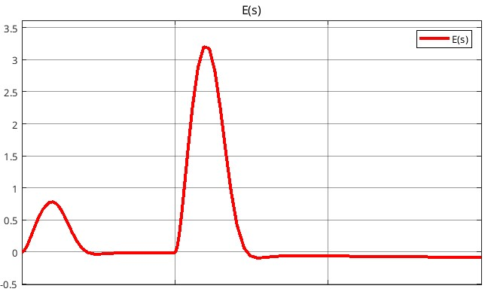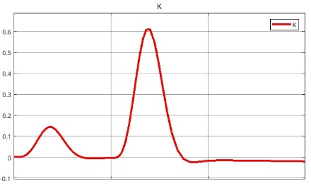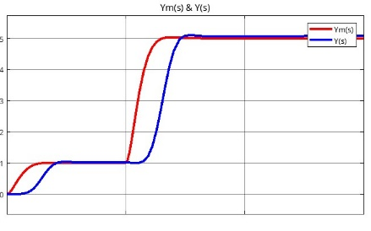

Figure 8: Control output for normalizated adaptive control.

# **Conclusion**

MRAC is a powerful control strategy that adapts to uncertainties in plant dynamics by continuously updating control parameters to achieve desired performance. With its ability to handle time-varying and unknown parameters, MRAC finds applications in various engineering domains. However, challenges like ensuring stability and managing computational complexity must be addressed for successful implementation. The combination of theoretical robustness and practical adaptability makes MRAC a cornerstone of modern control system design.

The modelling physical system is very important to control it. Many algorithms are developed according to requirements and where it uses. Mostly uses are RLS, ELS, LMS, PA and SA. In this study, these algorithms are compared in MATLAB simulation program by using an example. For this example, RLS gives the better result. Closed loop feedback control with current output is better than closed loop feedback using previous output value.