

**EED604E OPTIMIZATION**

**HOMEWORK 2**

**Dr. Öğr. Üyesi Mohammed ALKRUNZ**

**Istanbul Aydin University**

**Engineering Faculty, Electrical and Electronics Department**

**2024-2025 Fall Semester**

Hüseyin KURT

**MODEL REFERENCE ADAPTIVE CONTROL (MRAC)**

# **Introduction**

Model Reference Adaptive Control (MRAC) is a prominent technique in adaptive control systems designed to ensure that a plant (the system to be controlled) follows the behavior of a defined model (reference model). The reference model includes the desired dynamics of the plant system, requiring performance and robustness. Adaptive control, in general, is employed when system parameters are uncertain, time varying, or difficult to measure (especially nonlinear system). MRAC achieves adaptation by continuously updating control parameters to minimize the difference between the plant's output and the reference model's output. MRAC updates the control parameters using rules derived from optimization criteria such as MIT rule, Lyapunov, Gradient Descent. MIT Rule minimizes a chosen performance index (squared error or absolute error). Lyapunov-Based Adaptive Control ensures system stability by leveraging Lyapunov functions. Gradient Descent iteratively adjusts parameters to minimize error.

# **Methodology**

The reference model ensures the system requirements according to desired performance specifications of the plant system (settling time, overshoot, steady-state error etc.).

$G\left(s\right)=\frac{b}{s*(s+5)}$ (1)

The employed plant system is second order system demonstrating equation 1.

$u\left(t\right)=K(u_{c}\left(t\right)-y(t))$ (2)

Equation 2 includes the proportional controller of the system. It is closed loop controller.

$G_{m}\left(s\right)=\frac{9}{s^{2}+5*s+9)}$ (3)

The reference model shows in equation 3 which has second order model.

$J=\frac{1}{2}*e^{2}$ (4)

The cost function for MIT rule is defined as in equation 4. The e is output error and is difference between plant system output and reference mode output.

$\frac{dK}{dt}=-γ\frac{∂J}{∂K}$ (5)

The changing in time for the parameter defining as K depends on changing on cost function according to K parameter as shown in equation 5.

$\frac{dK}{dt}=-γ*e\frac{∂e}{∂K}$ (6)

The main purpose of this rule to minimize the error by adjusting the K parameter.

$U(s)=\frac{K}{1+K*G(s)}*U_{c}(s)$ (7)

The closed loop input of the plant systems in s domain is indicated in equation 7.

$Y(s)=\frac{K*b}{s*\left(s+5\right)+K*b}*U_{c}(s)$ (8)

Equation 8 is output of the plant system with the parameter and unknown value.

$E\left(s\right)=Y_{m}(s)-Y(s)$ (9)

$\frac{∂E(s)}{∂K}=-\frac{b*\left(s^{2}+5*s\right)}{{(s*\left(s+5\right)+K*b)}^{2}}*U_{c}(s)$ (10)

Equation 9 shows the error signal in s domain. When the equation is taken the derivative according to K parameter, equation 10 is obtained. Hence, there is no any K parameter on $Y_{m}(s)$, there is only on $Y(s)$.

$\frac{dK}{dt}=γ*e*\frac{b*\left(s^{2}+5*s\right)}{{(s*\left(s+5\right)+K*b)}^{2}}*U_{c}(s)$ (11)

$K=\frac{γ}{s}*E(s)*\frac{b*\left(s^{2}+5*s\right)}{{(s*\left(s+5\right)+K*b)}^{2}}*U_{c}(s)$ (12)

The parameter K changing in time and s-domain equations are given equation 11 and 12 respectively.

$J=|e|$ (13)

Absolute error cost function is given equation 13.

$\frac{dK}{dt}=-γ*sign\left(e\right)*\frac{∂e}{∂K}$ (14)

$K=\frac{γ}{s}*sign(E\left(s\right))*\frac{b*\left(s^{2}+5*s\right)}{{(s*\left(s+5\right)+K*b)}^{2}}*U_{c}(s)$ (15)

Equation 14 and 15 indicate K parameter changing in time and s-domain equations respectively.

# **Simulation and Results**

The system consisting of MRAC controller simulated with MIT rule. In the steady state, the desired value for error is to minimize or zero.

$Y(s)=Y_{m}(s)$ (16)

$Y\left(s\right)=\frac{K*b*U_{c}\left(s\right)}{s*\left(s+5\right)+K*b}=Y_{m}\left(s\right)=\frac{9*U_{c}\left(s\right)}{s*\left(s+5\right)+9}$ (17)

Therefore, multiplication of K parameter and unknown value ($K*b$) should be equal to 9 for the simulation. Gamma used in equation 12 and 15 is 1.

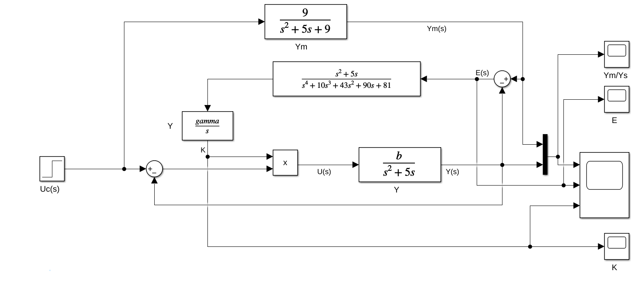

Figure 1:Block diagram for squared error.

Squared error block diagram for MRAC system is demonstrated on Figure 1. There is step function as input signal with 1 amplitude.

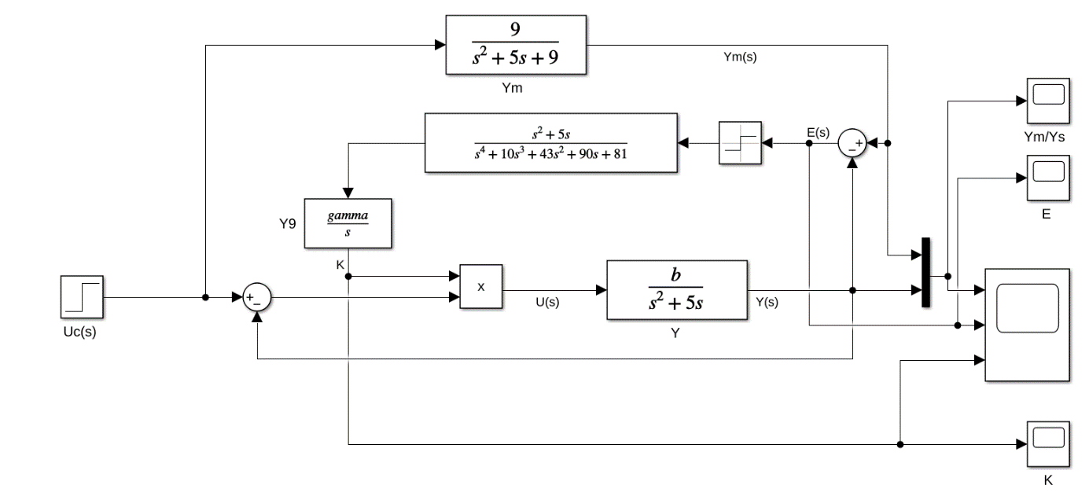

Figure 2: Block diagram for absolute error.

Figure 2 shows the same system with absolute error block diagram.

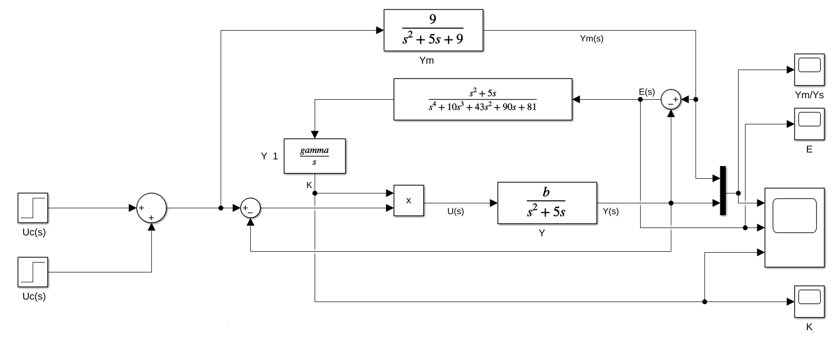

Figure 3: Block diagram for different amplitude.

To investigate the system stability of the MRAC system, the design shown in figure 3 is used with two different amplitude input signal.

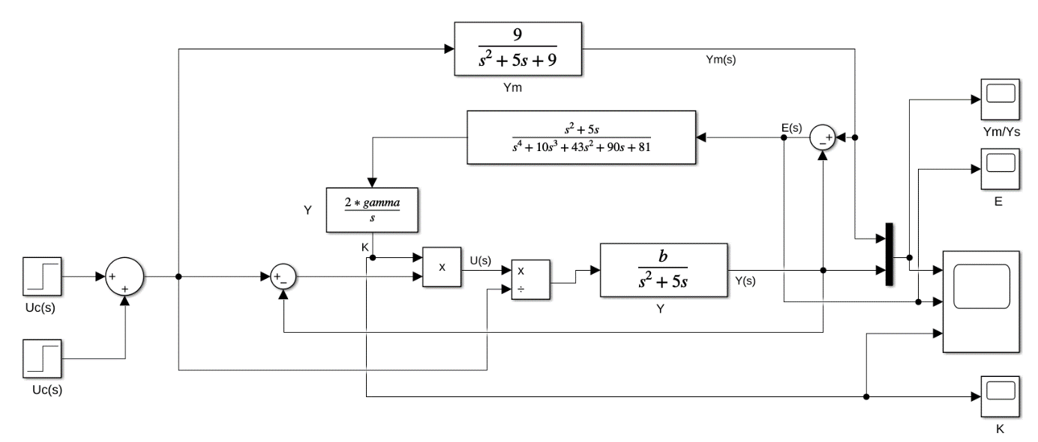

Figure 4: Block diagram for normalized adaptive control.

To normalize the MRAC system, the plant input signal is divided by the input control signal to become independent of the input control signal.

(b)

(a)

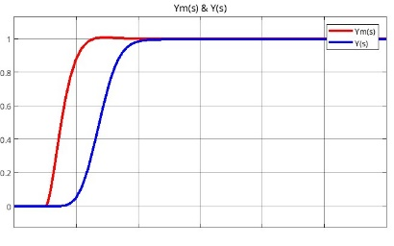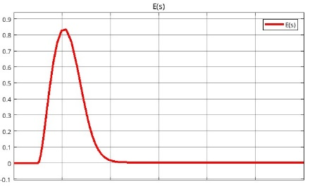

Figure 5: Control output for squared error.

Figure 5 shows the changing on the output of reference model and the plant system. The control able to follow reference model successfully by adjusting the parameter in squared error criteria.

(b)

(a)

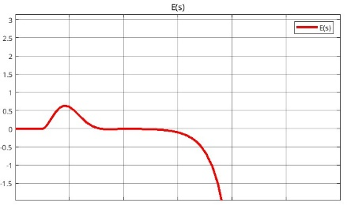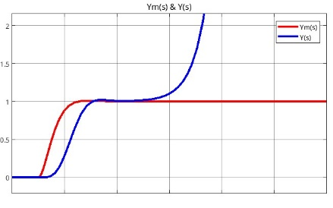

Figure 6: Control output for absolute error.

Figure 6 shows the output of reference model and the plant system (a) and difference between them (b). The plant cannot follow the reference model in the absolute error. The error goes to infinite.

(b)

(a)

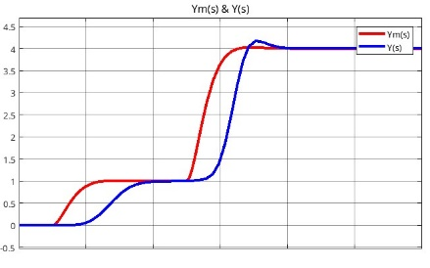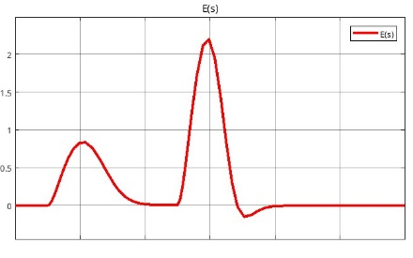

Figure 7: Control output for different control input.

In the different amplitude input signal, figure 7 shows the output of reference model and the plant system (a) and difference between them (b). The plant can follow the reference model in the squared error. In the second changing, the control has short overshoot.

(b)

(a)

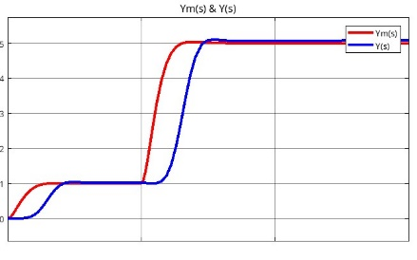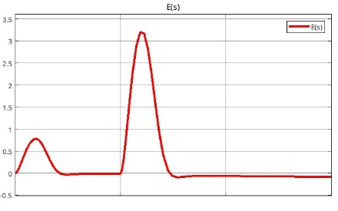

Figure 8: Control output for normalized adaptive control.

In the different amplitude input signal, figure 8 shows the output of reference model and the plant system (a) and difference between them (b). The plant able to pursuit the reference model in the squared error. Normalizing provides better control. It decreases the overshoot.

# **Conclusion**

MRAC is a powerful control strategy that adapts to uncertainties in plant dynamics by continuously updating control parameters to achieve desired performance. With its ability to handle time-varying and unknown parameters, MRAC finds applications in various engineering domains. However, challenges like ensuring stability and managing computational complexity must be addressed for successful implementation. The combination of theoretical robustness and practical adaptability makes MRAC a key factor of modern control system design. This study handles that MRAC has better solution for nonlinear system to control plant system by adjusting controller parameters.