Create a project containing a .gitlab-ci.yml file and register a GitLab Runner

LAB 1: REVIEW EXAMPLE GITLAB CI/CD SECTION
review lab file from source

http://gitlab.vclass.local/my-test-group/gitlab-cicd-hands-on-demo
http://gitlab.vclass.local/my-test-group/gitlab-cicd-hands-on-demo/-/snippets

LAB : CREATE A PROJECT CONTAINING .gitlab-ci.yml FILE AND REGISTER A GITLAB RUNNER

A. Go to your gitlab.vclass.local and Create a project
- In the top navigation bar, click Menu > Group > MYT1
- Select Create a project. Select Create blank project.
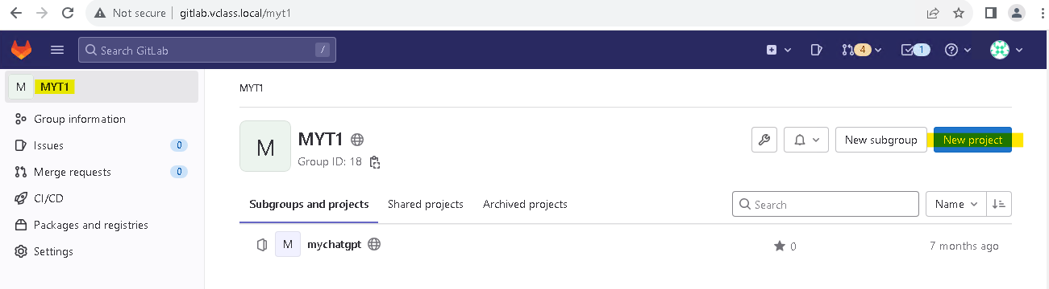
- In the Project name field, enter CICD Demo. In the Project URL Projects dropdown, select MYG1 to create your project within your group’s namespace and not your user’s top-level namespace.
- Under Visibility Level, select the radio button for Public.
- Enable the Initialize repository with a README checkbox.
Note: If you do not initialize your repository with a README, you will create a “bare” Git repo that will be difficult to work with in GitLab until you push files to it from a local repository.
- Select Create project.
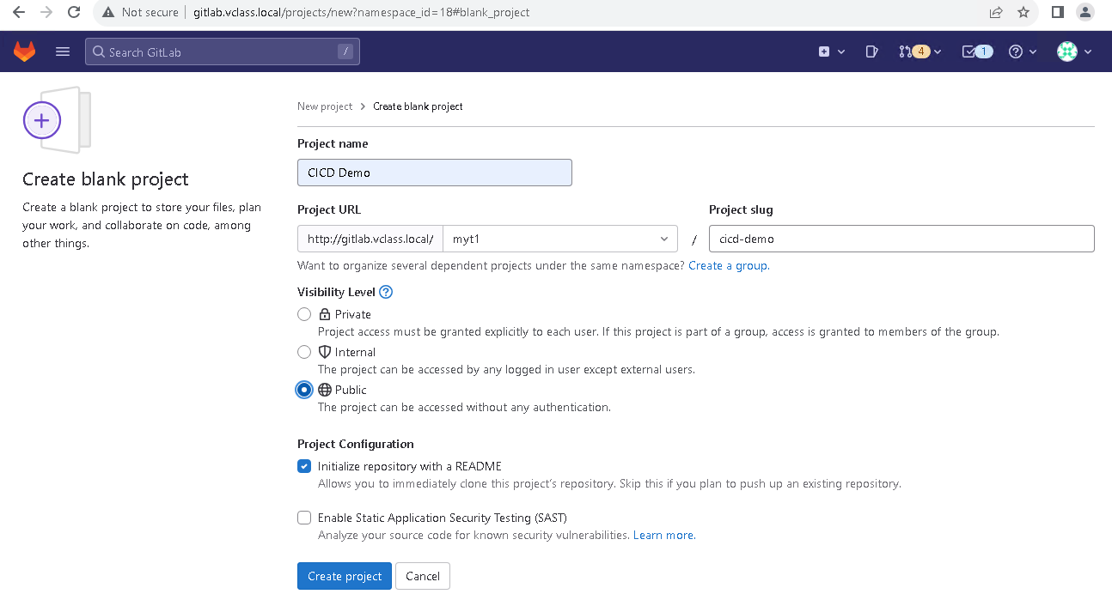

Add a .gitlab-ci.yml file

- From the new project's landing page, add a new file to the project’s repository by finding the + dropdown , Select + > This directory > New file.
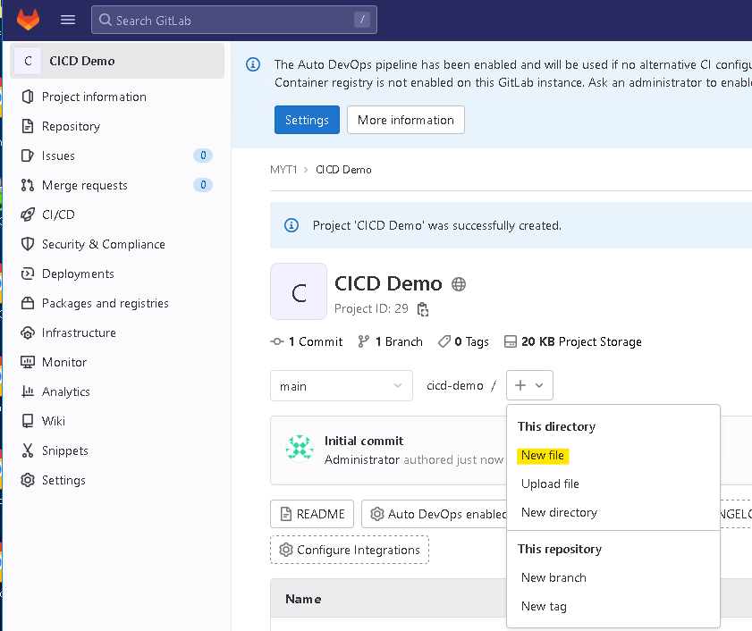
- In the File name field, enter .gitlab-ci.yml
- Select .gitlab-ci.yml for template type and apply the Bash template. This will pre-populate the file.
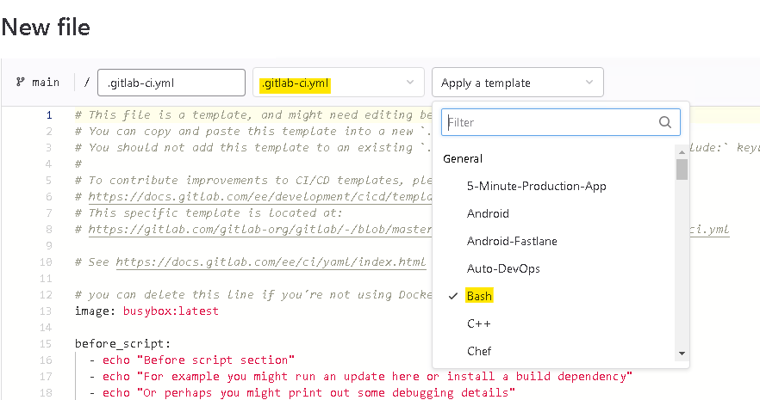
- To create a minimal .gitlab-ci.yml file:
  - Delete all lines above build1.
  - Delete all lines below echo "For example run a test suite" in the test1 section.
- Add build and test stages by pasting these lines at the top of the file. Tip: watch the spacing before and after the hyphens!
stages:
- build
- test
- Select Commit changes.
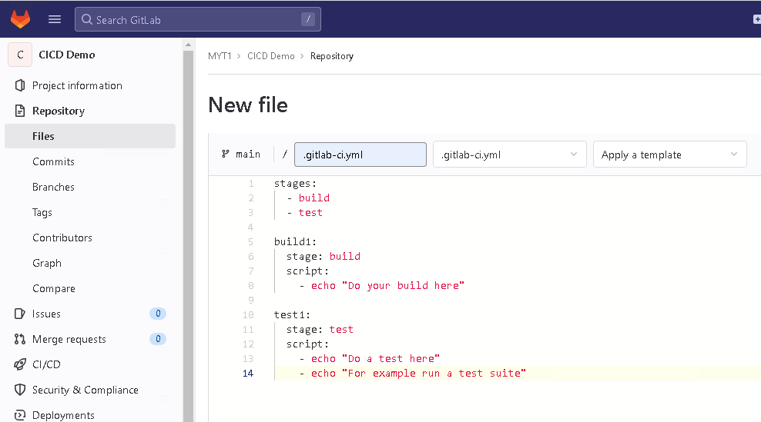

C. View a pipeline’s status, stages, jobs, and GitLab runner
- In the left navigation pane, click CI/CD > Pipelines to see an overview of all pipelines. The top row in the overview shows the pipeline that started a few seconds ago, when you committed .gitlab-ci.yml. The status icon at the left of the row should say running, passed or pending.
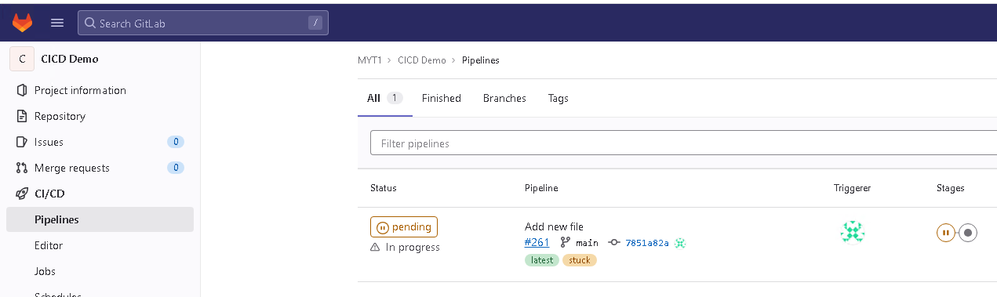
*** set the gitlab runner to group share runner ***

Go to you first project (nginx), then go to Settings, CI/CD, runners
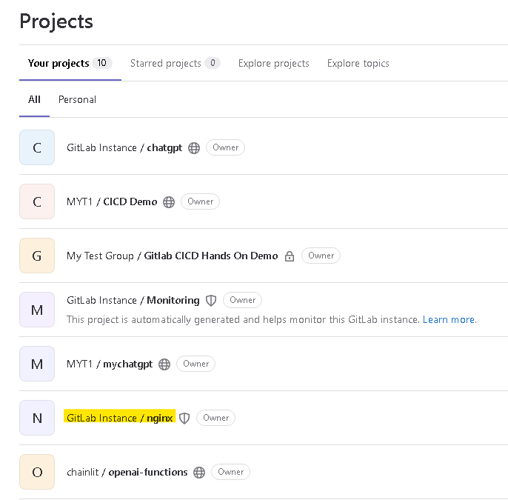
Select your runner (master1), then check the pencil

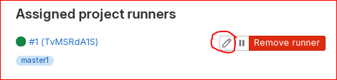

Then uncheck “Lock to current projects”, let the runner share to another project
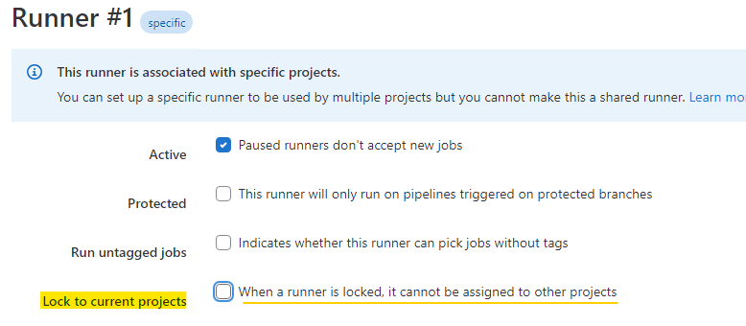
Now go back to “CICD Demo” project, “enable runner for this project”:
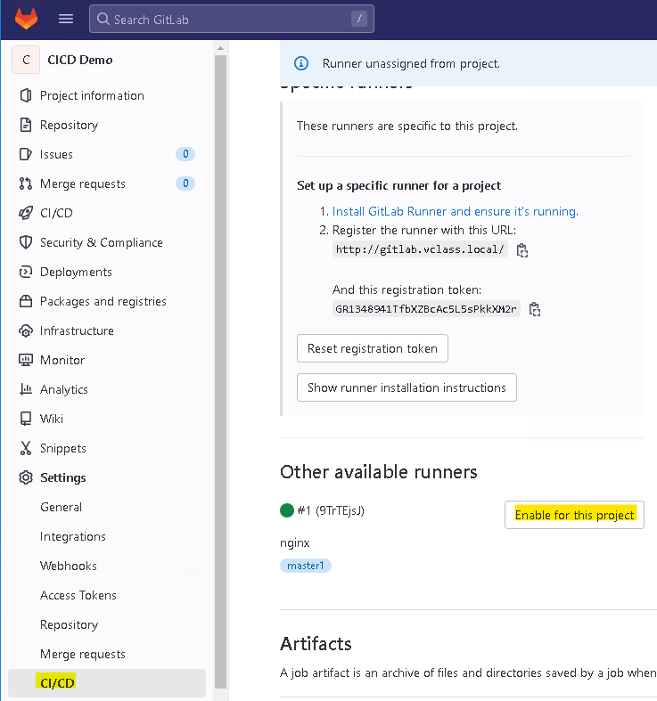
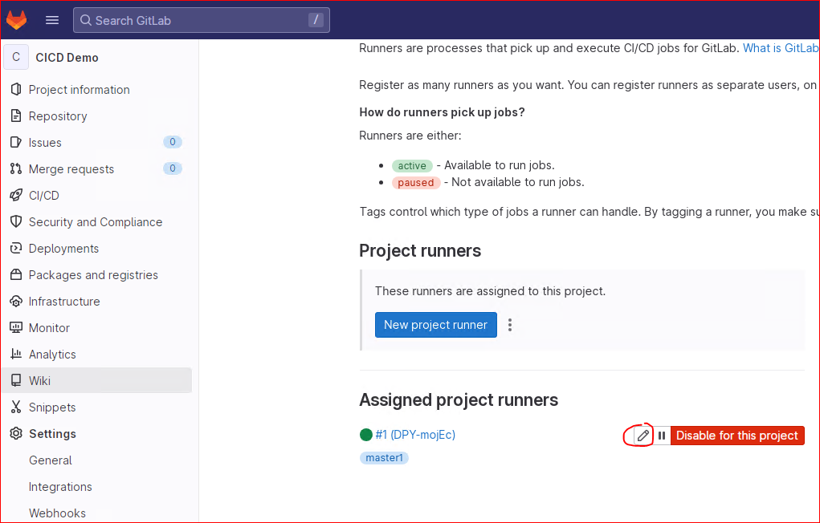
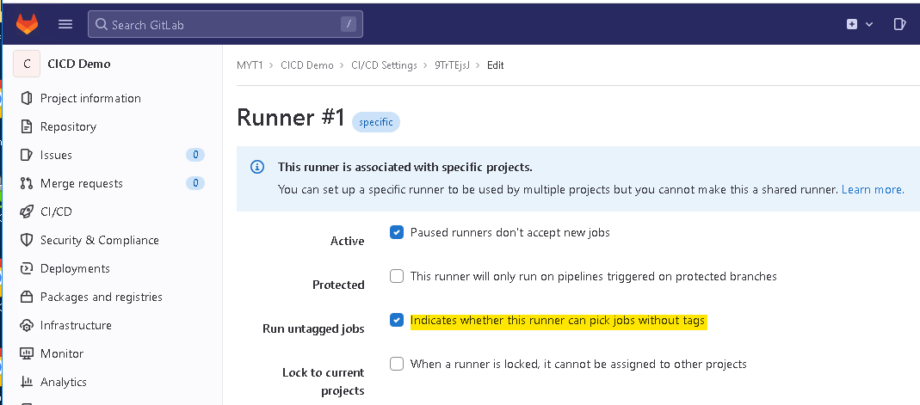
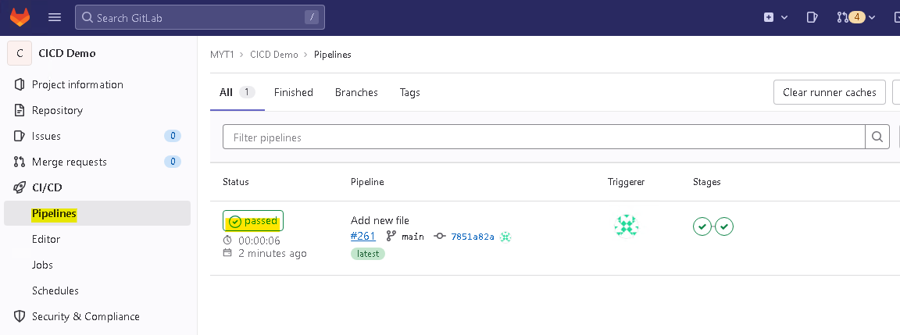
- Click the status icon of the top row to see the details of the most recent pipeline. You’ll see columns representing the pipeline’s stages, and widgets representing jobs within each stage.
- Click each of the two jobs to see the output in a web terminal. Identify the gitlab-runner for each job Hint: it’s listed near the top of each job’s output. You can use tags to limit which runners run which jobs.

LAB 3: CREATE A BASIC CI CONFIGURATION
- Open the http://gitlab.vclass.local/my-test-group/gitlab-cicd-hands-on-demo of the CICD Hands On Demo project in a seperate window or tab.
- Open the ci-starter snippets. Click the Copy file contents icon in the upper right corner of the file.
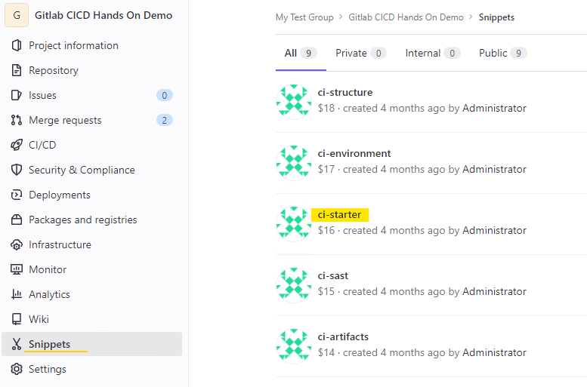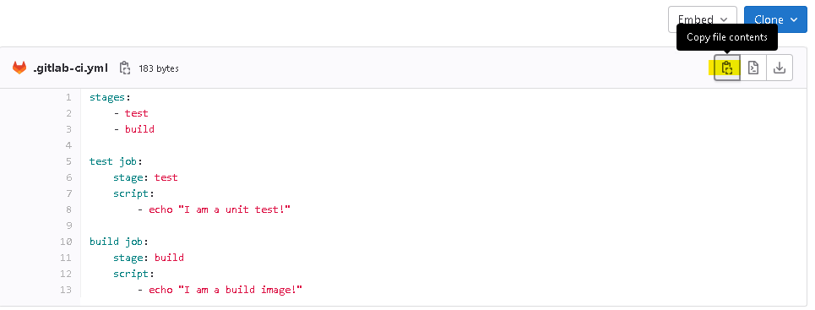
- Open your CICD Demo project from the last lab.
- Click on your “.gitlab-ci.yml” file to view its contents. Select the dropdown arrow next to Open in Web IDE. Select Edit this file only, then select Edit. Replace all the code in .gitlab-ci.yml with the content of the snippet you copied. (Note: the pipeline logic will be almost identical to what you had previously, just the job names and echo statements will change slightly.)
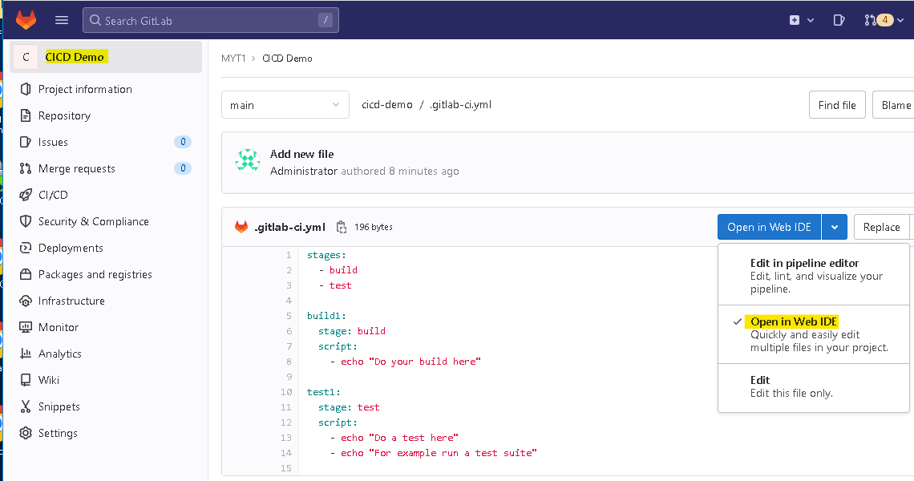
- In the Commit message field, type Add CI starter and click Commit changes.
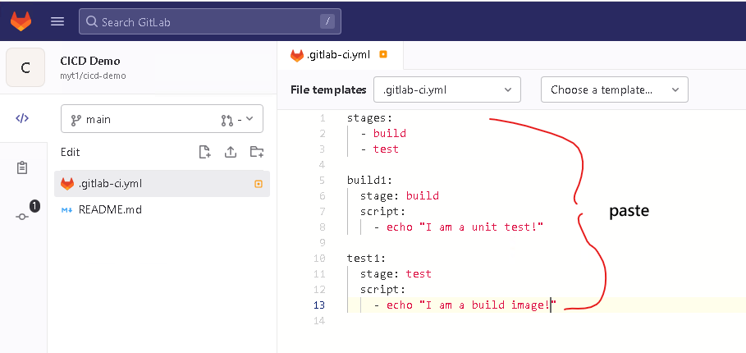
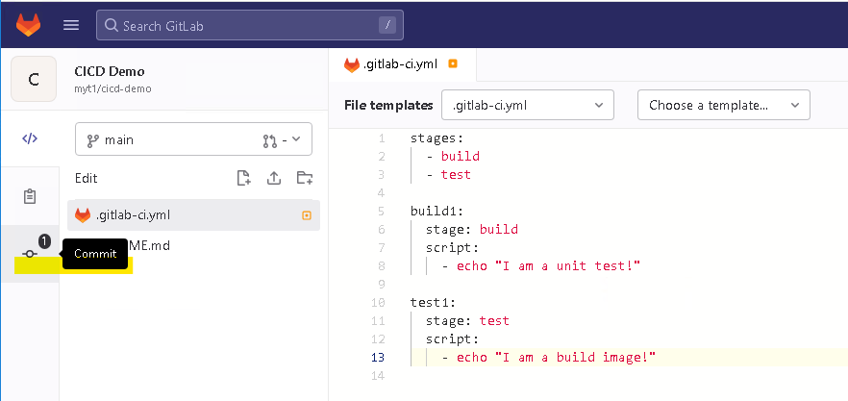

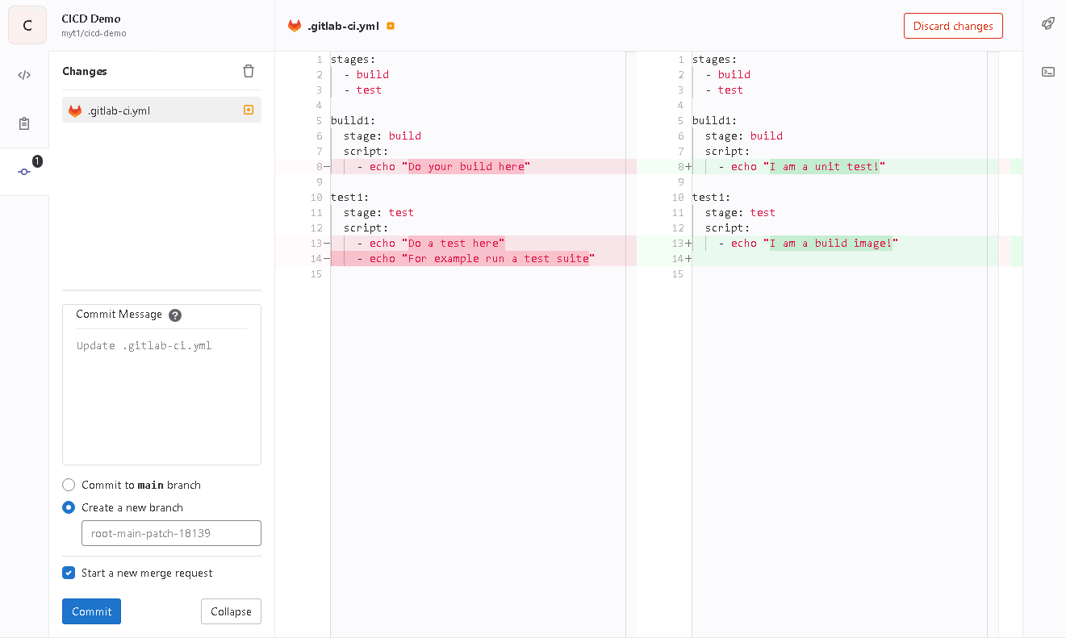
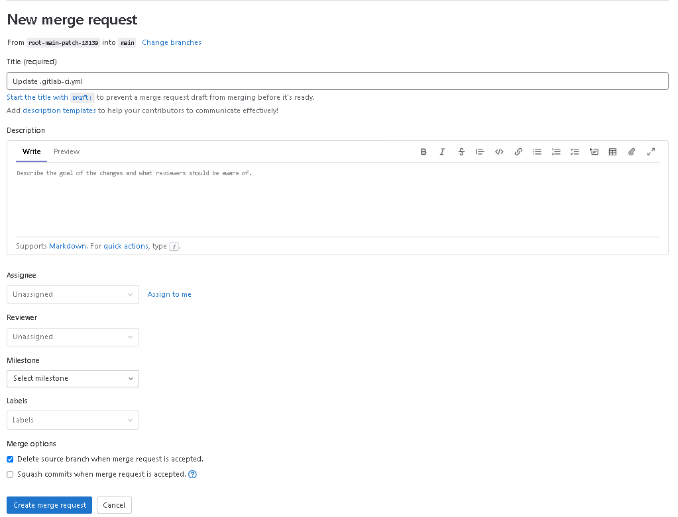
- Refresh the page to make the pipeline status icon appear. Validate that the configuration is valid and that the pipeline is running by hovering over the Pipeline: running icon or the Pipeline: passed icon in the upper right corner of the page, to the left of the commit's SHA.
- When the pipeline status changes to the Pipeline: passed icon, click it to review the pipeline graph for your CI configuration.
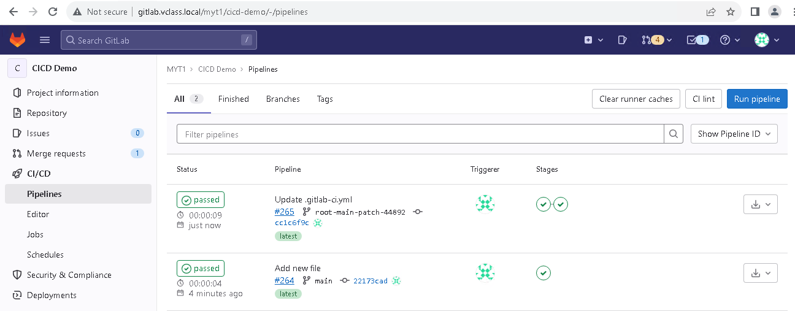

Display pipeline environment info

- Go to the http://gitlab.vclass.local/my-test-group/gitlab-cicd-hands-on-demo/-/snippets of the CICD Hands On Demo project you have open in a seperate window/tab.
- Open the ci-environment snippet and select the Copy file contents icon in the upper right corner of the file.
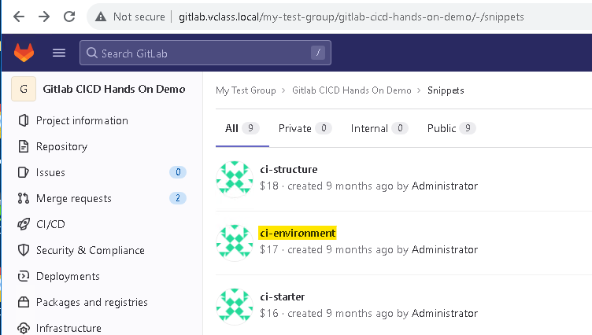
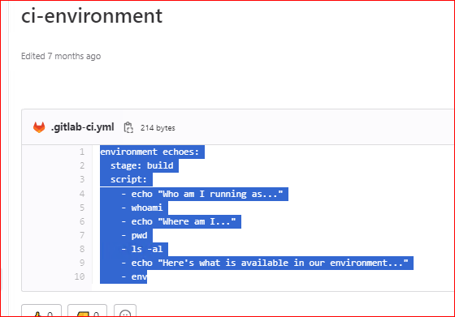
- Open your CICD Demo project from previous labs.
- Select on your .gitlab-ci.yml file to view its contents. Select the dropdown next to Edit, then Select Edit this file only.
- Paste the content of the snippet at the bottom of .gitlab-ci.yml. There should be an empty line between the file's previous content and the pasted snippet content.
- In the Commit message field, type Display pipeline environment variables, ensure the Target Branch is set to main, and select Commit changes.
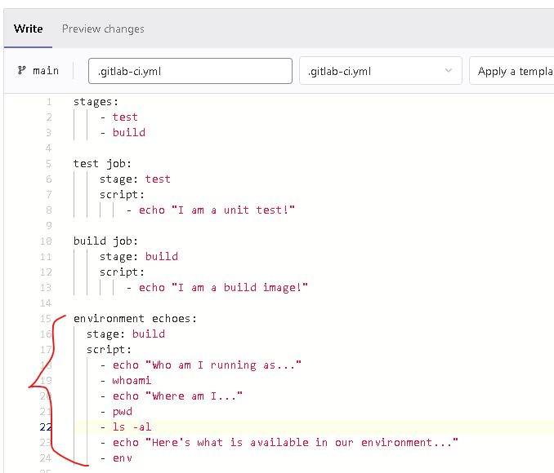

- In the left-hand navigation pane, select CI/CD > Pipelines. The pipeline that was started when you committed changes is represented by the first row in that table.
- Select the status icon at the left of the first row to see the pipeline's jobs. Select the environment echoes job and review its output to review about the environment variables exported to the runner.

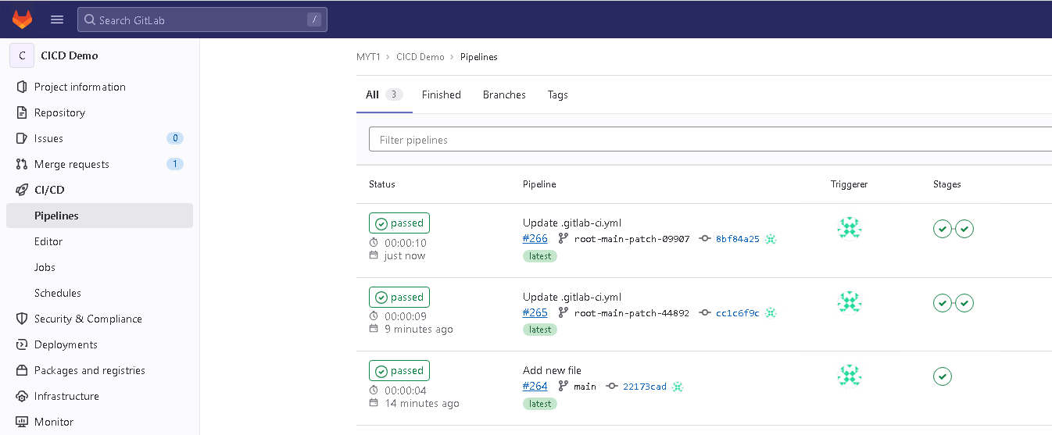

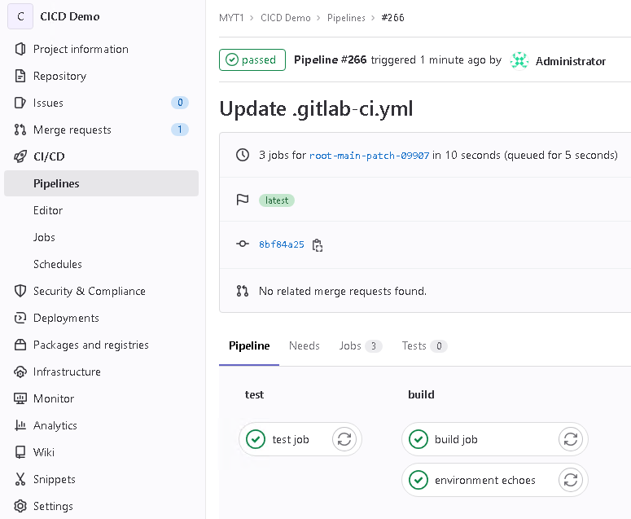
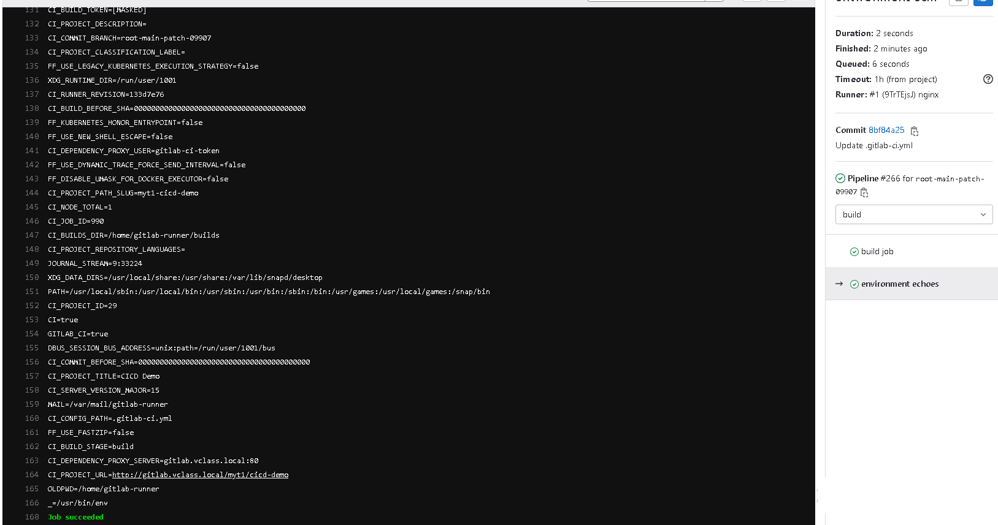

VARIABLE HIERARCHY

Add custom variables
- Go to the http://gitlab.vclass.local/my-test-group/gitlab-cicd-hands-on-demo/-/snippets of the CI-CD Hands On Demo project.
- Open the ci-variables snippet and click the Copy file contents icon in the upper right corner of the file.
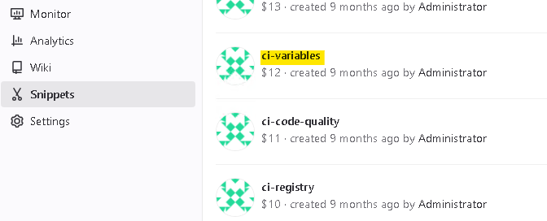
- Open your CICD Demo project from previous labs.
- Select your .gitlab-ci.yml file to view its contents. Select the Open inWeb IDE
- Select Edit. Paste the snippet at the end of the file, with an empty line between the file's previous content and the snippet's content.
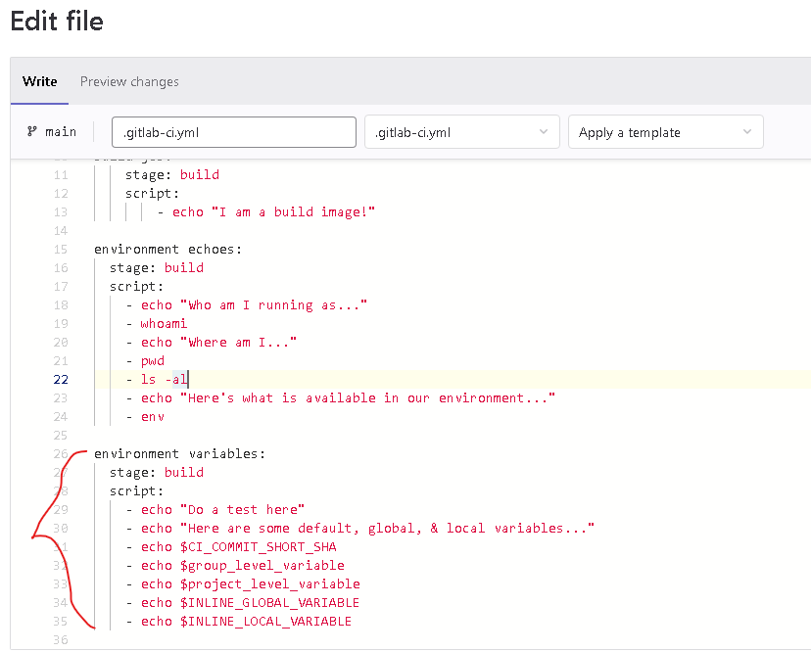
- Near the top of your .gitlab-ci.yml, in a new line below the entire stages section, paste the following:
variables:
INLINE_GLOBAL_VARIABLE: "I'm an inline variable set at the global level of the CI/CD configuration file"
- Inside the environment variables job, just below that job's stage: build line (but before the script line), paste the following. The variables keyword should be at the same indendation as that job's stage and script keywords.
variables:
INLINE_LOCAL_VARIABLE: "I'm an inline variable set at the job level of the CI/CD configuration file"
When defining variables, watch your indentation. Global variables must be indented by 2 spaces, and must be immediately under a flush-left variables keyword that is outside any job definition. Local variables must be indented 4 spaces, and must be immediately under a variables keyword that is indented 2 spaces and is within a job definition. Here's a reference example of how to define global and local variables:
# NOTE: this code demonstrates how to define global and local variables.
# Do NOT copy and paste this code into your .gitlab-ci.yml file.

variables:
GLOBAL_SCOPE_VAR: "value1"

job-a:
variables:
LOCAL_SCOPE_VAR: "value2"
script:
- echo $LOCAL_SCOPE_VAR
- echo $GLOBAL_SCOPE_VAR
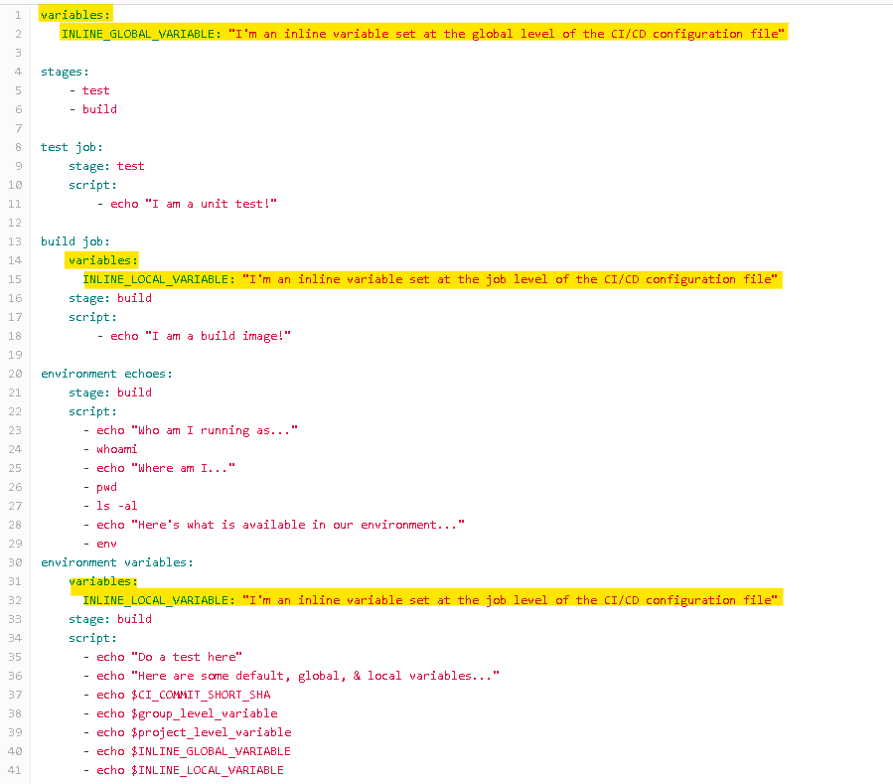
- In the Commit message field, type Add custom variables, ensure the Target Branch set to main, and click Commit changes.
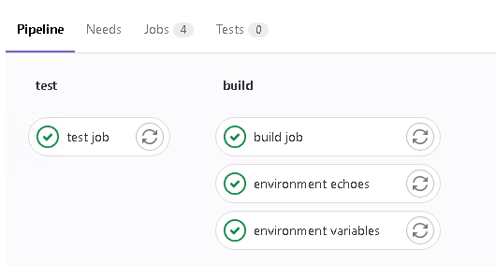
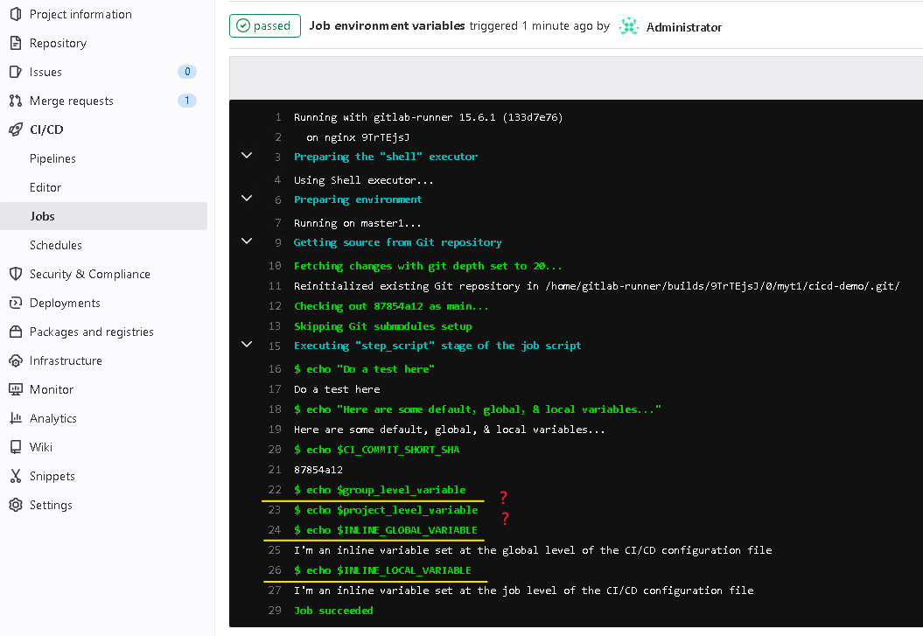

Add group- and project-level variables
- Navigate to your MYT1 group by selecting it from the breadcrumbs at the top of the page.
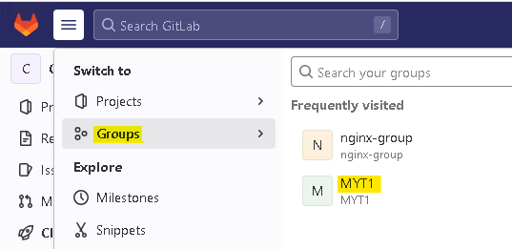
- In the left-hand navigation pane, select Settings > CI/CD
- In the Variables section, select the Expand button.
- Select Add Variable. Enter group_level_variable in the Key dialog box. Hint: watch your spelling, capitalization, and underscores! This variable will be visible within all subgroups and projects that live in this group.
- Type I'm a variable set at the group level in the Value dialog box.
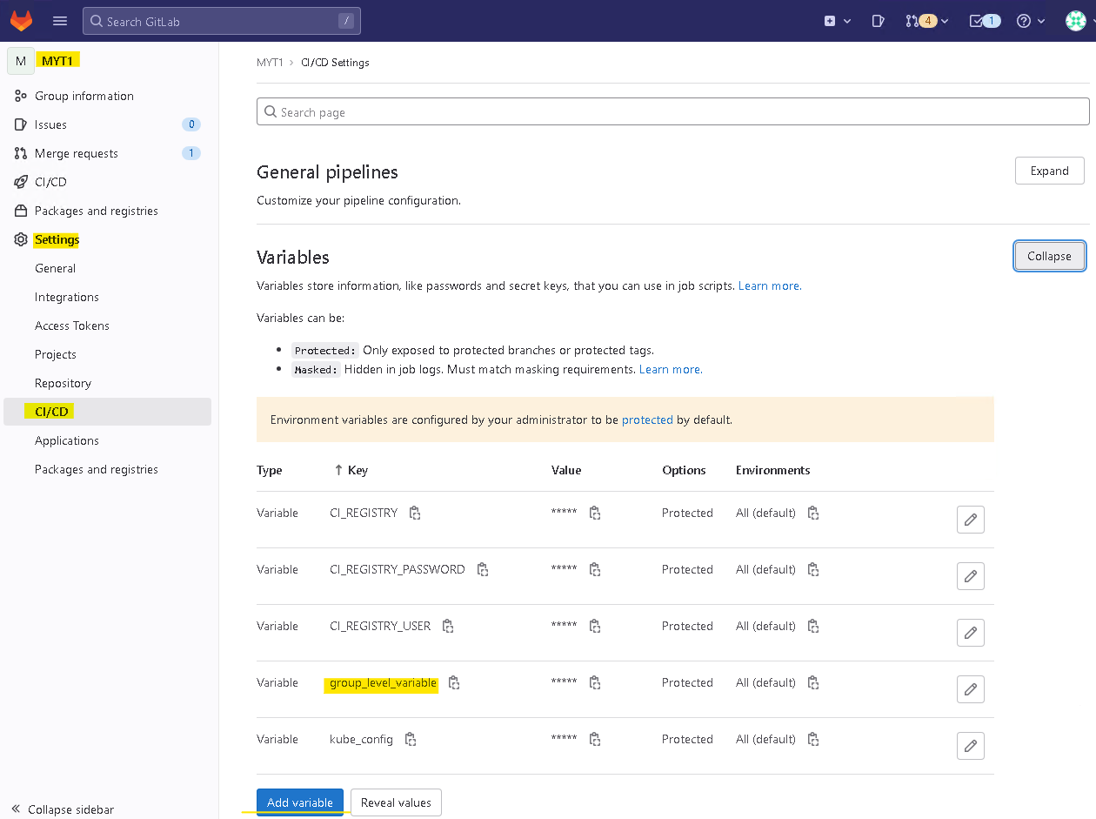
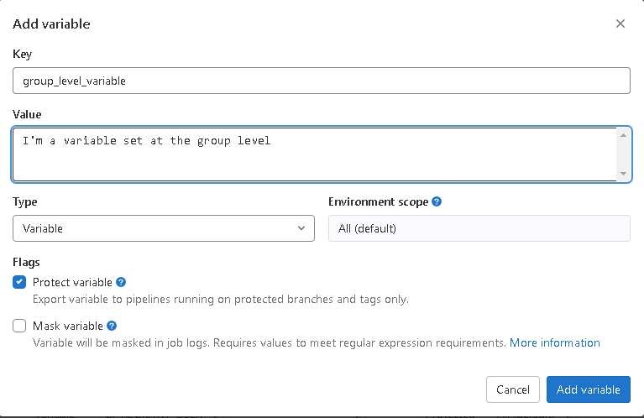
- Leave all other options at their defaults and select Add variable.
- Navigate to your project by clicking MYT1 in the breadcrumbs at the top of the page, and then clicking on your “CICD Demo” project.
- Repeat steps 2 to 6, entering project_level_variable in the Key field and I'm a variable set at the project level in the Value field.
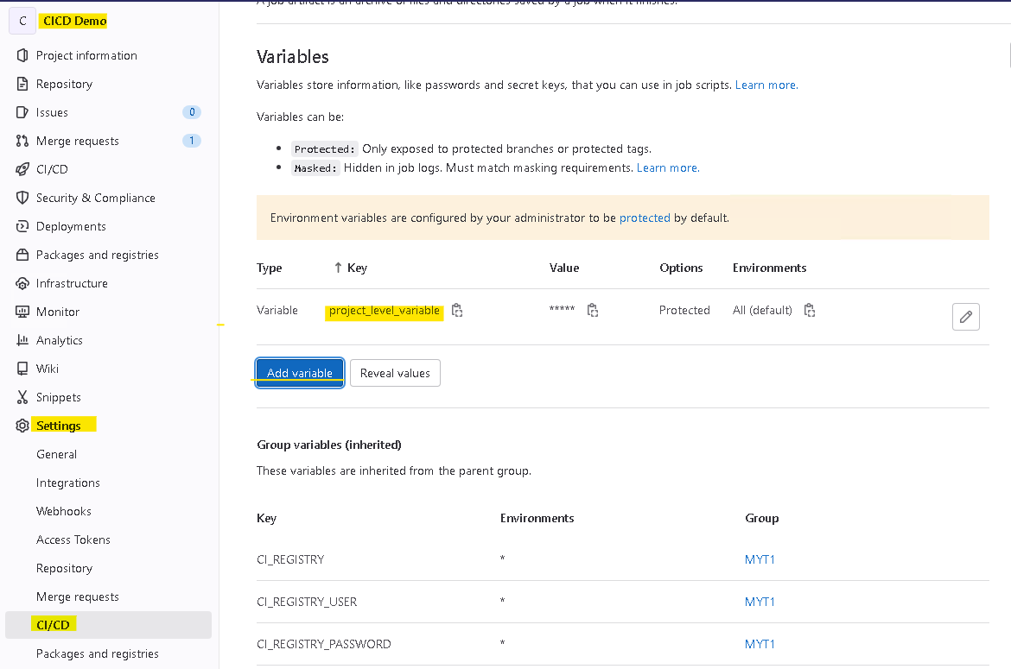
- Setting variables does not trigger a pipeline run, so click CI/CD > Pipelines in the left navigation pane, click the Run Pipeline button, and click the second Run Pipeline button.
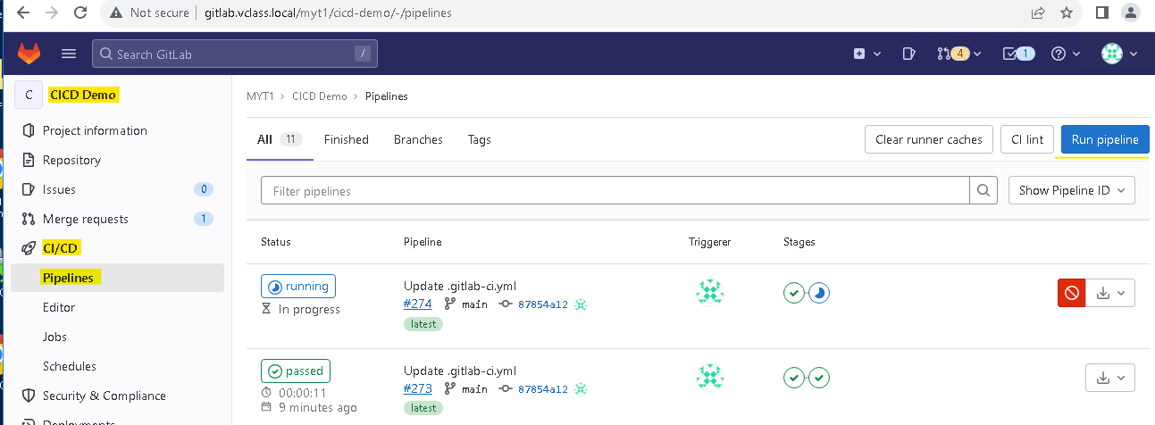
- Select on the widget for the environment variables job from your running pipeline and verify the variables and their values are correctly displayed in the job output.
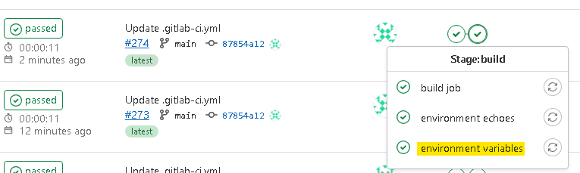
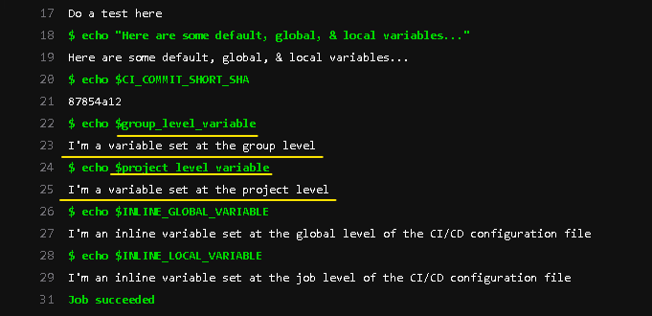

JOB POLICY PATTERN
- Go to the http://gitlab.vclass.local/my-test-group/gitlab-cicd-hands-on-demo/ of the CICD Hands On Demo project.
- Open the ci-structure snippet and select the Copy file contents icon in the upper right corner of the file.
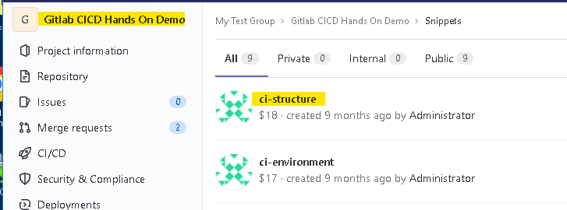
- Open your CICD Demo project from previous labs.
- Select your .gitlab-ci.yml file to view its contents. Select Edit (use the dropdown if needed to select Edit this file only). Paste the snippet's contents at the end of the file.
- At the top of .gitlab-ci.yml, in the stages section, add review and deploy stages.
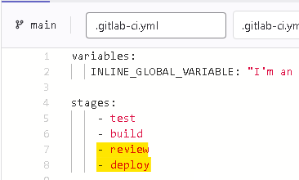
- In the Commit message field, type Add CI structure job definitions, ensure the Target Branch is set to main, and select Commit changes.
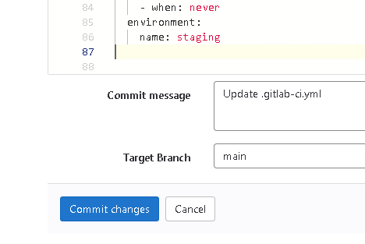
- In the left-hand navigation pane, select CI/CD > Pipelines and select the status icon next to the most recent pipeline run.
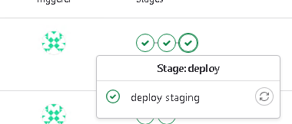
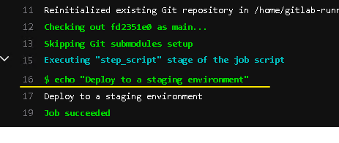
- Select the widgets to see what environment the pipeline is deploying the code to. In the left sidebar, select Deployments > Environments to see the environments that have been created.
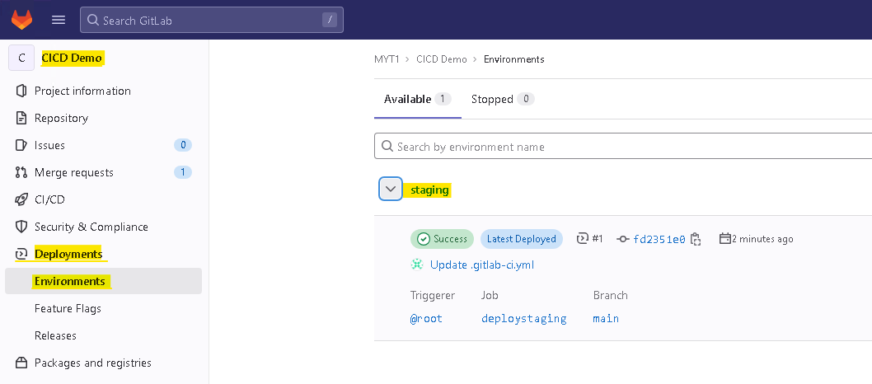
- Optional: Experiment with triggering pipelines using different branches and tags. Can you get different pipeline runs to execute the deploy release, deploy review, and deploy staging jobs?
Hint: Look at the rules keyword in the relevant .gitlab-ci.yml job definitions.

Case 1: Commit to a New branch with no tag

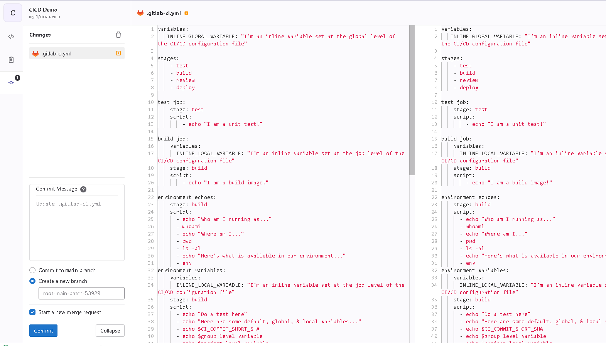

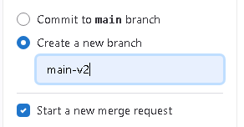

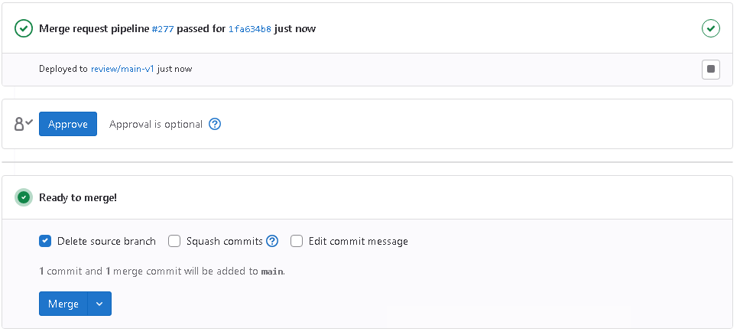
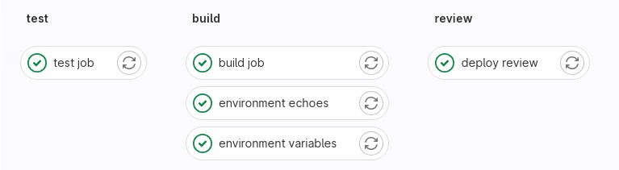

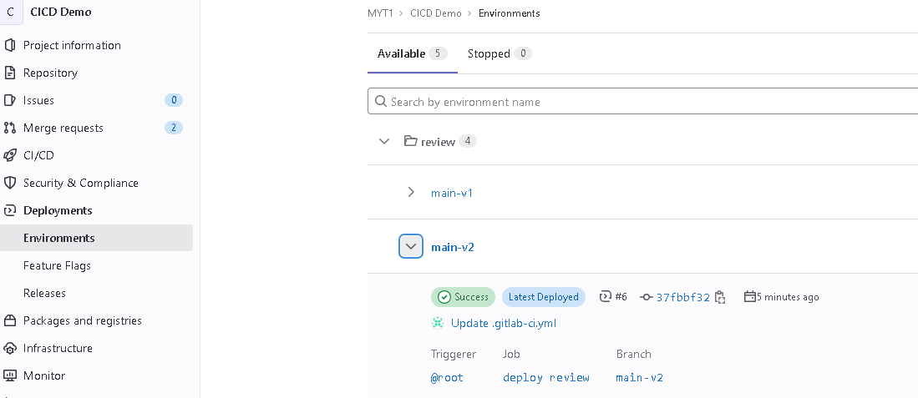

Print variable
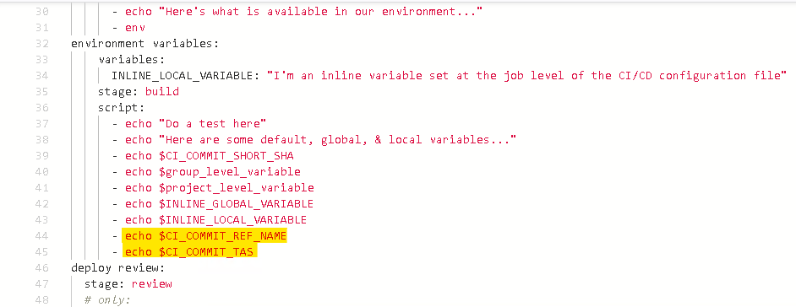
result
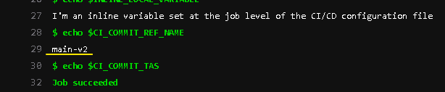

Case 2: Branch with Tag
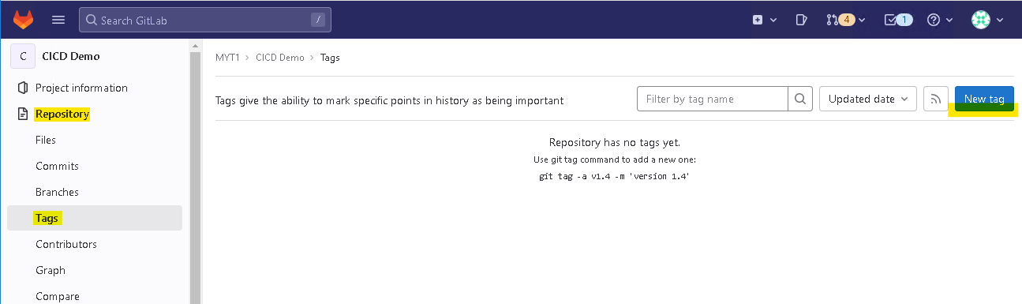

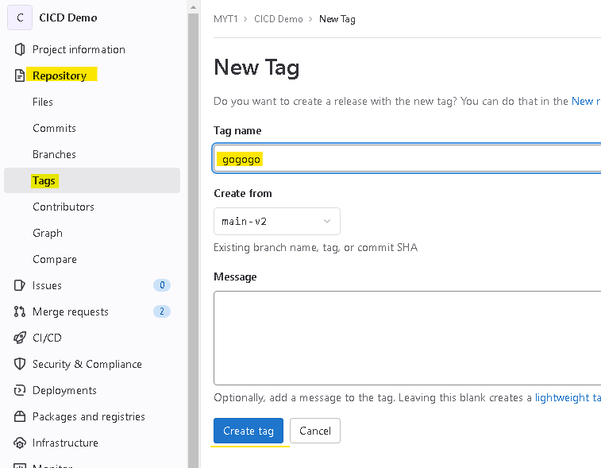

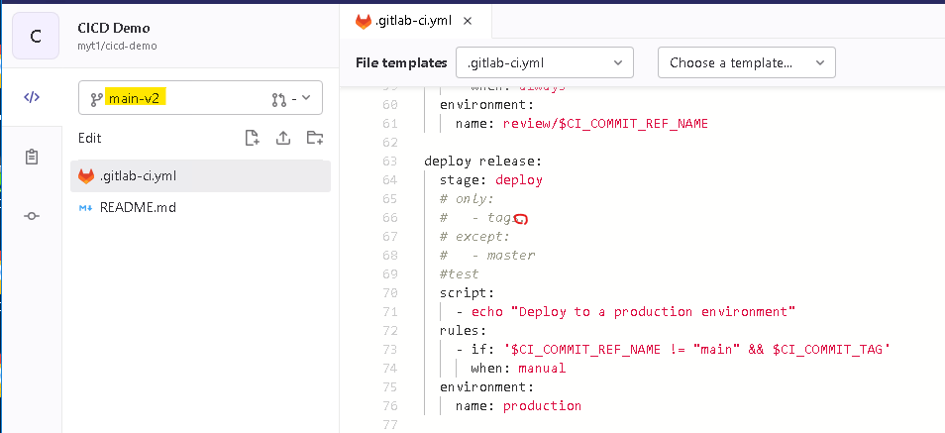

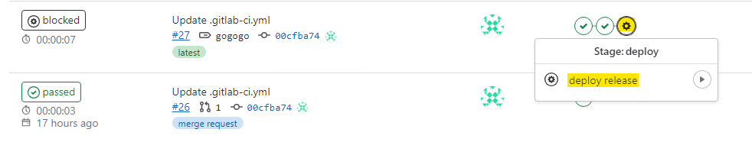
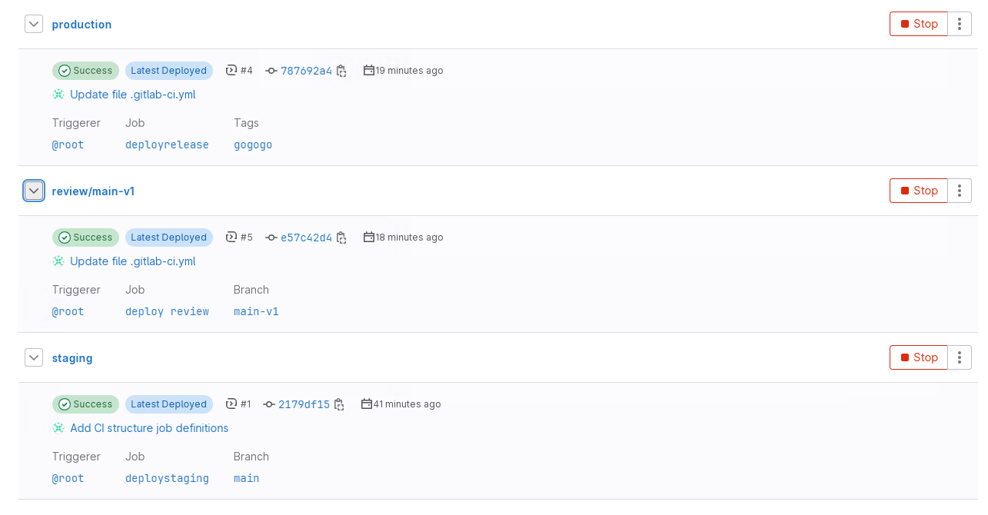

More information:

Gitlab CI/CD has multiple 'pipeline sources', and some of the Predefined Variables only exist for certain sources.
For example, if you simply push a new commit to the remote, the value of CI_PIPELINE_SOURCE will be push. For push pipelines, many of the Predefined Variables will not exist, such as CI_COMMIT_TAG, CI_MERGE_REQUEST_SOURCE_BRANCH_NAME, CI_EXTERNAL_PULL_REQUEST_SOURCE_BRANCH_NAME, etc.

However if you create a Git Tag either in the GitLab UI or from a git push --tags command, it will create a Tag pipeline, and variables like CI_COMMIT_TAG will exist, but CI_COMMIT_BRANCH will not.

One variable that will always be present regardless what triggered the pipeline is CI_COMMIT_REF_NAME. For Push sources where the commit is tied to a branch, this variable will hold the branch name. If the commit isn't tied to a branch (ie, there was once a branch for that commit but now it's been deleted) it will hold the full commit SHA. Or, if the pipeline is for a tag, it will hold the tag name.

For more information, read through the different Pipeline Sources (in the description of the CI_PIPELINE_SOURCE variable)

USING ARTIFACTS
Add artifacts to your pipeline
- Go to the http://gitlab.vclass.local/my-test-group/gitlab-cicd-hands-on-demo of the CICD Hands On Demo project.
- Open the ci-artifacts snippet and select the Copy file contents icon in the upper right corner of the file.
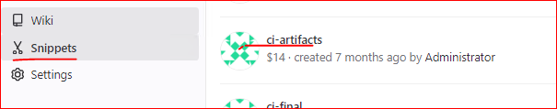
- Open your CICD Demo project from previous labs.
- Create Merge requests:
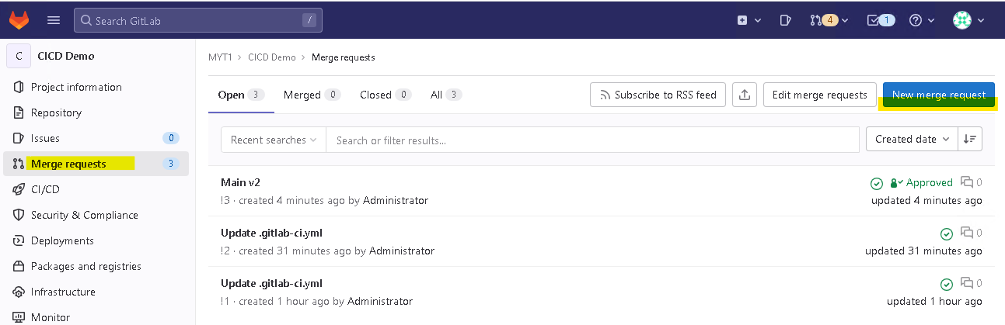
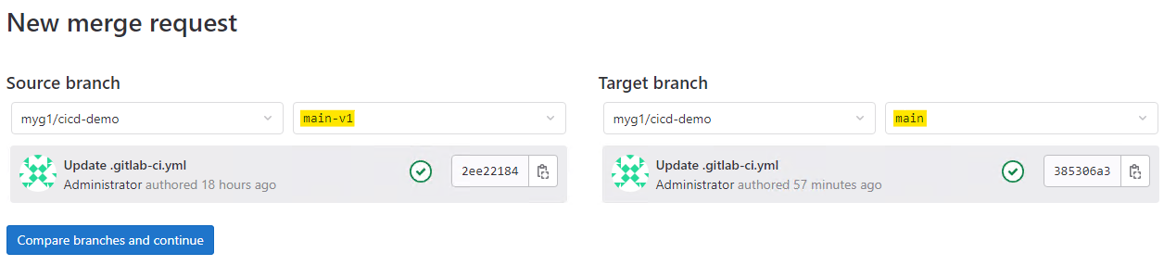
Set Assignee and Reviewer user to “administrator”, uncheck “Delete source branch when request is accepted”
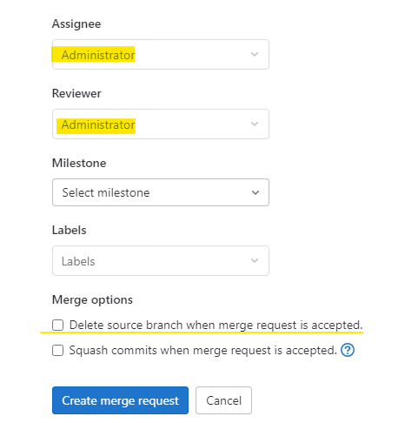
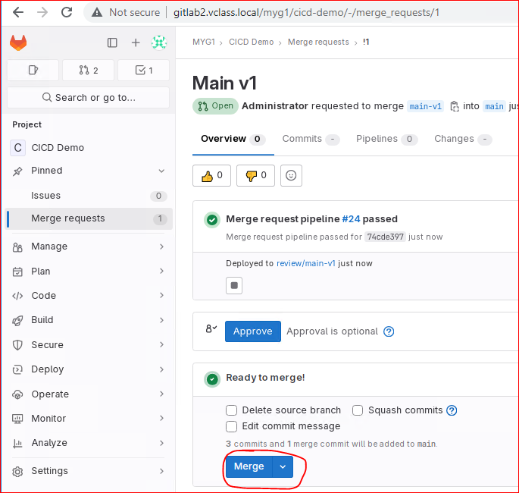

- Select your .gitlab-ci.yml file to view its contents. Select the Edit button (if needed, use the dropdown to select Edit this file only). Paste the snippet at the end of the file.
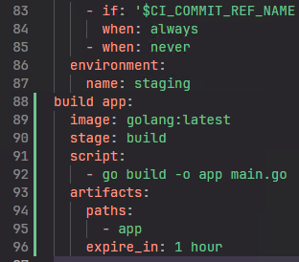
- In the Commit message field, type Add CI artifacts, ensure the Target Branch is set to main, and select Commit changes.
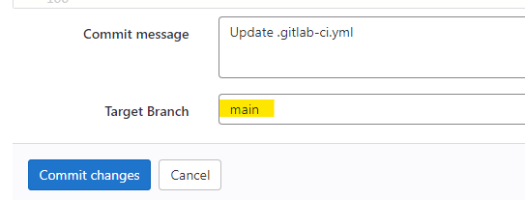
Add a main.go file
- Navigate to the repository of the http://gitlab.vclass.local/my-test-group/gitlab-cicd-hands-on-demo/ project.
- Select the main.go file to open it.
- Select the Copy file contents icon in the upper right-hand corner of the file.
- Navigate back to the Repository page of your CICD Demo project and add a new file by selecting + > This directory > New file
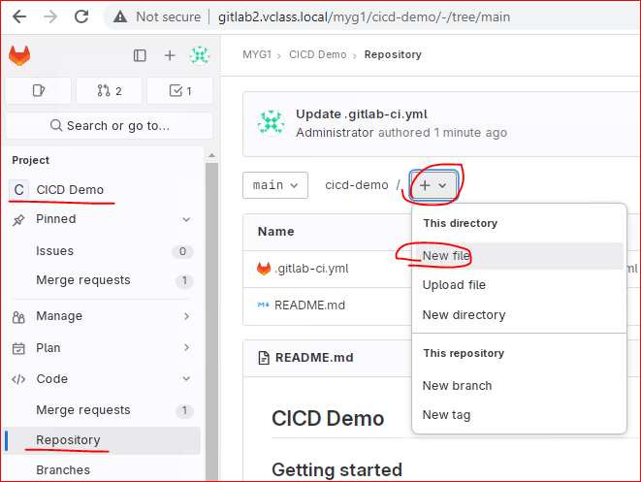
- In the File name field, enter main.go
- Paste the code you copied from main.go at the beginning of line 1 of the new file.
- In the Commit message field, type Add main.go file, ensure the Target Branch is set to main, and select Commit changes.
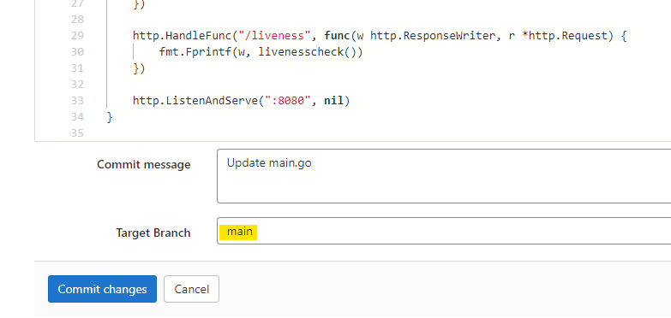
- In the left-hand navigation pane, select CI/CD > Pipelines and select the status icon for the most recent pipeline run.
- When the build app job finishes, select it to review the job's output log.
If the job fails with a message about being unable to find go.mod, retry the job until it passes. This is an intermittent Go build bug.
