STAT 413 Homework 9 Web Scraping Using an API

Hyo Young Ana Lim

4/9/2021

#DS 413/613 Homework 9 Web Scraping using an API  
#Instructions: Generate an Rmardown file and a Word file that shows all required code and output. Push your files to GitHub Repository.  
  
library(tidycensus)  
library(tidyverse)

## ── Attaching packages ─────────────────────────────────────── tidyverse 1.3.0 ──

## ✓ ggplot2 3.3.3 ✓ purrr 0.3.4  
## ✓ tibble 3.0.5 ✓ dplyr 1.0.3  
## ✓ tidyr 1.1.2 ✓ stringr 1.4.0  
## ✓ readr 1.4.0 ✓ forcats 0.5.0

## ── Conflicts ────────────────────────────────────────── tidyverse_conflicts() ──  
## x dplyr::filter() masks stats::filter()  
## x dplyr::lag() masks stats::lag()

library(dplyr)  
library(ggplot2)  
  
#1) Show and use a census API key that gives you access to the ACS data. Do not use my API key, use and show your own key.  
  
census_api_key("9d741b3a47d8eebc4f3bf383a807c165842ea6d8")

## To install your API key for use in future sessions, run this function with `install = TRUE`.

install = TRUE  
  
#2) Using ACS census data from 2015, show and use R code to do the following:  
  
#a) Produce a tibble that shows the median income estimates and the margin of errors for white males ages 35 to 44 in the counties of California. The required variable code starts with the characters BO1OO1. Use the table to find the other characters.  
#The first five rows of your tibble are provided below:  
  
v15 <- load_variables(2015, "acs1", cache = TRUE)  
  
View(v15)  
  
ca <- get_acs(geography = "county",   
 variables = c(medincome = "B01001A_011"),   
 state = "CA",   
 year = 2015)

## Getting data from the 2011-2015 5-year ACS

ca

## # A tibble: 58 x 5  
## GEOID NAME variable estimate moe  
## <chr> <chr> <chr> <dbl> <dbl>  
## 1 06001 Alameda County, California medincome 51644 667  
## 2 06003 Alpine County, California medincome 50 26  
## 3 06005 Amador County, California medincome 1809 72  
## 4 06007 Butte County, California medincome 9962 128  
## 5 06009 Calaveras County, California medincome 1927 74  
## 6 06011 Colusa County, California medincome 1147 79  
## 7 06013 Contra Costa County, California medincome 42756 605  
## 8 06015 Del Norte County, California medincome 1629 90  
## 9 06017 El Dorado County, California medincome 8609 141  
## 10 06019 Fresno County, California medincome 34979 714  
## # … with 48 more rows

mean(ca$moe)

## [1] 358.3621

median(ca$estimate)

## [1] 8122.5

#b) Use a dplyr functions to change your table of part a so that it reflects estimates that are greater than $30,000 dollars and list the estimates in descending order.  
  
ca %>%  
 filter(estimate > 30000) %>%  
 arrange(desc(estimate)) -> ca1  
  
ca1

## # A tibble: 13 x 5  
## GEOID NAME variable estimate moe  
## <chr> <chr> <chr> <dbl> <dbl>  
## 1 06037 Los Angeles County, California medincome 375435 2332  
## 2 06073 San Diego County, California medincome 150891 1008  
## 3 06059 Orange County, California medincome 126819 1152  
## 4 06065 Riverside County, California medincome 92346 1004  
## 5 06071 San Bernardino County, California medincome 80925 1160  
## 6 06085 Santa Clara County, California medincome 63036 879  
## 7 06067 Sacramento County, California medincome 56066 553  
## 8 06001 Alameda County, California medincome 51644 667  
## 9 06013 Contra Costa County, California medincome 42756 605  
## 10 06075 San Francisco County, California medincome 42307 542  
## 11 06029 Kern County, California medincome 42121 575  
## 12 06111 Ventura County, California medincome 41155 557  
## 13 06019 Fresno County, California medincome 34979 714

#c) Using the tibble that you produced in part b, use and show R code that will show the county that has a median income estimate of 51644 and a margin of error of 667.  
  
ca1 %>%  
 filter(estimate == 51644 & moe == 667)

## # A tibble: 1 x 5  
## GEOID NAME variable estimate moe  
## <chr> <chr> <chr> <dbl> <dbl>  
## 1 06001 Alameda County, California medincome 51644 667

#d) Use and show ggplot coding that will produce the following boxplot for the data that you generated for part b.  
  
ca1 %>%  
 ggplot(aes(x = estimate)) +  
 geom_boxplot(color = "black", fill = "red")

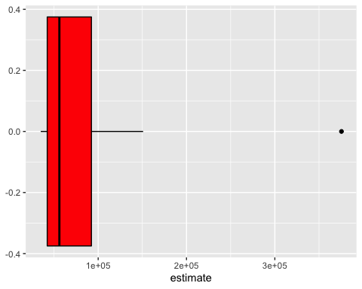

#e) Use and show R code that will produce the following graph for the data generated in part b  
  
ca1 %>%  
 mutate(NAME = gsub(" County, California", "", NAME)) %>%  
 ggplot(aes(x = estimate, y = reorder(NAME, estimate))) +  
 geom_errorbarh(aes(xmin = estimate - moe, xmax = estimate + moe)) +  
 geom_point(color = "blue", size = 3) +  
 labs(title = "Median Income for White Males by County",  
 subtitle = "2014-2018 American Community Survey",  
 y = "",  
 x = "ACS estimate (bars represent margin of error)")

