AN LIGHTWEIGHT EXPLAINABLE ARTIFICIAL INTELLIGENCE MODEL FOR DIABETIC RETINOPATHY DETECTION USING FUNDUS IMAGES

Himangshu Lahkar

Mid-Thesis Report

September 2020

TABLE OF CONTENTS

ACKNOWLEDGMENT
DEDICATION
ABSTRACT
LIST OF TABLES
LIST OF FIGURES
LIST OF ABBREVIATIONS
CHAPTER 1: INTRODUCTION
1.1 Background of the Study
1.2 Problem Statement
1.3 Aim and Objectives
1.4 Scope of the Study
1.5 Significance of the Study
1.6 Structure of the Study

CHAPTER 2: LITERATURE REVIEW
2.1 Introduction
2.2 Artificial Intelligence in Opthalmology
2.3 Artificial Intelligence in Diabetic Retinopathy

2.4 Explainable Artificial Intelligence (XAI)
2.5 XAI Systems in Medical Imaging
2.6 Related Research Publications
2.6.1 Integrated Gradient
2.6.2 Expressive Gradient
2.7 Summary

CHAPTER 3: RESEARCH METHODOLOGY
3.1 Introduction
3.2 Research Methodology
3.2.1 Data Selection
3.2.2 Data Pre-processing
3.2.3 Data Transformation
3.2.4 Interactive Visual Analytics
3.2.5 Evaluation
3.3 Proposed Method (Classification and Explainability)
3.4 Summary

CHAPTER 4: ANALYSIS 50
(Sample Sub-sections)
4.1 Introduction 50
4.2 Dataset Description 51
4.3 Data Preparation 54
4.3.1 Elimination of Variables 54
4.3.2 Transformation into Categorical Variables 54
4.3.3 Identification of missing values 54
4.3.4 Univariate analysis 56
4.3.5 Treatment of missing values 64
4.3.6 Splitting of original dataset 65
4.4 Exploratory Data Analysis (Bivariate analysis) 65
4.4.1 Chi-square test 66
……
……
4.5 Data Visualization 87
……
……
……
4.9 Summary 112
CHAPTER 5: RESULTS AND DISCUSSIONS 114
(Sample Sub-sections)
5.1 Introduction 114
5.2 Interpretation of Visualizations 115
5.3 Evaluation of Sampling Methods and Results 119
……
……
……

5.4 Testing on Validation Dataset 142
……
……
……
5.6 Summary 149
CHAPTER 6: CONCLUSIONS AND RECOMMENDATIONS 151
6.1 Introduction 151
6.2 Discussion and Conclusion 151
6.3 Contribution to knowledge 153
6.4 Future Recommendations 153

REFERENCES
APPENDIX A: RESEARCH PLAN
APPENDIX B: RESEARCH PROPOSAL

ACKNOWLEDGMENT
First and foremost I would like to thank God for giving me the strength, ability, and patience for undertaking this study towards the completion of my MSc. A very special thanks to my family; my wife Himsikha Das and my son Prajval Lahkar; who have sacrificed a lot for enabling me to undertake this study and help in the completion of this dissertation.
I would also like to thank my parents Dakshya Prasad Lahkar (my father) and Urbashi Lahkar (my mother); who have sacrificed a lot in their life to ensure we grow up a good and capable person. It is due to their hard work, sacrifices and words of wisdom that I am what I am today. I would also like to my elder brother Dr Ratul Lahkar who has always been a guiding light in term of the Academic excellence I wanted to achieve.
Very special gratitude my Supervisor Mr Sanchit Aggarwal and Dr Manoj Jayabalan; who were always there to guide and advice me whenever I got stuck with a problem. Without their timely guidance, I would never have been able to complete this work.
A special thanks to my colleagues Mr Amit Srivastava and Mr Lijoy J who coaxed me to get into the field of Artificial Intelligence and encouraged me to go for higher studies. The kind of belief they showed in me helped me to grow the belief inside me that I will be able to do this.
Finally, I would like to acknowledge all my friends who had to delay all their fun plans involving me; so that I would not be missing out on the same. I cannot name each one of them here, but you all were there to support me whenever I needed the same.
DEDICATION

This work is dedicated to all the patients of Diabetic Retinopathy who had to suffer due to late detection of their condition; due to the absence of adequate resources and technology.
ABSTRACT
Diabetes is fast becoming a global health problem especially affecting the urban working population; mainly due to the changed lifestyle of the urban population. About one-third of the Diabetes patients eventually go on to develop an eye condition called Diabetic Retinopathy; which occurs due to the weakening of blood vessels in the eye retina due to presence of high level of blood sugar. The enormity of the problem can be understood by the fact the Diabetic Retinopathy is the leading cause of blindness in the world. However; on a positive note; Diabetic Retinopathy takes a long time to develop and a major percentage of blindness can be prevented if the condition is detected at an early stage.
The medical practitioners use fundus images of the eye to screen and detect the presence of Diabetic Retinopathy. With the recent advances in image processing techniques; Artificial Intelligence and neural networks become an ideal candidate for assisting the medical experts in the screening of the Diabetic Retinopathy. Recently there has been a lot of work done in this field using deep learning and Convolutional Neural Networks and has been able to achieve remarkable results in terms of performance and accuracy. However, the acceptance of this models has been very low among the medical community as Deep learning models work as a Black Box and lacks the level of explainability that is needed for a widespread acceptance of these techniques.
This study is a try to bring in that explainability factor into the models using different techniques; so that it can lead to a greater acceptance of these automated techniques among the Ophthalmologists; which will eventually help in the timely detection of Diabetic Retinopathy and prevent blindness due to the same.
LIST OF TABLES
Table 1 - Diabetic Retinopathy Severity Scale 11
Table 2 - Taxonomy of XAI Systems 18
Table 3 – XAI systems in Medical Imaging 20
Table 4 – Dataset Distribution into different grades of Diabetic Retinopathy 24

LIST OF FIGURES

Fig 1 - DR Grade Prediction Attribution 21
Fig 2 – Grade 0 DR 26
Fig 3 – Grade 1 DR 26
Fig 4 – Grade 2 DR 26
Fig 5 – Grade 3 DR 26
Fig 6 – Grade 4 DR 26
Fig 7 – Data Preprocessing Pipeline 27
Fig 8 – Deep Learning and XAI Architecture for DR Classification 28

LIST OF ABBREVIATIONS

DR – Diabetic Retinopathy
XAI – Explainable Artificial Intelligence
AI – Artificial Intelligence
OCT – Optical Coherence Tomography
CNN – Convolutional Neural Networks

1. Introduction
1.1 Background of the Study
In the present world where a majority of the population is an urban population; the lifestyle changes that is happening has led a very big surge in the occurrence of Diabetes among the working population worldwide. If the current trend continues people suffering from Diabetes will be close to 700 million by the year 2035. Around one-third of the patients suffering from Diabetes eventually get affected by Diabetic Retinopathy; an underlying condition where the retina of the eye gets affected due to high blood sugar levels and can lead to eventual blindness if not treated on time (Wang and Yang, 2017)⁠. The majority of the people affected by Diabetes and Diabetic Retinopathy falls under the age band of 35-70 years; thus a major effect of this can be seen in the working-age population and Diabetic Retinopathy is the major cause of blindness in the working-class population(Li et al., 2019)⁠.
Studies have shown that timely and effective treatment can reduce vision loss by close to 90% for the patients affected by Diabetic Retinopathy(Wilkinson et al., 2003)⁠. Thus this becomes very important to detect the underlying conditions at an early stage. For detecting DR at an early stage it becomes very important for the Diabetic patients to get a periodic review of their eyes done by trained Ophthalmologists; however, there is a growing gap between the number of patients and ophthalmologists available. Also, the screening for DR is a slow process and only a limited number of patients can be screened on a particular day. With the above background in mind; it becomes very important to have automated systems which can do the preliminary screening so that the medical practitioners can spend their efforts on treating the patient who needs actual treatment rather than on the screening process.

1.2 Problem Statement
Diabetic Retinopathy can be classified into two broad categories Non-Referable Diabetic Retinopathy and Referable Diabetic Retinopathy. Non-Referable Diabetic Retinopathy does not need any immediate treatment however a periodic review is needed every 6 months; proliferative Diabetic Retinopathy needs immediate attention by trained Ophthalmologists. This classification is based on the severity level of the disease that can be seen in Table 1.

Type of DR | Severity Level | Observable Abnormalities
Non-Referable DR | 0 | No observable abnormality
Non-Referable DR | 1 | Presence of microaneurysms only
Non-Referable DR | 2 | Along with the microaneurysms, small haemorrhages start to appear
Referable DR | 3 | Presence of any of the following:  - more than 20 intraretinal haemorrhages in each of eye quadrants  - venous beading in more than 2 quadrants of the eye  - prominent intraretinal microvascular abnormality in at least one quadrant of the eye
Referable DR | 4 | Presence of neovascularization, vitreous / preretinal haemorrhage

Table 1 - Diabetic Retinopathy Severity Scale(Wilkinson et al., 2003)⁠
The screening of Diabetic Retinopathy is done through fundus imaging wherein the picture of the retina is captured by the fundus camera. This makes Deep Learning-based classification models a very good tool for the automation of Diabetic Retinopathy Screening. However, a major disadvantage of deep learning systems is that it acts as a black box and it is extremely difficult to explain how the predictions are being made. There is a need to bring in explainability into the automation systems used in healthcare systems so that it is widely accepted and trusted by the medical practitioners and to be deployed for practical purposes.
Recent regulations by different governments across the world like the European General Data Protection Regulation (GDPR) makes the re-traceability of the decisions made by AI systems a new requirement.
Keeping these factors in mind there has been a lot of studies done in recent times on explainable artificial intelligence (XAI) both in general image detection system and in the field of medical imaging. Another advantage of XAI systems is that it can also give important pointers to the medical practitioner as to which features of the fundus image were considered during the screening process to classify the image. However, there has been a very limited amount of study in thins direction for the development of XAI systems for the detection and classification of Diabetic Retinopathy. This study aims to apply XAI techniques to DR detection models and help in the Computer-Aided Diagnosis (CAD) of DR.

1.3 Aim and Objectives
This study aims to understand the XAI techniques and their usage in Medical Imaging. Once this understanding is built; apply the techniques to the Diabetic Retinopathy models and propose one XAI model/system for practical usage.

1.4 Scope of the Study
During the study, the data set will be explored to get a proper understanding of the data and underlying features in the eye fundus images that lead to detection and classifying of the images into different stages of Diabetic Retinopathy. Once this understanding of the data is there; deep learning techniques will be applied on the dataset to come up with a model for detecting and classifying the images for Diabetic Retinopathy.
Once after the model is developed; post hoc analysis on the same will be done using techniques such as Integrated Gradients, Expressive Gradients, DeConvNet etc. to come up with an Explainable Artificial Intelligence Model (XAI). The reason for choosing the post hoc analysis methods is that it needs little to no change in the original classification models for the analysis to be done; this gives the advantage of using the technique on any model once the same is developed.

1.5 Significance of the Study
During recent times a lot of research has been done on the detection and classification of Diabetic Retinopathy which involves deep learning models. However, in terms of acceptance by the medical community the success stories have been very limited; mostly due to the lack of explainability in the deep learning models; the deep learning models lack the explainability which is needed to get the trust of both the medical practitioners and the patients.
This study aims to bridge this gap by bringing in some form of explaining the ability to the models so that a layman; in terms of artificial intelligence; can understand the decision-making process of the model and get the confidence of using the same and automating the task of Diabetic Retinopathy screening.
1.6 Structure of the Study
The remainder of the study is mostly organized as follows:
In Chapter 2 the study will discuss more on Diabetic Retinopathy; how it occurs and what are effects of the same. Along with this previous work on Diabetic Retinopathy detection using AI and ML will be discussed along with different techniques of XAI.
Chapter 3 will have the details of the methodology that has been applied until this point and also that will be applied during this study.
CHAPTER 2: LITERATURE REVIEW
2.1 Introduction
As we can see from the previous chapter how Diabetes and Diabetic Retinopathy has become a major health problem. The conservative estimates projects that close to 700 million people will get affected by Diabetes within the next 15-20 years; out of which around one-third of the population; around 250 million; will get impacted by some form of DR (Lim et al., 2020)⁠. DR is one of the leading causes of blindness among the working population of the world. From this, we can see the enormity of the problem.
Research has shown that early detection of DR via screening along with providing treatment on time can reduce the potential effects; loss of vision; for the patients. However, the manual process of screening of DR is long and tenuous and is a very specialized job which needs trained ophthalmologists; due to this reason a lot of research has been done in recent times for automating the process of DR screening and further classifying them into Referable and non-Referable DR.
In this section of the study will review some of the previous work done in the field of Ophthalmology using Artificial Intelligence with a special focus on Diabetic Retinopathy detection and classification.
2.2 Artificial Intelligence in Opthalmology
There has been a lot of work that used medical imaging identification techniques and auxiliary diagnosis using Artificial Intelligence especially deep learning techniques. Most of the work done has been concentrated on the diseases which lead to eventual blindness; such as Age-Related Macular Degeneration(AMD), Retinal Vein Occlusion (RVO), Retinopathy of Prematurity (ROP), Anterior Segment Diseases(ASD) and Diabetic Retinopathy (DR); but can be prevented if treated timely(Du et al., 2018)⁠.
AMD is a disease that affects mostly people above 50 years of age and is a major cause of blindness among senior citizens. The screening of AMD happens through Fundus Images from where the features are extracted to distinguish between healthy and affected eyes (Mookiah et al., 2015)⁠. RVO is another leading cause of blindness that affects old age people and people having other diseases such as cardiovascular diseases, hypertension etc. (Zhao et al., 2015)⁠ developed a CNN based model which achieved around 97% accuracy. Glaucoma is another major blindness causing disease that occurs due to the damage in the optic nerve. (Omodaka et al., 2017)⁠ developed was able to achieve 88% accuracy using machine learning algorithms on top of optical coherence tomography (OCT) images.
Research has indicated that Diabetic Retinopathy is the biggest cause of blindness among the world population; mainly affecting the retina over a period leading to a progressive blindness(Du et al., 2018)⁠. As the number of people getting affected by Diabetes and in turn by DR; both Diabetes and DR are turning into a major health problem worldwide. Also as DR is a progressive disease; the same can be treated effectively if detected at an early stage. The screening of DR is done by taking fundus photographs which is then manually screened by trained Ophthalmologists; becoming a very time-consuming process; thus becoming a very good candidate for automation. Due to these reasons, there has been a lot of focus in the Artificial Intelligence community for the detection and classification of DR into its different stages
2.3 Artificial Intelligence in Diabetic Retinopathy
Recent times there has been a lot of study in the Automatic Detection of Diabetic Retinopathy using both Machine Learning and Deep Learning Techniques. (Acharya U et al., 2008)⁠ proposed an SVM based model which gave a diagnostic accuracy of 82%. (Carrera et al., 2017)⁠ worked on the Diabetic Retinopathy detection problem using Decision Trees and SVM classifiers and achieved an accuracy of 92.0% and 92.4% respectively. (Romero-Aroca et al., 2019)⁠ developed a system using Fuzzy Random Forest and achieved a Sensitivity of 80.67% and Specificity of 85.96%.
(Gulshan et al., 2016)⁠ used a data set of more than 128000 images which were graded by a panel of 54 Ophthalmologists to train the network and achieved a ROC curve of .991. This method used an ensemble of 10 Inception 3 modules. (Yang et al., 2017)⁠ used a two-stage Deep CNN on the Kaggle Dataset to identify the Lesions on the fundus Image and also to classify the images into the different stages of DR; the lesion classifier was a binary classifier telling the presence or absence of Lesions on certain areas of the eye and the DR classifier was a multi-stage classifier; this two-stage network was able to achieve an AUC score of .9687 for the DR classification. (Wan et al., 2018)⁠ used the Kaggle Dataset and trained the VGG-Net architecture to achieve an accuracy of 95.68%. (Shah et al., 2017)⁠ presented a CNN based architecture to classify DR into referable and non-referable on top of 112489 fundus achieved an AUC of .991 for DR Detection and .969 on referable DR Detection; however, this work was mainly directed as binary classification problem of identifying the images as Referable and non-referable Diabetic Retinopathy. (Shankar et al., 2020)⁠ proposed a novel architecture for the detection for DR grading using a Synergic Deep Learning model and achieved an accuracy of 99.28% and sensitivity and specificity of 98 and 99 respectively; the Authors used Resnet-50 based Deep CNN and Histogram based image segmentation techniques while proposing the solution.
The above Deep learning methods used a large dataset for achieving the kind of accuracy as mentioned. There have been some studies done using relatively small datasets for Diabetic Retinopathy Detection. (Shanthi and Sabeenian, 2019)⁠ resented a modified Alexnet architecture that could achieve an accuracy of 93%. (Hagos and Kant, 2019)⁠ presented a model based on Transfer learning that could achieve around 90% accuracy. (Doshi et al., 2020) tried using image downscaling algorithms and were able to achieve an accuracy of 85.2%. (Costa et al., 2018)⁠ developed a model which was given interpretability to the ophthalmologists on how the model concluded; however, it was a binary classifier telling whether the input image had Diabetic Retinopathy or not. The model achieved an accuracy of 96%.
2.4 Explainable Artificial Intelligence (XAI)
During recent times deep learning has become popular among the Machine learning community owing to the advances in hardware technology and deep learning algorithms. Due to the ability to learn from data and to show superior performance when compared to other techniques the same is being increasingly used in the industry for making critical processes such as medical imaging, weather prediction etc. However owing to their internal complexity deep learning methods have been considered as black boxes as the reasoning behind their predictions are not clearly understood (Alber et al., 2019)⁠. Owing to these there has been a lot of recent work that has been undertaken to get an understanding of how these deep learning systems work and goes about the process of prediction.
XAI systems can be divided into many taxonomies. Table 2 gives a brief about the different taxonomies into which XAI systems are divided into.

XAI Taxonomy | Brief Description
Model Specific and Model Agnostic | Methods which are tied to the architecture of a model are called Model Specific; whereas the posthoc analysis methods which are not limited to any particular architecture of model are known as Model Agnostic methods.
Global and Local Methods | If the interpretability analysis applies to a single result of the model is called as Local method otherwise Global Method.
Premodel, in-model, post-model | Premodel methods are done before building the main classification model examples for this are methods such as PCA, t-SNE etc.  In model are the methods where the explainability is built into the main classification model itself. Attention networks are examples of such methods.  Post model methods are the method where post-hoc analysis is done after building the main classification model; this is the most widespread XAI methodology as it needs little to no change on the existing models' architectures. One very popular example of this is Integrated Gradients(Sundararajan et al., 2017)⁠.
Surrogate and Visualization methods | When a different model is used to analyze the results of the black box models. In this method, both the black-box model and the surrogate model are run separately on the data and the results are compared for the explainability. Decision tree used in conjunction with Deep Networks is one such example.  Visualization methods give some kind of a visual explanation so as the decisions made by the Black box models can be understood. Activation maps are an example of this.
Table 2 - Taxonomy of XAI Systems (Singh et al., 2020)⁠

2.5 XAI Systems in Medical Imaging
Deep Neural Networks are used widely in the field of Medical Imaging. When it comes to the XAI approaches for applications in the field of medical imaging it can be broadly divided into two classes:
a. Architecture Specific Techniques – These techniques are specific to the Machine Learning Architecture that is being used for the task at hand. Attention networks is an example of this. (Zhang et al., 2017) proposed an Attention-based Medical Image Diagnosis Network which could give semantic and visual interpretability to the models. (Kim et al., 2018)⁠ proposed a method called Testing Concept Activation Vectors (TCAV) using directional derivatives to check how a user-defined concept is important to the final classification result. TCAV tested for medical application by trying out on the Kaggle Diabetic Retinopathy dataset, and was able to identify the correct diagnostic concepts; however, for Level 1 DR this method was consistently predicting the same as Level 2 DR
b. Attribution Based Methods – If we go through the medical imaging literature we can find that the majority of the interpretability methods studied are standard methods for attribution markup; due to their ease of use and implementation. On using attribution based methods allows the use of the already existing model on top of which the interpretability methods can be directly applied thus leveraging the power of other techniques such as transfer learning and also making the implementation of model interpretation easier than other Architecture specific techniques (Singh et al., 2020)⁠. These methods have been widely studied and applied in the healthcare industry mainly for classifying medical images . Some of the fields where these methods are applied are brain MRI, breast imaging, skin imaging, CT images and Retinal Images. Some of the attribution based methods and their applications in the field of Medical Imaging is mentioned in Table 3.
Applications | Dataset Type | XAI Methodology
Alzheimer’s detection | Brain MRI | (Eitel and Ritter, 2019)⁠ tried out Guided backpropagation, LayerWise Relevance Propagation (LRP), Gradient Input and Occlusion methods on Alzheimer's Detection models. LRP gave the best results in terms of model explainability.
Grading of Brain Tumor | Brain MRI | (Pereira et al., 2018)⁠ developed a CNN based model for Brain tumour classification and used Guided backpropagation and Gradient activation map for the putting in interpretability to the model.
AMD Detection | Retinal OCT | (Yang et al., 2019)⁠ used Expressive Gradients (EG); which is an extension of Integrated Gradients (IG) for AMD Detection. On these experiments, EG worked better than IG and Guided backpropagation.
Melanoma Detection | Skin Images | (Young et al., 2019)⁠ used GRADCAM and Kernel SHAP method to understand the interpretability for the models used for Melanoma detection.
Liver Tumor | CT Imaging | DeepDreams
COVID-19 detection | X Rays | Very recently (Wang and Wong, 2020)⁠ published a work on a COVID Dataset. They developed a CNN based model to classify between normal X-Ray images and COVID affected images. It used GSInquire, GBP and activation maps to explain the decisions made by their model.
DR Grading | Retinal Fundus Imaging | (Sayres et al., 2019)⁠ developed a system for interpretable DR Grading on top of an Inception-V4 based CNN. They built in the interpretability using IG.
Table 3 – XAI systems in Medical Imaging

2.6 Related Research Publications
2.6.1 Integrated Gradient
Most of the attribute-based XAI systems fail to satisfy the two fundamental axioms of Sensitivity and Implementation Invariance. An attribution method is said to satisfy the axiom of Sensitivity provided for every input if the baseline is changed by one feature at a time then the differing feature should get a non zero attribute (Sundararajan et al., 2017)⁠. The second axiom of Implementation Invariance tells that the attributions are always identical for two networks which are functionally equivalent i.e. if two networks have same outputs for identical inputs irrespective of the network implementation; the attributions calculated by the attribution system for the networks also have to be identical (Sundararajan et al., 2017)⁠.
Integrated Gradient (IG) is one such system which successfully satisfies these two axioms of Sensitivity and Implementation Invariance. According to (Sundararajan et al., 2017)⁠ the formula for the Integrated Gradients is given as below:
……….eq(1)
Further (Sundararajan et al., 2017)⁠ proposes that if the function F is continuous everywhere and the partial derivative for F satisfies Lebesgue’s integrability condition then:
………………………………….eq (2)
(Sundararajan et al., 2017)⁠ demonstrated their IG method on top of (Gulshan et al., 2016)⁠ network for DR classification. Here is an example of the same.

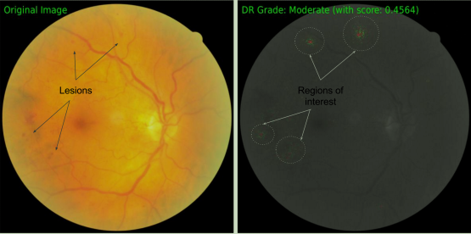

Fig 1 - DR Grade Prediction Attribution (Sundararajan et al., 2017)⁠
However, IG had a serious drawback in terms of dead neurons due to the dying ReLU problem. The gradients for these dead neurons are not available during the backpropagation thus degrading the explainability during IG as IG tends to exploit the gradients concerning the input image (Yang et al., 2019)⁠. To overcome this problem the method of Expressive Gradient was proposed.
2.6.2 Expressive Gradient
To solve the problem mentioned in section 2.6 (Yang et al., 2019)⁠ proposed Expressive gradient which extends on the concepts given by Integrated gradients. The problems seen in IG is especially magnified for the medical images owing to lower quality images. EG tries to solve the problems seen in IG by exploiting the gradients of the intermediate features along with gradients wrt to the original input image. (Yang et al., 2019)⁠ proposed the below equation for the EG:
………..eq (3)
(Yang et al., 2019)⁠ gave a proof that EG works better than the IG by doing their experiments on OCT images for detecting Age-Related Macular Degeneration. Their results showed that EG performs much better in terms of attribute mapping than IG.
2.7 Summary
Taking a cue from the previous studies done in Integrated Gradient and Expressive Gradients; this study will aim to develop a custom CNN model to classify the fundus images for Diabetic Retinopathy. Once the model is built this study will further go ahead apply the Integrated Gradient and Extended Gradient method on to come up with attribution maps and propose an XAI system for DR detection which can put into clinical usage.
CHAPTER 3: RESEARCH METHODOLOGY
3.1 Introduction
Artificial Intelligence systems generally take up a measurable problem of real-world interest and aim to provide an automated solution for that. Some of the constraints for an Artificial Intelligence system to work properly is that the problem at hand should have measurable observations that can be used by the system to calculate estimates based on the observations.
The general flow of an AI system is that a hypothesis is formulated based on the observations available which are then generalized for the real-world problem. Once this generalization of the hypothesis is tested on new data; the same is then applied as a general approach for the problem.
In this chapter, we will discuss the problem of Diabetic Retinopathy detection using a Deep Learning system. The dataset used for the study is the Indian Diabetic Retinopathy Dataset (IDRiD) available on Kaggle and https://idrid.grand-challenge.org/. During this study, a major focus will be put on the interpretability and explainability of the system. We have already discussed on the importance on interpretability and explainability of a deep learning system in the previous chapters; in this chapter, we will delve more on the methodologies that are going to apply during this study.

3.2 Research Methodology
3.2.1 Data Set Selection
Fundus photographs play a very important role in the field of Ophthalmology. Ophthalmologists use fundus photographs to document the disease process and uses them for classifying and treating the patients' eyes. Fundus images are used for diagnosing different types of disorders in the eye; such as retinopathy due to different underlying conditions such as hypertension and diabetes, glaucoma, AMD, etc (Jain et al., 2015)⁠. Digital fundus photography involves capturing the image of the rear of the eye which is also known as fundus in Ophthalmology terms.
Fundus imaging; especially red-free fundus photography; is one of the primary ways of screening patients for Diabetic Retinopathy. In this particular technique, a blue-green filter of approximately 500 nm width is used for blocking the red wavelengths of light. Due to this particular technique gives a better view of the retinal blood vessels and the associated haemorrhages (Suspension, 2018)⁠.
The IDRiD dataset consists of 516 fundus images that were captured in the Eye Clinic located in Nanded, Maharashtra India. The images were captured using a Kowa VX-10 fundus camera with a 50-degree field of view. All the images are stored in the jpeg file format and have dimensions 4288 * 2848 pixels. All the images were carefully examined by Ophthalmologists to ensure that the images are of adequate quality for grading purposes and are clinically relevant. Care was taken to ensure that no duplicate images were present in the dataset.
All the images in the dataset were further checked for different stages of DR by Ophthalmologists and classified. The image distribution as per the dataset classification is given below in table 4.
DR Grade | Count of Images | Percentage
Grade 0 | 168 | 32.56%
Grade 1 | 25 | 4.84%
Grade 2 | 168 | 32.56%
Grade 3 | 93 | 18.02%
Grade 4 | 62 | 12.02%
Total | 516 | 100.00%
Table 4 – Dataset Distribution into different grades of Diabetic Retinopathy

3.2.2 Data Pre-processing
Data preprocessing is the most important part of any Artificial Intelligence system. During this study also a data preprocessing will be one of the important steps for developing the system. Some of the steps that will be followed during the data preprocessing step are mentioned below.
3.2.2.1 Image Cropping
As the first step of the data preprocessing step, the unnecessary parts of the image will be cropped. As we can see from the images in Figure2; the black part of the images can be removed from using Image Cropping Techniques as these parts do not provide any additional information for the classification task. Once the image is cropped we will be having a much-focused image mostly containing the retina part of the eye.
3.2.2.2 Image Downscaling / Resizing
From section 3.1 we can see the images are of size 4288 * 2848 pixels. The images in question being colour images with RGB channels the total number of features in each of the images will be 36636672 (4288 * 2848 * 3). If an image of this size is fed into a CNN the number of trainable parameters will run into millions; also the amount of time and resources that will be needed to train a network on an image of this size will be prohibitive. Taking this into consideration the images has to be downscaled/resized into smaller sizes.
During the study, some of the downscaling algorithms that will be tried out are Nearest Neighbour, Lanczos, RDIP(Weber et al., 2016)⁠, LID(Sun and Chen, 2020)⁠ etc. RDIP and LID have an advantage over other downscaling algorithms in the sense that they can preserve a major part of the original images after downsampling of the images (Doshi et al., 2020)⁠.
3.2.2.3 Green Channel Extraction
Once after the images are resized the Green Channel is extracted from the images. This is done since the green channel provides the finer details of the retinal images such as the optic features in a more prominent manner.

3.2.3 Data Transformation
As the data set here is quite small having only 516 images as well as highly imbalanced in the data distribution; data augmentation techniques will be widely used to increase the number of training samples as well as to remove the class imbalance problem. Some of the Augmentation techniques are:
The first step for data augmentation that has been applied is Horizontal Flipping. As the Fundus images have a horizontal orientation; horizontal flipping has been applied for the images. For the Grade 1 Images, further Brightness change will be applied to specifically increase the number of images for this grade and remove the class imbalance to an extent. Finally, Gaussian noise is introduced into the images specifically with the following parameters translation from the range [−23%, 23%] of the image width for x and y; rotation from [−19◦, 19◦]; scaling from [0.9, 2.0] with a sigma uniformly sampled from [0, 0.04]; the contrast is sampled within [−0.8, 0.4]; multiplicative colour changes to the Green Channel; since we are only considering the green channel; per image from [0.5, 2]; additive brightness changes using Gaussian with a sigma of 0.2 and gamma values from [0.7, 1.5] (Dosovitskiy et al., 2015)⁠.

3.2.4 Interactive Visual Analytics
Figure 2-5 are representative images of Grade 0 to Grade 2 Diabetic Retinopathy with some of the markers for identification of the same.
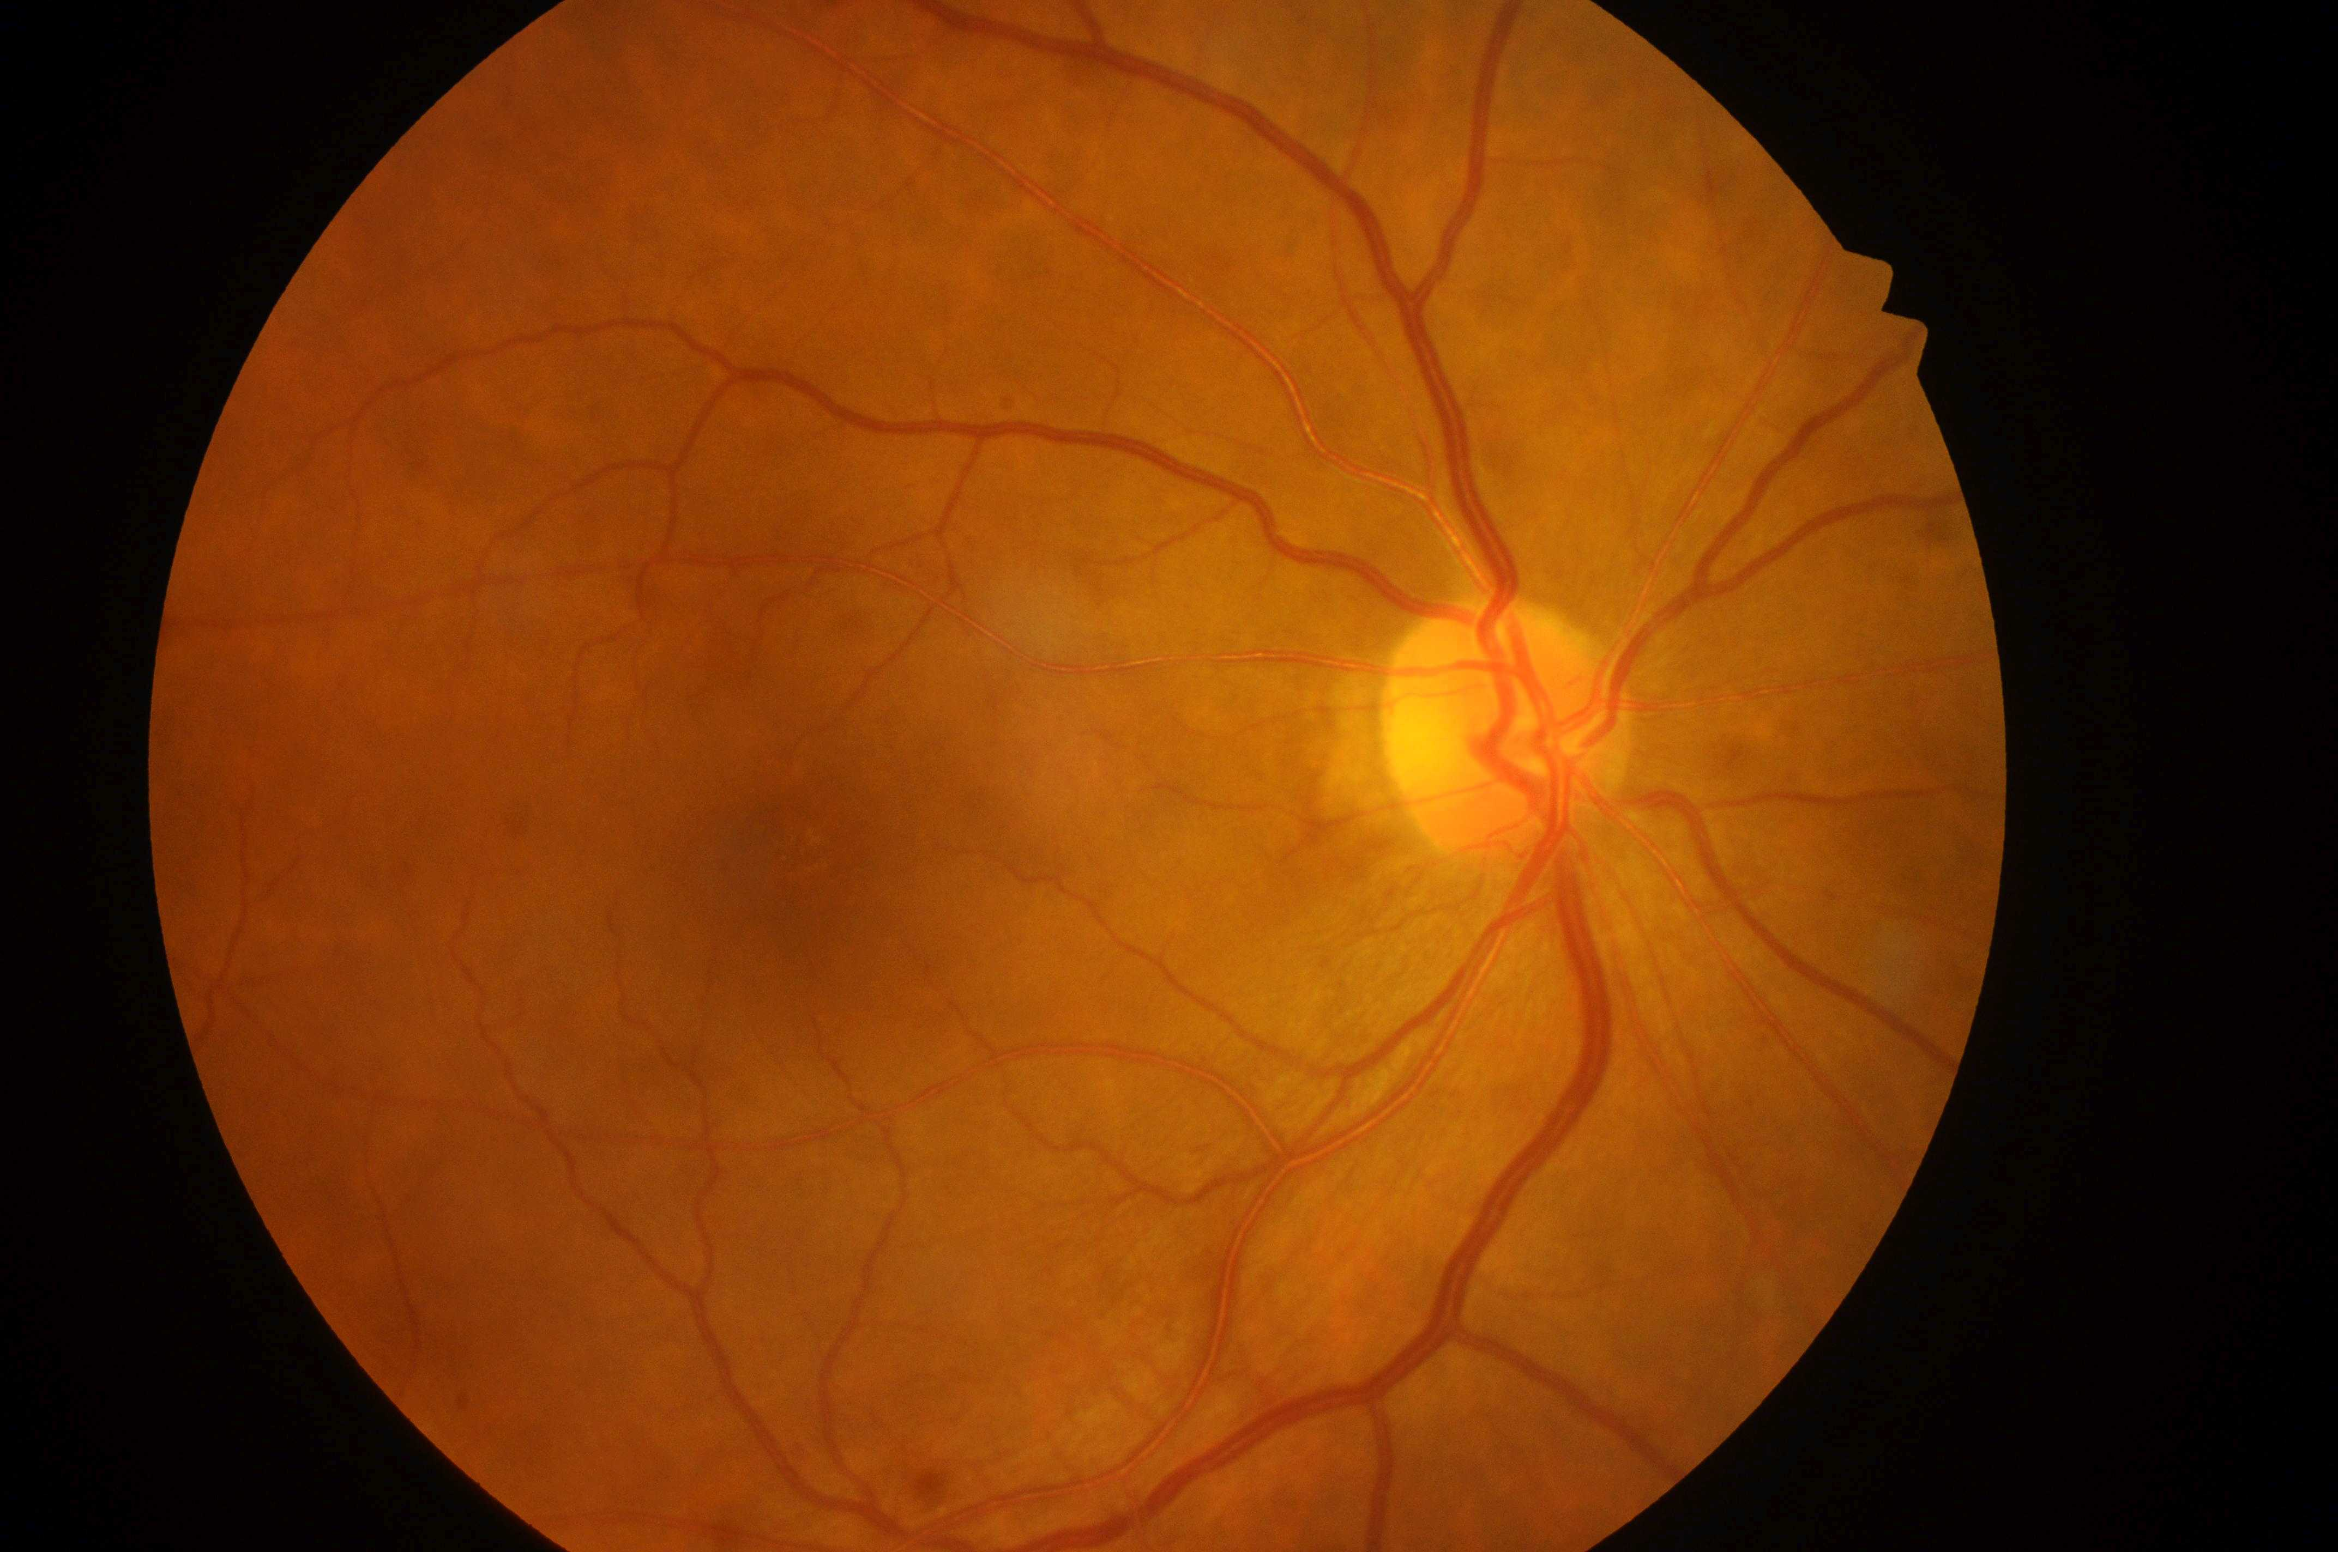
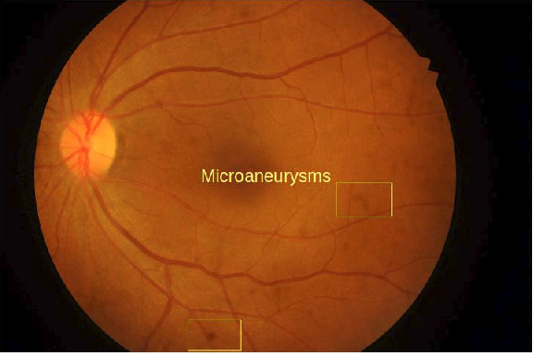
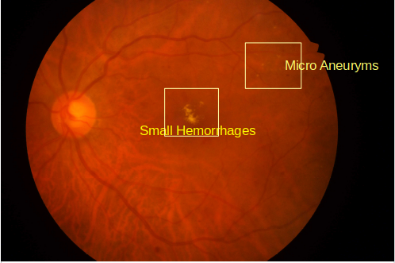

Fig 2 – Grade 0 DR Fig 3 – Grade 1 DR Fig 4 – Grade 2 DR

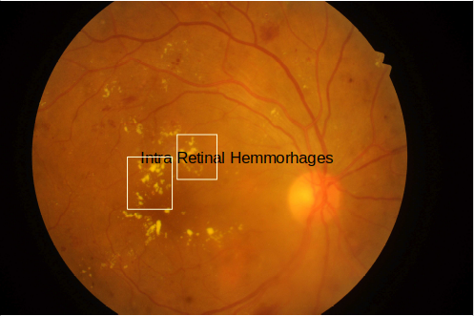
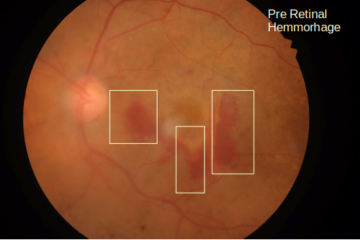

Fig 5 – Grade 3 DR Fig 6 – Grade 4 DR

When we go through the images for different DR images we can see the different features that can be used to differentiate the different grades of Diabetic Retinopathy. For Grade 0 DR there are no abnormalities seen in the images. For Grade 1 DR we can see the small patches (Microaneurysms) on the image. For Grade 2 DR the patches have become slightly bigger and yellowish; these are signs of small haemorrhages in the eye. For Grade 3 images if we observe the number of haemorrhages has increased significantly and we can also see some small red patches in the image showing the intraretinal haemorrhages. Grade 4 DR images show big red coloured patches showing proof of preretinal haemorrhage.
This clearly shows that classification of DR is an excellent candidate for Deep Learning methods; especially Convolutional Neural Networks.

3.2.5 Evaluation
Finally, for the evaluation of the model standard metrics such as Precision, Recall and Accuracy will be used. Below are the formulas for each of these metrics.

Precision will give the measure of the Relevance of the results predicted by the model on the other hand Recall will tell the percentage of correct predictions by the model.

3.3 Proposed Method
The whole methodology has been mainly broken down into three parts. The pipeline consists of the data preprocessing part wherein all the preprocessing and EDA on the data is done; to extract as much data as possible. Once the data preprocessing is done the data will be then fed into a customized Convolutional Neural Network (CNN) for the classification task. Finally Expected Gradients will be applied to bring in the explainability to the system.
The data preprocessing pipeline is depicted in Figure 6. We will not delve more into the data preprocessing techniques here as the same has been already covered in the previous section.
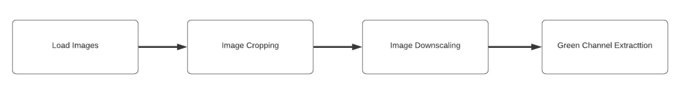
Fig 7 – Data Preprocessing Pipeline

Once the data is pre-processed; the same will be fed into the CNN for getting the classification results. We will be following a customized CNN module for doing the classification. Before feeding the image into the network; then it will be downgraded from the original size of 4288 * 2848 to 536 * 356; the green channel of the image will be extracted; this downgraded image will be then fed into the CNN.
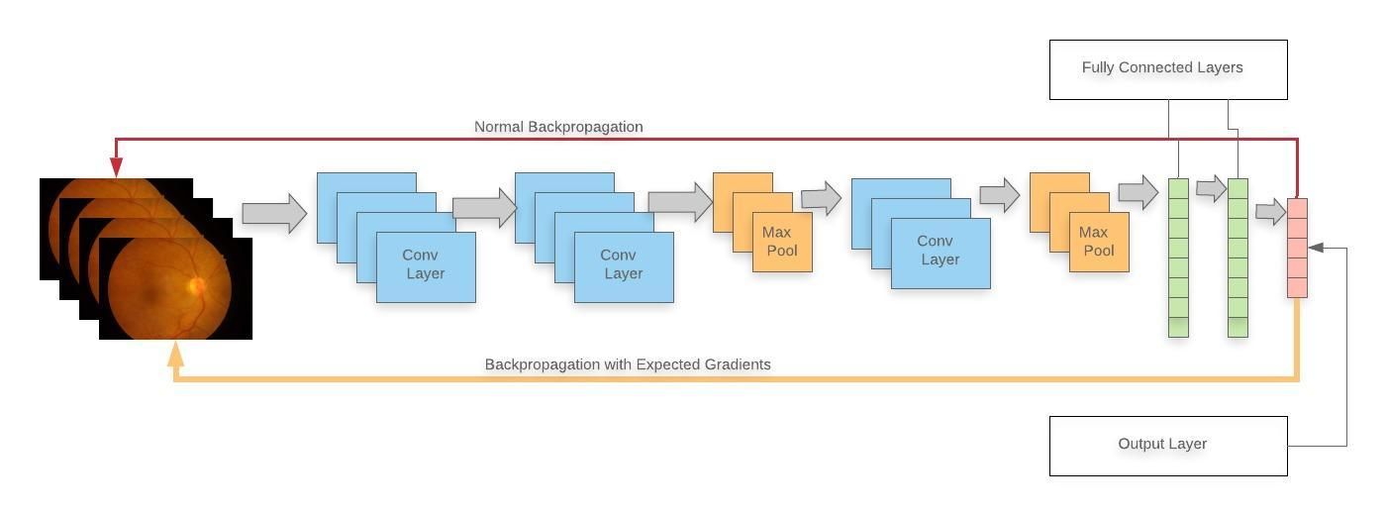
Fig 8 – Deep Learning and XAI Architecture for DR Classification
The CNN itself will consist of 4 Convolutional Blocks; consisting of Convolutional and Max Pooling layers. The kernel size used will be 3x3 with a stride of one. Once after the image passes through the Convolutional blocks it will be flattened and passed through two fully connected layers; we will be applying dropouts here; the optimum value will be found out during the experiments. Finally, we will have the output layer; here we will be applying Softmax for classifying the images into the five different DR Grades. We will be applying batch normalization to prevent bias towards a particular class in a batch; this will also solve the vanishing gradient problem to an extent(Yang et al., 2019)⁠.
Once the classification result is achieved we will be calculating the attribution maps by executing the Expected Gradient algorithms to bring in the explainability to the model developed. Expected Gradient will be calculated by calculating the gradients while doing backpropagation as per the formula given by Equation 3. The baseline image that will be used for calculating the expected gradients is the black image; this will correspond to the of Equation 3.
Once the attribution maps are calculated we will be doing a quantitative evaluation of the attribution maps against the attribute maps calculated using Integrated Algorithm.

3.4 Summary
To summarize this will be a four-step process of Data Preprocessing, Model Building, Model Evaluation and Model Explainability. In the preprocessing steps, the data set of DR images will be explored and preprocessed to get a better understanding and extract maximum information out of it and make it suitable for feeding into the Neural Network Architecture designed.
The processed images will then be fed into the Network for coming up with a model. The model will be then evaluated using the standard metrics of Precisions, Recall, Accuracy. The results will also be compared against the pre-existing models for Diabetic Retinopathy detection to come up with a comparative study and evaluate where this model stands.
The final step of the study will be to run explainability algorithms over the model designed to come up with a proper explanation for model results. This explainability will go a long way in getting a clinical acceptance of such models in the future.
CHAPTER 4

4.1 Introduction
This chapter explains the different Artificial Intelligence and Machine Learning methodologies that has been followed during this study. The methodologies includes but not limited to Data Collection, preparation and preprocessing of the data using different EDA and data augmentation techniques. Once the preprocessing of the data is done the study moves towards the implementation of the main Machine Learning Algorithm. Finally the algorithm is executed the and the results are analyzed and interpreted to understand whether it meets the expectation of the study or there is further scope of improvement for the same.
The study here mainly tries to understand the usage of Artificial Intelligence techniques on the detection and classification of Diabetic Retinopathy into different categories. Our study is mainly limited towards the usage of Deep Learning techniques for the above mentioned goals the dataset consists of a purely images which are generally analyzed by trained Ophthalmologists for the purpose of detection of Diabetic Retinopathy and grading of the same.
4.2 Dataset Description
The primary dataset used for the testing the results of the study is the IDRID (Indian Diabetic Retinopathy Image Dataset). This dataset consists of three subsets of images, one of Diabetic Retinopathy detection, second is for Segmentation and the third one is Disease Localization. As our study is mainly directed towards Diabetic Retinopathy detection and grading we use the first subset which.
The dataset is divided into two parts Training and Testing Dataset. The training dataset consists of 413 fundus images with a distribution as mentioned in the Table 5.
Retinopathy Grade | Count of Image | Percentage Distribution
0 | 134 | 32.45%
1 | 20 | 4.84%
2 | 136 | 32.93%
3 | 74 | 17.92%
4 | 49 | 11.86%
Total | 413 | 100%
Table 5 – Distribution of IDRID images for each category of Diabetic Retinopathy

From the above table we can clearly see that the size of the dataset is very small. To enhance the dataset for the training purpose we decided to use the publicly available kaggle dataset https://www.kaggle.com/tanlikesmath/diabetic-retinopathy-resized. The statistics of the train dataset for the above dataset is as mentioned in Table 6.

Retinopathy Grade | Count of Image | Percentage Distribution
0 | 25802 | 73.49%
1 | 2438 | 6.94%
2 | 5288 | 15.06%
3 | 872 | 2.48%
4 | 708 | 2.02%
Total | 35108 | 100%
Table 6 – Distribution of Kaggle images for each category of Diabetic Retinopathy
For the test purpose we used the test part of the IDRID test dataset which consisted of 103 images for different categories of Diabetic Retinopathy. The distribution for the same is mentioned in Tables 7 below.

Retinopathy Grade | Count of Image | Percentage Distribution
0 | 34 | 33.01%
1 | 5 | 4.85%
2 | 32 | 31.07%
3 | 19 | 18.45%
4 | 13 | 12.62%
Total | 103 | 100%
Table 7 – Test dataset distribution for Diabetic Retinopathy
All the above mentioned dataset consisted of fundus images which are standard images used by Ophthalmologists for diagnosis of different kinds of eye ailments. During fundus photography the rear of the eye is photographed; this rear of the eye is known as fundus in medical terms; hence the term fundus photography. The main structures that are involved in fundus photographs are the retina (both central and peripheral parts), the optic disc and macula. For the purpose of Diabetic Retinopathy detection the retina is analyzed by the medical experts.
The IDRID database that is used for testing has been collected from an eye clinic in Nanded Maharashtra and has been made available publicly through https://idrid.grand-challenge.org/Data/.
4.3 Data Preparation
4.3.1 Image Resizing
As the images for training purposes were taken from different datasets there was a variation of image sizes in both the datasets. The images in the IDRID dataset were of the size 4288×2848 pixels. The images in the Kaggle Dataset ranged from 1024×1024 pixels to 788×1024 pixels. All the images were stored in the RGB color format and storage format was jpeg.
Due to the above variation in image sizes it was decided to resize the images to a uniform size so that the same can be fed into the Neural Network in a seamless manner. For the purpose of experimentation we resized the images into three different image sizes so that the same can be fed into different neural networks and the results can be measured. From the above dataset one dataset were prepared first by merging the IDRID training dataset and the Kaggle dataset; this resulted in a total dataset size of 35521 (35108 + 413) images. From the merged dataset three datasets were prepared. The first dataset had an image size of 256×256 pixels; the second had an image size of 512×512 and the third one had image size of 1024×1024 pixels.
4.3.2 Transformation into Categorical Variables
The images were already labeled from Level 0 to Level 4 in terms of Diabetic Retinopathy Grade in both the Kaggle Dataset as well as the IDRID dataset. As these labels were already available there was no further need to transform the dataset into any categorical variables as the labels could be directly used for the purpose of categorization.
4.3.6 Splitting of original dataset
The original dataset was already divided into train and test dataset. For the purpose of this study the test dataset was further split into a 80:20 ratio for training and validation. On analysis of the dataset it was observed that the distribution of the data was highly skewed resulting in an highly imbalanced data wherein Class 0 diabetic retinopathy samples were close to 74% whereas the sample size for Class 3 and Class 4 were around 2-3% only.
Seeing the above pattern it was decided to under sample Class 0 images to bring in a balance to the dataset distribution.
4.4 Exploratory Data Analysis
4.4.1 Gaussian Blur
On analysis of the image it was found that there was a lot of unwanted noise on the image. To remove this noise Gaussian Blur technique was used. In the process the image is blurred by introducing a Gaussian function to the image. For the purpose of our study we put with sigmaX and sigmaY values set to 30. Figure 9 and 10 shows the image before and after applying Gaussian Blur.

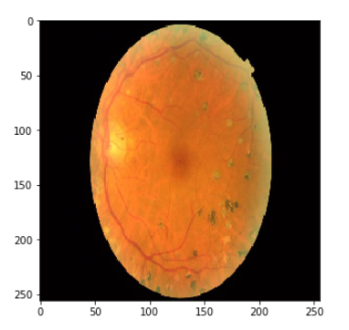
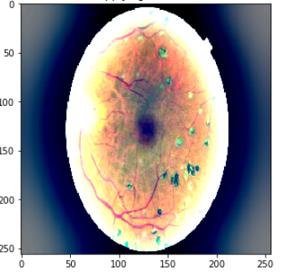

Figure 9 – Original Image Figure 10 – Gaussian Blur Applied Image
4.4.2 Circular Cropping
For the purpose of detecting Diabetic Retinopathy we are only interested in the the Retina of the eye. Since the retina of the eye circular in shape and covers only the central part of the image; circular cropping was applied on the images to remove the unwanted parts of the image. Figure 11 shows the how the image looks after applying circular cropping.
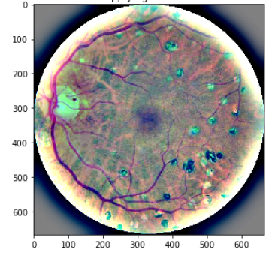

Figure 11 – Image after applying Circular Cropping
4.4.3 Image Scaling
For the purpose of feeding the images into the neural networks images had to be resized. For this the Open CV Image resize method was used with the interpolation method set to Lanczos4. The Lanczos intrepolation algorithm can be understoon from the below equation:
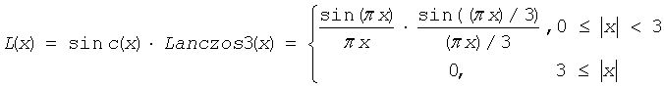
The Lanczos algorithm is used as a low pass filter which is used to smoothly interpolate the values of a digital signal. This algorithm is widely used for the digital image scaling.
4.4.5 Image Gray scaling
During the EDA phase images were analyzed in the RGB mode, Gray scale mode and by extracting only the Green Channel from the images. On analysis it was found that the best results for the purpose of the Network training will come if we use the images in the Gray scale mode as the visibility of the lesions and micro aneurysms is more prominent in the Gray scale mode. The comparison images in the different modes is shown below for reference. Figure 12 shows the Grayscaled Image after Circular Cropping.
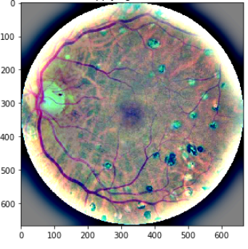

Figure 12 – Gray scaled Image
4.4.6 Data Augmentation
For the purpose of Data Augmentation different algorithms such as horizontal flipping, image shearing, image rotation were used. Sample results of this can be seen in the below images.
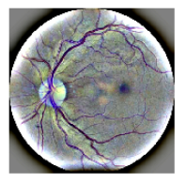
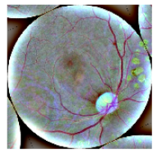

Figure 13 – Horizontal Flipping Figure 14 – Random Rotation

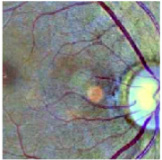
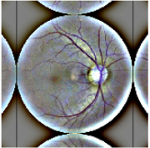

Figure 15 – Random Zoom Figure 16 – Center Crop

4.5 Model Architecture
For the purpose of experimentation we tried out different architectures. As one of the aim of the study was to come up with a lightweight model which can be used on devices with a limited memory footprint;; the architectures tried out were mainly lightweight architecture such as MobileNetV2, EfficientNet B3, EfficientNet B5. For the purpose of comparison the same set of the experiments were tried out on top of ResNet. For all the architecture used Transfer Learning was heavily used by taking the initial weights from Image Net. The experiments conducted on each of this architecture are briefly explained in the following sub sections.
4.5.1 MobileNetV2
Mobile Net V2 (Sandler et al., 2018)⁠ is a mobile architecture which is based on a residual structure with shortcut connections between the thin bottleneck layers. The basic building block is the depth separable bottleneck convolutions with residuals.
For our experimentation purposes we removed the top layers of the MobileNetV2; which is used for the classification purpose; and added our custom layers on top of the rest of the MobileNetV2 model for classification. We initially set the base-model of MobileNetV2 as not trainable and fed our data for 5 epochs. Once we got the initial results we set the topmost 58 layers from the base model as trainable to fine tune the weights. For the initial 5 epochs we set the learning rate as 0.01 and for the fine tuning part we set the initial learning rate to 0.001 and reduced the learning rate on plateau with a patience of 3. Similarly early stopping was set for the fine tuning part with a patience level set to 5.

4.5.3 EfficientNet
Mobile Net V2 (Tan and Le, 2019)⁠ studies the whether the balancing of the network width, depth and resolution can lead to a better performance in terms of resource usage versus model results. Based on the study the researchers proposed 7 versions of EfficientNet starting from B1 to B7. For our study purpose we used the EfficientNet B3 and EfficientNet B5 versions.
In both the versions we removed the top layers from the predefined Keras models; which is used for the classification purpose; and added our custom layers on top of the rest of the model for classification. We initially set the base-model of B3 and B5 model as not trainable and fed our data for 5 epochs. Once we got the initial results we set the topmost 58 layers from the base model as trainable to fine tune the weights. For the initial 5 epochs we set the learning rate as 0.01 and for the fine tuning part we set the initial learning rate to 0.001 and reduced the learning rate on plateau with a patience of 3. Similarly early stopping was set for the fine tuning part with a patience level set to 5.
4.5.4 ResNet 50
Mobile Net V2 (Sandler et al., 2018)⁠ is a mobile architecture which is based on a residual structure with shortcut connections between the thin bottleneck layers. The basic building block is the depth separable bottleneck convolutions with residuals.
For our experimentation purposes we removed the top layers of the MobileNetV2; which is used for the classification purpose; and added our custom layers on top of the rest of the MobileNetV2 model for classification. We initially set the base-model of MobileNetV2 as not trainable and fed our data for 5 epochs. Once we got the initial results we set the topmost 58 layers from the base model as trainable to fine tune the weights. For the initial 5 epochs we set the learning rate as 0.01 and for the fine tuning part we set the initial learning rate to 0.001 and reduced the learning rate on plateau with a patience of 3. Similarly early stopping was set for the fine tuning part with a patience level set to 5.

4.9 Summary
In this chapter the dataset was described in details. Along with the dataset descriptions;the steps taken to for exploratory data analysis (EDA) was also discussed. As part of EDA the Images were analyzed using different techniques. It was found that the clarity of the lesions and the micro aneurysms increased greatly when Gaussian Blur is applied on the images. Also as the images were of different sizes and it had to be resized and scaled down to be fit into the proposed network architecture. As part of the image resizing various algorithms were tried out such as nearest neighbour interpolation, bicubic interpolation, lanczos interpolation, etc. The results from the Lanczos interpolation was the best; hence it was decided to go ahead with the rest of the experiments on the images generated from Lanczos resizing.
Once the images were resized and gray scaled; we applied different Data Augmentation techniques such as Horizontal flipping, image shearing, rotation etc. Also from the analysis of the dataset it could be easily seen that the data was heavily skewed and imbalanced. Hence under sampling was done for Class 0 Diabetic Retinopathy images to bring in some kind of balance to the data.
Once the data preparation was done the data was fed into the different models for experimentation purpose. For the purpose of this study four models were tried out, namely MobileNetV2, EfficientNet B3, EfficientNet B5 and Resnet 50. Once the model results came out for Integrated Gradient and Expressive Gradient algorithm were applied on top of the model result to analyze the results and build in some explainability to the developed system.
CHAPTER 5: RESULTS AND DISCUSSIONS
5.1 Introduction
This chapter will briefly describe the various evaluation methods used to measure the performance of the various models. Along with the definitions this chapter will also briefly explain the results achieved during the experimentation phase of this study. For the purpose of this study 4 different methods of classification methods were used on top of the dataset described in Chapter 4.
5.3 Evaluation Methods and Results
5.3.1 Cohen Kappa Methodology
Cohen Kappa Methodology was first published by Jacob Cohen. It is used to measure the inter rater reliability between two different raters for classifying categorical items. The formula for Cohen’s Kappa score (k) is given as:

where p_{o} is the agreement observed between the raters, p_{e} is the probability of getting a chance agreement. The above equation can be further broken down as below:

From the above equation we have can clearly see that the value of k can range from 0 to 1; 0 being absolute disagreement while 1 being absolute agreement. Table 8 gives a mapping between the Kappa score and the inter rater agreement level.
Cohen Kappa Score Range | Agreement Level
0.00 – 0.20 | None to Slight Agreement
0.21 - 0.40 | Fair Agreement
0.41 – 0.60 | Moderate Agreement
0.61 – 0.80 | Substantial Agreement
0.81 – 1.00 | Almost Perfect Agreement
Table 8 – Cohen Kappa Agreement Range
5.3.1.1 Training Cohen Kappa Score Modified MobileNetV2
During the training phases of the MobileNetV2 Architecture was able to achieve an Cohen Kappa Score of 0.8441, which falls in the range of almost perfect agreement for Cohen Kappa Score. The training accuracy attained during this phase is 0.8962. Figure 17 shows the increasing trend for Training Cohen Kappa Score MobileNetV2.

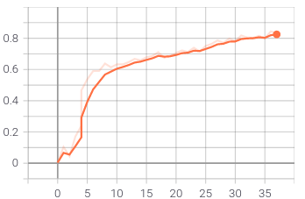

Figure 17 – Cohen Kappa Score for MobileNetV2

5.3.1.2 Training Cohen Kappa Score Modified EfficientNetB5
During the training phases of the EfficientNetB5 Architecture was able to achieve an Cohen Kappa Score of 0.7258, which falls in the range of substantial agreement for Cohen Kappa Score. The training accuracy attained during this phase is 0.8233. Figure 18 shows the increasing trend for Training Cohen Kappa Score EfficientNetB5.
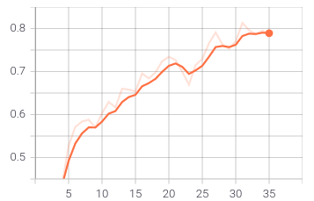

Figure 18 – Cohen Kappa Score for EfficientNetB5

5.3.1.3 Training Cohen Kappa Score Modified EfficientNetB3
During the training phases of the EfficientNetB3 Architecture was able to achieve an Cohen Kappa Score of 0.7258, which falls in the range of substantial agreement for Cohen Kappa Score. The training accuracy attained during this phase is 0.8233. Figure 19 shows the increasing trend for Training Cohen Kappa Score EfficientNetB3.

Figure 19 – Cohen Kappa Score for EfficientNetB3
5.3.1.4 Training Cohen Kappa Score Modified ResNet50
During the training phases of the ResNet50 Architecture was able to achieve an Cohen Kappa Score of 0.7258, which falls in the range of substantial agreement for Cohen Kappa Score. The training accuracy attained during this phase is 0.8233. Figure 20 shows the increasing trend for Training Cohen Kappa Score ResNet50.
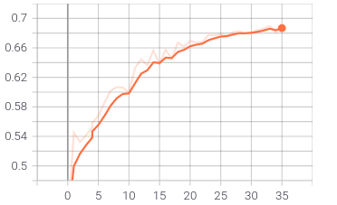

Figure 20 – Cohen Kappa Score for ResNet50
5.3.2 Multi Class Confusion Matrix
As the dataset given is a multi class data; we have used a multi class confusion matrix for the purpose of measuring the True Positive, True Negative, False Positive and False Negative rates for each class of data. During the calculation of multi class confusion matrix; the data is treated as binarized as one vs rest for each of the classes and the confusion matrix is created for the each of the classes as per this binarization.
5.3.2.1 Training Multi Class Confusion Matrix Score Modified MobileNetV2
During the training phases of the MobileNetV2 Architecture was able to get an score of 490 for the Multi class confusion matrix; figure 21 depicts the same.

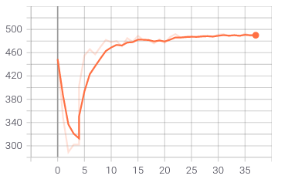

Figure 21 – Multi Class Confusion Score for MobileNetV2
5.3.2.2 Training Multi Class Confusion Matrix Score Modified EfficientNetB5
During the training phases of the EfficientNetB5 Architecture was able to get an score of 490 for the Multi class confusion matrix; figure 22 depicts the same.

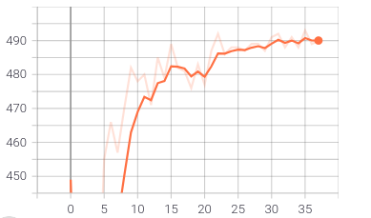

Figure 22 – Multi Class Confusion Score for EfficientNetB5
5.3.2.3 Training Multi Class Confusion Matrix Score Modified EfficientNetB3
During the training phases of the EfficientNetB3 Architecture was able to get an score of 490 for the Multi class confusion matrix; figure 23 depicts the same.

Figure 23 – Multi Class Confusion Score for EfficientNetB3
5.3.2.4 Training Multi Class Confusion Matrix Score Modified ResNet50
During the training phases of the ResNet50 Architecture was able to get an score of 490 for the Multi class confusion matrix; figure 23 depicts the same.

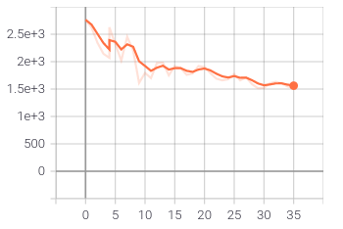

Figure 23 – Multi Class Confusion Score for ResNet50
5.4 Testing on Validation Dataset
Once the experiments were over on the training dataset; the models were tested on the validation set. Below is a summary of the results on the validation set for the different architectures. For the validation purpose 15% of the data was kept aside and the validation was done that set.
5.4.1 Modified MobileNetV2
The MobileNetV2 was able to achieve an Cohen Kappa Score of 0.8105; which falls in the range of almost perfect agreement for Cohen Kappa Score. The validation accuracy attained during this phase is 0.8743. The Multi Class Confusion Matrix Score was 486. Figure 24 and 25 show the Cohen Kappa Score and Multi Class Confusion Matrix Score during the validation phase.

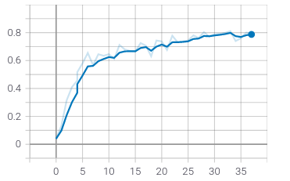
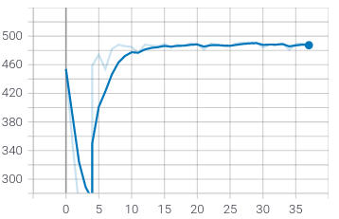

Figure 24 – Cohen Kappa Score MobileNetV2 Figure 25 – Multi Class Confusion Matrix MobileNetV2

5.4.2 Modified EfficientNetB5
The EfficientNetB5 was able to achieve an Cohen Kappa Score of 0.8105; which falls in the range of almost perfect agreement for Cohen Kappa Score. The validation accuracy attained during this phase is 0.8743. The Multi Class Confusion Matrix Score was 486. Figure 26 and 27 show the Cohen Kappa Score and Multi Class Confusion Matrix Score during the validation phase.

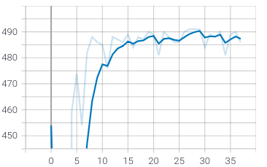
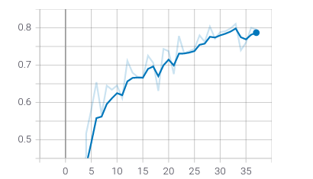
Figure 26–Cohen Kappa Score EfficientNetB5 Figure 27–Multi Class Confusion Matrix EfficientNetB5
5.4.3 Modified EfficientNetB3
The EfficientNetB3 was able to achieve an Cohen Kappa Score of 0.8105; which falls in the range of almost perfect agreement for Cohen Kappa Score. The validation accuracy attained during this phase is 0.8743. The Multi Class Confusion Matrix Score was 486. Figure 26 and 27 show the Cohen Kappa Score and Multi Class Confusion Matrix Score during the validation phase.

Figure 24–Cohen Kappa Score EfficientNetB3 Figure 24–Multi Class Confusion Matrix EfficientNetB3
5.4.4 Modified ResNet50
The ResNet50 was able to achieve an Cohen Kappa Score of 0.8105; which falls in the range of almost perfect agreement for Cohen Kappa Score. The validation accuracy attained during this phase is 0.8743. The Multi Class Confusion Matrix Score was 486. Figure 26 and 27 show the Cohen Kappa Score and Multi Class Confusion Matrix Score during the validation phase.
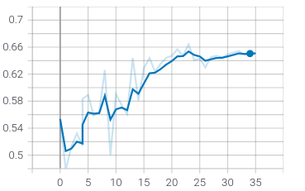
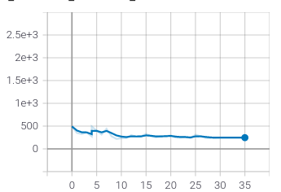
Figure 24–Cohen Kappa Score ResNet50 Figure 24–Multi Class Confusion Matrix ResNet50
5.6 Summary

APPENDIX A: RESEARCH PLAN

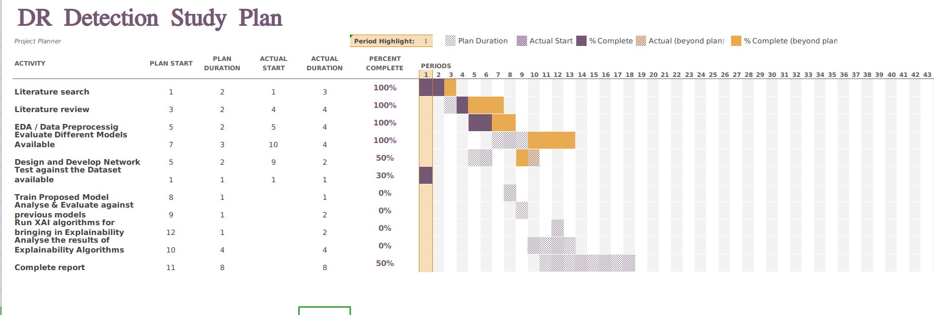
APPENDIX B: RESEARCH PROPOSAL
and interpretable

HIMANGSHU LAHKAR

A thesis submitted in fulfilment of the
requirements for the award of the degree of
Master of Science in ARTIFICIAL INTELLIGENCE & MACHINE LEARNING

Liverpool John Moores University (LJMU)

July 2020

Abstract

In the recent past Diabetes has become one of the biggest health concerns in the world due to the large number of persons affected in the working age population especially in the urban population. As per the statistics available around one third of the population affected by Diabetes will be eventually affected by Diabetic Retinopathy; which might lead to eventual vision loss for the affected population.
Diabetic Retinopathy is caused by the prolonged exposure to high levels of glucose in the blood. Over a period of time this leads to the weakening of the blood vessels inside the retina leading to hemorrhages, exudates and other similar conditions leading to eventual blindness. Some of the potential complications of these conditions are reduced night and peripheral vision, internal bleeding inside the eye leading to complete blindness.
Fortunately Diabetic Retinopathy can be treated if detected at the initial stages. Thus, the detection of Diabetic Retinopathy during the initial stages and properly grading the severity of the disease becomes extremely important as it can lead to proper treatment being made available to the affected population. Taking into account the huge percentage of population that is going to be impacted we can see the Automating this process of Diabetic Detection will prevent a great amount of stress on the Doctors as well as the patients.
Diabetic Retinopathy can be classified into 5 stages depending on the spread of the disease and fundus imaging is one of the major ways of detecting and grading Diabetic Retinopathy that is used by Ophthalmologists worldwide. This work will eventually come up with a model that will take in the fundus images as an input and come up with an classification algorithm to classify these images into the different stages of Diabetic Retinopathy.
Table of Contents
Abstract 2
1. Introduction 4
2. Background and related research 4
3. Research Questions (If any) 6
4. Aim and Objectives 7
5. Research Methodology 8
6. Expected Outcomes 9
7. Requirements / resources 9
8. Research Plan 10
References 11

1. Introduction

In the present scenario with the lifestyle changes in the urban population Diabetes has become one of the major chronic Diseases worldwide; including the Developed World and the Developing Countries such as India(Yang et al., 2017)⁠ . Some of the recent studies have shown that there will be close to 700 million people suffering from Diabetes by the year 2035 and about one-third of this population; around 250 million; will be affected by Diabetes Retinopathy(DR)(Lim et al., 2020)⁠.
Since Diabetes and DR occurs in mostly in the age group of 35 – 70; the major effect can be seen in the working class population and DR has become one of the main reasons for blindness in the working class population(Li et al., 2019)
DR can be classified into five stages based on the disease severity(Chen et al., 2011)⁠. They are
- DR Absent; these are perfectly healthy eyes not showing any abnormalities
- Mild Non Proliferative Diabetic Retinopathy (NPDR); this is the first stage of DR where some Micro-aneurysm are visible
- Moderate NPDR; as the disease gets on to the next stage along with the Micro-aneurysm small hemorrhages start to appear in the eye
- Severe NPDR; at this stage of DR extensive retinal hemorrhages can be seen in the eye
- Proliferative DR; this is extreme stage of DR wherein we can see neovascular or pre retinal hemorrhages

2. Background and related research

From the above we can see the enormity of the problem of DR and the kind of stress it will bring on to the society, economy and medical practitioners in particular. However the positive side of this is that DR progresses very slowly and it takes years to actually cause blindness. Hence if DR can be diagnosed in the early stages it can be controlled by proper Medical Treatment; this makes the early detection of the DR very important.
During Recent times there has been a lot of study in the Automatic Detection of Diabetic Retinopathy using both Machine Learning and Deep Learning Techniques. (Acharya U et al., 2008)⁠ proposed an SVM based model which gave an diagnostic accuracy of 82%. (Carrera et al., 2017)⁠ worked on the Diabetic Retinopathy detection problem using Decision Trees and SVM classifiers and achieved an accuracy of 92.0% and 92.4% respectively. (Romero-Aroca et al., 2019)⁠ developed a system using Fuzzy Random Forest and achieved a Sensitivity of 80.67% and Specificity of 85.96%.
(Gulshan et al., 2016)⁠ used a data set of more than 128000 images which were graded by a panel of 54 Ophthalmologists to train the network and achieved a ROC curve of .991. This method used an ensemble of 10 Inception 3 modules. (Yang et al., 2017)⁠ used a two stage Deep CNN on the Kaggle Dataset to identify the Lesions on the fundus Image and also to classify the images into the different stages of DR; the lesion classifier was a binary classifier telling the presence or absence of Lesions on certain areas of the eye and the DR classifier was a multi stage classifier; this two-stage network was able to achieve an AUC score of .9687 for the DR classification. (Wan et al., 2018)⁠ used the Kaggle Dataset and trained the VGG-Net architecture to achieve an accuracy of 95.68%. (Shah et al., 2017)⁠ presented a CNN based architecture to classify DR into referable and non referable on top of 112489 fundus achieved an AUC of .991 for DR Detection and .969 on referable DR Detection; however this work was mainly directed as binary classification problem of identifying the images as Referable and non referable Diabetic Retinopathy. (Shankar et al., 2020)⁠ pproposed a novel architecture for the detection for DR grading using a Synergic Deep Learning model and achieved an accuracy of 99.28% and sensitivity and specificity of 98 and 99 respectively; the Authors used Resnet-50 based Deep CNN and Histogram based image segmentation techniques while proposing the solution.
The above Deep learning methods used a large dataset for achieving the kind of accuracy as mentioned. There have been some studies done using relatively small datasets for Diabetic Retinopathy detection. (Shanthi and Sabeenian, 2019)⁠ resented a modified Alexnet architecture that could achieve an accuracy of 93%. (Hagos and Kant, 2019)⁠ presented a model based on Transfer learning that could achieve around 90% accuracy. (Doshi et al., 2020)⁠ tried using image downscaling algorithms and were able to achieve an accuracy of 85.2%..
(Costa et al., 2018)⁠ developed a model which was given interpretability to the ophthalmologists on how the model arrived at the conclusion; however it was a binary classifier telling whether the input image had Diabetic Retinopathy or not. The model achieved an accuracy of 96%.

3. Research Questions (If any)

From the above Literature Review we can see that a lot of work has been done on this area detection using both Machine Learning and Deep Learning Methods. While the initial work that was done using Machine Learning techniques were not able to give results that were suitable to be used for clinical diagnosis; the results of the deep learning methods were quite impressive.
However the deep learning methods that could give results comparable to grading by trained Ophthalmologists had to use a huge data set for training their models. The results dip by a very significant amount if the dataset used for training is small. Another common observation is that the models that are showing excellent results are very complex and end up taking a lot of time in training and end up giving a huge set of parameters; thus making them unsuitable for use in devices with low processing and memory resources.
Another common observation is that the majority of the models work as blackbox to achieve high levels of accuracy. As the interpretability is built into the model it loses its classification power and the metrics start coming down significantly.
With the above observations in mind some of the questions that this work will try to answer are:
- Is it possible to train a model that is comparable in performance with DR grading by trained Ophthalmologists with a small dataset.
- Whether a model can be built to be used in low cost devices; so that the same can be deployed in small hand carried devices by field agents of different agencies for initial screening purpose; so that the trained Ophthalmologists can use their expertise for treatment rather than screening of patients.
- How to build in the interpretability into the model without losing its predictive powers.

4. Aim and Objectives

The main aim of this research is to propose a CNN based Model for the classification of Diabetic Retinopathy into the different stages. The identification of the different stages of the Diabetic Retinopathy depends on the below observations:
- Healthy Eye – There are no abnormalities seen in the fundus image
- Mild NPDR – Only Micro-aneurysm are visible
- Moderate NPDR – Along with Microaneurysm small hemorrhages can be seen
- Severe NPDR – Extensive intra retinal hemorrhages can be seen
- PDR – Neovascular or pre retinal hemorrhages can be seen

The final aim is to come up with a combination of Pre-processing and Modeling techniques to improve the classification metrics for Diabetic Retinopathy detection using the aforementioned model.
Keeping the above in mind this work mainly thrives to achieve the below two object:

- To build a method of DR Grading using a small dataset; which is comparable to the DR Grading done by trained Ophthalmologists.
- To solve the class imbalance problem that is inherent in this problem, as the majority of the people screened generally belongs to the healthy eye category.
- To build in interpretability to the model using various Image processing techniques

5. Research Methodology

For the research will be using the IDRID Dataset available in Kaggle site. This data set is divided into three parts: Segmentation, Disease Grading & Localization. This is the first dataset which is representative of an Indian Population. This work will be using the Disease Grading Section of the dataset.
The dataset has a total of 516 images of the different grades of Diabetic Retinopathy. This has been further divided into a training set of 413 images and a test set of 103 images. On further analysis of the training set it can be seen the images are distributed as below:
DR Stage | Images in dataset
No DR | 134
Mild NPDR | 20
Moderate NPDR | 136
Severe NPDR | 74
PDR | 49

From the above we can see two major problems in the dataset; the first one being a relatively small dataset and the second problem is of class imbalance as can be seen from the above table.
The first phase of the work will be aimed towards solving the above mentioned problems by using techniques of Data Augmentation to increase the size of the dataset. During this phase different techniques like Oversampling and SMOTE will be tried out to solve the problem of Class Imbalance.
One the above mentioned problems are solved the work will go ahead to find the various features in the images such as microaneurysms and hemorrhages in images using different image processing techniques such as image segmentation, image filtering etc.
Once the image processing is done as mentioned above this will be fed into the Neural Network model to come up with the final classification problem. The model thus built will be further tuned so as to come up with the best possible metrics in terms of accuracy, sensitivity, specificity, AUC under the ROC.
Below is a simplified flow of how the work will proceed in the different phases:

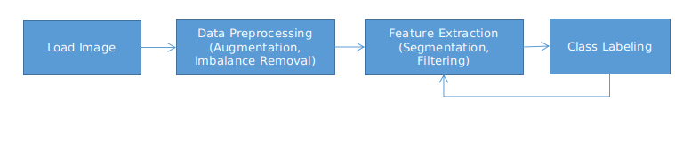

6. Expected Outcomes
The final outcome of this work will be a model that will be able to Detect Diabetic Retinopathy and grade the same into the various stages of the same. Some of the implicit outcomes the work will be:
- A lightweight model which is comparable in performance with the human grading of Diabetic Retinopathy so that the same can be deployed into devices with low resources and can be used for practical screening of patients in low income areas
- A unique combination of image processing and modeling technique that can solve the problems of a small and imbalanced dataset.

7. Requirements / resources

Some of the Resource Requirements for carrying out the work and building the model are:
- One computer with GPU for training the Neural Networks – The GPU will be needed for image processing and the CNN training part.
- Deep Learning Platform – TensorFlow / PyTorch – This platforms provide the necessary Application Programming Interfaces to be used for building the Neural Networks
- Image processing Software – Open CV – Image processing software will be used for all the pre-processing activities for the data set before feeding the same into the Model that has been built
- SK Learn / Stats model Tools – These tools will be used for calculating the metrics of the model that will be built as part of the research.

8. Research Plan
The Research is planned from 1st of May till 2nd of November; this is a period of around 26 weeks. The plan is done for 24 weeks keeping 2 weeks as a buffer to keep a track of unavoidable delays in some of the stages. Below is a snapshot for the same.

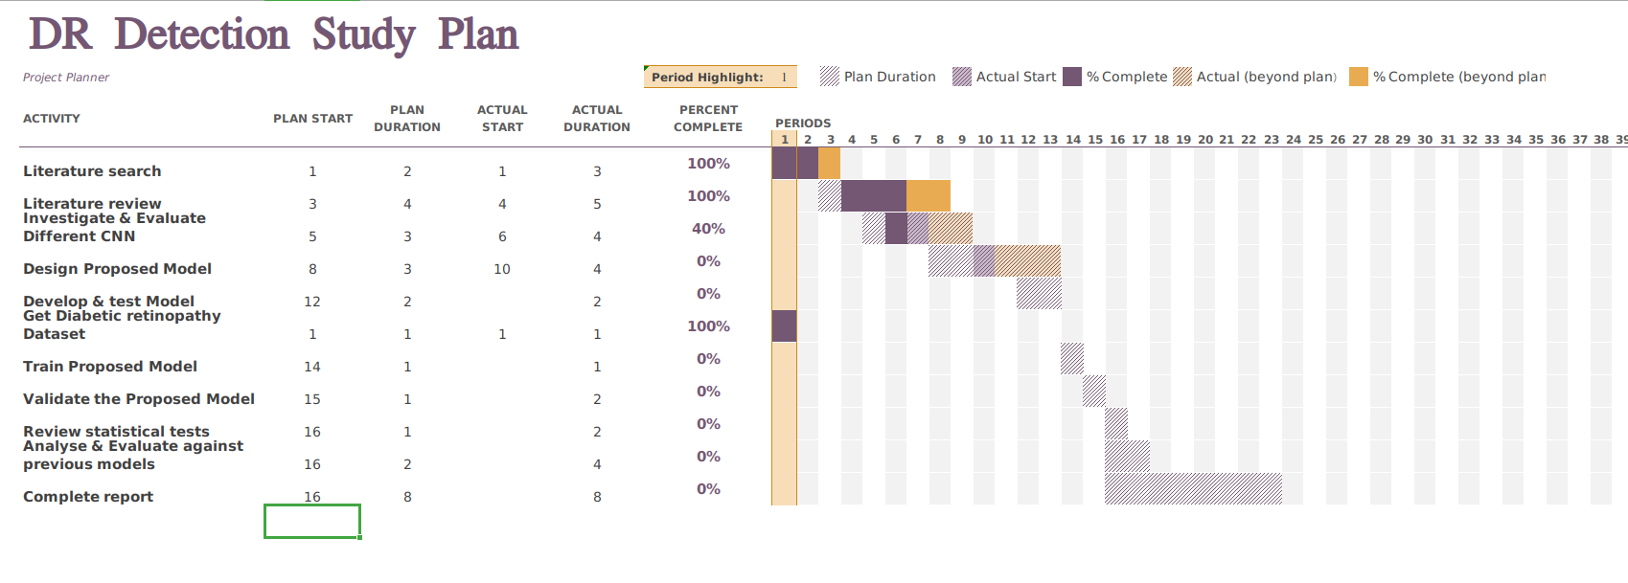

References

Acharya U, R., Chua, C.K., Ng, E.Y.K., Yu, W. and Chee, C., (2008) Application of higher order spectra for the identification of diabetes retinopathy stages. Journal of Medical Systems, 326, pp.481–488.
Carrera, E. V., Gonzalez, A. and Carrera, R., (2017) Automated detection of diabetic retinopathy using SVM. Proceedings of the 2017 IEEE 24th International Congress on Electronics, Electrical Engineering and Computing, INTERCON 2017, pp.6–9.
Chen, Z., Zhang, S.S. and Zhu, H.M., (2011) Analysis of international clinical diabetic retinopathy disease severity scale. International Journal of Ophthalmology, 118, pp.1394–1401.
Costa, P., Galdran, A., Smailagic, A. and Campilho, A., (2018) A Weakly-Supervised Framework for Interpretable Diabetic Retinopathy Detection on Retinal Images. IEEE Access, 6, pp.18747–18758.
Doshi, N., Oza, U. and Kumar, P., (2020) Diabetic Retinopathy Classification using Downscaling Algorithms and Deep Learning. In: 2020 7th International Conference on Signal Processing and Integrated Networks (SPIN). [online] IEEE, pp.950–955.
Gulshan, V., Peng, L., Coram, M., Stumpe, M.C., Wu, D., Narayanaswamy, A., Venugopalan, S., Widner, K., Madams, T., Cuadros, J., Kim, R., Raman, R., Nelson, P.C., Mega, J.L. and Webster, D.R., (2016) Development and validation of a deep learning algorithm for detection of diabetic retinopathy in retinal fundus photographs. JAMA - Journal of the American Medical Association, 31622, pp.2402–2410.
Hagos, M.T. and Kant, S., (2019) Transfer Learning based Detection of Diabetic Retinopathy from Small Dataset.
Li, T., Gao, Y., Wang, K., Guo, S., Liu, H. and Kang, H., (2019) Diagnostic assessment of deep learning algorithms for diabetic retinopathy screening. Information Sciences, [online] 501June 2019, pp.511–522.
Lim, G., Bellemo, V., Xie, Y., Lee, X.Q., Yip, M.Y.T. and Ting, D.S.W., (2020) Different fundus imaging modalities and technical factors in AI screening for diabetic retinopathy: a review. Eye and Vision, 71, pp.1–13.
Romero-Aroca, P., Valls, A., Moreno, A., Sagarra-Alamo, R., Basora-Gallisa, J., Saleh, E., Baget-Bernaldiz, M. and Puig, D., (2019) A Clinical Decision Support System for Diabetic Retinopathy Screening: Creating a Clinical Support Application. Telemedicine and e-Health, 251, pp.31–40.
Shah, P., Mishra, D.K., Shanmugam, M.P., Doshi, B., Jayaraj, H. and Ramanjulu, R., (2017) Symposium Recent advances and challenges in the management of retinoblastoma Globe - saving Treatments. BMC Ophthalmology, [online] 171, p.1.
Shankar, K., Sait, A.R.W., Gupta, D., Lakshmanaprabu, S.K., Khanna, A. and Pandey, H.M., (2020) Automated detection and classification of fundus diabetic retinopathy images using synergic deep learning model. Pattern Recognition Letters, [online] 133, pp.210–216.
Shanthi, T. and Sabeenian, R.S., (2019) Modified Alexnet architecture for classification of diabetic retinopathy images. Computers and Electrical Engineering
Wan, S., Liang, Y. and Zhang, Y., (2018) Deep convolutional neural networks for diabetic retinopathy detection by image classification. Computers and Electrical Engineering
Yang, Y., Li, T., Li, W., Wu, H., Fan, W. and Zhang, W., (2017) Lesion detection and grading of diabetic retinopathy via two-stages deep convolutional neural networks. Lecture Notes in Computer Science (including subseries Lecture Notes in Artificial Intelligence and Lecture Notes in Bioinformatics), 10435 LNCS, pp.533–540.

