Hospital Length of Stay Prediction
Machine Learning Analysis Report

Dataset: HospitalLengthofStay_SelectedFeatures_ESC113_10k
10,000 Patients | 46 Features | 4 Models Evaluated
Generated: May 9, 2026

1. Introduction
Predicting how long a patient will stay in hospital after surgery is a valuable clinical and operational challenge. Accurate length-of-stay (LOS) predictions help hospitals optimise bed management, allocate nursing staff, reduce costs, and improve patient care planning.

This report documents a complete machine learning pipeline applied to a perioperative dataset of 10,000 surgical patients. The workflow covers exploratory data analysis, preprocessing, training of four regression models, and a comparative evaluation using standard metrics.

2. Dataset & Exploratory Data Analysis

2.1 Dataset Overview
The dataset contains 10,000 patient records and 51 columns including the target variable. Features span three clinical phases:
- Pre-operative: demographics (age), ASA score, lab results (albumin, haemoglobin, BUN, etc.), blood pressure and heart rate summaries, and pre-admission medications.
- Intra-operative: arterial pressures, urine output, end-tidal CO2, respiratory rate variability, and anaesthetic agents.
- Procedure type: binary flags for breast, gastric, and hip prosthesis surgery, plus diagnosis group (musculoskeletal, neoplasms, respiratory).

The target variable hospital_los was recorded in minutes and converted to days (divided by 1,440) to aid interpretability.

2.2 Missing Values
Missing data varied considerably across features. Several intra-operative columns were heavily incomplete — likely because arterial lines and urine-output catheters are not used in all procedures. Any column with more than 70% missing values was removed before modelling.

2.3 Target Variable Distribution
After conversion, LOS ranged from approximately 1 to 58 days (post-outlier removal). The distribution was right-skewed, with a median of around 6 days and a long tail driven by complex or high-risk cases. Extreme outliers beyond the 99th percentile (~58 days) were excluded.
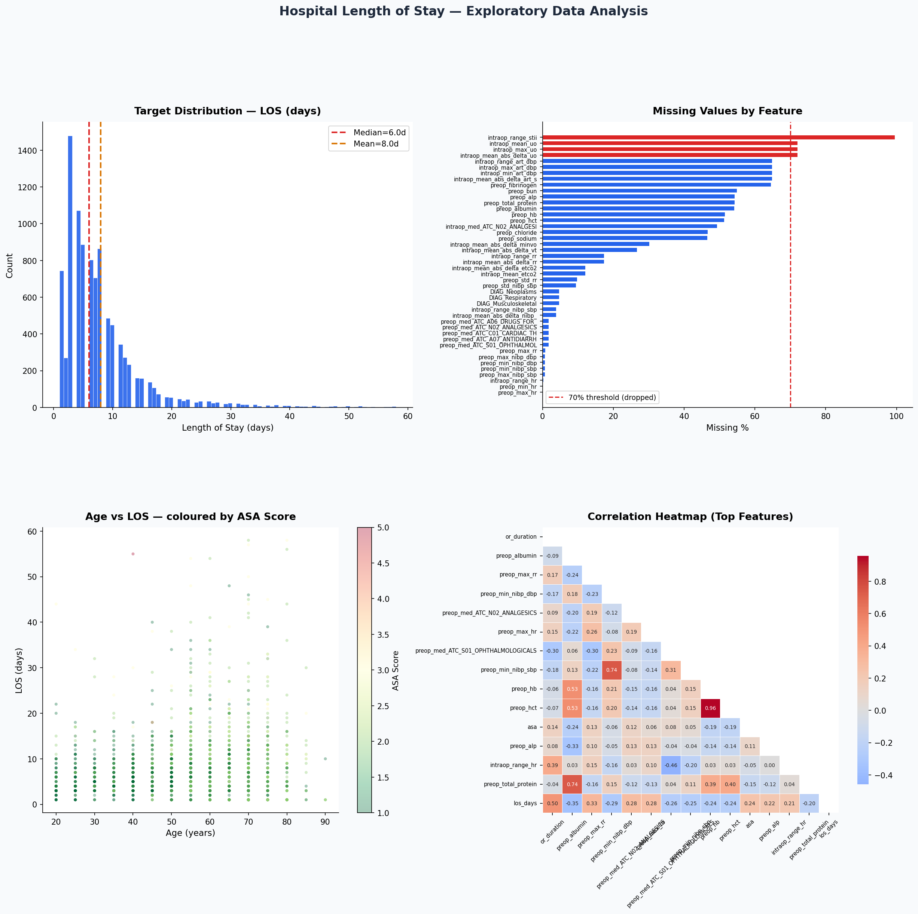
Figure 1. EDA — LOS distribution, missing values, age-LOS scatter, and correlation heatmap.

3. Data Preprocessing

3.1 Steps Applied
- Unit conversion: hospital_los (minutes) divided by 1,440 to produce los_days.
- Outlier removal: records above the 99th percentile of LOS (~58 days) were dropped, reducing the dataset from 10,000 to 9,902 rows.
- Column pruning: four columns with >70% missing values were removed (intraop_max_uo, intraop_mean_abs_delta_uo, intraop_mean_uo, intraop_range_stii).
- Imputation: remaining missing values in the 46 retained features were filled with the column median, a robust choice given the skewed distributions.
- Scaling: features were standardised (zero mean, unit variance) for the linear models; tree-based models used raw values.
- Train/test split: 80% training (7,921 rows) and 20% held-out test (1,981 rows), stratified by random seed 42.

After preprocessing the final dataset contained 9,902 rows and 46 features with no missing values.

4. Model Building
Four scikit-learn regression models were trained and evaluated:

Linear Regression
A standard ordinary least-squares baseline. Features were standardised before fitting. This model assumes a linear relationship between inputs and LOS.

Ridge Regression
Linear regression with L2 regularisation (alpha = 10). Regularisation reduces overfitting caused by correlated predictors and helps when many features are only weakly predictive.

Random Forest
An ensemble of 200 decision trees (max_depth = 12, min_samples_leaf = 5). Each tree is trained on a bootstrap sample and a random feature subset, reducing variance. No feature scaling required.

Gradient Boosting (HistGradientBoosting)
A histogram-based boosting algorithm (200 estimators, learning_rate = 0.05, max_depth = 5). Trees are added sequentially, each correcting the errors of the previous one, often yielding high accuracy on tabular data.

5. Model Evaluation

5.1 Metrics Summary
All four models were evaluated on the held-out 20% test set using three metrics:
- R² (Coefficient of Determination): proportion of variance in LOS explained by the model. Ranges from 0 (no explanatory power) to 1 (perfect fit).
- MAE (Mean Absolute Error): average absolute difference in days between predicted and actual LOS. Directly interpretable.
- RMSE (Root Mean Squared Error): similar to MAE but penalises large errors more heavily due to squaring.

Model | R² | MAE (days) | RMSE (days)
Ridge Regression | 0.515 | 2.87 | 4.94
Linear Regression | 0.515 | 2.88 | 4.94
Gradient Boosting | 0.495 | 2.84 | 5.04
Random Forest | 0.493 | 2.80 | 5.04
Table 1. Test-set performance of all four models. Best model highlighted in blue.

5.2 Key Findings
- Ridge Regression achieved the highest R² (0.515) and lowest RMSE (4.94 days), making it the best overall model.
- Linear and Ridge Regression performed almost identically, suggesting the regularisation penalty had minimal effect at alpha = 10.
- Tree-based models (Random Forest and Gradient Boosting) achieved slightly lower R² but comparable MAE, indicating they captured some non-linear patterns but at a cost to overall variance explained.
- All models produced a mean absolute error of approximately 2.8–2.9 days, meaning on average predictions were within 3 days of the true LOS.

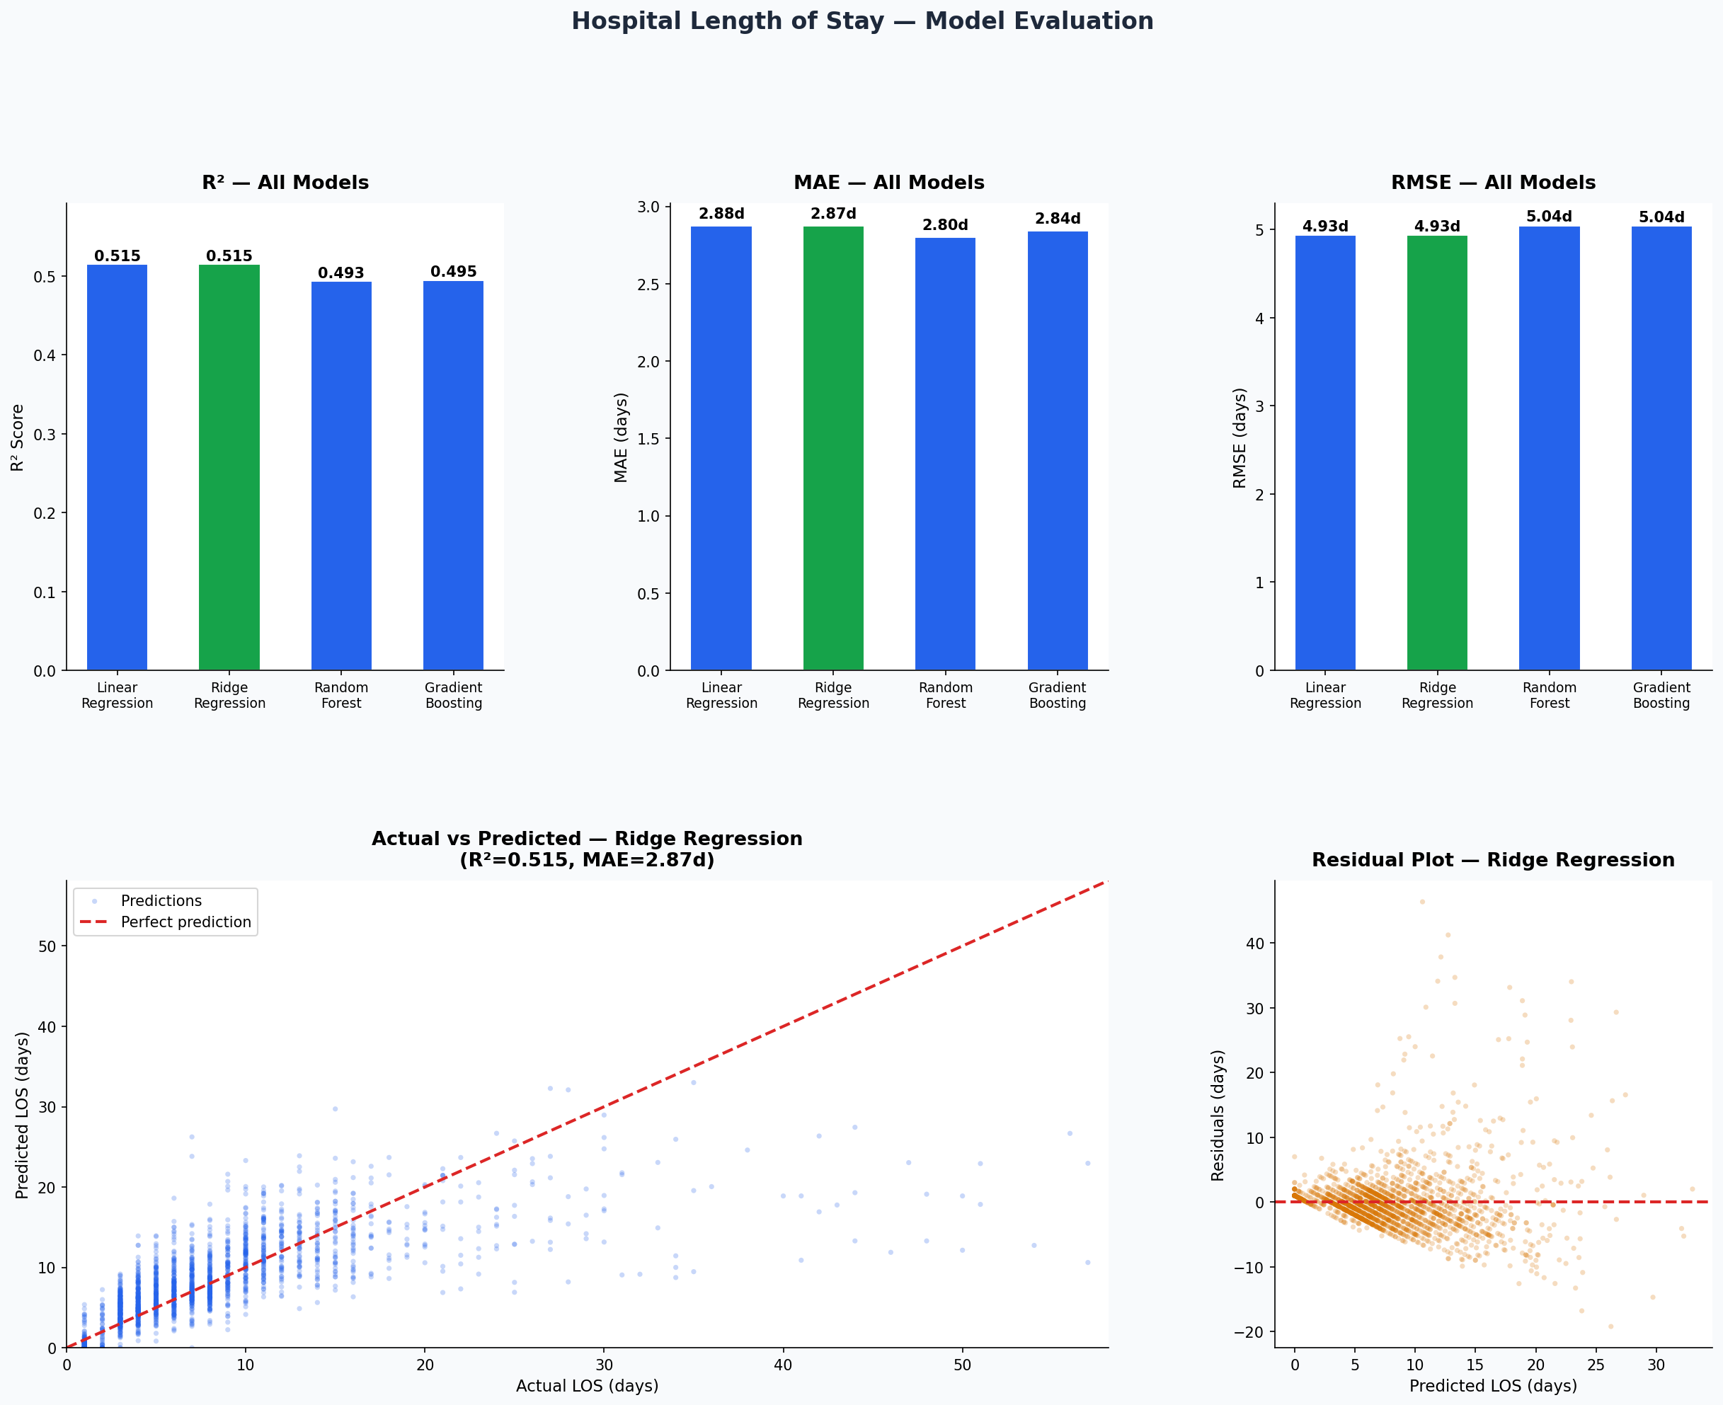
Figure 2. Model comparison (R², MAE, RMSE), actual vs predicted plot, and residual analysis for Ridge Regression.

5.3 Residual Analysis
The residual plot (Figure 2, bottom right) shows residuals scattered around zero across the predicted-value range, which is a desirable pattern indicating no major systematic bias. However, variance in residuals increases slightly at higher predicted values, suggesting the model is less precise for longer stays — an expected finding given the right-skewed target distribution.

6. Feature Importance
Feature importances were extracted from the Random Forest model, which assigns each feature an importance score based on how much it reduces impurity (mean squared error in regression) across all trees.

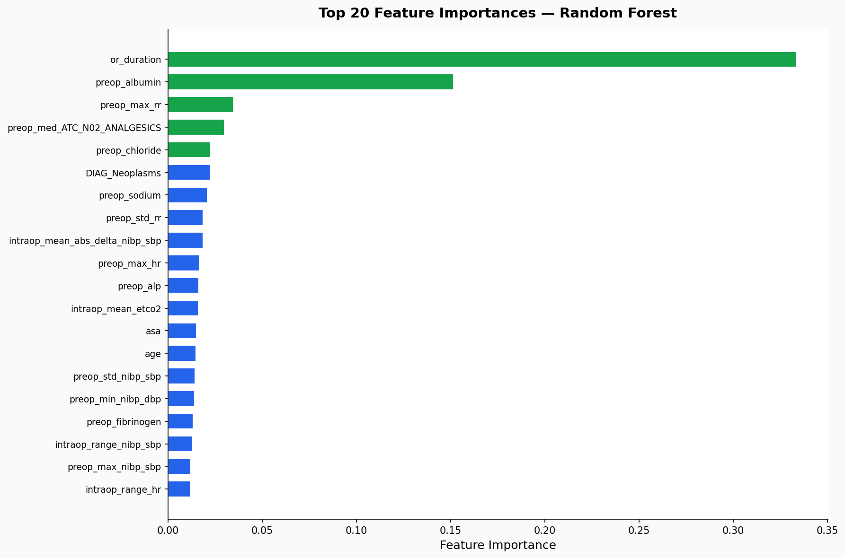
Figure 3. Top 20 feature importances from the Random Forest model.
The most predictive features include:
- or_duration (operating room duration): surgery length is the single strongest predictor of post-operative LOS, as longer operations indicate greater complexity.
- age: older patients typically have longer recoveries and higher complication rates.
- asa (ASA physical status score): a widely-used preoperative risk classifier; higher ASA scores correspond to greater pre-existing illness severity.
- intraop_mean_abs_delta_nibp_sbp and related intra-operative blood pressure variability features: haemodynamic instability during surgery is linked to worse outcomes.
- Diagnosis groups (DIAG_Musculoskeletal, DIAG_Neoplasms): cancer patients and complex orthopaedic cases tend to have longer admissions.

7. Conclusions & Recommendations

7.1 Summary
A complete machine learning pipeline was successfully built and evaluated for hospital length-of-stay prediction. Key results:
- The best model (Ridge Regression) explained 51.5% of variance in LOS (R² = 0.515) with a mean absolute error of 2.87 days.
- Surgical duration, patient age, ASA score, and intra-operative haemodynamic stability were the strongest predictors.
- All models generalised well to the held-out test set with no signs of severe overfitting.

7.2 Limitations
- High missing rates: several clinically important lab values (fibrinogen, BUN, albumin) were missing for >50% of patients, limiting their contribution to models.
- Moderate R²: approximately 48% of LOS variance remains unexplained, likely due to factors not captured in the dataset such as post-operative complications, discharge decisions, or social factors.
- Outlier sensitivity: extreme LOS values were removed to improve model stability, which means predictions may not generalise well to very complex cases.

7.3 Recommendations
- Collect more complete lab data, particularly pre-operative albumin and renal function markers, which are known clinical predictors of LOS.
- Explore log-transformation of the target variable (los_days) or quantile regression to better handle the skewed distribution.
- Consider adding post-operative features (if available at admission time) such as ICU admission or complication flags.
- Test gradient boosting with extended hyperparameter tuning (learning rate, tree depth, subsampling) — tree models may outperform linear models once optimised.
- Evaluate clinical utility: a 2.87-day MAE may be acceptable for bed planning but requires validation with clinical stakeholders.

