**Ma323-LAB 09**

**Name**: Harsh Yadav **Roll. No.**: 180123015 **Dept.**: Mathematics and Computing

**Submission Date**: 11-11-2020

This Lab assignment was done by using the values of = 0.0002981060700200021 and

and S(0)=185.399994 as calculated in Lab 7.

For simulating the BSM model with the ratio of asset price after and before a jump should follow the log-normal distribution LN( ,), I have used the first approach i.e. Simulating the dates to generate the path of stock prices S(t).

The stock prices S(t) were generated for N ~ Poisson () for = 0.1.

Mean and variance of the price of avg price Asian put option calculated without using control variate with the payoff formula given in the lab assignment, and are tabulated below:

|  |  |
| --- | --- |
| (sampling mean) | (sampling variance) |
| 21.524791304962715 | 623.9950622528808 |

The calculated 95% Confidence interval is: [ -17.15082334522346, 60.200405955148895]

Mean and variance of the same avg price Asian put option calculated by using the price of an European put option as the control variate are tabulated below:

|  |  |
| --- | --- |
|  |  |
| 21.524791304962715 | 214.19639211420284 |

Note:

* After introducing the control variate the variance decreases from 623.9950622528808 to 214.19639211420284.
* It can be seen that even after introducing the control variate the remains same which shows that the control variate (European put option price) is an unbiased estimator.

The output of the code can be seen below:

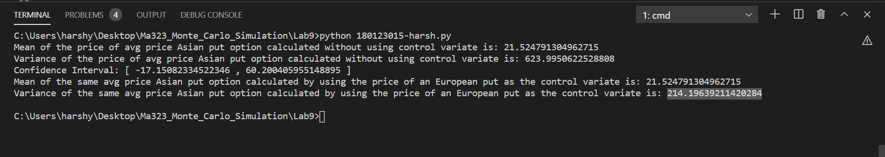

Reference for data: https://finance.yahoo.com/quote/SBIN.NS/history/