**Ma323-LAB 08**

**Name**: Harsh Yadav **Roll. No.**: 180123015 **Dept.**: Mathematics and Computing

**Submission Date**: 01-11-2020

This Lab assignment was done by using the values of $μ$ = 0.0002981060700200021 and

$σ^{2}=0.000496475360718651$ and S(0)=185.399994 as calculated in Lab 7. For simulating the jump diffusion model with given condition that the ratio of asset price after and before a jump should follow the log-normal distribution LN( $μ$, $σ^{2}$), I have used the first approach i.e. **Simulating the dates** to generate the path of stock prices S(t).

The path of stock prices S(t) for N ~ Poisson ($λ$) for given $λ$ values as [0.01, 0.05, 0.1, 0.2] are shown below:

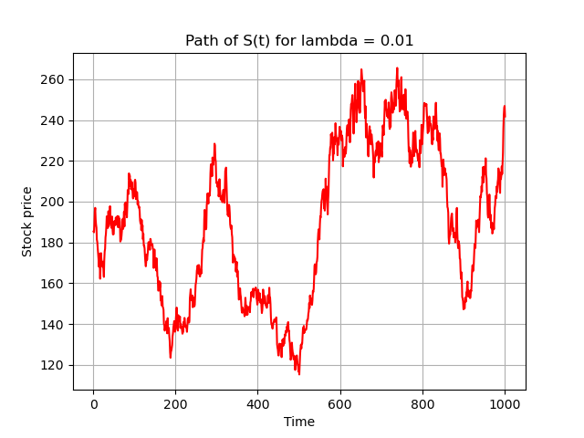

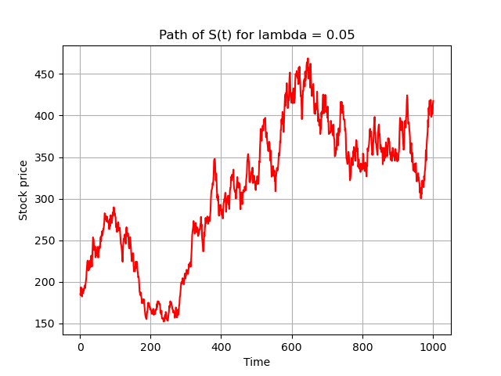

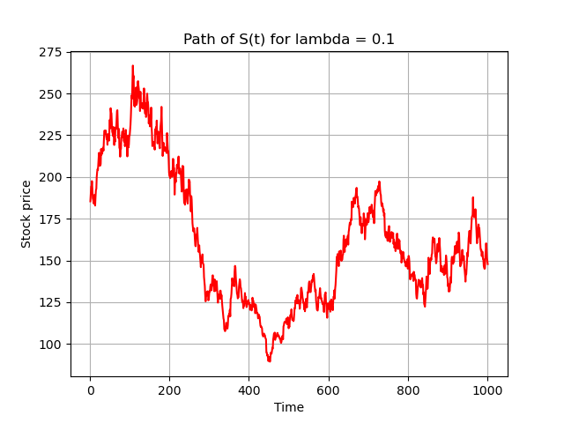

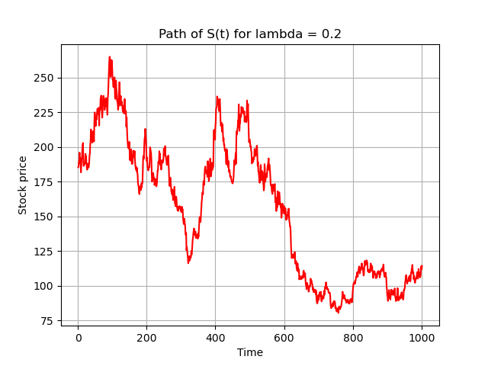

**Note**: These outputs can vary with time as they are subject to randomness generated by Normal and Poisson processes used in simulating the model.

Reference for data: https://finance.yahoo.com/quote/SBIN.NS/history/