Homework 1 - Alteryx
Accounting Analytics 5559
Henry Laudano
9/22/2026

Exploratory Analysis

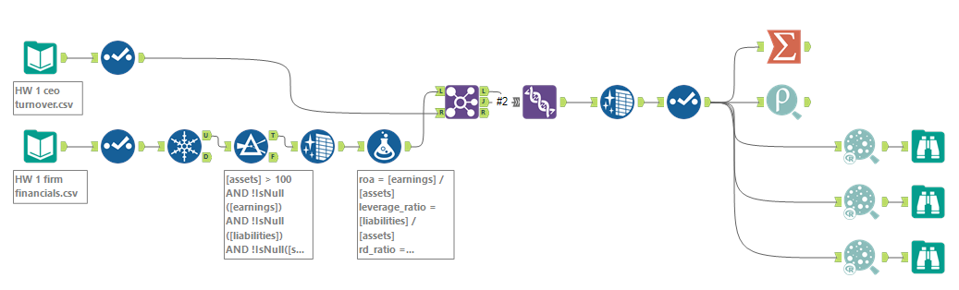

- Averages & Correlations


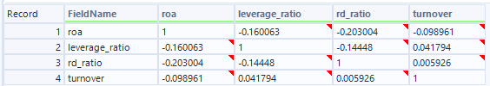

The averages suggest that firms with CEO turnover have, on average, a lower return on assets (−0.032 vs. 0.042), a higher leverage ratio (0.627 vs. 0.558), and a relatively similar R&D to assets ratio (0.032 vs. 0.030). This is supported by the correlations with turnover, which are slightly negative (r = −0.099), slightly positive (r = 0.042), and less than 0.01 (r = 0.006) for return on assets, leverage, and R&D, respectively.

- Scatterplots

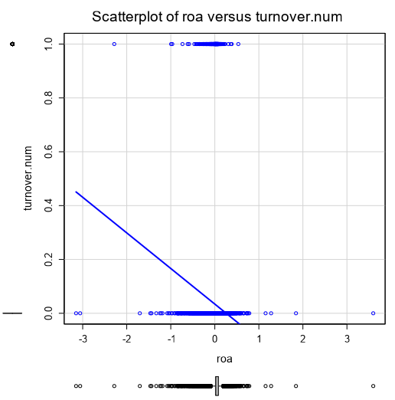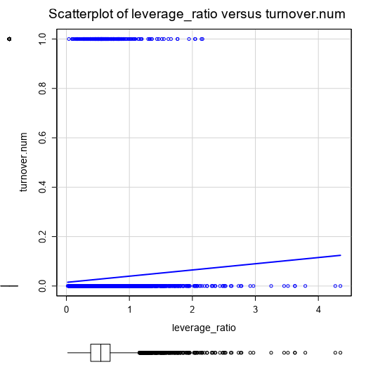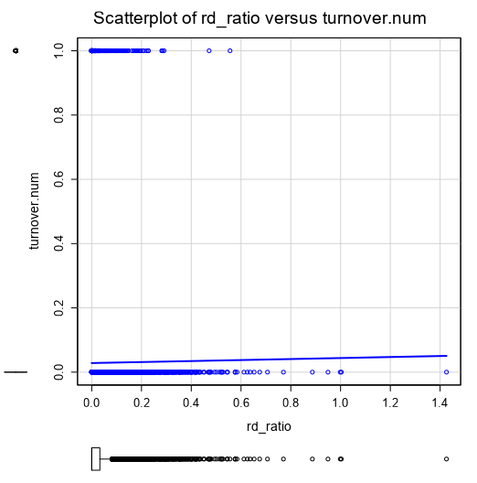

Such correlations are not visualized very well in the scatterplots, because they are binary – these relationships can be investigated further using statistical analysis.

Statistical Analysis

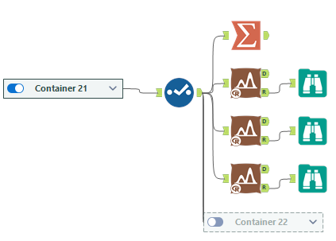

- Test of Means

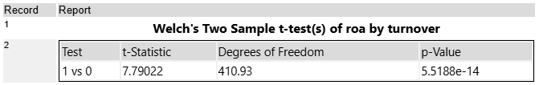

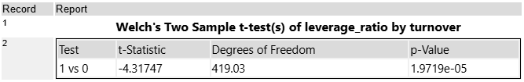

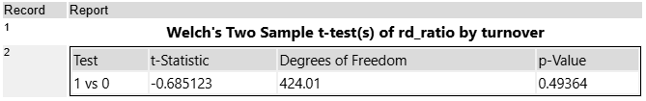

The two-sample t-tests confirm the trend shown from the averages, where both return on assets (t = 7.79, p < .001) and leverage ratio (t = −4.32, p < .001) have p values < .01, showing a lower average return on assets when there is turnover, and a higher average leverage ratio. The R&D ratio difference in the two means was insignificant (t = −0.69, p = .494).

Predictive Analysis

- Logistic Regression

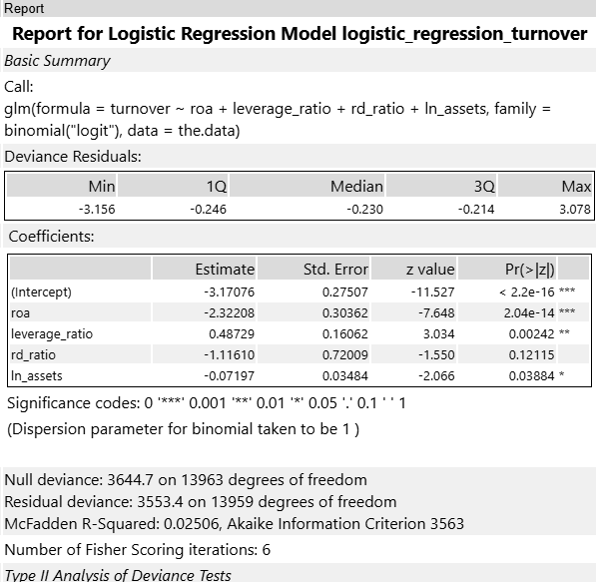

The directional estimates of the coefficients and their significance line up with the exploratory and statistical analysis done earlier, with the significant relationships of return on assets having a negative relationship with turnover (β = −2.32, z = −7.65, p < .001) and leverage ratio having a positive one (β = 0.49, z = 3.03, p = .002). R&D ratio was not a significant predictor (β = −1.12, z = −1.55, p = .121). The new predictor, ln(assets), was a significant negative predictor (β = −0.07, z = −2.07, p = .039), added as another predictor suggesting that larger firms have less CEO turnover, holding the other variables constant.

Intuitively, this makes sense – struggling or poorly returning firms would likely fire their CEOs, and return on assets is a good measure of this performance. These struggling firms might be more in financial distress, reflecting the leverage ratio relationship. Larger firms might be more successful with higher-quality CEOs, reflecting a lower need for them to be fired. Finally, R&D ratio is likely just an indicator of different business models, suggesting no relationship there.

- Neural Network Model Comparison

Both models have essentially the same high performance (neural network very marginally higher accuracy, 97.12% vs. 97.10%). The logistic regression model has a higher F1 (0.005 vs. null) whereas the neural network has a higher AUC (0.696 vs. 0.667).

- Prediction vs. Averages

Since the neural network had both higher accuracy and a higher AUC, it was selected as the better-performing model and used for the prediction. The predicted turnover probability from the neural network was 13.3%, which is higher than the average turnover of 2.9%.

Based on this finding, yes, the CEO should be worried about their job, as their risk of being fired is higher. I would recommend the CEO both work on bringing the company to profitability (raise the ROA) and to de-lever as priorities based on this model, but it is important to note these models are observational and do not indicate causation.

