Homework 2 - Alteryx
Accounting Analytics 5559
Henry Laudano
9/28/2026

Analysis 1

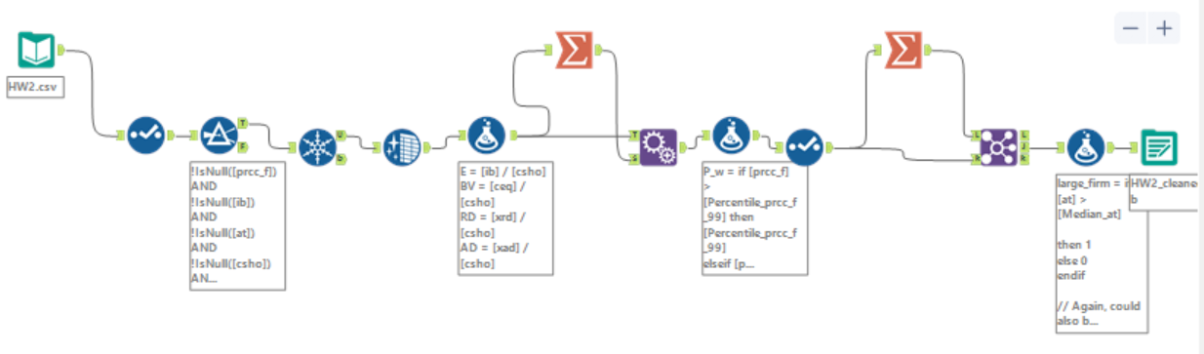

This is the data cleaner used on the canvas Compustat data.

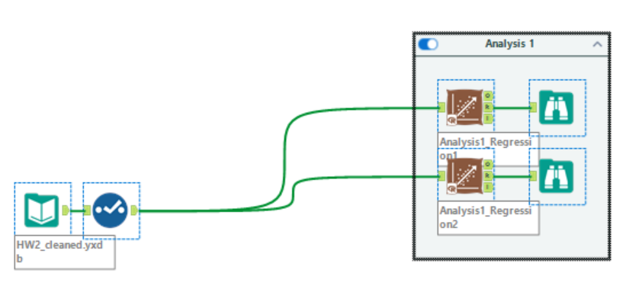

This is the workflow used for analysis 1, and below are the regression reports.

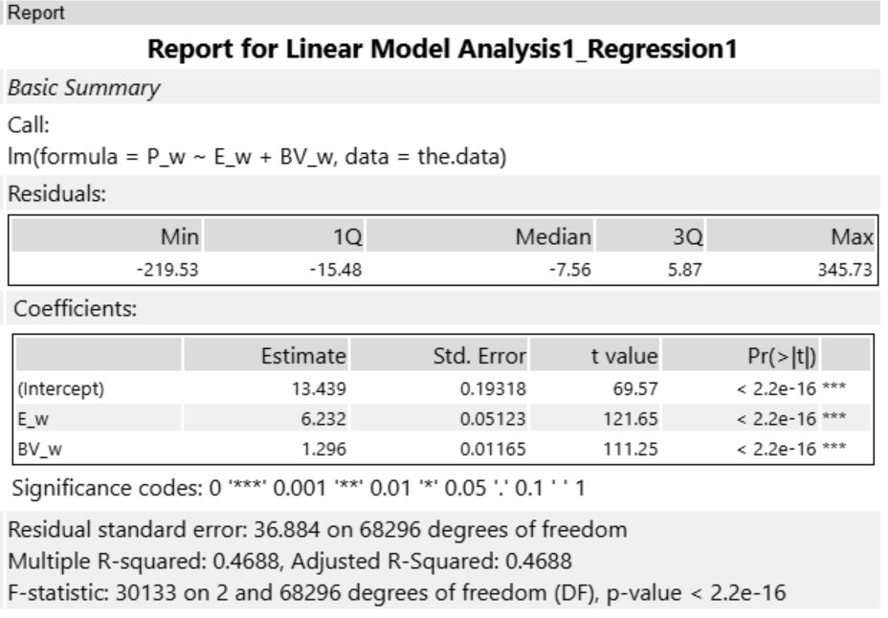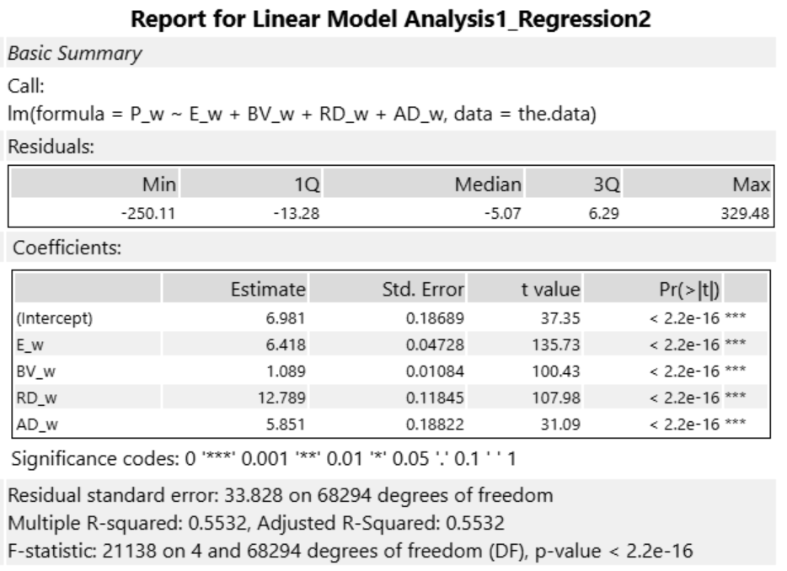

Both regressions are significant overall across ~70k firm-years (Regression 1: F(2, 68296) = 30,133, p < .001; Regression 2: F(4, 68294) = 21,138, p < .001), and every coefficient is positive and significant. In Regression 1, $1 of earnings per share is associated with a $6.23 higher stock price (β = 6.23, t = 121.65, p < .001), and each $1 of book value per share with a $1.30 higher price (β = 1.30, t = 111.25, p < .001). In Regression 2, R&D per share (β = 12.79, t = 107.98, p < .001) and advertising per share (β = 5.85, t = 31.09, p < .001) are also priced positively, even though both are expensed and lower reported earnings. This suggests investors treat that spending as an investment in future earnings growth. The earnings coefficient also rises slightly once R&D and advertising are controlled for (β = 6.42, t = 135.73, p < .001), likely because expensing R&D understates earnings for R&D-heavy firms.

Overall, the accounting items are value-relevant. Earnings and book value alone explain about 47% of the variation in stock prices (R² = .469, adjusted R² = .469), which is high for a sample covering 25 years and many industries. Adding R&D and advertising raises this to about 55% (R² = .553, adjusted R² = .553).

Analysis 2

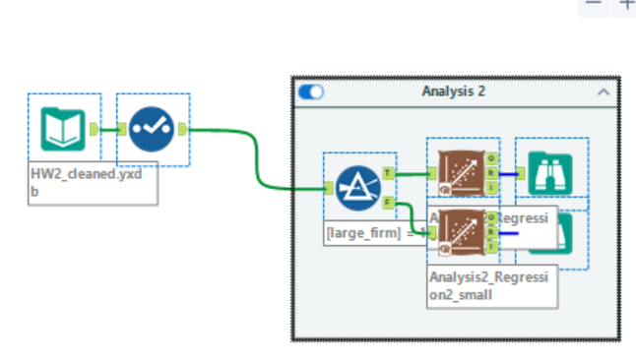

This is the workflow used for analysis 2, and below are the regression reports.

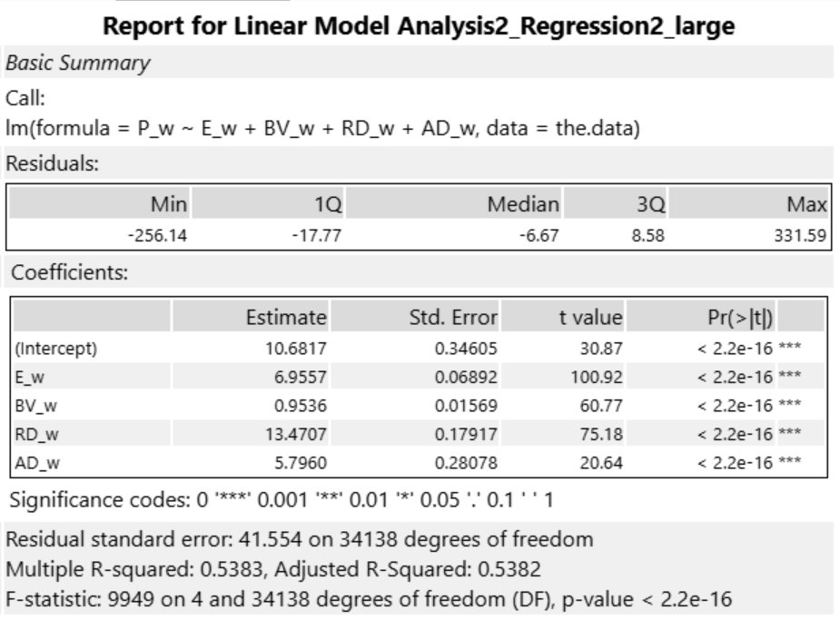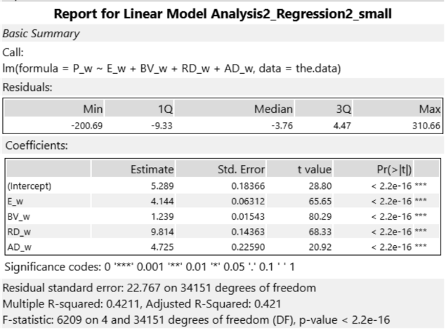

Regression 2 is significant for both large firms (F(4, 34138) = 9,949, p < .001) and small firms (F(4, 34151) = 6,209, p < .001), and every coefficient is positive and significant at p < .001 in both groups, so accounting information is value-relevant for both. However, it is more value-relevant for large firms, where the model explains about 54% of the variation in stock prices (R² = .538, adjusted R² = .538) compared to 42% for small firms (R² = .421, adjusted R² = .421). Large firms' prices also respond more to each dollar of earnings (large: β = 6.96, t = 100.92; small: β = 4.14, t = 65.65), R&D (large: β = 13.47, t = 75.18; small: β = 9.81, t = 68.33), and advertising (large: β = 5.80, t = 20.64; small: β = 4.73, t = 20.92), but this may be due to liquidity reasons. Book value carries more weight for small firms (large: β = 0.95, t = 60.77; small: β = 1.24, t = 80.29), perhaps because small firms report losses more often, so investors lean more on the balance sheet.

Overall though, for relative explanability, I think this is because large firms tend to have more stable, recurring earnings, so current earnings are a better signal of future cash flows. They also get more analyst and institutional coverage, so their prices track accounting information more closely.

Analysis 3

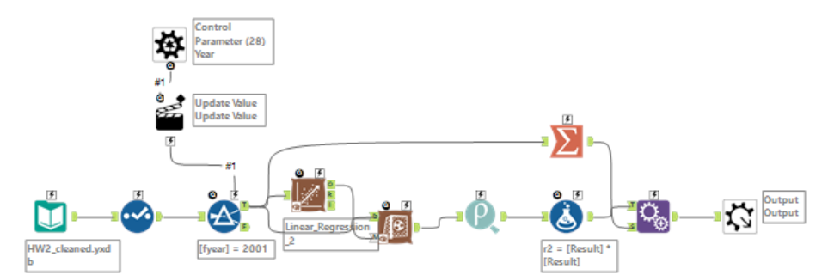

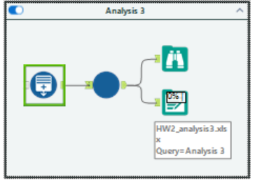

This is the macro for analysis 3 and the corresponding workflow to run it. Below is a line chart with a trendline of the resulting calcualted R⁻² values for each year’s regression model.

Accounting information has not lost its value relevance in recent years based on this analysis. The trendline shows a slight increase, from about .51 in 2001 to about .61 in 2025, and the most recent years (2023–2025) are among the highest in the sample. Value relevance does drop in recession years (about .48 in 2008 and .50 in 2020) but recovers within one to two years. In recessions, prices move more on uncertainty about the future, and/or one-time losses and write-downs make current earnings a weaker signal of long-run value.

