Hlavka DVD Database

Capstone Project Proposal

Justina L. Hlavka

17 NOV 2018

CIT 255 / Fall 2018 Semester

Professor – John Velis

TOC

Overview 3

User Stories 3

Entity Diagram 4

Wireframes 5

Development Environment 6

# Overview

*"Have you ever by the massive amount of DVD’s, CD’s, Video Games or Digital Content you have and wished you could organize it better, the way you want it organized?*

*Well, I media databases the give you the freedom to organize your data and media into an easy to read format. The clients I work with generally understand the value of organization and are ready to acquire a system to make their lives easier. We can track all types of media, such as DVD’s, CD’s, Digital Music, Video Games, VHS Tapes, Cassette Tapes, 8 Tracks, Vinyl Albums, Etc. Basically we can input any of your media collections and make sure that they are organized and up to date.*

*I consult media heavy clients and business owners on how use this new database program and keep it up to data with new incoming content. I'm in a unique position to help my clients because I've faced the same struggle of having so much content that I can no longer keep track of it in my head.*

*I'd love the opportunity to schedule a time to talk more about some of digital content and type of information that you’d like to store about that content, and explore how we may be able to work together."*

# User Stories

Hlavka DVD Database Program

|  |  |  |
| --- | --- | --- |
| As a/an… | I want to… | So that… |
| User | I want to be able to causally scroll through my DVD’s without having to inundated with information. Mainly just the title and maybe a year so that I know if its an original or a remake. | So that I can quickly scroll through the DVD list |
| User | If I see a DVD that I want to watch I’d like to be able to bring up all DVD details, such a length, if is a squeal or not and main actor along with the original info of DVD title and year. | So that I can make a educated DVD viewing decision |
| User | I want to be able to Exit the DVD Details screen. | So that I can go back to the main form |
| User | I want to be able to Exit the Main Form screen. | So that I can exit the program |

# Entity Diagram

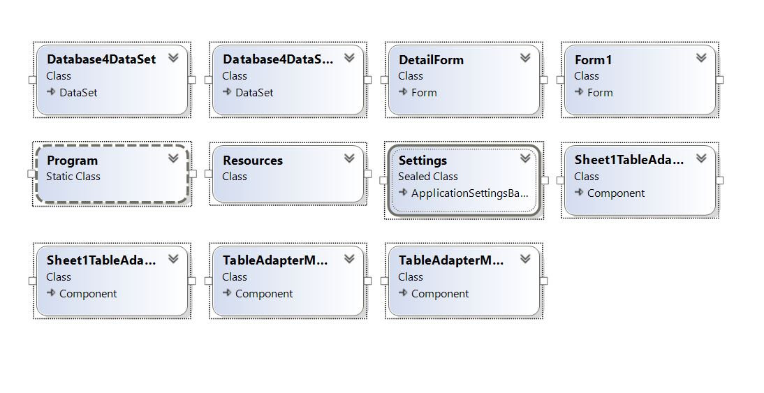

# 

# Wireframes

Wireframe of the Main screen

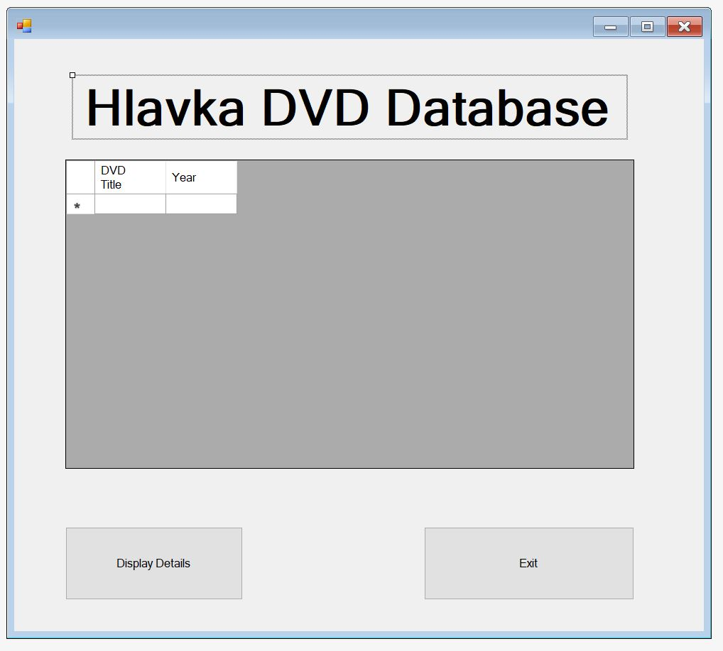

Wireframe of the Details screen

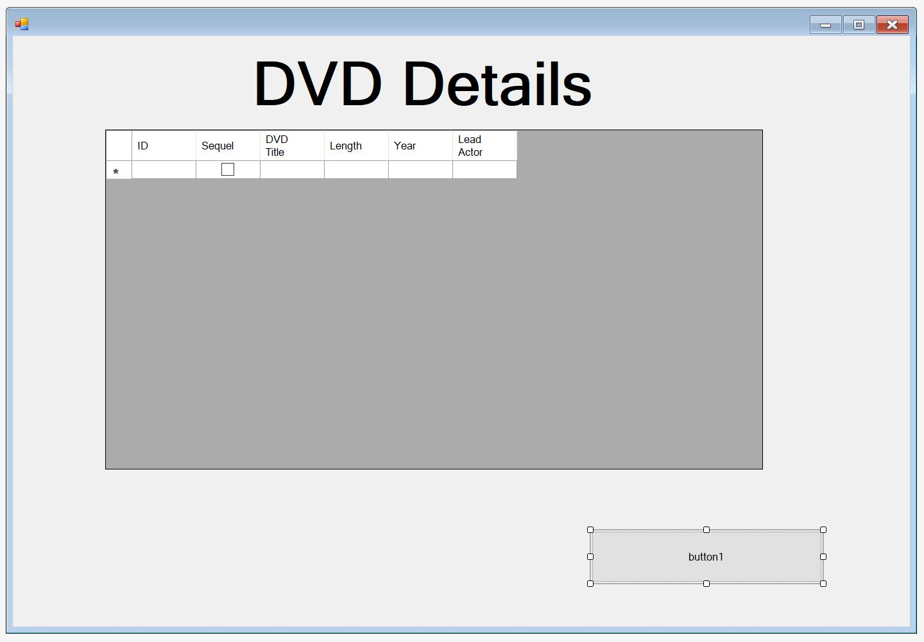

# Development Environment

1. Development Environment – My project will be put together in the only coding environment we have worked with here at NMC. Visual Studio.
2. Description of Persistence – I will be using a database type persistence that is imported from Microsoft Access.
3. Location of Persistence – The database will be saved into the project locally in an .accdb file.
4. Design Pattern - I intend to make a multipage project
5. Target Platform - I intend to write a WinForms application.
6. Discussion of the Development Pattern- I will be operating on a Domain Driven Design.