Table 3. Statistical significance (indicated by bold type) of slope coefficients for the predictor variables (year [YR], landscape-scale harvest intensity [LSHI], their interaction [YR×LSHI], elevation [EL], aspect [ASP] squared [ASP2], topographic position index [TPI], stand age [AGE] squared [AGE2], proportion of all forest [PAF] / shrub cover [PS] / deciduous forest [PDF] / conifer forest [PCF] within 50 m, proportion of all forest [PAFkm] / shrub cover [PSkm] within 1 km, and landscape patch richness [LPR] / mean core forest patches [MCFP] / forest patch density [FPD] / open habitat patch density [OHPD] / total forest edge [TFE] within 1 km) corresponding to overall species richness (ALL), guild (early-successional / edge-associated [ESEA], forest-interior [INT], forest-gap [GAP], and forest generalist [GEN]) richness, and focal songbird species abundance (see Table 1 for species codes).

|  |  |  |  |  |  |  |  |  |  |  |  |
| --- | --- | --- | --- | --- | --- | --- | --- | --- | --- | --- | --- |
| **Response** | **YR** | **LSHI** | **YR×LSHI** | **EL** | **ASP** | **ASP2** | **TPI** | **AGE** | **AGE2** | **PAF** | **PS** |
| ALL | **-0.021** | **0.170** | **0.074** | **-0.221** | **-0.031** | **-0.020** | 0.010 | -0.004 | **0.012** | **0.046** | **0.017** |
| ESEA | -0.023 | **0.300** | **0.183** | **-0.542** | -0.023 | -0.044 | 0.003 | -0.042 | **0.031** | -0.032 | **0.024** |
| BHCO | **-0.371** | -0.266 | 0.131 | **-0.608** | -0.147 | **-0.314** | -0.076 | 0.105 | 0.072 | **-0.301** | -0.076 |
| CSWA | **-0.386** | **1.402** | **0.482** | -0.156 | 0.122 | -0.041 | -0.113 | -0.072 | 0.053 | **-0.302** | **0.091** |
| EATO | **0.409** | **1.492** | 0.236 | **-0.398** | -0.066 | -0.120 | 0.073 | **-0.200** | -0.011 | **-0.297** | 0.007 |
| INBU | 0.015 | **0.752** | 0.388 | **-0.684** | -0.080 | -0.090 | 0.054 | -0.149 | 0.080 | **-0.473** | -0.037 |
| INT | **-0.034** | **0.188** | 0.011 | **-0.092** | **-0.028** | -0.010 | 0.001 | **0.016** | 0.002 | **0.062** | -0.002 |
| BTNW | **-0.226** | **0.640** | **0.379** | **0.263** | **-0.074** | 0.020 | 0.040 | 0.002 | -0.020 | 0.037 | -0.010 |
| DEJU | **-0.286** | **2.029** | **0.782** | **0.574** | -0.016 | **0.113** | **-0.071** | **0.088** | 0.027 | 0.007 | 0.001 |
| REVI | **-0.286** | **0.381** | **0.392** | **-0.229** | 0.035 | -0.001 | 0.010 | **-0.056** | -0.020 | -0.054 | 0.012 |
| WOTH | -0.086 | -0.264 | -0.135 | **-0.876** | 0.006 | -0.069 | -0.003 | 0.026 | -0.041 | **-0.275** | **-0.215** |
| GAP | **-0.099** | **0.266** | **0.199** | **-0.499** | 0.010 | **-0.045** | 0.000 | -0.017 | **0.026** | **0.157** | **0.025** |
| AMRE | **-0.259** | -0.721 | **0.681** | **-0.623** | -0.047 | 0.045 | -0.009 | 0.004 | 0.027 | -0.114 | 0.014 |
| CERW | -0.166 | **-1.914** | -0.509 | -0.288 | -0.070 | 0.145 | 0.141 | 0.159 | -0.068 | **0.520** | -0.192 |
| HOWA | -0.170 | **0.855** | **0.788** | **-0.787** | 0.087 | -0.149 | -0.018 | 0.020 | 0.031 | 0.021 | 0.058 |
| VEER | **-0.326** | **1.974** | 0.279 | 0.060 | **0.111** | 0.062 | -0.003 | -0.058 | 0.036 | 0.059 | 0.029 |
| GEN | **0.039** | 0.016 | **0.124** | **-0.325** | **-0.068** | -0.023 | **0.052** | -0.016 | 0.012 | -0.019 | -0.010 |
| AMRO | 0.090 | **1.053** | 0.326 | -0.084 | 0.032 | 0.069 | 0.043 | -0.013 | 0.027 | **-0.303** | -0.036 |
| BCCH | **-0.244** | **0.817** | **0.559** | -0.011 | -0.065 | -0.011 | **0.102** | -0.059 | **0.053** | 0.121 | -0.040 |
| WBNU | 0.083 | 0.125 | 0.051 | **-0.337** | -0.039 | -0.089 | **0.156** | 0.071 | -0.007 | **-0.432** | -0.009 |

Table 3. Continued.

|  |  |  |  |  |  |  |  |  |  |
| --- | --- | --- | --- | --- | --- | --- | --- | --- | --- |
| **Response** | **PDF** | **PCF** | **PAFkm** | **PSkm** | **LPR** | **MCFP** | **FPD** | **OHPF** | **TFE** |
| ALL | **-0.096** | -0.011 | -0.012 | 0.016 | **0.041** | **-0.019** | -0.009 | **0.023** | **-0.050** |
| ESEA | **-0.468** | -0.041 | **-0.076** | **0.076** | **0.076** | -0.041 | -0.018 | **0.106** | **-0.168** |
| BHCO | **0.387** | **-1.066** | -0.121 | **0.384** | 0.211 | -0.024 | -0.063 | -0.093 | -0.256 |
| CSWA | **0.366** | -0.019 | 0.225 | 0.117 | -0.009 | -0.097 | -0.148 | 0.134 | 0.284 |
| EATO | 0.195 | -0.020 | **0.249** | 0.097 | 0.096 | 0.051 | 0.000 | 0.128 | 0.037 |
| INBU | **0.502** | 0.077 | -0.197 | 0.035 | **0.170** | 0.028 | -0.102 | 0.015 | -0.208 |
| INT | 0.040 | 0.008 | **0.032** | 0.014 | 0.013 | **-0.020** | **-0.038** | -0.003 | **0.029** |
| BTNW | **0.110** | **-0.128** | **0.211** | 0.052 | **-0.086** | -0.047 | -0.076 | **-0.102** | **0.236** |
| DEJU | **-0.158** | **-0.072** | 0.046 | **-0.097** | 0.012 | 0.047 | 0.045 | -0.043 | 0.065 |
| REVI | **0.264** | **-0.236** | **0.146** | 0.029 | 0.031 | 0.022 | 0.059 | **-0.065** | 0.021 |
| WOTH | **0.312** | -0.060 | 0.156 | **0.309** | 0.041 | 0.070 | 0.010 | -0.072 | 0.004 |
| GAP | **-0.398** | **-0.121** | 0.007 | **0.039** | **0.061** | -0.025 | -0.019 | -0.027 | -0.027 |
| AMRE | **0.592** | -0.026 | **0.321** | **0.378** | **0.156** | **0.176** | -0.012 | -0.093 | -0.062 |
| CERW | **0.427** | 0.168 | 0.470 | -0.010 | **0.444** | -0.019 | 0.081 | 0.181 | -0.164 |
| HOWA | 0.116 | -0.150 | 0.179 | -0.004 | -0.032 | -0.028 | -0.088 | **0.224** | 0.021 |
| VEER | **0.176** | -0.121 | 0.153 | 0.037 | -0.103 | -0.075 | 0.008 | **-0.210** | **0.332** |
| GEN | **-0.297** | **-0.087** | **-0.069** | **-0.070** | **0.103** | -0.001 | **0.055** | **0.073** | **-0.213** |
| AMRO | **0.221** | -0.028 | 0.085 | -0.119 | -0.005 | -0.060 | **0.197** | 0.092 | 0.020 |
| BCCH | **-0.284** | -0.055 | -0.145 | **-0.202** | -0.062 | 0.075 | 0.075 | 0.044 | **-0.284** |
| WBNU | **0.568** | 0.031 | 0.080 | -0.092 | 0.116 | 0.114 | **0.209** | -0.044 | **-0.270** |

Table 4. Statistical significance (indicated by bold type) of slope coefficients for the predictor variables (year [YR], landscape-scale harvest intensity [LSHI], interaction [YR×LSHI] between year and landscape-scale harvest intensity, harvest history [HH] of nest search plot, and nest search plot located in mature forest [MF]) corresponding to the probability of nest success during the incubation and brooding periods. Focal species (see Table 1 for species codes) are arranged by habitat-related guild designation (early-successional / edge-associated [ESEA], forest-interior [INT], and forest-gap [GAP]).

|  |  |  |  |  |  |  |  |  |  |  |  |
| --- | --- | --- | --- | --- | --- | --- | --- | --- | --- | --- | --- |
| **Species** | **Guild** | **Incubation Period** | | | | | **Brooding Period** | | | | |
| **YR** | **LSHI** | **YR×LSHI** | **HH** | **MF** | **YR** | **LSHI** | **YR×LSHI** | **HH** | **MF** |
| EATO | ESEA | 0.217 | -0.773 | -0.501 | 0.785 | -1.402 | 1.458 | -1.347 | -2.006 | 1.528 | 0.446 |
| INBU | ESEA | 2.211 | -0.330 | **-3.336** | 1.476 | -1.150 | -2.766 | 1.886 | 4.840 | 1.047 | 1.577 |
| DEJU | INT | -1.391 | 1.516 | 1.560 | 0.893 | 0.360 | -4.751 | 0.050 | 4.700 | 0.631 | 1.194 |
| REVI | INT | -1.150 | -0.692 | 1.888 | -0.518 | 0.043 | -0.459 | -2.115 | 1.647 | -0.266 | -0.025 |
| WOTH | INT | 0.081 | **-1.099** | -0.968 | 0.434 | -0.415 | -0.748 | 1.184 | 2.320 | **-1.427** | -0.797 |
| VEER | GAP | -0.548 | -0.100 | 0.539 | -0.664 | -0.744 | 1.022 | -0.469 | -4.535 | 4.768 | -2.662 |

Table 5. Statistical significance (indicated by bold type) of the annual effective slope coefficients for landscape-scale harvest intensity on overall species richness (ALL), guild (early-successional / edge-associated [ESEA], forest-interior [INT], forest-gap [GAP], and forest generalist [GEN]) richness, focal songbird species abundance (see Table 1 for species codes), and focal songbird species nest success corresponding to each year in the study period. Model type is denoted such that GR = guild richness, FSA = focal species abundance, FSNS-I = focal species nest success during the incubation period, and FSNS-B = focal species nest success during the brooding period.

|  |  |  |  |  |  |  |  |  |  |
| --- | --- | --- | --- | --- | --- | --- | --- | --- | --- |
| **Response** | **Model** | **1993** | **1994** | **1995** | **1996** | **1997** | **1998** | **1999** | **2000** |
| ALL | GR | --- | --- | --- | **0.079** | **0.096** | **0.112** | **0.128** | **0.144** |
| ESEA | GR | --- | --- | --- | 0.074 | **0.114** | **0.154** | **0.195** | **0.235** |
| BHCO | FSA | --- | --- | --- | -0.428 | -0.399 | -0.370 | -0.342 | -0.313 |
| CSWA | FSA | --- | --- | --- | **0.807** | **0.913** | **1.018** | **1.124** | **1.229** |
| EATO | FSA | --- | --- | --- | **1.200** | **1.252** | **1.304** | **1.356** | **1.407** |
|  | FSNS-I | -0.110 | -0.246 | -0.382 | -0.518 | -0.654 | -0.790 | -0.925 | -1.061 |
|  | FSNS-B | 1.306 | 0.763 | 0.219 | -0.324 | -0.868 | -1.411 | -1.955 | -2.499 |
| INBU | FSA | --- | --- | --- | 0.273 | 0.358 | 0.443 | 0.528 | **0.613** |
|  | FSNS-I | **4.084** | 3.180 | 2.275 | 1.371 | 0.467 | -0.437 | -1.341 | -2.245 |
|  | FSNS-B | -4.516 | -3.205 | -1.893 | -0.582 | 0.730 | 2.042 | 3.353 | 4.665 |
| INT | GR | --- | --- | --- | **0.174** | **0.177** | **0.179** | **0.182** | **0.184** |
| BTNW | FSA | --- | --- | --- | 0.172 | 0.255 | **0.338** | **0.421** | **0.504** |
| DEJU | FSA | --- | --- | --- | **1.063** | **1.234** | **1.405** | **1.577** | **1.748** |
|  | FSNS-I | -0.547 | -0.124 | 0.298 | 0.721 | 1.144 | 1.567 | 1.989 | 2.412 |
|  | FSNS-B | -6.168 | -4.894 | -3.620 | -2.346 | -1.073 | 0.201 | 1.475 | 2.749 |
| REVI | FSA | --- | --- | --- | -0.103 | -0.017 | 0.069 | 0.155 | **0.240** |
|  | FSNS-I | **-3.189** | **-2.677** | -2.166 | -1.654 | -1.143 | -0.631 | -0.119 | 0.392 |
|  | FSNS-B | -4.294 | -3.848 | -3.401 | -2.955 | -2.508 | -2.062 | -1.616 | -1.169 |
| WOTH | FSA | --- | --- | --- | -0.097 | -0.127 | -0.156 | -0.186 | -0.216 |
|  | FSNS-I | 0.181 | -0.081 | -0.343 | -0.606 | -0.868 | **-1.130** | **-1.393** | **-1.655** |
|  | FSNS-B | -1.886 | -1.257 | -0.628 | 0.001 | 0.630 | 1.259 | 1.887 | 2.516 |
| GAP | GR | --- | --- | --- | 0.021 | 0.064 | **0.108** | **0.152** | **0.195** |
| AMRE | FSA | --- | --- | --- | **-1.561** | **-1.412** | **-1.263** | **-1.114** | **-0.965** |
| CERW | FSA | --- | --- | --- | -1.285 | -1.397 | **-1.508** | **-1.620** | **-1.732** |
| HOWA | FSA | --- | --- | --- | -0.119 | 0.054 | 0.227 | 0.399 | **0.572** |
| VEER | FSA | --- | --- | --- | **1.630** | **1.691** | **1.752** | **1.813** | **1.874** |
|  | FSNS-I | -0.813 | -0.667 | -0.521 | -0.375 | -0.229 | -0.082 | 0.064 | 0.210 |
|  | FSNS-B | 5.529 | 4.300 | 3.071 | 1.842 | 0.614 | -0.615 | -1.844 | -3.073 |
| GEN | GR | --- | --- | --- | **-0.137** | -0.110 | -0.082 | -0.055 | -0.028 |
| AMRO | FSA | --- | --- | --- | 0.651 | 0.722 | **0.794** | **0.865** | **0.936** |
| BCCH | FSA | --- | --- | --- | 0.126 | 0.249 | 0.371 | **0.494** | **0.616** |
| WBNU | FSA | --- | --- | --- | 0.062 | 0.073 | 0.084 | 0.096 | 0.107 |

Table 5. Continued.

|  |  |  |  |  |  |  |  |  |  |  |
| --- | --- | --- | --- | --- | --- | --- | --- | --- | --- | --- |
| **Response** | **Model** | **2001** | **2002** | **2003** | **2004** | **2005** | **2006** | **2007** | **2008** | **2009** |
| ALL | GR | **0.160** | **0.176** | **0.193** | **0.209** | **0.225** | **0.241** | **0.257** | **0.273** | **0.290** |
| ESEA | GR | **0.275** | **0.315** | **0.355** | **0.395** | **0.436** | **0.476** | **0.516** | **0.556** | **0.596** |
| BHCO | FSA | -0.284 | -0.256 | -0.227 | -0.198 | -0.170 | -0.141 | -0.112 | -0.083 | -0.055 |
| CSWA | FSA | **1.335** | **1.440** | **1.546** | **1.651** | **1.757** | **1.862** | **1.968** | **2.073** | **2.179** |
| EATO | FSA | **1.459** | **1.511** | **1.562** | **1.614** | **1.666** | **1.717** | **1.769** | **1.821** | **1.873** |
|  | FSNS-I | -1.197 | -1.333 | -1.469 | -1.605 | -1.740 | -1.876 | -2.012 | -2.148 | --- |
|  | FSNS-B | -3.042 | -3.586 | -4.129 | -4.673 | -5.216 | -5.760 | -6.303 | -6.847 | --- |
| INBU | FSA | **0.698** | **0.783** | **0.868** | **0.953** | **1.038** | **1.123** | **1.208** | **1.293** | **1.378** |
|  | FSNS-I | -3.150 | -4.054 | -4.958 | -5.862 | -6.766 | -7.670 | -8.575 | -9.479 | --- |
|  | FSNS-B | 5.976 | 7.288 | 8.599 | 9.911 | 11.223 | 12.534 | 13.846 | 15.157 | --- |
| INT | GR | **0.187** | **0.189** | **0.192** | **0.194** | **0.197** | **0.199** | **0.202** | **0.204** | **0.207** |
| BTNW | FSA | **0.587** | **0.670** | **0.753** | **0.836** | **0.919** | **1.002** | **1.085** | **1.168** | **1.251** |
| DEJU | FSA | **1.919** | **2.091** | **2.262** | **2.433** | **2.605** | **2.776** | **2.947** | **3.119** | **3.290** |
|  | FSNS-I | 2.835 | 3.258 | 3.680 | 4.103 | 4.526 | 4.949 | 5.372 | 5.794 | --- |
|  | FSNS-B | 4.022 | 5.296 | 6.570 | 7.844 | 9.118 | 10.391 | 11.665 | 12.939 | --- |
| REVI | FSA | **0.326** | **0.412** | **0.498** | **0.584** | **0.670** | **0.755** | **0.841** | **0.927** | **1.013** |
|  | FSNS-I | 0.904 | 1.415 | 1.927 | 2.439 | 2.950 | 3.462 | 3.973 | 4.485 | --- |
|  | FSNS-B | -0.723 | -0.277 | 0.170 | 0.616 | 1.062 | 1.509 | 1.955 | 2.401 | --- |
| WOTH | FSA | -0.245 | -0.275 | -0.305 | -0.334 | -0.364 | -0.393 | -0.423 | -0.453 | -0.482 |
|  | FSNS-I | **-1.917** | **-2.180** | **-2.442** | **-2.704** | **-2.967** | -3.229 | -3.491 | -3.754 | --- |
|  | FSNS-B | 3.145 | 3.774 | 4.403 | 5.032 | 5.660 | 6.289 | 6.918 | 7.547 | --- |
| GAP | GR | **0.239** | **0.282** | **0.326** | **0.369** | **0.413** | **0.456** | **0.500** | **0.544** | **0.587** |
| AMRE | FSA | **-0.816** | -0.667 | -0.517 | -0.368 | -0.219 | -0.070 | 0.079 | 0.228 | 0.377 |
| CERW | FSA | **-1.843** | **-1.955** | **-2.066** | **-2.178** | **-2.290** | **-2.401** | -2.513 | -2.624 | -2.736 |
| HOWA | FSA | **0.745** | **0.918** | **1.090** | **1.263** | **1.436** | **1.609** | **1.781** | **1.954** | **2.127** |
| VEER | FSA | **1.935** | **1.996** | **2.058** | **2.119** | **2.180** | **2.241** | **2.302** | **2.363** | **2.424** |
|  | FSNS-I | 0.356 | 0.502 | 0.648 | 0.794 | 0.940 | 1.086 | 1.232 | 1.378 | --- |
|  | FSNS-B | -4.302 | -5.531 | -6.760 | -7.989 | -9.218 | -10.447 | -11.676 | -12.905 | --- |
| GEN | GR | -0.001 | 0.026 | 0.053 | 0.081 | **0.108** | **0.135** | **0.162** | **0.189** | **0.216** |
| AMRO | FSA | **1.008** | **1.079** | **1.151** | **1.222** | **1.293** | **1.365** | **1.436** | **1.508** | **1.579** |
| BCCH | FSA | **0.739** | **0.861** | **0.984** | **1.106** | **1.229** | **1.351** | **1.473** | **1.596** | **1.718** |
| WBNU | FSA | 0.118 | 0.129 | 0.140 | 0.152 | 0.163 | 0.174 | 0.185 | 0.196 | 0.208 |

Table 6. Statistical significance (indicated by bold type) of the effective slope coefficients for year on overall species richness (ALL), guild (early-successional / edge-associated [ESEA], forest-interior [INT], forest-gap [GAP], and forest generalist [GEN]) richness, focal songbird species abundance (see Table 1 for species codes), and focal songbird species nest success in an actively harvested landscape and minimally harvested landscape. Model type is denoted such that GR = guild richness, FSA = focal species abundance, FSNS-I = focal species nest success during the incubation period, and FSNS-B = focal species nest success during the brooding period.

|  |  |  |  |  |
| --- | --- | --- | --- | --- |
| **Guild** | **Species** | **Model** | **Actively Harvested** | **Minimally Harvested** |
| ALL |  | GR | **0.053** | **-0.021** |
| ESEA |  | GR | **0.161** | -0.023 |
|  | BHCO | FSA | -0.240 | **-0.371** |
|  | CSWA | FSA | 0.096 | **-0.386** |
|  | EATO | FSA | **0.645** | **0.409** |
|  |  | FSNS-I | -0.285 | 0.217 |
|  |  | FSNS-B | -0.548 | 1.458 |
|  | INBU | FSA | **0.403** | 0.015 |
|  |  | FSNS-I | -1.125 | 2.211 |
|  |  | FSNS-B | 2.074 | -2.766 |
| INT |  | GR | **-0.022** | **-0.034** |
|  | BTNW | FSA | 0.153 | **-0.226** |
|  | DEJU | FSA | **0.496** | **-0.286** |
|  |  | FSNS-I | 0.169 | -1.391 |
|  |  | FSNS-B | -0.051 | -4.751 |
|  | REVI | FSA | 0.106 | **-0.286** |
|  |  | FSNS-I | 0.738 | **-1.150** |
|  |  | FSNS-B | 1.188 | -0.459 |
|  | WOTH | FSA | -0.222 | -0.086 |
|  |  | FSNS-I | **-0.887** | 0.081 |
|  |  | FSNS-B | 1.572 | -0.748 |
| GAP |  | GR | **0.100** | **-0.099** |
|  | AMRE | FSA | 0.422 | **-0.259** |
|  | CERW | FSA | -0.676 | -0.166 |
|  | HOWA | FSA | **0.618** | -0.170 |
|  | VEER | FSA | -0.047 | **-0.326** |
|  |  | FSNS-I | -0.010 | -0.548 |
|  |  | FSNS-B | -3.513 | 1.022 |
| GEN |  | GR | **0.163** | **0.039** |
|  | AMRO | FSA | **0.416** | 0.090 |
|  | BCCH | FSA | 0.315 | **-0.244** |
|  | WBNU | FSA | 0.135 | 0.083 |

Table 7. Statistical significance (indicated by bold type) of the effective slope coefficients for year on overall nest success of focal songbird species (see Table 1 for species codes) in an actively harvested landscape (AHL) and minimally harvested landscape (MHL) during the years in the study period. Effective slope coefficients for overall nest success in each year and for each level of landscape-scale harvest intensity (LSHI) were determined by calculating the change in estimated probability of nest success during the entire nesting period from one year to the next. Habitat-related guild designation (early-successional / edge-associated [ESEA], forest-interior [INT], forest-gap [GAP], and forest generalist [GEN]) of each species is noted in parentheticals.

|  |  |  |  |  |  |  |  |  |  |  |  |  |  |  |  |  |
| --- | --- | --- | --- | --- | --- | --- | --- | --- | --- | --- | --- | --- | --- | --- | --- | --- |
| **Species** | **LSHI** | **1993** | **1994** | **1995** | **1996** | **1997** | **1998** | **1999** | **2000** | **2001** | **2002** | **2003** | **2004** | **2005** | **2006** | **2007** |
| EATO  (ESEA) | AHL | -0.015 | -0.017 | -0.018 | -0.018 | -0.019 | -0.019 | -0.018 | -0.017 | -0.016 | -0.014 | -0.013 | -0.011 | -0.009 | -0.008 | -0.006 |
| MHL | 0.040 | 0.047 | 0.048 | 0.041 | 0.032 | 0.022 | 0.015 | 0.010 | 0.007 | 0.005 | 0.003 | 0.002 | 0.001 | 0.000 | 0.000 |
| INBU  (ESEA) | AHL | 0.035 | 0.044 | 0.053 | 0.053 | 0.037 | 0.011 | -0.015 | -0.035 | -0.048 | -0.054 | -0.056 | -0.054 | -0.049 | -0.043 | -0.037 |
| MHL | 0.079 | 0.095 | 0.077 | 0.008 | -0.069 | -0.099 | -0.085 | -0.060 | -0.042 | -0.029 | -0.021 | -0.016 | -0.012 | -0.009 | -0.007 |
| DEJU (INT) | AHL | 0.006 | 0.005 | 0.005 | 0.004 | 0.003 | 0.002 | 0.001 | 0.000 | -0.001 | -0.002 | -0.003 | -0.003 | -0.004 | -0.004 | -0.005 |
| MHL | -0.021 | -0.042 | -0.075 | -0.118 | -0.156 | -0.113 | -0.057 | -0.027 | -0.013 | -0.007 | -0.005 | -0.003 | -0.002 | -0.002 | -0.001 |
| REVI  (INT) | AHL | 0.014 | 0.018 | 0.024 | 0.031 | 0.040 | 0.049 | 0.055 | 0.055 | 0.050 | 0.042 | 0.034 | 0.028 | 0.022 | 0.018 | 0.014 |
| MHL | -0.017 | -0.030 | -0.047 | -0.064 | -0.077 | -0.080 | -0.074 | -0.063 | -0.051 | -0.040 | -0.031 | -0.024 | -0.019 | -0.015 | -0.012 |
| WOTH  (INT) | AHL | 0.028 | 0.025 | 0.013 | -0.009 | -0.028 | -0.039 | -0.042 | -0.041 | -0.037 | -0.033 | **-0.028** | **-0.024** | **-0.020** | **-0.017** | **-0.014** |
| MHL | -0.005 | -0.009 | -0.014 | -0.019 | -0.024 | -0.029 | -0.033 | -0.035 | -0.035 | -0.033 | -0.031 | -0.028 | -0.025 | -0.022 | -0.020 |
| VEER  (GAP) | AHL | -0.011 | -0.019 | -0.031 | -0.046 | -0.063 | -0.074 | -0.076 | -0.067 | -0.049 | -0.032 | -0.019 | -0.012 | -0.008 | -0.006 | -0.004 |
| MHL | 0.030 | 0.033 | 0.030 | 0.017 | -0.002 | -0.017 | -0.024 | -0.026 | -0.025 | -0.022 | -0.020 | -0.017 | -0.015 | -0.013 | -0.011 |

generalist guild).

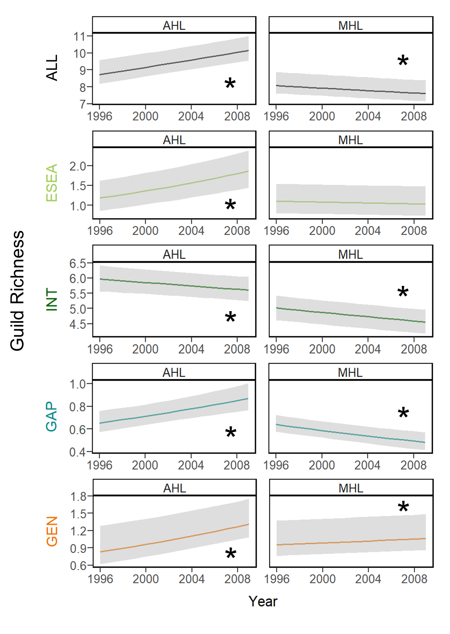

Figure 9. Plots of the change over time in overall species richness (ALL), guild (early-successional / edge-associated [ESEA], forest-interior [INT], forest-gap [GAP], and forest generalist [GEN]) richness (see Appendix A for guild designations and associated forest songbird species) within an actively harvested landscape (AHL) and minimally harvested landscape (MHL). An asterisk indicates a significant trend, where the 95% credible interval of the effective slope coefficient for year does not overlap 0.

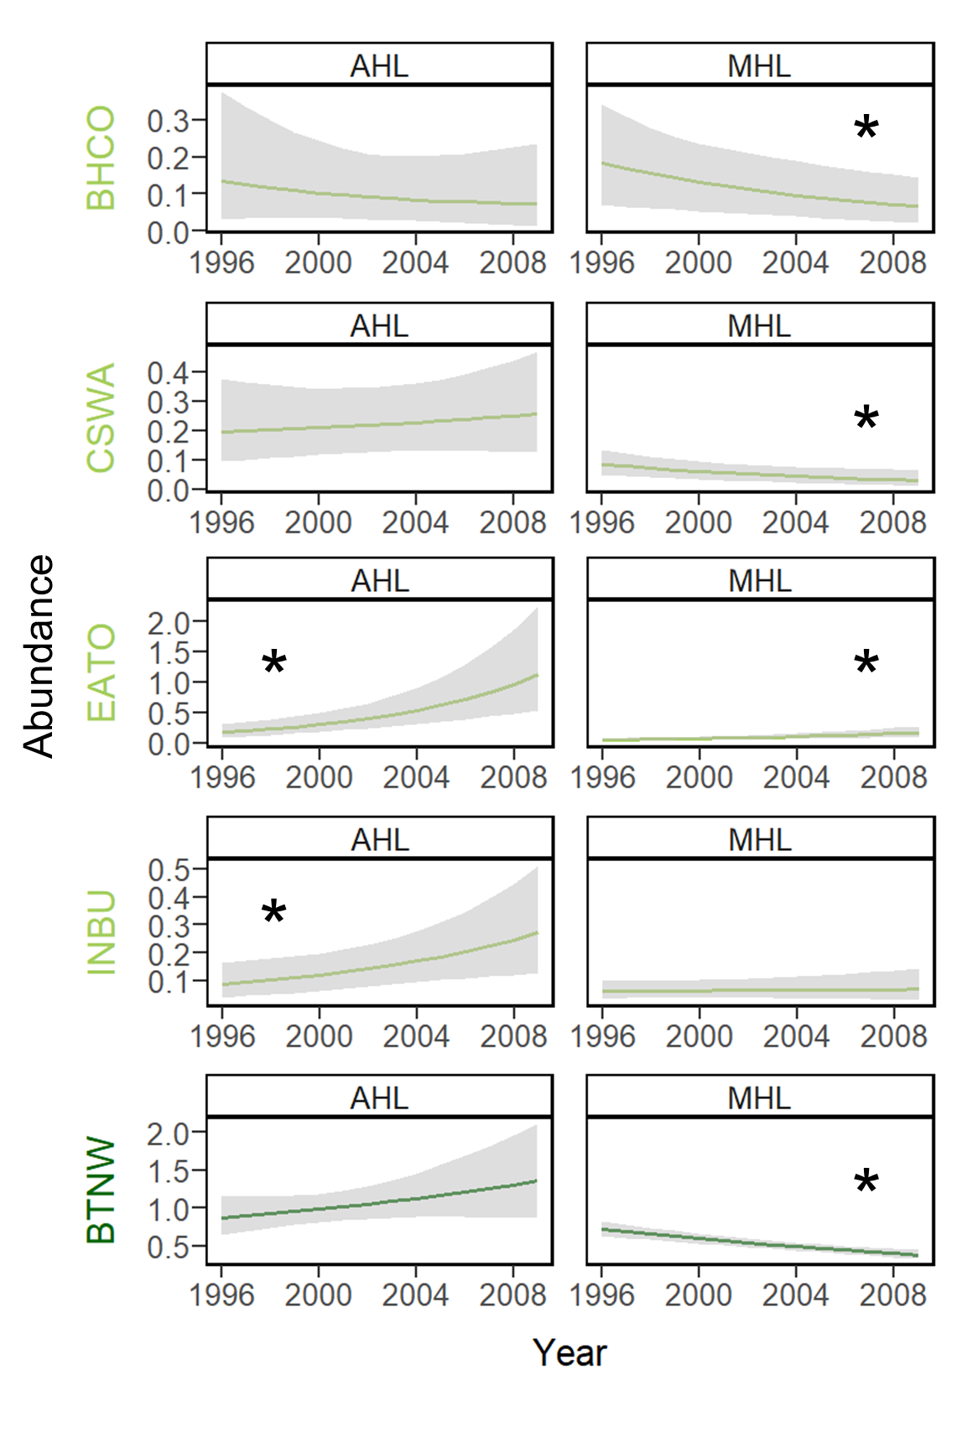

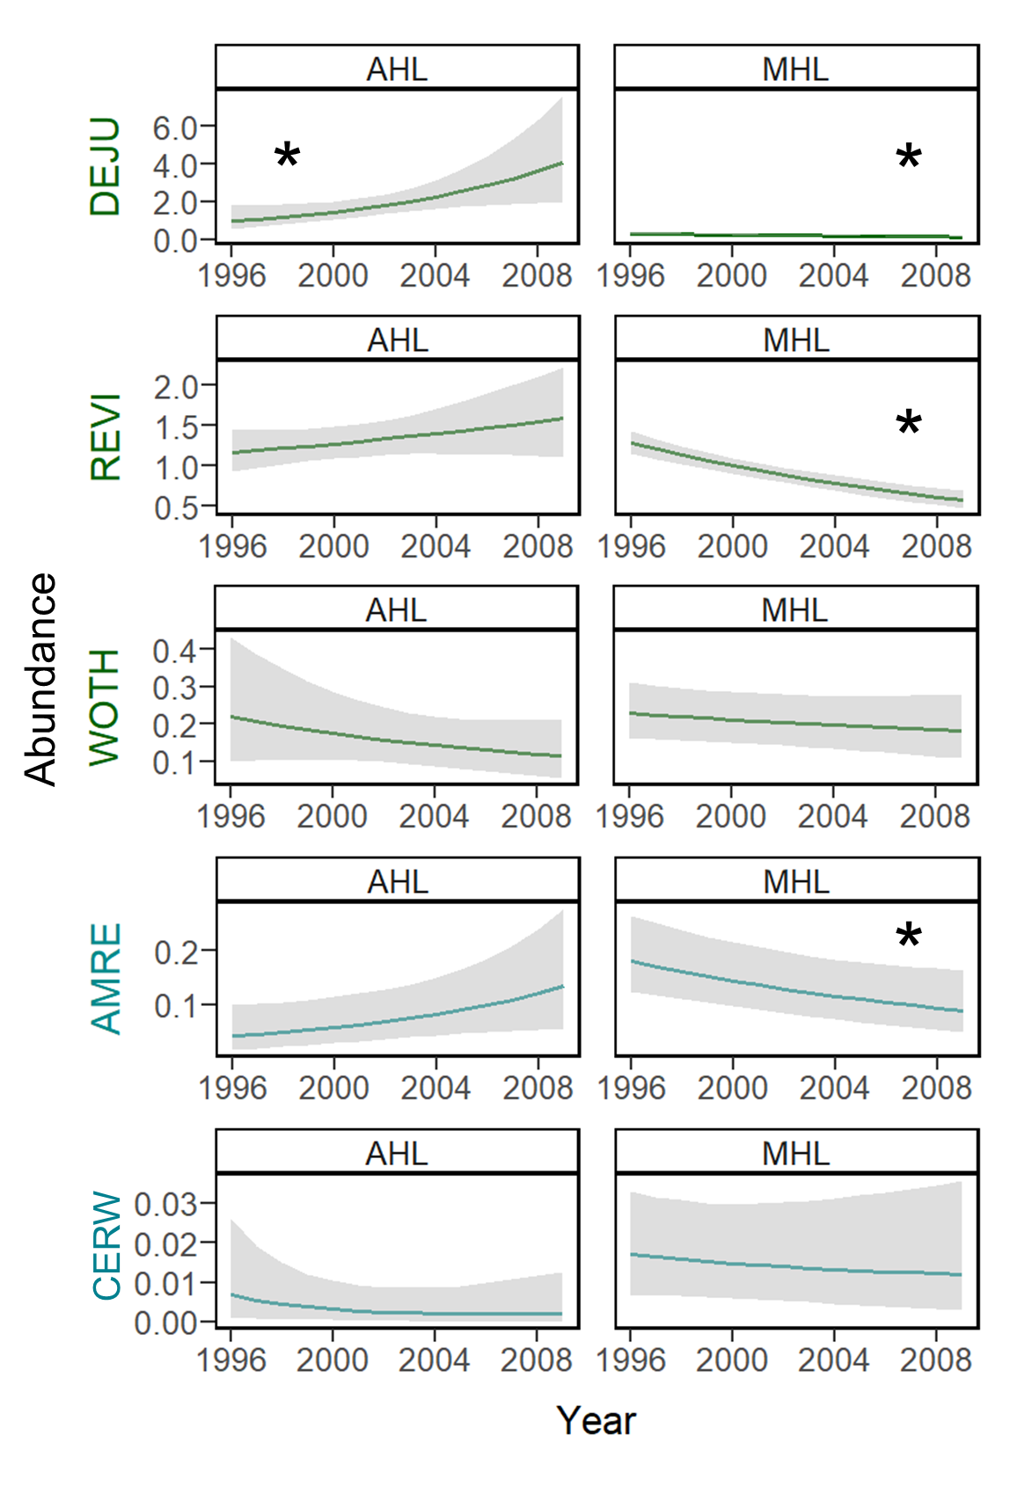

Figure 10. Plots of the change over time in focal songbird species abundance (see Table 1 for species codes) within an actively harvested landscape (AHL) and minimally harvested landscape (MHL). Color of the 4-letter species code and plot elements indicates the species’ guild designation (light green = early-successional or edge-associated guild, dark green = forest-interior guild, teal = forest-gap guild, and orange = forest generalist guild). An asterisk indicates a significant trend, where the 95% credible interval of the effective slope coefficient for year does not overlap 0.